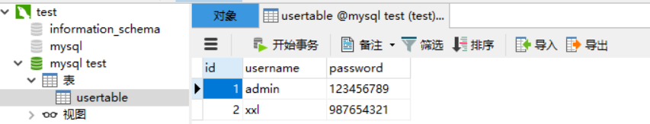

<form action=*"MainServlet"* method=*"get"*>

用户名：<input type = *"text"* name = *"username"*><br>

密码：<input type = *"text"* name = *"password"*><br>

<input type = *"submit"* value = *"提交"*>

</form>

<body>

登陆成功

</body>

<body>

登陆错误

</body>

**try**{

Class.*forName*("com.mysql.cj.jdbc.Driver");

String uri = "jdbc:mysql://localhost:3306/mysql test?serverTimezone=UTC";

conn = DriverManager.*getConnection*(uri, "root", "Lele001028@l");

}**catch**(Exception e){

e.printStackTrace();

}

**boolean** validated=**false**;

SqlSrvDBConn sqlsrvdb=**new** SqlSrvDBConn();

HttpSession session=request.getSession();

UserTable user=**null**;

**while**(rs.next()) { **if**((rs.getString("username").trim().compareTo(usr)==0)&&(rs.getString("password"). compareTo(pwd)==0)){

user=**new** UserTable();

user.setId(rs.getInt(1));

user.setUsername(rs.getString(2));

user.setPassword(rs.getString(3));

session.setAttribute("user", user);

validated=**true**;

}

}

**if**(validated){

response.sendRedirect("main.jsp");

}

**else**{

response.sendRedirect("error.jsp");

}