首先导入数据

直接使用import Data 那个按键，选中Excel表

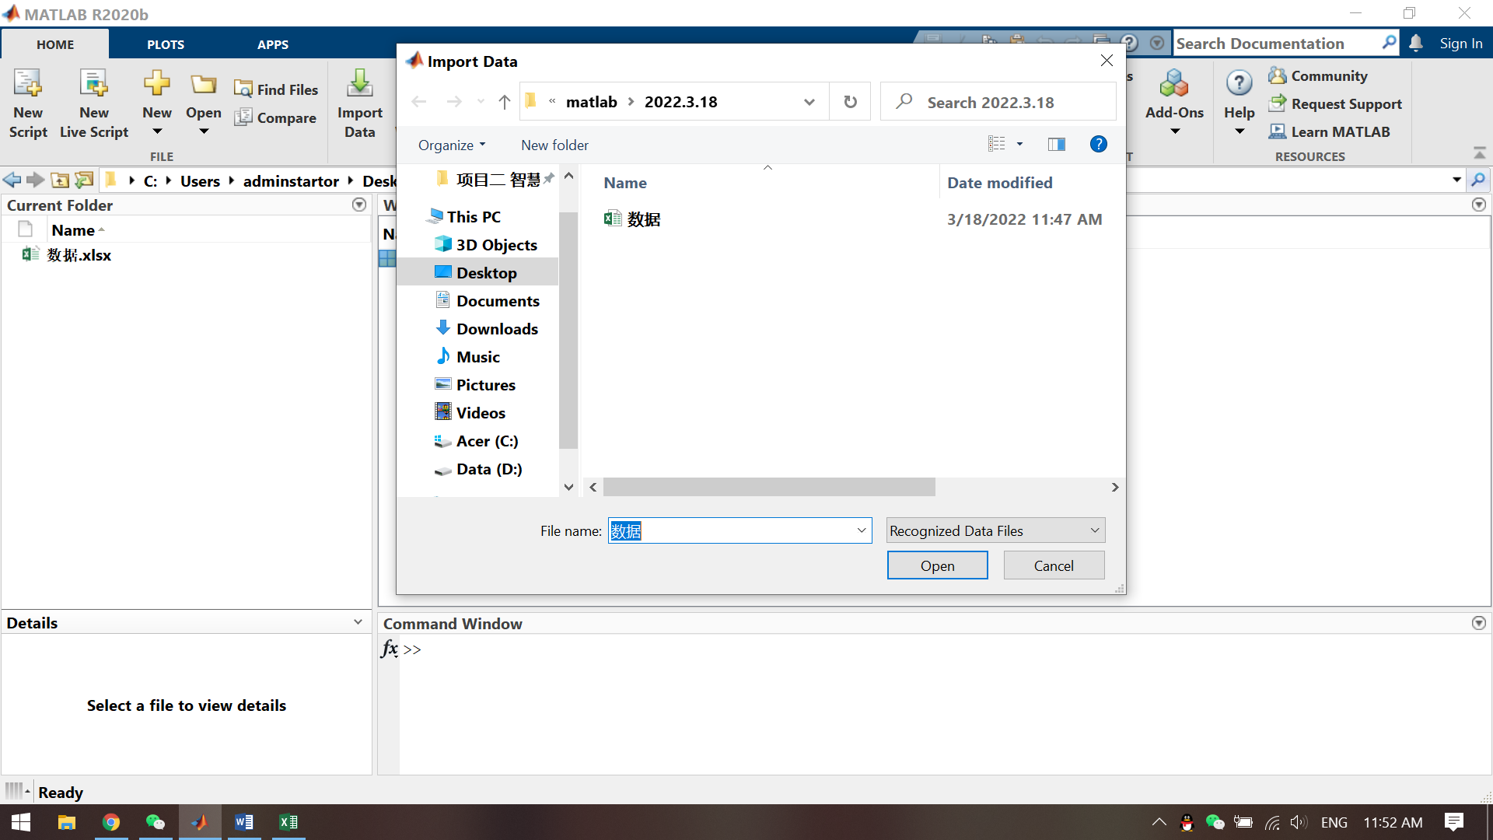

将数据输出类型选择为矩阵

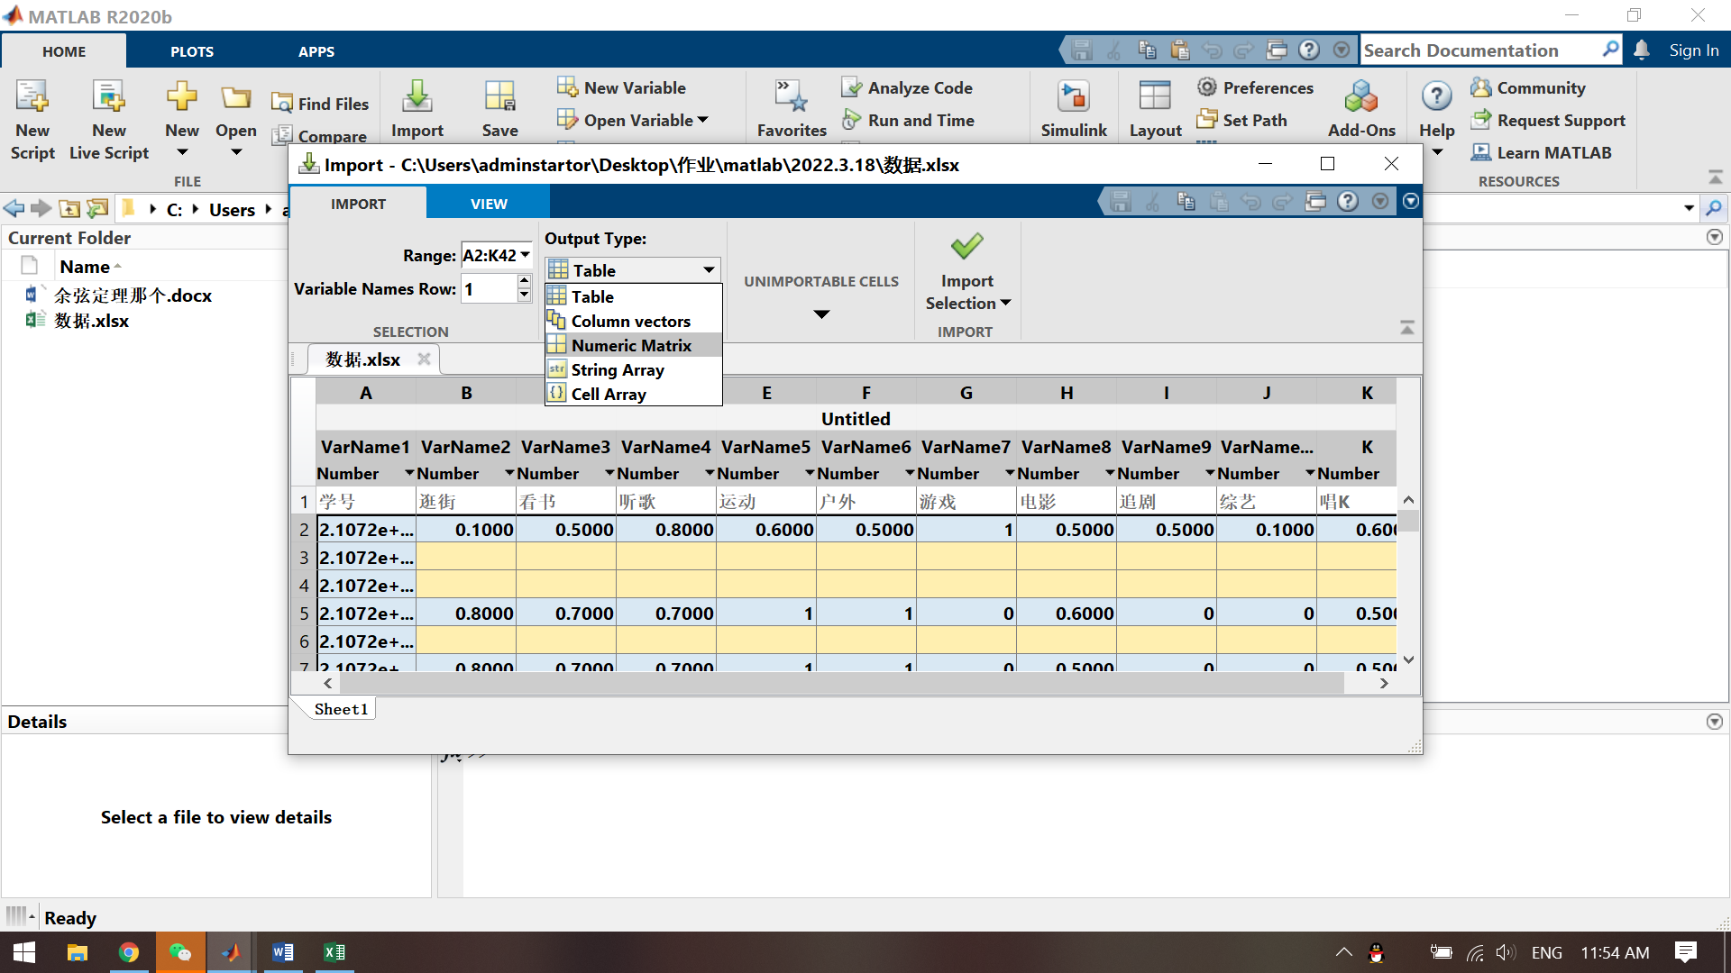

而且import的选项选择为导入数据

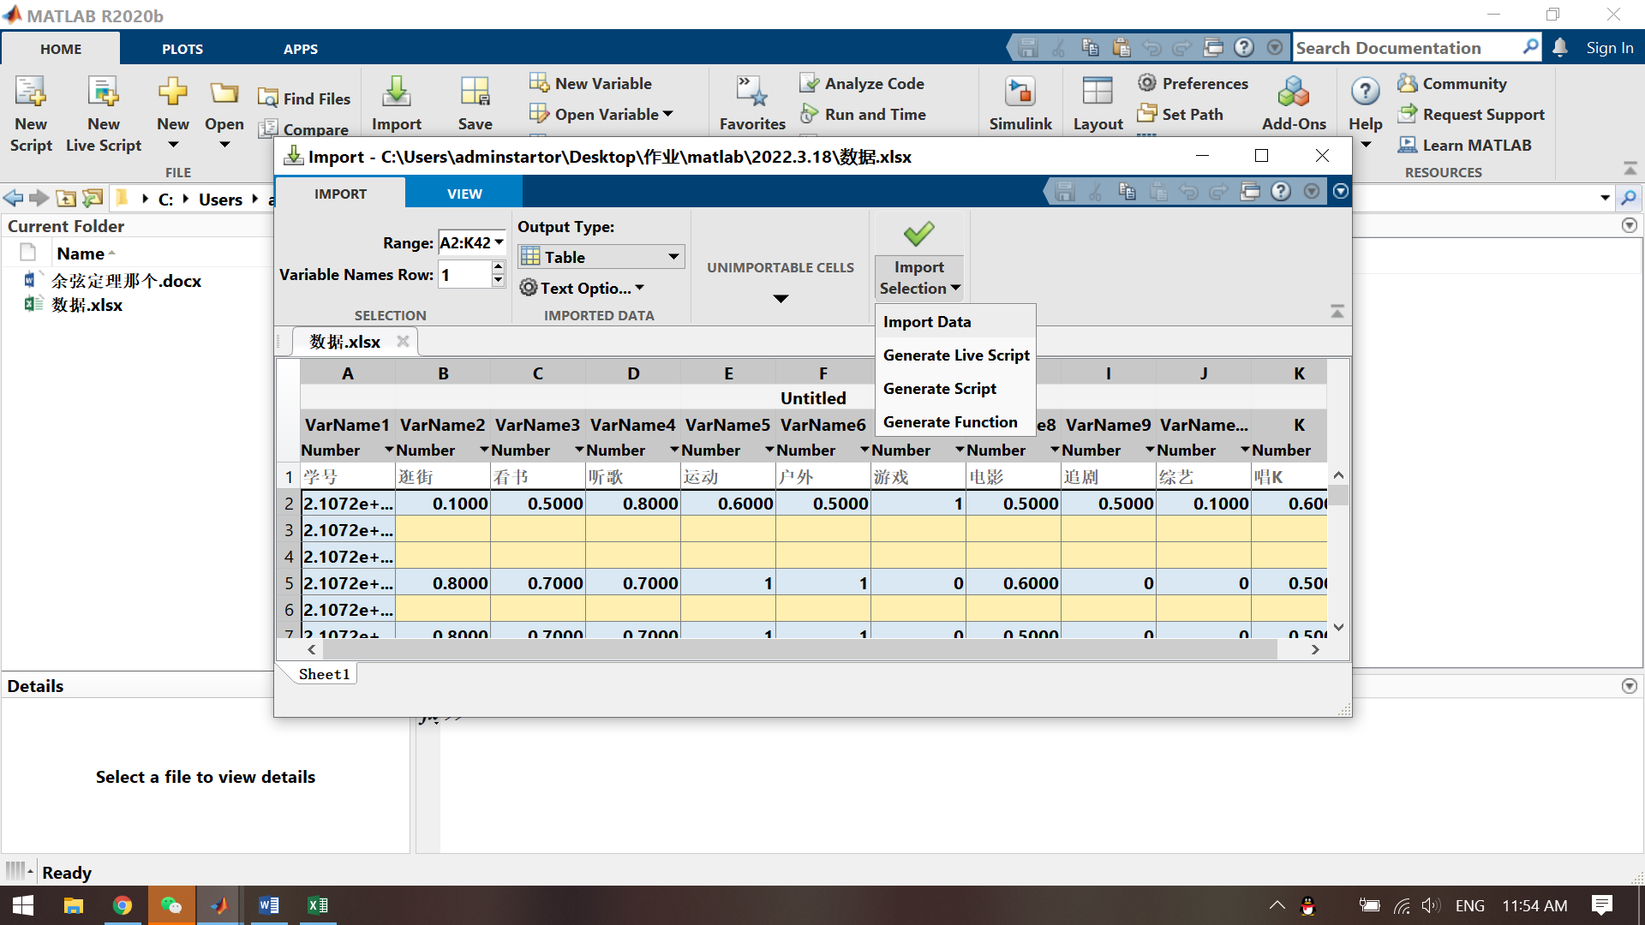

## 计算自己与班上志同道合的同学：

myself = Data(29, 2:11);

myself_2 = 0;

someone = 0;

for i=1:10

myself_2 = myself_2 + (myself(1, i)).^2;

end

for i = 1:41

t = sum(myself .* Data(i, 2:11));

for j=2:11

someone = someone + (Data(i, j))^2;

end

show = t / (sqrt(myself_2) * sqrt(someone));

if (show > 0.9)

disp(Data(i, 1));

end

someone = 0;

end

结果如下：

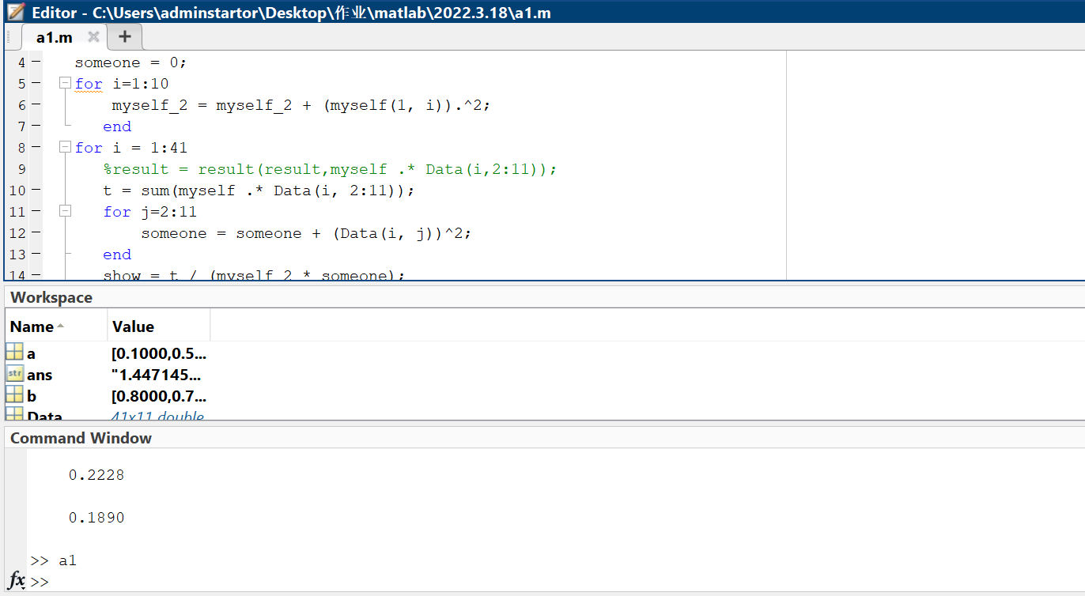

计算分组

person = [];

mo = [];

mo_result = 0;

result = zeros(41,41);

for i = 1:41

%person(end + 1) = sum(Data(i,2:11));

for j = 2:11

mo_result = mo_result + (Data(i,j))^2;

end

mo(end + 1) = sqrt(mo_result);

mo_result = 0;

end

mo_2 = mo';

for i = 1:41

for j = 1:41

t = (sum(Data(i, 2:11) .* Data(j, 2:11))) ./ (mo(i) .* mo_2(j));

result(i, j) = t;

if (t > 0.9)

result(i, j) = 1;

else

result(i, j) = 0;

end

end

end

ans = 0;

ans_2 = 0;

group = [];

for i = 1:41

group(end + 1) = i;

for j = 1:41

if result(i, j) == 1 && result(j, i) == 1

ans = ans + 1;

group(end + 1) = j;

end

end

if ans >= 4

ans_2 = ans_2 + 1;

for k = 1:length(group)

disp(group);

end

end

ans = 0;

group = [];

end

disp(ans_2)

结果如下：

