第一题：

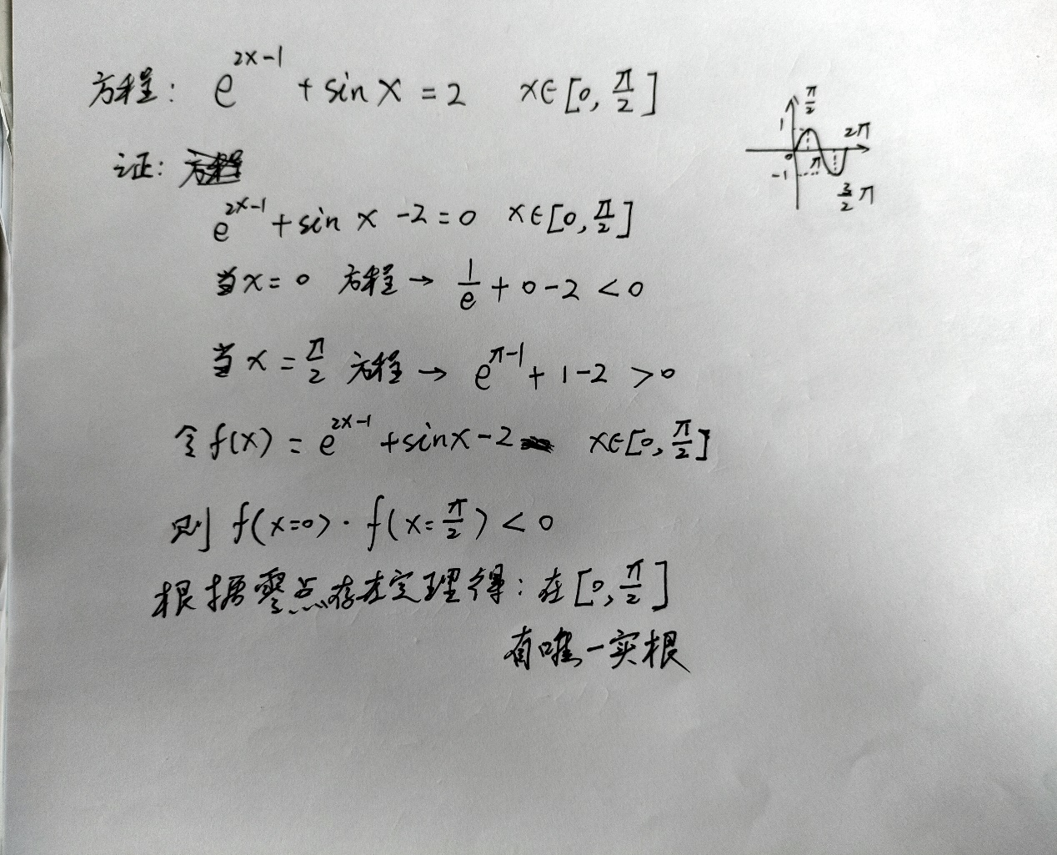

function [y] = f(x)

%UNTITLED2 Summary of this function goes here

% Detailed explanation goes here

y = exp(2 \* x - 1) + sin (x) - 2;

end

left = 0;

right = pi / 2;

mid = (left + right) / 2;

result = f(mid);

while (result ~= 0)

if (f(left) \* result < 0)

right = mid;

else

left = mid;

end

mid = (left + right) / 2;

result = f(mid);

end

fprintf("The result is %.6f\n", mid);

结果：

