ONLINE SHOPPING FOR ELECTRONIC ITEMS

**Name: P.Ponnarasi Day : 02**

**Reg.No : 17BCB0130 Date : 20/03/2020**

**INTRODUCTION:-**

Online shopping website is developed using HTML, Java script, CSS for frontend and mongoDB and Node JS for background.

Shopping Cart System is the simple shopping Solution. It’s a full-featured website and shopping cart system that bends over backwards to give you the flexibility you need to run your online store.

The basic concept of the application is to allow the customer to shop virtually using the Internet and allow customers to buy products of their desire from the store.

The information pertaining to the products are stores on an RDBMS at the server side. The Server process the customers and the items are shipped to the address submitted by them. The details of the items are brought forward from the database for the customer view based on the selection through the menu and the database of all the products are updated at the end of each transaction.

# Proposed System Overview

* + 1. Multiuser environment is provided. In this when one user is updating a form. The other user cannot open the same form to avoid conflicts.
    2. Security to the data is provided by means of Login Form. Only authorized users can have access to the system.
    3. The system allows users to maintain records of customers, account details, delivery details.
    4. This system also allows users to generate Customer reports, account detail reports, delivery detail report.



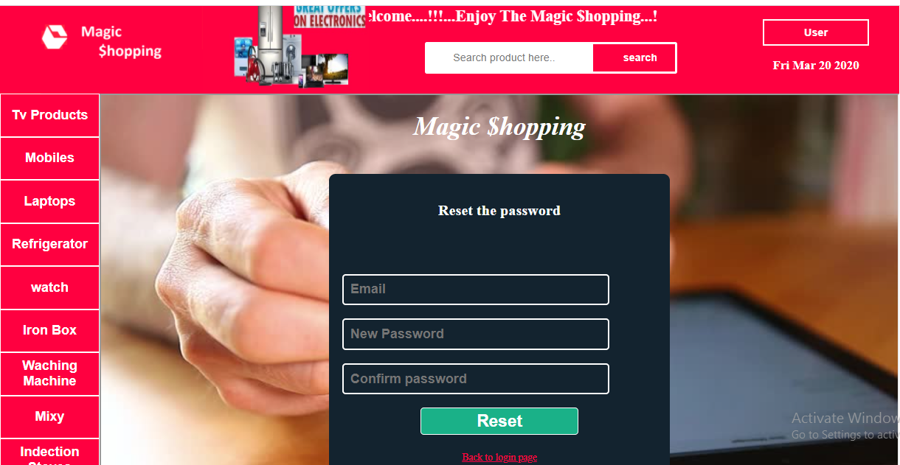

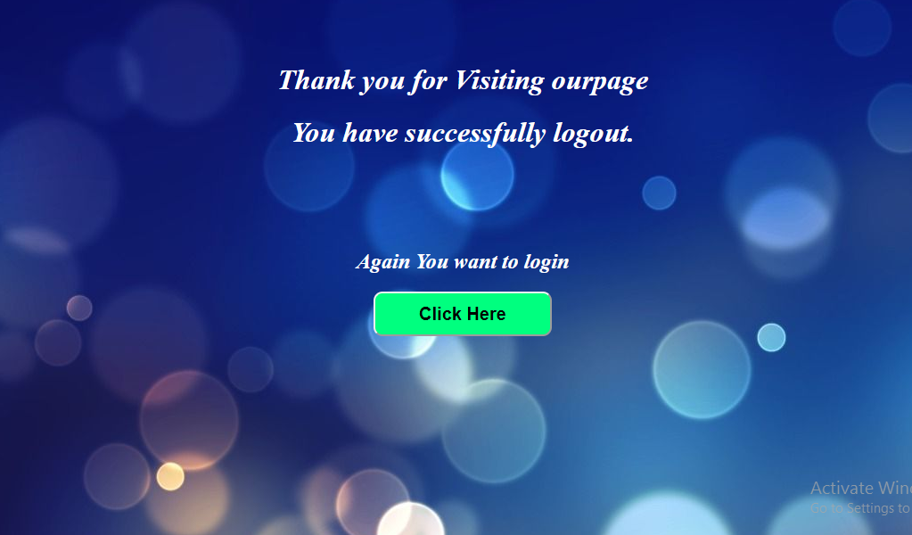

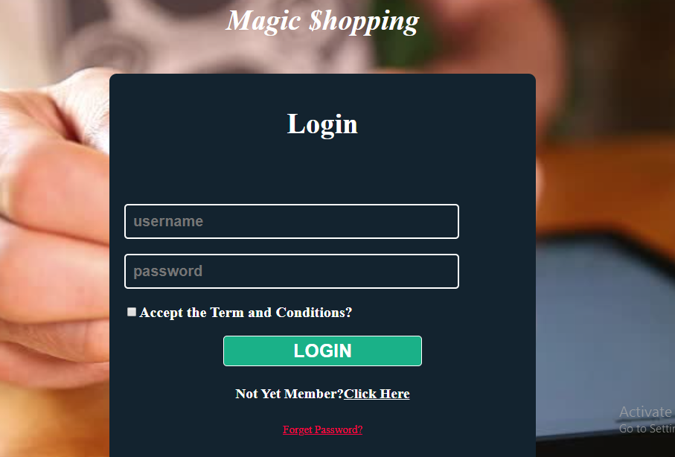

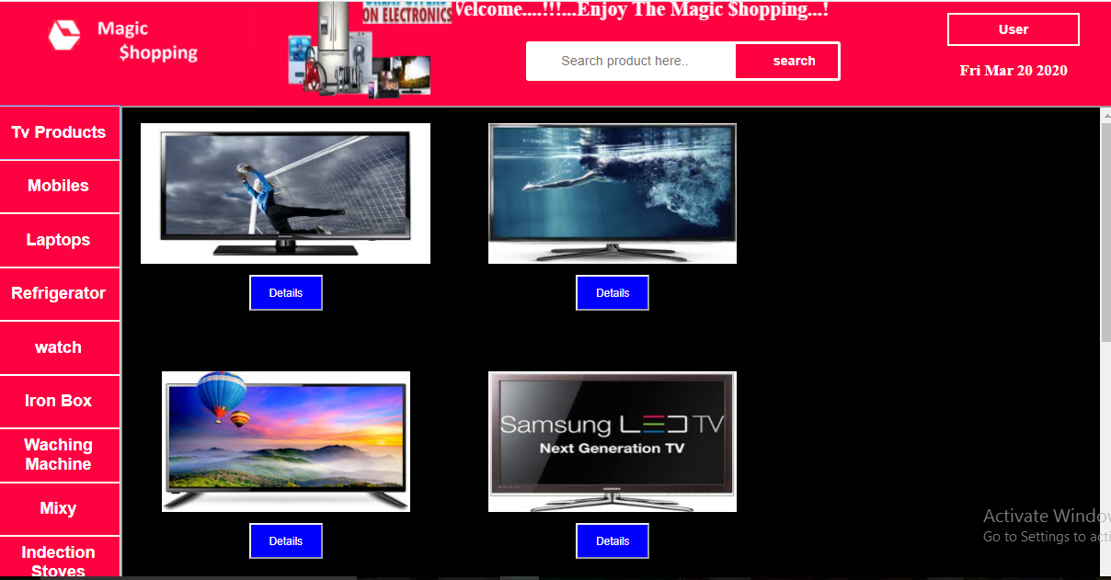

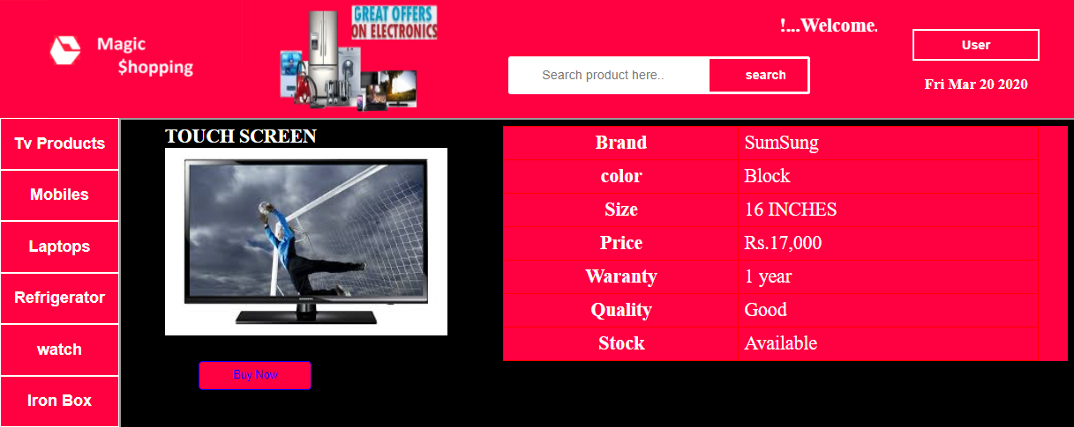

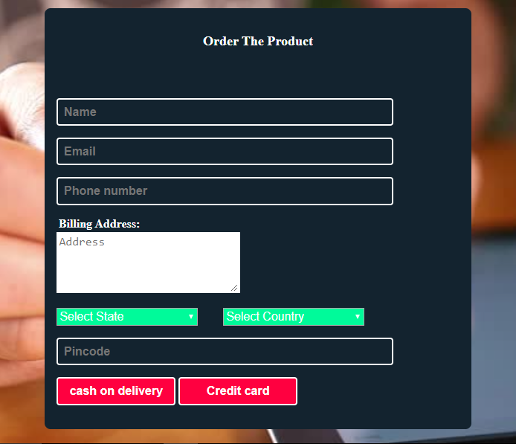

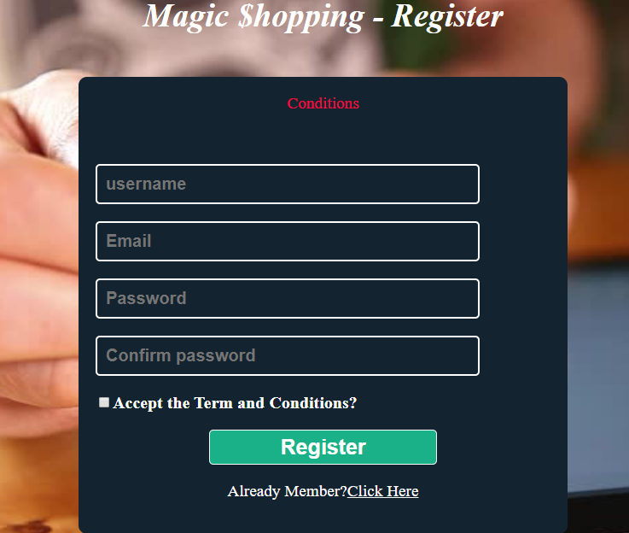

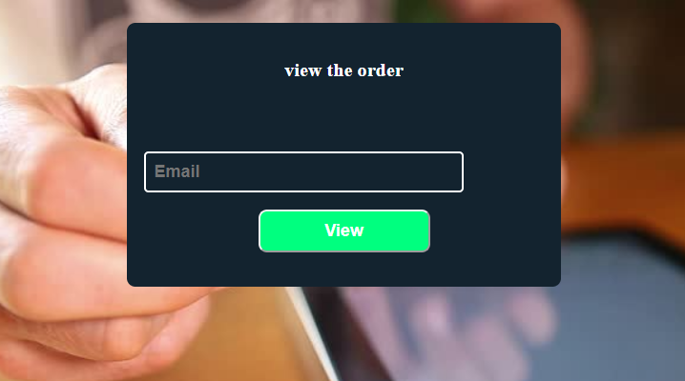

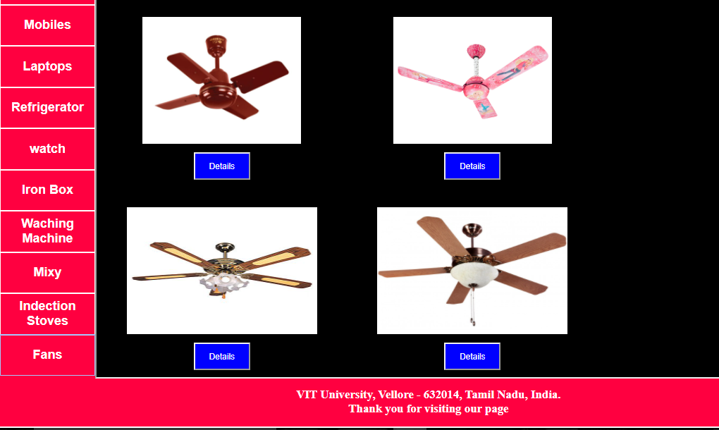

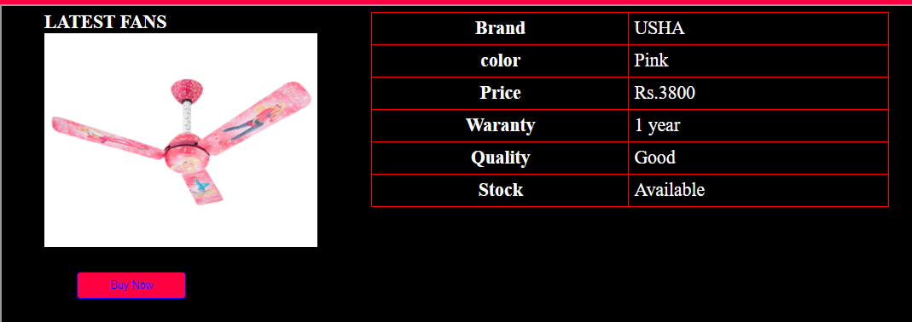

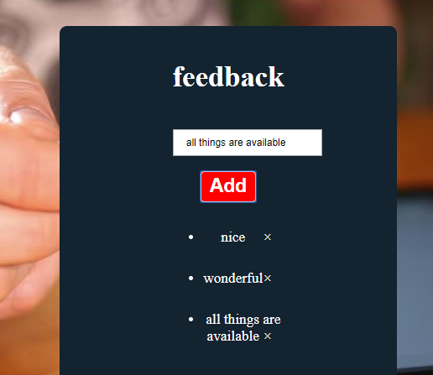

<!DOCTYPE html>

<html>

<head>

<title>Magic $hopping</title>

<style>

#bottom

{

width:1351px;

float:left;

background-color:#ff0040;

height:80px;

color:white;

text-align:center;

}

.sbtn

{

width: 130px;

border:3px solid white;

border-radius: 0px 3px 3px 0px;

font-size: 16px;

font-weight: bold;

background-color: #ff0040;

color: white;

background-position: 10px 10px;

background-repeat: no-repeat;

padding: 12px 20px 12px 40px;

cursor: pointer;

}

.button{

background-color:#ff0040;

cursor:pointer;

color:white;

border:1px solid white;

border-radius:none;

width:150px;

height:65px;

text-align:center;

font-size:20px;

}

.button:hover

{

background-color:#32c881;

color:white;

}

input[type=text] {

width: 250px;

box-sizing:border-box;

border:3px solid white;

border-radius: 3px 0px 0px 3px;

font-size: 16px;

background-color:white;

color:black;

background-position: 10px 10px;

background-repeat: no-repeat;

padding: 12px 20px 12px 40px;

}

input[type=text]:focus {

width: 400px;

}

.dropbtn {

background-color: #ff0040;

color: white;

width: 160px;

height: 40px;

font-weight: bold;

font-size: 16px;

border: 2px solid white;

cursor: pointer;

}

.dropdown {

position: relative;

display: inline-block;

}

.dropdown-content {

display: none;

position: absolute;

background-color: #ff0040;

min-width: 160px;

box-shadow: 0px 8px 16px 0px rgba(0,0,0,0.2);

z-index: 1;

}

.dropdown-content a {

color: white;

padding: 12px 16px;

font-size: 16px;

font-weight: bold;

text-decoration: none;

display: block;

}

.dropdown-content a:hover {background-color: #00FF47}

.dropdown:hover .dropdown-content {

display: block;

}

</style>

</head>

<body text="white" style="overflow-x:hidden">

<link rel="stylesheet" type="text/css" href="first_page.css" />

<div id="container">

<div id="topleft">

<a href="1stpage.html" style="cursor:ponter">

<img src="image/shopimage.png" width="305px" height="150px">

</a>

</div>

<div id="topright0" style="width:250px;height:150px">

<img src="image/trimage.jpg" style="width:250px;height:150px">

</div>

<div id="topright" style="text:white">

<?html if(isset($_SESSION["username"])): ?>

<marquee><h2>!...Welcome....<strong><?html echo $_SESSION['username']; ?>!!!...Enjoy The Magic $hopping...!</strong></h1></marquee>

<?html endif ?>

<form action="1stpage.html" method="POST">

<input type="text" name="searchh" placeholder="Search product here.."><button class="sbtn" type="submit" name="search">search</button>

</form>

</div>

<div id="topright1" style="width:250px;height:150px;text-align:center">

<br><br>

<div class="dropdown">

<button class="dropbtn">User</button>

<div class="dropdown-content">

<a href="1stpage.html">Home</a>

<a href="vieworder.html" target="frame">Order View</a>

<a href="reset.html" target="frame">Password Reset</a>

<a href="feedback.html" target="frame">feedback</a>

<a href="logout.html?logout='1'">Logout</a>

</div>

</div>

<h3 id="demo" style="text-align:center"></h3>

<script>

var d = new Date();

document.getElementById("demo").innerHTML = d.toDateString();

</script>

</div>

<div id="leftside">

<a href="tv.html" target="frame">

<button class="button button"><strong>Tv Products</strong></button>

</a>

<a href="mobile.html" target="frame">

<button class="button button"><strong>Mobiles</strong></button>

</a>

<a href="laptop.html" target="frame">

<button class="button button"><strong>Laptops</strong></button>

</a>

<a href="fridge.html" target="frame">

<button class="button button"><strong>Refrigerator</strong></button>

</a>

<a href="watch.html" target="frame">

<button class="button button"><strong>watch</strong></button>

</a>

<a href="box.html" target="frame">

<button class="button button"><strong>Iron Box</strong></button>

</a>

<a href="washing.html" target="frame">

<button class="button button"><strong>Waching Machine</strong></button>

</a>

<a href="mixy.html" target="frame">

<button class="button button"><strong>Mixy</strong></button>

</a>

<a href="stove.html" target="frame">

<button class="button button"><strong>Indection Stoves</strong></button>

</a>

<a href="fan.html" target="frame">

<button class="button button"><strong>Fans</strong></button>

</a>

</div>

<div id="rightside">

<iframe src="new.html" name="frame" width="1200px" height="650px">

</iframe>

</div>

<div id="bottom">

<h3><strong>VIT University, Vellore - 632014, Tamil Nadu, India.<br>

Thank you for visiting our page</strong></h3>

</div>

</div>

</body>

</html>

**fan.html:-**

<!DOCTYPE html>

<html>

<head>

<title>container</title>

<style>

body{background-color:black;}

.button{

background-color:blue;

color:white;

text-allign:center;

padding:12px 22px;

cursor:pointer;

}

.button:hover{

color:green;

background-color:pink;

}

#option1:hover{

background-color:#32c881;

cursor:pointer;

}

#option2:hover{

background-color:#32c881;

cursor:pointer;

}

#option3:hover{

background-color:#32c881;

cursor:pointer;

}

#option4:hover{

background-color:#32c881;

cursor:pointer;

}

#option5:hover{

background-color: #32c881;

cursor:pointer;

}

#option6:hover{

background-color:#32c881;

cursor:pointer;

}

#option7:hover{

background-color:#32c881;

cursor:pointer;

}

#option8:hover{

background-color:#32c881;

cursor:pointer;

}

#option9:hover{

background-color:#32c881;

cursor:pointer;

}

</style>

</head>

<body style="font-size:10px">

<link rel="stylesheet" type="text/css" href="container.css" />

<div id="container">

<div id="option1">

<br>

<img src="fan1.jpg" width="230px" height="200px"><br><br>

<a href="fan_table1.html"><button class="button">Details</button></a>

</div>

<div id="option2">

<br>

<img src="fan2.jpg" width="230px" height="180px"><br><br>

<a href="fan_table2.html"><button class="button">Details</button></a>

</div>

<div id="option3">

<br>

<img src="fan3.jpg" width="200px" height="200px"><br><br>

<a href="fan_table3.html"><button class="button">Details</button></a>

</div>

<div id="option4">

<br>

<img src="fan4.jpg" width="300px" height="200px"><br><br>

<a href="fan_table4.html"><button class="button">Details</button></a>

</div>

<div id="option5">

<br>

<img src="fan5.jpg" width="250px" height="200px"><br><br>

<a href="fan_table5.html"><button class="button">Details</button></a>

</div>

<div id="option6">

<br>

<img src="fan6.jpg" width="250px" height="200px"><br><br>

<a href="fan_table6.html"><button class="button">Details</button></a>

</div>

<div id="option7">

<br>

<img src="fan7.jpg" width="300px" height="200px"><br><br>

<a href="fan_table7.html"><button class="button">Details</button></a>

</div>

<div id="option8">

<br>

<img src="fan8.jpg" width="300px" height="200px"><br><br>

<a href="fan_table8.html"><button class="button">Details</button></a>

</div>

<div id="option9">

<br>

<img src="fan9.jpg" width="300px" height="200px"><br><br>

<a href="fan_table9.html"><button class="button">Details</button></a>

</div>

</div>

</body>

</html>

**fan_table1.html**

<!DOCTYPE html>

<html>

<head>

<script src="https://ajax.googleapis.com/ajax/libs/jquery/1.12.4/jquery.min.js"></script>

<script>

$(document).ready(function(){

$("img").dblclick(function(){

$("table").fadeToggle(2000);

});

});

</script>

<style>

body{background-color:black;}

h{

font-size:150%;

margin-left:10%;

}

img{

margin-left:10%;

}

.tfbutton {

padding: 2%;

font-family: Arial, Helvetica, sans-serif;

font-size:14px;

outline: none;

cursor: pointer;

text-align: center;

text-decoration: none;

color: blue;

border: solid 1px ;

background-color:#ff0040;

border-top-right-radius: 5px 5px;

border-bottom-right-radius: 5px 5px;

}

.tfbutton:hover{

border:1px solid red;

color:yellow;

}

#buttonstyle

{

height:2%;

width:30%;

border-radius:5px;

margin-left:19%;

}

table,th,td{

border:2px solid red;

border-collapse: collapse;

}

#division{

display:inline-block;

float:left;

}

#division:hover{background-color:#ff0040;

cursor:pointer;}

th,td{

padding:1%;

font-size:150%;

}

h,th{

color:white;

}

td{

color:white;

}

</style>

</head>

<body background img="background3.jpeg">

<div id="division" style="width:40%;height:100%;">

<h><b>LATEST FANS</b></h><br>

<img src="fan1.jpg" width="75%"></img><br>

<b style="font-size:150%;margin-left:22%">Rs.3000</b><br>

<a href="buyform.html" target="blank"><button class="tfbutton" id="buttonstyle">Buy Now</button></a>

</div>

<div id="division" style="width:60%;height:100%;">

<table style="width:95%">

<tr>

<th>Brand</th>

<td>USHA</td>

</tr>

<tr>

<th>color</th>

<td>Brown</td>

</tr>

<tr>

<th>Price</th>

<td>Rs.3000</td>

</tr>

<tr>

<th>Waranty</th>

<td>1 year</td>

</tr>

<tr>

<th>Quality</th>

<td>Good</td>

</tr>

<tr>

<th>Stock</th>

<td>Available</td>

</tr>

</table>

</div>

</body>

</html>

**finish.html**

<!DOCTYPE html>

<html>

<head>

<title>logout</title>

<style>

.button{

background-color:#00FF7F;

border-radius:10px;

color:black;

width:200px;

height:50px;

font-size:20px;

cursor:pointer;

}

.button:hover{

background-color:#de001f;

color:white;

}

</style>

</head>

<body background="image/index.jpg"style="text-align:center;color:white">

<br><br><br>

<h1><strong><i>Thank you for Visiting ourpage</i></strong></h1>

<h1><strong><i>You have successfully paid.</i></strong></h1>

<br><br><br><br>

<h2><strong><i>Again You want to login</i></strong></h2>

<a href="sign in.html"><button class="button button"><strong>Click Here</strong></button></a>

</body>

</html>

**Payment.html**

<!DOCTYPE html>

<html>

<head>

<style>

.h3

{

color:white;

font-size: 20px;

font-weight: bold;

}

</style>

<title>payment</title>

<link rel="stylesheet" type="text/css" href="log.css">

</head>

<body>

<div class="header">

<h3 style="text-align:center;color:white"><i>PayMent</i></h3>

<?php include('errors.php'); ?>

</div>

<form action="http://127.0.0.1:8081/process3" method="POST" name="pay">

<div class="logindata">

<input type="text" name="card" placeholder="Card On Name"/required>

</div>

<div class="logindata">

<input type="text" name="cardno" placeholder="Card Number"/required>

</div>

<div class="logindata">

<input type="date" name="expdate" placeholder="Exp Date"/required>

</div>

<div class="logindata">

<input type="password" name="pin" placeholder="PIN(security code)"/required >

</div>

<div class="logindata" style="text-align:center">

<a href="payment.php"><input type="submit" name="payment" value="pay" style="width:200px;background-color:#ff0040;cursor:pointer"></a>

</div>

</form>

</body>

</html>

**reset.html**

<!DOCTYPE html>

<html>

<head>

<title>reset</title>

<link rel="stylesheet" type="text/css" href="register.css">

</head>

<body>

<h1 style="color:white;text-align:center"><i>Magic $hopping</i></h1>

<div class="header">

<h3>Reset the password</h3>

</div>

<form action="http://127.0.0.1:8081/process4" method="POST" name="reset">

<?php include('errors.php'); ?>

<div class="logindata">

<input type="text" name="email" placeholder="Email"/required>

</div>

<div class="logindata">

<input type="password" name="pwd1" placeholder="New Password"/required>

</div>

<div class="logindata">

<input type="password" name="pwd2" placeholder="Confirm password"/required >

</div>

<div class="logindata" style="text-align:center">

<button type="submit" name="reset" class="rbutton">Reset</button><br><br>

<a href="sign in.html" style="color:#ff0040;font-size:15px;text-align:center;">Back to login page</a>

</div>

</form>

</body>

</html>

**sign up.html**

<!DOCTYPE html>

<html>

<head>

<style>

.h3

{

color:white;

font-size: 20px;

font-weight: bold;

}

</style>

<title>login page</title>

<link rel="stylesheet" type="text/css" href="log.css">

</head>

<body>

<h1 style="color:white;text-align:center"><i>Magic $hopping</i></h1>

<div class="header">

<h1>Login</h1>

</div>

<form action="http://127.0.0.1:8081/1stpage.html" method="POST" name="sign in">

<div class="logindata">

<input type="text" name="username" placeholder="username"/required>

</div>

<div class="logindata">

<input type="password" name="password" placeholder="password" /required>

</div>

<div class="h3">

<input type="checkbox" name="check" /required>Accept the Term and Conditions?

</div>

<div class="logindata" style="text-align:center">

<a href="1stpage.html"><button type="submit" name="login" class="rbutton">LOGIN</button></a>

<h4 style="color:white">Not Yet Member?<a href="sign up.html" style="color:white">Click Here</a></h4>

<a href="reset.html" style="color:#ff0040;font-size:15px">Forget Password?</a>

</div>

</form>

</body>

</html>

**THANK YOU**