COMP47500 - Advanced Data Structures in Java
Assignment 5 Report

Field | Details
Assignment No. | 5
Date | 06/05/2026
Title | Emergency Evacuation Route Planning Using Weighted Graphs
Assignment Type of Submission | Individual
Group | No
Student Name | Jiawei Li
Student ID | [Insert Student ID]
% Contribution | 100%
Assignment Workload | All design, implementation, experiments, analysis and report writing completed individually.

Problem Domain Description:
This assignment addresses emergency evacuation route planning in a building. During an emergency, occupants may need to move from rooms or corridors to safe exits while avoiding routes that are smoky, crowded, blocked, or close to danger. A simple shortest physical route may not be the safest evacuation route, because a short corridor can still have high risk or congestion. The objective of the system is therefore to find a minimum-cost evacuation path rather than only the route with the fewest corridors.
Graphs are appropriate for this problem because a building can naturally be represented as a network. Rooms, corridors, stairwells, lobbies and exits are vertices. Walkable connections are edges. Each edge stores distance, risk and congestion, which are combined into a single evacuation cost. The implemented system compares breadth-first search (BFS), which finds a fewest-edge route, with Dijkstra’s algorithm, which finds the route with the lowest total evacuation cost.
Graph Element | Meaning in this Project
Vertex | Room, corridor, stairwell, lobby or exit
Edge | Walkable connection between two locations
Distance | Length or travel effort of a route segment
Risk | Danger level, such as smoke, heat or proximity to hazard
Congestion | Crowding level or expected delay
Evacuation cost | Combined edge weight used by Dijkstra’s algorithm

Theoretical Foundations of the Data Structure(s) utilised
A graph G = (V, E) consists of a set of vertices V and a set of edges E connecting pairs of vertices. In this project the graph is undirected because movement is assumed possible in both directions along a corridor unless an edge is removed to simulate a blocked route. The graph is also weighted because each route segment has a cost. An adjacency-list representation is used because it stores only existing edges and is therefore space-efficient for sparse networks such as building layouts.
For each edge, the evacuation cost is calculated as follows:
cost = distance + 2 * risk + congestion
Risk is weighted twice as heavily as distance because, in an evacuation scenario, safety is more important than taking the physically shortest route. This does not force the algorithm to always choose the safest-looking route; instead, it balances distance, risk and congestion into one cost value. Dijkstra’s algorithm then chooses the path with the minimum total accumulated cost.
Algorithm | Purpose in System | Time Complexity | Space Complexity
BFS | Fewest-edge route in an unweighted view of the graph | O(V + E) | O(V)
DFS | Reachability checking between two locations | O(V + E) | O(V)
Dijkstra - linear scan | Weighted shortest path using linear minimum selection | O(V^2 + E) | O(V)
Dijkstra - PriorityQueue | Weighted shortest path using heap-based minimum selection | O((V + E) log V) | O(V + E)

BFS and DFS are linear in the size of the graph because each vertex and edge is processed at most once. Linear-scan Dijkstra is less efficient because each iteration searches all unvisited vertices to find the current smallest distance. The PriorityQueue version improves practical efficiency by making the next-vertex selection heap-based, which is more suitable for large sparse graphs. This is why the PriorityQueue implementation is used as the main weighted routing algorithm.

Analysis/Design (UML Diagram(s))
The system is organised into seven main classes. Graph stores the adjacency-list structure; Edge stores destination and weighted evacuation information; GraphAlgorithms contains BFS, DFS and both Dijkstra implementations; GraphGenerator creates sample and random graphs; ExperimentRunner executes the performance experiments; PathResult stores the returned path and metrics; and Main runs the full demonstration.
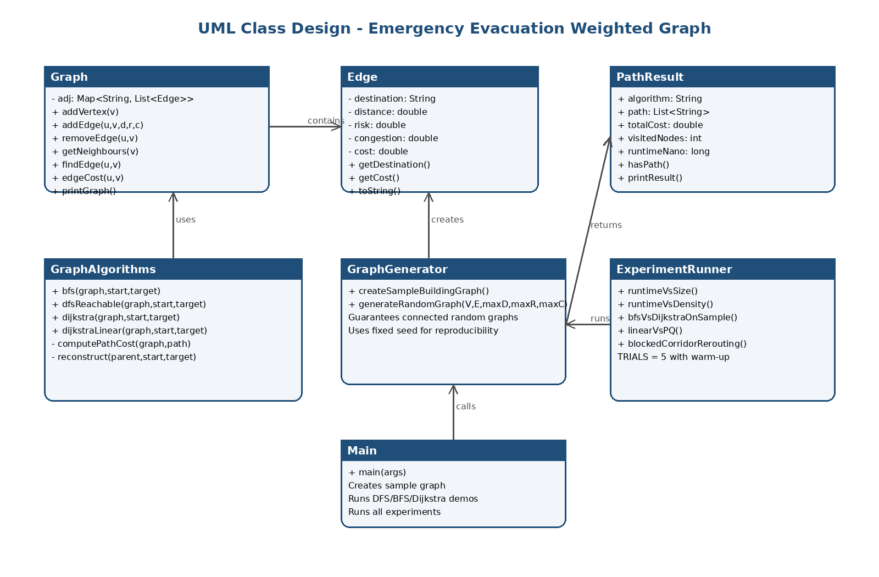
Figure 1. UML-style design of the implemented graph evacuation system.
Class | Main Responsibility
Edge | Immutable route segment storing destination, distance, risk, congestion and calculated cost.
Graph | Custom undirected adjacency-list graph with add, remove, lookup and print operations.
PathResult | Stores algorithm name, path, total cost, visited nodes and runtime.
GraphAlgorithms | Implements BFS, DFS reachability, Dijkstra with PriorityQueue and linear Dijkstra.
GraphGenerator | Creates a sample evacuation graph and reproducible connected random graphs.
ExperimentRunner | Runs the five experiments and prints report-friendly tables.
Main | Runs the demonstration, invalid input test and all experiments automatically.

Code Implementation
GitHub (link): [Insert GitHub repository link here]
The repository should add the lecturer GitHub account as a collaborator as requested in the assignment template: https://github.com/jrgarga.
The code is written in Java and compiles directly from the terminal. The project does not use an external graph library. Java collections such as HashMap, ArrayList, HashSet, ArrayDeque and PriorityQueue are used to support the custom data structure and algorithms.
javac src/*.java
java -cp src Main
File | Purpose
Edge.java | Defines immutable weighted edge objects and the evacuation cost formula.
Graph.java | Implements the custom undirected adjacency-list graph.
PathResult.java | Stores path, cost, visited-node count and runtime.
GraphAlgorithms.java | Implements BFS, DFS, Dijkstra with PriorityQueue and linear Dijkstra.
GraphGenerator.java | Creates sample and random graphs.
ExperimentRunner.java | Runs all experimental tests and prints tables.
Main.java | Demonstrates the system and runs all experiments.

Set of Experiments run and results:
All experiments were run from the Main class using terminal compilation and execution. Runtime was measured with System.nanoTime(). For the main performance experiments, each setting used one warm-up run followed by five measured trials, and the average runtime is reported. Random graphs were generated with fixed seeds to make the results reproducible. The main metrics are runtime in milliseconds, total evacuation cost and, where relevant, speedup.

Experiment 1: BFS vs Dijkstra on the sample building graph
Aim: compare the route chosen by BFS with the route chosen by Dijkstra’s algorithm. BFS ignores weights and returns the route with the fewest corridors. Dijkstra uses the evacuation cost and returns the route with the lowest total weighted cost.
Algorithm | Path | Hops | Total Cost | Visited Nodes
BFS | RoomA -> Corr1 -> Stair1 -> Exit1 | 3 | 72.000 | 7
Dijkstra (PQ) | RoomA -> RoomB -> Corr2 -> Lobby -> Exit1 | 4 | 39.000 | 9
Dijkstra (linear) | RoomA -> RoomB -> Corr2 -> Lobby -> Exit1 | 4 | 39.000 | 9

The result shows that BFS selected the route with fewer hops, but this route had a much higher evacuation cost of 72. Dijkstra selected a longer route with four hops, but its total cost was only 39. This supports the main design argument of the project: in emergency evacuation, the best path should be based on combined safety and congestion cost, not only the number of corridors.

Experiment 2: Blocked corridor rerouting
Aim: test whether the graph can adapt when a corridor becomes unavailable. The system first runs Dijkstra from RoomA to Exit1, removes the first edge on the chosen path, and then reruns Dijkstra. The removed corridor is restored using its original distance, risk and congestion values after the experiment.
Scenario | Path | Hops | Total Cost
Before blocking | RoomA -> RoomB -> Corr2 -> Lobby -> Exit1 | 4 | 39.000
After blocking RoomA <-> RoomB | RoomA -> Corr1 -> Stair1 -> Exit1 | 3 | 72.000

After blocking the safer RoomA to RoomB route, Dijkstra found an alternative route through Corr1 and Stair1. The rerouted path had a higher cost because it used riskier corridors. This experiment demonstrates that the graph model can represent dynamic changes such as blocked corridors, and that shortest-path algorithms can rerun on the updated graph.

Experiment 3: Dijkstra runtime vs graph size
Aim: evaluate how Dijkstra’s runtime changes as the number of vertices and edges increases. The number of edges was set to E = 3V, representing sparse connected graphs similar to building or route networks.
Vertices | Edges | Avg PQ Time (ms) | Avg Linear Time (ms) | PQ Cost
100 | 300 | 0.178 | 0.599 | 41.976
500 | 1500 | 0.286 | 1.669 | 36.586
1000 | 3000 | 0.717 | 4.999 | 47.551
3000 | 9000 | 1.234 | 29.107 | 58.679
5000 | 15000 | 1.785 | Skipped | 58.433

The PriorityQueue Dijkstra runtime generally increased as the graph grew, from 0.178 ms at 100 vertices to 1.785 ms at 5000 vertices. This trend is expected because larger graphs contain more vertices and edges to process. The linear version became much slower as the graph grew, so it was skipped at 5000 vertices to keep the experiment practical.

Experiment 4: Dijkstra runtime vs graph density
Aim: evaluate how increasing the number of edges affects runtime when the number of vertices is fixed at 1000. Higher density means each vertex has more neighbours, so more edge relaxations may be required.
Vertices | Edges | Avg PQ Time (ms) | Avg Linear Time (ms) | PQ Cost
1000 | 1000 | 0.049 | 1.036 | 137.942
1000 | 3000 | 0.107 | 1.271 | 44.862
1000 | 5000 | 0.383 | 4.330 | 44.862
1000 | 10000 | 0.617 | 3.748 | 33.699
1000 | 20000 | 1.048 | 3.648 | 22.856

The PriorityQueue implementation shows a clear upward trend as edge count increases, rising from 0.049 ms at 1000 edges to 1.048 ms at 20000 edges. This matches the theoretical expectation that Dijkstra must inspect more adjacent edges in denser graphs. The path cost decreases as density increases because more edges give the algorithm more route options and increase the chance of finding a lower-cost path.
The linear runtime is less smooth, which is acceptable in small Java timing experiments. Minor fluctuations can be caused by JVM warm-up, garbage collection, random graph topology and early termination when the target vertex is reached. The overall conclusion is still that the PriorityQueue version remains consistently faster.

Experiment 5: Linear Dijkstra vs PriorityQueue Dijkstra
Aim: measure the practical efficiency gained by replacing linear minimum-distance selection with a PriorityQueue. Each graph used E = 3V and results are averaged over five trials.
Vertices | Edges | Avg PQ Time (ms) | Avg Linear Time (ms) | Speedup
200 | 600 | 0.067 | 0.170 | 2.53x
500 | 1500 | 0.047 | 0.284 | 6.02x
1000 | 3000 | 0.093 | 0.678 | 7.32x
2000 | 6000 | 1.088 | 17.645 | 16.21x

The PriorityQueue version was faster for every tested graph size. The speedup increased with graph size, reaching 16.21x at 2000 vertices. This confirms the practical value of algorithm tuning: both versions produce the same minimum-cost path, but the PriorityQueue version is more scalable for larger graphs.

Comments:
A key design decision was to use an adjacency list instead of an adjacency matrix. This is more suitable for sparse networks, where the number of actual corridors is much smaller than the maximum possible number of vertex pairs. The graph also uses immutable Edge objects with private fields and getters, which makes the cost values safer and easier to reason about.
Another important decision was to separate BFS from Dijkstra conceptually. BFS is useful as a baseline because it finds the fewest-edge route, but it is not suitable for weighted safety-aware evacuation. Dijkstra is the main algorithm because it minimises total evacuation cost. The linear Dijkstra version was included only for comparison, allowing the report to discuss practical efficiency tuning.
The main limitation is that the cost formula is simplified. In a real evacuation system, distance, risk and congestion would come from sensors, maps, fire alarms or crowd simulation data. The current system also assumes static edge weights during each algorithm run. Future work could include dynamic edge updates, multiple exits chosen automatically, A* search with spatial heuristics, or multi-objective routing where safety and time are considered separately rather than collapsed into one cost.

Video of the Implementation running
The demonstration video should show the project compiling and running from the terminal, then briefly explain the sample graph, BFS vs Dijkstra result, blocked corridor rerouting, and the experiment tables.
Video Requirement | Details to Fill
Zoom link & password | [Insert video link and password here]
Suggested content | Show javac command, java command, sample graph output, BFS vs Dijkstra, blocked corridor rerouting, and performance tables.
Suggested length | Approximately 2-4 minutes.

Conclusion
This project implemented a custom weighted graph data structure in Java and applied it to emergency evacuation route planning. The experiments showed that BFS can find a shorter route in terms of hops, but this route may have a higher safety cost. Dijkstra’s algorithm is more appropriate for the chosen problem because it uses edge weights that combine distance, risk and congestion. The PriorityQueue implementation also demonstrated better practical efficiency than linear-scan Dijkstra, especially as graph size increased. Overall, the project satisfies the assignment goal by implementing graphs, applying graph algorithms to a specific real-world problem, running experiments, and analysing practical performance tuning.

References
Dijkstra, E. W. (1959). A note on two problems in connexion with graphs. Numerische Mathematik, 1, 269-271.
Cormen, T. H., Leiserson, C. E., Rivest, R. L., & Stein, C. (2022). Introduction to Algorithms (4th ed.). MIT Press.
Goodrich, M. T., Tamassia, R., & Goldwasser, M. H. (2014). Data Structures and Algorithms in Java (6th ed.). Wiley.
Sedgewick, R., & Wayne, K. (2011). Algorithms (4th ed.). Addison-Wesley.

