ABSTRACT

This paper presents an Advanced Smart AI-Based Home Automation and Security System developed using the ESP32 microcontroller, intelligent sensors, and cloud-based Artificial Intelligence (AI) techniques. The proposed system aims to enhance home comfort, energy efficiency, and security through real-time monitoring and autonomous decision-making. Multiple sensors, including temperature and humidity sensors, light sensors, gas/smoke sensors, and door access sensors, continuously collect environmental and occupancy data. The ESP32 processes and transmits this data to a secure cloud platform, where AI algorithms analyze user behavior, daily activity patterns, and environmental conditions. Based on these insights, household appliances such as lighting, ventilation, HVAC systems, and security devices are automatically controlled to optimize energy consumption and user comfort. To strengthen security, the system integrates AI-driven intrusion detection, anomaly-based motion analysis, and emergency threat detection for gas leaks and fire hazards. Any unauthorized access or abnormal activity triggers instant alerts to the homeowner through a mobile application and cloud dashboard. Additionally, encrypted IoT communication, secure authentication, and role-based access control are implemented to ensure data privacy and system reliability. The proposed Smart AI Home Automation and Security System minimizes human intervention while providing an intelligent, adaptive, and scalable solution for modern smart homes, making it suitable for future IoT-enabled living environments.

Keywords: Smart home automation, Internet of Things (IoT), ESP32, artificial intelligence, cloud computing, intrusion detection, energy efficiency, intelligent sensors, home security.

TABLE OF CONTENTS

CHAPTER NO | TITLE | PAGE NO
 | ABSTRACT | iii
 | LIST OF FIGURES | viii
 | LIST OF ABBREVIATIONS | ix
1. | INTRODUCTION | 1
 | 1.1 Introduction | 1
 | 1.2 Overview | 1
 | 1.2.1 Architectural Components and Flow | 2
 | 1.2.2 Technological Stack | 3
 | 1.3 Approaches | 3
 | 1.3.1 Sensor Based Data Acquisition | 4
 | 1.3.2 Embedded System Processing | 5
 | 1.3.3 Cloud Based AI Analysis | 6
 | 1.3.4 Automated Control and Alert Mechanism | 6
 | 1.4 Technologies | 7
 | 1.4.1 Embedded System Technology (ESP32) | 7
 | 1.4.2 Internet of Things (IoT) Communication | 7
 | 1.4.3 Cloud Computing and Data Analytics | 8
 | 1.5 Scope of the Project | 8
 | 1.6 Objective | 9
2. | LITERATURE SURVEY | 10
 | 2.1 Introduction | 10
 | 2.2 Literature survey | 10
3. | SYSTEM ANALYSIS | 14
 | 3.1 Introduction | 14
 | 3.2 Existing System | 14
 | 3.2.1 Limitations of Existing System | 15
 | 3.3 Proposed System | 15
 | 3.3.1 Flow Chart | 16
 | 3.3.2 Block Diagram | 18
 | 3.3.3 Circuit Diagram | 21
 | 3.3.4 Advantages | 23
4. | SYSTEM REQUIREMNETS | 24
 | 4.1 Introduction | 24
 | 4.2 Hardware Requirements  4.3 Software Requirements | 24  24
 | 4.4 Hardware Description | 25
 | 4.4.1 ESP32 Module | 25
 | 4.4.2 ESP32 Camera Module | 26
 | 4.4.3 Power Supply Unit | 28
 | 4.4.4 LCD Display | 31
 | 4.4.5 MQ135 Gas Sensor  4.4.6 Ultrasonic Sensor  4.4.7 DHT11 Sensor  4.4.8 Energy Meter Module  4.4.9. Relay Module | 34  36  38  40  42
 | 4.5 Software Requirements  4.5.1 Programming Language  4.5.2 Embedded Program  4.4.3 OpenAI Integration | 44  44  44  46
5. | PROJECT DESCRIPTION | 51
 | 5.1 Introduction | 51
 | 5.2 Working of Proposed System | 51
 | 5.3 Result | 54
6. | CONCLUSION AND FUTURE WORK | 58
 | LIST OF PUBLICATIONS  REFERENCES | 60  61

LIST OF FIGURES

FIGURE NO | TITLE | PAGE NO
1.1 | ESP32 Based Sensor Integration Framework | 4
3.1 | Flow Chart Of System Operation | 17
3.2 | Block Diagram of ESP32 Controller | 19
3.3 | Circuit Diagram of Proposed System | 22
4.1 | ESP32 Wroom Development Board | 25
4.2 | ESP32 Board Highlights | 26
4.3 | ESP32 Camera Module | 27
4.4 | Flow of Regulated DC Power Supply | 30
4.5 | Pin Diagram of LCD Display | 32
4.6 | Flow Chart of Interfacing LCD Display | 33
4.7 | MQ-135 Gas Sensor | 34
4.8 | HC-SR04 Ultrasonic Sensor | 36
4.9 | DHT11 Temperature and Humidity Sensor | 38
4.10 | PZEM-004T Meter Module | 40
4.11 | Electromechanical Relay Module | 42
5.1 | Hardware Output | 54
5.2 | Software Output | 55

LIST OF ABBREVIATIONS
LCD Liquid Crystal Display

IC Integrated Circuit

LED Light Emitting Diode

I/O Input/output

MHZ Mega Hertz

KHZ Kilo Hertz

LF Low Frequency

HF High Frequency

UHF Ultra High Frequency

VLF Very Low Frequency

PWM Pulse Width Modulation

RAM Random Access Memory

IDE Integrated Development Environment

HTTP Hypertext Transfer Protocol

FTP File Transfer Protocol

HTML Hypertext Markup Language

CHAPTER 1
INTRODUCTION

INTRODUCTION
The rapid advancement of Internet of Things (IoT) and Artificial Intelligence (AI) technologies has transformed traditional residential environments into intelligent living spaces. Modern homes demand not only automation for comfort and energy efficiency but also advanced security mechanisms to protect occupants and assets. In this context, AI-based smart home automation systems provide the ability to monitor environmental conditions, understand user behavior, and respond intelligently to real-time situations. By integrating an ESP32 microcontroller with multiple sensors and secure cloud connectivity, smart homes can autonomously control appliances, optimize power consumption, and detect potential threats such as unauthorized access, fire, or gas leakage. The incorporation of AI enables predictive decision-making and anomaly detection, while secure IoT communication ensures data privacy and system reliability. Consequently, intelligent home automation systems represent a significant step toward safe, energy-efficient, and adaptive living environments.

1.2 OVERVIEW
The proposed system is an AI-based smart home automation and security framework designed to provide intelligent monitoring, control, and protection of residential environments. It integrates IoT-enabled sensors, the ESP32 microcontroller, and cloud-based AI techniques to automate household operations. The system continuously collects real-time data such as temperature, humidity, gas levels, and motion detection. This data is processed locally and further analyzed in the cloud to enable smart decision-making. Based on the analysis, the system automatically controls appliances and generates alerts during abnormal conditions, ensuring enhanced comfort, energy efficiency, and security.

1.2.1 ARCHITECTURAL COMPONENTS AND FLOW
The architecture of the proposed system is carefully designed using a modular and layered approach to ensure smooth data flow, scalability, and high system reliability. This structured design divides the system into three primary layers: the sensing layer, the processing layer, and the cloud/AI layer, each performing a specific set of functions while working together seamlessly. The sensing layer forms the foundation of the system and is responsible for collecting real-time data from the environment. It consists of multiple sensors such as the DHT11 sensor for monitoring temperature and humidity levels, gas sensors for detecting hazardous gases like LPG or smoke, ultrasonic sensors for measuring distance or detecting obstacles, and door sensors for identifying unauthorized access or intrusion. These sensors continuously gather environmental and security-related parameters and transmit the collected data to the central controller.
The processing layer is built around the ESP32 microcontroller, which acts as the core component or “brain” of the system. It receives input data from all connected sensors and performs initial data processing and filtering. Based on predefined conditions and threshold values, the ESP32 is capable of making immediate decisions, such as activating a fan when temperature rises, triggering an alarm when gas leakage is detected, or turning on lights when motion is sensed. In addition to local decision-making, the ESP32 manages communication between the hardware components and the cloud platform using its built-in Wi-Fi capability, ensuring continuous data transmission and remote accessibility.
The cloud/AI layer represents the intelligent part of the system, where advanced data analysis and automation take place. The data sent from the ESP32 is stored in a cloud database and processed using AI algorithms to identify usage patterns, environmental trends, and potential risks. By learning user behavior over time, the system can make predictive decisions, such as adjusting appliances automatically based on routine activities. Furthermore, this layer generates alerts and notifications in case of abnormal conditions, enhancing safety and responsiveness.
The overall data flow begins at the sensing layer, moves through the processing layer, and reaches the cloud/AI layer, from where control commands or alerts are sent back to the system or user. This well-organized architecture ensures efficient real-time monitoring, smart automation, improved energy management, and enhanced security for modern smart home environments.

1.2.2 TECHNOLOGICAL STACK
The technological stack of the proposed system combines hardware, software, communication protocols, and cloud-based AI technologies to create a comprehensive smart home solution. Each component plays a crucial role in ensuring efficient operation and intelligent automation. On the hardware side, the ESP32 microcontroller serves as the core processing unit due to its high performance, built-in Wi-Fi, and low power consumption. Various sensors such as DHT11, gas sensors, ultrasonic sensors, and relays are integrated to monitor environmental conditions and control electrical appliances. The ESP32-CAM module is used for visual monitoring and security purposes.
The software stack includes the Arduino IDE, which is used for programming the ESP32 using Embedded C. The system logic, sensor interfacing, and automation rules are implemented through this platform. Additionally, cloud platforms like ThingSpeak are used for data storage, visualization, and remote monitoring. Communication is established using Wi-Fi and HTTP protocols, enabling real-time data transmission between the ESP32 and cloud servers. Secure data handling mechanisms are implemented to ensure privacy and reliability. Artificial Intelligence plays a vital role in analyzing collected data. AI models process user behavior and environmental trends to enable predictive automation and anomaly detection. Integration with AI platforms allows the system to provide intelligent responses and alerts. Overall, the combination of IoT hardware, embedded software, cloud computing, and AI technologies creates a robust, scalable, and efficient smart home automation system.

1.3 APPROACHES
The proposed AI-based smart home automation and security system adopts a multi-layered approach to ensure efficient monitoring, intelligent decision-making, and enhanced security. The system integrates IoT sensors, embedded processing, cloud computing, and Artificial Intelligence to automate household operations. Initially, real-time data is collected through various sensors that monitor environmental and security parameters. This data is processed locally using the ESP32 microcontroller and then transmitted to the cloud for advanced analysis. AI algorithms analyze patterns, detect anomalies, and trigger appropriate actions. The system emphasizes automation, energy optimization, and rapid response to threats, ensuring reliability, scalability, and user convenience.

1.3.1 SENSOR BASED DATA ACQUISTION
The first approach of the proposed system emphasizes accurate and continuous data acquisition through the integration of multiple sensors, forming the backbone of the entire smart home architecture. A variety of sensors such as the DHT11 sensor, gas sensors, ultrasonic sensors, and light-dependent resistors (LDR) are strategically deployed within the environment to monitor both safety and comfort-related parameters. Each sensor is responsible for capturing specific data: the DHT11 measures temperature and humidity, gas sensors detect the presence of harmful or combustible gases, ultrasonic sensors are used for distance measurement and motion detection, and LDR sensors monitor ambient light intensity. Together, these sensors provide a comprehensive understanding of the surrounding environment by collecting real-time data on various physical conditions.
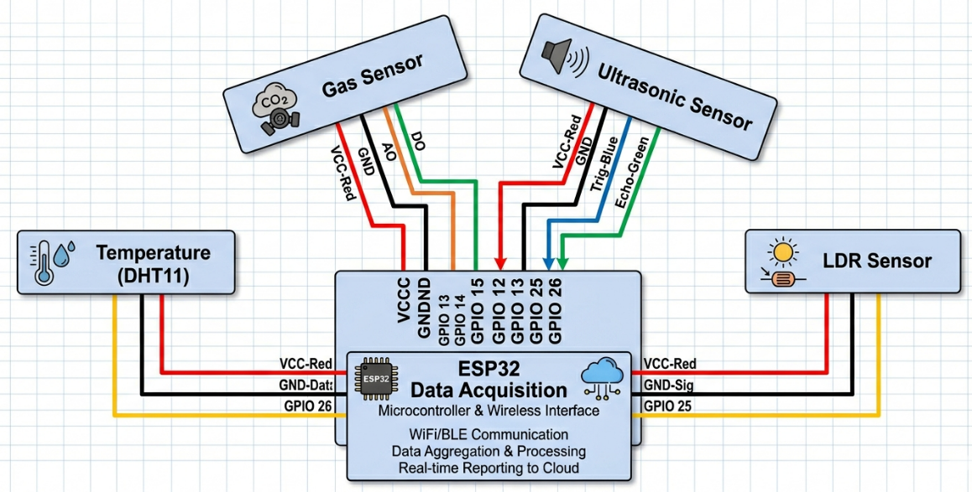
Fig. 1.1 ESP32 Based Sensor Integration Framework

The system is designed to perform continuous data acquisition, meaning that sensors operate without interruption and consistently transmit updated readings to the processing unit. This continuous monitoring enables the system to detect even the slightest variations in environmental conditions, such as a gradual rise in temperature, the presence of a small gas leak, or changes in lighting levels. As a result, the system remains proactive, identifying potential risks or changes before they escalate into critical situations. This real-time sensing capability significantly enhances the responsiveness and effectiveness of the overall system.
Moreover, the reliability and accuracy of the data collected depend heavily on proper sensor calibration and optimal placement within the environment. Calibration ensures that sensors provide precise readings by adjusting them to known standards, while strategic placement minimizes interference and maximizes coverage. For instance, gas sensors must be placed in areas prone to leakage, and LDR sensors should be positioned where they can accurately measure natural light. Proper handling of these factors reduces the chances of false readings and improves the consistency of the data.
The data collected from these sensors serves as the foundational input for further processing and intelligent decision-making within the system. It is transmitted to the microcontroller, where it is analyzed and used to trigger appropriate actions or forwarded to higher-level systems such as cloud-based AI platforms. Therefore, this approach of continuous and accurate data acquisition is crucial, as it directly influences the system’s ability to perform efficient automation, ensure safety, and deliver reliable smart home functionality.

1.3.2 EMBEDDED SYSTEM PROCESSING
The second approach involves processing the acquired sensor data using the ESP32 microcontroller. The ESP32 acts as the central processing unit of the system, responsible for reading sensor inputs, performing initial analysis, and controlling output devices such as relays, buzzers, and displays. It processes data in real time and executes predefined logic for immediate responses, such as turning on lights in low-light conditions or activating a fan when temperature exceeds a threshold. The embedded system ensures low latency and reliable operation even without continuous cloud connectivity. It also manages communication with external devices and cloud platforms via built-in Wi-Fi capabilities. Efficient memory usage, multitasking capabilities, and low power consumption make ESP32 suitable for such applications. This approach ensures that critical actions are performed instantly, enhancing system responsiveness and reliability in real-time scenarios.

1.3.3 CLOUD BASED AI ANALYSIS
The third approach utilizes cloud computing and Artificial Intelligence to enhance the intelligence of the system. Data transmitted from the ESP32 is stored and processed in cloud platforms such as ThingSpeak. AI algorithms analyze this data to identify usage patterns, user behavior, and environmental trends. Machine learning techniques can be applied to predict future conditions and automate decisions accordingly. For example, the system can learn user preferences for lighting and temperature settings and adjust them automatically. Additionally, anomaly detection techniques help identify unusual activities such as unauthorized access or sudden gas leakage. Cloud-based analysis enables more complex computations that are not feasible on embedded devices due to hardware limitations. This approach enhances the adaptability and intelligence of the system, allowing it to evolve over time and provide personalized automation and improved security.

1.3.4 AUTOMATED CONTROL AND ALERT MECHANISM
The final approach focuses on automated control and real-time alert generation based on processed data. Once decisions are made either locally by the ESP32 or through cloud-based AI analysis, the system automatically controls appliances such as lights, fans, and security devices using relay modules. In addition to automation, the system generates alerts during abnormal or dangerous conditions, such as gas leaks, fire hazards, or unauthorized entry. These alerts are sent to the user via mobile applications or cloud dashboards, enabling immediate action. The integration of buzzers and visual indicators further enhances on-site awareness. This approach minimizes human intervention while ensuring safety and convenience. The combination of automation and alert mechanisms creates a responsive and intelligent system capable of maintaining optimal living conditions and providing enhanced protection for occupants.

1.4 TECHNOLOGIES
The proposed AI-based smart home automation and security system is built using a combination of advanced hardware and software technologies. These technologies work together to enable real-time monitoring, intelligent decision-making, and automated control of home appliances. The system integrates embedded systems, IoT communication, cloud computing, and Artificial Intelligence to create a reliable and scalable smart home solution. Each technology plays a vital role in ensuring efficient data collection, processing, transmission, and response. The following sections describe the key technologies used in the implementation of the system.

1.4.1 EMBEDDED SYSTEM TECHNOLOGY (ESP32)
Embedded system technology forms the backbone of the proposed system, with the ESP32 microcontroller acting as the central processing unit. The ESP32 is a powerful, low-cost microcontroller with built-in Wi-Fi and Bluetooth capabilities, making it ideal for IoT applications. It is responsible for interfacing with various sensors, collecting real-time data, and performing initial data processing. The ESP32 executes programmed instructions to control output devices such as relays, buzzers, and displays based on sensor inputs. Its dual-core processor enables multitasking, allowing simultaneous data acquisition, processing, and communication. Additionally, the ESP32 supports low power consumption modes, making it suitable for continuous operation in smart home environments. Its flexibility, high performance, and integrated connectivity make it a crucial component in enabling real-time automation and control within the system.

1.4.2 INTERNET OF THINGS (IOT) COMMUNICATION
The Internet of Things (IoT) plays a significant role in enabling communication between devices and remote systems. In this project, IoT technology is used to transmit data from the ESP32 to cloud platforms using Wi-Fi connectivity. The system uses standard communication protocols such as HTTP and MQTT to send sensor data securely over the internet. This enables users to monitor and control home appliances remotely through mobile applications or web dashboards. IoT communication ensures seamless integration between hardware components and cloud services, allowing real-time data exchange. It also supports scalability, meaning additional devices and sensors can be easily integrated into the system. By enabling remote access and control, IoT enhances user convenience and allows continuous monitoring of home conditions from anywhere in the world.

1.4.3 CLOUD COMPUTING AND DATA ANALYTICS
Cloud computing provides the infrastructure required for data storage, processing, and analysis. In this system, platforms such as ThingSpeak are used to store sensor data and visualize it in real time. The cloud acts as a centralized system where large volumes of data can be processed efficiently. Data analytics techniques are applied to identify trends, patterns, and anomalies in the collected data. This helps in understanding user behavior and environmental conditions over time. Cloud platforms also enable remote access to data through dashboards, graphs, and alerts. Additionally, cloud computing reduces the processing burden on the embedded system by handling complex computations externally. This improves system efficiency and allows advanced features such as predictive analysis and intelligent automation to be implemented effectively.

1.5 SCOPE OF THE PROJECT
The scope of the proposed AI-based smart home automation and security system is focused on developing an intelligent, efficient, and scalable solution for modern residential environments. The system is designed to automate household appliances, monitor environmental conditions, and enhance security using IoT and Artificial Intelligence technologies. It covers real-time data collection through sensors, local processing using the ESP32 microcontroller, and cloud-based analysis for intelligent decision-making. The project scope includes controlling devices such as lights, fans, and alarms based on environmental parameters like temperature, humidity, gas levels, and motion detection. It also provides security features such as intrusion detection, gas leakage alerts, and emergency notifications. The system supports remote monitoring and control through internet connectivity, allowing users to access their home status from anywhere. Additionally, the project can be extended to include advanced AI models, voice control systems, facial recognition using ESP32-CAM, and integration with smart assistants. The scalability of the system allows the addition of more sensors and devices, making it suitable for larger smart home infrastructures. Overall, the project serves as a foundation for future smart living solutions with improved automation, safety, and energy efficiency.

1.6 OBJECTIVE
The main objective of this project is to design and implement an intelligent AI-based home automation and security system that enhances convenience, safety, and energy efficiency in modern homes. The system aims to monitor environmental parameters such as temperature, humidity, light intensity, gas leakage, and motion using various sensors and process the data using the ESP32 microcontroller. It focuses on enabling automatic control of household appliances and providing real-time alerts during abnormal conditions. Additionally, the project seeks to integrate IoT and cloud technologies for remote monitoring and data analysis, while incorporating Artificial Intelligence to enable smart decision-making, predictive automation, and improved security management with minimal human intervention.

CHAPTER 2

LITERATURE SURVEY

2.1 INTRODUCTION
The rapid evolution of Internet of Things (IoT) and Artificial Intelligence (AI) technologies has significantly influenced the development of smart home automation and security systems. Traditional homes are being transformed into intelligent environments capable of monitoring, analyzing, and responding to various conditions in real time. Home automation systems initially focused on simple remote control of appliances using wired or wireless communication. However, with the advancement of IoT, these systems have become more interconnected, enabling seamless communication between devices and cloud platforms. The integration of AI has further enhanced these systems by enabling predictive decision-making, pattern recognition, and anomaly detection. Various research works have explored different approaches to improve efficiency, security, and user convenience in smart homes. These studies highlight the importance of combining embedded systems, sensor networks, and cloud computing to achieve intelligent automation. Additionally, security has become a critical concern, leading to the development of advanced intrusion detection and alert mechanisms. Despite significant progress, challenges such as data privacy, energy optimization, and system scalability still exist. This chapter reviews existing literature related to IoT-based home automation, cloud-integrated systems, smart security solutions, and AI-driven approaches, providing a comprehensive understanding of current technologies and identifying gaps for further improvement.
2.2 LITERATURE SURVEY
The concept of smart home automation has evolved significantly over the past few decades, driven by advancements in embedded systems, wireless communication, and intelligent computing. Early home automation systems were primarily based on wired communication and simple microcontroller-based designs, which allowed users to control appliances remotely through switches or basic interfaces. However, these systems lacked flexibility, scalability, and intelligence. With the introduction of IoT technology, researchers began developing systems that could connect devices over the internet, enabling real-time monitoring and control from remote locations. IoT-based smart home systems typically use sensors to collect environmental data and transmit it to cloud platforms for processing and visualization.
One of the widely studied approaches in literature is IoT-based home automation using microcontrollers such as Arduino, Raspberry Pi, and ESP32. These systems integrate sensors like temperature, humidity, and motion detectors to monitor environmental conditions and automate devices accordingly. Researchers have demonstrated that such systems improve energy efficiency and user convenience by enabling automatic control based on predefined conditions. However, many of these systems rely on rule-based automation, which limits their adaptability to changing user behaviors and environmental conditions.
Cloud-based home automation systems represent another significant advancement in this field. In these systems, sensor data is transmitted to cloud platforms such as AWS, Google Cloud, or ThingSpeak, where it is stored, analyzed, and visualized. Users can access this data through mobile applications or web interfaces, allowing remote monitoring and control of home appliances. Cloud computing provides scalability and computational power, enabling the processing of large volumes of data. However, early cloud-based systems mainly focused on data storage and manual control, with limited implementation of intelligent decision-making capabilities.
Security is a critical aspect of smart home systems, and several research works have focused on developing IoT-based security solutions. These systems use sensors such as PIR motion detectors, gas sensors, smoke detectors, and door sensors to detect potential threats. When abnormal conditions are detected, alerts are sent to users via SMS, email, or mobile applications. While these systems enhance safety, they often rely on simple threshold-based detection methods, which can lead to false alarms or delayed responses. This limitation has led researchers to explore more advanced techniques for improving security and reliability.
The integration of Artificial Intelligence and Machine Learning in smart home systems has gained significant attention in recent years. AI-based systems analyze sensor data to identify patterns, learn user preferences, and make intelligent decisions. For example, machine learning algorithms can predict user behavior and automatically adjust lighting, temperature, and other settings to improve comfort and energy efficiency. AI is also used for anomaly detection, enabling the system to identify unusual activities such as unauthorized access or sudden environmental changes. Studies have shown that AI-based systems reduce false alarms and improve system responsiveness compared to traditional rule-based approaches.
Another important area of research is the use of ESP32 microcontroller in smart home applications. The ESP32 has become popular due to its built-in Wi-Fi and Bluetooth capabilities, high processing power, and low cost. Researchers have developed various ESP32-based systems that integrate multiple sensors and IoT platforms for real-time monitoring and control. These systems are efficient, scalable, and suitable for modern smart home environments. However, integrating advanced AI algorithms directly into embedded devices remains a challenge due to limited computational resources.
Recent studies have also explored the use of camera-based systems and computer vision techniques for smart home security. Devices such as ESP32-CAM enable image capture and video streaming, which can be used for facial recognition, object detection, and surveillance. AI models can analyze visual data to detect intrusions and identify individuals, enhancing the security capabilities of the system. Although these systems provide advanced features, they require higher processing power and raise concerns related to privacy and data security. Energy efficiency is another key focus area in smart home research. Several studies have proposed systems that optimize energy consumption by automatically controlling appliances based on occupancy and environmental conditions. For instance, lights can be turned off when a room is unoccupied, and air conditioning systems can be adjusted based on temperature and humidity levels. These approaches not only reduce energy consumption but also contribute to environmental sustainability. However, achieving optimal energy management requires accurate data analysis and intelligent decision-making.
In addition to automation and security, user interaction and interface design play an important role in smart home systems. Researchers have developed mobile applications, web dashboards, and voice-controlled interfaces to improve user experience. Integration with voice assistants such as Alexa and Google Assistant allows users to control devices using voice commands, making the system more convenient and accessible. Despite these advancements, ensuring seamless and user-friendly interaction remains a challenge.Data privacy and security are major concerns in IoT-based systems, as sensitive information is transmitted over the internet. Researchers have proposed various encryption techniques, authentication mechanisms, and secure communication protocols to protect data from unauthorized access. Implementing these security measures is essential to ensure the reliability and trustworthiness of smart home systems.
Overall, the literature indicates that while significant progress has been made in developing smart home automation and security systems, there are still several challenges to address. Many existing systems lack full integration of AI, IoT, and cloud technologies, limiting their efficiency and adaptability. Issues such as data privacy, system scalability, and real-time performance need further improvement. The proposed project aims to overcome these limitations by integrating intelligent sensors, ESP32-based embedded processing, cloud-based AI analysis, and secure IoT communication. This combination provides a more efficient, reliable, and intelligent solution for modern smart home environments.

CHAPTER 3

SYSTEM ANALYSIS
3.1 INTRODUCTION
System analysis is an essential phase in the development of any project, as it involves understanding the existing system, identifying its limitations, and defining the requirements for the proposed system. In the context of smart home automation, traditional systems often rely on manual control and lack intelligence, adaptability, and real-time monitoring capabilities. The proposed AI-based home automation and security system addresses these limitations by integrating IoT, embedded systems, and Artificial Intelligence. This chapter provides a detailed analysis of the existing system, highlights its drawbacks, and explains the advantages of the proposed system along with its feasibility.
3.2 EXISTING SYSTEMS
Existing home automation systems are largely rooted in conventional control paradigms, relying either on manual switching mechanisms or rudimentary microcontroller-based architectures. These systems typically facilitate the operation of household appliances—such as lighting, fans, and basic electrical devices—through physical switches or simple remote-control interfaces. In more advanced variants, wireless communication protocols like Bluetooth and Wi-Fi enable users to interact with appliances via mobile applications. Despite these enhancements, the underlying logic remains relatively static, with operations driven by predefined rules or direct user input rather than adaptive decision-making. Consequently, these systems function more as remote-control extensions rather than truly autonomous environments.
A significant limitation of such systems is their lack of contextual awareness and intelligent processing. They generally do not incorporate real-time environmental sensing, predictive analytics, or user behavior modeling, which are essential for achieving efficient and personalized automation. Security capabilities are similarly constrained, often depending on basic threshold-based sensors that may generate false alarms or fail to detect nuanced threats. Furthermore, the absence of robust cloud integration restricts remote monitoring, data storage, and advanced analytics, thereby limiting scalability and system optimization. As a result, these traditional home automation solutions tend to be less energy-efficient, less secure, and heavily dependent on continuous human intervention, undermining their potential to deliver a seamless smart living experience.

3.2.1 LIMITATION OF EXISTING SYSTEM
The existing systems suffer from several limitations that reduce their effectiveness and usability.
- Lack of intelligent decision-making and automation
- Limited or no integration with cloud platforms
- Absence of real-time monitoring and data analytics
- High dependency on manual control
- Inadequate security mechanisms
- No predictive analysis or learning capability
- Limited scalability and flexibility
These limitations highlight the need for a more advanced and intelligent system that can operate efficiently with minimal human intervention.

3.3 PROPOSED SYSTEM
The proposed system introduces an advanced AI-driven smart home automation and security framework that addresses the shortcomings of traditional systems by incorporating intelligence, adaptability, and real-time responsiveness. At its core, the system leverages the ESP32 microcontroller as a central processing unit, interfacing with a network of sensors and IoT modules. These sensors continuously monitor environmental parameters such as temperature, humidity, gas concentration, and motion activity, enabling the system to maintain a comprehensive awareness of the home environment. Unlike conventional setups that rely on static rules, this architecture is designed to dynamically interpret incoming data and respond accordingly, forming the foundation of a truly autonomous smart home ecosystem.
A key strength of the system lies in its integration with cloud-based platforms, where collected data is transmitted for advanced processing and storage. Artificial Intelligence algorithms deployed in the cloud analyze this data to detect patterns, predict user behavior, and make informed decisions in real time. For instance, the system can automatically adjust lighting and ventilation based on occupancy patterns or environmental conditions, optimizing both comfort and energy efficiency. The continuous feedback loop between sensors, the ESP32, and cloud intelligence ensures that the system evolves over time, learning user preferences and adapting its operations without requiring manual reconfiguration.
In addition to automation, the system incorporates robust security features that significantly enhance home safety. It includes intelligent intrusion detection mechanisms, gas leakage monitoring, and immediate alert systems that notify users through mobile applications. These alerts are not merely threshold-based but are supported by AI-driven analysis, reducing false positives and improving reliability. The framework is also designed with scalability in mind, allowing the addition of new devices and sensors without major system modifications. Overall, the proposed solution delivers a comprehensive, efficient, and adaptive smart home environment that aligns with the demands of modern living while ensuring enhanced security and user convenience.

3.3.1 FLOW CHART
The flowchart represents the working process of the proposed AI-based smart home automation and security system using ESP32. The process begins with the start node, where the system is powered on and initialized. In this initial stage, the ESP32 microcontroller establishes connections with all the integrated sensors, including temperature, humidity, gas, light, and door sensors. This initialization ensures that each component is ready to collect and transmit real-time environmental data. Once the setup is complete, the system enters the main operational phase, where it continuously reads sensor data. The data collected includes temperature levels, ambient light intensity, gas concentration, and the status of the door (open or closed). This continuous monitoring forms the core of the system, enabling real-time decision-making and automation.

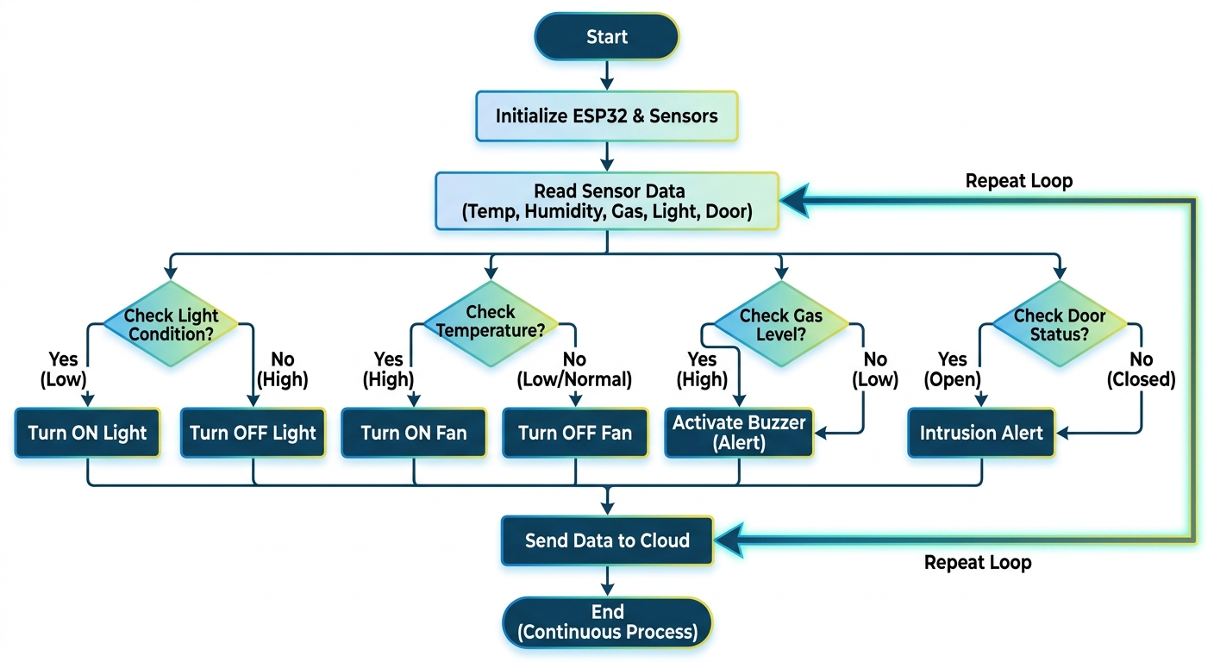

Fig. 3.1 Flow Chart of System Operation
After acquiring the sensor data, the system evaluates different environmental conditions through a series of decision-making steps. First, the light condition is checked. If the system detects low light intensity, it automatically turns on the lights to maintain proper illumination. Conversely, if sufficient or high light is detected, the system turns off the lights to conserve energy. Next, the temperature condition is analyzed. If the temperature is above a predefined threshold, indicating a high temperature, the system activates the fan to regulate the environment. If the temperature is within a normal or low range, the fan is turned off to save power and maintain efficiency.
Simultaneously, the system checks the gas level to ensure safety. If a high gas concentration is detected, which could indicate a potential hazard such as a gas leak, the system immediately activates a buzzer or alarm to alert occupants. If the gas level is within safe limits, no action is taken, and monitoring continues. Another critical aspect of the system is door status monitoring. The system checks whether the door is open or closed. If the door is found to be open unexpectedly, especially during restricted conditions, it triggers an intrusion alert to notify the user of a possible security breach. If the door is closed, the system maintains normal operation without triggering any alerts.
After evaluating all conditions and executing the necessary actions, the system proceeds to send the collected data and status updates to a cloud platform. This enables remote monitoring and control, allowing users to access real-time information about their home environment from anywhere. The cloud integration also supports data logging and analysis, which can be further utilized for implementing AI-based predictions and automation improvements.
The entire process operates in a continuous loop, as indicated by the repeat loop in the flowchart. This ensures that the system constantly monitors environmental conditions and responds instantly to any changes. The loop structure allows the system to function autonomously without interruption, making it highly reliable for both automation and security purposes. The process does not terminate after a single cycle; instead, it continuously repeats the steps of data collection, condition checking, action execution, and data transmission. This continuous operation enhances the efficiency, responsiveness, and intelligence of the system, making it suitable for modern smart home applications.


3.3.2 BLOCK DIAGRAM

The block diagram of the proposed AI-based smart home automation and security system illustrates the complete architecture and the interaction between various hardware and software components that work together to create an intelligent, responsive, and secure home environment. At the foundation of the system lies the power supply unit, which is responsible for providing a stable and regulated DC voltage to all components in the circuit. Since devices like sensors, microcontrollers, and communication modules require specific voltage levels for proper functioning, the power supply ensures uninterrupted and reliable operation of the entire system.

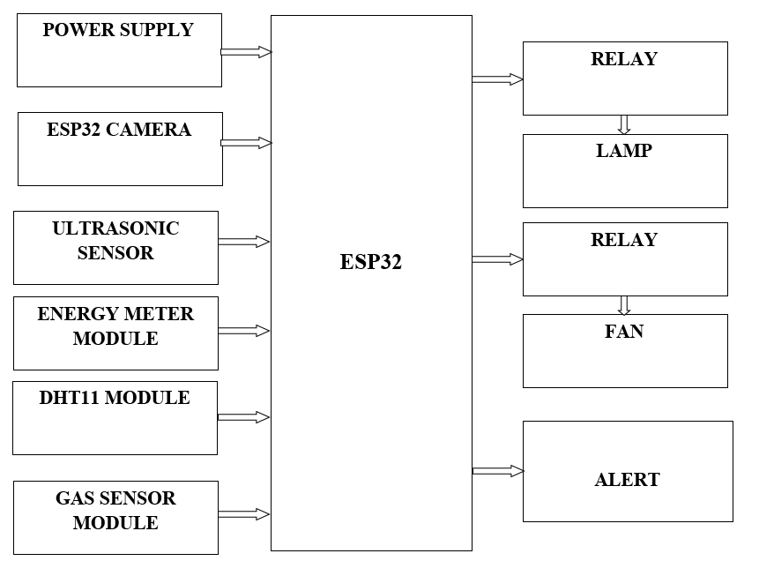
Fig. 3.2 Block Diagram of ESP32 Controller

The system incorporates multiple input devices in the form of sensors that continuously monitor environmental and security-related parameters. These include the DHT11 sensor for measuring temperature and humidity, a gas sensor for detecting harmful gases or leakage, an ultrasonic sensor for measuring distance and detecting motion or obstacles, and a light sensor for identifying ambient light intensity. Each of these sensors plays a crucial role in collecting real-time data from the surroundings. The collected data is transmitted to the ESP32 microcontroller, which serves as the central processing unit of the system. The ESP32 is a powerful and efficient microcontroller equipped with built-in Wi-Fi capabilities, making it ideal for IoT-based applications. It receives data from all connected sensors, processes the information, and makes intelligent decisions based on predefined algorithms and conditions. For instance, if the temperature exceeds a certain threshold, the system may automatically turn on a fan or cooling device. Similarly, if the gas sensor detects leakage, the ESP32 immediately triggers safety measures. Its ability to handle multiple inputs and perform real-time processing makes it the core component of the entire system.
In addition to environmental sensing, the system enhances security through the integration of the ESP32-CAM module. This module enables real-time image capturing and video streaming, allowing users to visually monitor their homes remotely. It can also be extended with artificial intelligence techniques such as facial recognition or motion detection to identify unauthorized access and improve surveillance capabilities. This adds an extra layer of protection and makes the system more robust compared to traditional security setups.
The processed data from the ESP32 is used to control various output devices through relay modules. Relays act as electrically operated switches that allow low-power signals from the microcontroller to control high-power appliances such as lights, fans, or other household devices. This enables automation, where appliances can be turned on or off automatically based on sensor inputs or user preferences. For example, lights can be switched on when the light intensity is low, ensuring energy efficiency and convenience.
To further enhance safety, the system includes alert mechanisms such as buzzers that are activated during abnormal conditions like gas leaks, fire hazards, or unauthorized entry detection. These alerts provide immediate notification to users within the home. Additionally, the system integrates an energy monitoring module, specifically the PZEM module, which tracks real-time power consumption. This helps in analyzing energy usage patterns and promotes efficient energy management, reducing electricity wastage and cost. A key feature of the system is its cloud connectivity. Using the ESP32’s Wi-Fi capability, all collected data is transmitted to a cloud platform where it is stored and analyzed. This allows users to monitor and control their home remotely through smartphones or web applications. Cloud integration also supports future enhancements such as AI-based analytics, predictive maintenance, and smart decision-making. Overall, the block diagram clearly represents the flow of data from sensors to the processing unit, and then to output devices and cloud services. It demonstrates how the system combines automation, security, and energy management into a single platform, resulting in a smart, efficient, and intelligent home solution.

3.3.3 CIRCUIT DIAGRAM

The proposed system is an integrated environmental monitoring and control platform designed to seamlessly connect digital data processing with high-voltage electrical management, making it suitable for smart home as well as industrial safety applications. At the core of the system is the ESP32 microcontroller, which functions as the central processing unit and decision-making hub. It continuously collects real-time data from multiple sensors, including temperature, humidity, and gas detection modules. These sensors play a vital role in monitoring environmental conditions and detecting potential hazards such as overheating or gas leakage. The ESP32 processes this incoming data instantly using embedded logic and programmed thresholds, ensuring that the system responds quickly to any abnormal changes. Additionally, the processed data is displayed on an LCD screen, providing users with a clear and immediate visual representation of environmental parameters, thereby enhancing user awareness and control.
One of the key strengths of the system is its ability to perform autonomous safety interventions without requiring constant human supervision. When certain environmental thresholds are exceeded—such as a rise in temperature beyond safe limits or the detection of smoke or harmful gases—the system automatically initiates corrective actions. For example, it can activate ventilation systems to improve air circulation or switch on lighting systems as a warning mechanism. This intelligent automation not only improves convenience but also significantly enhances safety by reducing response time during critical situations.
The power architecture of the system is carefully designed using a multi-stage approach to safely bridge low-voltage electronic components with high-voltage household appliances. Initially, a step-down transformer reduces the high mains AC voltage to a lower AC level suitable for further processing. This reduced voltage is then passed through a rectifier, which converts the AC signal into DC. Following rectification, a voltage regulator is used to provide a stable and consistent DC output, ensuring that sensitive electronic components receive the correct operating voltage. This stage is crucial for maintaining system reliability and preventing fluctuations that could damage components.
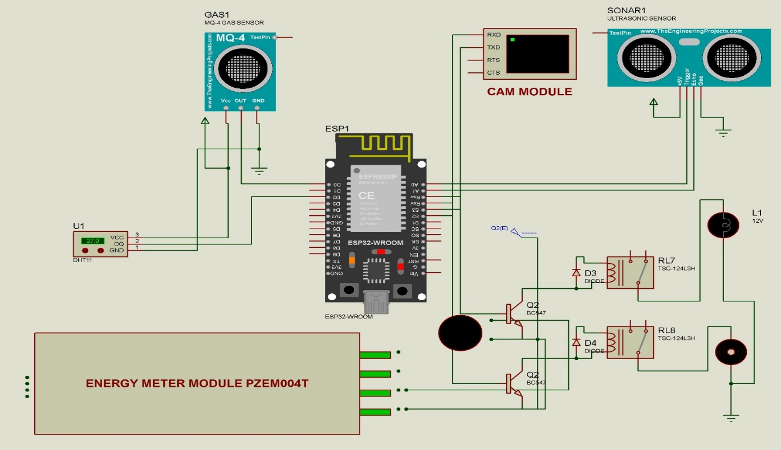
Fig.3.3 Circuit Diagram of Proposed System
The system operates on a dual-voltage configuration, which is essential for handling both control and actuation processes. Low-voltage levels such as 3.3V and 5V are used to power the ESP32 microcontroller and the connected sensors, ensuring safe and efficient operation of the digital circuitry. At the same time, higher voltage levels are maintained to drive electromagnetic relays, which are responsible for controlling high-power electrical appliances. To ensure smooth communication between components operating at different voltage levels, logic level converters are incorporated into the design. These converters prevent voltage mismatches and protect the microcontroller from potential damage caused by higher voltage signals, thereby increasing the overall durability of the system.
In the final stage, the system performs actuation through a relay-controlled interface. Relays act as electrically operated switches that allow the microcontroller to control high-voltage AC appliances using low-voltage signals. When the ESP32 determines that an action is required based on sensor input, it sends a control signal to the relay module. The relay then completes or breaks the circuit of the connected appliance, enabling functions such as turning on a cooling fan for ventilation, activating a light bulb for illumination, or triggering an alarm system during hazardous conditions.
An important design consideration in this system is the physical and electrical isolation between the low-power sensing and control circuitry and the high-power load side. This separation helps to minimize electromagnetic interference and reduces the risk of damage to sensitive components. As a result, the system achieves stable performance, high reliability, and improved safety. Overall, this integrated platform provides an efficient, intelligent, and automated solution for environmental monitoring and control, making it highly suitable for modern smart homes and safety-critical environments.

3.3.4 ADVANTAGES

The proposed AI-based smart home automation and security system offers several significant advantages that enhance convenience, safety, and efficiency in modern living environments. One of the key benefits is intelligent automation, where household appliances such as lights and fans are automatically controlled based on real-time environmental conditions, reducing the need for manual intervention. The system also improves energy efficiency by ensuring that devices operate only when required, thereby minimizing power consumption and reducing electricity costs. Enhanced security is another major advantage, as the system continuously monitors for threats such as gas leakage, fire hazards, and unauthorized access, and instantly generates alerts through buzzers and cloud notifications. The integration of IoT enables remote monitoring and control from anywhere, providing users with greater flexibility and control over their home environment. Additionally, the use of cloud-based AI allows the system to learn user behavior and adapt accordingly, making it more intelligent over time. The system is also scalable and cost-effective, as additional sensors and devices can be easily integrated without major modifications. Overall, the proposed system provides a reliable, efficient, and user-friendly solution for smart home automation.

CHAPTER 4

SYSTEM REQUIREMENTS

INTRODUCTION

System requirements define the essential components and conditions necessary for the successful implementation and operation of the proposed AI-based smart home automation and security system. These requirements include both hardware and software elements that ensure proper functionality, reliability, and performance. The hardware requirements consist of microcontrollers, sensors, and supporting electronic components, while the software requirements include programming tools, IoT platforms, and communication protocols. Clearly identifying these requirements helps in designing an efficient system architecture and ensures smooth integration of all modules. Proper system requirements also contribute to scalability, maintainability, and overall system effectiveness.

HARDWARE REQUIREMENTS
- ESP32 Module
- ESP32 CAM Module
- Power supply Unit
- LCD Display
- MQ135 sensor
- DHT11 sensor
- Ultrasonic sensor
- PZEM
- RELAY
- Buzzer

SOFTWARE REQUIREMENTS
- Arduino IDE
- ThingSpeak
- OpenAI

HARDWARE DESCRIPTION

The hardware components of the system include the ESP32 microcontroller, ESP32-CAM, sensors such as DHT11, gas sensor, ultrasonic sensor, relay modules, LCD display, buzzer, and power supply unit. These components work together to collect data, process information, and control appliances, enabling efficient automation and security functionality.
4.4.1 ESP 32 MODULE
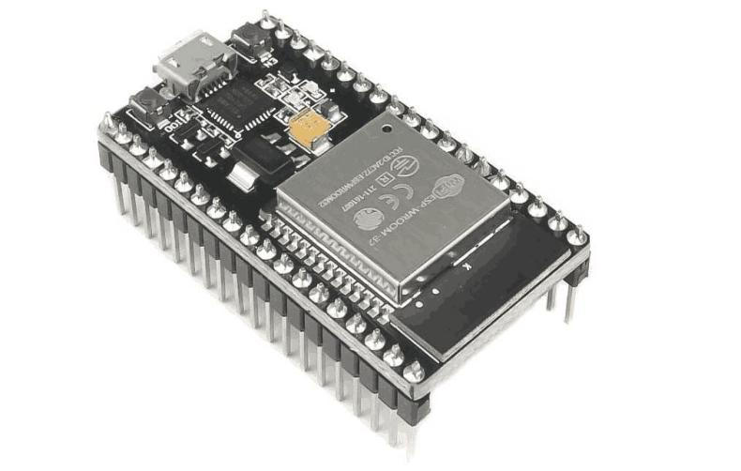
Fig. 4.1 ESP32 Wroom Development Board

The ESP-WROOM-32 module, based on the ESP32 platform, is a highly integrated and versatile microcontroller designed for a wide range of embedded and IoT applications. At its core lies the Tensilica Xtensa® Dual-Core 32-bit LX6 microprocessor, capable of operating at clock speeds ranging from 80 MHz up to 240 MHz. This dual-core architecture allows efficient multitasking, enabling one core to handle application logic while the other manages communication protocols such as Wi-Fi and Bluetooth. With a performance rating of approximately 994.26 CoreMark (4.14 CoreMark/MHz), the processor delivers significant computational capability for real-time processing tasks. The module includes 448 KB of ROM, which stores essential bootloader code and core system functions, ensuring reliable startup operations. In addition, it provides 520 KB of on-chip SRAM for dynamic data storage and instruction execution, facilitating fast access and low latency. The inclusion of 4 MB of external flash memory allows sufficient space for firmware, user applications, and data logging. Furthermore, the 16 KB of RTC (Real-Time Clock) SRAM enables low-power data retention during deep sleep modes, making the ESP32 suitable for energy-efficient designs.
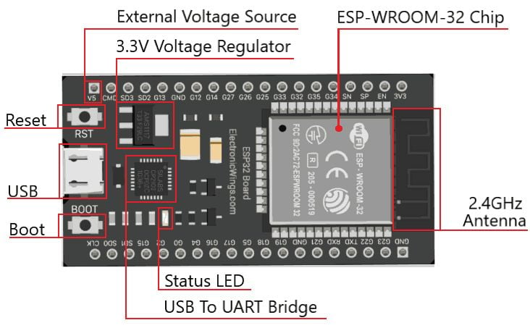
Fig. 4.2 ESP32 Board Highlights

A major strength of the ESP-WROOM-32 is its integrated wireless communication capabilities. It supports Wi-Fi standards 802.11 b/g/n, operating in the 2.4 GHz frequency band with data rates of up to 150 Mbps. This enables seamless connectivity for applications such as smart home devices, remote monitoring systems, and cloud-based data exchange. Additionally, the module supports Bluetooth v4.2, including both BR/EDR (Basic Rate/Enhanced Data Rate) and Bluetooth Low Energy (BLE). This dual-mode Bluetooth functionality enhances versatility, allowing the device to communicate with a wide range of peripherals, from smartphones to low-power sensors.

The ESP32 development board built around this module includes several practical hardware features. It is equipped with two push buttons: a Reset (RST/EN) button used to restart the microcontroller, and a BOOT button that places the device into programming mode for firmware uploads. Power can be supplied either through a USB connection or an external 5V source. An onboard 1117 voltage regulator converts this input to a stable 3.3V output, which is within the operating voltage range of 2.3V to 3.6V. The recommended current supply is at least 600 mA to ensure stable operation.

Additionally, a red LED indicator is typically included on the board to display status information during program uploading and serial communication. Overall, the ESP-WROOM-32 combines processing power, memory resources, and robust connectivity features, making it an ideal choice for modern embedded and IoT system development.
4.4.2 ESP32 CAMERA MODULE
The ESP32-CAM is a compact, low-cost development board built around the ESP32-S system-on-chip from Espressif Systems. It integrates a powerful and programmable microcontroller with built-in Wi-Fi and Bluetooth capabilities, making it highly suitable for Internet of Things (IoT) and embedded vision applications. Despite its small size and affordability—typically priced around $7—the ESP32-CAM offers an impressive set of features, including an onboard camera module, MicroSD card support, and additional PSRAM, which are rarely found together in boards within this price range.
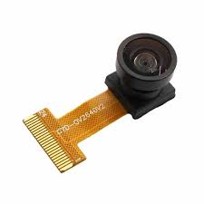
Fig. 4.3 ESP32 Camera Module
At the core of the ESP32-CAM lies the ESP32-D0WD processor, a dual-core microcontroller that delivers reliable performance for both communication and processing tasks. It is equipped with 32 Mbit (4 MB) flash memory for program storage and 512 KB of internal SRAM, along with an additional 4 MB of PSRAM. This extended memory is particularly beneficial for image processing and buffering tasks, allowing the board to handle camera data efficiently. The module supports IEEE 802.11 b/g/n Wi-Fi standards and Bluetooth 4.2, enabling seamless wireless communication for remote monitoring and control systems.
One of the defining features of the ESP32-CAM is its onboard camera, typically the OV2640 module. This camera supports JPEG compression and can capture images at various resolutions, making it ideal for applications such as video streaming, image capture, and machine vision. While earlier documentation suggested compatibility only with OV2640 and OV7670 cameras, the board can, in practice, interface with a broader range of camera modules with appropriate configuration and driver support.

The board also includes a TF (MicroSD) card slot, supporting storage capacities of up to 4 GB. This allows users to store captured images, video data, or other application files locally. Such storage capability is essential in applications where continuous data logging or offline operation is required. Additionally, the ESP32-CAM supports Wi-Fi-based image transmission, enabling real-time video monitoring and cloud integration.
Unlike many development boards, the ESP32-CAM does not feature a built-in USB interface. As a result, programming the board requires an external USB-to-serial converter such as an FTDI programmer, an add-on HAT, or even an Arduino Uno configured as a serial interface. Development is typically carried out using environments like the Arduino IDE or the ESP-IDF, both of which provide robust support for ESP32-based devices.
From a hardware perspective, the ESP32-CAM operates on a 5V power supply and includes multiple communication interfaces such as UART, SPI, I2C, and PWM. It provides around 9 general-purpose input/output (GPIO) pins, which can be used to interface with sensors, actuators, or other peripherals. The board also supports multiple sleep modes, including deep sleep, significantly reducing power consumption and making it suitable for battery-powered applications.
Due to its compact form factor and low cost, the ESP32-CAM has gained widespread popularity in various domains. It is commonly used in smart home surveillance systems, wireless security cameras, intelligent agriculture monitoring, QR code identification systems, and even basic facial recognition applications. Its ability to operate reliably across a wide temperature range further enhances its suitability for real-world deployments. Overall, the ESP32-CAM provides a powerful and economical solution for developers looking to integrate wireless connectivity and imaging capabilities into their projects.
4.4.3 POWER SUPPLY UNIT
The present chapter introduces the operation of power supply circuits built using filters, rectifiers, and then voltage regulators. Starting with an AC voltage, a steady DC voltage is obtained by rectifying the AC voltage, then filtering to a DC level, and finally, regulating to obtain a desired fixed DC voltage. The regulation is usually obtained from an IC voltage regulator unit, which takes a DC voltage and provides a somewhat lower DC voltage, which remains the same even if the input DC voltage varies, or the output load connected to the DC voltage changes.
A block diagram containing the parts of a typical power supply and the voltage at various points in the unit is shown in fig. The AC voltage, typically 120 Vrms, is connected to a transformer, which steps that AC voltage down to the level for the desired DC output. A diode rectifier then provides a full-wave rectified voltage that is initially filtered by a simple capacitor filter to produce a DC voltage. This resulting DC voltage usually has some ripple or AC voltage variation. A Regulator circuit can use this DC input to provide a DC voltage that not only has much less ripple voltage but also remains the same DC value even if the input DC voltage varies somewhat, or the load connected to the output DC voltage changes.A transformer is a static (or stationary) piece of which electric power in one circuit is transformed into electric power of the same frequency in another circuit. It can raise or lower the voltage in a circuit but with a corresponding decrease or increase in current. It works with the principle of mutual induction.
In this project, a step-down transformer is used to convert high-voltage alternating current (AC) from the mains supply into a lower and safer voltage suitable for electronic circuits. A 15-0-15 center-tapped transformer is specifically chosen, which provides two 15V outputs with a common center reference, enabling flexible circuit design and efficient rectification. The AC output obtained from the transformer is then converted into direct current (DC) using a full-wave rectifier circuit configured with four diodes arranged in a bridge formation. During the positive half-cycle of the AC input (t = 0 to T/2), two diodes (D2 and D3) are forward-biased and conduct current, while the other two diodes (D1 and D4) remain reverse-biased and do not conduct. In the negative half-cycle, the roles reverse, with diodes D1 and D4 conducting and D2 and D3 turning off. Despite this switching action, the direction of current through the load remains the same in both cycles, ensuring a unidirectional flow. This process effectively utilizes both halves of the AC waveform, resulting in a smoother and higher average DC output compared to half-wave rectification. Consequently, full-wave rectification improves efficiency and increases the DC output level by nearly 100%, making it highly suitable for powering electronic devices.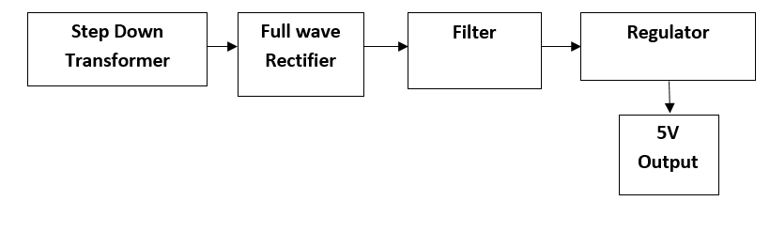
Fig. 4.4 Flow of Regulated DC Power Supply

The filter circuit used here is the capacitor filter circuit where a capacitor is connected at the rectifier output, and a DC is obtained across it. The filtered waveform is essentially a DC voltage with negligible ripples, which is ultimately fed to the load. The output voltage from the capacitor is more filtered and finally regulated. The voltage regulator is a device, which maintains the output voltage constant irrespective of the change in supply variations, load variation and temperature changes. Here we use two fixed voltage regulators namely LM 812, LM 7805 and LM7912. The IC 7812 is a +12V regulator IC 7912 is a -12V regulator and IC 7805 is a +5V regulator. This project uses +5V, +12V power supply for the operations of the IC’s and relay driver circuit. Voltage regulators comprise a class of widely used ICs. Regulator IC units contain the circuitry for reference source, comparator amplifier, control device, and overload protection all in a single IC. Although the internal construction of the IC is somewhat different from that described for discrete voltage regulator circuits, the external operation is much the same. IC units provide regulation of either a fixed positive voltage, a fixed negative voltage, or an adjustable set voltage.
A power supply can be built using a transformer connected to the ac supply line to step the ac voltage to desired amplitude, then rectifying that ac voltage, filtering with a capacitor and RC filter, if desired, and finally regulating the dc voltage using an IC regulator. The regulators can be selected for operation with load currents from hundreds of Milli-amperes to tens of amperes, corresponding to power ratings from mill watts to tens of watts. This is basic connection of a three-terminal voltage regulator. The fixed voltage regulator has an unregulated dc input voltage, VI, applied to one input terminal, a regulated output dc voltage, Vo, from a second terminal, with the third terminal connected to ground. For a selected regulator, IC device specifications list a voltage range over which the input voltage can vary to maintain a regulated output voltage over a range of load current. The specifications also list the amount of output voltage change resulting from a change in load current (load regulation) or in input voltage (line regulation. The series 78 regulators provide fixed regulated voltages from 5 to 24V. A 7812 is connected to provide voltage regulation with output from this Unit of +12V dc. An unregulated input voltage VI is filtered by capacitor C1 And connected to the IC’s IN terminal. The IC’s OUT terminal provides a Regulated + 12V which are filtered by capacitor C2 (mostly for any high-Frequency noise). The third IC terminal is connected to ground (GND). While the input voltage may vary over some permissible voltage range, and the output load may vary over some acceptable range, the output voltage remains constant within specified voltage variation limits.
Since all electronic circuits work only with low D.C. voltage we need a power supply unit to provide the appropriate voltage supply. This unit consists of transformer, rectifier, filter and regulator. AC voltage typically 230V rms is connected to a transformer which steps that AC voltage down to the level to the desired AC voltage. A diode rectifier then provides a full-wave rectified voltage that is initially filtered by a simple capacitor filter to produce a DC voltage. This resulting DC voltage usually has some ripple or AC voltage variations. A regulator circuit can use this DC input to provide DC voltage that not only has much less ripple voltage but also remains the same DC value even the DC voltage varies somewhat, or the load connected to the output DC voltages changes.

4.4.4 LCD DISPLAY
Liquid Crystal Display (LCD) modules are among the most widely used output devices in hobbyist and embedded system projects due to their versatility, readability, and ease of interfacing. Compared to other display technologies, LCDs offer a balance of low power consumption, compact size, and the ability to display alphanumeric as well as custom characters. Once the basic interfacing technique is understood, they become one of the most reliable and user-friendly output devices for microcontroller-based applications.
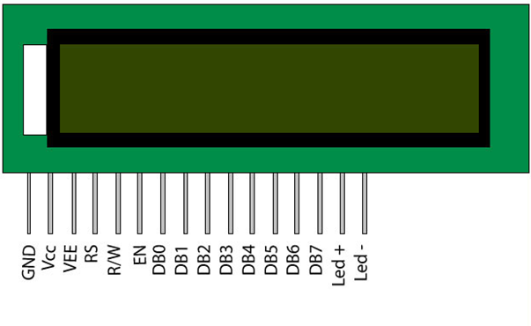
Fig. 4.5 Pin Diagram of LCD Display

In many embedded systems, especially those developed by hobbyists, debugging tools such as advanced emulators or real-time debuggers are not always available. In such scenarios, LCD displays serve as an effective alternative for monitoring system behavior. By displaying intermediate values, status messages, or sensor readings, developers can verify whether the program is functioning correctly. This makes LCDs not only an output device but also a valuable diagnostic tool during development and testing.
An LCD module typically communicates with a microcontroller using two categories of signals: data signals and control signals. The distinction between these signals is determined by the status of the Register Select (RS) pin. When the RS pin is set to a specific logic level (usually low), the incoming data is interpreted as a command instruction, such as clearing the display or setting the cursor position. When RS is set to the opposite level (usually high), the incoming data is treated as display data, meaning the characters to be shown on the screen.
Another important control pin is the Read/Write (R/W) pin. When this pin is set low, the LCD operates in write mode, allowing the microcontroller to send commands or data to the display. When R/W is set high, the LCD enters read mode, enabling the microcontroller to read data or status information from the LCD. This feature is particularly useful for checking whether the LCD is busy processing a previous instruction. The Enable (E) pin plays a crucial role in synchronizing data transfer. The LCD reads the data present on the data lines at the falling edge of the enable pulse. Therefore, to send a command or data byte, the microcontroller must first place the appropriate value on the data lines, set the RS and R/W pins accordingly, and then generate a high-to-low pulse on the E pin. This ensures that the LCD correctly latches and processes the input.
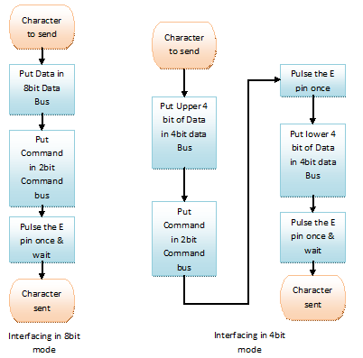
Fig. 4.6 Flow chart of interfacing LCD display
Timing is a critical aspect of LCD interfacing. Most standard LCD modules require approximately 39 to 43 microseconds to execute a typical command or display a character. However, certain operations such as clearing the display or returning the cursor to the home position take significantly longer, typically between 1.53 milliseconds and 1.64 milliseconds. If new data is sent before the LCD has completed its current operation, it may lead to incorrect execution or data loss. While some advanced LCD controllers include internal buffering mechanisms to handle such situations, it is generally recommended to implement appropriate delays or check the busy flag before sending new instructions.
Internally, LCD modules are equipped with two types of memory: Display Data RAM (DDRAM) and Character Generator RAM (CGRAM). DDRAM is responsible for storing the characters that are currently displayed on the screen. Each memory location in DDRAM corresponds to a specific position on the LCD, and the value stored at that location determines which character (based on the ASCII table) is shown. The LCD controller continuously scans DDRAM and updates the display accordingly.
CGRAM, on the other hand, provides the capability to define custom characters. A portion of the memory is reserved for user-defined patterns, allowing developers to create unique symbols or icons that are not part of the standard ASCII set. Typically, up to eight custom characters can be defined at a time. Once these characters are stored in CGRAM, they can be displayed just like regular characters by referencing their assigned memory locations. LCD displays are powerful and flexible components that enhance both the functionality and usability of embedded systems. Their straightforward interfacing, combined with features like customizable characters and built-in memory structures, makes them an essential tool for hobbyists and engineers.
4.4.5 MQ-135 SENSOR
The MQ-135 gas sensor is a highly versatile and widely adopted component in air quality monitoring systems, particularly in hobbyist and embedded applications. It is specifically designed to detect a broad spectrum of gases that are commonly associated with environmental pollution and health hazards. These gases include ammonia (NH₃), nitrogen oxides (NOx), alcohol vapors, benzene, smoke, and carbon dioxide (CO₂). Due to its multi-gas detection capability, the MQ-135 is often preferred in projects where comprehensive air quality analysis is required rather than monitoring a single gas. Its affordability and ease of availability further contribute to its popularity among students, researchers, and engineers working on environmental sensing systems.
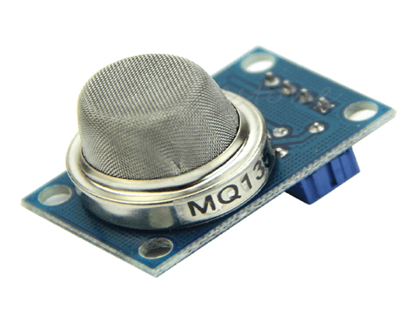
Fig. 4.7 MQ-135 Gas Sensor

One of the key features of the MQ-135 sensor is its dual output capability, which allows it to function in both digital and analog modes. The module is equipped with a digital output pin that can directly provide a HIGH or LOW signal based on a preset threshold level. This threshold can typically be adjusted using an onboard potentiometer, making it convenient for applications where only the presence or absence of a gas needs to be detected. In such cases, the sensor can operate independently without requiring complex programming or continuous monitoring by a microcontroller. This feature is particularly useful in simple gas leakage detection systems, alarm circuits, or safety devices.

For applications requiring more precise measurement, the analog output pin of the MQ-135 sensor is utilized. This pin provides a continuous voltage output ranging from 0V to 5V, which corresponds to the concentration of gases present in the surrounding environment. Since the analog output follows TTL (Transistor-Transistor Logic) levels and operates at 5V, it is compatible with most commonly used microcontrollers such as Arduino, PIC, and AVR families. By reading this analog voltage through an analog-to-digital converter (ADC), the microcontroller can estimate the gas concentration in parts per million (PPM). However, accurate PPM calculation requires proper calibration and reference data, as the sensor's response may vary depending on environmental conditions such as temperature and humidity.
The working principle of the MQ-135 sensor is based on a sensing material, typically tin dioxide (SnO₂), whose electrical resistance changes in the presence of certain gases. When the sensor is exposed to clean air, it exhibits a certain baseline resistance. As the concentration of target gases increases, the resistance of the sensing element decreases, resulting in a change in the output voltage. This variation is then interpreted as gas concentration. To ensure accurate and stable operation, the sensor requires a preheating phase, usually around 20 seconds or more, during which the internal heater element stabilizes the sensing material. Without adequate preheating, the readings may be inconsistent or unreliable.
In practical applications, the MQ-135 sensor plays a crucial role in maintaining environmental safety and monitoring air quality. It is widely used in indoor air quality monitoring systems, industrial safety devices, pollution detection units, and smart home automation systems. The sensor helps in identifying harmful gas leaks and excessive pollutant levels, enabling timely preventive actions. For example, it can trigger alarms, activate ventilation systems, or send alerts to users when unsafe conditions are detected. Its ability to monitor multiple gases simultaneously makes it an efficient and cost-effective solution for comprehensive air quality assessment. Overall, the MQ-135 sensor serves as a reliable and flexible tool for detecting and measuring hazardous gases, contributing significantly to health and safety in various environments.
4.4.6. ULTRASONIC SENSOR
The HC-SR04 ultrasonic ranging module is a widely used distance measurement sensor in embedded systems and robotics due to its simplicity, accuracy, and cost-effectiveness. It is capable of measuring distances in the range of approximately 2 cm to 400 cm, with an accuracy of up to 3 mm under ideal conditions. The module consists of an ultrasonic transmitter, a receiver, and an integrated control circuit that manages signal generation and processing. Its compact design and ease of interfacing make it highly suitable for hobbyist projects, automation systems, obstacle detection, and real-time distance measurement applications.
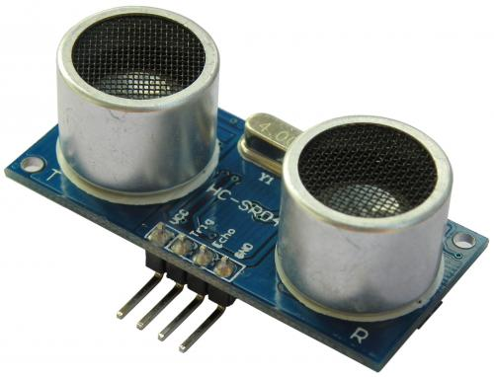
Fig. 4.8 HC-SR04 Ultrasonic sensor
The working principle of the HC-SR04 sensor is based on ultrasonic wave propagation and the time-of-flight measurement technique. The module emits high-frequency sound waves at 40 kHz, which are inaudible to the human ear. When these waves encounter an object, they are reflected back toward the sensor. By measuring the time taken for the sound waves to travel to the object and return, the distance can be calculated. Since the speed of sound in air is approximately 340 meters per second, the distance to the object is determined using the formula: Distance = (Time × Speed of Sound) / 2. The division by two accounts for the round-trip travel of the sound wave.
To initiate a measurement, the microcontroller sends a trigger signal to the sensor through the Trig pin. This involves applying a high pulse of at least 10 microseconds. Upon receiving this signal, the HC-SR04 module automatically generates eight cycles of 40 kHz ultrasonic pulses. After transmitting these pulses, the module sets the Echo pin to a high state and begins waiting for the reflected signal. When the reflected wave is detected by the receiver, the Echo pin returns to a low state. The duration for which the Echo pin remains high corresponds to the total travel time of the ultrasonic pulse, which can then be used to calculate the distance.
The Echo signal plays a critical role in determining the distance accurately. The microcontroller measures the width of the high pulse received on the Echo pin using internal timers or counters. This measured time interval is directly proportional to the distance between the sensor and the object. By applying the known speed of sound, the system converts this time into a distance value. This method ensures non-contact measurement, which is especially useful in environments where physical contact with objects is not possible or desirable, such as in hazardous or sensitive conditions.
From an electrical perspective, the HC-SR04 sensor operates on a standard 5V DC power supply and typically consumes around 15 mA of current during operation. It uses TTL logic levels for both input and output signals, ensuring compatibility with most microcontrollers such as Arduino, PIC, and AVR. The sensor has a relatively narrow sensing angle of about 15 degrees, which allows for focused and directional distance measurement. However, this also means that proper alignment of the sensor is important to ensure accurate readings, as objects outside the sensing cone may not be detected effectively.
Ultrasonic sensing technology has seen significant advancements over the years, leading to its widespread use across various fields. In addition to basic distance measurement, ultrasonic sensors are used in applications such as level sensing, object detection, collision avoidance systems in robotics, and even in automotive parking assistance systems. Beyond industrial and consumer electronics, ultrasonic principles are also applied in medical imaging, non-destructive testing, and material thickness measurement. The HC-SR04 module, in particular, serves as an excellent introduction to this technology, offering a reliable and efficient solution for implementing distance measurement in embedded system projects.
4.4.7 DHT11 SENSOR
The DHT11 temperature and humidity sensor is a commonly used device in embedded systems and environmental monitoring applications due to its simplicity, reliability, and cost-effectiveness. It is designed to measure both temperature and relative humidity and provide the output in a calibrated digital format. The sensor integrates a high-performance 8-bit microcontroller, which handles signal processing and ensures stable and accurate readings. Because of its built-in calibration and digital output, the DHT11 reduces the need for additional signal conditioning components, making it an ideal choice for beginners as well as for low-cost projects.
The internal structure of the DHT11 sensor consists of two primary sensing components: a resistive-type humidity sensing element and an NTC (Negative Temperature Coefficient) thermistor for temperature measurement. The humidity sensor detects moisture levels in the air by measuring changes in electrical resistance, while the NTC thermistor responds to temperature variations by altering its resistance accordingly. These analog signals are processed internally by the integrated microcontroller, which converts them into a digital signal. This internal processing enhances accuracy and minimizes external interference, ensuring reliable performance over extended periods.
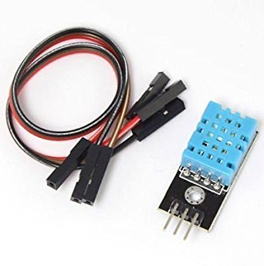
Fig. 4.9 DHT11 Temperature and Humidity Sensor
One of the key advantages of the DHT11 sensor is its factory calibration. Each sensor is calibrated in a controlled humidity chamber, and the calibration coefficients are stored in its internal OTP (One-Time Programmable) memory. During operation, the sensor uses these stored coefficients to adjust and refine the measured values, thereby improving accuracy. This eliminates the need for user-side calibration, simplifying implementation. The sensor also exhibits good long-term stability, meaning that its performance does not degrade significantly over time, making it suitable for continuous monitoring applications.
The DHT11 communicates with a microcontroller using a single-wire serial interface, which simplifies wiring and reduces the number of required I/O pins. Although some descriptions incorrectly state that it provides an analog output, the DHT11 actually transmits data digitally in a serial format. It typically uses three active pins: VCC (power supply), GND (ground), and a data pin for communication. The sensor operates at a low voltage (usually 3.3V to 5V) and consumes minimal power, making it suitable for battery-powered devices. Additionally, it supports signal transmission over distances of up to 20 meters under proper conditions, enabling flexible placement in various environments.
In practical applications, the DHT11 sensor provides real-time temperature and humidity readings that can be further used to calculate derived environmental parameters such as dew point and heat index. The dew point represents the temperature at which air becomes saturated with moisture and water droplets begin to form, which is critical in weather monitoring and HVAC systems. The heat index, on the other hand, indicates how hot it feels to the human body by combining temperature and humidity effects. High humidity reduces the efficiency of sweat evaporation, making the body feel warmer than the actual temperature, which is an important factor in comfort and health assessments.
Due to its compact size, ease of interfacing, and dependable performance, the DHT11 sensor is widely used in applications such as weather stations, home automation systems, greenhouse monitoring, and indoor air quality assessment. It is particularly useful in environments where moderate accuracy is sufficient, and cost constraints are a consideration. While more advanced sensors like DHT22 offer higher precision and wider measurement ranges, the DHT11 remains a popular choice for basic projects. Overall, it serves as an efficient and practical solution for measuring environmental conditions and contributes significantly to the development of smart sensing systems.
4.4.8 ENERGY METER MODULE
The PZEM-004T (V1.0) is a multifunctional electrical parameter measurement module widely used in energy monitoring systems due to its accuracy, versatility, and ease of integration. It is specifically designed to measure and display essential electrical parameters such as voltage, current, active power, and total energy consumption. This makes it highly suitable for applications in residential, commercial, and small-scale industrial environments where real-time monitoring of electrical usage is required. The module provides a comprehensive solution by combining measurement, display, and communication capabilities into a compact and efficient design.

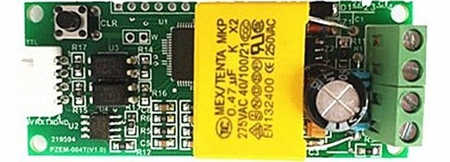
Fig. 4.10 PZEM-004T Meter Module

One of the notable features of the PZEM-004T module is its ability to retain energy consumption data even during power interruptions. This non-volatile memory capability ensures that accumulated energy readings are preserved, allowing for continuous tracking without loss of information. Additionally, the module includes a dedicated reset function, which enables users to clear the stored energy values when needed. The reset process involves a specific sequence of operations, typically requiring a long press followed by a short press of the onboard key, ensuring that accidental resets are avoided. This feature is particularly useful in applications where periodic energy monitoring or billing cycles are implemented.
The module is equipped with a clear and structured display system that presents electrical parameters across multiple windows. Each parameter is displayed with an appropriate level of precision depending on its measurement range. For example, voltage readings are provided within a range of 80 to 260 VAC, while current measurements can go up to 100 A. Power readings are supported up to 22 kW, with dynamic adjustment of decimal precision to ensure readability across different load conditions. Similarly, energy consumption is measured in kilowatt-hours (kWh), with values ranging from very small increments (as low as 1 Wh) up to 9999 kWh. This adaptive resolution allows the module to accurately represent both low and high power consumption scenarios.
From an interfacing perspective, the PZEM-004T module is designed with flexibility in mind. It features two primary sections for connectivity: one for direct electrical measurement (voltage and current inputs) and another for communication. The module uses a TTL (Transistor-Transistor Logic) serial communication interface, which allows it to connect seamlessly with microcontrollers such as Arduino, PIC, or other embedded platforms. This enables users to remotely read measurement data, configure parameters, and integrate the module into larger automation or monitoring systems. For communication with a personal computer, external converters such as TTL-to-USB or TTL-to-RS232 are typically required.
The communication protocol used by the PZEM-004T module is based on structured hexadecimal commands with checksum verification. This ensures reliable data transmission between the module and external devices. Users can send commands to read parameters such as voltage, current, power, and energy, as well as to configure device-specific settings like communication addresses and power alarm thresholds. The inclusion of address-setting functionality allows multiple modules to operate on the same communication bus, making it suitable for scalable monitoring systems. The checksum mechanism, typically based on cumulative summation, helps detect transmission errors and ensures data integrity.
In terms of operation and safety, proper wiring and adherence to electrical specifications are critical. The module is intended for indoor use and should be connected carefully to avoid damage or inaccurate readings. It operates within a voltage range of 80 to 260 VAC and supports a frequency range of 45 to 65 Hz, making it compatible with standard power systems. The maximum supported current is 100 A, and the load connected should not exceed the rated capacity of the module. With a measurement accuracy of approximately 1.0 grade, the PZEM-004T provides reliable performance for general-purpose energy monitoring. Overall, it serves as an efficient and practical tool for tracking electrical parameters and improving energy management in various applications.
4.4.9 RELAY MODULE
A relay is an electrical switch that opens and closes under the control of another electrical circuit. In the original form, the switch is operated by an electromagnet to open or close one or many sets of contacts. It was invented by Joseph Henry in 1835. Because a relay is able to control an output circuit of higher power than the input circuit, it can be considered to be, in a broad sense, a form of an electrical amplifier.

Fig. 4.11 Electromechanical Relay Module
A simple electromagnetic relay, such as the one taken from a car in the first picture, is an adaptation of an electromagnet. It consists of a coil of wire surrounding a soft iron core, an iron yoke, which provides a low reluctance path for magnetic flux, a moveable iron armature, and a set, or sets, of contacts; two in the relay pictured. The armature is hinged to the yoke and mechanically linked to a moving contact or contacts. It is held in place by a spring so that when the relay is de-energized there is an air gap in the magnetic circuit. In this condition, one of the two sets of contacts in the relay pictured is closed, and the other set is open. Other relays may have more or fewer sets of contacts depending on their function. The relay in the picture also has a wire connecting the armature to the yoke. This ensures continuity of the circuit between the moving contacts on the armature, and the circuit track on the Printed Circuit Board (PCB) via the yoke, which is soldered to the PCB. When an electric current is passed through the coil, the resulting magnetic field attracts the armature and the consequent movement of the movable contact or contacts either makes or breaks a connection with a fixed contact. If the set of contacts was closed when the relay was de-energized, then the movement opens the contacts and breaks the connection, and vice versa if the contacts were open. When the current to the coil is switched off, the armature is returned by a force, approximately half as strong as the magnetic force, to its relaxed position. Usually this force is provided by a spring, but gravity is also used commonly in industrial motor starters. Most relays are manufactured to operate quickly. In a low voltage application, this is to reduce noise. In a high voltage or high current application, this is to reduce arcing.
If the coil is energized with DC, a diode is frequently installed across the coil, to dissipate the energy from the collapsing magnetic field at deactivation, which would otherwise generate a voltage spike dangerous to circuit components. Some automotive relays already include that diode inside the relay case. Alternatively a contact protection network, consisting of a capacitor and resistor in series, may absorb the surge. If the coil is designed to be energized with AC, a small copper ring can be crimped to the end of the solenoid. This "shading ring" creates a small out-of-phase current, which increases the minimum pull on the armature during the AC cycle.
By analogy with the functions of the original electromagnetic device, a solid-state relay is made with a thyristor or other solid-state switching device. To achieve electrical isolation an optocoupler can be used which is a light-emitting diode (LED) coupled with a photo transistor. Since relays are switches, the terminology applied to switches is also applied to relays. A relay will switch one or more poles, each of whose contacts can be thrown by energizing the coil in one of three ways. Normally-open (NO) contacts connect the circuit when the relay is activated; the circuit is disconnected when the relay is inactive. It is also called a Form A contact or "make" contact. Normally-closed (NC) contacts disconnect the circuit when the relay is activated; the circuit is connected when the relay is inactive. It is also called a Form B contact or "break" contact. Change-over (CO), or double-throw (DT), contacts control two circuits: one normally-open contact and one normally-closed contact with a common terminal. It is also called a Form C contact or "transfer" contact ("break before make"). If this type of contact utilizes a "make before break" functionality, then it is called a Form D contact.

4.5 SOFTWARE REQUIREMENTS
Arduino is an open-source electronics prototyping platform designed to simplify the process of building interactive electronic projects for beginners as well as professionals. It is based on both easy-to-use hardware and software, making it highly accessible for users with minimal technical background. The hardware component typically consists of a programmable circuit board containing a microcontroller, which acts as the brain of the system by executing instructions defined in the program. These boards include digital and analog input/output pins that allow the user to connect various sensors, actuators, and other electronic components. On the software side, Arduino provides the Arduino Integrated Development Environment (IDE), which is a user-friendly programming interface used to write, compile, and upload code to the board. The programming language used in Arduino IDE is based on simplified C/C++, making it easier to understand and implement. One of the key advantages of Arduino is its extensive library support, which allows users to easily interface with a wide range of devices such as displays, motors, communication modules, and sensors without writing complex code from scratch.
4.5.1 PROGRAMMING LANGUAGE
- Embedded C
4.5.2 EMBEDDED PROGRAM
This project implements an integrated IoT-based environmental and energy monitoring system using an ESP32 microcontroller, combining multiple sensors, cloud platforms, and automation features into a cohesive smart monitoring solution. The code begins by configuring necessary libraries for WiFi communication, cloud interaction, sensor interfacing, and display handling. It uses Blynk for real-time remote monitoring and control, ThingSpeak for data logging and analytics, and various hardware modules such as a DHT11 temperature and humidity sensor, MQ135 air quality sensor, ultrasonic sensor for distance and occupancy detection, PZEM-004T module for electrical parameter monitoring, and an I2C-based LCD for local visualization. The system is designed to provide both automation and user control, making it suitable for applications like smart homes, environmental monitoring stations, or industrial safety systems.
The ESP32 connects to a WiFi network using predefined credentials and establishes communication with Blynk using an authentication token, allowing the user to control devices such as relays remotely via a mobile application. Two relays are used in the system: one for controlling a fan based on temperature and another for controlling a device based on occupancy detection. These relays can also be overridden manually through Blynk virtual pins V7 and V8, enabling flexibility between automation and manual control. The system periodically reads sensor data using a timer-based function called sendSensor, which executes every three seconds. This function collects temperature and humidity data from the DHT11 sensor, air quality data from the MQ135 sensor, and distance measurements from the ultrasonic sensor. The ultrasonic sensor operates by sending a trigger pulse and measuring the echo response time to calculate distance, which is then used to determine whether a person is present within a specified range.
In addition to environmental monitoring, the system also measures electrical parameters such as voltage, current, and energy consumption using the PZEM-004T module. Based on the energy consumption, an estimated electricity bill is calculated using a fixed rate, demonstrating how IoT systems can be extended to include cost analysis and resource management. The automation logic is straightforward yet effective: if the temperature exceeds 36 degrees Celsius, the fan (connected to Relay1) is automatically turned on; otherwise, it remains off. Similarly, if the ultrasonic sensor detects an object within 40 cm, the system assumes occupancy and activates Relay2. These conditional controls help in optimizing energy usage and enhancing user convenience.
All collected data is uploaded to the ThingSpeak cloud platform using predefined fields, enabling long-term storage and analysis. Each parameter, including temperature, humidity, air quality, distance, voltage, current, energy, and calculated bill, is mapped to a specific field in the ThingSpeak channel. This allows users to visualize trends over time and gain insights into environmental conditions and energy usage patterns. Simultaneously, the system updates a 16x2 LCD display to provide real-time feedback locally. The LCD interface is designed with multiple pages, cycling through different sets of information every four seconds. This paging mechanism ensures that all relevant data is displayed without overcrowding the limited screen space.

The LCD displays temperature and humidity on the first page, air quality status on the second, occupancy and distance on the third, voltage and current on the fourth, and energy consumption with billing information on the fifth. The air quality status is categorized into “Fresh,” “Good,” or “Bad” based on sensor readings, and a buzzer is activated if the air quality crosses a certain threshold, providing an immediate alert mechanism. This adds a layer of safety, particularly in environments where air pollution or gas leaks may pose risks. The buzzer remains off during normal conditions and is triggered only when poor air quality is detected.
The system uses non-blocking timing techniques with the millis() function to manage LCD updates efficiently, ensuring smooth operation without interrupting sensor readings or cloud communication. The use of BlynkTimer further enhances system performance by scheduling tasks without relying on delay-based blocking code. This approach is essential in IoT applications where multiple processes must run concurrently.
During initialization in the setup function, all pins are configured appropriately, sensors are initialized, and connections to WiFi, Blynk, and ThingSpeak are established. The LCD is also initialized and set to display mode. The main loop continuously runs Blynk and timer functions, ensuring uninterrupted communication and periodic data updates. Overall, this code demonstrates a well-structured and scalable IoT system that integrates sensing, automation, cloud connectivity, and user interaction. It highlights how multiple technologies can be combined to create a smart, responsive environment capable of monitoring conditions, making decisions, and providing both local and remote feedback in real time.
4.5.3 OPENAI INTEGRATION
OpenAI provides a comprehensive suite of advanced artificial intelligence models and developer APIs that enable applications to transform various forms of input—such as text, audio, and images—into meaningful and actionable outputs. These outputs may include answers to user queries, summarized content, structured instructions, or even synthesized speech. The OpenAI platform is designed with flexibility and scalability in mind, exposing both RESTful and streaming endpoints that allow developers to integrate AI capabilities into a wide range of systems, including web applications, mobile apps, embedded devices, and enterprise platforms.
At a fundamental level, the OpenAI API allows developers to send requests containing input data (for example, a text prompt or an audio stream) and receive responses generated by powerful large language models (LLMs). These models are trained on extensive datasets and are capable of understanding context, generating human-like responses, and performing complex reasoning tasks. The availability of streaming endpoints further enhances responsiveness by allowing partial outputs to be delivered in real time, which is especially valuable in interactive applications such as chatbots, live transcription systems, and voice assistants.
For use cases that demand low latency and seamless interaction, OpenAI offers specialized realtime and audio-enabled APIs. These APIs are specifically optimized for handling continuous streams of audio input and output, enabling developers to build systems that support natural, real-time conversations. Unlike traditional architectures that rely on separate speech-to-text (STT) and text-to-speech (TTS) components, OpenAI’s integrated approach reduces latency by minimizing the number of processing steps. This results in faster response times and smoother conversational experiences, which are critical for applications like virtual assistants, accessibility tools, and interactive voice response systems.
The realtime capabilities also support multimodal interactions, where systems can process and respond to a combination of inputs such as voice, text, and contextual signals. This opens up opportunities for more intuitive human-computer interaction, allowing users to communicate in a way that feels natural rather than constrained by rigid interfaces. For instance, a user could speak a query, receive a spoken response, and simultaneously view relevant information on a screen. Such capabilities are particularly valuable in assistive technologies, where ease of use and accessibility are paramount.
When applying OpenAI technologies in safety-oriented assistive systems—such as an Autism Spectrum Disorder (ASD) emotion and behavior monitoring system—it is essential to adopt a structured and carefully controlled design approach. In such systems, sensors and monitoring devices collect data related to the user’s physiological signals, environmental context, or behavioral patterns. This raw data is typically processed locally to generate a concise state summary, which is then sent to the OpenAI model in the form of a tightly constrained prompt.
The design of this prompt is critical. Instead of sending large amounts of raw data, the system should extract only the most relevant features and present them in a structured, minimal format. For example, a prompt might include indicators such as “elevated heart rate,” “increased movement,” and “noisy environment,” along with a request for a brief interpretation. The model is then instructed to return a highly constrained output—such as a single short phrase describing the emotional state (e.g., “possible anxiety”) along with one or two concise caregiver suggestions (e.g., “reduce noise” or “offer calming support”).
This structured interaction pattern ensures that the system remains predictable, efficient, and easy to interpret. It also reduces the risk of generating overly verbose or potentially inappropriate responses, which is especially important in sensitive contexts involving vulnerable individuals. Prompt engineering plays a central role in achieving this reliability. By providing clear instructions, specifying output formats (such as fixed tags or single-line responses), and maintaining a conservative tone, developers can guide the model toward producing safe and useful outputs.
OpenAI’s documentation emphasizes the importance of prompt clarity and constraint. Ambiguous or overly open-ended prompts can lead to inconsistent or undesired results, whereas well-designed prompts with explicit boundaries help ensure that the model behaves in a controlled and deterministic manner. Techniques such as few-shot examples, role-based instructions, and output validation further enhance the robustness of the system.
From an operational perspective, deploying OpenAI in production environments requires a strong focus on security, privacy, and system integrity. One of the most critical best practices is to never expose API keys in client-side applications, such as mobile apps or browser-based code. Instead, all API interactions should be routed through a secure backend server that acts as a proxy. This backend is responsible for storing API keys securely, authenticating incoming requests, enforcing access control, and logging usage for auditing purposes.
In addition to key protection, the backend can implement rate limiting to prevent abuse, as well as data sanitization to ensure that only appropriate and non-sensitive information is sent to the model. This is particularly important in assistive systems that may handle sensitive biometric or behavioral data. Developers should also adopt practices such as regular key rotation, the use of environment variables, and integration with secure key management services to further strengthen security.
Privacy considerations are equally important. In many assistive applications, especially those involving minors or individuals with special needs, data sensitivity is high. A recommended architectural approach is to process raw sensor data locally on the device whenever possible, and only transmit minimal, anonymized summaries to the cloud. This reduces the risk of data exposure and aligns with privacy-by-design principles. Additionally, developers should provide users and caregivers with clear controls over data sharing, including options to opt in or out of certain features.
Safety is another critical dimension. While OpenAI models are powerful tools for generating insights and recommendations, they are not substitutes for professional medical or clinical judgment. In safety-oriented systems, it is essential to include explicit disclaimers that clarify the role of the AI as a supportive tool rather than a diagnostic authority. The system should also incorporate escalation mechanisms for critical situations. For example, if sensor data indicates a potential emergency (such as extreme distress or dangerous environmental conditions), the system should trigger predefined actions such as notifying caregivers, contacting emergency services, or activating alarms.
Human oversight is indispensable in such deployments. Caregivers should be able to review, interpret, and override AI-generated suggestions as needed. Training caregivers to understand the system’s capabilities and limitations is equally important, as it ensures that they can use the technology effectively and responsibly. The user interface should be designed to present information clearly and concisely, avoiding unnecessary complexity while highlighting critical alerts. Another key consideration is system reliability. Assistive applications often operate in real-time and must deliver consistent performance under varying conditions. This requires robust error handling, fallback mechanisms, and continuous monitoring of system health. For example, if the AI service becomes temporarily unavailable, the system should still be able to provide basic functionality or alerts based on local rules.
In terms of user experience, the integration of OpenAI should enhance, rather than complicate, the interaction flow. Outputs should be concise, actionable, and easy to understand. For voice-enabled systems, natural and clear speech synthesis is essential, while for visual interfaces, notifications should be timely and unobtrusive. The goal is to provide meaningful assistance without overwhelming the user or caregiver.
In conclusion, OpenAI’s platform offers a powerful foundation for building intelligent, responsive, and scalable applications across a wide range of domains. When applied to safety-oriented assistive systems, such as ASD emotion and behavior monitoring, these technologies can significantly enhance situational awareness and caregiver support. However, achieving this potential requires careful attention to prompt design, system architecture, security practices, and user experience. By prioritizing privacy, safety, and human oversight, developers can create solutions that are not only technologically advanced but also ethically responsible and practically effective.

CHAPTER 5

PROJECT DESCRIPTION
  - INTRODUCTION

The proposed project focuses on the design and implementation of an intelligent AI-based home automation and security system that integrates Internet of Things (IoT) technology, embedded systems, and cloud-based Artificial Intelligence. The primary aim of this system is to enhance the comfort, safety, and energy efficiency of modern homes through automated monitoring and control. The system utilizes the ESP32 microcontroller as the central unit, which is connected to multiple sensors such as temperature and humidity sensors, gas sensors, light sensors, and motion or door sensors. These sensors continuously collect real-time data from the environment and send it to the ESP32 for processing. Based on predefined conditions and intelligent analysis, the system automatically controls household appliances like lights and fans using relay modules. In addition to automation, the system incorporates advanced security features, including gas leakage detection, intrusion alerts, and real-time notifications through cloud platforms. The integration of IoT enables remote monitoring and control via mobile devices, allowing users to access their home system from anywhere. Furthermore, cloud-based AI techniques are used to analyze user behavior and environmental patterns, enabling predictive decision-making and adaptive automation. The system also includes an ESP32-CAM module for visual monitoring and surveillance, enhancing overall security. By combining real-time sensing, intelligent processing, and automated control, the project provides a reliable and scalable solution for smart home applications. This approach reduces human intervention, optimizes energy consumption, and ensures a safer living environment, making it suitable for next-generation smart homes.
  - WORKING OF PROPOSED SYSTEM
The proposed AI-based smart home automation and security system represents an advanced integration of embedded systems, Internet of Things (IoT) communication, and cloud-based intelligence to deliver a comprehensive, real-time monitoring and control solution for modern households. This system is designed not only to automate routine tasks but also to enhance safety, optimize energy consumption, and provide intelligent decision-making capabilities through continuous learning.
At the core of the system lies a structured initialization process. When the system is powered on, all hardware components—including sensors, the ESP32 microcontroller, the ESP32-CAM module, and various output devices such as lights, fans, and buzzers—are initialized and synchronized. This ensures that each component is ready to operate efficiently and communicate seamlessly within the network. The ESP32 microcontroller serves as the central processing unit, coordinating all operations and managing data flow between input sensors, output devices, and the cloud platform.
A variety of sensors are deployed throughout the home to continuously monitor environmental and security-related parameters. The DHT11 sensor measures temperature and humidity levels, providing essential data for maintaining indoor comfort. The gas sensor is responsible for detecting harmful gases or leaks, which is critical for preventing hazardous situations. The Light Dependent Resistor (LDR) monitors ambient light intensity, enabling automated lighting control. Additionally, door sensors and motion detectors enhance security by identifying unauthorized access or unusual movement within the premises. These sensors operate continuously, collecting real-time data and feeding it into the system.
The ESP32 microcontroller processes this incoming data in real time. It is programmed with predefined conditions and thresholds that determine how the system should respond to various scenarios. For instance, when the LDR detects low light levels, the system automatically switches on the lights, ensuring convenience and energy efficiency. Similarly, if the temperature exceeds a predefined threshold, the system activates cooling devices such as fans or air conditioning units. This immediate response capability ensures that the home environment remains comfortable without requiring manual intervention.
In terms of safety, the system is designed to respond rapidly to potential threats. If the gas sensor detects a leak, the ESP32 triggers an alarm system, typically in the form of a buzzer, and sends alerts to the user. Likewise, if a door sensor detects unauthorized entry or a motion sensor identifies suspicious activity, the system initiates security protocols. These may include sounding alarms, capturing images via the ESP32-CAM, and notifying the homeowner through connected applications. This layered approach significantly enhances home security by combining detection, alerting, and visual verification.
Beyond local processing, the system leverages IoT capabilities to transmit collected data to a cloud platform via Wi-Fi. This connectivity allows for remote monitoring and control, enabling users to access their home systems from anywhere using mobile applications or web dashboards. The cloud platform acts as a centralized repository, storing historical data and enabling advanced analytics. This is where artificial intelligence plays a crucial role.
AI algorithms analyze the accumulated data to identify patterns in user behavior and environmental conditions. For example, the system may learn that the user typically turns on lights at a certain time in the evening or prefers specific temperature settings during different times of the day. Over time, the system adapts to these patterns and automates actions accordingly, reducing the need for manual input. This predictive capability transforms the system from a reactive setup into a proactive and intelligent assistant.
The ESP32-CAM module adds a visual dimension to the system by enabling real-time video streaming and image capture. This feature is particularly valuable for surveillance and security monitoring. Users can view live footage of their home, receive snapshots during security events, and even store recordings in the cloud for later review. The integration of visual data with sensor inputs enhances situational awareness and provides a more robust security solution.
Another significant advantage of this system is its contribution to energy efficiency. By automating appliances based on real-time conditions and learned behavior patterns, the system minimizes unnecessary energy consumption. For instance, lights are only activated when needed, and cooling systems operate based on actual temperature requirements rather than manual settings. This not only reduces electricity bills but also supports sustainable energy usage.
The entire system operates in a continuous loop, ensuring uninterrupted monitoring and response. Sensor data is constantly collected, processed, and transmitted, while the cloud platform continuously updates its analysis and recommendations. This dynamic operation ensures that the system remains responsive to changing conditions and user needs at all times.
The AI-based smart home automation and security system offers a holistic solution that combines real-time monitoring, automated control, intelligent learning, and remote accessibility. By integrating advanced hardware components with IoT connectivity and cloud-based AI, the system enhances convenience, improves safety, and optimizes energy usage. As technology continues to evolve, such systems are expected to become increasingly sophisticated, paving the way for fully autonomous and intelligent living environments.

RESULT

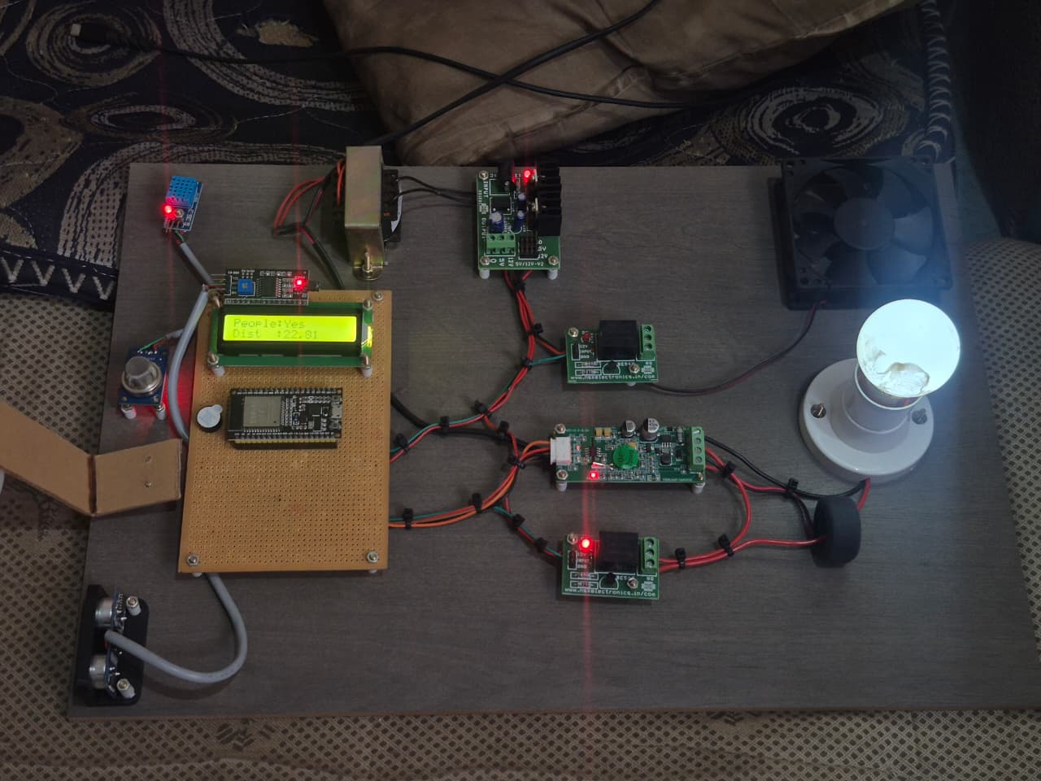
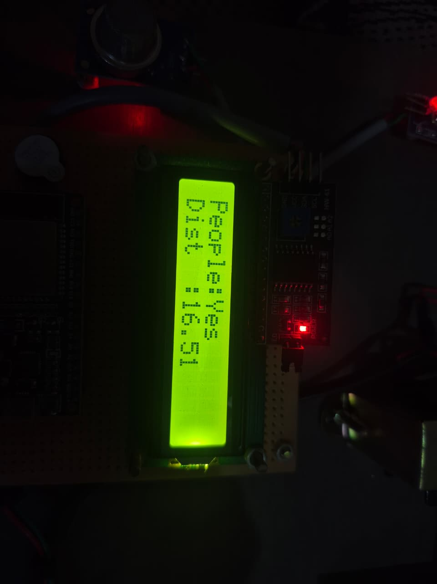

Fig. 5.1 Hardware Output

The proposed AI-based smart home automation and security system was successfully designed, implemented, and tested using the ESP32 microcontroller, multiple sensors, and cloud-based IoT platforms. The system demonstrated efficient real-time monitoring, intelligent decision-making, and reliable automation of household appliances. The results obtained from the implementation clearly indicate that the system meets the objectives of improving convenience, enhancing security, and optimizing energy consumption in a smart home environment.
During the testing phase, the sensors accurately collected environmental data such as temperature, humidity, light intensity, gas levels, and door status. The DHT11 sensor provided consistent readings of temperature and humidity, enabling the system to respond effectively to changes in environmental conditions. The light-dependent resistor (LDR) successfully detected variations in light intensity, allowing automatic control of lighting systems. Similarly, the gas sensor effectively detected the presence of harmful gases, ensuring timely alerts in case of gas leakage. The door sensor accurately identified unauthorized access, contributing to the overall security of the system.

Fig 5.3 Software Output
The ESP32 microcontroller efficiently processed the sensor data and executed the control logic in real time. Based on the input conditions, the system automatically controlled appliances such as lights and fans through relay modules. For instance, when the light intensity dropped below a predefined threshold, the system turned on the lights, and when sufficient light was available, the lights were turned off. Likewise, the fan was automatically activated when the temperature exceeded a certain limit and deactivated when the temperature returned to normal. This automatic control reduced the need for manual intervention and improved energy efficiency.
One of the key results of the project was the successful implementation of real-time alert mechanisms. When abnormal conditions such as gas leakage or unauthorized door access were detected, the system immediately activated a buzzer and generated alerts. These alerts were also transmitted to the cloud platform, enabling users to receive notifications through mobile applications or dashboards. This ensured a quick response to potential hazards, significantly improving the safety of the home environment.
The integration of IoT technology allowed seamless communication between the ESP32 and the cloud platform. The system successfully transmitted sensor data to the cloud using Wi-Fi connectivity. The cloud platform stored the data and displayed it in graphical formats, enabling users to monitor environmental conditions remotely. The real-time data visualization helped in understanding system performance and environmental trends over time. Additionally, users were able to access the system from any location, demonstrating the effectiveness of remote monitoring and control.
Another important result was the implementation of AI-based analysis in the cloud. The system utilized AI techniques to analyze sensor data and identify patterns in user behavior and environmental conditions. Based on this analysis, the system was able to make intelligent decisions and improve automation efficiency. For example, the system learned user preferences for lighting and temperature settings and adjusted appliance operations accordingly. This adaptive behavior enhanced user comfort and reduced energy wastage.
The ESP32-CAM module further enhanced the system by providing visual monitoring capabilities. The camera module successfully captured images and supported real-time video streaming over Wi-Fi. This feature allowed users to monitor their home environment remotely, adding an extra layer of security. The integration of camera-based monitoring with sensor-based detection created a comprehensive security system capable of detecting both environmental and visual threats.
The energy efficiency of the system was also evaluated as part of the results. By automating the operation of appliances based on real-time conditions, the system significantly reduced unnecessary power consumption. For instance, lights were turned off automatically when not required, and fans operated only when temperature conditions demanded. The inclusion of the energy meter module (PZEM) enabled monitoring of power consumption, providing insights into energy usage patterns. This helped in optimizing energy utilization and reducing electricity costs.
The system demonstrated high reliability and stability during continuous operation. The ESP32 microcontroller handled multiple tasks simultaneously, including sensor data acquisition, processing, and communication, without significant delays. The use of efficient programming and optimized logic ensured smooth operation of the system. Additionally, the system showed good scalability, as additional sensors and devices could be easily integrated without affecting performance.
Security and data transmission were also tested to ensure safe operation. The system used secure communication protocols to transmit data between the ESP32 and the cloud platform. This ensured that sensitive information was protected from unauthorized access. The implementation of authentication mechanisms further enhanced system security, making it suitable for real-world applications. Overall, the results demonstrate that the proposed system is capable of providing an intelligent, automated, and secure home environment. The combination of IoT, AI, and embedded systems enabled efficient monitoring, real-time decision-making, and automated control of appliances. The system not only improved user convenience but also enhanced safety and energy efficiency.
In conclusion, the successful implementation and testing of the AI-based smart home automation and security system validate its effectiveness and reliability. The system achieved all the intended objectives and proved to be a practical solution for modern smart homes. The results highlight the potential of integrating advanced technologies to create intelligent living environments that are safe, efficient, and user-friendly.

CHAPTER 6

CONCLUSION AND FUTURE WORK

CONCLUSION
The proposed AI-based smart home automation and security system has been successfully designed and implemented, demonstrating the effective integration of IoT, embedded systems, and Artificial Intelligence technologies. The system efficiently monitors environmental conditions using various sensors and performs automated control of household appliances based on real-time data. The use of the ESP32 microcontroller ensures reliable processing and seamless communication with cloud platforms, enabling remote monitoring and control. The overall system enhances convenience by reducing manual effort and providing a smarter way to manage home appliances.
In addition to automation, the project significantly improves home security through features such as gas leakage detection, intrusion alerts, and real-time notifications. The integration of the ESP32-CAM module further strengthens the system by enabling visual monitoring and surveillance. The use of AI techniques allows the system to analyze data, learn user behavior, and make intelligent decisions, thereby improving system efficiency and adaptability over time. These features collectively contribute to a safer and more responsive home environment.
Furthermore, the system promotes energy efficiency by ensuring optimal usage of electrical appliances based on environmental conditions and user preferences. The scalable and cost-effective design makes it suitable for real-world applications and future enhancements. Overall, the project demonstrates the potential of combining IoT and AI to develop intelligent systems that improve quality of life, making it a valuable solution for next-generation smart homes.

FUTURE WORK
The proposed AI-based smart home automation and security system can be further enhanced with several advanced features and technologies to improve its performance, intelligence, and usability. One of the major future improvements is the integration of advanced machine learning and deep learning algorithms directly into the system to enable more accurate predictions, behavior analysis, and decision-making. This would allow the system to learn user habits more effectively and provide highly personalized automation. The inclusion of voice control using virtual assistants such as Alexa or Google Assistant can make the system more user-friendly by enabling hands-free operation of appliances. Additionally, the system can be expanded by incorporating facial recognition and object detection using the ESP32-CAM or more powerful vision modules, thereby enhancing security through real-time identification of authorized and unauthorized individuals. Another important enhancement is the integration of mobile applications with improved user interfaces, allowing users to monitor and control the system more efficiently with real-time notifications and customizable settings. The system can also be extended to support smart grid integration and advanced energy management techniques, enabling users to monitor energy consumption in detail and optimize usage based on demand and cost. Furthermore, implementing stronger cybersecurity measures such as end-to-end encryption, multi-factor authentication, and secure communication protocols will improve data privacy and protection against cyber threats. The addition of more sensors and devices, such as smart locks, fire detectors, and water leakage sensors, can further enhance the functionality and coverage of the system. The system can also be adapted for industrial and commercial applications, making it more versatile and scalable. Integration with edge computing can reduce dependency on cloud platforms and improve response time by processing data locally. Finally, the development of a fully autonomous system capable of self-diagnosis and maintenance alerts would increase reliability and reduce manual intervention. These future enhancements will transform the system into a more intelligent, secure, and efficient solution for next-generation smart environments.

LIST OF PUBLICATIONS

Suriya R, Nivetha R, Libikasri S, Ragula Sangeerthiyan R, Arun J, "Design and Implementation of an Intelligent AI Based Home Automation And Security Framework," 6th International Conference on Recent Trends in Engineering Technology and Management(ICRETM).

REFERENCES

[1] M. A. Addow, “A low-cost IoT-based smart home automation system for urban environments,” Smart Cities and IoT Systems, 2025.
[2] A. Alheraish, “Design and implementation of home automation system,” IEEE Transactions on Consumer Electronics, vol. 50, no. 4, pp. 1087–1092, Nov. 2004.
[3] L. Atzori, A. Iera, and G. Morabito, “The Internet of Things: A survey,” Computer Networks, vol. 54, no. 15, pp. 2787–2805, Oct. 2010.
[4] Y. Chen, “Design and implementation of smart home system based on Internet of Things,” Smart Cities Journal, 2024.
[5] S. R. Das, D. J. Cook, A. Bhattacharya, E. O. Heierman, and T. Lin, “The role of prediction algorithms in the MavHome smart home architecture,” IEEE Wireless Communications, vol. 9, no. 6, pp. 77–84, Dec. 2002.
[6] M. Johnson and M. Shabiyemba, “IoT-based smart home automation system: Design and development,” International Journal of Computing and Applied Informatics, 2025.
[7] D. Kakani, A. Kulkarni, Y. Pandya, and N. Mehendale, “IoT-based smart home automation using ESP32 and Blynk,” SSRN Electronic Journal, 2024.
[8] A. Kamble, S. Moon, S. Deodhe, and D. Bagde, “Home automation using ESP32,” International Journal of Novel Research and Development, vol. 10, no. 3, 2025.
[9] D. Pavithra and R. Balakrishnan, “IoT based monitoring and control system for home automation,” in 2015 Global Conference on Communication Technologies (GCCT), 2015, pp. 169–173.
[10] C. Withanage, R. Ashok, C. Yuen, and K. Otto, “A comparison of the popular home automation technologies,” in IEEE Innovative Smart Grid Technologies Conference, 2014, pp. 1–6.

