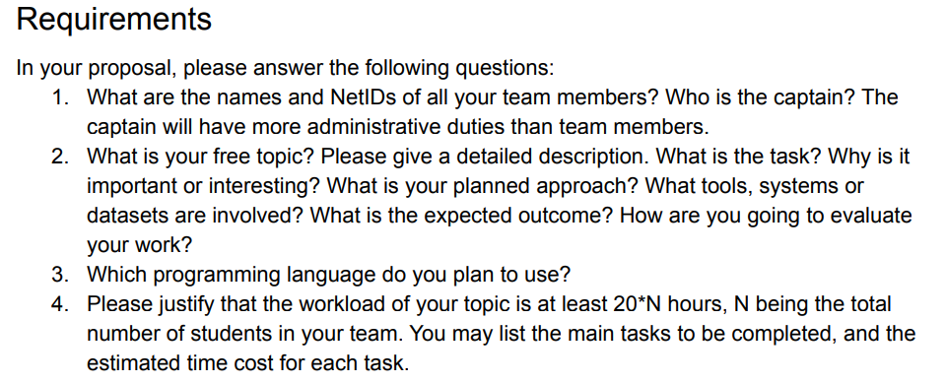

Answer:

1. Team Information:
   1. Captain: James He
   2. Team Member: Hao Yan
   3. Team Member: Xinyuan Chong (xchong2)
2. Topic Information:
   1. Topic: House Recommendation Engine
   2. Currently, the most commonly used house hunting website is Redfin.com. When users enter the interested location (city or zip code), all the houses for sale in the area will be provided. Users can also refine their search by price, lot size, bedroom number, etc. However, the search result is not ranked. Basically, users need to go through the result one by one. Our recommendation engine is targeted to provide more precise search result based on users’ input. For example, user A thinks price is the most important quality due to limited budget, or user B cares more about bathroom numbers. Our engine will add weight and rank the houses based on these input from users and finally provide users the best matching houses.
   3. The top 5(10?) best matching houses will be provided to users to check. It can save a lot of time for users going through every houses on Redfin.com, which sometimes can be hundreds for hot area.
   4. The information of houses for sale will be crawled from Redfin.com and form a dataset. Based on users’ input of the importance for different qualities of house, different weights will be added on each houses and eventually rank the houses.
   5. The dataset created by crawling from Redfin.com
   6. Top 5(10?) best matching houses
   7. Evaluation search will be defined
3. Python, HTML, CSS, JavaScript…?
4. The work will be divided into 3 portions: (1) Front End Interface: User can input the qualities of the house they think more important and also view the top matching search result (30h); (2) Back End: Web crawler and ranking function to create the dataset and add weight on houses based on users’ input (30h). (3) Integration: Collect the user input from Front End Interface and send to Back End. Get the ranked house information and share to Front End to display to users (25h).