**Workout:1**

**For home page:**

<html>

<head>

<title>academy</title>

<meta charset="UTF-8">

<meta name="viewport" content="width=device-width, initial-scale=1.0">

</head>

<body>

<center>

<h1> ABC academy 🚀</h1>

<h4> Trainig | Tech News | Freshers Guide </h4>

<h5> Emporing young developers to level up their skills through training in software development technolgies 👦💻 </h5>

<iframe width="560" height="315" src="https://www.youtube.com/embed/qz0aGYrrlhU?si=SBe0ZN-tFPEUvLO-" title="YouTube video player" frameborder="0" allow="accelerometer; autoplay; clipboard-write; encrypted-media; gyroscope; picture-in-picture; web-share" allowfullscreen></iframe>

</center>

<p style="text-align:justify"> In this video,I will explain what full stack development is and provide a detailed overview of the technologies used tobuild full stack web applications.Full stack web development involves building the front-end,back-end,and database components of a web application. This means that ful <br> stack developers are resposible for everything from designing the user to managing gthe server-side logic and database.<br>

<br>I will begin by discussing the key technologies and programming languages used in full stack web development, including HTML,CSS,javaScript,Node.js and variousfront-end frameworks such asReact and Angular. I will thenmove on to discuss the server side technologies like python,java<br>

and nodejs,and databases likeMySQL,MongoDB,Aws.

</p>

<b>lets Divide Full stack into 3 parts</b>

<ul>

<li>Frontend</li>

<li>Backend</li>

<li>Database</li>

</ul>

<b style=font-size:20;>Technologies Used for Full Stack Development</b>

<table border="1">

<tr>

<th>fronted</th>

<th>backend</th>

<th>database</th>

</tr>

<tr>

<td>HTML</td>

<td>CSS</td>

<td>Javascript</td>

</tr>

<tr>

<td>java</td>

<td>python</td>

<td>Node JS</td>

</tr>

<tr>

<td>Mongo DB</td>

<td>MySQL</td>

<td>AWS</td>

</tr>

</table>

<hr>

<center>

<a style="padding-right: 2;" href="x.html">register for a course | </a>

<a style="padding-right: 2;" href=https://www.instagram.com/>instagram | </a>

<a style="padding-right: 2;" href="https://www.youtube.com/">youtube| </a>

</center>

</body>

</html>

**For register form:**

**Code:**

**<**html>

<head>

<title>registerpage</title>

<meta charset="UTF-8">

<meta name="viewport" content="width=device-width, initial-scale=1.0">

</head>

<body>

<center>

<h1 style="font-size: 50"> ABC academy 🚀</h1>

<h3> Trainig | Tech News | Freshers Guide </h3>

<h4> Emporing young developers to level up their skills through training in software development technolgies 👦💻 </h4>

<hr>

<b>Registration Form</b> <br> <br>

<form>

&nbsp;&nbsp;&nbsp;&nbsp;&nbsp;&nbsp;&nbsp;&nbsp;Name:&nbsp;&nbsp;&nbsp;&nbsp;<input type="text"><br><br> &nbsp;&nbsp;&nbsp;&nbsp;&nbsp;&nbsp;&nbsp;&nbsp;

Age:&nbsp;&nbsp;&nbsp;&nbsp;&nbsp;&nbsp;&nbsp;&nbsp;<input type="number"><br><br>&nbsp;&nbsp;&nbsp;&nbsp;&nbsp;&nbsp;&nbsp;&nbsp;

Gender:&nbsp;&nbsp;&nbsp;&nbsp;&nbsp;&nbsp;&nbsp;<input type="radio" name="m" id="o">Female&nbsp;&nbsp;&nbsp;&nbsp;&nbsp;&nbsp;

<input type="radio" name="m" id="o">Male&nbsp;&nbsp;&nbsp;&nbsp;&nbsp;&nbsp;<br><br>

&nbsp;&nbsp;&nbsp;&nbsp;&nbsp;&nbsp;&nbsp;&nbsp;Email:&nbsp;&nbsp;&nbsp;&nbsp;&nbsp;&nbsp;<input type="email"> <br> <br>

<label for="course">&nbsp;&nbsp;&nbsp;&nbsp;&nbsp;&nbsp;&nbsp;&nbsp;&nbsp;Select a Course:</label>

<select name="course">

<option> </option>

<option>Full stack Development</option>

<option>Web Developer</option>

<option>Data Scientist</option>

</select><br><br>&nbsp;&nbsp;&nbsp;&nbsp;&nbsp;&nbsp;&nbsp;&nbsp;&nbsp;&nbsp;&nbsp;&nbsp;&nbsp;&nbsp;&nbsp;&nbsp;&nbsp;&nbsp;&nbsp;&nbsp;&nbsp;

&nbsp;&nbsp;&nbsp;&nbsp;&nbsp;&nbsp;&nbsp;&nbsp;&nbsp;&nbsp;&nbsp;&nbsp;&nbsp;&nbsp;&nbsp;&nbsp;Upload your Resume:<input type="file" ><br><br>

<button>Reset</button>

&nbsp;&nbsp;&nbsp;&nbsp;&nbsp;

<button>Submit</button><br>

<hr>

<center>

<a style="padding-right: 2;" href="workout.html">Home| </a>

<a style="padding-right: 2;" href="">instagram | </a>

<a style="padding-right: 2;" href="z.html">youtube| </a>

</center>

</form>

</center>

</body>

</html>

**OUTPUT:**

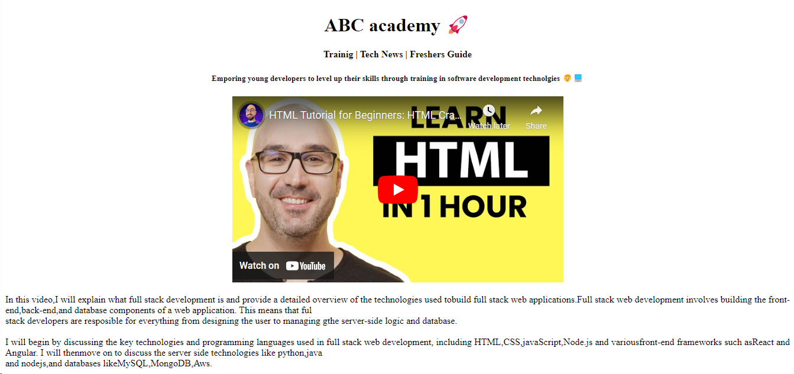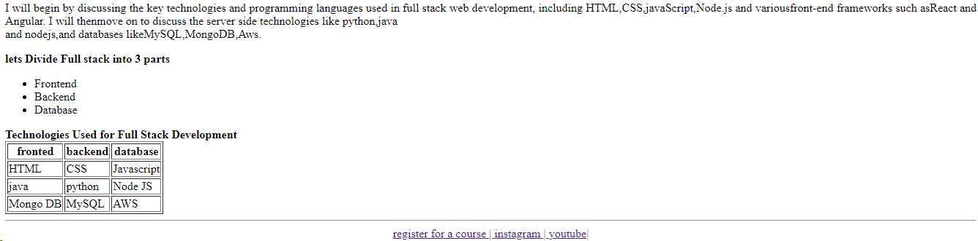

**For register form:**

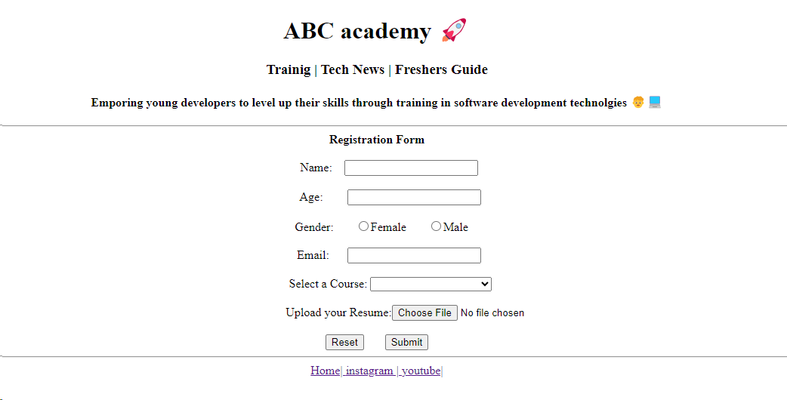

**Workout 2:**

<!DOCTYPE html>

<html>

<head>

<style>

body{

background-color:black;

background-size: cover;

</style>

<meta charset="UTF-8">

<meta name="viewport" content="width=device-width, initial-scale=1.0">

<title>workout2</title>

</head>

<body>

<center>

<h1 style=color:white;>Upcoming Events🗓️</h1>

</center>

<center>

<p style=color:white;>Dont miss any of your important events.Here are the important events you have registered for!</p>

</center>

<hr>

<p style=color:white;>Lorem ipsum dolor sit amet consectetur adipisicing elit. Id nulla voluptatem quas, est cupiditate nisi mollitia

optio, similique tempora quisquam voluptates. Quia nesciunt obcaecati repellendus assumenda aliquid hic aperiam

commodi, possimus aliquam nam, delectus quod soluta quidem rerum alias eaque voluptates repudiandae veniam velit

ullam eos tenetur? Obcaecati, hic, reiciendis quaerat praesentium cupiditate ea illum aliquam voluptatibus

molestias quisquam est repellat harum nesciunt asperiores voluptatem quidem laborum similique nemo iusto aut

minima nam. Minima, incidunt?</p>

<center><img src="a.png" alt=""></center>

<center>

<h2 style=color:white;>Photo Gallery Event</h2>

</center>

<center>

<h3 style=color:white;>Free Entry| Free Food| Pets are not allowed</h3>

</center>

<p style=color: white;>&nbsp;&nbsp;&nbsp;&nbsp;&nbsp;&nbsp;&nbsp;&nbsp;&nbsp;&nbsp;&nbsp;&nbsp;&nbsp;&nbsp;&nbsp;&nbsp;&nbsp;&nbsp;&nbsp;&nbsp;&nbsp;&nbsp;&nbsp;&nbsp;Lorem ipsum dolor sit amet consectetur, adipisicing elit. Asperiores accusantium expedita ipsam rerum, incidunt

omnis adipisci, ipsum eaque odio placeat cum provident porro corrupti aperiam harum alias.</p>

<center><img src="b.png" alt=""></center>

<center><a href=''>Fashion Store</a></center>

<center>

<h3 style=color:white;>Free Entry| Free Food| Pets are not allowed</h3>

</center>

<p style=color:white;>&nbsp;&nbsp;&nbsp;&nbsp;&nbsp;&nbsp;&nbsp;&nbsp;&nbsp;&nbsp;&nbsp;&nbsp;&nbsp;&nbsp;&nbsp;&nbsp;&nbsp;&nbsp;&nbsp;&nbsp;&nbsp;&nbsp;&nbsp;&nbsp;Lorem ipsum dolor sit amet consectetur, adipisicing elit. Asperiores accusantium expedita ipsam rerum, incidunt

omnis adipisci, ipsum eaque odio placeat cum provident porro corrupti aperiam harum alias.

culpa.</p>

<hr>

<center>

<h2 style="color: white;">Contact</h2>

<h3 style="color: white;">+91 9834678921| eventclub@gmail.com</h3> <p style=color:white;>North street, Madurai, 625009</p>

</center>

</body>

</html>

**Output:**

