Min-Cost Max-Flow Interception Assignment Integration and Validation Report
Yeqi Sang
1. Introduction
Version 46 (V46) replaces the interceptor selection module in the original simulation with a global assignment strategy based on min-cost max-flow (MCMF). To validate this new module in a reliable and interpretable way, the validation process was divided into four stages. s
I separated the assignment algorithm into its own module. First, I tested the algorithm logic by itself using mock sensor data, target data, and bidding costs. Then, I tested whether the same algorithm could work with the current simulation structure.
For the simulation-level test, I used event injection for a short simulation period. This means I set simulation in a short time (8 sec and 30 sec), manually created a specific situation where two targets enter PENDING_SELECTION at the same time. This lets me check whether the system can choose the best overall interceptor combination for both targets globally, instead of selecting interceptors for each target separately.

2. What Was Designed in V46
V46 Design Overview
In V45, interceptor selection was performed inside the simulation through a min-max conflict-resolution strategy based on bidding logic. In V46, a clearer strategy boundary was introduced so that the assignment module could be tested independently from the rest of the simulation.
The main components introduced in V46 are as follows.
2.1 MCMF Solver
The new interceptor assignment strategy is formulated as a min-cost max-flow problem. Each calling target is expanded into interceptor slots, where the number of required slots is equal to the number of calling targets multiplied by the maximum number of active interceptors per target. Each candidate sensor has capacity 1, meaning that one sensor cannot be assigned to more than one target at the same time.
Table 1 example: we have targets t1 and t2. Available sensors are [ 5, 6, 7, 8, 9]. And for each target, the cost matrix (bidding cost) is:
Target | Sensor 5 | Sensor 6 | Sensor 7 | Sensor 8 | Sensor 9
t1 | 1 | 2 | 3 | 4 | 5
t2 | 1 | 2 | 1000 | 1000 | 1000
Table 1: cost matrix for Section 2.1 example
Next, the algorithm creates interceptor slots. Since for each target, we want to assign them two interceptors, so each target has 2 interceptor slots, 4 interceptor slots in total: t1-slot1, t1-slot2, t2-slot1, t2-slot2

Figure 1 provides a brief overview of the flow network.
Each sensor is represented by a corresponding sensor node. The network also includes a source node and a sink node, which define the start and end points of each flow path.
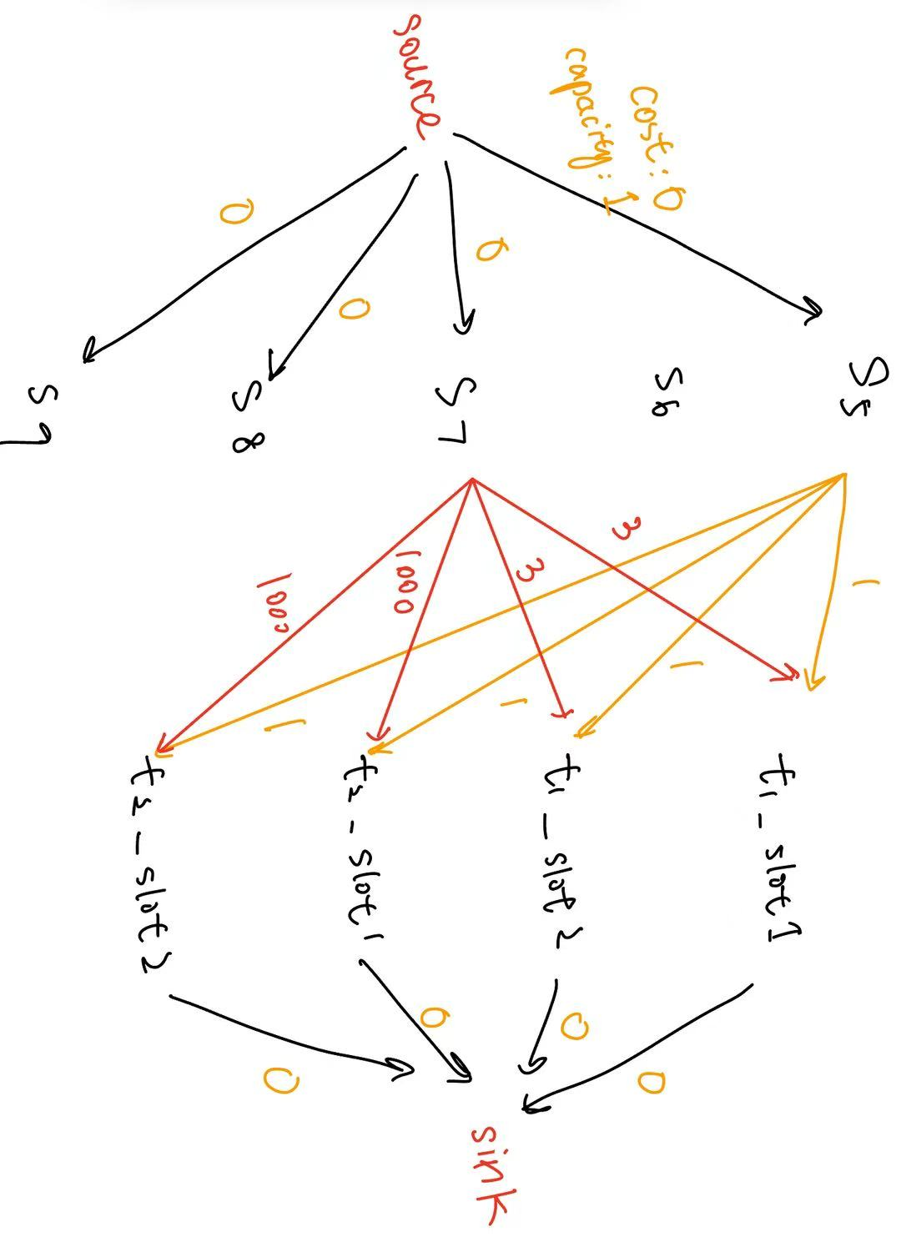
Figure 1. Initial flow network: Each sensor node has directed edges to each interceptor slot
For edges:
We have source $→$ sensor node, and capacity=1 represents each sensor candidate can be at most used once:
e.g. source $→$ s5, capacity = 1, cost = 0
source $→$ s6, capacity = 1, cost = 0
….
source $→$ s9, capacity = 1, cost = 0

Then we have sensor $→$ interceptor slot.
s5 $→$ t1-slot1, cost = 1
s5 $→$ t2-slot1, cost = 1
….
s7 $→$ t2-slot1, cost = 1000
s7 $→$ t2-slot 2, cost = 1000
….
s9 $→$ t2-slot 2, cost = 1000
The cost is based on the Table 1.

We have interceptor slot $→$ sink, capacity=1 represents each interceptor slot can only accept one sensor candidate.
t1-slot1 $→$ sink, capacity = 1, cost = 0
…
t2-slot2 $→$ sink, capacity = 1, cost = 0
Then, the algorithm tries to find the maximum number of flows with the minimum total cost. In this model, one unit of flow represents one sensor assignment. Each flow starts from the source node, passes through one sensor and one interceptor slot, and ends at the sink node.
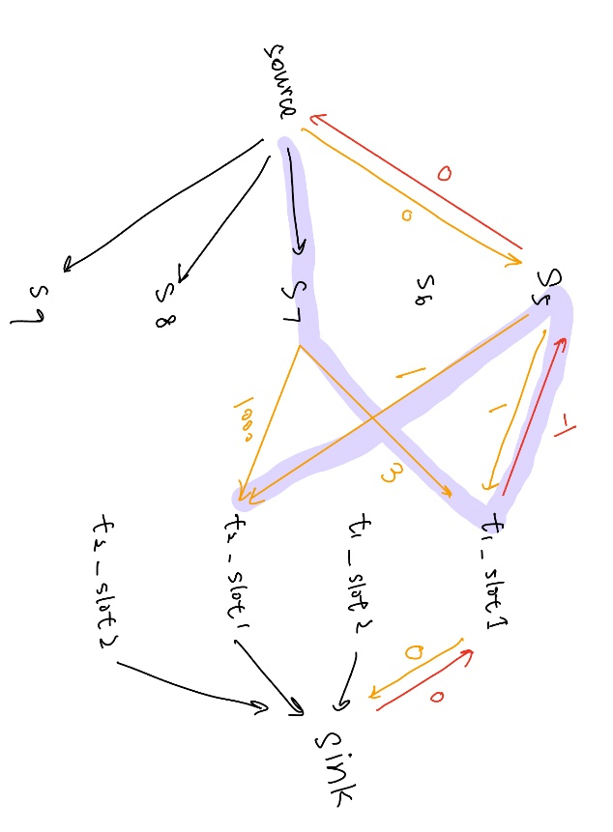
Figure 2. reverse edge t1_slot1 $→$ s5 reduces the global cost

For example, in Figure 2, the algorithm may first create this flow:
$$source →s5→t1_slot1→sink$$
This means that sensor 5 is assigned to t1_slot1. After this flow is created, the residual network includes a reverse edge:
$$t1_slot1→s5$$
This reverse edge allows the algorithm to adjust the previous assignment later if a better global solution is found.
Later, suppose the algorithm considers assigning sensor 7 directly to t2_slot1:
$$source →s7→t2_slot1→sink$$
This assignment has a very high cost because sensor 7 is not a good choice for target 2, with cost 1000. However, because the reverse edge t1_slot1 $→$ s5 exists, the algorithm can re-route the assignment:
$$source →s7→t1_slot1→s5→t2_slot1→sink$$
This path means that sensor 7 replaces sensor 5 for t1_slot1, with cost 1, as described in Table, and sensor 5 is moved to t2_slot1, with cost 3. In other words, the algorithm swaps the previous assignment to reduce the total cost. This is how the residual edges allow MCMF to improve the global assignment instead of keeping the first local choice fixed.

2.2 Validation with Mock Data
A separate mock test file is created to test the MCMF algorithm outside the full simulation. The mock data includes sensor states, target states and mocked interception points, which have the same structure as the real simulation data. This test checks whether the MCMF solver can correctly use the simulation-style inputs and be integrated into the existing simulation system.

2.3 A/B Switching Between MCMF and Min-max for Validation
The wrapper function solveInterceptorAssignments(...) preserves the original V45 min-max assignment strategy while enabling the new MCMF solver. This provides a fair A/B comparison framework, because both algorithms can be evaluated using the same candidate sensors and the same bidding cost matrix.
The MCMF objective is two-step: it first maximizes the number of assigned interceptor slots, and then minimizes the total assignment cost among solutions with the same number of assigned slots.

3. Validation Strategy and Results
3.1 Stage 1: Unit Test
Stage 1 focuses on validating the MCMF solver itself. 5 unit tests were designed to verify the correctness of the assignment algorithm under controlled cost-matrix inputs. These tests focus only on algorithm-level correctness, such as feasibility, non-duplicate assignment, and behavior under shortage conditions.
s,

3.2 Stage 2: Short Simulation Validation
Stage 2 is the first validation stage that runs the MCMF logic inside a real V46-derived simulation loop. Its purpose is to verify that the MCMF path can be applied in the actual simulation environment, rather than only in unit tests.
Stage 2 uses example_v46_stage2_Yeqi.m, which is a dedicated Stage 2 copy of V46 with an event trigger. For example, in an 8-sec simulation scenario, target 1 and target 2 are forced into simultaneous PENDING_SELECTION at timestamp=5.0 , after which the real simulation loop continues normally.
The main setup is summarized below:
- Runtime: 8 s with injection at 5 s for the standard case; an additional 30 s / 15 s case was also tested.
- Manual Event Trigger: target 1 and target 2 enter PENDING_SELECTION.
- Active trackers at injection: target 1$→$ [1, 2], target 2 $→$ [3, 4].
- Cost function: unchanged from the original simulation.
- Impact on normal V46: none, because the manual event trigger is isolated in example_v46_stage2_Yeqi.m rather than the clean example_V46_Yeqi.m.
Scenario | MCMF Assignment | Minmax Assignment | Cost Improvement
8s/5s | T1 [6, 7],  T2 [8, 9],  Cost 1.2443 | T1 [7, 11],  T2 [6, 8],  Cost 1.3038 | 0.0595
30s/15s | T1 [6, 8],  T2 [7, 9],  Cost 1.0341 | T1 [8, 6],  T2 [7, 12]  Cost 1.0968 | 0.0626
Table 2: Comparison of MCMF and Minmax solutions for Interceptor Selection Conflict
Table 2 shows that the MCMF-based assignment strategy is not only algorithmically correct, but also successfully integrated into the V46 simulation framework.

4.3 Stage 3: Full Natural Simulation
Stage 3 runs the clean main script example_V46_Yeqi.m directly. No stage 3 injection file is used. Table 3 shows a summary of the natural simulation.
MAT output | logs/wsn_data_20260408_183623.mat
Log output | logs/wsn_log_20260408_183623.log
Assignment events | 12 times, all MCMF
Multi-target natural assignment events | 0
Successful Intercepts | 9
Simulation Completion | Reached t=75s
Table 3: Full 75-Second Simulation Output Summary

Figure 3: Simulation Under the Same Configuration as V45, with MCMF Enabled
As Figure 3 shown, MCMF is naturally invoked by the clean full simulation. However, this natural run did not produce simultaneous multi-target selection, so it does not replace the controlled conflict evidence form Stage 1&2, and Stage 3. I may need to find more test cases then.

Figure 4 provides a supplementary 15 s natural simulation case, which was also examined to show that MCMF can operate correctly in a naturally occurring simultaneous two-target assignment event. In this case, target 1 and target 2 naturally entered PENDING_SELECTION at the same time, without any manual injection.
MCMF:
- T1 $→$ [17 21], cost 0.6211
- T2 $→$ [7 11], cost 0.5849
- total 1.2060
Minmax:
- T1 $→$ [11 17], cost 0.5997
- T2 $→$ [7 1], cost 0.6137
- total 1.2133
Although the improvement is small, this remains a useful no-injection example in which MCMF outperformed the minmax strategy.

Figure4: 15 s Simulation with MCMF
5. More Examples. And Improvement.
Figure 5 shows a full simulation from example_V45_V38_b_Yeqi.m (V45), using the original min-max conflict resolution strategy.to solve the conflict. In V45, conflicts are only solved when multiple targets enter the PENDING_SELECTION state at the exact same simulation timestamp.

Figure5: Full simulation from V45(example_V45_V38_b_Yeqi.m)
After observing the simulation more closely, I found an addition conflict case. At t=38.9, target 1 selected sensor 10 and sensor 14 as its interceptors. Sensor 14 was assigned to move toward the predicted interception point for target 1. However, at t=39.5, target 2 also entered the PENDING_SELECTION state. During this later selection process, target 2 selected sensor 20 and took sensor 14 away from target 1, even though sensor 14 was already executing an interception task for target 1. This behavior is shown is Figure 6.
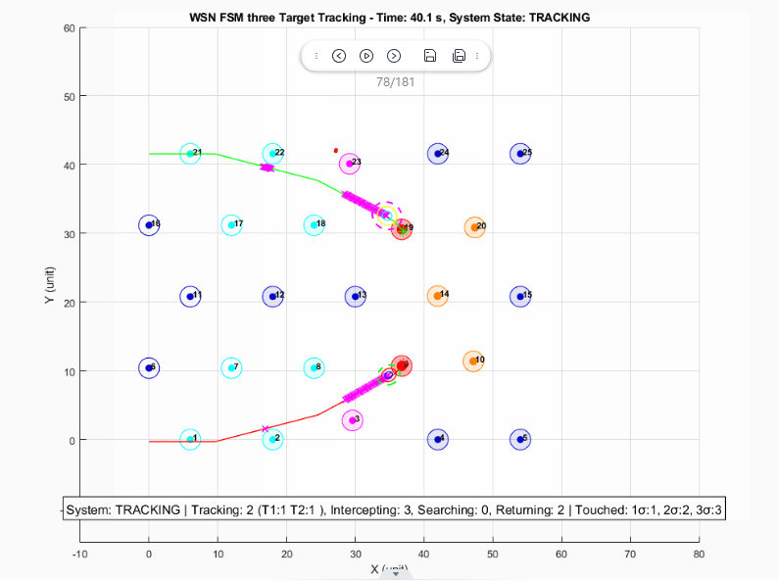
Figure6: t=40.1 for V45 simulation. Target 2 took over sensor 14 from Target 1.

This is an interesting and important observation because the system is a discrete-event system. Although the two targets did not enter PENDING_SELECTION at the exact same timestamp, the later selection by target 2 still created a conflict with the existing interceptor assignment of target 1. Therefore, this case should also be treated as a conflict event.
To address this issue, I added a new conflict-handling mechanism in example_V46_Yeqi.m(V46). In V46, when a target attempts to select an interceptor that is already assigned to another target, the system identifies this as an inter-target interceptor conflict. Instead of allowing the new target to simply take the sensor away, the affected targets are grouped together, and a new round of selection is performed across all of them. In this situation, the MCMF formulation arises naturally: the conflicting targets and their candidate interceptors form a shared assignment problem. By solving this problem in a global scope, the system can determine the minimum-cost combination of interception assignments for both targets, rather than optimizing each target independently. This allows the final interceptor allocation to be globally optimal across the affected group of targets.
Furthermore, when an existing assignment is disrupted, the original target’s interception point may no longer be optimal. Therefore, for Target 1 in this case, the interception point must be recalculated before performing the updated selection. This allows the reassignment process to use the latest target prediction and improves the likelihood of successful interception.

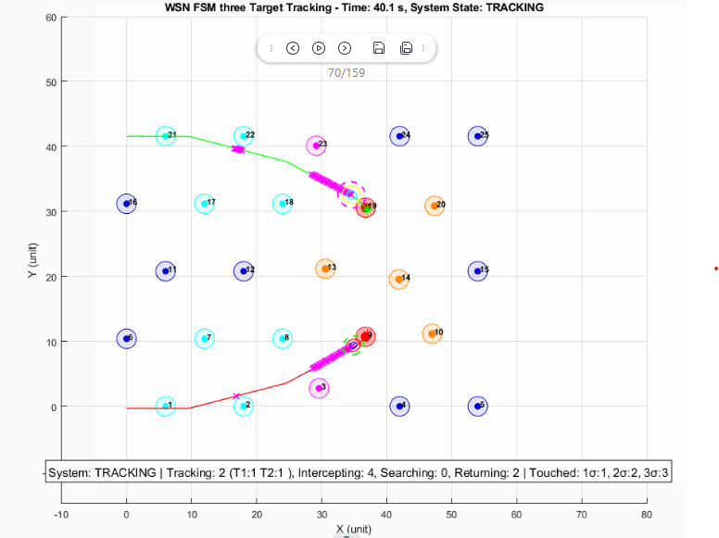
Figure6: t=40.1 for V46 simulation. Target 2 now employes sensor 13 and sensor 20, instead of taking over sensor 14 from Target 1
Figure 7 shows the result after applying the V46 fix. At t = 39.5 s, Target 2 no longer takes Sensor 14 away from Target 1. Instead, the updated global selection assigns Sensor 13 and Sensor 20 to Target 2, while Target 1 retains its assigned interceptors. This confirms that the revised conflict-resolution logic prevents an active interception assignment from being overwritten by a later target selection.

MinMax V.S. MCMF on Interceptor Assignment Conflict

Figure8: Full simulation from V46(example_V46_Yeqi.m)
Figure 8 shows the full simulation result from V46 after introducing the updated conflict-resolution mechanism. At t = 39.5 s, Target 1 and Target 2 trigger an assignment conflict, causing the system to perform a joint reassignment process to find a better global interceptor allocation.

Method | Target | Selected Sensors | Individual Costs | Target Total Cost | Total Cost
MinMax | Target 1 | S14, S18 | 0.193, 0.397 | 0.590 | 1.181
MinMax | Target 2 | S13, S20 | 0.306, 0.285 | 0.591
MCMF | Target 1 | S10, S14 | 0.300, 0.193 | 0.493 | 1.084
MCMF | Target 2 | S13, S20 | 0.306, 0.285 | 0.591
Table 4: Interceptor Assignment Comparison Between MinMax and MCMF
Table 4 summarizes the interceptor assignment results produced by MinMax and MCMF for the conflict event at t = 39.5. Overall, MCMF reduces the total assignment cost from 1.181 to 1.084, showing that it can find a better global assignment in this conflict case compared with MinMax.

Appendix: Source Files in ZIP
Purpose
V46 natural simulation | example_V46_Yeqi.m
Logs | V45-example1.log, V46-example1.log
Helper functions | solveInterceptorAssignments.m, solveInterceptorAssignmentMCMF.m, solveInterceptorAssignmentLegacy.m, buildAssignmentCostMatrixForCallingTargets.m, calculateEnhancedBid.m, getSharedTargetInfo.m, findNearbySensors.m, expandCallingTargetsForJointReselection.m

