Min-Cost Max-Flow Interception Assignment Integration and Validation Report
Yeqi Sang
1. Introduction
Version 46 (V46) replaces the interceptor selection module in the original simulation with a global assignment strategy based on min-cost max-flow (MCMF). To validate this new module in a reliable and interpretable way, the validation process was divided into four stages. s
I separated the assignment algorithm into its own module. First, I tested the algorithm logic by itself using mock sensor data, target data, and bidding costs. Then, I tested whether the same algorithm could work with the current simulation structure.
For the simulation-level test, I used event injection for a short simulation period. This means I set simulation in a short time (8 sec and 30 sec), manually created a specific situation where two targets enter PENDING_SELECTION at the same time. This lets me check whether the system can choose the best overall interceptor combination for both targets globally, instead of selecting interceptors for each target separately.

2. What Was Designed in V46
V46 Design Overview
In V45, interceptor selection was performed inside the simulation through a min-max conflict-resolution strategy based on bidding logic. In V46, a clearer strategy boundary was introduced so that the assignment module could be tested independently from the rest of the simulation.
The main components introduced in V46 are as follows.

2.1 MCMF Solver
In V46, the interceptor selection problem is treated as a global assignment problem between available sensors and targets that request interceptors. When one or more targets enter PENDING_SELECTION, each target requires two interceptor sensors. The algorithm must select sensors for all calling targets at the same time, while ensuring that the same sensor is not assigned to more than one target.
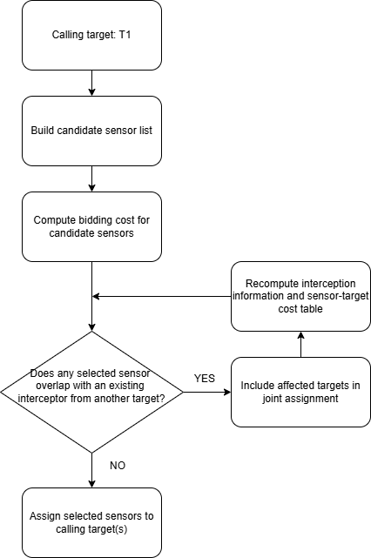
Figure1: Interceptor Assignment Workflow for Multiple Targets

For each calling target, the simulation first predicts an interception point based on the current EKF target estimate and the predicted tracker-loss point. Then for every available candidate sensor, the simulation calculates an bidding cost to that target. The cost represents how suitable the sensor is for that target. A lower cost means the sensor is a better candidate.
The bidding cost is:
$$c\left(i, j\right)=w_{1} P_home(i)+w_{2} P_spatial(i, j)+w_{3} P_temporal(i, j) +w_{4} P_uncertainty(i, j)$$
- $P_home(i)$penalizes the displacement of a sensor from its home location.
- $P_spatial(i, j)$ penalizes the distance from the sensor to the target intercept point.
- $P_temporal(i, j)$ penalizes poor arrival timing relative to the target motion.
- $P_uncertainty(i, j)$ penalizes low shared confidence in the target estimate.
Therefore, when multiple targets request interceptors at the same time, the system builds a sensor-target cost table. Each row represents one available candidate sensor, and each column represents the bidding cost for each target. The value in each cell is the bidding cost of assigning that sensor to that target. A lower cost means that the sensor is more suitable for that target.
Table 1 shows an example with two targets, t1 and t2, and five available candidate sensors: S5, S6, S7, S8, and S9.
Candidate Sensor | Bidding cost for Target 1 | Bidding Cost for Target 2
S5 | 0.219 | 0.193
S6 | 0.285 | 0.377
S7 | 0.306 | 0.304
S8 | 0.362 | 0.306
S9 | 0.377 | 0.300
Table 1: cost matrix for Section 2.1 example
In this example, each target requires two interceptor sensors. Therefore, the system must make four assignments in total: two sensors for t1 and two sensors for t2. These four required interceptor positions can be described as t1 Interceptor 1, t1 Interceptor 2, t2 Interceptor 1, and t2 Interceptor 2.
Each candidate sensor can be selected at most once. Therefore, the algorithm cannot simply choose the two lowest-cost sensors for each target independently, because the same sensor may be selected by more than one target based on the bidding result. Instead, the algorithm evaluates the combined assignment for all requesting targets and selects a non-overlapping set of sensors with the lowest global total bidding cost. Figure 2 illustrates the sensor-target assignment structure for interceptor selection.
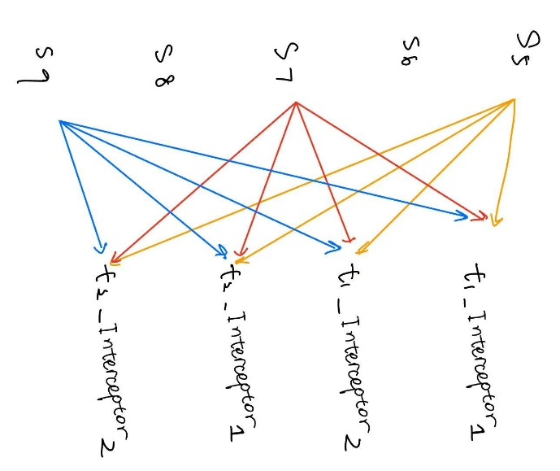
Figure 2. Sensor-target assignment structure for interceptor selection
In this example, s5 has the lowest bidding cost for both t1 and t2. If t1 selects first, it may choose s5 and s6, because these are the two lowest-cost candidates for t1. Then t2 must select from the remaining sensors, such as s7 and s9. This target-by-target assignment gives:
t1: s5 and s6, cost = 0.219 + 0.285 = 0.504
t2: s7 and s9, cost = 0.300 + 0.304 = 0.604
Total cost = 1.108

However, this is not the best global assignment. The global assignment method compares the total cost across both targets and selects a non-overlapping assignment with the lowest combined cost. In this case, it assigns s6 and s7 to t1, and s5 and s9 to t2:
t1: s6 and s7, cost = 0.285 + 0.306 = 0.591
t2: s5 and s9, cost = 0.193 + 0.300 = 0.493
Total cost = 1.084
Therefore, the global assignment reduces the total cost from 1.108 to 1.084 while ensuring that each sensor is assigned to only one target.

2.2 Real-Time Feasibility and Required System Information
Before assignment, the system collects the handover-related information: requesting targets, candidate sensors, current sensor positions, predicted interception points, EKF-based target estimates, and current tracker/interceptor assignments. Each candidate sensor computes one bid cost for each calling target, so the cost-table construction requires M x N bid calculations, where M is the number of candidate sensors and N is the number of calling targets.
The MCMF assignment then selects up to K interceptor sensors per target while ensuring that each candidate sensor is assigned at most once. Therefore, the number of assigned sensors is at most min(M, K x N). The current implementation has the worst-case runtime:
O(min(M, K x N)(M + K x N + 2)^3)
In this simulation, M <= 25, N <= 3, and K = 2. Therefore, the largest case is bounded by:
O(6(25 + 6 + 2)^3) = O(6 x 33^3) ≈ 2.16 x 10^5
The cost table is also small, with at most 25 x 3 = 75 bidding costs. Therefore, the assignment problem is bounded for the current simulation. For larger systems, it can remain practical by limiting the candidate sensor set and keeping the number of required interceptors per target small.
In the decentralized interpretation, the MCMF assignment is coordinated by one temporary node rather than executed by every sensor. Each candidate sensor computes its own bid cost locally and sends this scalar value to the coordinator. The coordinator collects the bids, forms the cost matrix, runs the MCMF assignment, and broadcasts the selected interceptor IDs back to the candidates. The coordinator can be the primary tracker, the sensor with the earliest predicted loss time, or an ongoing interceptor. The measured MCMF runtime is reported in the next section.

2.3 Measurement on Workstation
For the real-time feasibility test, I measured the assignment runtime using the Section 4 simulation on my workstation with a CPU with 4.5GHz. Since the result depends on the hardware, this measurement should be treated as a practical baseline rather than a universal runtime guarantee.
In the simulation, each time step is 0.1 s. At the two-target conflict event at t = 39.50 s, there were 23 candidate sensors and 2 calling targets. The cost-matrix construction took 0.000732 s, and the selected MCMF solver took 0.000522 s. Therefore, the MCMF-only assignment computation took approximately: 0.001254 s. This is only 1.254% of one 0.1 s simulation time step.
The full logged assignment step was larger, 0.046972 s, because the validation version also ran the Min-max solver for A/B comparison. The Min-max solver alone took 0.043506 s. The full assignment step also includes logging output to the file. Therefore, for an MCMF-only deployment, the relevant runtime is the cost-matrix construction plus the MCMF solver time, not the full validation logging block. Based on this measurement, the MCMF assignment completes well within the 0.1 s time-step requirement on this baseline workstation.

2.4 Ideal Processor-Frequency Scaling Estimate
Using my workstation as the baseline, the measured MCMF-only assignment time was 0.001254 s on a CPU operating at approximately 4.5 GHz. This gives an estimated computational cost of:
total_cycles = 0.001254 x 4.5 x 10^9 ≈ 5.64 x 10^6 cycles
If the assignment computation must finish within one 0.1 s simulation time step, then the ideal minimum processor frequency is:
min_frequency_required = total_cycles / 0.1 = 5.64 x 10^6 / 0.1= 56.4 MHz
Based on this ideal frequency-only scaling assumption, the estimated assignment runtime on different processors is shown in Table 2.
Processor frequency | Estimated runtime | Percentage of 0.1s time step
4.5 GHz, baseline workstation | 0.001254 s | 1.254%
1.0 GHz | 0.00564s | 5.64%
600 MHz | 0.00941 s | 9.41%
200 MHz | 0.0282 s | 28.2%
100 MHz | 0.0564 s | 56.4%
56.4 MHz, lower bound | 0.1 s | 100%
Table 2: Ideal Frequency-Scaling Estimate for MCMF-Only Assignment Runtime
This estimate shows that 56.4 MHz is the ideal lower-bound processor frequency for completing the MCMF-only assignment within one 0.1 s time step. However, this only includes computation time and does not include communication delays such as broadcasting the request, collecting bids, and sending the final assignment. Therefore, the real available computation time is much less than 0.1 s. To leave enough margin for communication delay and microcontroller inefficiencies, a processor of at least about 600 MHz is recommended. At 600 MHz, the estimated MCMF-only runtime is 0.00941 s, or 9.41% of one simulation time step.

2.5 Validation with Mock Data
A separate mock test file is created to test the MCMF algorithm outside the full simulation. The mock data includes sensor states, target states and mocked interception points, which have the same structure as the real simulation data. This test checks whether the MCMF solver can correctly use the simulation-style inputs and be integrated into the existing simulation system.

2.6 A/B Switching Between MCMF and Min-max for Validation
The wrapper function solveInterceptorAssignments(...) preserves the original V45 min-max assignment strategy while enabling the new MCMF solver. This provides a fair A/B comparison framework, because both algorithms can be evaluated using the same candidate sensors and the same bidding cost matrix.
The MCMF objective is two-step: it first maximizes the number of assigned interceptor slots, and then minimizes the total assignment cost among solutions with the same number of assigned slots.
3. Validation Strategy and Results
3.1 Stage 1: Unit Test
Stage 1 focuses on validating the MCMF solver itself. 5 unit tests were designed to verify the correctness of the assignment algorithm under controlled cost-matrix inputs. These tests focus only on algorithm-level correctness, such as feasibility, non-duplicate assignment, and behavior under shortage conditions.s,
3.2 Stage 2: Short Simulation Validation
Stage 2 is the first validation stage that runs the MCMF logic inside a real V46-derived simulation loop. Its purpose is to verify that the MCMF path can be applied in the actual simulation environment, rather than only in unit tests.
Stage 2 uses example_v46_stage2_Yeqi.m, which is a dedicated Stage 2 copy of V46 with an event trigger. For example, in an 8-sec simulation scenario, target 1 and target 2 are forced into simultaneous PENDING_SELECTION at timestamp=5.0 , after which the real simulation loop continues normally.
The main setup is summarized below:
- Runtime: 8 s with injection at 5 s for the standard case; an additional 30 s / 15 s case was also tested.
- Manual Event Trigger: target 1 and target 2 enter PENDING_SELECTION.
- Active trackers at injection: target 1$→$ [1, 2], target 2 $→$ [3, 4].
- Cost function: unchanged from the original simulation.
- Impact on normal V46: none, because the manual event trigger is isolated in example_v46_stage2_Yeqi.m rather than the clean example_V46_Yeqi.m.
Scenario | MCMF Assignment | Minmax Assignment | Cost Improvement
8s/5s | T1 [6, 7],  T2 [8, 9],  Cost 1.2443 | T1 [7, 11],  T2 [6, 8],  Cost 1.3038 | 0.0595
30s/15s | T1 [6, 8],  T2 [7, 9],  Cost 1.0341 | T1 [8, 6],  T2 [7, 12]  Cost 1.0968 | 0.0626
Table 3: Comparison of MCMF and Minmax solutions for Interceptor Selection Conflict
Table 3 shows that the MCMF-based assignment strategy is not only algorithmically correct, but also successfully integrated into the V46 simulation framework.
3.3 Stage 3: Full Natural Simulation
Stage 3 runs the clean main script example_V46_Yeqi.m directly. No stage 3 injection file is used.

Figure 3: Simulation Under the Same Configuration as V45, with MCMF Enabled
As Figure 3 shown, MCMF is naturally invoked by the clean full simulation. However, this natural run did not produce simultaneous multi-target selection, so it does not replace the controlled conflict evidence form Stage 1&2, and Stage 3. I may need to find more test cases then.

Figure 4 provides a supplementary 15 s natural simulation case, which was also examined to show that MCMF can operate correctly in a naturally occurring simultaneous two-target assignment event. In this case, target 1 and target 2 naturally entered PENDING_SELECTION at the same time, without any manual injection.
MCMF:
- T1 $→$ [17 21], cost 0.6211
- T2 $→$ [7 11], cost 0.5849
- total 1.2060
Minmax:
- T1 $→$ [11 17], cost 0.5997
- T2 $→$ [7 1], cost 0.6137
- total 1.2133
Although the improvement is small, this remains a useful no-injection example in which MCMF outperformed the minmax strategy.

Figure4: 15 s Simulation with MCMF

4. More Examples. And Improvement.
Figure 5 shows a full simulation from example_V45_V38_b_Yeqi.m (V45), using the original min-max conflict resolution strategy.to solve the conflict. In V45, conflicts are only solved when multiple targets enter the PENDING_SELECTION state at the exact same simulation timestamp.

Figure5: Full simulation from V45(example_V45_V38_b_Yeqi.m)
After observing the simulation more closely, I found an addition conflict case. At t=38.9, target 1 selected sensor 10 and sensor 14 as its interceptors. Sensor 14 was assigned to move toward the predicted interception point for target 1. However, at t=39.5, target 2 also entered the PENDING_SELECTION state. During this later selection process, target 2 selected sensor 20 and took sensor 14 away from target 1, even though sensor 14 was already executing an interception task for target 1. This behavior is shown is Figure 6.
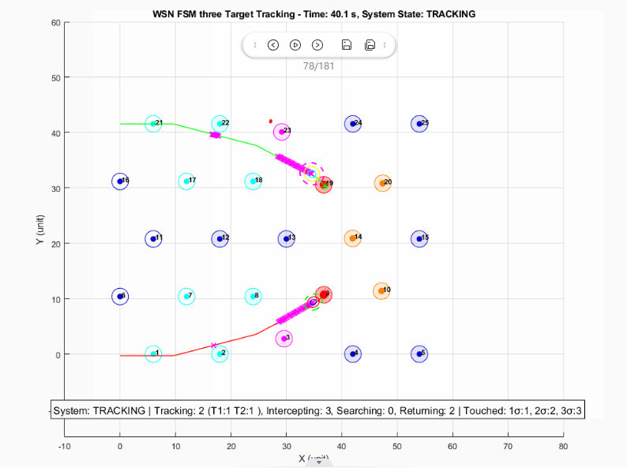
Figure6: t=40.1 for V45 simulation. Target 2 took over sensor 14 from Target 1.
This is an interesting and important observation because the system is a discrete-event system. Although the two targets did not enter PENDING_SELECTION at the exact same timestamp, the later selection by target 2 still created a conflict with the existing interceptor assignment of target 1. Therefore, this case should also be treated as a conflict event.
To address this issue, I added a new conflict-handling mechanism in example_V46_Yeqi.m(V46). In V46, when a target attempts to select an interceptor that is already assigned to another target, the system identifies this as an inter-target interceptor conflict. Instead of allowing the new target to simply take the sensor away, the affected targets are grouped together, and a new round of selection is performed across all of them. In this situation, the MCMF formulation arises naturally: the conflicting targets and their candidate interceptors form a shared assignment problem. By solving this problem in a global scope, the system can determine the minimum-cost combination of interception assignments for both targets, rather than optimizing each target independently. This allows the final interceptor allocation to be globally optimal across the affected group of targets.
Furthermore, when an existing assignment is disrupted, the original target’s interception point may no longer be optimal. Therefore, for Target 1 in this case, the interception point must be recalculated before performing the updated selection. This allows the reassignment process to use the latest target prediction and improves the likelihood of successful interception.

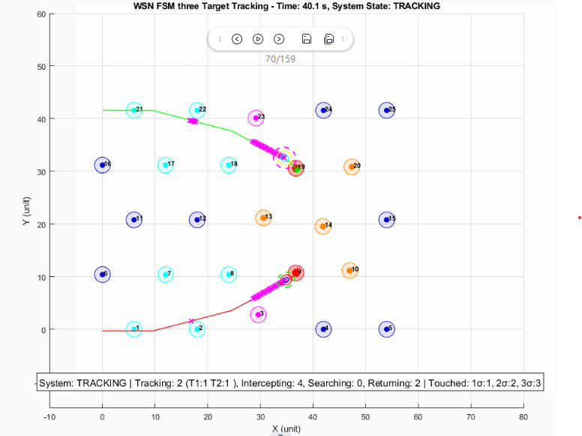
Figure7: t=40.1 for V46 simulation. Target 2 now employes sensor 13 and sensor 20, instead of taking over sensor 14 from Target 1
Figure 7 shows the result after applying the V46 fix. At t = 39.5 s, Target 2 no longer takes Sensor 14 away from Target 1. Instead, the updated global selection assigns Sensor 13 and Sensor 20 to Target 2, while Target 1 retains its assigned interceptors. This confirms that the revised conflict-resolution logic prevents an active interception assignment from being overwritten by a later target selection.

MinMax V.S. MCMF on Interceptor Assignment Conflict

Figure8: Full simulation from V46(example_V46_Yeqi.m)
Figure 8 shows the full simulation result from V46 after introducing the updated conflict-resolution mechanism. At t = 39.5 s, Target 1 and Target 2 trigger an assignment conflict, causing the system to perform a joint reassignment process to find a better global interceptor allocation.

Method | Target | Selected Sensors | Individual Costs | Target Total Cost | Total Cost
MinMax | Target 1 | S14, S18 | 0.193, 0.397 | 0.590 | 1.181
MinMax | Target 2 | S13, S20 | 0.306, 0.285 | 0.591
MCMF | Target 1 | S10, S14 | 0.300, 0.193 | 0.493 | 1.084
MCMF | Target 2 | S13, S20 | 0.306, 0.285 | 0.591
Table 4: Interceptor Assignment Comparison Between MinMax and MCMF
Table 4 summarizes the interceptor assignment results produced by MinMax and MCMF for the conflict event at t = 39.5. Overall, MCMF reduces the total assignment cost from 1.181 to 1.084, showing that it can find a better global assignment in this conflict case compared with MinMax.

Appendix: Source Files in ZIP
Purpose
V46 natural simulation | example_V46_Yeqi.m
Logs | V45-example1.log, V46-example1.log
Helper functions | solveInterceptorAssignments.m, solveInterceptorAssignmentMCMF.m, solveInterceptorAssignmentLegacy.m, buildAssignmentCostMatrixForCallingTargets.m, calculateEnhancedBid.m, getSharedTargetInfo.m, findNearbySensors.m, expandCallingTargetsForJointReselection.m

