Affected-Target Expansion and Lexicographic Interceptor Assignment
for Cooperative Multi-Target Tracking in Mobile WSNs
Yeqi Sang
MIE8888 Final Report

Abstract
This report studies interceptor assignment conflicts in a mobile wireless sensor network (WSN) for cooperative multi-target tracking. In Naeimeh’s previous work [1], interceptor conflicts were resolved through a MinMax objective that attempts to minimize the worst team cost among the targets involved in the same conflict-resolution step. The formulation provides a fairness-oriented baseline, but it does not directly optimize the assignment total cost. In addition, when a later handover request takes over a sensor that has already been committed to another target, the previously served target will lose that committed sensor, thereby reducing its probability of successful interception.
The revised method differs from the previous approach in three ways. First, it expands the affected-target set beyond the current calling targets to include any previously served target whose committed interceptor is taken over by a later handover request. Second, it adopts a lexicographic objective that first maximizes the number of assigned interceptor slots across the affected targets and then minimizes the total assignment cost. Third, it replaces non-overlapping two-sensor team comparison with an event-local optimal sensor-to-target assignment over all affected targets and all eligible candidate sensors. Under ideal communication assumptions in simulation, the resulting formulation retains the distributed execution logic of the original DES framework while providing a different mechanism for resolving interceptor assignment conflicts; the communication requirements and implications for physical-platform implementation are discussed later in the report.

- Introduction
Mobile wireless sensor networks (WSNs) provide a flexible platform for cooperative multi-target tracking because mobile sensors can reposition themselves in response to target motion and local tracking needs. In Naeimeh's previous work [1], this capability was organized through a distributed Discrete Event System (DES) framework in which sensors coordinate proactive handover through local bid computation, handover-request broadcasting, and Finite State Machine (FSM)-based execution. During operation, an active tracker issues a handover request when target loss is predicted, and available candidate sensors participate in an auction-like bidding process to determine which sensors should serve as interceptors. The selected interceptors then move toward the predicted interception region to support tracking continuity before the current tracker loses the target. This distributed handover framework provides the system baseline for the present report.
This report focuses on a narrow but important issue within that framework: interceptor assignment conflict resolution. In the DES framework, interceptor assignment conflicts arise when multiple handover requests compete for the same candidate sensors or when a later handover request attempts to use a sensor already committed to another target. In the previous method, conflicts among handover requests within the same conflict-resolution step were handled through a MinMax objective that attempts to minimize the worst team cost among the involved targets. This formulation provides a fairness-oriented baseline and helps reduce the likelihood that any target receives a poor interceptor configuration. However, because the MinMax objective optimizes the worst-case team cost rather than the total assignment cost, it does not necessarily produce the most efficient overall assignment. In addition, although the previous work already provides a reasonable DES-based mechanism for resolving conflicts that occur within an assignment interval, another limitation remains: a later handover request can reassign a sensor that has already been committed to another target without simultaneously reconsidering the target that loses this interceptor. When that happens, the previously served target loses one of its committed interceptors, which can reduce its probability of successful interception.
The contribution of this report is a reformulation of the interceptor conflict-resolution mechanism together with a corresponding optimal assignment procedure. Compared with the previous MinMax-based method, the revised method differs in three ways. First, it expands the affected-target set beyond the current calling targets to include any previously served target whose committed interceptor is taken over by a later handover request. Second, it adopts a lexicographic objective that first maximizes the number of assigned interceptor slots across the affected targets and then minimizes the total assignment cost. Third, it replaces the previous comparison of non-overlapping two-sensor teams with a constrained sensor-to-target assignment model that jointly enforces the interceptor capacity of each target and the one-target-at-a-time constraint of each sensor. Under ideal communication assumptions in simulation, this revised formulation retains the distributed execution logic of the original DES framework while providing a different mechanism for resolving interceptor assignment conflicts. The communication requirements and implications for physical-platform implementation are discussed later in the report.

- Related Work
Multi-target tracking in wireless sensor networks (WSNs) has evolved from reactive detection-based strategies to predictive and coordinated frameworks. Early approaches primarily relied on passive tracking, where sensors detect targets within range and reacquire them after loss through opportunistic encounters. While simple, such methods may suffer from frequent tracking interruptions when targets move quickly or when sensor coverage is sparse.
To address these limitations, predictive tracking frameworks have been developed to anticipate tracking loss and enable proactive coordination. The DES-based coordination framework proposed in [1] integrates Extended Kalman Filter (EKF)-based loss prediction, guidance-based sensor repositioning, and distributed bidding for sensor allocation. In that framework, sensors operate using a finite-state-machine architecture and transition between tracking and repositioning roles, enabling proactive handover before target loss occurs. This framework provides the baseline system architecture for the present report.
Task allocation in multi-robot and sensor networks is commonly handled through auction-based or bidding-based mechanisms because they allow agents to evaluate task suitability locally. These mechanisms are suitable for distributed systems, but conflicts may arise when multiple targets require support from the same limited set of candidate sensors. Therefore, the assignment objective plays an important role in determining how limited sensor resources are allocated. A MinMax objective provides a fairness-oriented solution by reducing the worst target-level team cost, while total-cost-based objectives prioritize lower combined assignment cost under the same feasibility constraints.
In the DES framework of [1], interceptor conflict resolution is handled using a MinMax objective when multiple targets compete for candidate sensors within the same assignment process. This provides a meaningful fairness-oriented baseline. However, the original formulation mainly addresses conflicts within the active assignment procedure and does not explicitly include the later DES condition in which a new handover request contests a sensor that has already been committed as an interceptor for another target. In this case, the previously served target may be affected even though it is not part of the current calling-target set.
This report builds upon [1] by extending the assignment scope through affected-target expansion. When a committed interceptor is contested by a later handover request, the target that may lose that interceptor is added to the affected-target set before the assignment problem is solved. The report then applies an event-local lexicographic assignment objective over the affected targets and eligible candidate sensors. Unlike the MinMax objective, which emphasizes worst-team-cost fairness, the proposed lexicographic objective first maximizes the number of filled interceptor slots and then minimizes the total assignment cost among feasible assignments with the same number of filled slots.

- System Model and Problem Formulation
3.1 System Model and Assumptions
This section models the interceptor assignment problem. Consider a WSN with N mobile sensors that cooperatively track up to K targets. Each target can be assigned up to two active tracking sensors, and up to $m$ interceptor sensors when a potential target loss is predicted.
Each sensor,$i∈N=\{1,…,N\}$, has a home position, $h_{i}ϵR^{2}$ and a current position $s_{i}\left(t\right)ϵR^{2}$. Each target, k ∈ K$=\{1,…,K\}$, , has state $x_{k}\left(t\right)=[p_{k}\left(t\right), v_{k}\left(t\right)]$, where $p_{k}\left(t\right)$ is the target position and $v_{k}\left(t\right)$ is the target velocity. Sensors have identical capabilities: detection radius $r_{d}$, maximum velocity $v_{s}$ and communication range $r_{c}$. Target detection occurs when $\left\|s_{i}\left(t\right)−p_{k}(t)\right\|≤r_{d}$. Upon detection, sensor $i$ obtains a noisy position measurement of target $k$, $z_{ik}\left(t\right)=p_{k}\left(t\right)+n(t)$ where $n(t)$ is zero-mean measurement noise with covariance $R$.
In the underlying DES framework, proactive handover is triggered when an active tracker predicts that its target may soon be lost. The tracker then broadcasts a handover request to available candidate sensors. The candidate sensors participate in a bidding process, in which each candidate computes a bid metric representing its suitability for the handover task. The selected candidates are assigned as interceptors and are dispatched toward the predicted interception region to support tracking continuity before target loss occurs. Sensors assigned to execute such a handover request are referred to as interceptors in the remainder of this report.
Throughout the report, calling targets are targets that initiate a handover request and enter the interceptor assignment process. Candidate sensors are eligible sensors that may bid for those targets, while active trackers are the sensors currently responsible for direct target tracking and are excluded from interceptor bidding during the event. An assignment event consists of the broadcast, bidding, and selection stages initiated by one or more handover requests.
The system assumptions used in the remainder of the report are as follows: the workspace is planar, sensors are homogeneous, assignments are event-triggered, and each sensor can serve at most one target at a time within the current assignment event. Because different targets may enter the assignment process at different times, a later handover request may compete with sensors that have already been committed to another target. The proposed method addresses this case by expanding the affected-target set before solving the assignment problem.

3.2 Problem Formulation and Bidding Cost Function
When one or more targets issue handover requests, the system defines a set of affected targets and a set of candidate sensors. The affected-target set includes the current calling targets and any previously served targets whose committed interceptors may be reassigned due to the current conflict-resolution event.
For each calling target, one of its active trackers first predicts an interception point based on the current EKF target estimate and the predicted tracker-loss point. This information is then broadcast to the network. Each eligible candidate sensor evaluates a bidding cost for that target. A lower bid indicates that the sensor is a more suitable interceptor candidate.

Following the formulation in [1], the bidding cost is defined as:
$$c\left(i, k\right)=w_{1} P_home(i)+w_{2} P_spatial(i, k)+w_{3} P_temporal(i, k) +w_{4} P_uncertainty(i, k)$$
- $P_home(i)$penalizes the displacement of a sensor from its home location.
- $P_spatial(i, k)$ penalizes the distance from the sensor to the target intercept point.
- $P_temporal(i, k)$ penalizes poor arrival timing relative to the target motion.
- $P_uncertainty(i, k)$ penalizes low shared confidence in the target estimate.
Let $x\left(i, k\right)$ indicate whether sensor $i$ is assigned to target k, then we can have:
$$x\left(i,k\right)= \left\{\begin{aligned}1, if sensor is assigned to target k \\ 0, otherwise\end{aligned}\right.$$
Let $N_{c}$denote the set of candidate sensors and $K_{a}$denote the set of affected targets. First, it maximizes the total number of interceptor slots filled across the affected targets:
$$max\sum_{k∈K_{a}}{\sum_{i∈N_{c}}{x(i, k)}}$$
Then, among all assignments that achieve this maximum value, it minimizes the total assignment cost:
$$min\sum_{k∈K_{a}}{\sum_{i∈N_{c}}{c\left(i,k\right)x(i, k)}}$$
The assignment is subject to the following constraints:
$$\sum_{k∈K_{a}}{x\left(i,k\right)}≤1, ∀ i∈N_{c}$$
$$\sum_{i∈N_{c}}{x(i,k)}≤m, ∀ k∈K_{a}$$
$$x\left(i,k\right)∈\left\{0, 1\right\}, ∀ i∈N_{c}, ∀ k∈K_{a}$$
The first constraint ensures that each candidate sensor can be assigned to at most one target in the current assignment event. The second constraint ensures that each affected target receives no more than its allowed number of interceptors, where $m$is the maximum number of interceptors per target.

- Methodology

  - Conflict Detection and Affected-Target Grouping
The interceptor assignment workflow is activated when an active tracker predicts that a target may soon be lost and initiates a handover request. Within the DES process, a conflict is detected when multiple handover requests compete for one or more of the same candidate sensors. This can occur either because their assignment intervals overlap or because a later handover request attempts to use a sensor that has already been committed to another target.
In [1], conflicts are identified at the event level by checking whether the same candidate sensor appears in more than one active request set. This report extends the conflict condition to include the case where a new handover request attempts to employ a sensor that has already broadcast the commitment message to another target. This extension ensures that the previously served target is also included in the assignment problem when one of its committed interceptors is contested by a later handover request, since losing an interceptor may increase its risk of target loss.
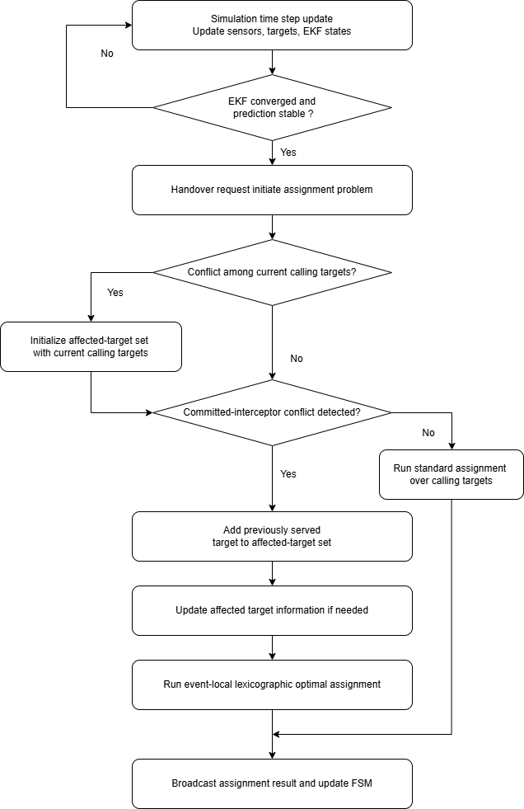
Figure1: Conflict-aware interceptor assignment workflow in the DES framework.
To address this issue, the proposed method introduces an affected-target expansion mechanism. The affected-target set initially consists of the current calling targets in the assignment event. If the conflict involves only these current handover requests, no expansion is needed. The expansion step is triggered only when a committed-interceptor overlap is detected. In that case, the target that may lose its committed interceptor is added to the affected-target set. The resulting affected-target set defines the expanded scope of the assignment problem, which is then solved once so that any target affected by the conflict is considered within the same assignment step.

  - Lexicographic Optimal Assignment
The assignment problem introduced in Section 4.1 involves assigning eligible candidate sensors to interceptor slots of multiple affected targets under capacity constraints. The proposed assignment method enforces that each sensor can be selected at most once within the current assignment event, while each affected target can receive no more than its allowed number of interceptors. The objective is lexicographic: the method first maximizes the number of filled interceptor slots across the affected targets and then minimizes the total assignment cost among all assignments that achieve the same number of filled slots.
Table 1 illustrates a simplified example involving two affected targets, $T_{1}$and $T_{2}$, and five eligible candidate sensors: $S_{10}$, $S_{13}$, $S_{14}$, $S_{18}$, and $S_{20}$. In this example, a later handover request from $T_{2}$ attempts to employ $S_{14}$, while $S_{14}$ has already been committed as an interceptor for $T_{1}$. Following the affected-target grouping mechanism in Section 4.1, both $T_{1}$and $T_{2}$are included in the same assignment problem.

Candidate Sensor | Bidding cost for Target 2 | Bidding Cost for Target 1
$$S_{10}$$ | 0.377 | 0.300
$$S_{13}$$ | 0.306 | 0.304
$$S_{14}$$ | 0.219 | 0.193
$$S_{18}$$ | 0.327 | 0.397
$$S_{20}$$ | 0.285 | 0.377
Table 1: Example bidding-cost matrix for two affected targets.
In this example, each target can receive up to two interceptor sensors. Therefore, the assignment problem can fill up to four interceptor slots in total: two for $T_{1}$and two for $T_{2}$. Each candidate sensor, however, can be assigned to at most one target. The algorithm therefore cannot simply select the two lowest-cost sensors for each target independently, because the same sensor may be preferred by more than one target. Instead, the assignment must be solved jointly over the affected-target set while enforcing non-overlapping sensor use.
Table 2 compares the assignments produced by three different selection rules. The greedy assignment processes the targets sequentially and is therefore order dependent. The MinMax assignment minimizes the worst target-level team cost, which provides a fairness-oriented solution. The proposed lexicographic assignment first fills the maximum feasible number of interceptor slots and then selects the feasible assignment with the lowest total cost.
Algorithm | Target 2 | Target 2 Cost | Target 1 | Target 1 Cost | Total | Worst Team Cost
Greedy [T2, T1] | $$S_{14}, S_{20}$$ | 0.504 | $$S_{10}, S_{13}$$ | 0.604 | 1.108 | 0.604
MinMax | $$S_{13}, S_{20}$$ | 0.591 | $$S_{14}, S_{18}$$ | 0.590 | 1.182 | 0.591
Lexicographic | $$S_{13}, S_{20}$$ | 0.591 | $$S_{10}, S_{14}$$ | 0.493 | 1.085 | 0.591
Table 2: Assignment comparison under greedy, MinMax, and lexicographic assignment methods.
The greedy method assigns $S_{14}$ and $S_{20}$ to $T_{2}$ first, leaving $S_{10}$ and $S_{13}$ for $T_{1}$. This produces a total assignment cost of 1.108. Although this result is feasible, it depends on the order in which targets are processed and does not solve the joint assignment problem optimally.
The MinMax method considers both targets but optimizes a different objective. It selects the assignment that minimizes the worst target-level team cost. In this example, MinMax assigns $S_{13}$ and $S_{20}$ to $T_{2}$, and $S_{14}$ and $S_{18}$ to $T_{1}$, producing a worst team cost of 0.591 and a total cost of 1.181. This reflects the fairness-oriented behavior of the MinMax objective.
The proposed lexicographic assignment selects $S_{13}$ and $S_{20}$ for $T_{2}$, and $S_{10}$ and $S_{14}$ for $T_{1}$. This assignment fills all four interceptor slots and achieves the lowest total cost among the feasible assignments shown in Table 2. Therefore, within the affected-target set and eligible candidate sensors of the current assignment event, the proposed method obtains the total-cost optimal assignment after satisfying the maximum-slot objective.

  - Objective Trade-off Between Fairness and Total Assignment Cost Minimization
The MinMax method and the proposed lexicographic optimal assignment method differ fundamentally in their optimization objectives. The MinMax method minimizes the worst-case target-level team cost, leading to a fairness-oriented assignment that prevents any involved target from receiving a significantly inferior interceptor configuration. This objective is meaningful when balanced tracking support across targets is the primary system priority.
In contrast, the proposed lexicographic assignment method first maximizes the number of filled interceptor slots across the affected targets and then minimizes the total assignment cost among assignments with the same number of filled slots. This objective prioritizes assignment coverage and total assignment cost minimization rather than worst-case fairness. Therefore, the two methods may produce different assignments under the same bidding-cost matrix: MinMax may accept a higher total assignment cost to reduce the worst target-level cost, while the proposed method may accept a less balanced distribution of target-level costs if doing so reduces the total assignment cost after the maximum-slot objective is satisfied. In this report, the lexicographic assignment method is adopted because the goal is to resolve interceptor assignment conflicts by jointly considering all affected targets and enforcing non-overlapping sensor use within the current assignment event.

  - Feasibility as a Distributed System
The proposed lexicographic assignment method preserves the distributed DES architecture by avoiding a permanent coordinator or centralized bid collector. The method changes the assignment rule, but it does not change the sensor-level execution logic of the original framework from [1]. Each sensor still operates according to its own FSM, computes its own bid locally, and updates its own state based on the assignment result. The optimality of the method refers to the event-local assignment problem over the affected targets and eligible candidate sensors, rather than centralized control over the entire WSN.
When an active tracker predicts that interceptor support is required, it broadcasts a handover request. This request is propagated through the communication network, and any non-active-tracking sensor that receives the request before the bidding deadline and satisfies the feasibility conditions is treated as an eligible candidate. Each candidate sensor computes its own bid cost locally according to the same bidding function. Therefore, the proposed method does not require any sensor to compute costs on behalf of other sensors.
After receiving the request, candidate sensors broadcast their bid values during a fixed bidding window, denoted by $Δt_{\text{bid}}$. This window allows bid messages to propagate through the participating sensor group before the selection step is executed. In the simulation, $Δt_{\text{bid}}$ can be set to one DES time step, or to a fraction of a time step, such as half a time step, depending on the desired trade-off between communication completeness and response speed. At the end of the bidding window, each participating sensor reconstructs the same event-local assignment problem using the bid information received before the deadline and applies the same deterministic lexicographic assignment rule. The rule is identical for all participating sensors and enforces the same capacity constraints: each target can receive at most two interceptors, and each sensor can be assigned to at most one target.
Under ideal communication, all participating sensors receive the same bid information before the deadline. In that case, they reconstruct the same assignment problem and obtain the same final assignment without requiring a central sensor to collect bids or broadcast the decision. If a sensor determines from the reconstructed assignment that it has been selected as an interceptor, it transitions to the interceptor state and broadcasts a commitment message indicating that it has accepted the assignment. If the sensor is not selected, it remains idle for later handover requests. In this way, bid computation, assignment reconstruction, commitment, and state transition are all performed locally.
The fixed bidding window also provides a practical mechanism for handling communication delay. Bids that arrive before the selection deadline are included in the assignment calculation, while late bids are excluded from the current assignment event. This deadline-based rule is consistent with the real-time nature of the DES framework. A sensor whose bid cannot reach the participating group before the deadline cannot be safely used for the current handover decision, even if its motion-based bid cost is low. Therefore, communication reachability is treated as part of assignment feasibility. Future implementations may incorporate communication delay or link reliability directly into the bid cost, but in the present formulation this constraint is handled through the bidding deadline.
The total delay of the assignment process includes more than the computation time of the lexicographic assignment rule. It also includes the request propagation time, the bidding window, local assignment computation and commitment broadcast:
$$Δt={Δt}_{\text{request}}+Δt_{\text{bid}}+{Δt}_{\text{local_assignment}}+{Δt}_{\text{commit}}$$
Therefore, real-time feasibility must be evaluated using both computation and communication costs. In the current simulation, the method follows the same ideal communication assumption used in [1], so the assignment results are meaningful for algorithmic comparison. However, deployment on an embedded robotic platform would require measuring or bounding bid propagation delay, packet loss, commitment confirmation time, and the probability of inconsistent assignment reconstruction. Thus, the proposed method remains distributed at the sensor-execution level, but its practical feasibility depends on whether the communication network can support the required bidding and commitment exchange within the DES selection window.

- Simulated Experiments
  - Experimental Setup
The experiments are conducted using the simulation framework developed in [1]. The same discrete-event-system (DES) architecture, sensor models, EKF-based state estimation, bidding-cost formulation, and target motion configurations are adopted to ensure a fair comparison between the original MinMax-based method and the proposed affected-target expansion and lexicographic assignment method. The main difference between the two versions lies in how interceptor assignment conflicts are handled once handover requests compete for the same candidate sensors or when a committed interceptor is contested by a later handover request.
The wireless sensor network consists of 25 mobile sensors arranged in a 5 × 5 hexagonal grid with an inter-node spacing $d=12$ units. Sensors have a fixed detection range $r_{d}=1.5$ units, communication range $r_{c}=18$ units, which enables each sensor to coordinate with first and second-tier neighbors. The hexagonal geometry provides efficient coverage while maintaining structured communication patterns for distributed coordination.
Because the sensor behaviors, target motion, EKF settings, and bidding-cost computation are kept the same in all experiments, any differences in the assignment outcomes arise from the assignment strategy itself: the original MinMax-based conflict-resolution method versus the proposed method that expands the affected-target set and solves the resulting assignment problem using a lexicographic objective. Sections 5.2 and 5.3 use a two-target scenario to demonstrate the committed-interceptor conflict and the effect of affected-target expansion, while Section 5.4 uses a three-target example to compare the assignment-cost outcomes under MinMax and the proposed lexicographic assignment method.

  - Committed-Interceptor Conflict in the Baseline Method
A two-target scenario is first used to illustrate the committed-interceptor conflict in the baseline method. This example focuses on the case where a later handover request affects an existing interceptor assignment that was already committed to another target.
At $t=39.2$s, Target 1 selected $S_{10}$ and $S_{14}$ as its interceptors. $S_{14}$ was therefore committed to Target 1 and started moving toward the predicted interception region for Target 1, as shown in Figure 3.
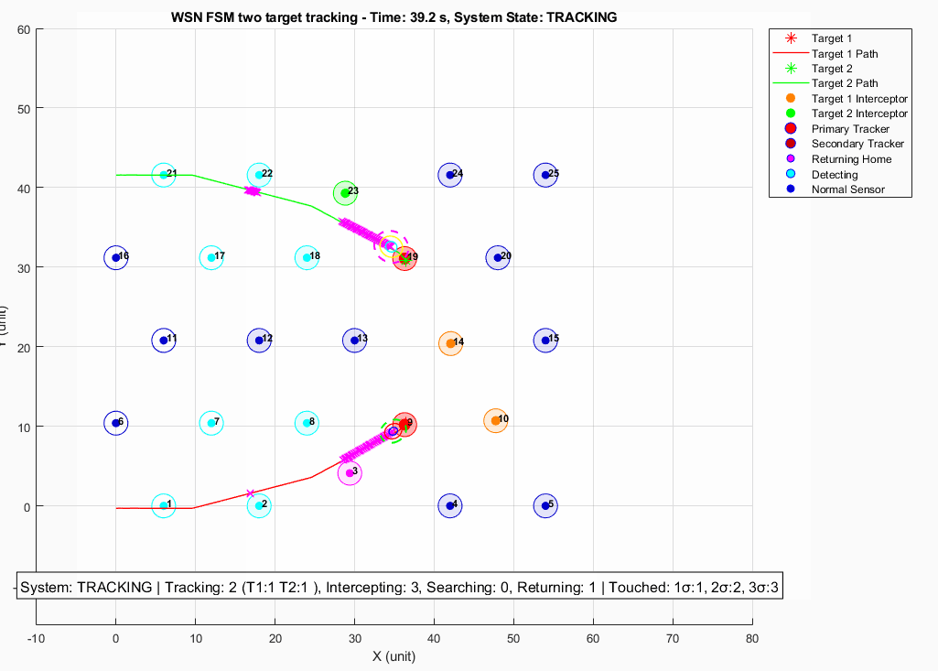
Figure2: Baseline snapshot t=39.4s, $S_{10}$and $S_{14}$ are committed to Target 1.

However, at $t=40.0$s, Target 2 entered the selection stage after issuing a later handover request. During this selection, Target 2 selected $S_{20}$ and $S_{14}$. Since $S_{14}$ had already been committed to Target 1, this created a committed-interceptor conflict. As shown in Figure 2, Target 2 took over $S_{14}$, and Target 1 lost one of its committed interceptors.
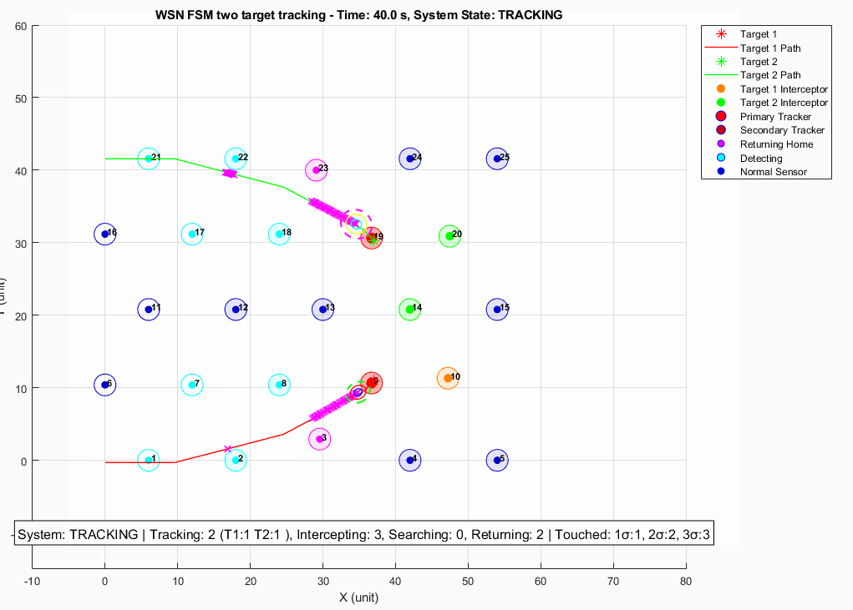
Figure3: Baseline V45 snapshot at t=40.0s, Target 2 takes over $S_{14}$ from Target 1.
This case shows that the baseline method does not include the previously served target in the assignment problem when one of its committed interceptors is contested by a later handover request. Although Target 1 and Target 2 were not handled within the same assignment procedure, the later handover request from Target 2 still affected the existing interceptor assignment of Target 1. This motivates the affected-target expansion mechanism introduced in Section 4.1.

  - Effect of Affected-Target Expansion
The proposed method addresses the committed-interceptor conflict by expanding the affected-target set before solving the assignment problem. When the later handover request from Target 2 attempts to use $S_{14}$, the system detects that $S_{14}$ has already been committed to Target 1. Therefore, Target 1 is added to the affected-target set together with the current calling target, Target 2.
The assignment problem is then solved once over the expanded affected-target set and the eligible candidate sensors. This prevents the later handover request from directly overwriting the existing interceptor assignment of Target 1. Instead, both targets are considered within the same assignment step, and the lexicographic assignment rule selects a feasible non-overlapping sensor allocation.
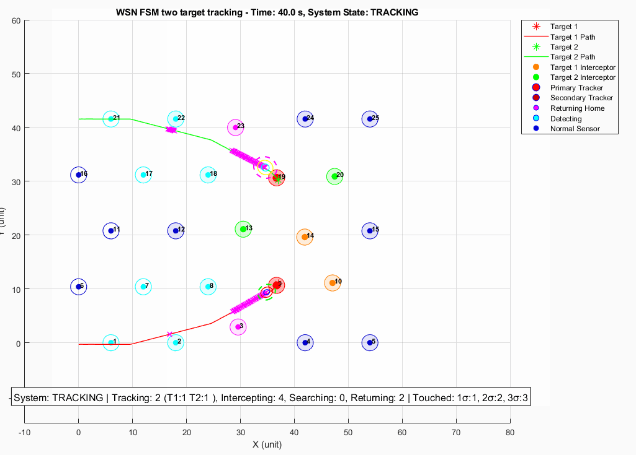
Figure 4: Proposed affected-target expansion at $t=40.0$s.
Figure 4 shows the result after applying the proposed affected-target expansion mechanism. Target 2 no longer takes $S_{14}$ away from Target 1. Instead, Target 2 selects $S_{13}$ and $S_{20}$, while Target 1 retains $S_{14}$ as one of its committed interceptors. This confirms that the proposed method includes the previously served target in the assignment problem when its committed interceptor is contested by a later handover request.

  - Effect of Affected-Target Expansion and Assignment Objective in a Three-Target Event
This section uses a three-target event to separate two effects: affected-target expansion and assignment-objective selection. The original MinMax-based method without affected-target expansion is discussed as a scope limitation, because it would not form the full [$T_{3}$, $T_{2}$, $T_{1}$] assignment problem as a single event-level instance. Therefore, the event-level cost comparison is made only between methods that use the same expanded affected-target set: MinMax with affected-target expansion and the proposed lexicographic assignment with affected-target expansion.
Figure 5 illustrates the three-target affected-target expansion event. Target 3 first issues a handover request. During the assignment process, $S_{20}$ is found to have already been committed to Target 2, so Target 2 is added to the affected-target set. A further committed-interceptor overlap occurs when the assignment process involving Target 2 includes $S_{13}$, which has already been committed to Target 1. As a result, the assignment scope expands from a single calling target to the three-target affected-target set [$T_{3}$, $T_{2}$, $T_{1}$]. This example shows that affected-target expansion prevents previously served targets from being excluded when their committed interceptors are contested by later handover requests.
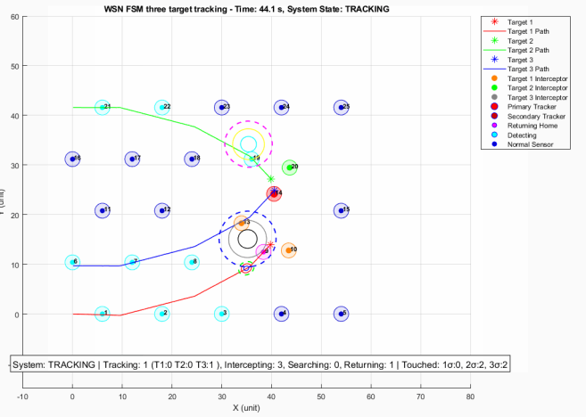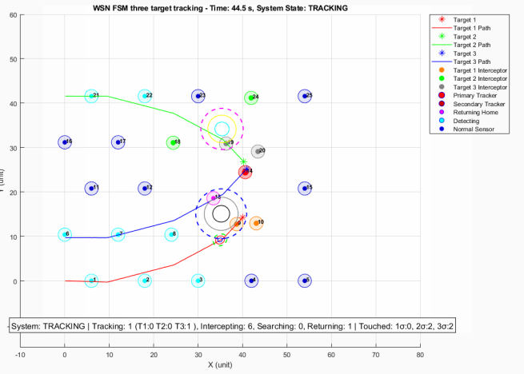
Figure5: Three-target affected-target expansion event at $t=44.2$s.
Once the affected-target set is fixed, MinMax and the proposed lexicographic assignment differ only in their assignment objective. MinMax prioritizes the worst target-level team cost, while the proposed lexicographic assignment first maximizes the number of filled interceptor slots and then minimizes the total assignment cost.

Method | Target 3 assignment (team cost) | Target 2 assignment (team cost) | Target 1 assignment (team cost) | Worst team cost | Total Cost
MinMax with affected-target expansion | $S_{19}$, $S_{20}$ (0.57317) | $S_{18}$, $S_{24}$ (0.67203) | $S_{9}$, $S_{10}$ (0.22667) | 0.67203 | 1.47187
Lexicographic assignment with affected-target expansion | $S_{13}$, $S_{15}$ (0.64247) | $S_{19}$, $S_{20}$ (0.46429) | $S_{9}$, $S_{10}$ (0.22667) | 0.64247 | 1.33343
Table 3: Assignment comparison for the three-target affected set.
Table 3 shows that both methods fill all six requested interceptor slots, but the lexicographic assignment achieves a lower total assignment cost, reducing the cost from 1.47187 to 1.33343. This result supports the event-level objective defined in this report: after the maximum-slot objective is satisfied, the lexicographic method selects the feasible non-overlapping assignment with the lowest total cost.
To complement the event-level comparison, the total tracked target time is also recorded over the full simulation. This metric is reported in target-seconds, where one target-second represents one target being successfully tracked for one second.
Method | T1 tracked time | T2 tracked time | T3 tracked time | Total tracked time ratio
MinMax with affected-target expansion | 27.40 / 75.00 s | 25.20 / 71.00 s | 17.30 / 68.50 s | 32.59%
Lexicographic assignment with affected-target expansion | 39.00 / 75.00 s | 14.70 / 71.00 s | 14.80 / 68.50 s | 31.94%
Table 4: Full-simulation tracked-target time comparison for the three-target example.
Table 4 provides a complementary observation rather than the primary event-level comparison. In this simulation seed, the lexicographic assignment produces a slightly lower total tracked-time ratio than the MinMax variant, 31.94% compared with 32.59%. The per-target results also show that the lexicographic objective shifts more tracking time toward Target 1, while Target 2 and Target 3 receive less tracked time than under MinMax. This does not contradict the event-level assignment result, because full-simulation tracking time depends on later target motion, subsequent handover timing, future conflicts, and downstream effects of earlier assignment decisions.
Overall, this example shows that affected-target expansion and assignment-objective selection should be understood separately. Affected-target expansion determines which targets are included in the assignment problem, while the choice between MinMax and lexicographic assignment determines how the system prioritizes balanced target-level support versus lower event-level total assignment cost.

- Conclusion and Future Work
This report studied interceptor assignment conflicts in a mobile WSN for cooperative multi-target tracking. Building on the DES-based proactive handover framework in [1], the report focused on the case where a later handover request contests a sensor that has already been committed as an interceptor for another target. To address this issue, the proposed method expands the affected-target set beyond the current calling targets so that any previously served target whose committed interceptor is contested is also included in the assignment problem. The resulting assignment is solved using a lexicographic objective that first maximizes the number of filled interceptor slots and then minimizes the total assignment cost. Simulation examples show that affected-target expansion prevents previously served targets from being excluded during committed-interceptor conflicts, while the lexicographic assignment achieves lower event-level total assignment cost than MinMax in the examined three-target event. The results also show that MinMax remains a meaningful fairness-oriented baseline, while the proposed lexicographic method prioritizes event-level total assignment cost minimization.

Future work should evaluate the proposed method under more realistic communication and hardware constraints. The current simulation assumes ideal communication, but physical deployment would require measuring bid propagation delay, packet loss, commitment confirmation time, and the possibility of inconsistent assignment reconstruction among sensors. In addition, the simulation results suggest that lower event-level assignment cost does not necessarily guarantee better aggregate tracked-target time in every seed. Future work should therefore investigate adaptive objective selection, where the system can switch between MinMax and lexicographic assignment depending on target priority, uncertainty level, fairness requirements, or long-horizon tracking performance. More simulation seeds and more diverse multi-target trajectories should also be tested to evaluate the robustness of affected-target expansion under different conflict patterns.

- References
[1] N. Najafizadeh Sari, Y. Sang, G. Nejat, and B. Benhabib, “Reconfigurable Wireless Sensor Network Coordination for Simultaneous Multi-Target Tracking”
8. Appendix:
The appendix includes the main simulation script and representative log files used for the affected-target expansion experiments.
- Example_V47_Yeqi.m — main simulation script for the V47 affected-target expansion experiment.
- example2-affected-group-lexicographic.log — log file for the affected-target expansion experiment using the lexicographic assignment objective.
- example2-affected-group-minmax.log — log file for the affected-target expansion experiment using the MinMax assignment objective.

