Expanded Joint Interceptor Assignment for Cooperative Multi-Target Tracking
Yeqi Sang
MIE8888 Final Report

Abstract
This report studies interceptor assignment conflicts in a mobile wireless sensor network (WSN) for cooperative multi-target tracking. In [1], interceptor conflicts were resolved through a MinMax objective that attempts to minimize the worst team cost among the targets involved in the same conflict-resolution step. This formulation provides a fairness-oriented baseline, but it does not directly optimize the total assignment cost. In addition, when a later handover request takes over a sensor that has already been committed to another target, the previously served target may lose that committed sensor, thereby reducing its probability of successful interception.

In this report, the proposed method is referred to as an expanded joint assignment approach. Here, “expanded” means that the joint assignment scope includes not only the current calling targets, but also any previously served target whose committed interceptor is contested by a later handover request. The method differs from the previous approach in three ways. First, it includes both the current calling targets and the previously served targets whose committed interceptors are contested in the same joint assignment problem. Second, it uses a two-stage assignment objective that first maximizes the number of filled interceptor slots and then minimizes the total sensor-to-target assignment cost among assignments with the same number of filled slots. Third, it replaces non-overlapping candidate team comparison with an event-local sensor-to-target assignment over all involved targets and eligible candidate sensors. Under ideal communication assumptions in simulation, the resulting formulation retains the distributed execution logic of the original DES framework while providing a different mechanism for resolving interceptor assignment conflicts. The communication requirements and implications for physical-platform implementation are discussed later in the report.

- Introduction
Mobile wireless sensor networks (WSNs) provide a flexible platform for cooperative multi-target tracking because mobile sensors can reposition themselves in response to target motion and local tracking needs. In [1], this capability was organized through a distributed Discrete Event System (DES) framework in which sensors coordinate proactive handover through local bid computation, handover-request broadcasting, and Finite State Machine (FSM)-based execution. During operation, an active tracker issues a handover request when target loss is predicted, and available candidate sensors participate in an auction-like bidding process to determine which sensors should serve as interceptors. The selected interceptors then move toward the predicted interception region to support tracking continuity before the current tracker loses the target. This distributed handover framework provides the system baseline for the present report.

This report focuses on a narrow but important issue within that framework: interceptor assignment conflict resolution. In the DES framework, interceptor assignment conflicts arise when multiple handover requests compete for the same candidate sensors or when a later handover request attempts to use a sensor already committed to another target. In the previous method, conflicts among handover requests within the same conflict-resolution step were handled through a MinMax objective that attempts to minimize the worst team cost among the involved targets. This formulation provides a fairness-oriented baseline and helps reduce the likelihood that any target receives a poor interceptor configuration. However, because the MinMax objective optimizes the worst-case team cost rather than the total assignment cost, it does not necessarily produce the most efficient overall assignment. In addition, although the previous work already provides a reasonable DES-based mechanism for resolving conflicts that occur within an assignment interval, another limitation remains: a later handover request can reassign a sensor that has already been committed to another target without simultaneously reconsidering the target that loses this interceptor. When that happens, the previously served target loses one of its committed interceptors, which can reduce its probability of successful interception.

This report formulates committed-interceptor conflict resolution as an expanded joint assignment problem. Compared with the previous MinMax-based method, the proposed approach differs in three main ways. First, it expands the joint assignment scope beyond the current calling targets by including any previously served target whose committed interceptor is contested by a later handover request. Second, it adopts a two-stage assignment objective that first maximizes the number of filled interceptor slots across the involved targets and then minimizes the total assignment cost among assignments that achieve the same number of filled slots. Third, it replaces the previous comparison of non-overlapping candidate teams with a constrained sensor-to-target assignment model that jointly enforces each target’s interceptor capacity and each sensor’s one-target-at-a-time constraint. Under ideal communication assumptions in simulation, this revised formulation preserves the distributed execution logic of the original DES framework while providing a different mechanism for resolving committed-interceptor conflicts. The communication requirements and implications for physical-platform implementation are discussed later in the report.

- Related Work
Mobile wireless sensor networks (WSNs) have been widely studied for cooperative target tracking because distributed mobile sensors can jointly observe moving targets over a shared workspace [2]–[4]. Compared with single-sensor tracking, distributed sensing can improve coverage and robustness. However, maintaining continuous observation remains difficult when sensors have limited sensing range, mobility, and communication capability. Tracking interruptions are especially likely when targets move faster than the sensors or traverse sparsely covered regions, where reactive handover strategies depend on reacquisition only after target loss rather than preparation before loss [5].

To reduce such interruptions, prior work has incorporated motion prediction and adaptive coordination into target tracking. Prediction-based methods have been used to anticipate target motion in local areas [6], while coordinated and adaptive information collection has been proposed to improve network-level tracking performance [7]. Related work on resilient active target tracking [8] and distributed multi-target tracking in heterogeneous mobile sensing networks [9] further demonstrates the value of cooperation, prediction, and distributed estimation. Nevertheless, these studies mainly emphasize estimation accuracy, sensing coverage, resilience, or data association, rather than explicitly determining when a current tracker is likely to lose a target and how another mobile sensor should be repositioned in advance to preserve tracking continuity.

The work most closely related to this report is the DES/FSM-based proactive handover framework in [1]. In that framework, each sensor follows a finite-state-machine architecture and uses EKF-based prediction to anticipate potential target loss. Once a handover is triggered, candidate interceptor sensors are guided toward predicted handover points and selected through a distributed bidding process that accounts for network preservation, spatial proximity, temporal feasibility, and estimation uncertainty. This framework provides the baseline system architecture for the present study.

Interceptor selection is also closely related to distributed task allocation, since candidate sensors must choose among competing support tasks. Auction-based and bidding-based approaches are widely used in multi-robot systems because agents can evaluate task suitability using local information. Representative examples include group-based distributed auction algorithms with conflict resolution and time-window constraints [10], resource-oriented decentralized auction methods under energy and communication limits [11], and consensus-based bundle approaches for distributed coordination [12]. These studies support the use of distributed bidding in sensor networks. However, they do not directly address proactive interceptor reassignment when multiple targets compete for the same limited set of mobile sensors.

In the baseline framework [1], conflicts among simultaneous handover requests are resolved using a MinMax objective that selects non-overlapping interceptor teams by minimizing the maximum target-level team cost. This objective promotes fairness across the targets involved in the same handover cycle. The problem considered in this report is different: a new handover request may contest a sensor that has already been committed as an interceptor for another target. As a result, a target outside the current request set may lose previously allocated support. Accordingly, this report expands the assignment scope to include both the currently calling targets and any previously supported target whose committed interceptor is contested. The resulting assignment problem is then addressed with a two-stage objective that first maximizes the number of filled interceptor slots and then minimizes total assignment cost among assignments with the same number of filled slots.

- System Model and Problem Formulation
3.1 System Model and Assumptions
This section models the interceptor assignment problem. Consider a WSN with N mobile sensors that cooperatively track up to $K$ targets. Each target can be assigned up to two active tracking sensors, and up to $m=2$ interceptor sensors when a potential target loss is predicted.

Each sensor, $i∈N=\{1,…,N\}$, has a home position, $h_{i} ϵ{ R}^{2}$ and a current position $s_{i}\left(t\right) ϵ R^{2}$. Each target, $k∈ K=\{1,…,K\}$, has state $x_{k}\left(t\right)=[p_{k}\left(t\right), v_{k}\left(t\right)]$, where $p_{k}\left(t\right)$ is the target position and $v_{k}\left(t\right)$ is the target velocity. Sensors have identical capabilities: detection radius $r_{d}$, maximum velocity $v_{s}$ and communication range $r_{c}$. Target detection occurs when $\left\|s_{i}\left(t\right)-p_{k}(t)\right\|≤r_{d}$. Upon detection, sensor $i$ obtains a noisy position measurement of target $k$, $z_{ik}\left(t\right)=p_{k}\left(t\right)+n(t)$ where $n(t)$ is zero-mean measurement noise with covariance $R$.

In the underlying DES framework, proactive handover is triggered when an active tracker predicts that its target may soon be lost. The tracker then broadcasts a handover request to available candidate sensors. The candidate sensors participate in a bidding process, in which each candidate computes a bid metric representing its suitability for the handover task. The selected candidates are assigned as interceptors and are dispatched toward the predicted interception region to support tracking continuity before target loss occurs. Sensors assigned to execute such a handover request are referred to as interceptors in the remainder of this report.

Throughout the report, calling targets are targets that initiate a handover request and enter the interceptor assignment process. Candidate sensors are eligible sensors that may bid for those targets, while active trackers are the sensors currently responsible for direct target tracking and are excluded from interceptor bidding during the event. An assignment event consists of the broadcast, bidding, and selection stages initiated by one or more handover requests.
The system assumptions used in the remainder of the report follow [1]: the workspace is planar, sensors are homogeneous, assignments are event-triggered, and each sensor can serve at most one target at a time within the current assignment event. Because different targets may enter the assignment process at different times, a later handover request may compete with sensors that have already been committed to another target. The proposed method addresses this case by expanding the joint assignment scope before solving the assignment problem.

3.2 Problem Formulation and Bidding Cost Function
When one or more targets issue handover requests, the system defines the set of targets included in the expanded joint assignment and the set of candidate sensors. The target set includes the current calling targets and any previously served targets whose committed interceptors may be reassigned due to the current conflict-resolution event.

For each calling target, one of its active trackers first predicts an interception point based on the current EKF target estimate and the predicted tracker-loss point. This information is then broadcast to the network. Each eligible candidate sensor evaluates a bidding cost for that target. A lower bid indicates that the sensor is a more suitable interceptor candidate.

Following the formulation in [1], the bidding cost is defined as:
$$c\left(i, k\right)=w_{1} P_home(i)+w_{2} P_spatial(i, k)+w_{3} P_temporal(i, k) +w_{4} P_uncertainty(i, k)$$
- $P_home(i)$penalizes the displacement of a sensor from its home location.
- $P_spatial(i, k)$ penalizes the distance from the sensor to the target intercept point.
- $P_temporal(i, k)$ penalizes poor arrival timing relative to the target motion.
- $P_uncertainty(i, k)$ penalizes low shared confidence in the target estimate.

Let $x\left(i, k\right)$ indicate whether sensor $i$ is assigned to target k, then we can have:

$$x\left(i,k\right)= \left\{\begin{aligned}1, if sensor is assigned to target k \\ 0, otherwise\end{aligned}\right.$$

Let $N_{c}$ denote the set of candidate sensors and $K_{a}$ denote the set of involved targets in the expanded joint assignment. The proposed two-stage objective is defined as follows. The first stage maximizes the total number of interceptor slots filled across the targets in the assignment scope:
$$max\sum_{k∈K_{a}}{\sum_{i∈N_{c}}{x(i, k)}}$$

The second stage then minimizes the total assignment cost over all feasible assignments that achieve the maximum number of filled slots from the first stage.:

$$min\sum_{k∈K_{a}}{\sum_{i∈N_{c}}{c\left(i,k\right)x(i, k)}}$$

The assignment is subject to the following constraints:

$$\sum_{k∈K_{a}}{x(i, k)≤1}, ∀i∈N_{c}$$

$$\sum_{i∈N_{c}}{x(i, k)≤m}, ∀ k∈K_{a}$$

$$x\left(i,k\right)∈\left\{0, 1\right\}, ∀ i∈N_{c}, ∀ k∈K_{a}$$

The first constraint ensures that each candidate sensor can be assigned to at most one target in the current assignment event. The second constraint ensures that each involved target receives no more than its allowed number of interceptors, where $m$is the maximum number of interceptors per target.

- Methodology
  - Conflict Detection and Expanded Joint Assignment Scope
The interceptor assignment workflow is activated when an active tracker predicts that a target may soon be lost and initiates a handover request. Within the DES process, a conflict is detected when multiple handover requests compete for one or more of the same candidate sensors. This can occur either because their assignment intervals overlap or because a later handover request attempts to use a sensor that has already been committed to another target.

In [1], conflicts are identified at the event level by checking whether the same candidate sensor appears in more than one active request set. This report extends the conflict condition to include the case where a new handover request attempts to employ a sensor that has already broadcast the commitment message to another target. This extension ensures that the previously served target is also included in the expanded joint assignment problem when one of its committed interceptors is contested by a later handover request, since losing an interceptor may increase its risk of target loss.
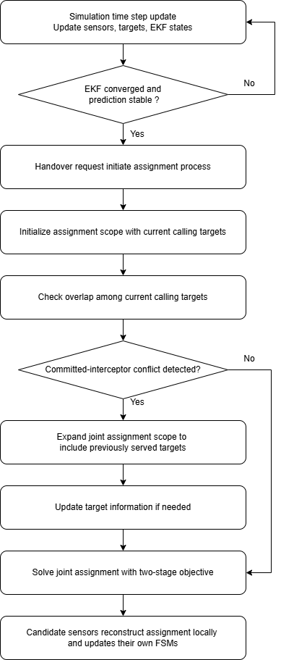
Figure 1: Joint interceptor assignment workflow in the DES framework.

Figure 1 summarizes the proposed interceptor-assignment workflow. To address this issue, the proposed method expands the joint assignment scope when necessary. The joint assignment scope initially consists of the current calling targets in the assignment event. If the conflict involves only these current handover requests, no further scope expansion is needed. The scope is expanded only when a committed-interceptor overlap is detected. In that case, the target that may lose its committed interceptor is added to the joint assignment problem. The assignment problem is then solved once over the expanded joint assignment scope, so that any target whose committed interceptor is contested is considered within the same assignment step.

  - Two-Stage Assignment Objective
The assignment problem introduced in Section 4.1 assigns eligible candidate sensors to interceptor slots for multiple involved targets under capacity constraints. The proposed method ensures that each sensor can be assigned to at most one target within the current assignment event, while each involved target receives no more than its allowed number of interceptors. The method uses a two-stage assignment objective: it first maximizes the number of filled interceptor slots across the involved targets and then minimizes the total assignment cost among assignments with the same number of filled slots.
Table 1 illustrates a simplified example based on the committed-interceptor conflict snapshot shown in Figure 4 in Section 5.3 at t=40.0 s, involving two targets, $T_{1}$and $T_{2}$, and five eligible candidate sensors: $S_{10}$, $S_{13}$, $S_{14}$, $S_{18}$, and $S_{20}$. In this example, a later handover request from $T_{2}$ attempts to employ $S_{14}$, while $S_{14}$ has already been committed as an interceptor for $T_{1}$. Following the expanded joint assignment defined in Section 4.1, both $T_{1}$and $T_{2}$are included in the same assignment problem.

Candidate Sensor | Bidding Cost for Target 2 | Bidding Cost for Target 1
$$S_{10}$$ | 0.377 | 0.300
$$S_{13}$$ | 0.306 | 0.304
$$S_{14}$$ | 0.219 | 0.193
$$S_{18}$$ | 0.327 | 0.397
$$S_{20}$$ | 0.285 | 0.377
Table 1: Example bidding-cost matrix for two targets.

In this example, each target can receive up to two interceptor sensors. Therefore, the assignment problem can fill up to four interceptor slots in total: two for $T_{1}$and two for $T_{2}$. Each candidate sensor, however, can be assigned to at most one target. The algorithm therefore cannot simply select the two lowest-cost sensors for each target independently, because the same sensor may be preferred by more than one target. Instead, the assignment must be solved jointly over the involved targets while enforcing non-overlapping sensor use.

Table 2 compares the assignments produced by three different selection rules. The greedy assignment processes the targets sequentially and is therefore order dependent. The MinMax assignment minimizes the worst target-level team cost, which provides a fairness-oriented solution. The proposed two-stage assignment objective first fills the maximum feasible number of interceptor slots and then selects the feasible assignment with the lowest total cost.

Algorithm | Target 2 | Target 2 Cost | Target 1 | Target 1 Cost | Total | Worst Team Cost
Greedy [T2, T1] | $$S_{14}, S_{20}$$ | 0.504 | $$S_{10}, S_{13}$$ | 0.604 | 1.108 | 0.604
MinMax | $$S_{13}, S_{20}$$ | 0.591 | $$S_{14}, S_{18}$$ | 0.590 | 1.182 | 0.591
Two-Stage | $$S_{13}, S_{20}$$ | 0.591 | $$S_{10}, S_{14}$$ | 0.493 | 1.085 | 0.591
Table 2: Assignment comparison under greedy, MinMax, and two-stage assignment methods.

The greedy method assigns $S_{14}$ and $S_{20}$ to $T_{2}$ first, leaving $S_{10}$ and $S_{13}$ for $T_{1}$. This produces a total assignment cost of 1.108. Although this result is feasible, it depends on the order in which targets are processed and does not solve the joint assignment problem optimally.

The MinMax method considers both targets but optimizes a different objective. It selects the assignment that minimizes the worst target-level team cost. In this example, MinMax assigns $S_{13}$ and $S_{20}$ to $T_{2}$, and $S_{14}$ and $S_{18}$ to $T_{1}$, producing a worst team cost of 0.591 and a total cost of 1.181. This reflects the fairness-oriented behavior of the MinMax objective.

The proposed two-stage method selects $S_{13}$ and $S_{20}$ for $T_{2}$, and $S_{10}$ and $S_{14}$ for $T_{1}$. This assignment fills all four interceptor slots and achieves the lowest total cost among the feasible assignments shown in Table 2. Therefore, within the involved targets and eligible candidate sensors of the current assignment event, the proposed method obtains the total-cost optimal assignment after satisfying the maximum-slot objective.

  - Objective Trade-off Between Fairness and Total Assignment Cost Minimization
The MinMax method and the proposed two-stage assignment method differ fundamentally in their optimization objectives. The MinMax method minimizes the worst-case target-level team cost, leading to a fairness-oriented assignment that helps prevent any involved target from receiving a significantly inferior interceptor configuration. This objective is meaningful when balanced tracking support across targets is the primary system priority.

In contrast, the proposed two-stage assignment method first maximizes the number of filled interceptor slots across the involved targets and then minimizes the total assignment cost while preserving the maximum number of filled interceptor slots obtained in the first stage. This objective prioritizes assignment coverage and total assignment cost minimization rather than worst-case fairness. Therefore, the two methods may produce different assignments under the same bidding-cost matrix: MinMax may accept a higher total assignment cost to reduce the worst target-level cost, while the proposed method may accept a less balanced distribution of target-level costs if doing so reduces the total assignment cost after the filled-slot maximization step is satisfied. In this report, the two-stage assignment method is adopted because the goal is to resolve interceptor assignment conflicts by jointly considering all targets included in the expanded joint assignment and enforcing non-overlapping sensor use within the current assignment event.

  - Feasibility as a Distributed System
The proposed two-stage assignment method preserves the distributed DES architecture by avoiding a coordinator or centralized bid collector. The method changes the assignment rule, but it does not change the sensor-level execution logic of the original framework from [1]. Each sensor still operates according to its own FSM, computes its own bid locally, and updates its own state based on the assignment result. The optimality of the method refers to the event-local assignment problem over the involved targets and eligible candidate sensors, rather than centralized control over the entire WSN.

When an active tracker predicts that interceptor support is required, it broadcasts a handover request. This request is propagated through the communication network, and any non-active-tracking sensor that receives the request before the bidding deadline and satisfies the feasibility conditions is treated as an eligible candidate. Each candidate sensor computes its own bid cost locally according to the same bidding function. Therefore, the proposed method does not require any sensor to compute costs on behalf of other sensors.

After receiving the request, candidate sensors broadcast their bid values during a fixed bidding window, denoted by $Δt_{\text{bid}}$. This window allows bid messages to propagate through the participating sensor group before the selection step is executed. In the simulation, $Δt_{\text{bid}}$ can be set to one DES time step, or to a fraction of a time step, such as half a time step, depending on the desired trade-off between communication completeness and response speed. At the end of the bidding window, each participating sensor reconstructs the same event-local assignment problem using the bid information received before the deadline and applies the same deterministic two-stage assignment rule. The rule is identical for all participating sensors and enforces the same capacity constraints: each target can receive at most two interceptors, and each sensor can be assigned to at most one target.

Under ideal communication, all participating sensors receive the same bid information before the deadline. In that case, they reconstruct the same assignment problem and obtain the same final assignment without requiring a central sensor to collect bids or broadcast the decision. If a sensor determines from the reconstructed assignment that it has been selected as an interceptor, it transitions to the interceptor state and broadcasts a commitment message. If the sensor is not selected, it remains idle for later handover requests. In this way, bid computation, assignment reconstruction, commitment, and state transition are all performed locally.

The fixed bidding window also provides a practical mechanism for handling communication delays. Bids that arrive before the selection deadline are included in the assignment calculation, while late bids are excluded from the current assignment event. Therefore, communication reachability is treated as part of assignment feasibility.

4.5 Timing and Embedded Feasibility
The total delay of the assignment process includes more than the computation time of the two-stage assignment objective. It also includes the request propagation time, the bidding window, local assignment computation and commitment-message broadcast:

$$Δt={Δt}_{\text{request}}+Δt_{\text{bid}}+{Δt}_{\text{local_assignment}}+{Δt}_{\text{commit}}$$

In the current MATLAB simulation, the DES time step is $0.1\text{ s}$. For the observed two-target conflict event, the measured cost-matrix construction and two-stage assignment computation took $0.001254 \text{s}$ on a 4.5 GHz workstation. As a rough order-of-magnitude estimate for a Crazyflie 2.0-class platform, using its 168 MHz STM32F405 ARM Cortex-M4 MCU, simplified frequency-only scaling gives

$$0.001254×\frac{4.5×{10}^{9}}{168×{10}^{6}}≈0.0336\text{ s}$$

This is approximately $33.6\%$ of one $0.1\text{ s}$ DES time step. This estimate is not a measured embedded runtime, because a microcontroller differs from a workstation CPU in architecture, memory access, floating-point performance, and compiler optimization.

Communication delay is also non-negligible. Prior Crazyflie swarm experiments in [13] reported message-level latency on the order of $8$–$23\text{ ms}$, with physical measurements approximately $3\text{ ms}$ higher. Using a conservative $20\text{ ms}$ estimate for request propagation and another $20\text{ ms}$ for commitment exchange,

$$Δt_{\text{request}}+Δt_{\text{commit}}≈0.020+0.020=0.040\text{ s}$$

Together with the rough Crazyflie-class computation estimate, the non-bidding portion of the assignment process is approximately

$$Δt_{\text{request}}+Δt_{\text{local_assignment}}+Δt_{\text{commit}}≈0.020+0.0336+0.020=0.0736\text{ s}$$

This is approximately 73.6%of one DES time step, 0.1" s", before including the bidding window. Since Δt_"bid" is a design parameter, the total delay depends on how long the system waits for bid messages before executing the assignment rule. Therefore, although the assignment computation is fast in the MATLAB simulation, embedded computation and communication delay may become significant on a Crazyflie-class platform. Direct C/C++ profiling and communication-delay measurement would be required before making a physical deployment claim.

- Simulated Experiments
  - Experimental Setup
The experiments are conducted using the simulation framework developed in [1]. The same DES architecture, sensor models, EKF-based state estimation, bidding-cost formulation, and target motion configurations are adopted to ensure a fair comparison between the original MinMax-based method and the proposed expanded joint assignment approach with a two-stage assignment objective. The main difference between the two versions lies in how interceptor assignment conflicts are handled once handover requests compete for the same candidate sensors or when a committed interceptor is contested by a later handover request.

The wireless sensor network consists of 25 mobile sensors arranged in a 5 × 5 hexagonal grid with an inter-node spacing $d=12$ units. Sensors have a fixed detection range $r_{d}=1.5$ units, communication range $r_{c}=18$ units, which enables each sensor to coordinate with first and second-tier neighbors. In all experiments, the maximum sensor speed is fixed at 0.75 units/time unit, while the target speeds vary across different targets but remain above 1.0 unit/time unit. Therefore, target loss can occur naturally, and proactive handover is required to maintain tracking continuity. The hexagonal geometry provides efficient coverage while maintaining structured communication patterns for distributed coordination. A single fixed simulation seed is used throughout the experiments to provide a controlled case-study comparison under the same target trajectories, sensor initial conditions, and conflict events.

Because the sensor behaviors, target motion, EKF settings, and bidding-cost computation are kept the same in all experiments, any differences in assignment outcomes are caused by the assignment strategy itself. Specifically, the experiments compare the original MinMax-based conflict-resolution method with the proposed expanded joint assignment method, which expands the joint assignment scope when a committed-interceptor conflict occurs and solves the resulting assignment problem using a two-stage objective. Sections 5.2 and 5.3 use a two-target scenario to demonstrate the committed-interceptor conflict and the effect of expanding the joint assignment scope, while Section 5.4 uses a three-target example to compare the assignment-cost outcomes under MinMax and the proposed two-stage assignment method.

  - Committed-Interceptor Conflict in the Baseline Method
A two-target scenario is first used to illustrate the committed-interceptor conflict in the baseline method. This example focuses on the case where a later handover request affects an existing interceptor assignment that was already committed to another target.

At $t=39.2$s, Target 1 selected $S_{10}$ and $S_{14}$ as its interceptors. $S_{14}$ was therefore committed to Target 1 and started moving toward the predicted interception region for Target 1, as shown in Figure 2.

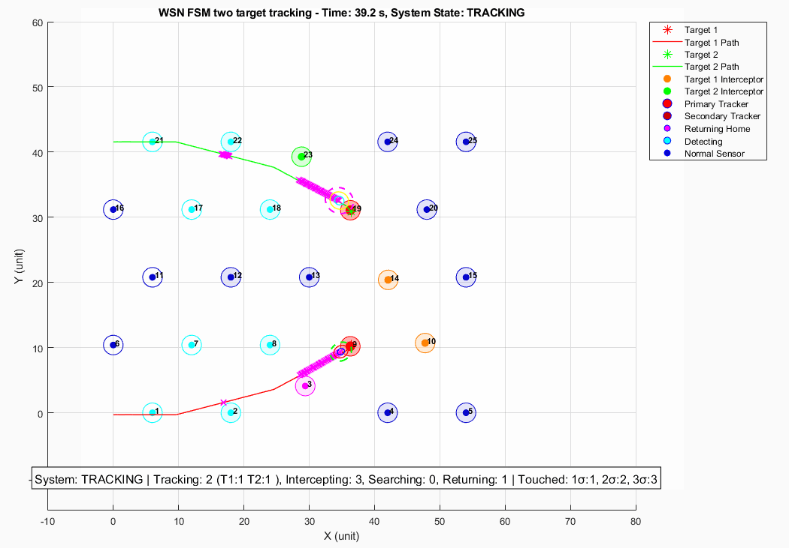
Figure 2: Baseline snapshot t=39.2s, $S_{10}$and $S_{14}$ are committed to Target 1.

However, at $t=40.0$s, Target 2 entered the selection stage after issuing a later handover request. During this selection, Target 2 selected $S_{20}$ and $S_{14}$. Since $S_{14}$ had already been committed to Target 1, this created a committed-interceptor conflict. As shown in Figure 3, Target 2 took over $S_{14}$, and Target 1 lost one of its committed interceptors.

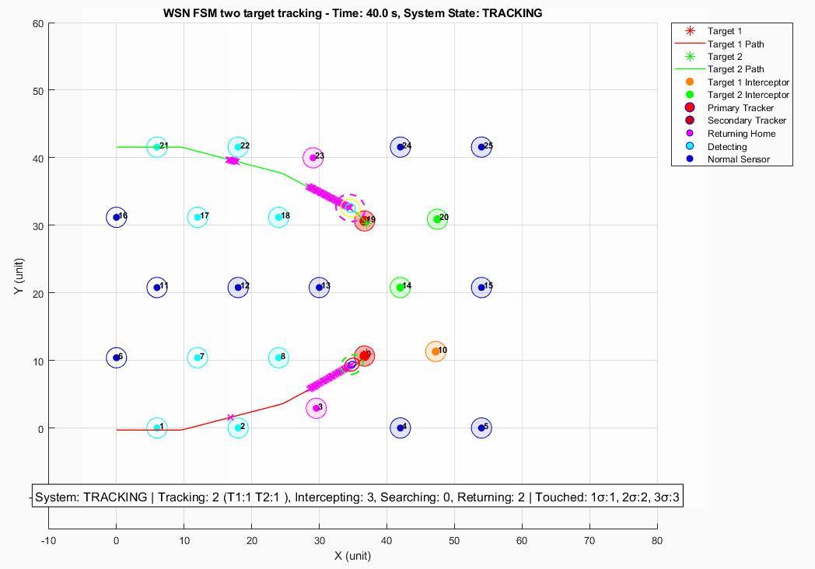
Figure 3: Baseline snapshot at t=40.0s, Target 2 takes over $S_{14}$ from Target 1.

This case shows that the baseline method does not include the previously served target in the assignment problem when one of its committed interceptors is contested by a later handover request. Although Target 1 and Target 2 were not handled within the same assignment procedure, the later handover request from Target 2 still affected the existing interceptor assignment of Target 1. This motivates the joint assignment scope expansion mechanism introduced in Section 4.1.

  - Effect of the Expanded Joint Assignment Scope
The proposed method addresses the committed-interceptor conflict by expanding the joint assignment scope before solving the assignment problem. When the later handover request from Target 2 attempts to use $S_{14}$, the system detects that $S_{14}$ has already been committed to Target 1. Therefore, Target 1 is added to the joint assignment scope together with the current calling target, Target 2.

The assignment problem is then solved once over the expanded joint assignment and the eligible candidate sensors. This prevents the later handover request from directly overwriting the existing interceptor assignment of Target 1. Instead, both targets are considered within the same assignment step, and the two-stage assignment objective selects a feasible non-overlapping sensor-to-target allocation.

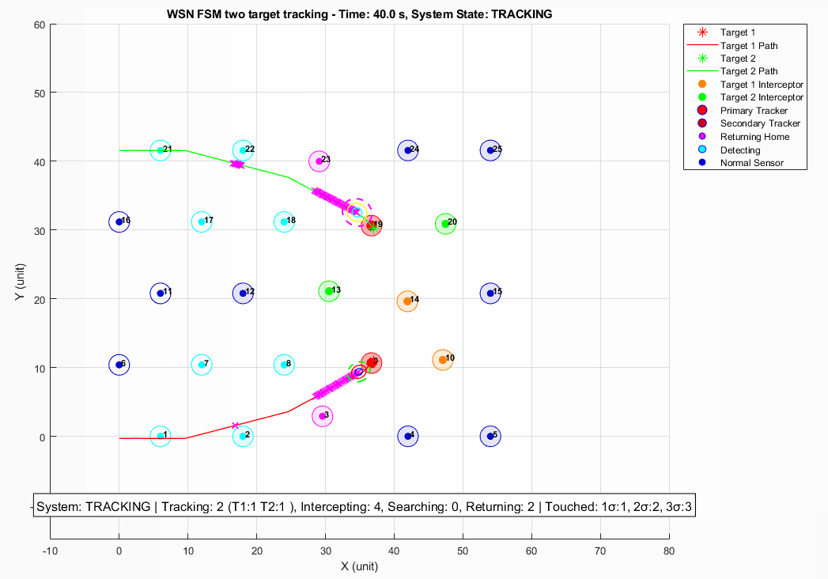
Figure 4: Proposed expanded joint assignment at $t=40.0$s.

Figure 4 shows the result after applying the proposed expanded joint assignment approach. Target 2 no longer takes $S_{14}$ away from Target 1. Instead, Target 2 selects $S_{13}$ and $S_{20}$, while Target 1 retains $S_{14}$ as one of its committed interceptors. This confirms that the proposed method includes the previously served target in the assignment problem when its committed interceptor is contested by a later handover request.

  - Three-Target Event: Separating Assignment Scope from Assignment Objective
This section uses a three-target event to separate two effects: the expanded joint assignment scope and assignment-objective selection. The original MinMax-based method without the expanded joint assignment scope is discussed as a scope limitation, because it would not form the full [$T_{3}$, $T_{2}$, $T_{1}$] assignment problem as a single event-level instance. Therefore, the event-level cost comparison is made only between methods that use the same expanded assignment scope: MinMax with expanded assignment scope and the proposed two-stage assignment with expanded assignment scope.

Figure 5 illustrates the three-target expanded joint assignment event. Target 3 first issues a handover request. During the assignment process, $S_{20}$ is found to have already been committed to Target 2, so Target 2 is added to the expanded joint assignment. A further committed-interceptor overlap occurs when the assignment process involving Target 2 includes $S_{13}$, which has already been committed to Target 1. As a result, the assignment scope expands from a single calling target to the three-target assignment scope [$T_{3}$, $T_{2}$, $T_{1}$]. This example shows that the expanded joint assignment scope prevents previously served targets from being excluded when their committed interceptors are contested by later handover requests.
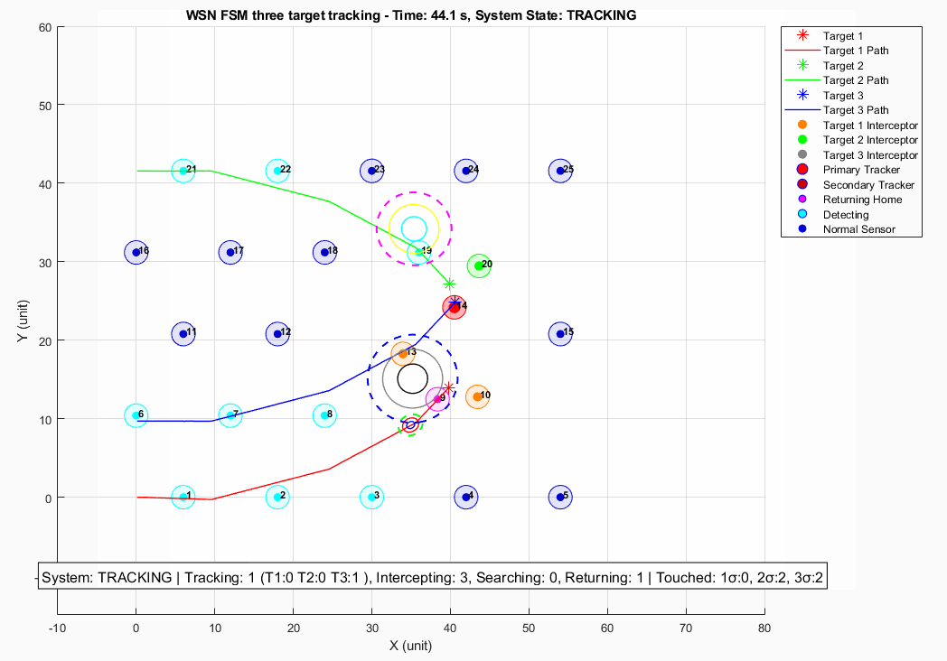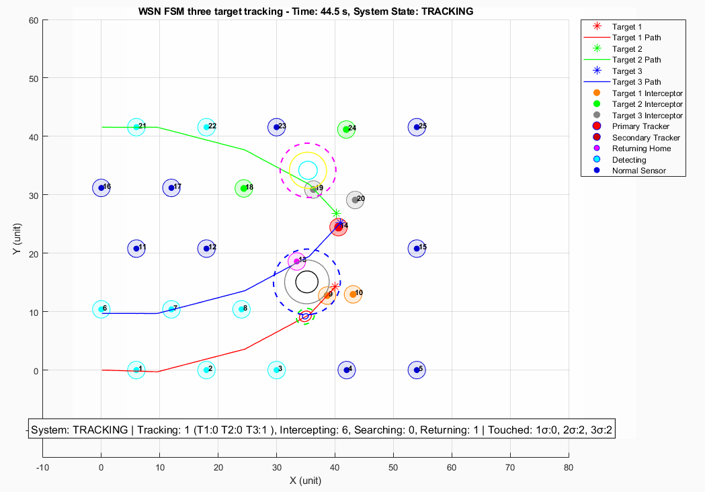
Figure 5: Three-target expanded joint assignment event at $t=44.2$s.

Once the expanded joint assignment scope is fixed, MinMax and the proposed two-stage assignment differ only in their assignment objective. MinMax prioritizes the worst target-level team cost, while the proposed two-stage objective first maximizes the number of filled interceptor slots and then minimizes the total assignment cost.

Method | Target 3 assignment (team cost) | Target 2 assignment (team cost) | Target 1 assignment (team cost) | Worst team cost | Total Cost
MinMax with expanded joint assignment scope | $S_{19}$, $S_{20}$ (0.57317) | $S_{18}$, $S_{24}$ (0.67203) | $S_{9}$, $S_{10}$ (0.22667) | 0.67203 | 1.47187
Two-Stage with expanded joint assignment scope | $S_{13}$, $S_{15}$ (0.64247) | $S_{19}$, $S_{20}$ (0.46429) | $S_{9}$, $S_{10}$ (0.22667) | 0.64247 | 1.33343
Table 3: Assignment comparison for the three-target event.

Table 3 shows that both methods fill all six requested interceptor slots, but the two-stage assignment objective achieves a lower total assignment cost, reducing the cost from 1.47187 to 1.33343. This result supports the event-level objective defined in this report: after the filled-slot maximization step is satisfied, the two-stage method selects the feasible non-overlapping assignment with the lowest total cost.

To complement the event-level comparison, the total tracked target time is also recorded over the full simulation. This metric is reported in target-seconds, where one target-second represents one target being successfully tracked for one second.

Method | T1 tracked time | T2 tracked time | T3 tracked time | Total tracked time ratio
MinMax with expanded joint assignment scope | 27.40 / 75.00 s | 25.20 / 71.00 s | 17.30 / 68.50 s | 32.59%
Two-Stage with expanded joint assignment scope | 39.00 / 75.00 s | 14.70 / 71.00 s | 14.80 / 68.50 s | 31.94%
Table 4: Full-simulation tracked-target time comparison for the three-target example.

Table 4 provides a complementary observation rather than the primary event-level comparison. In this simulation seed, the two-stage assignment objective produces a slightly lower total tracked-time ratio than the MinMax variant, 31.94% compared with 32.59%. The per-target results also show that the two-stage objective shifts more tracking time toward Target 1, while Target 2 and Target 3 receive less tracked time than under MinMax. This does not contradict the event-level assignment result, because full-simulation tracking time depends on later target motion, subsequent handover timing, future conflicts, and downstream effects of earlier assignment decisions.

Overall, this example shows that the expanded joint assignment scope and assignment-objective selection should be understood separately. The expanded joint assignment scope determines which targets are included in the assignment problem, while the choice between MinMax and the two-stage assignment objective determines how the system prioritizes balanced target-level support versus lower event-level total assignment cost.

- Conclusion and Future Work
This report studied interceptor assignment conflicts in a mobile WSN for cooperative multi-target tracking. Building on the DES-based proactive handover framework in [1], the report focused on the case where a later handover request contests a sensor that has already been committed as an interceptor for another target. To address this issue, the proposed method expands the joint assignment scope beyond the current calling targets so that any previously served target whose committed interceptor is contested is also included in the assignment problem. The resulting assignment is solved using a two-stage objective that first maximizes the number of filled interceptor slots and then minimizes the total assignment cost. In the examined simulation examples, the expanded joint assignment prevents previously served targets from being excluded during committed-interceptor conflicts, while the two-stage assignment objective achieves lower event-level total assignment cost than MinMax in the examined three-target event. The results also show that MinMax remains a meaningful fairness-oriented baseline, while the proposed two-stage method prioritizes event-level total assignment cost minimization.

Future work should evaluate the proposed method under more realistic communication and hardware constraints. The current simulation assumes ideal communication, but physical deployment would require measuring bid propagation delay, packet loss, commitment confirmation time, and the possibility of inconsistent assignment reconstruction among sensors. In addition, the simulation results suggest that lower event-level assignment cost does not necessarily guarantee better aggregate tracked-target time in every seed. Future work should also investigate adaptive objective selection with explicit switching conditions. MinMax may be more suitable when target-level team costs, EKF uncertainty, or predicted loss risk are highly unbalanced, while the system still aims to track as many targets as possible. In contrast, the two-stage objective may be preferred when the involved targets have comparable urgency. It could also be extended by incorporating target priority, so that higher-priority or higher-risk targets are protected first, while tracking opportunities for other targets are still preserved as much as possible. More simulation seeds and more diverse multi-target trajectories should also be tested to evaluate the robustness of the expanded joint assignment under different conflict patterns.

- References
[1] N. Najafizadeh Sari, Y. Sang, G. Nejat, and B. Benhabib, “Reconfigurable Wireless Sensor Network Coordination for Simultaneous Multi-Target Tracking.”
[2] J. K. Verma, J. K. Chhabra, and V. Ranga, “Track Consensus-Based Labeled Multi-Target Tracking in Mobile Distributed Sensor Network,” IEEE Transactions on Mobile Computing, vol. 23, no. 6, pp. 7351–7362, June 2024.
[3] P. Dames and V. Kumar, “Autonomous Localization of an Unknown Number of Targets Without Data Association Using Teams of Mobile Sensors,” IEEE Transactions on Automation Science and Engineering, vol. 12, no. 3, pp. 850–864, July 2015.
[4] H. Zhang, X. Zhou, Z. Wang, H. Yan, and J. Sun, “Adaptive Consensus-Based Distributed Target Tracking With Dynamic Cluster in Sensor Networks,” IEEE Transactions on Cybernetics, vol. 49, no. 5, pp. 1580–1591, May 2019.
[5] Y. Qi et al., “Energy-Efficient Target Tracking by Mobile Sensors With Limited Sensing Range,” IEEE Transactions on Industrial Electronics, vol. 63, no. 11, pp. 6949–6961, Nov. 2016.
[6] M. Z. A. Bhuiyan, G. Wang, and A. V. Vasilakos, “Local Area Prediction-Based Mobile Target Tracking in Wireless Sensor Networks,” IEEE Transactions on Computers, vol. 64, no. 7, pp. 1968–1982, July 2015.
[7] J. Feng, B. Lian, and H. Zhao, “Coordinated and Adaptive Information Collecting in Target Tracking Wireless Sensor Networks,” IEEE Sensors Journal, vol. 15, no. 6, pp. 3436–3445, June 2015.
[8] L. Zhou, V. Tzoumas, G. J. Pappas, and P. Tokekar, “Resilient Active Target Tracking With Multiple Robots,” IEEE Robotics and Automation Letters, vol. 4, no. 1, pp. 129–136, Jan. 2019.
[9] J. Chen and P. Dames, “Distributed Multi-Target Tracking for Heterogeneous Mobile Sensing Networks with Limited Field of Views,” in IEEE International Conference on Robotics and Automation, 2021, pp. 9058–9064.
[10] X. Bai, A. Fielbaum, M. Kronmüller, L. Knoedler, and J. Alonso-Mora, “Group-Based Distributed Auction Algorithms for Multi-Robot Task Assignment,” IEEE Transactions on Automation Science and Engineering, vol. 20, no. 2, pp. 1292–1303, Apr. 2023.
[11] D.-H. Lee, S. A. Zaheer, and J.-H. Kim, “A Resource-Oriented, Decentralized Auction Algorithm for Multirobot Task Allocation,” IEEE Transactions on Automation Science and Engineering, vol. 12, no. 4, pp. 1469–1481, Oct. 2015.
[12] O. Sanni, “Advanced Teaming with the Consensus-Based Bundle Algorithm,” in International Conference on Control, Automation and Robotics, 2021, pp. 65–70.
[13] J. A. Preiss, W. Hönig, G. S. Sukhatme, and N. Ayanian, “Crazyswarm: A large nano-quadcopter swarm,” in Proc. IEEE International Conference on Robotics and Automation (ICRA), Singapore, 2017, pp. 3299–3304.

- Appendix:
- example_V47_Yeqi.m — main simulation script for the V47 expanded joint assignment experiment.
- example2-expanded-group-two-stage.log — log file for the expanded joint assignment experiment using the two-stage assignment objective.
- example2- expanded-group-minmax.log — log file for the expanded joint assignment experiment using the MinMax assignment objective.

