

**FACULTY OF MANAGEMENT SCIENCES**

**DEPARTMENT OF COMPUTING AND INFORMATION SCIENCES**

**PROGRAM: BACHELOR OF SCIENCE IN COMPUTER SCIENCE**

**COURSEUNIT:** **ARTIFICIAL INTELLIGENCE**

**GROUP THREE:**

**KUGUMIKIRIZA ANDREW 20/U/0208/LCS**

**KITIMBO BONIFACE 20/U/0205/LCS**

**MATAGALA DERRICK 20/U/0220/LCS**

**QUESTION**: DISCUSS UTILITY BASED AGENTS

**Utility-Based Agents**

Utility-Based-Agent = Goal-Based-Agent + Utility-Function

**A utility-based agent** is an agent that acts based not only on what the goal is, but the best way to reach that goal.

It is an improvement over goal based agent as it not only involves the goal but also the way the goal can be achieved such that the goal can be achieved in a quicker, safer, cheaper way.

Utility agent have their end uses as their building blocks and is used when best action and decision needs to be taken from multiple alternatives. They choose actions based on a preference (utility) for each state.

The extra component of utility or method to achieve a goal provides a measure of success at a particular state that makes the utility agent different.

It takes the agent happiness into account and gives an idea of how happy the agent is because of the utility and hence, the action with maximum utility is considered. This associated degree of happiness can be calculated by mapping a state onto a real number.

Mapping of a state onto a real number with the help of utility function gives the efficiency of an action to achieve the goal.

This can be illustrated as follows: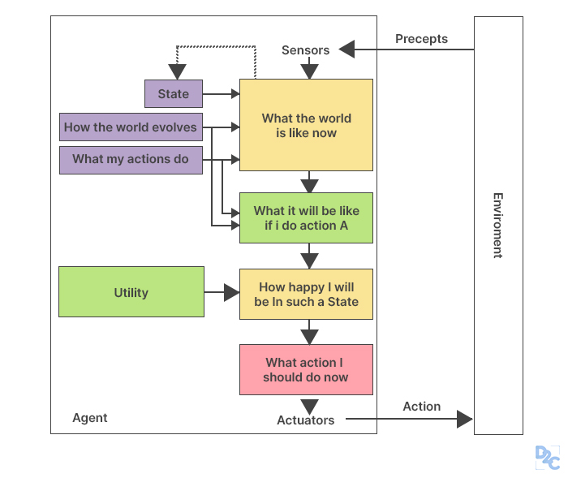

function UTILITY-BASED-AGENT (percept) returns an action

persistent: state, the agent’s current conception of the world state

model, a description of how the next state depends on current and action

utility - function, a description of the agent’s utility function

plan, a sequence of actions to take, initially empty

action, the most recent action, initially none

state ← UPDATE-STATE (state, action, percept, model)

if plan is empty then

plan ← PLAN (state, utility - function, model)

action ← FIRST (plan)

plan ← REST (plan)

return action

**Advantages**

Find best state using evaluation function or utility function

Can work efficiently in Continuous environment

**Disadvantages**

Limited Intelligence

**REFERENCES**

https://skillx.com

https://www.geeksforgeeks.org

<https://wikipedia.com>