DPM Group_6 lab5 hardware design 1.1

Yuhang Zhang Feb.19

**Objective:**

* To improve stability of the sensor support system, construct a rotating color sensor support system.

**Hardware Basis:**

* 2 us sensors: 2-D distance detection
* 2 color sensors: odometer and color detection respectively
* Robot chassis
* Rotating color sensor system
* Rotating color sensor support system

**Problem with version 1.0:**

The motor that rotates the color sensor is slightly unstable, and such problem could bring negative impact on software design and testing.

**How to achieve:**

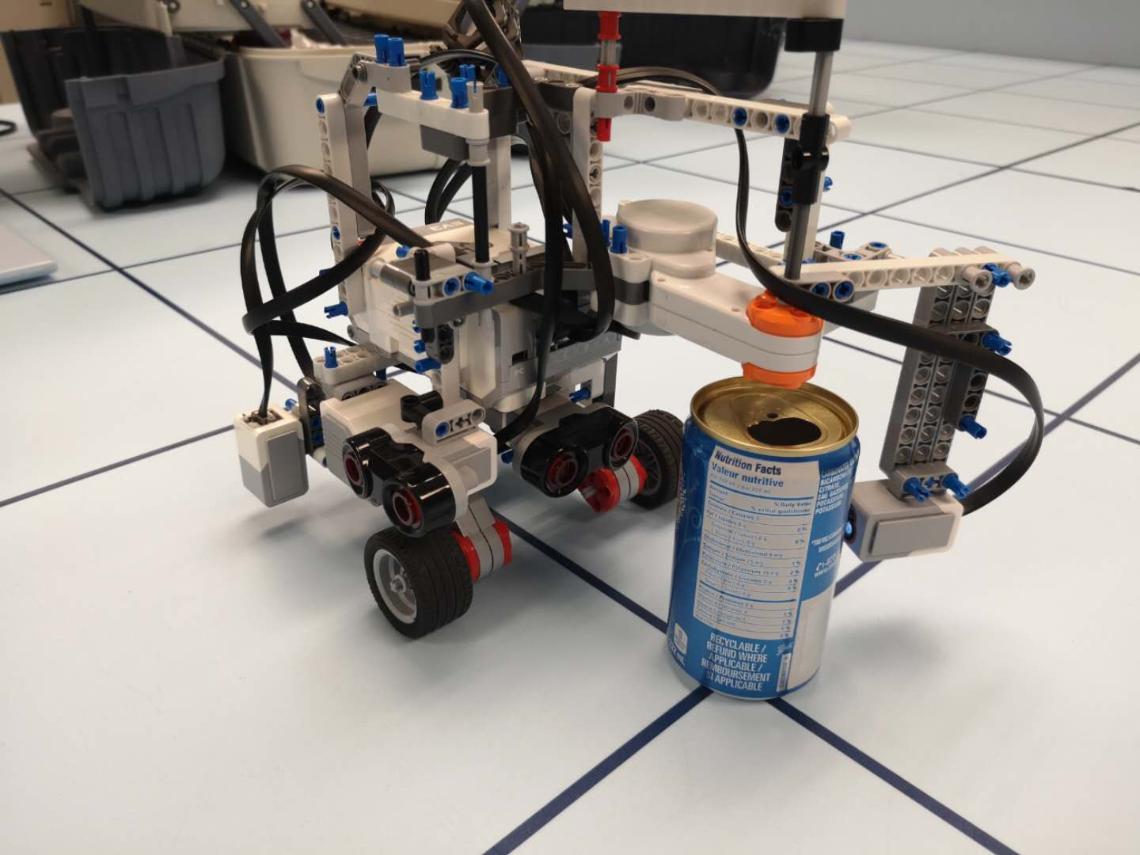To make a structural support for the rotation.

