Xcode Project

# Bitcode

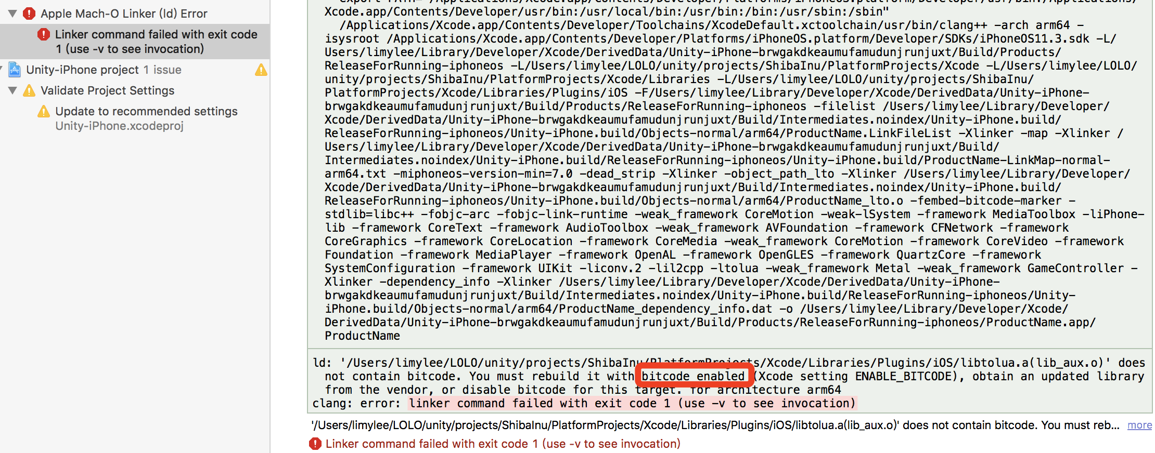

解决：

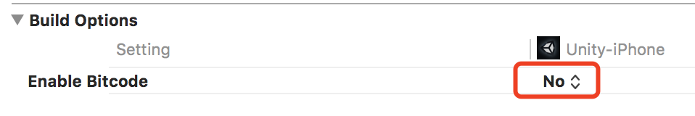

# Add Copy Res Script

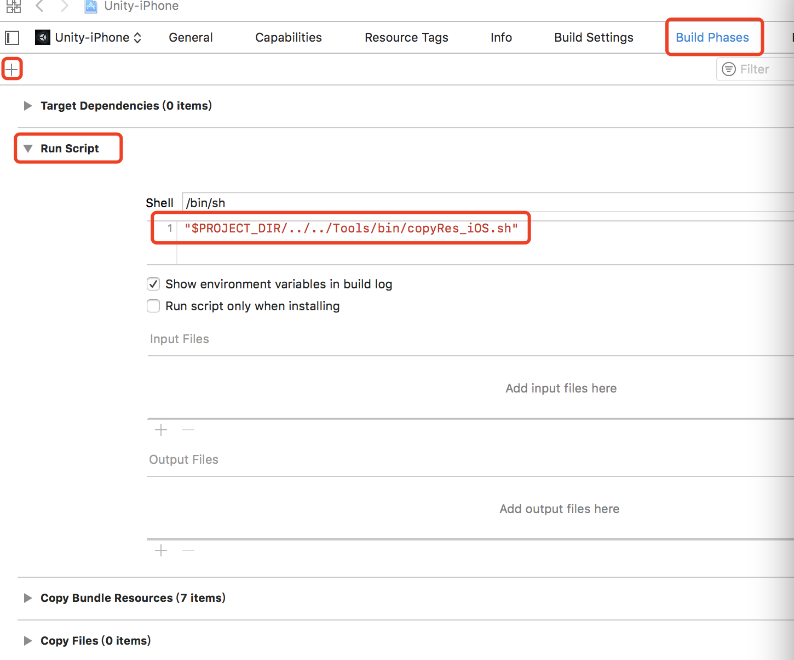

"$PROJECT_DIR/../../Tools/bin/copy-res-ios.sh"

# Could not produce class with ID [Number]

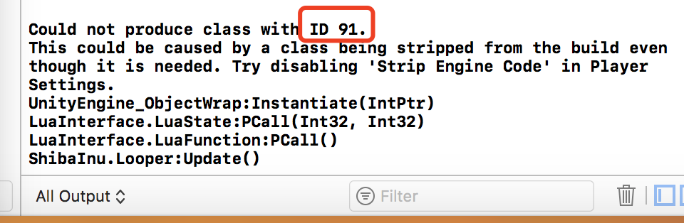

Find Class :

<https://docs.unity3d.com/2018.1/Documentation/Manual/ClassIDReference.html>

Append Class

to [ Assets/Link.xml ]

or [ Assets/Resources/Link.xxx ] ( Editor Class, Save File or Prefab )

# Could not launch “[App Name]”

*iPhone7-36 has denied the launch request.*

1. 原因可能是证书类型与运行目标类型不匹配。

打开Edit Scheme，确认 Build Configuration：Debug或Release，与Signing Certificate类型：Developer或Distribution是否匹配。

# 运行时崩溃

1. 查看控制台是否有Could not produce class with ID [Number] 错误。

# clang: error: linker command failed with exit code 1 (use -v to see invocation)

1. Native代码文件没有加入到项目中，选中文件夹（Classes/Nitive），右键，选择 Add Files to “[Project]”
2. 查看日志详情，是否native函数命名有误。