File Name: **dryrun.txt**

(Unique key values are created without using HashMap concept)

Duplicate keys are handled with suitable exception mesaage!!

**Key-Value Pair creation:**

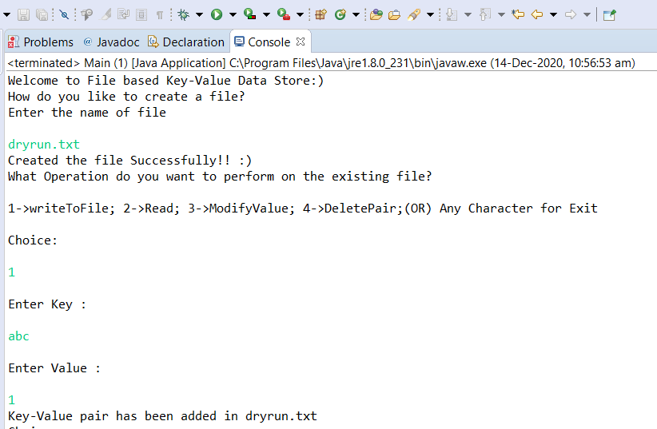

**Key-Value Pair read operation:**

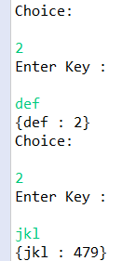

**Key-Value Pair modifying operation:**

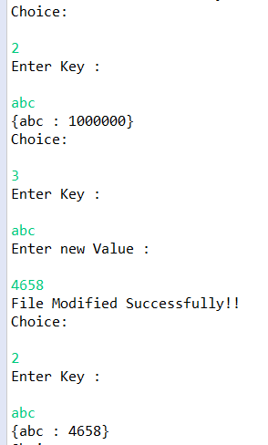

**Key-Value Pair Deletion operation:**

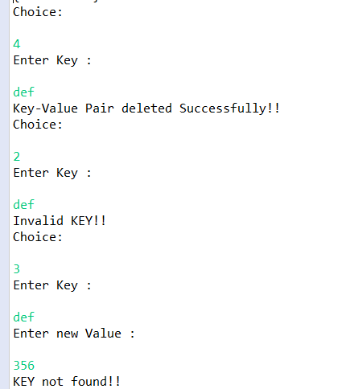

**Input/Output Handling:**

