

CUSTOMER SERVICE USER MANUAL

Sky World Customer support team

**Table of Content**

**First Time Login** 2

Step 1: Logging in**​** 2

Step 2: One Time Password (OTP) Verification**​** 2

Step 3: Change Password**​** 3

**Subsequent Log In** 4

**Tickets** 4

Creating a Ticket 5

View Tickets 6

Close Tickets 7

**Reports** 9

**RFC Tickets** 12

# **First Time Login**

## Step 1: Logging in[**​**](http://localhost:3000/#step-1-logging-in)

After you have been created as a user, you'll receive an email with your username and password that you will use to log in to the system.

1. Go to <https://customerservice.skyworld.co.ke/client/signin>

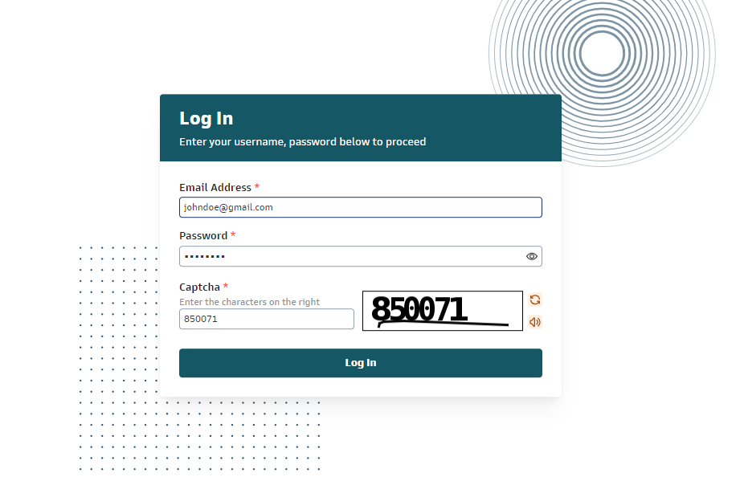

1. Enter initial password that was sent to you via email in the **Email Address** textbox.
2. Enter the captcha value you see on the textbox to the right.
3. Click on the **Log In** button.

## Step 2: One Time Password (OTP) Verification[**​**](http://localhost:3000/#step-2-one-time-password-otp-verification)

1. After clicking **Log In** an OTP will be sent to your phone number.

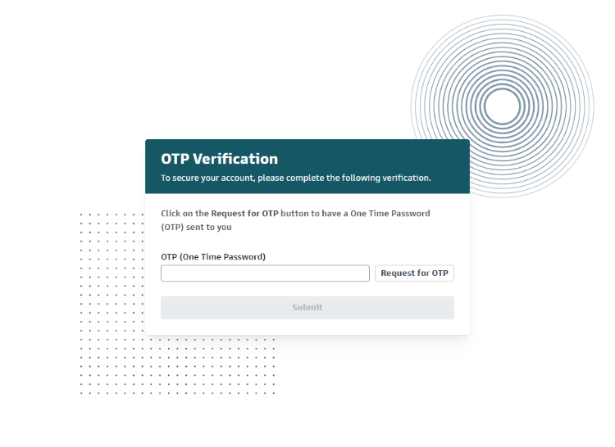

1. And in case the OTP was not sent click on the **Request for OTP** button

## Step 3: Change Password[**​**](http://localhost:3000/#step-3-change-password)

On first-time logging into the Customer Service Portal, this step is also added for the client to create a new password.

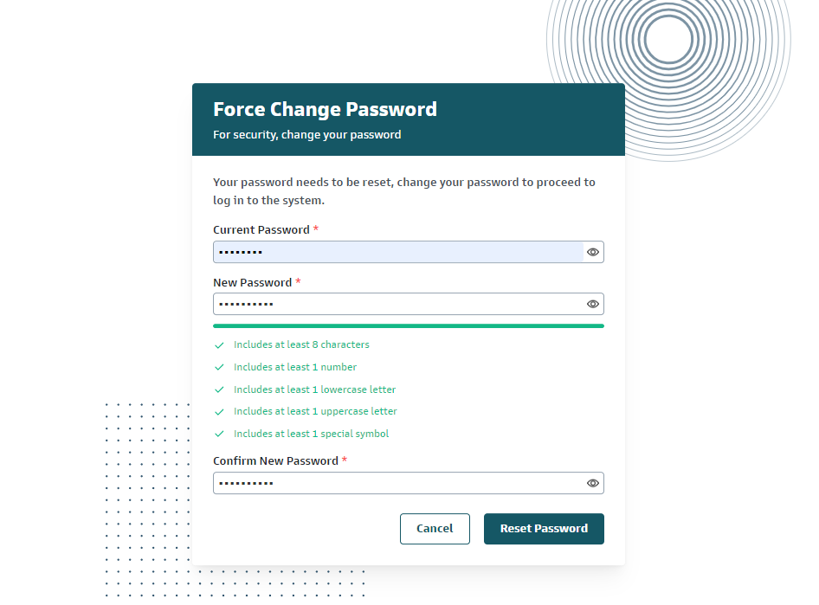

1. Enter the Current password sent via **Email** in the Current Password textbox.
2. Create a new password and enter it into the New Password and Confirm New Password fields, making sure to follow the rules highlighted on the screen.
3. Click on the **Reset Password** button.

After successfully changing the password:

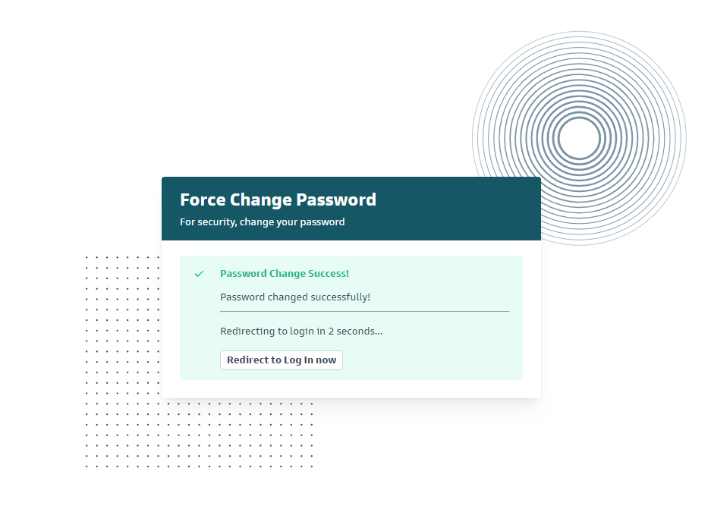

1. You will be redirected to the login page after a 5-second countdown lapses so you can log in with your new password.
2. You can also click on the **Redirect to Log in now** button.

# **Subsequent Log In**

Once you've changed your password, follow these steps to log in to your account:

1. **Navigate to the Login Page**: Go to the login section of the website or application.



1. **Enter Your Email Address**: Input your Email Address in the designated field.
2. **Enter Your Password**: Use the new password you just created.
3. **Enter Captcha**: Input the captcha provided in the captcha box.
4. **Log In**: Click the "Log In" button to access your account.
5. **Enter OTP Code**: Enter the OTP code that was sent to your phone number.

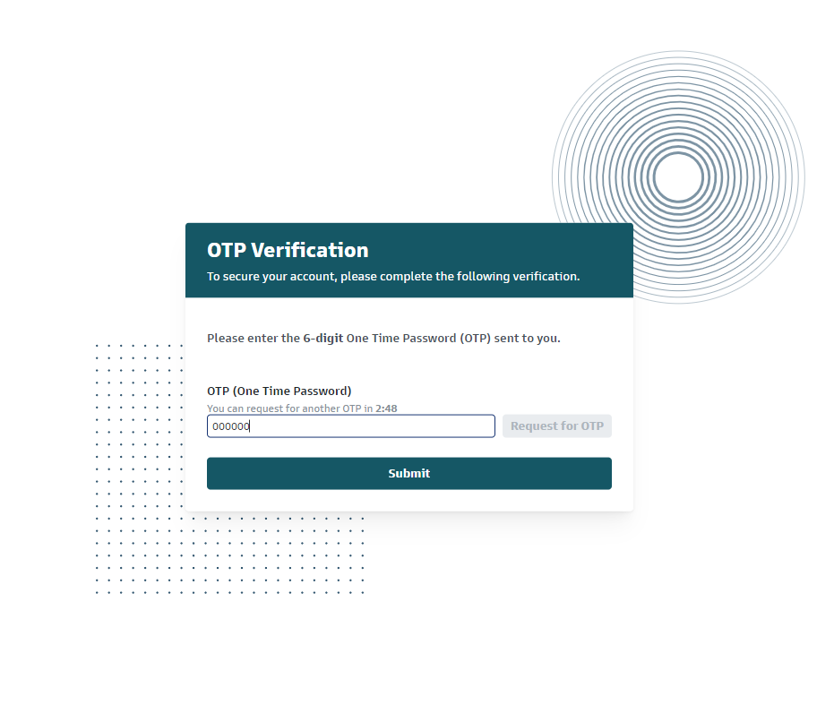

# **Tickets**

On the left sidebar, click **Tickets**.

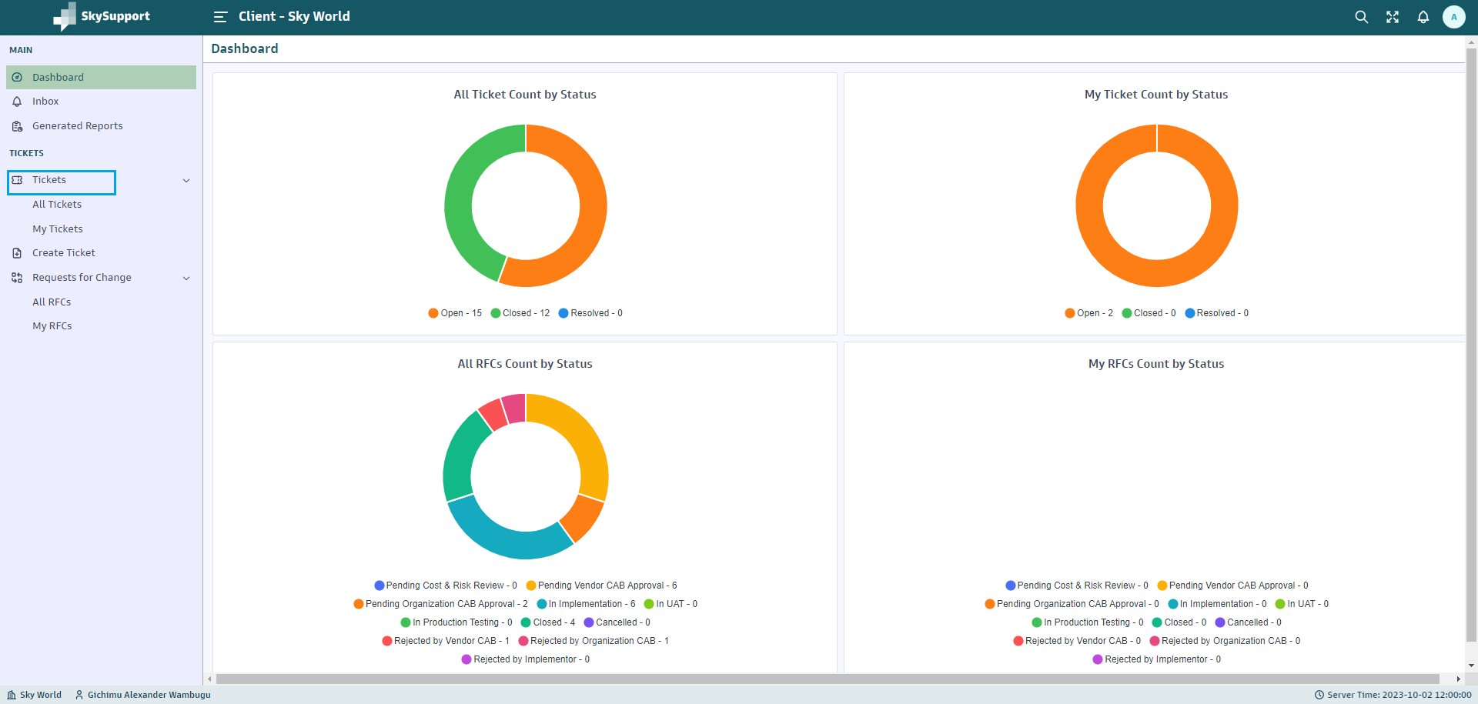

Here, you can:

* **Create** new tickets.
* **View** ticket status.
* **Close** resolved tickets.

## Creating a Ticket

1. Click **Create Ticket**.

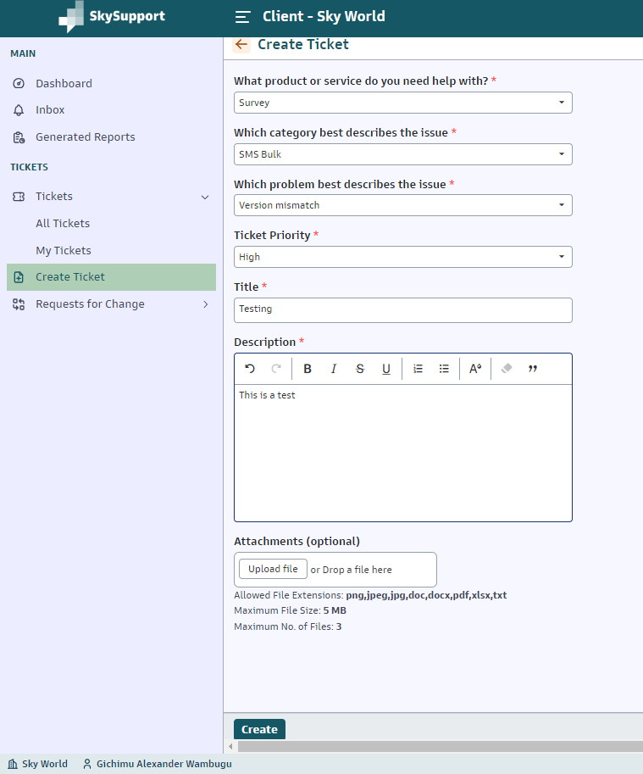

1. Select the product or service you need help with from the dropdown.
2. Choose the category that best describes the issue.
3. Select the problem from the dropdown.
4. Set the ticket priority.
5. Enter the title and description in the text box, then click **Create** to submit the ticket.

## View Tickets

Tickets are organized into the following tabs for better management:

* **All Tickets:** Displays all tickets that you as a user have created, including open, resolved, and closed tickets.

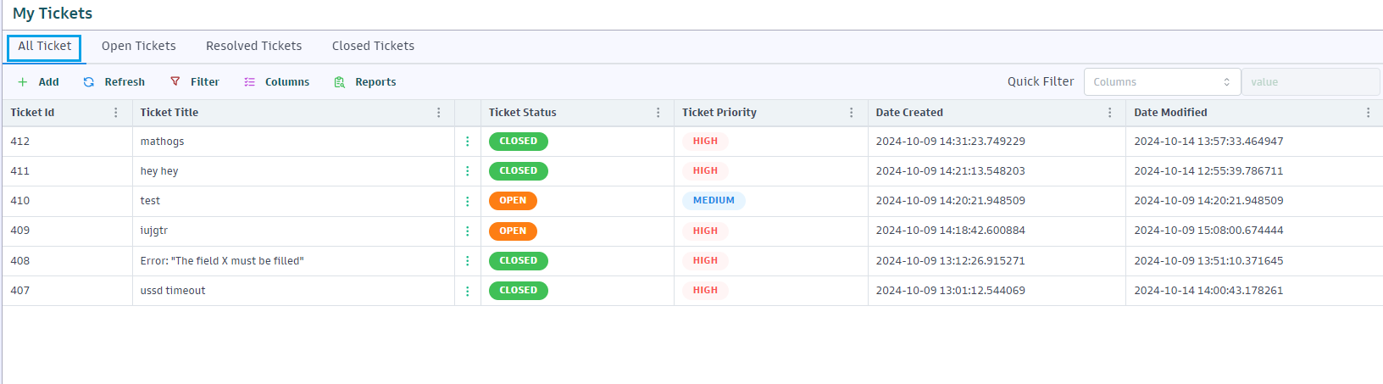

* **Open Tickets:** Shows tickets that awaiting action.

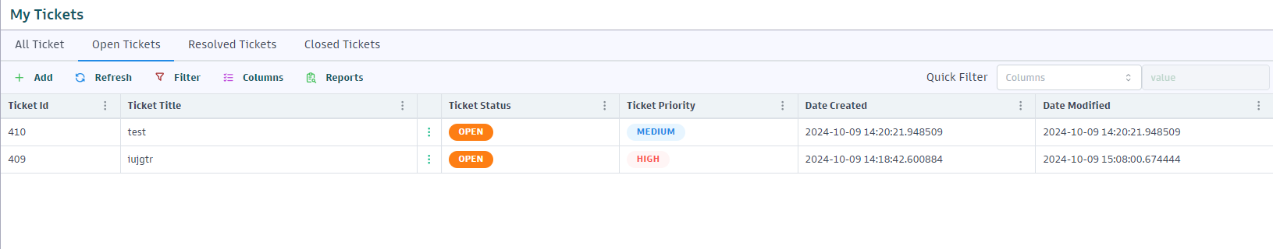

* **Resolved Tickets:** Lists tickets that have been addressed but not yet closed by the client.
* **Closed Tickets:** Displays tickets that have been successfully resolved and closed.

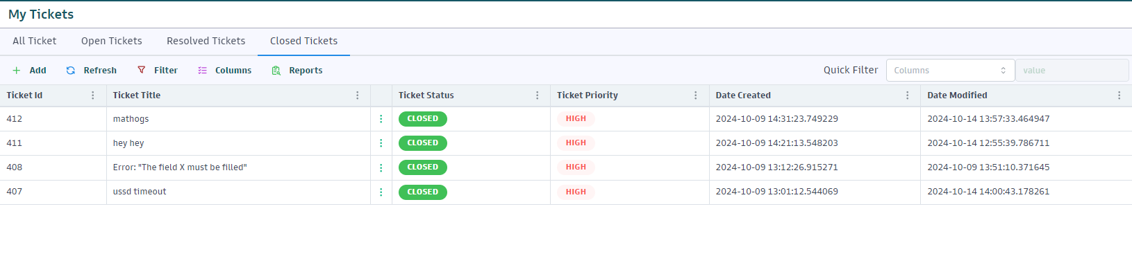

1. Click on **My Tickets** to view tickets that you, as the user, have created.

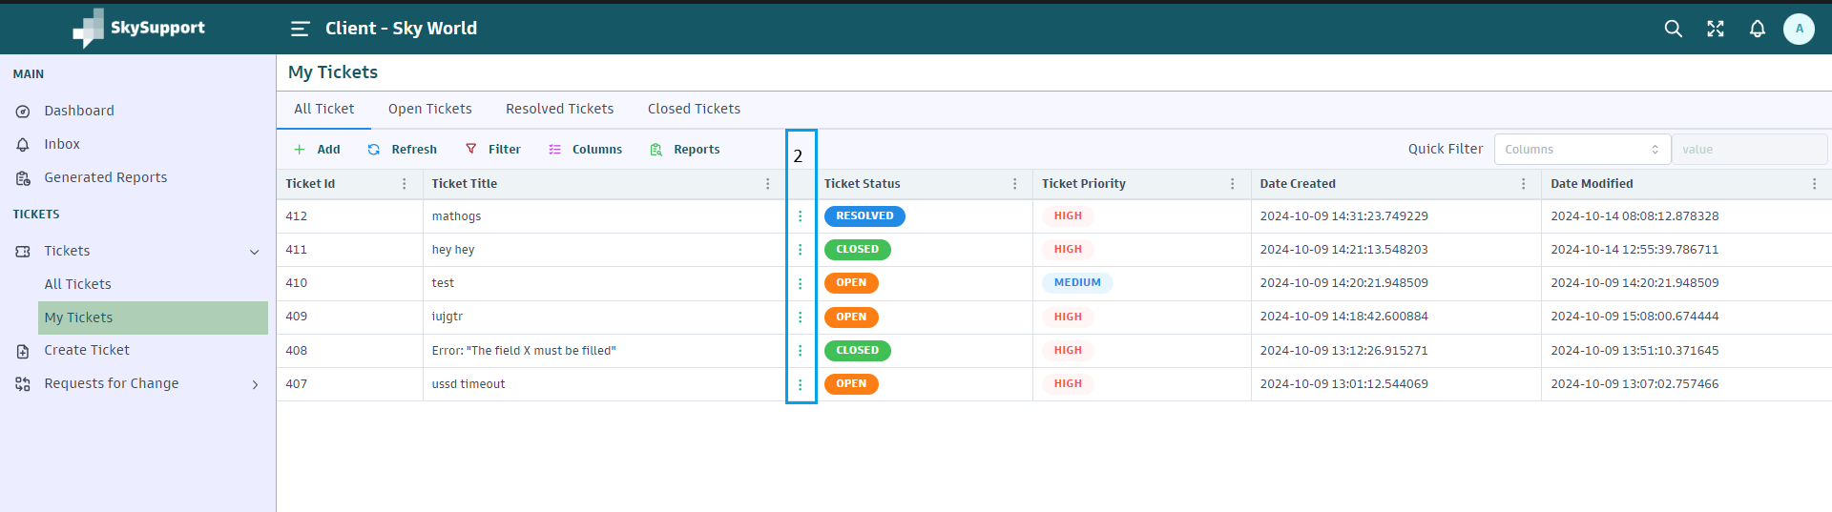

1. To view a specific ticket, click on the **(⋮)**.

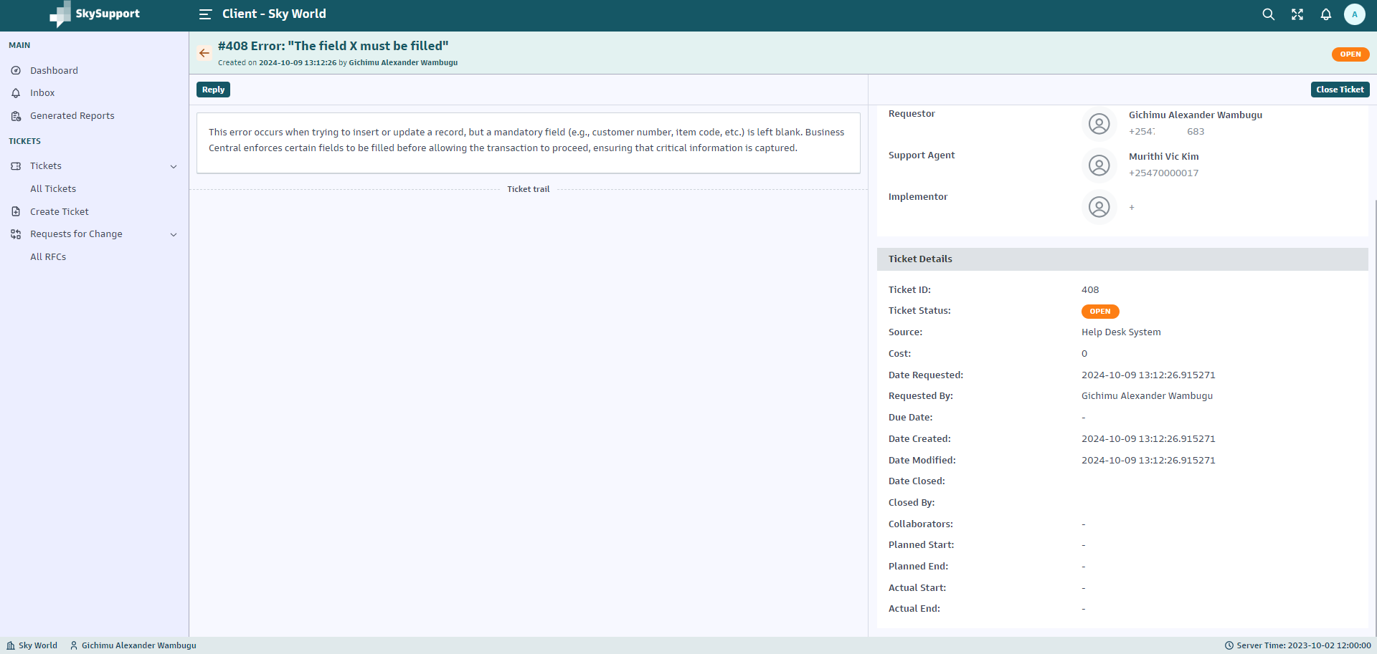

## Close Tickets

1. Click on **My Tickets** to view all tickets that you need to close.



1. Click on the **(⋮)** next to a ticket to open it.



1. To close a ticket you created, click on **Close Ticket** in the top right corner.

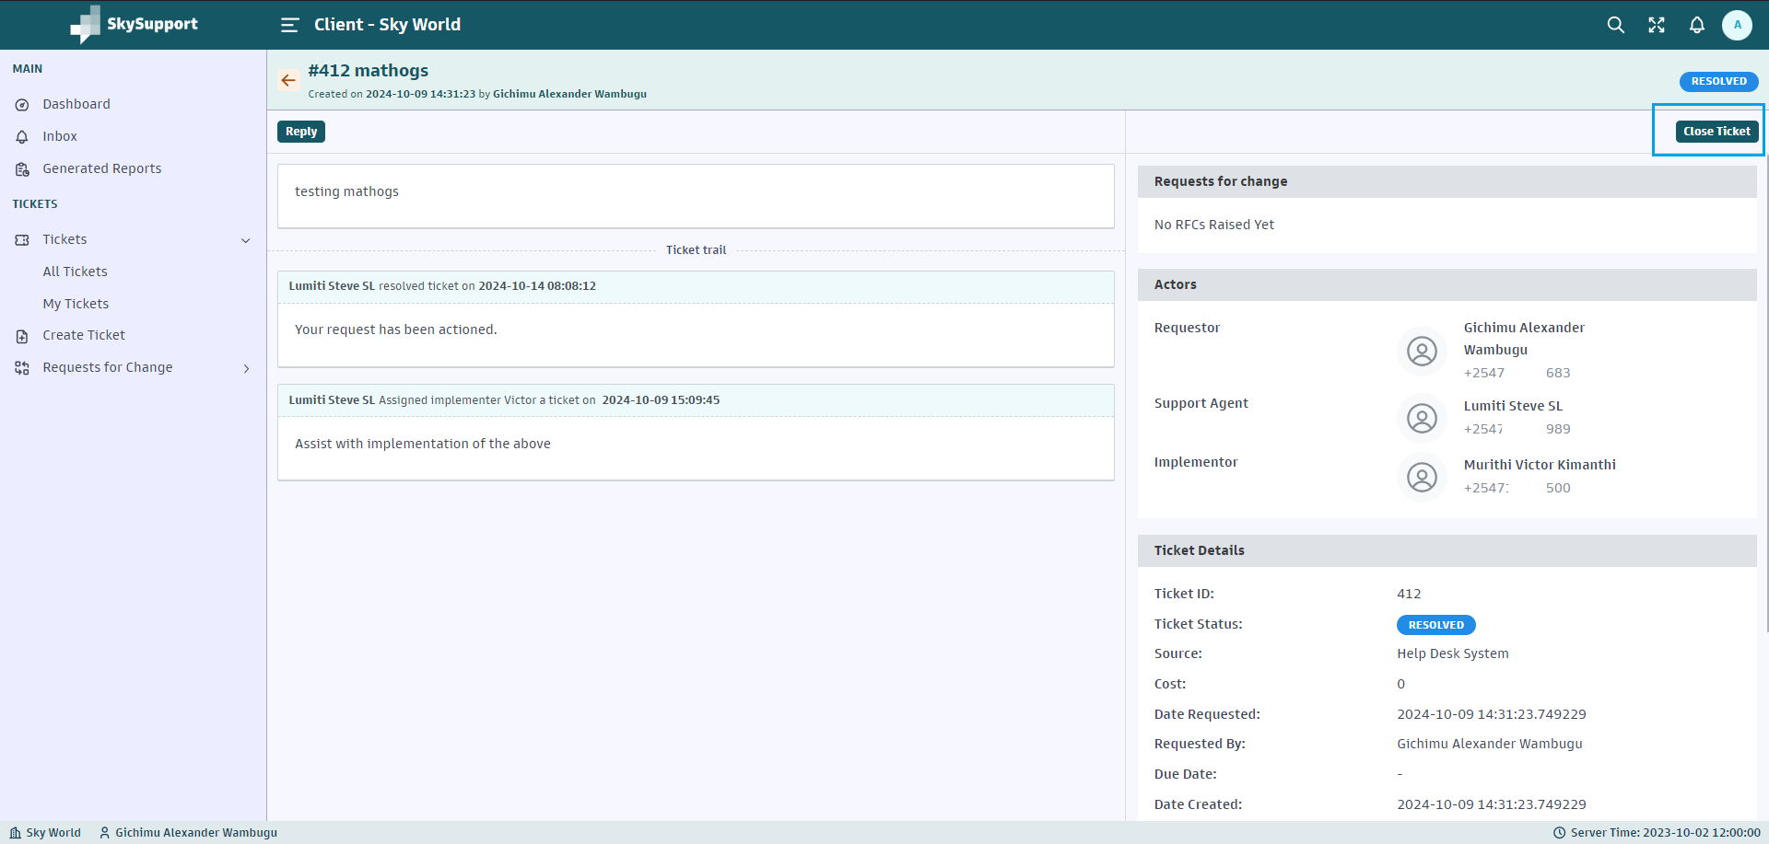

1. After clicking **Close Ticket**, a pop-up will appear. Add a comment in the text box explaining the closure.

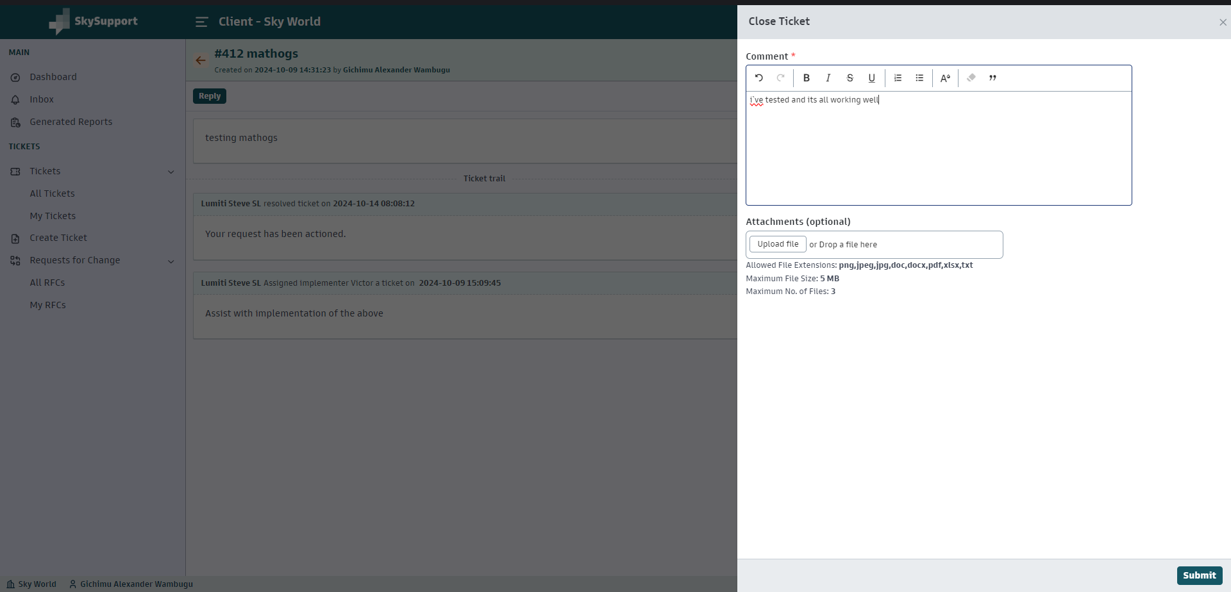

The following options are available when adding attachments (optional):

* + **Allowed File Extensions:** png, jpeg, jpg, doc, docx, pdf, xlsx, txt
  + **Maximum File Size:** 5 MB
  + **Maximum No. of Files:** 3

1. Click on **Submit**, after which the following confirmation pop-up will appear.

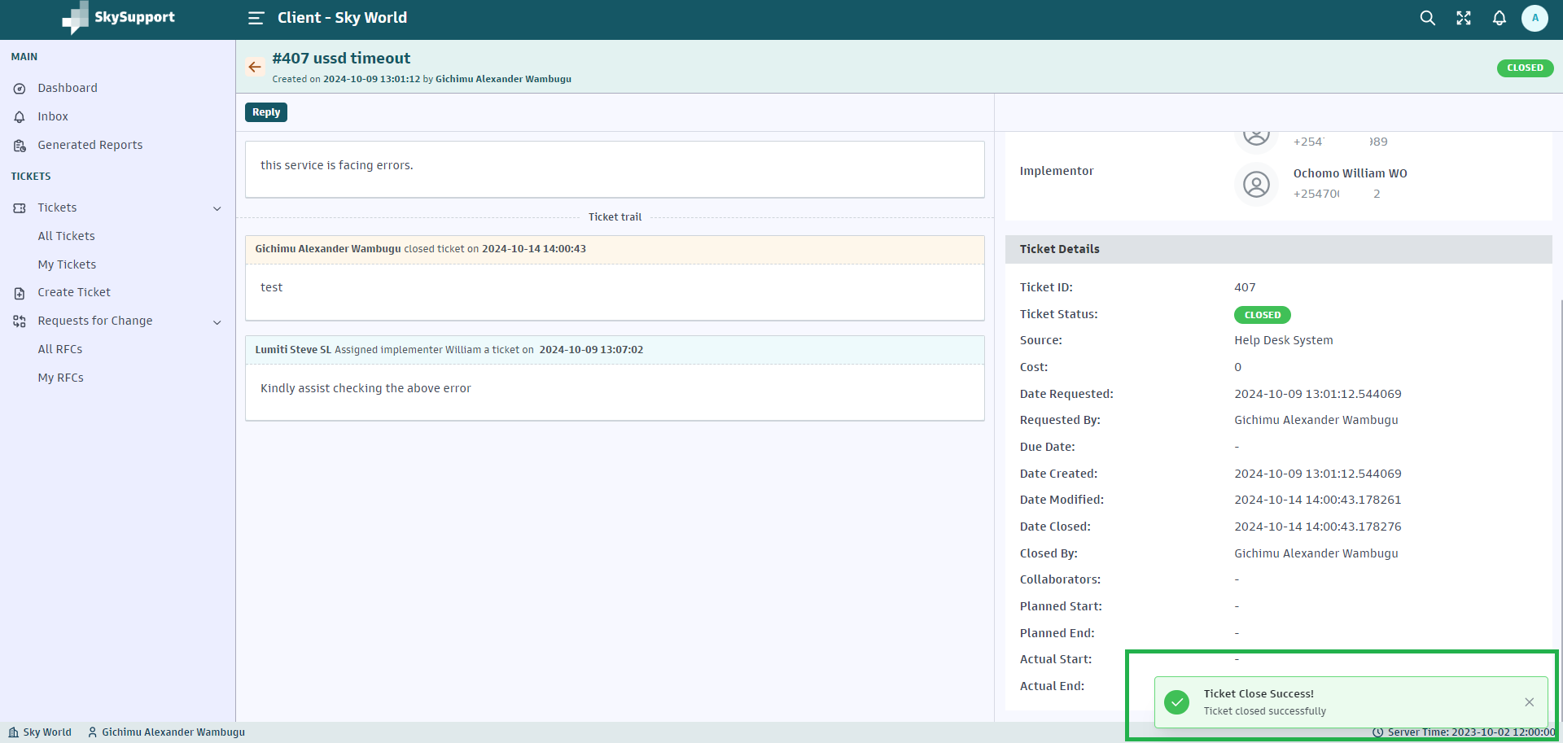

# **Reports**

1. Navigate to **My Tickets** under the **Tickets** section.
2. On the top navigation bar, click on **Reports**.

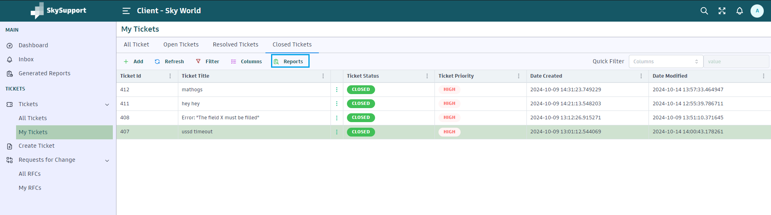

1. Click on **+ New Report**.

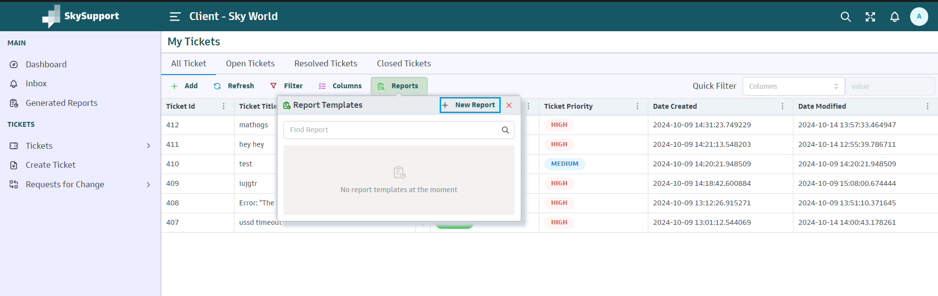

1. Enter the **Report Name** in the text box.

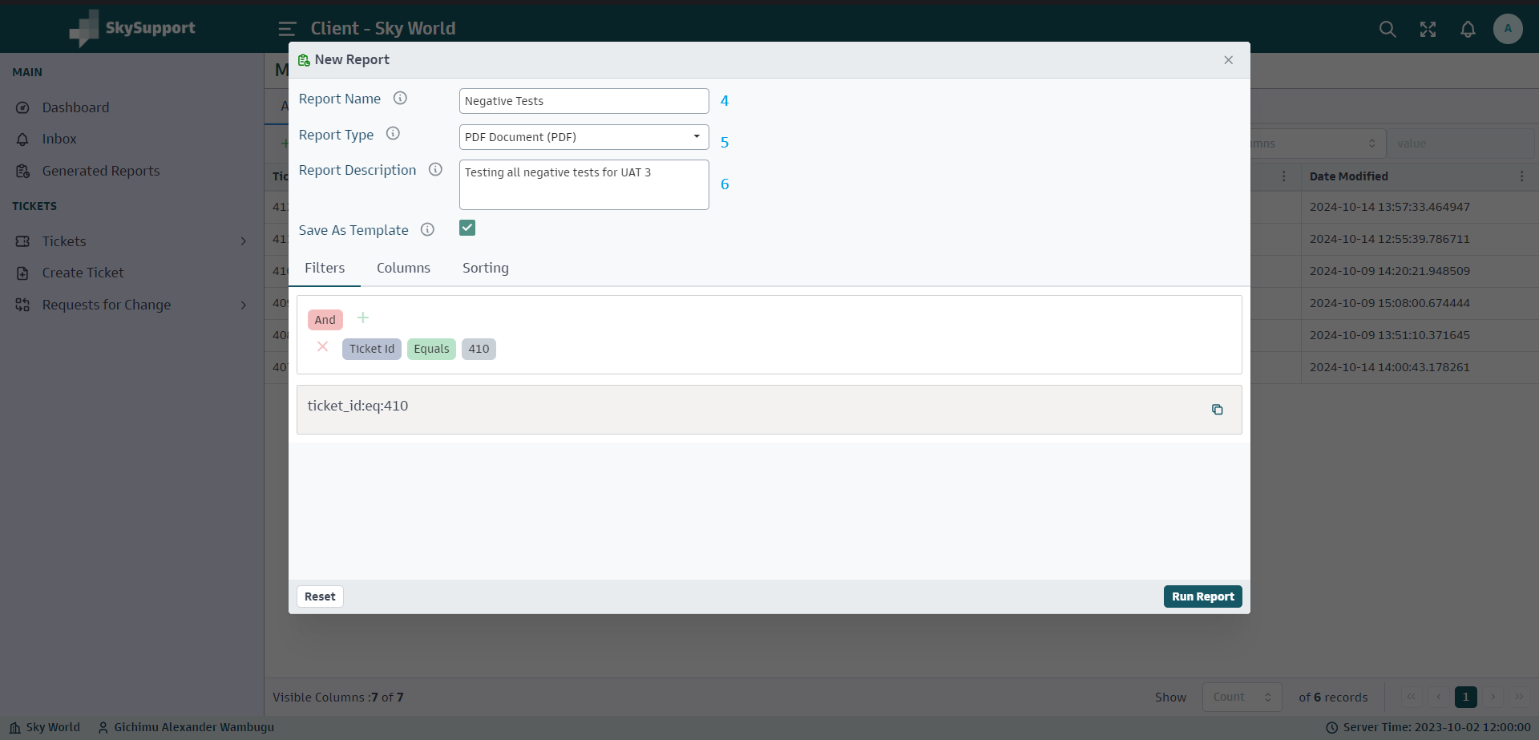

1. Select the **Report Type** from the dropdown.
2. Enter the **Report Description**.

**Optional:**[**​**](http://localhost:3000/Customer-Service-Portal-Manual/Reports#optional)

* Tick the **Save as Template** checkbox if you want to save the report as a template for future use.

**Adding Filters**[**​**](http://localhost:3000/Customer-Service-Portal-Manual/Reports#adding-filters)

1. Under **Filters**, you can set conditions to generate a specific report:
   * Click on **+**.
   * Select **Add Condition** to filter the report based on a specific ticket ID or other criteria.

**Running the Report**[**​**](http://localhost:3000/Customer-Service-Portal-Manual/Reports#running-the-report)

1. After setting the filters, click on **Run Report** to generate your report.
2. After the report is generated, you will receive a notification confirming its completion.

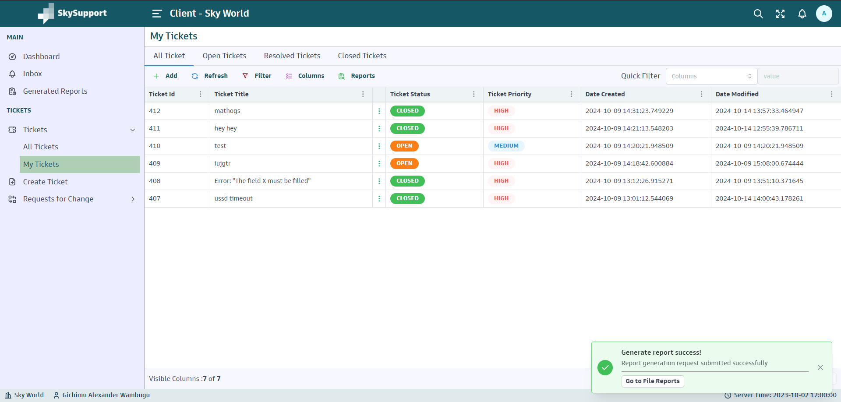

**Viewing Generated Reports**[**​**](http://localhost:3000/Customer-Service-Portal-Manual/Reports#viewing-generated-reports)

Only reports with a status of **Completed** can be downloaded.

1. Click **Generated Reports** in the navigation to view your reports.

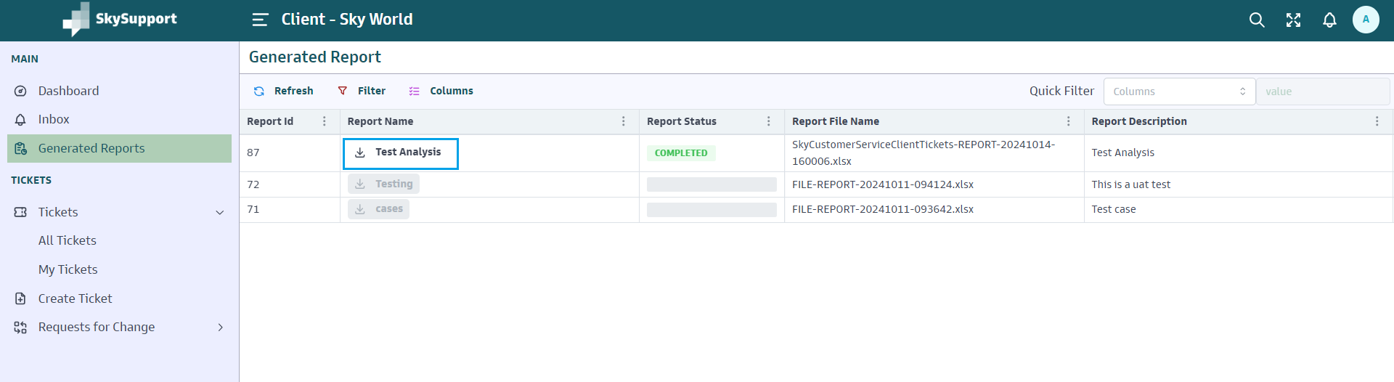

1. In the **Generated Reports** section, click the **Download Icon** button next to any completed report.

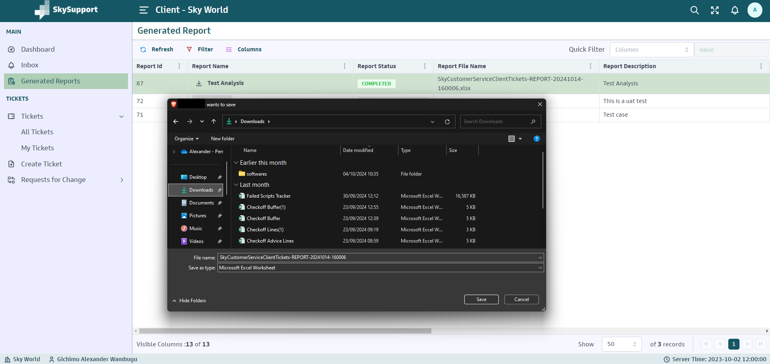

# **RFC Tickets**

On the left sidebar, click **My RFCs**.

RFCs are organized into the following tabs:

* **All RFCs:** Displays all the RFCs the Implementer raised.

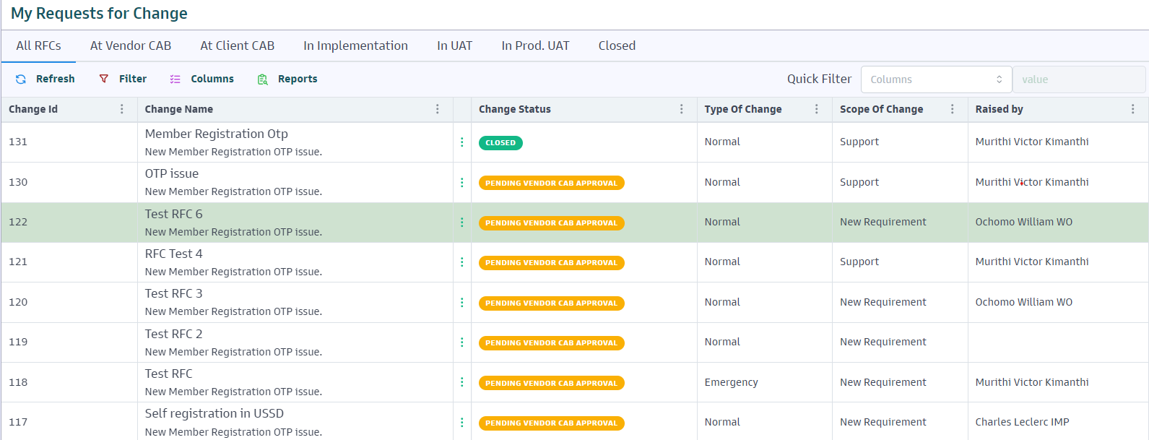

* **At Vendor CAB:** Displays all the RFCs pending vendor assessment for risk, cost, and approval/rejection.

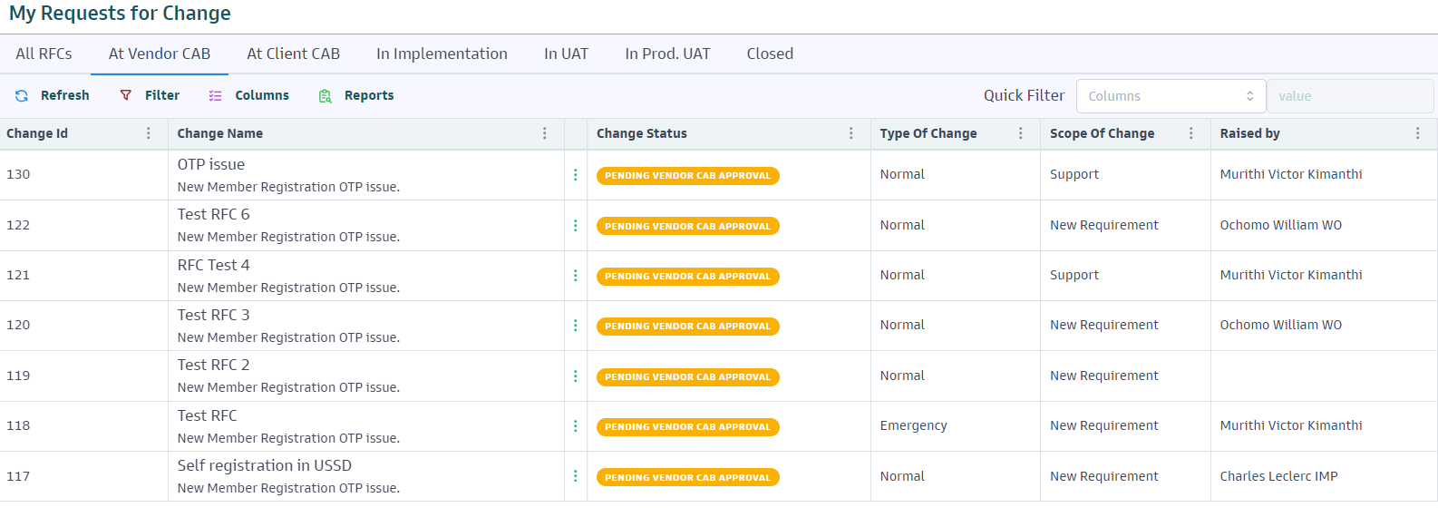

* **At Client CAB:** Displays all the RFCs pending client assessment for risk, cost, and approval/rejection.

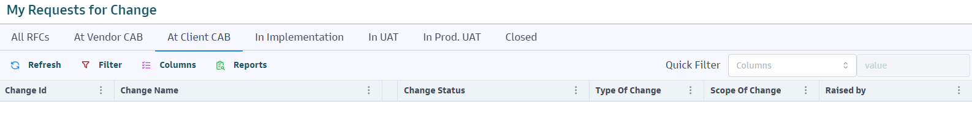

* **In Implementation:** Displays all the RFCs being actioned by the Implementer.

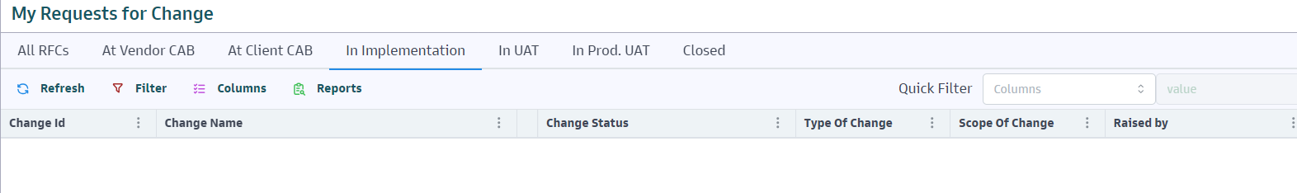

* **In UAT:** Displays all the RFCs that are in testing by the client awaiting approval/rejection.

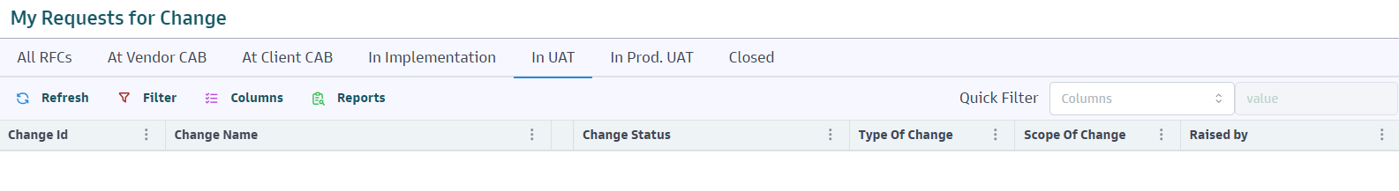

* **In Prod. UAT:** Displays all the RFCs that are in production testing by the client for final approval/rejection and ticket closure.

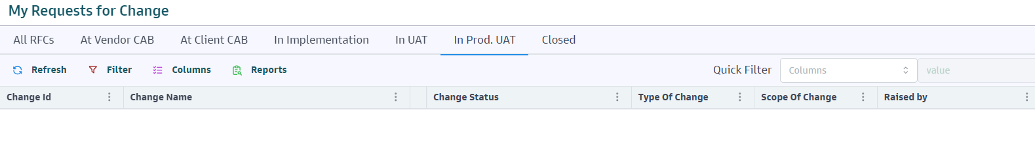

* **Closed:** All RFCs that have been resolved and closed.

