ConLLU File: ṚV, 1, 1

Sentence ID: 576247
Mantra Text:
agnim īḍe purohitam yajñasya devam ṛtvijam hotāram ratna dhātamam
[('1_2', '1_1', 'Karma'), ('1_1', '1_3', 'Viśeṣaṇam'), ('1_3', '1_4', 'Ṣaṣṭhīsambandhaḥ'), ('1_1', '1_5', 'Viśeṣaṇam'), ('1_1', '1_6', 'Viśeṣaṇam'), ('1_1', '1_7', 'Viśeṣaṇam'), ('1_9', '1_8', 'Karma'), ('1_7', '1_9', 'Viśeṣaṇam')]
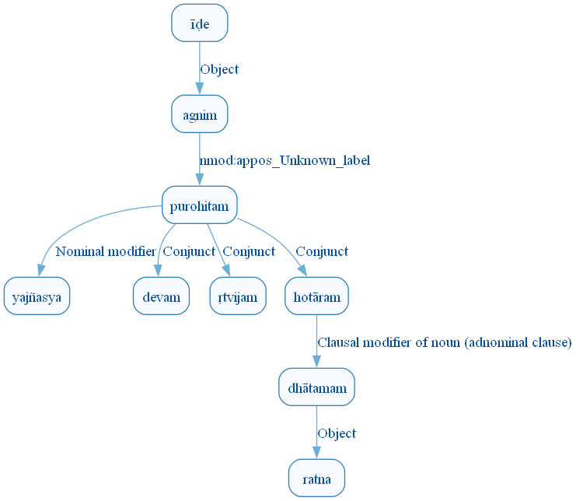
Figure 1: DCS Original Dependency Graph for Sentence ID 576247
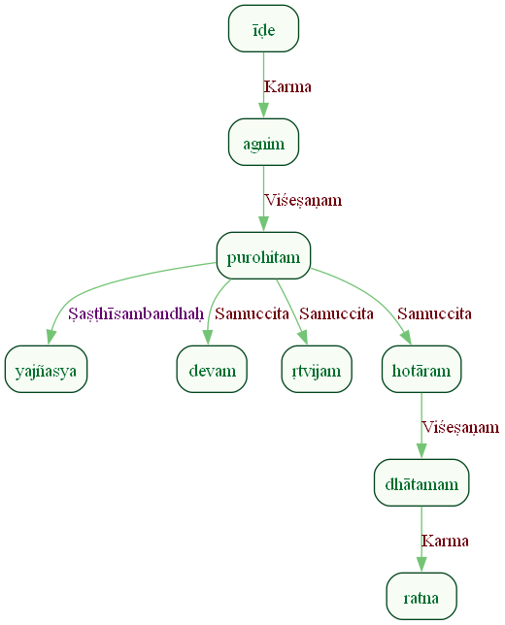
Figure 2: Sanskrit Tags Dependency Graph for Sentence ID 576247
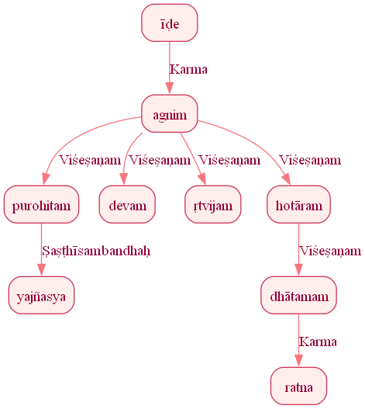
Figure 3: Reduced Dependency Graph for Sentence ID 576247

Sentence ID: 576249
Mantra Text:
agniḥ pūrvebhiḥ ṛṣibhiḥ īḍyaḥ nūtanaiḥ uta
[('1_4', '1_1', 'Karma'), ('1_3', '1_2', 'Viśeṣaṇam'), ('1_4', '1_3', 'Kartā'), ('1_3', '1_5', 'Viśeṣaṇam'), ('1_5', '1_6', 'Samuccita_dyotakaḥ')]
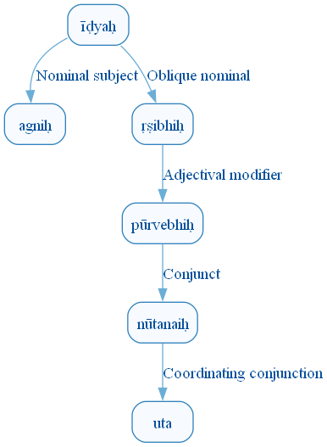
Figure 10: DCS Original Dependency Graph for Sentence ID 576249
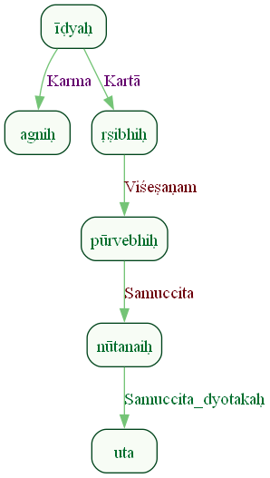
Figure 11: Sanskrit Tags Dependency Graph for Sentence ID 576249
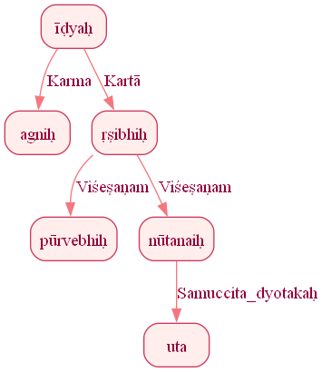
Figure 12: Reduced Dependency Graph for Sentence ID 576249

Sentence ID: 576250
Mantra Text:
sa devāṁ ā iha vakṣati
[('1_5', '1_1', 'Kartā'), ('1_5', '1_2', 'Karma'), ('1_4', '1_3', 'Karmapravacanīyaḥ'), ('1_5', '1_4', 'Kriyāviśeṣaṇam')]
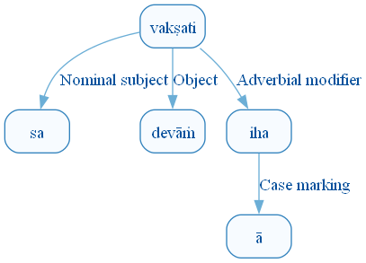
Figure 19: DCS Original Dependency Graph for Sentence ID 576250
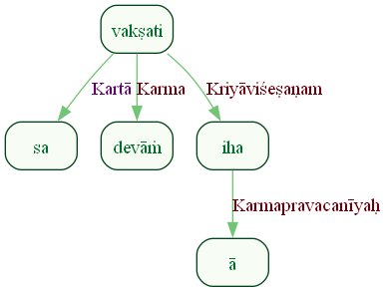
Figure 20: Sanskrit Tags Dependency Graph for Sentence ID 576250
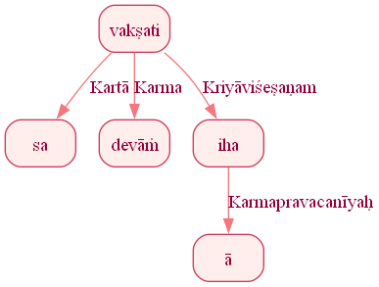
Figure 21: Reduced Dependency Graph for Sentence ID 576250

Sentence ID: 576251
Mantra Text:
agninā rayim aśnavat poṣam eva dive dive yaśasam vīravattamam
[('1_3', '1_1', 'Karaṇam'), ('1_3', '1_2', 'Karma'), ('1_2', '1_4', 'Viśeṣaṇam'), ('1_4', '1_5', 'Discourse_unknown_label'), ('1_3', '1_6', 'Adhikaraṇam'), ('1_6', '1_7', 'vīpsā'), ('1_4', '1_8', 'Viśeṣaṇam'), ('1_4', '1_9', 'Viśeṣaṇam')]
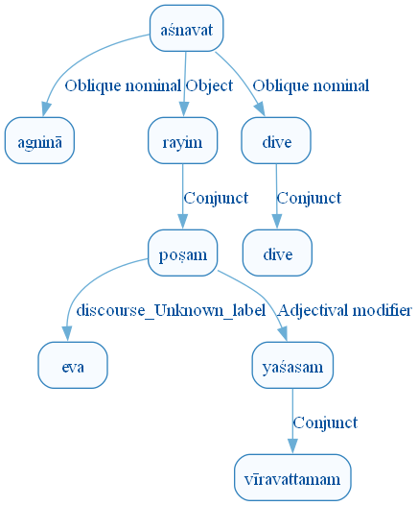
Figure 28: DCS Original Dependency Graph for Sentence ID 576251
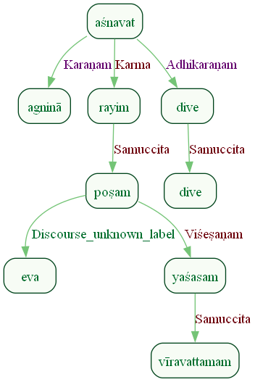
Figure 29: Sanskrit Tags Dependency Graph for Sentence ID 576251
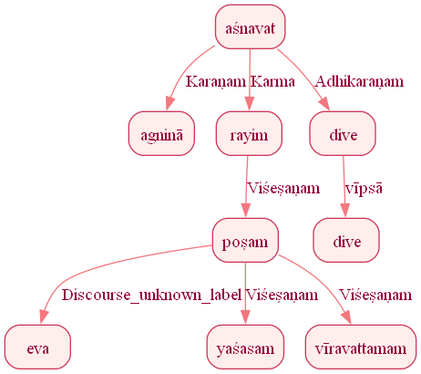
Figure 30: Reduced Dependency Graph for Sentence ID 576251

Sentence ID: 576254
Mantra Text:
agne yam yajñam adhvaram viśvatas paribhūḥ asi saḥ id deveṣu gacchati
[('1_6', '1_1', 'Sambodhyaḥ'), ('1_3', '1_2', 'Viśeṣaṇam'), ('1_6', '1_3', 'Karma'), ('1_3', '1_4', 'Viśeṣaṇam'), ('1_6', '1_5', 'Kriyāviśeṣaṇam'), ('1_8', '1_6', 'Viśeṣaṇam'), ('1_6', '1_7', 'Copula'), ('1_11', '1_8', 'Kartā'), ('1_8', '1_9', 'Discourse_unknown_label'), ('1_11', '1_10', 'Adhikaraṇam')]
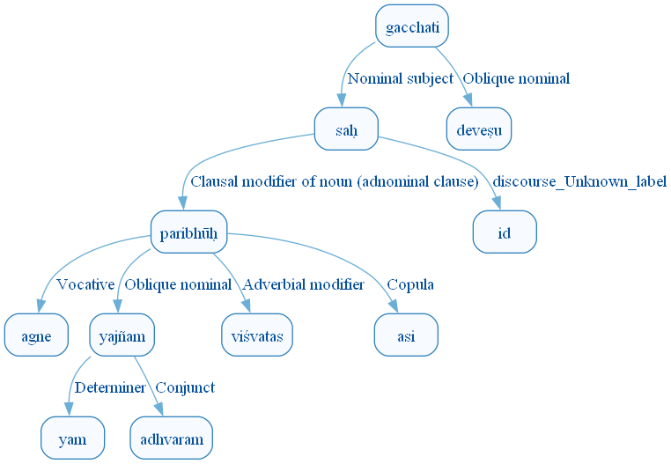
Figure 37: DCS Original Dependency Graph for Sentence ID 576254
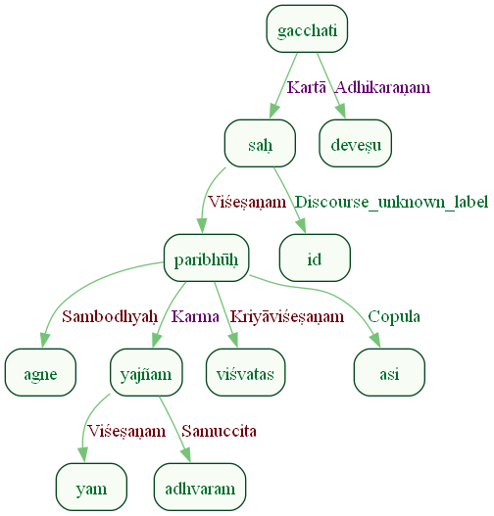
Figure 38: Sanskrit Tags Dependency Graph for Sentence ID 576254
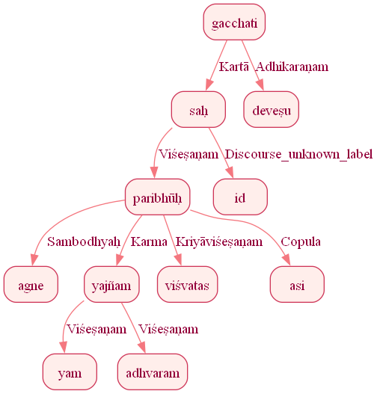
Figure 39: Reduced Dependency Graph for Sentence ID 576254

Sentence ID: 576256
Mantra Text:
agniḥ hotā kavi kratuḥ satyaḥ citraśravastamaḥ devaḥ devebhiḥ ā gamat
[('1_10', '1_1', 'Kartā'), ('1_1', '1_2', 'Viśeṣaṇam'), ('1_1', '1_3', 'Viśeṣaṇam'), ('1_1', '1_4', 'Viśeṣaṇam'), ('1_1', '1_5', 'Viśeṣaṇam'), ('1_1', '1_6', 'Viśeṣaṇam'), ('1_10', '1_7', 'Kriyāviśeṣaṇam'), ('1_10', '1_8', 'Karaṇam'), ('1_10', '1_9', 'Kriyāviśeṣaṇam')]
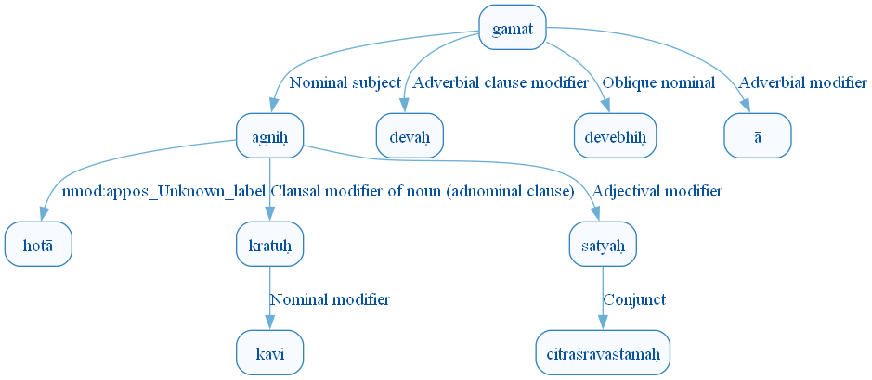
Figure 46: DCS Original Dependency Graph for Sentence ID 576256
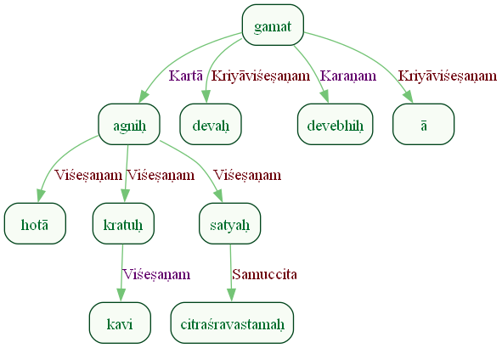
Figure 47: Sanskrit Tags Dependency Graph for Sentence ID 576256
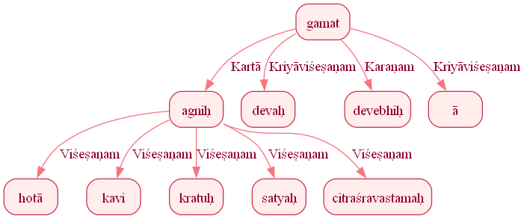
Figure 48: Reduced Dependency Graph for Sentence ID 576256

Sentence ID: 576258
Mantra Text:
yat aṅga dāśuṣe tvam agne bhadram kariṣyasi tava id tat satyam aṅgiraḥ
[('1_7', '1_1', 'Marker'), ('1_1', '1_2', 'Fixed multiword expression'), ('1_7', '1_3', 'Sampradānam'), ('1_7', '1_4', 'Kartā'), ('1_7', '1_5', 'Sambodhyaḥ'), ('1_7', '1_6', 'Karma'), ('1_11', '1_7', 'Kriyāviśeṣaṇam'), ('1_10', '1_8', 'Ṣaṣṭhīsambandhaḥ'), ('1_8', '1_9', 'Discourse_unknown_label'), ('1_11', '1_10', 'Kartā'), ('1_11', '1_12', 'Sambodhyaḥ')]
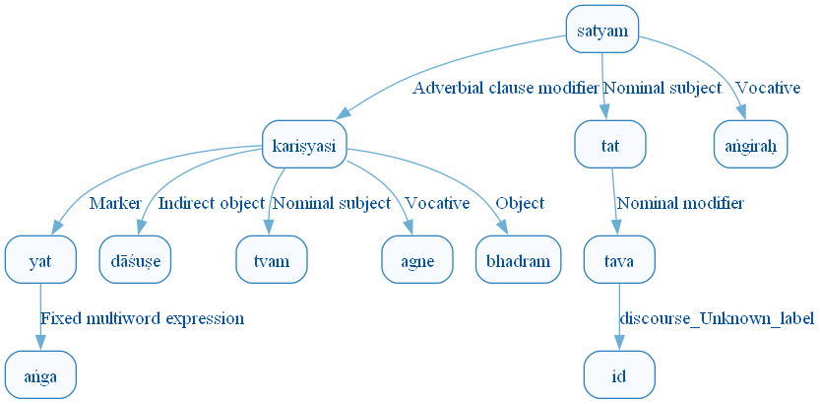
Figure 55: DCS Original Dependency Graph for Sentence ID 576258
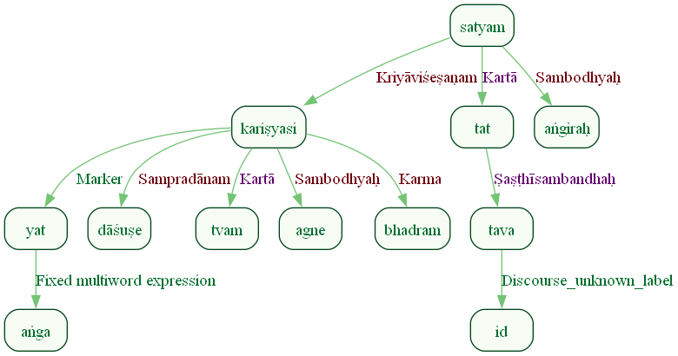
Figure 56: Sanskrit Tags Dependency Graph for Sentence ID 576258
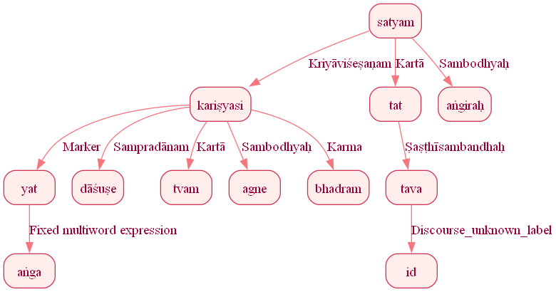
Figure 57: Reduced Dependency Graph for Sentence ID 576258

Sentence ID: 576260
Mantra Text:
upa tvā agne dive dive doṣāvastar dhiyā vayam namaḥ bharantaḥ ā imasi rājantam adhvarāṇām gopām ṛtasya dīdivim vardhamānam sve dame
[('1_2', '1_1', 'Karmapravacanīyaḥ'), ('1_12', '1_2', 'Karma'), ('1_12', '1_3', 'Sambodhyaḥ'), ('1_12', '1_4', 'Adhikaraṇam'), ('1_4', '1_5', 'vīpsā'), ('1_12', '1_6', 'Sambodhyaḥ'), ('1_12', '1_7', 'Karaṇam'), ('1_12', '1_8', 'Kartā'), ('1_10', '1_9', 'Karma'), ('1_12', '1_10', 'Kriyāviśeṣaṇam'), ('1_12', '1_11', 'Kriyāviśeṣaṇam'), ('1_2', '1_13', 'Viśeṣaṇam'), ('1_15', '1_14', 'Ṣaṣṭhīsambandhaḥ'), ('1_2', '1_15', 'Viśeṣaṇam'), ('1_17', '1_16', 'Ṣaṣṭhīsambandhaḥ'), ('1_2', '1_17', 'Viśeṣaṇam'), ('1_2', '1_18', 'Viśeṣaṇam'), ('1_20', '1_19', 'Viśeṣaṇam'), ('1_18', '1_20', 'Adhikaraṇam')]
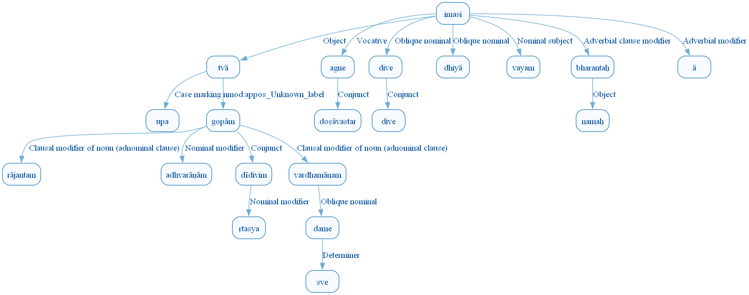
Figure 64: DCS Original Dependency Graph for Sentence ID 576260
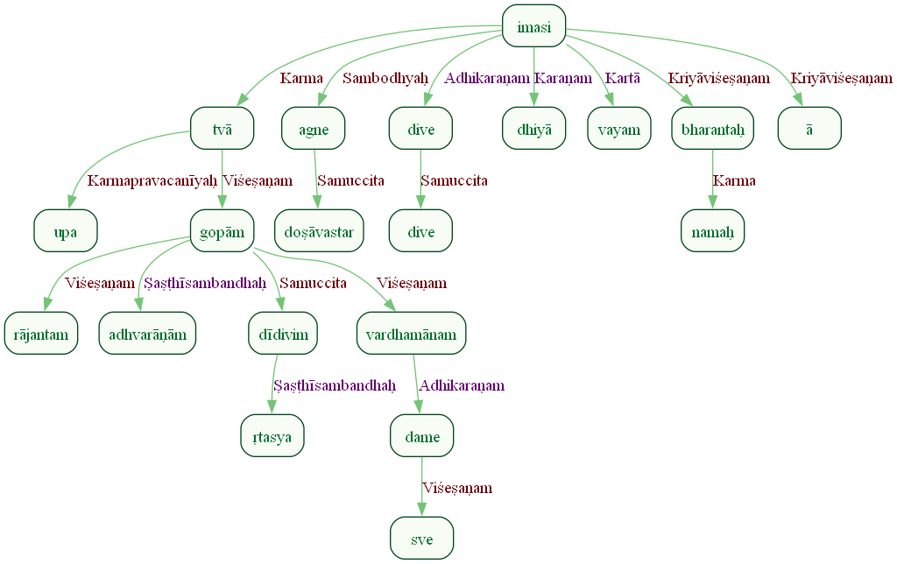
Figure 65: Sanskrit Tags Dependency Graph for Sentence ID 576260
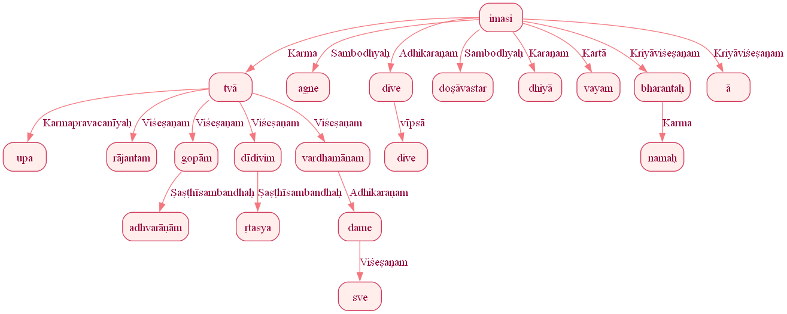
Figure 66: Reduced Dependency Graph for Sentence ID 576260

Sentence ID: 576263
Mantra Text:
sa naḥ pitā iva sūnave agne su upāyanaḥ bhava
[('1_9', '1_1', 'Kriyāviśeṣaṇam'), ('1_9', '1_2', 'Sampradānam'), ('1_9', '1_3', 'Advcl:manner_unknown_label'), ('1_3', '1_4', 'Mark:sim_unknown_label'), ('1_3', '1_5', 'Orphan'), ('1_9', '1_6', 'Sambodhyaḥ'), ('1_8', '1_7', 'Kriyāviśeṣaṇam'), ('1_9', '1_8', 'Open clausal complement')]
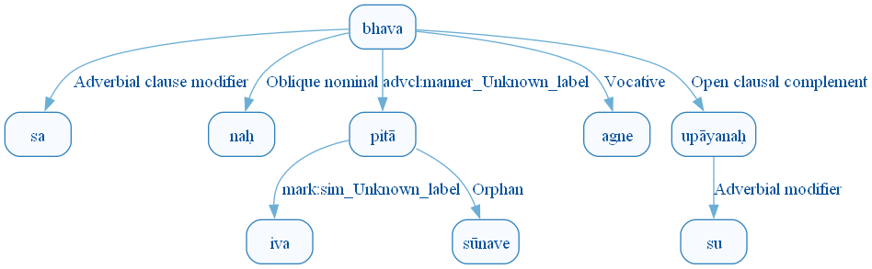
Figure 73: DCS Original Dependency Graph for Sentence ID 576263
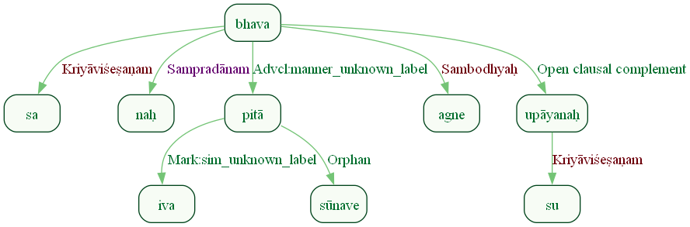
Figure 74: Sanskrit Tags Dependency Graph for Sentence ID 576263
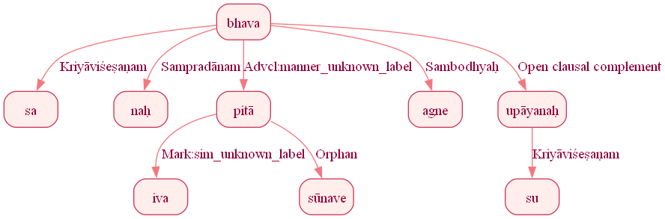
Figure 75: Reduced Dependency Graph for Sentence ID 576263

Sentence ID: 576264
Mantra Text:
sacasvā naḥ svastaye
[('1_1', '1_2', 'Karma'), ('1_1', '1_3', 'Sampradānam')]
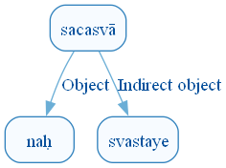
Figure 82: DCS Original Dependency Graph for Sentence ID 576264
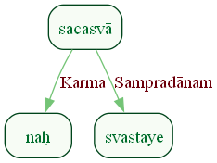
Figure 83: Sanskrit Tags Dependency Graph for Sentence ID 576264
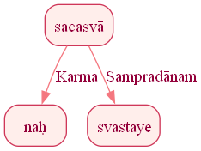
Figure 84: Reduced Dependency Graph for Sentence ID 576264

ConLLU File: ṚV, 1, 2

Sentence ID: 576265
Mantra Text:
vāyo ā yāhi darśata ime somāḥ araṃkṛtāḥ
[('1_3', '1_1', 'Sambodhyaḥ'), ('1_3', '1_2', 'Kriyāviśeṣaṇam'), ('1_1', '1_4', 'Viśeṣaṇam'), ('2_2', '2_1', 'Kartā'), ('2_2', '2_3', 'Acl:ptcp_unknown_label')]
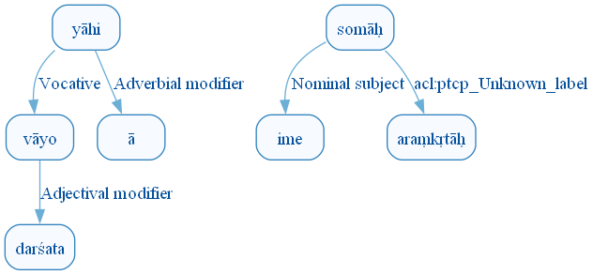
Figure 91: DCS Original Dependency Graph for Sentence ID 576265
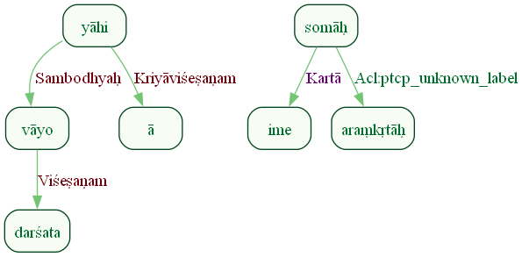
Figure 92: Sanskrit Tags Dependency Graph for Sentence ID 576265
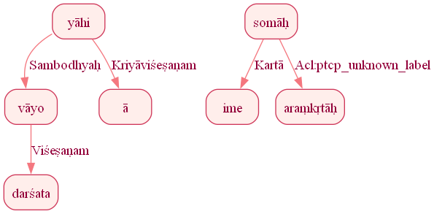
Figure 93: Reduced Dependency Graph for Sentence ID 576265

Sentence ID: 576266
Mantra Text:
teṣām pāhi śrudhi havam
[('1_2', '1_1', 'Karma'), ('2_1', '2_2', 'Karma')]
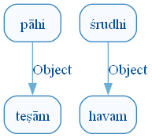
Figure 100: DCS Original Dependency Graph for Sentence ID 576266
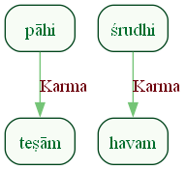
Figure 101: Sanskrit Tags Dependency Graph for Sentence ID 576266
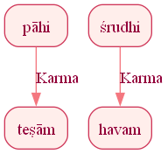
Figure 102: Reduced Dependency Graph for Sentence ID 576266

Sentence ID: 576267
Mantra Text:
vāyo ukthebhiḥ jarante tvām acchā jaritāraḥ suta somāḥ ahar vidaḥ
[('1_3', '1_1', 'Sambodhyaḥ'), ('1_3', '1_2', 'Obl:instr_unknown_label'), ('1_3', '1_4', 'Karma'), ('1_3', '1_5', 'Kriyāviśeṣaṇam'), ('1_3', '1_6', 'Kartā'), ('1_8', '1_7', 'Viśeṣaṇam'), ('1_6', '1_8', 'Acl:dpct_unknown_label'), ('1_10', '1_9', 'Karma'), ('1_6', '1_10', 'Acl:dpct_unknown_label')]
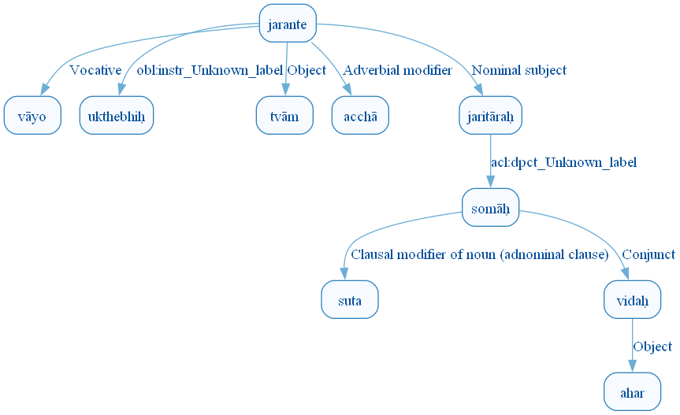
Figure 109: DCS Original Dependency Graph for Sentence ID 576267
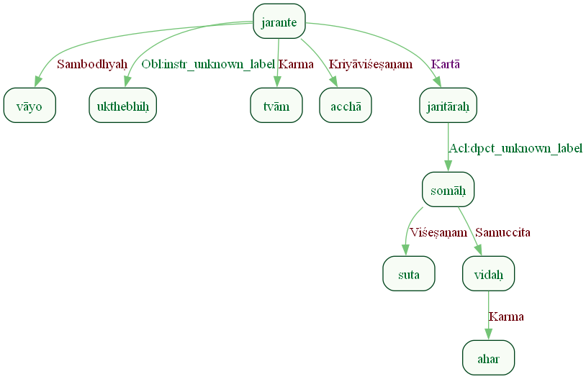
Figure 110: Sanskrit Tags Dependency Graph for Sentence ID 576267
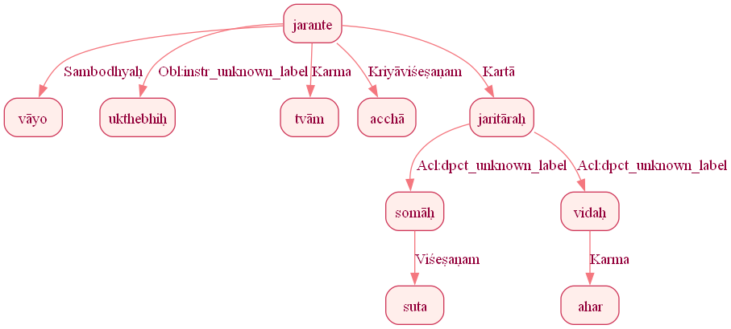
Figure 111: Reduced Dependency Graph for Sentence ID 576267

Sentence ID: 576269
Mantra Text:
prapṛñcatī vāyo tava prapṛñcatī dhenā jigāti dāśuṣe urūcī soma pītaye
[('2_5', '2_1', 'Sambodhyaḥ'), ('2_4', '2_2', 'Ṣaṣṭhīsambandhaḥ'), ('2_4', '2_3', 'Viśeṣaṇam'), ('2_5', '2_4', 'Kartā'), ('2_5', '2_6', 'Obl:benef_unknown_label'), ('2_4', '2_7', 'Advcl:dpct_unknown_label'), ('2_9', '2_8', 'Karma'), ('2_7', '2_9', 'Advcl:fin_unknown_label')]
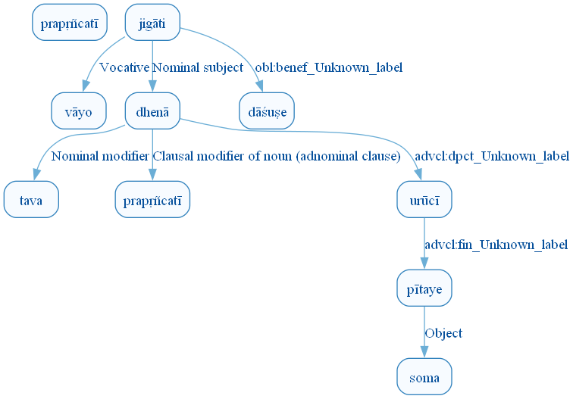
Figure 118: DCS Original Dependency Graph for Sentence ID 576269
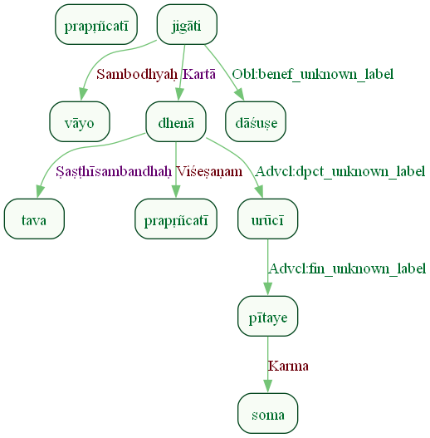
Figure 119: Sanskrit Tags Dependency Graph for Sentence ID 576269
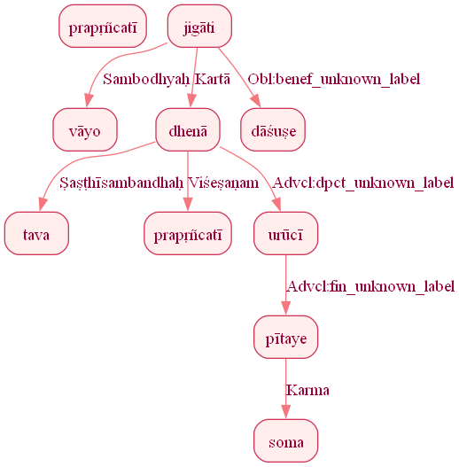
Figure 120: Reduced Dependency Graph for Sentence ID 576269

Sentence ID: 576271
Mantra Text:
indra vāyū ime sutāḥ upa prayobhiḥ ā gatam
[('1_2', '1_1', 'Compound:coord_unknown_label'), ('1_4', '1_2', 'Sambodhyaḥ'), ('1_4', '1_3', 'Kartā'), ('2_4', '2_1', 'Kriyāviśeṣaṇam'), ('2_4', '2_2', 'Obl:manner_unknown_label'), ('2_4', '2_3', 'Kriyāviśeṣaṇam')]
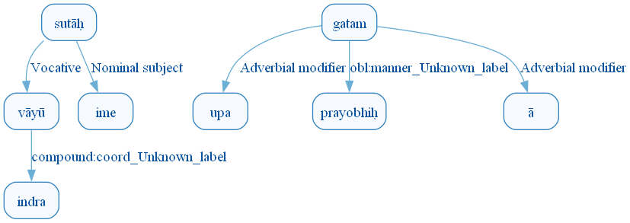
Figure 127: DCS Original Dependency Graph for Sentence ID 576271
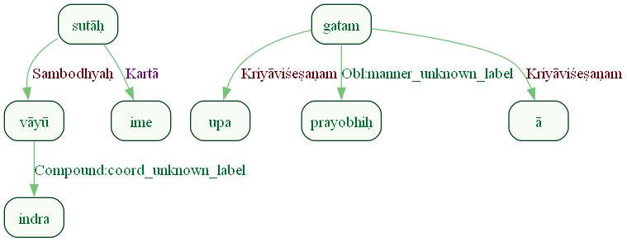
Figure 128: Sanskrit Tags Dependency Graph for Sentence ID 576271
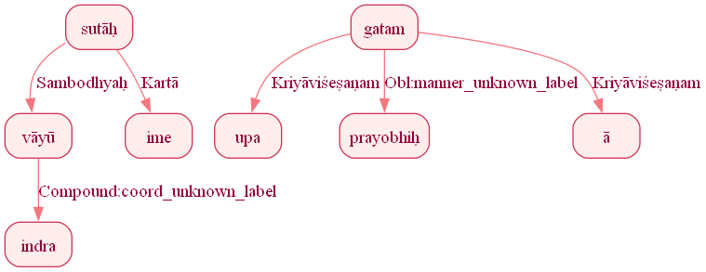
Figure 129: Reduced Dependency Graph for Sentence ID 576271

Sentence ID: 576272
Mantra Text:
indavaḥ vām uśanti hi
[('1_3', '1_1', 'Kartā'), ('1_3', '1_2', 'Karma'), ('1_3', '1_4', 'Discourse_unknown_label')]
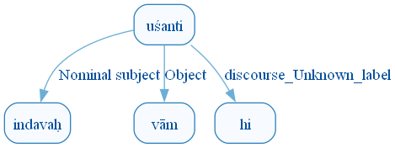
Figure 136: DCS Original Dependency Graph for Sentence ID 576272
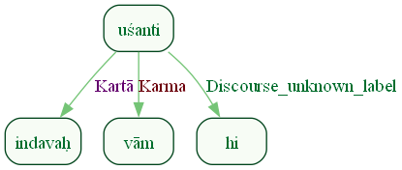
Figure 137: Sanskrit Tags Dependency Graph for Sentence ID 576272
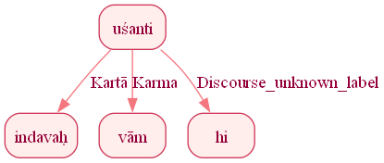
Figure 138: Reduced Dependency Graph for Sentence ID 576272

Sentence ID: 576273
Mantra Text:
vāyo indraḥ ca cetathaḥ sutānām vājinī vasū
[('1_4', '1_1', 'Sambodhyaḥ'), ('1_4', '1_2', 'Sambodhyaḥ'), ('1_2', '1_3', 'Samuccita_dyotakaḥ'), ('1_4', '1_5', 'Karma'), ('1_1', '1_6', 'Viśeṣaṇam'), ('1_1', '1_7', 'Viśeṣaṇam')]
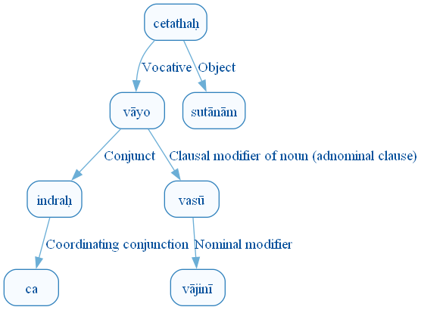
Figure 145: DCS Original Dependency Graph for Sentence ID 576273
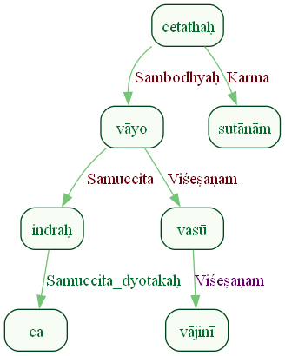
Figure 146: Sanskrit Tags Dependency Graph for Sentence ID 576273
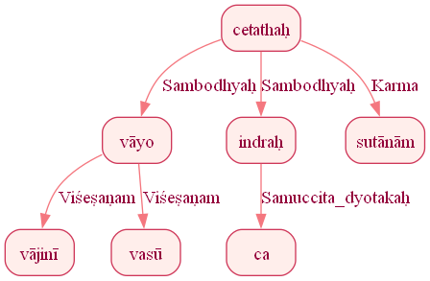
Figure 147: Reduced Dependency Graph for Sentence ID 576273

Sentence ID: 576274
Mantra Text:
tau ā yātam upa dravat
[('1_3', '1_1', 'Advcl:dpct_unknown_label'), ('1_3', '1_2', 'Kriyāviśeṣaṇam'), ('1_5', '1_4', 'Karmapravacanīyaḥ'), ('1_3', '1_5', 'Obl:manner_unknown_label')]
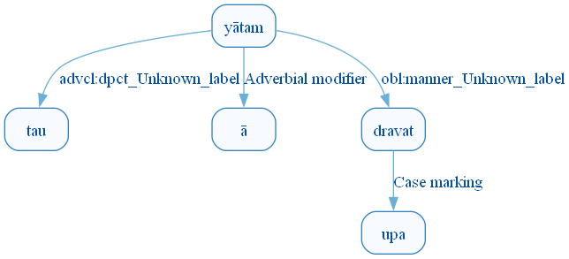
Figure 154: DCS Original Dependency Graph for Sentence ID 576274
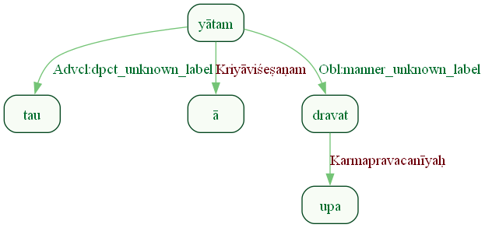
Figure 155: Sanskrit Tags Dependency Graph for Sentence ID 576274
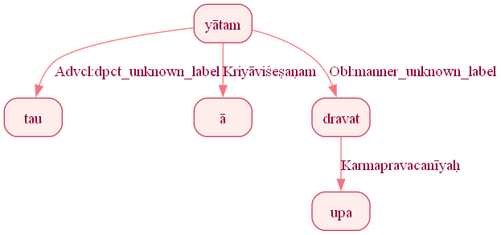
Figure 156: Reduced Dependency Graph for Sentence ID 576274

Sentence ID: 576275
Mantra Text:
vāyo indraḥ ca sunvataḥ ā yātam upa niṣkṛtam makṣū itthā dhiyā narā
[('1_6', '1_1', 'Sambodhyaḥ'), ('1_6', '1_2', 'Sambodhyaḥ'), ('1_2', '1_3', 'Samuccita_dyotakaḥ'), ('1_8', '1_4', 'Ṣaṣṭhīsambandhaḥ'), ('1_6', '1_5', 'Kriyāviśeṣaṇam'), ('1_8', '1_7', 'Karmapravacanīyaḥ'), ('1_6', '1_8', 'Obl:goal_unknown_label'), ('1_6', '1_9', 'Kriyāviśeṣaṇam'), ('1_6', '1_10', 'Kriyāviśeṣaṇam'), ('1_9', '1_11', 'Obl:instr_unknown_label'), ('1_1', '1_12', 'Viśeṣaṇam')]
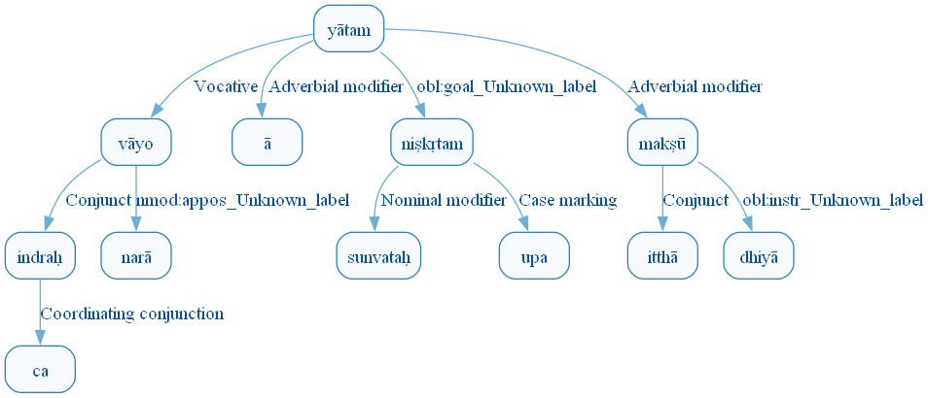
Figure 163: DCS Original Dependency Graph for Sentence ID 576275
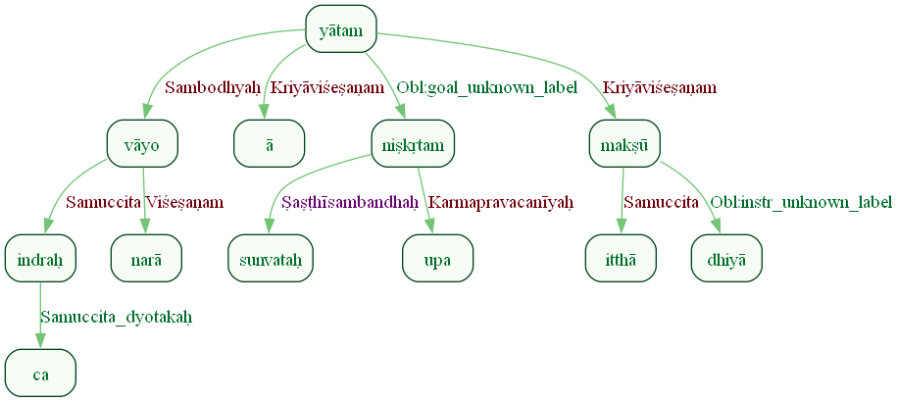
Figure 164: Sanskrit Tags Dependency Graph for Sentence ID 576275
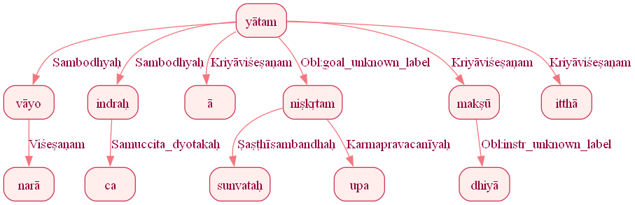
Figure 165: Reduced Dependency Graph for Sentence ID 576275

Sentence ID: 576277
Mantra Text:
mitram huve pūta dakṣam varuṇam ca riśādasam dhiyam ghṛtācīm sādhantā
[('1_2', '1_1', 'Karma'), ('1_4', '1_3', 'Viśeṣaṇam'), ('1_1', '1_4', 'Acl:attr_unknown_label'), ('1_1', '1_5', 'Viśeṣaṇam'), ('1_5', '1_6', 'Samuccita_dyotakaḥ'), ('1_5', '1_7', 'Viśeṣaṇam'), ('1_10', '1_8', 'Karma'), ('1_8', '1_9', 'Viśeṣaṇam'), ('1_1', '1_10', 'Viśeṣaṇam')]
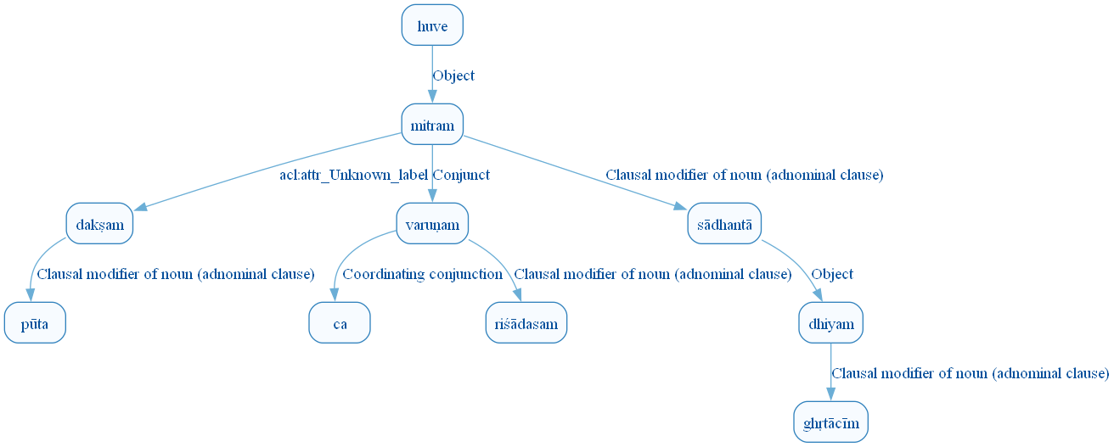
Figure 172: DCS Original Dependency Graph for Sentence ID 576277
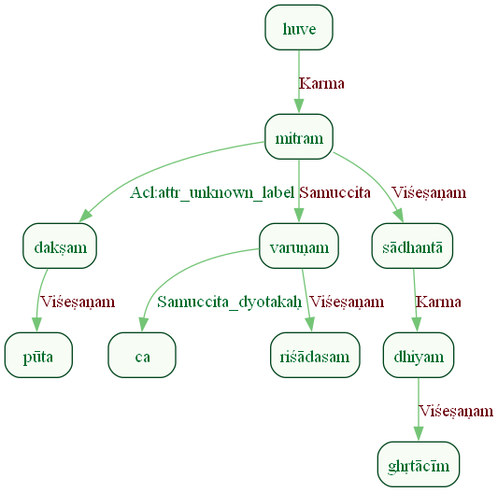
Figure 173: Sanskrit Tags Dependency Graph for Sentence ID 576277
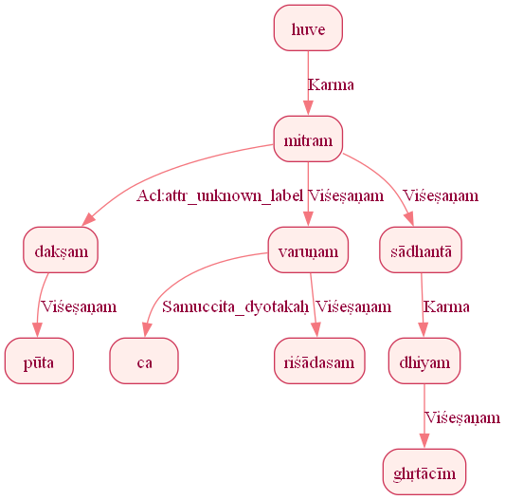
Figure 174: Reduced Dependency Graph for Sentence ID 576277

Sentence ID: 576280
Mantra Text:
ṛtena mitrāvaruṇau ṛtāvṛdhau ṛta spṛśā kratum bṛhantam āśāthe
[('1_8', '1_1', 'Obl:instr_unknown_label'), ('1_8', '1_2', 'Sambodhyaḥ'), ('1_2', '1_3', 'Acl:attr_unknown_label'), ('1_5', '1_4', 'Karma'), ('1_2', '1_5', 'Acl:attr_unknown_label'), ('1_8', '1_6', 'Karma'), ('1_6', '1_7', 'Viśeṣaṇam')]
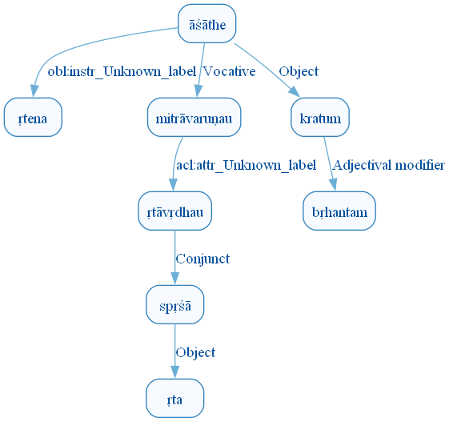
Figure 181: DCS Original Dependency Graph for Sentence ID 576280
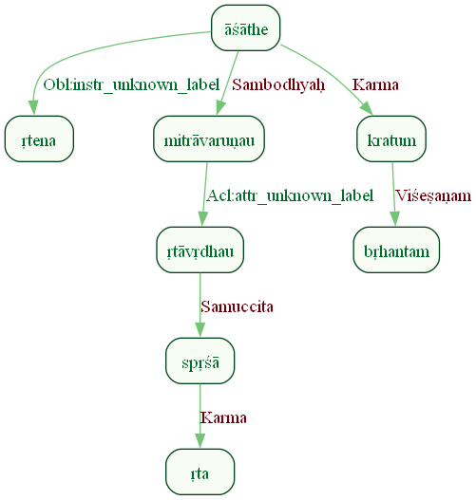
Figure 182: Sanskrit Tags Dependency Graph for Sentence ID 576280
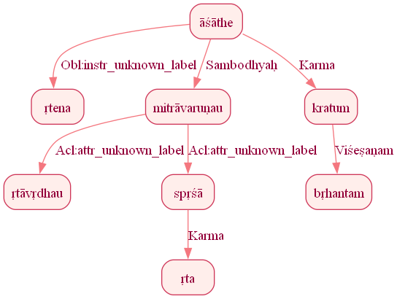
Figure 183: Reduced Dependency Graph for Sentence ID 576280

Sentence ID: 576282
Mantra Text:
kavī naḥ mitrāvaruṇā tuvi jātā uru kṣayā dakṣam dadhāte apasam
[('1_3', '1_1', 'Viśeṣaṇam'), ('1_9', '1_2', 'Sampradānam'), ('1_9', '1_3', 'Kartā'), ('1_5', '1_4', 'Kriyāviśeṣaṇam'), ('1_3', '1_5', 'Viśeṣaṇam'), ('1_7', '1_6', 'Viśeṣaṇam'), ('1_3', '1_7', 'Viśeṣaṇam'), ('1_9', '1_8', 'Karma'), ('1_8', '1_10', 'Viśeṣaṇam')]
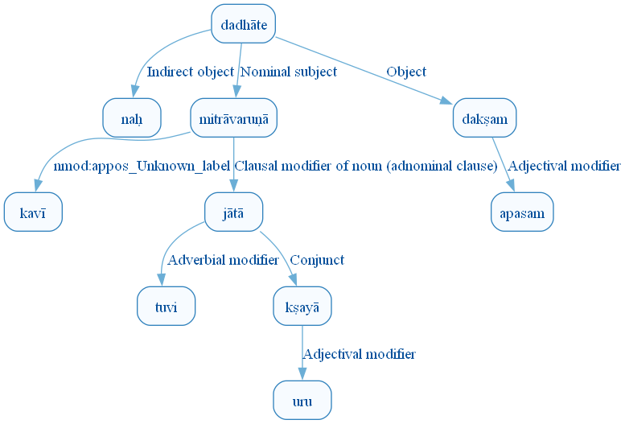
Figure 190: DCS Original Dependency Graph for Sentence ID 576282
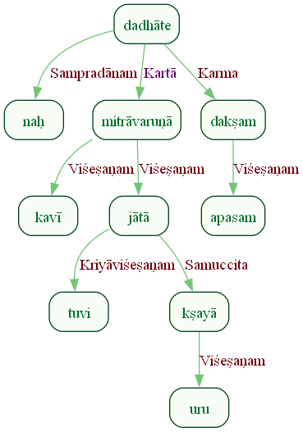
Figure 191: Sanskrit Tags Dependency Graph for Sentence ID 576282
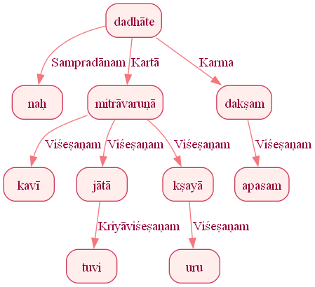
Figure 192: Reduced Dependency Graph for Sentence ID 576282

ConLLU File: ṚV, 1, 3

Sentence ID: 576283
Mantra Text:
aśvinā yajvarīr iṣo dravatpāṇī śubhas patī
[('0_3', '0_1', 'Sambodhyaḥ'), ('0_3', '0_2', 'Viśeṣaṇam'), ('0_1', '0_4', 'Viśeṣaṇam'), ('0_1', '0_5', 'Viśeṣaṇam'), ('0_7', '0_6', 'Ṣaṣṭhīsambandhaḥ'), ('0_3', '0_7', 'Sambodhyaḥ')]
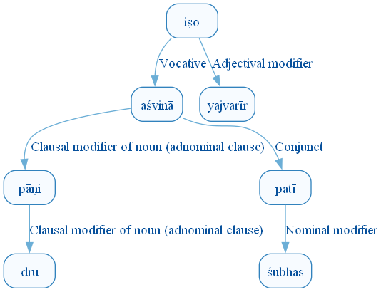
Figure 199: DCS Original Dependency Graph for Sentence ID 576283
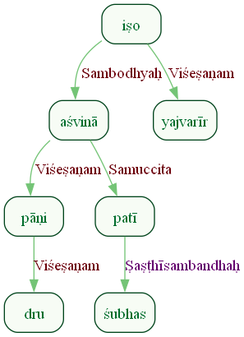
Figure 200: Sanskrit Tags Dependency Graph for Sentence ID 576283
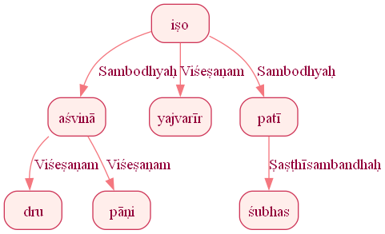
Figure 201: Reduced Dependency Graph for Sentence ID 576283

Sentence ID: 576284
Mantra Text:
purubhujā canasyatam
[('0_2', '0_1', 'Karma'), ('0_3', '0_2', 'Sambodhyaḥ')]
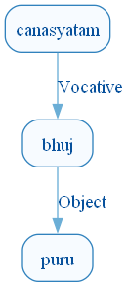
Figure 208: DCS Original Dependency Graph for Sentence ID 576284
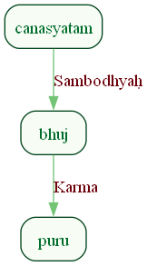
Figure 209: Sanskrit Tags Dependency Graph for Sentence ID 576284
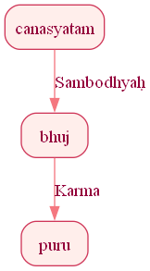
Figure 210: Reduced Dependency Graph for Sentence ID 576284

Sentence ID: 576285
Mantra Text:
aśvinā purudaṃsasā narā śavīrayā dhiyā
[('0_6', '0_1', 'Viśeṣaṇam'), ('0_1', '0_2', 'Viśeṣaṇam'), ('0_6', '0_3', 'Viśeṣaṇam'), ('0_6', '0_4', 'Viśeṣaṇam'), ('0_6', '0_5', 'Viśeṣaṇam')]
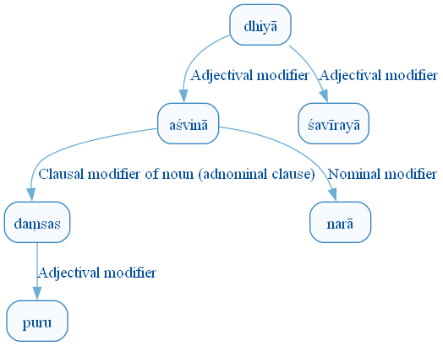
Figure 217: DCS Original Dependency Graph for Sentence ID 576285
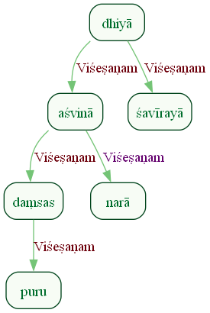
Figure 218: Sanskrit Tags Dependency Graph for Sentence ID 576285
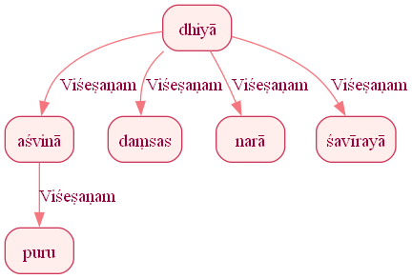
Figure 219: Reduced Dependency Graph for Sentence ID 576285

Sentence ID: 576286
Mantra Text:
dhiṣṇyā vanataṃ giraḥ
[('0_2', '0_1', 'Sambodhyaḥ'), ('0_2', '0_3', 'Karma')]
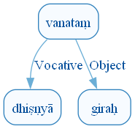
Figure 226: DCS Original Dependency Graph for Sentence ID 576286
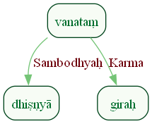
Figure 227: Sanskrit Tags Dependency Graph for Sentence ID 576286
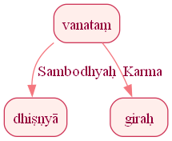
Figure 228: Reduced Dependency Graph for Sentence ID 576286

Sentence ID: 576287
Mantra Text:
dasrā yuvākavaḥ sutā nāsatyā vṛktabarhiṣaḥ
[('0_3', '0_1', 'Sambodhyaḥ'), ('0_3', '0_2', 'Kartā'), ('0_3', '0_4', 'Sambodhyaḥ'), ('0_4', '0_5', 'Viśeṣaṇam'), ('0_4', '0_6', 'Viśeṣaṇam')]
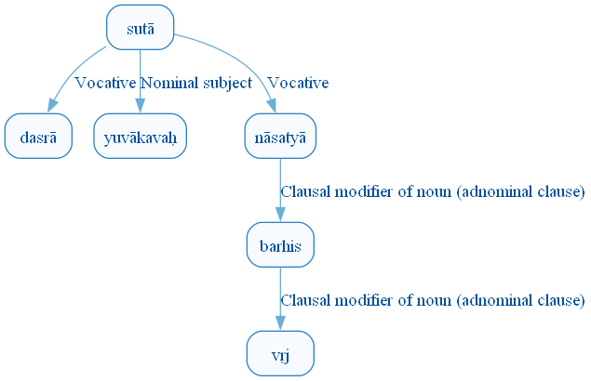
Figure 235: DCS Original Dependency Graph for Sentence ID 576287
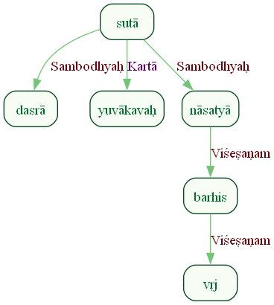
Figure 236: Sanskrit Tags Dependency Graph for Sentence ID 576287
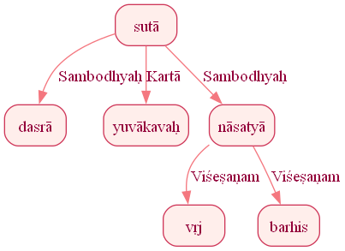
Figure 237: Reduced Dependency Graph for Sentence ID 576287

Sentence ID: 576288
Mantra Text:
ā yātaṃ rudravartanī
[('0_2', '0_1', 'Kriyāviśeṣaṇam'), ('0_2', '0_3', 'Sambodhyaḥ')]
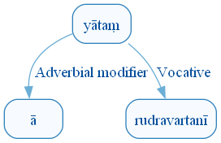
Figure 244: DCS Original Dependency Graph for Sentence ID 576288
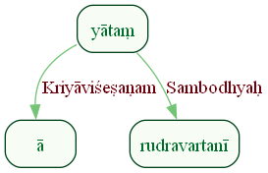
Figure 245: Sanskrit Tags Dependency Graph for Sentence ID 576288
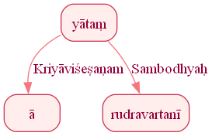
Figure 246: Reduced Dependency Graph for Sentence ID 576288

Sentence ID: 576289
Mantra Text:
indra ā yāhi citra bhāno sutāḥ ime tvāyavaḥ
[('0_3', '0_1', 'Sambodhyaḥ'), ('0_3', '0_2', 'Kriyāviśeṣaṇam'), ('0_5', '0_4', 'Viśeṣaṇam'), ('0_3', '0_5', 'Sambodhyaḥ'), ('1_3', '1_2', 'Viśeṣaṇam'), ('1_1', '1_3', 'Kartā')]
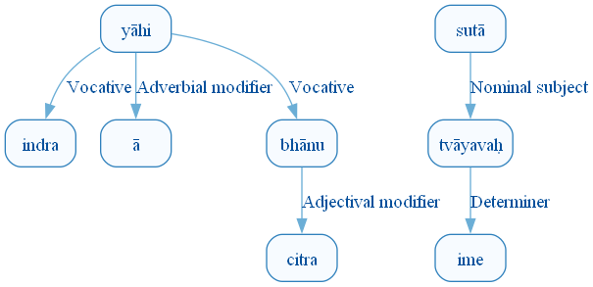
Figure 253: DCS Original Dependency Graph for Sentence ID 576289
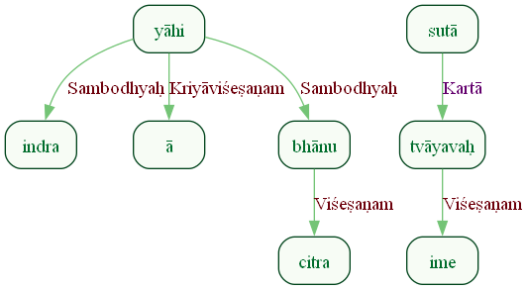
Figure 254: Sanskrit Tags Dependency Graph for Sentence ID 576289
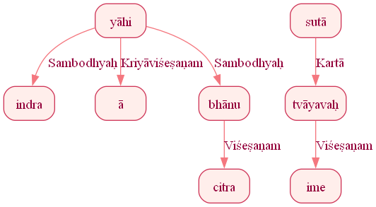
Figure 255: Reduced Dependency Graph for Sentence ID 576289

Sentence ID: 576290
Mantra Text:
aṇvībhis tanā pūtāsaḥ
[('0_2', '0_1', 'Viśeṣaṇam'), ('0_3', '0_2', 'Karaṇam')]
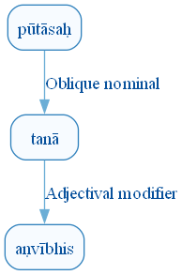
Figure 262: DCS Original Dependency Graph for Sentence ID 576290
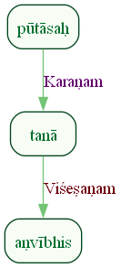
Figure 263: Sanskrit Tags Dependency Graph for Sentence ID 576290
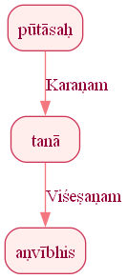
Figure 264: Reduced Dependency Graph for Sentence ID 576290

Sentence ID: 576291
Mantra Text:
indrā yāhi dhiyeṣito viprajūtaḥ sutāvataḥ
[('0_3', '0_1', 'Sambodhyaḥ'), ('0_3', '0_2', 'Kriyāviśeṣaṇam'), ('0_3', '0_4', 'Karaṇam'), ('0_3', '0_5', 'Kriyāviśeṣaṇam'), ('0_7', '0_6', 'Oblique nominal'), ('0_3', '0_7', 'Kriyāviśeṣaṇam'), ('0_3', '0_8', 'Oblique nominal')]
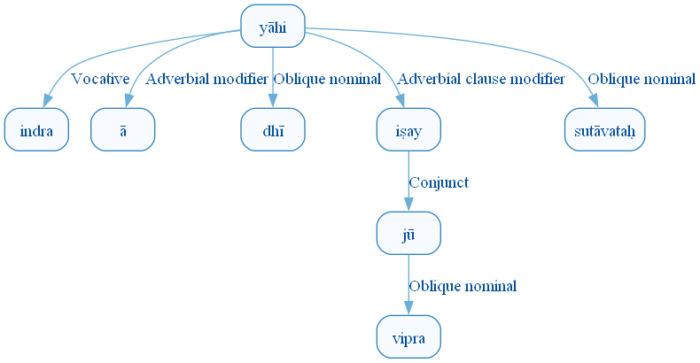
Figure 271: DCS Original Dependency Graph for Sentence ID 576291
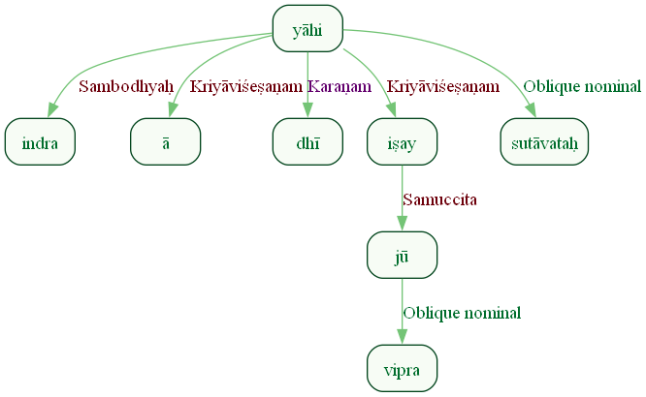
Figure 272: Sanskrit Tags Dependency Graph for Sentence ID 576291
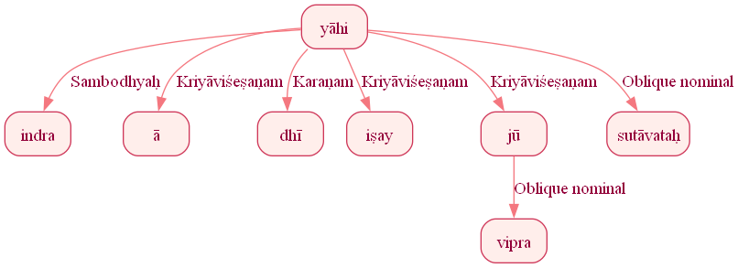
Figure 273: Reduced Dependency Graph for Sentence ID 576291

Sentence ID: 576292
Mantra Text:
upa brahmāṇi vāghataḥ
[('0_2', '0_3', 'Ṣaṣṭhīsambandhaḥ')]
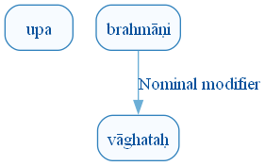
Figure 280: DCS Original Dependency Graph for Sentence ID 576292
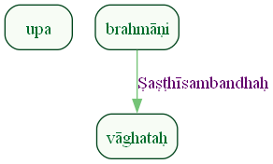
Figure 281: Sanskrit Tags Dependency Graph for Sentence ID 576292
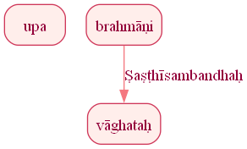
Figure 282: Reduced Dependency Graph for Sentence ID 576292

Sentence ID: 576293
Mantra Text:
indrā yāhi tūtujāna upa brahmāṇi harivaḥ
[('0_3', '0_1', 'Sambodhyaḥ'), ('0_3', '0_2', 'Kriyāviśeṣaṇam'), ('0_3', '0_4', 'Kriyāviśeṣaṇam'), ('0_6', '0_5', 'Karmapravacanīyaḥ'), ('0_3', '0_6', 'Karmapravacanīya_anvitaḥ'), ('0_3', '0_7', 'Sambodhyaḥ')]
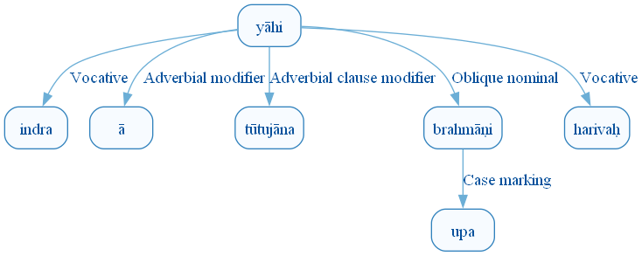
Figure 289: DCS Original Dependency Graph for Sentence ID 576293
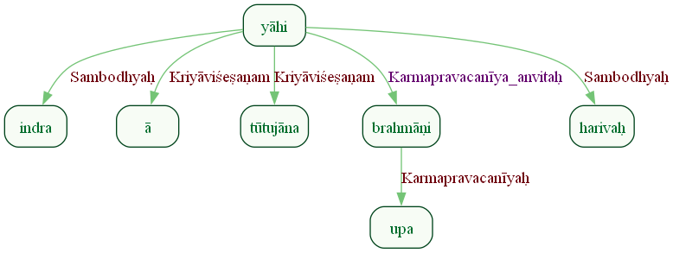
Figure 290: Sanskrit Tags Dependency Graph for Sentence ID 576293
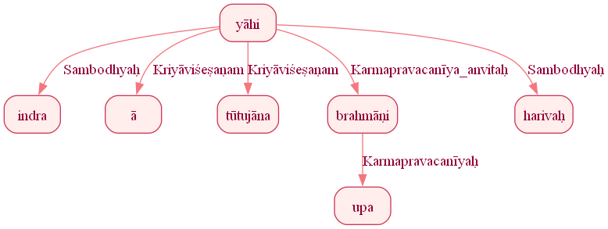
Figure 291: Reduced Dependency Graph for Sentence ID 576293

Sentence ID: 576294
Mantra Text:
sute dadhiṣva naś canaḥ
[('0_2', '0_1', 'Adhikaraṇam'), ('0_4', '0_3', 'Ṣaṣṭhīsambandhaḥ'), ('0_2', '0_4', 'Karma')]
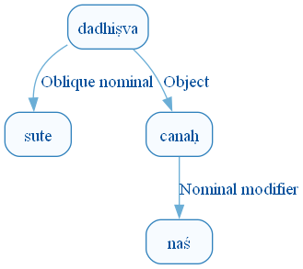
Figure 298: DCS Original Dependency Graph for Sentence ID 576294
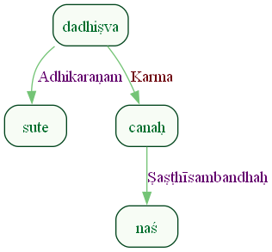
Figure 299: Sanskrit Tags Dependency Graph for Sentence ID 576294
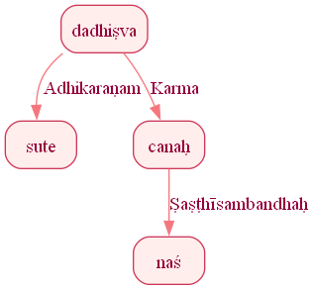
Figure 300: Reduced Dependency Graph for Sentence ID 576294

Sentence ID: 576295
Mantra Text:
omāsaś carṣaṇīdhṛto viśve devāsa ā gata
[('0_7', '0_1', 'Sambodhyaḥ'), ('0_3', '0_2', 'Karma'), ('0_1', '0_3', 'Viśeṣaṇam'), ('0_5', '0_4', 'Viśeṣaṇam'), ('0_7', '0_5', 'Sambodhyaḥ'), ('0_7', '0_6', 'Kriyāviśeṣaṇam')]
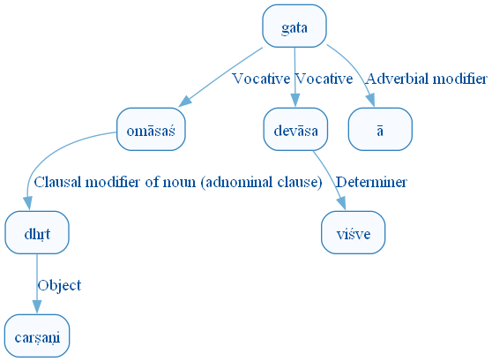
Figure 307: DCS Original Dependency Graph for Sentence ID 576295
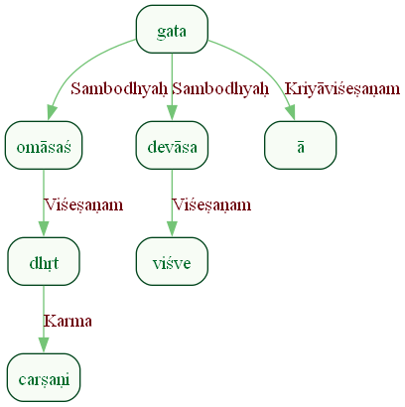
Figure 308: Sanskrit Tags Dependency Graph for Sentence ID 576295
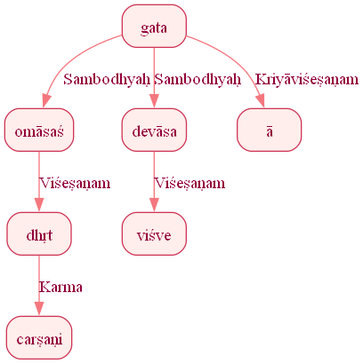
Figure 309: Reduced Dependency Graph for Sentence ID 576295

Sentence ID: 576296
Mantra Text:
dāśvāṃso dāśuṣaḥ sutam
[('0_3', '0_2', 'Ṣaṣṭhīsambandhaḥ'), ('0_1', '0_3', 'Karma')]
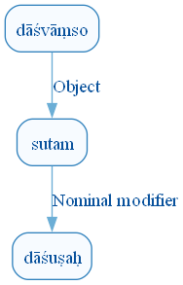
Figure 316: DCS Original Dependency Graph for Sentence ID 576296
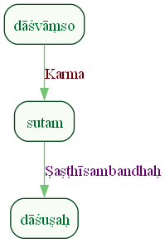
Figure 317: Sanskrit Tags Dependency Graph for Sentence ID 576296
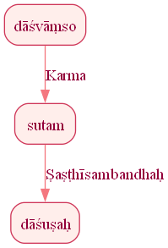
Figure 318: Reduced Dependency Graph for Sentence ID 576296

Sentence ID: 576297
Mantra Text:
viśve devāso apturaḥ sutam ā ganta tūrṇayaḥ
[('0_2', '0_1', 'Compound'), ('0_6', '0_2', 'Sambodhyaḥ'), ('0_2', '0_3', 'Viśeṣaṇam'), ('0_6', '0_4', 'Karma'), ('0_6', '0_5', 'Kriyāviśeṣaṇam'), ('0_6', '0_7', 'Kriyāviśeṣaṇam')]
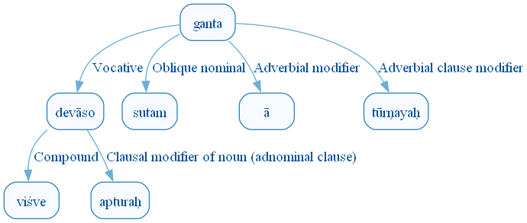
Figure 325: DCS Original Dependency Graph for Sentence ID 576297
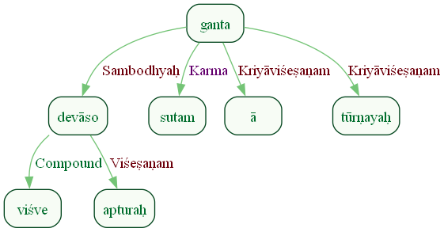
Figure 326: Sanskrit Tags Dependency Graph for Sentence ID 576297
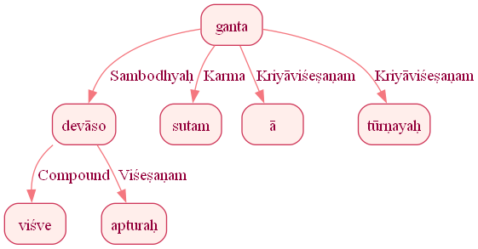
Figure 327: Reduced Dependency Graph for Sentence ID 576297

Sentence ID: 576298
Mantra Text:
usrā iva svasarāṇi
[('0_1', '0_2', 'Marker'), ('0_1', '0_3', 'Orphan')]
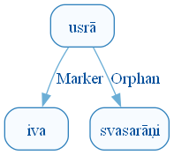
Figure 334: DCS Original Dependency Graph for Sentence ID 576298
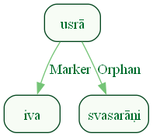
Figure 335: Sanskrit Tags Dependency Graph for Sentence ID 576298
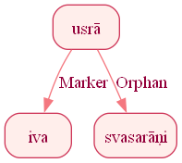
Figure 336: Reduced Dependency Graph for Sentence ID 576298

Sentence ID: 576299
Mantra Text:
viśve devāso asridha ehimāyāso adruhaḥ
[('0_2', '0_1', 'Compound'), ('0_2', '0_3', 'Viśeṣaṇam'), ('0_2', '0_4', 'Samuccita'), ('0_2', '0_5', 'Samuccita')]
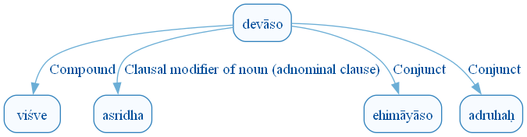
Figure 343: DCS Original Dependency Graph for Sentence ID 576299
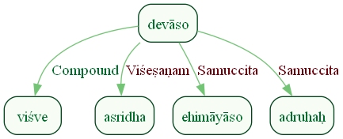
Figure 344: Sanskrit Tags Dependency Graph for Sentence ID 576299
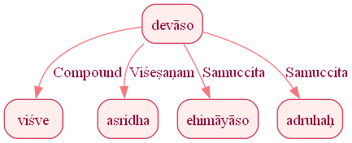
Figure 345: Reduced Dependency Graph for Sentence ID 576299

Sentence ID: 576300
Mantra Text:
medhaṃ juṣanta vahnayaḥ
[('0_2', '0_1', 'Karma'), ('0_2', '0_3', 'Kartā')]
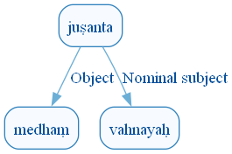
Figure 352: DCS Original Dependency Graph for Sentence ID 576300
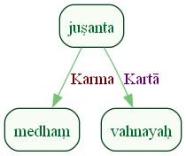
Figure 353: Sanskrit Tags Dependency Graph for Sentence ID 576300
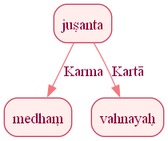
Figure 354: Reduced Dependency Graph for Sentence ID 576300

Sentence ID: 576302
Mantra Text:
pāvakā naḥ sarasvatī vājebhiḥ vājinīvatī yajñam vaṣṭu dhiyāvasuḥ
[('1_3', '1_1', 'Viśeṣaṇam'), ('1_6', '1_2', 'Ṣaṣṭhīsambandhaḥ'), ('1_7', '1_3', 'Kartā'), ('1_5', '1_4', 'Obl:soc_unknown_label'), ('1_3', '1_5', 'Viśeṣaṇam'), ('1_7', '1_6', 'Karma'), ('1_3', '1_8', 'Acl:dpct_unknown_label')]
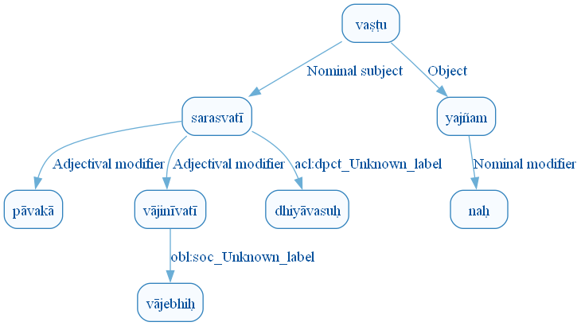
Figure 361: DCS Original Dependency Graph for Sentence ID 576302
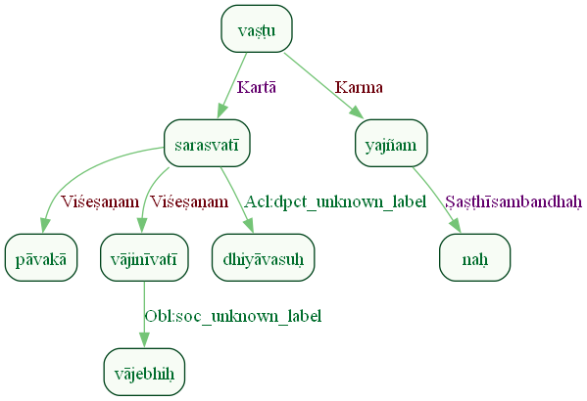
Figure 362: Sanskrit Tags Dependency Graph for Sentence ID 576302
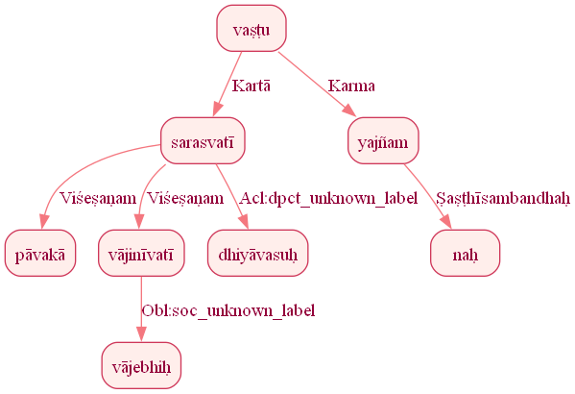
Figure 363: Reduced Dependency Graph for Sentence ID 576302

Sentence ID: 576304
Mantra Text:
codayitrī sūnṛtānām cetantī sumatīnām yajñam dadhe sarasvatī
[('1_7', '1_1', 'Acl:dpct_unknown_label'), ('1_1', '1_2', 'Ṣaṣṭhīsambandhaḥ'), ('1_7', '1_3', 'Acl:ptcp_unknown_label'), ('1_3', '1_4', 'Karma'), ('1_6', '1_5', 'Karma'), ('1_6', '1_7', 'Kartā')]
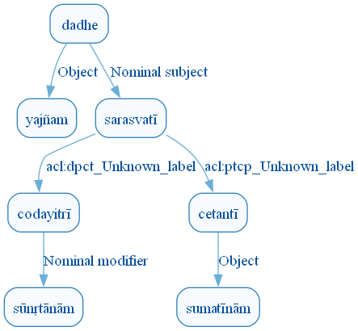
Figure 370: DCS Original Dependency Graph for Sentence ID 576304
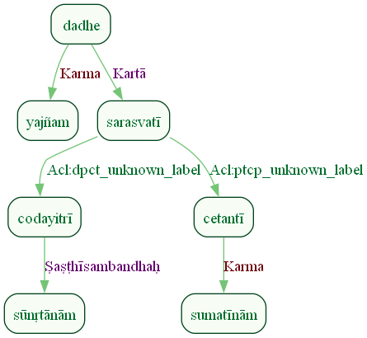
Figure 371: Sanskrit Tags Dependency Graph for Sentence ID 576304
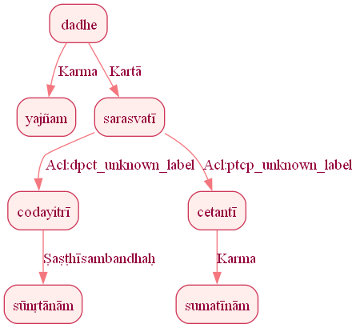
Figure 372: Reduced Dependency Graph for Sentence ID 576304

Sentence ID: 576305
Mantra Text:
mahaḥ arṇaḥ sarasvatī pra cetayati ketunā
[('1_2', '1_1', 'Viśeṣaṇam'), ('1_5', '1_2', 'Karma'), ('1_5', '1_3', 'Kartā'), ('1_5', '1_4', 'Kriyāviśeṣaṇam'), ('1_5', '1_6', 'Obl:instr_unknown_label')]
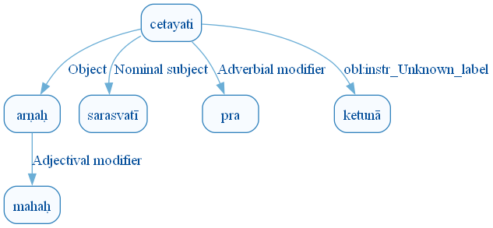
Figure 379: DCS Original Dependency Graph for Sentence ID 576305
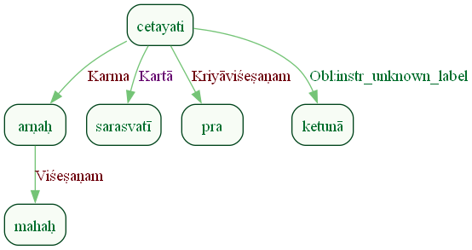
Figure 380: Sanskrit Tags Dependency Graph for Sentence ID 576305
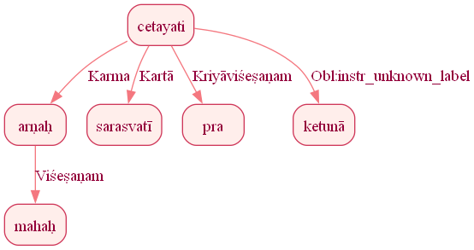
Figure 381: Reduced Dependency Graph for Sentence ID 576305

Sentence ID: 576306
Mantra Text:
dhiyaḥ viśvāḥ vi rājati
[('1_4', '1_1', 'Karma'), ('1_1', '1_2', 'Viśeṣaṇam'), ('1_4', '1_3', 'Kriyāviśeṣaṇam')]
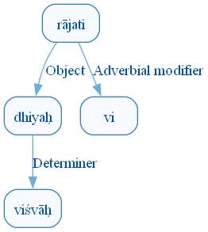
Figure 388: DCS Original Dependency Graph for Sentence ID 576306
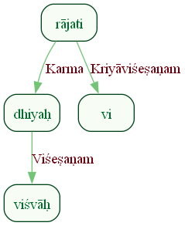
Figure 389: Sanskrit Tags Dependency Graph for Sentence ID 576306
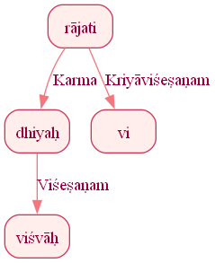
Figure 390: Reduced Dependency Graph for Sentence ID 576306

ConLLU File: ṚV, 1, 4

Sentence ID: 576307
Mantra Text:
surūpakṛtnum ūtaye sudughām iva goduhe
[('0_3', '0_1', 'Kriyāviśeṣaṇam'), ('0_3', '0_2', 'Karma'), ('0_3', '0_4', 'Kriyāviśeṣaṇam'), ('0_6', '0_5', 'Kriyāviśeṣaṇam'), ('0_3', '0_6', 'Samuccita'), ('0_6', '0_7', 'Kriyāviśeṣaṇam'), ('0_6', '0_8', 'Orphan')]
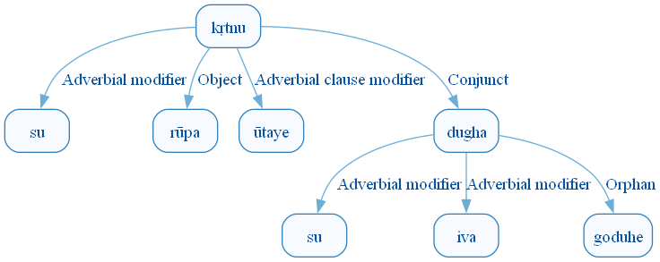
Figure 397: DCS Original Dependency Graph for Sentence ID 576307
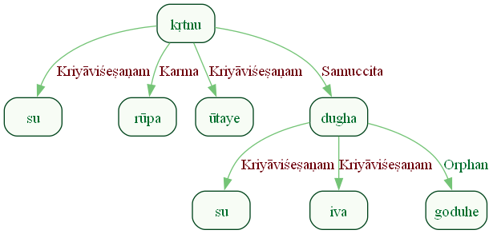
Figure 398: Sanskrit Tags Dependency Graph for Sentence ID 576307
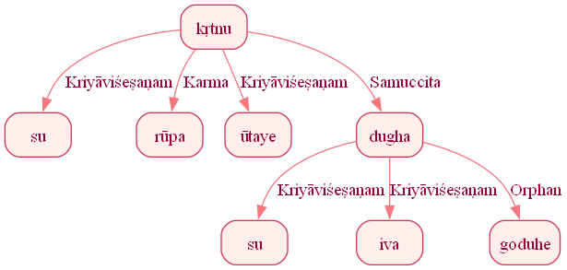
Figure 399: Reduced Dependency Graph for Sentence ID 576307

Sentence ID: 576308
Mantra Text:
juhūmasi dyavi dyavi
[('0_1', '0_2', 'Adhikaraṇam'), ('0_2', '0_3', 'vīpsā')]
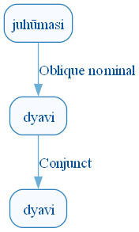
Figure 406: DCS Original Dependency Graph for Sentence ID 576308
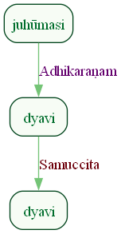
Figure 407: Sanskrit Tags Dependency Graph for Sentence ID 576308
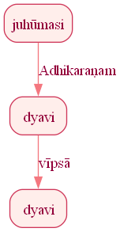
Figure 408: Reduced Dependency Graph for Sentence ID 576308

Sentence ID: 576309
Mantra Text:
upa naḥ savanā gahi somasya soma pāḥ piba
[('0_4', '0_1', 'Kriyāviśeṣaṇam'), ('0_3', '0_2', 'Ṣaṣṭhīsambandhaḥ'), ('0_4', '0_3', 'Karma'), ('1_3', '1_1', 'Karma'), ('1_3', '1_2', 'Karma'), ('1_4', '1_3', 'Sambodhyaḥ')]
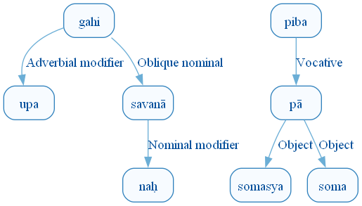
Figure 415: DCS Original Dependency Graph for Sentence ID 576309
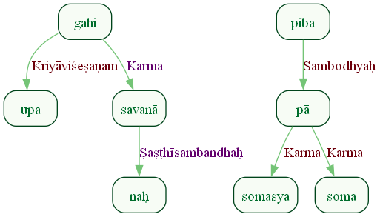
Figure 416: Sanskrit Tags Dependency Graph for Sentence ID 576309
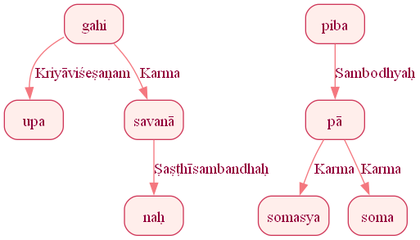
Figure 417: Reduced Dependency Graph for Sentence ID 576309

Sentence ID: 576310
Mantra Text:
godā id revato madaḥ
[('0_2', '0_1', 'Karma'), ('0_2', '0_3', 'Discourse_unknown_label'), ('0_5', '0_4', 'Viśeṣaṇam'), ('0_2', '0_5', 'Kartā')]
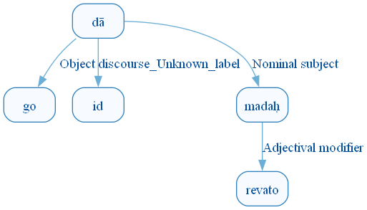
Figure 424: DCS Original Dependency Graph for Sentence ID 576310
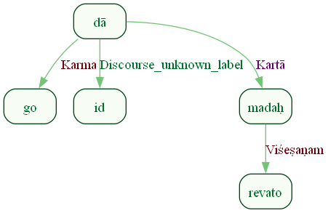
Figure 425: Sanskrit Tags Dependency Graph for Sentence ID 576310
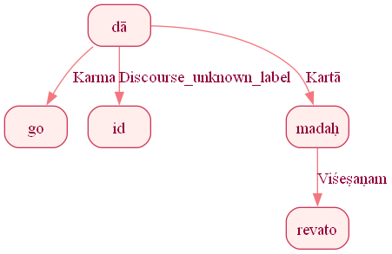
Figure 426: Reduced Dependency Graph for Sentence ID 576310

Sentence ID: 576311
Mantra Text:
athā te antamānāṃ vidyāma sumatīnām
[('0_4', '0_1', 'Kriyāviśeṣaṇam'), ('0_5', '0_2', 'Ṣaṣṭhīsambandhaḥ'), ('0_4', '0_3', 'Karma'), ('0_4', '0_5', 'Karma')]
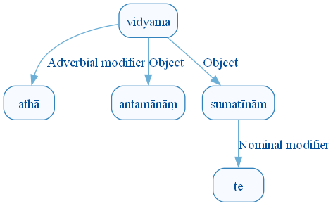
Figure 433: DCS Original Dependency Graph for Sentence ID 576311
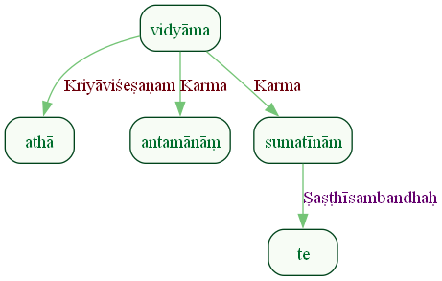
Figure 434: Sanskrit Tags Dependency Graph for Sentence ID 576311
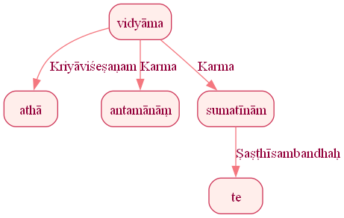
Figure 435: Reduced Dependency Graph for Sentence ID 576311

Sentence ID: 576312
Mantra Text:
mā naḥ ati khyaḥ ā gahi
[('0_4', '0_1', 'Kriyāviśeṣaṇam'), ('0_4', '0_2', 'Karma'), ('0_4', '0_3', 'Kriyāviśeṣaṇam'), ('1_2', '1_1', 'Kriyāviśeṣaṇam')]
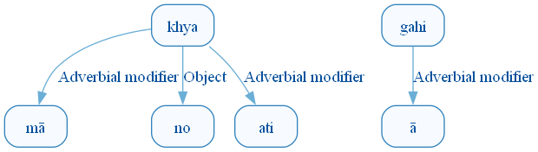
Figure 442: DCS Original Dependency Graph for Sentence ID 576312
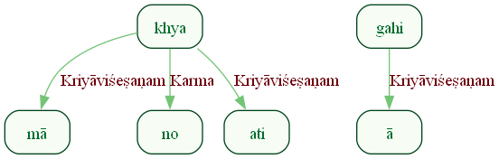
Figure 443: Sanskrit Tags Dependency Graph for Sentence ID 576312
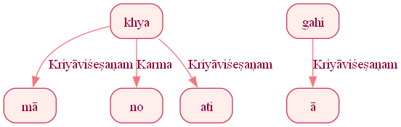
Figure 444: Reduced Dependency Graph for Sentence ID 576312

Sentence ID: 576313
Mantra Text:
parehi vigram astṛtam indram pṛcchā vipaścitam
[('1_3', '1_1', 'Viśeṣaṇam'), ('1_3', '1_2', 'Viśeṣaṇam'), ('1_4', '1_3', 'Karma'), ('1_3', '1_5', 'Viśeṣaṇam')]
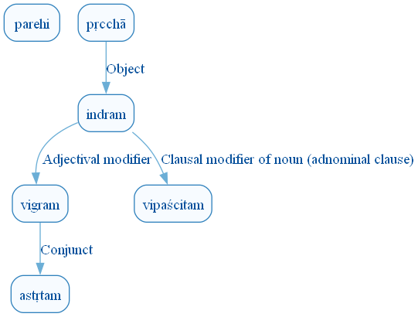
Figure 451: DCS Original Dependency Graph for Sentence ID 576313
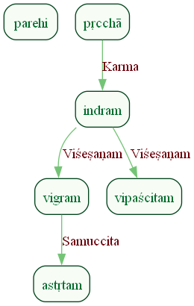
Figure 452: Sanskrit Tags Dependency Graph for Sentence ID 576313
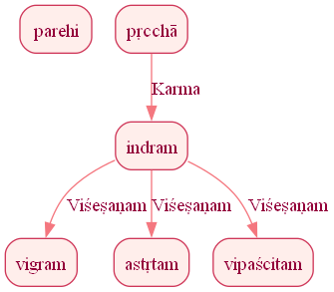
Figure 453: Reduced Dependency Graph for Sentence ID 576313

Sentence ID: 576314
Mantra Text:
yas te sakhibhya ā varam
[('0_5', '0_1', 'Kartā'), ('0_5', '0_2', 'Ṣaṣṭhīsambandhaḥ'), ('0_5', '0_3', 'Apādānam'), ('0_3', '0_4', 'Karmapravacanīyaḥ')]
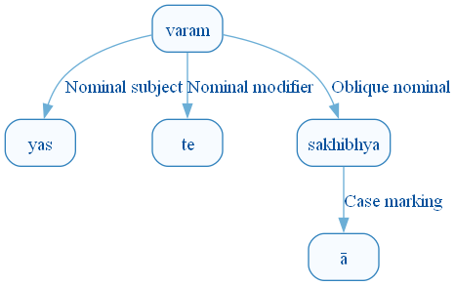
Figure 460: DCS Original Dependency Graph for Sentence ID 576314
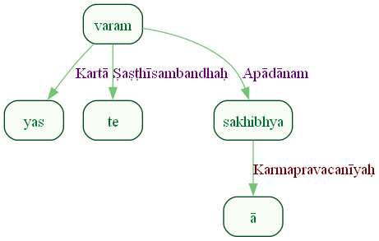
Figure 461: Sanskrit Tags Dependency Graph for Sentence ID 576314
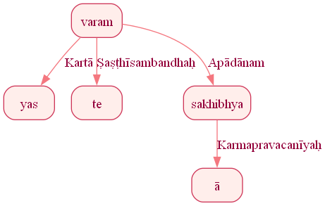
Figure 462: Reduced Dependency Graph for Sentence ID 576314

Sentence ID: 576315
Mantra Text:
uta bruvantu naḥ nidaḥ niḥ anyatas cit ārata
[('0_2', '0_1', 'Discourse_unknown_label'), ('0_4', '0_3', 'Ṣaṣṭhīsambandhaḥ'), ('0_2', '0_4', 'Kartā'), ('1_4', '1_1', 'Kriyāviśeṣaṇam'), ('1_4', '1_2', 'Kriyāviśeṣaṇam'), ('1_2', '1_3', 'Discourse_unknown_label')]
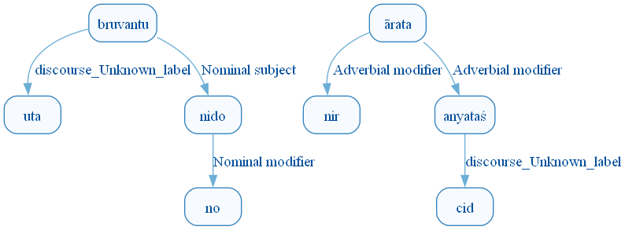
Figure 469: DCS Original Dependency Graph for Sentence ID 576315
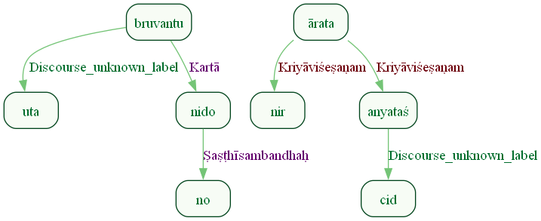
Figure 470: Sanskrit Tags Dependency Graph for Sentence ID 576315
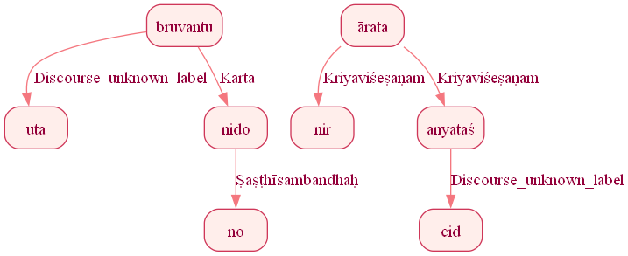
Figure 471: Reduced Dependency Graph for Sentence ID 576315

Sentence ID: 576316
Mantra Text:
dadhānā indra id duvaḥ
[('0_1', '0_2', 'Adhikaraṇam'), ('0_2', '0_3', 'Discourse_unknown_label'), ('0_1', '0_4', 'Karma')]
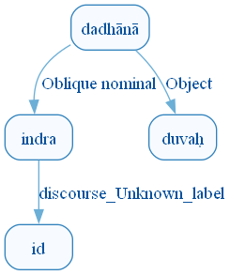
Figure 478: DCS Original Dependency Graph for Sentence ID 576316
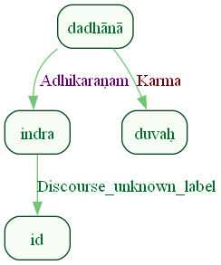
Figure 479: Sanskrit Tags Dependency Graph for Sentence ID 576316
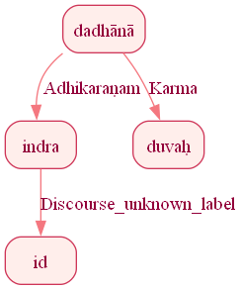
Figure 480: Reduced Dependency Graph for Sentence ID 576316

Sentence ID: 576317
Mantra Text:
uta naḥ subhagāṁ arir voceyur dasma kṛṣṭayaḥ
[('0_5', '0_1', 'Samuccita_dyotakaḥ'), ('0_5', '0_2', 'Karma'), ('0_5', '0_3', 'Open clausal complement'), ('0_5', '0_4', 'Kartā'), ('0_5', '0_6', 'Sambodhyaḥ'), ('0_4', '0_7', 'Appositional modifier')]
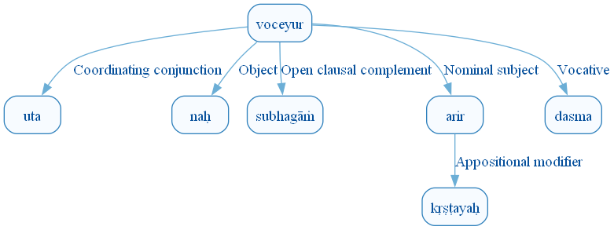
Figure 487: DCS Original Dependency Graph for Sentence ID 576317
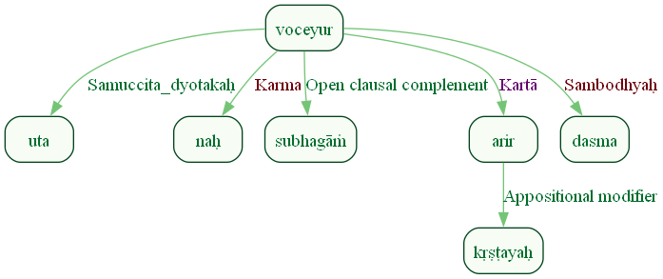
Figure 488: Sanskrit Tags Dependency Graph for Sentence ID 576317
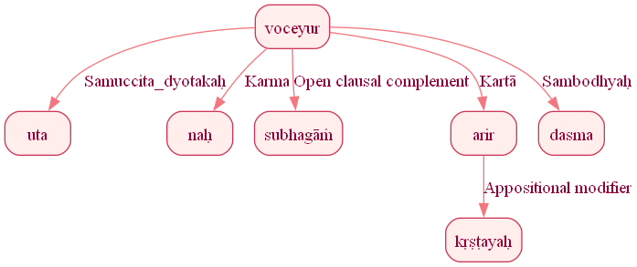
Figure 489: Reduced Dependency Graph for Sentence ID 576317

Sentence ID: 576318
Mantra Text:
syāmed indrasya śarmaṇi
[('0_4', '0_1', 'Copula'), ('0_1', '0_2', 'Discourse_unknown_label'), ('0_4', '0_3', 'Ṣaṣṭhīsambandhaḥ')]
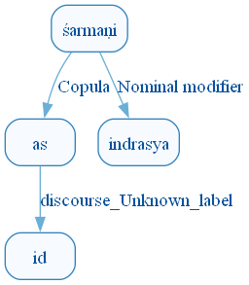
Figure 496: DCS Original Dependency Graph for Sentence ID 576318
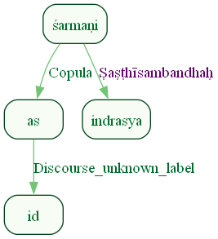
Figure 497: Sanskrit Tags Dependency Graph for Sentence ID 576318
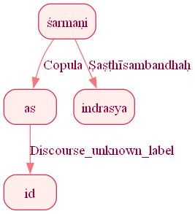
Figure 498: Reduced Dependency Graph for Sentence ID 576318

Sentence ID: 576319
Mantra Text:
em āśum āśave bhara yajñaśriyaṃ nṛmādanam
[('0_5', '0_1', 'Kriyāviśeṣaṇam'), ('0_5', '0_2', 'Karma'), ('0_2', '0_3', 'Viśeṣaṇam'), ('0_5', '0_4', 'Sampradānam'), ('0_2', '0_6', 'Viśeṣaṇam'), ('0_2', '0_7', 'Viśeṣaṇam'), ('0_9', '0_8', 'Karma'), ('0_2', '0_9', 'Viśeṣaṇam')]
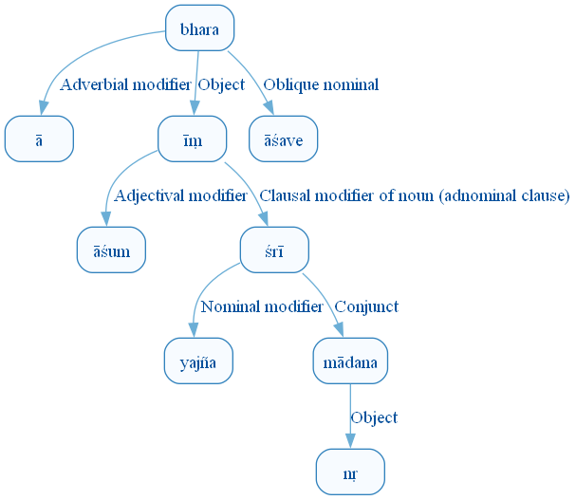
Figure 505: DCS Original Dependency Graph for Sentence ID 576319
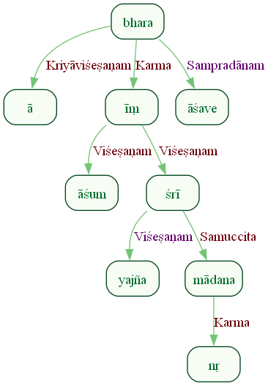
Figure 506: Sanskrit Tags Dependency Graph for Sentence ID 576319
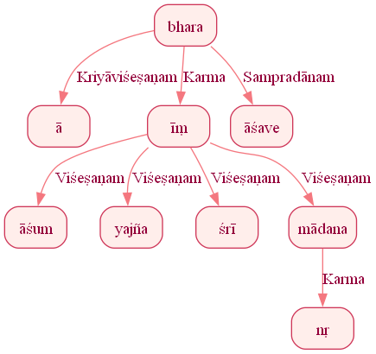
Figure 507: Reduced Dependency Graph for Sentence ID 576319

Sentence ID: 576320
Mantra Text:
patayan mandayatsakham
[('0_3', '0_2', 'Viśeṣaṇam'), ('0_1', '0_3', 'Karma')]
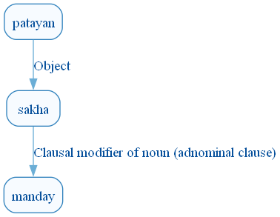
Figure 514: DCS Original Dependency Graph for Sentence ID 576320
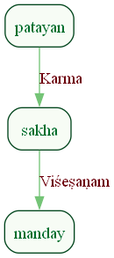
Figure 515: Sanskrit Tags Dependency Graph for Sentence ID 576320
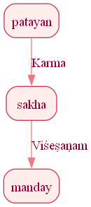
Figure 516: Reduced Dependency Graph for Sentence ID 576320

Sentence ID: 576321
Mantra Text:
asya pītvā śatakrato ghano vṛtrāṇām abhavaḥ
[('0_2', '0_1', 'Karma'), ('0_6', '0_2', 'Kriyāviśeṣaṇam'), ('0_6', '0_3', 'Sambodhyaḥ'), ('0_6', '0_4', 'Open clausal complement'), ('0_4', '0_5', 'Ṣaṣṭhīsambandhaḥ')]
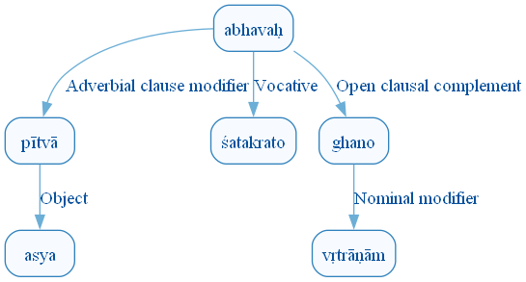
Figure 523: DCS Original Dependency Graph for Sentence ID 576321
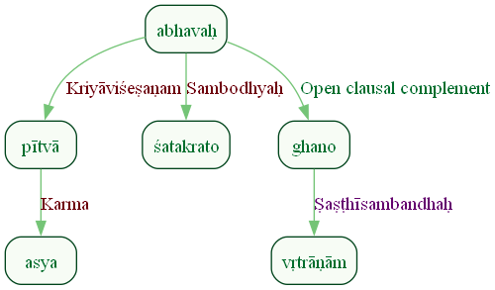
Figure 524: Sanskrit Tags Dependency Graph for Sentence ID 576321
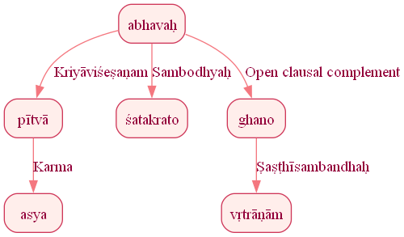
Figure 525: Reduced Dependency Graph for Sentence ID 576321

Sentence ID: 576322
Mantra Text:
prāvo vājeṣu vājinam
[('0_1', '0_2', 'Adhikaraṇam'), ('0_1', '0_3', 'Karma')]
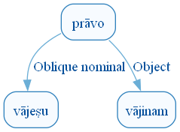
Figure 532: DCS Original Dependency Graph for Sentence ID 576322
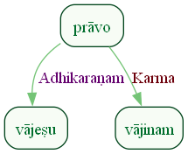
Figure 533: Sanskrit Tags Dependency Graph for Sentence ID 576322
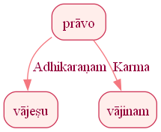
Figure 534: Reduced Dependency Graph for Sentence ID 576322

Sentence ID: 576323
Mantra Text:
taṃ tvā vājeṣu vājinaṃ vājayāmaḥ śatakrato
[('0_2', '0_1', 'Viśeṣaṇam'), ('0_5', '0_2', 'Karma'), ('0_5', '0_3', 'Adhikaraṇam'), ('0_2', '0_4', 'Viśeṣaṇam'), ('0_5', '0_6', 'Sambodhyaḥ')]
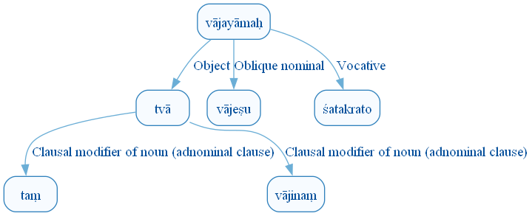
Figure 541: DCS Original Dependency Graph for Sentence ID 576323
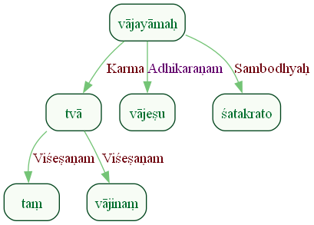
Figure 542: Sanskrit Tags Dependency Graph for Sentence ID 576323
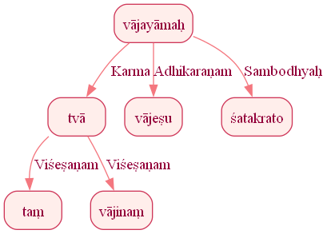
Figure 543: Reduced Dependency Graph for Sentence ID 576323

Sentence ID: 576324
Mantra Text:
dhanānām indra sātaye
[('0_3', '0_1', 'Ṣaṣṭhīsambandhaḥ'), ('0_3', '0_2', 'Sambodhyaḥ')]
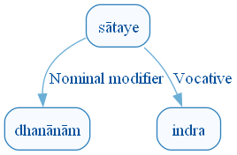
Figure 550: DCS Original Dependency Graph for Sentence ID 576324
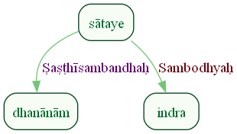
Figure 551: Sanskrit Tags Dependency Graph for Sentence ID 576324
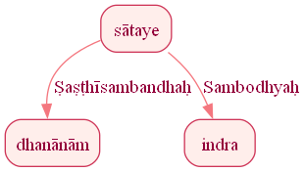
Figure 552: Reduced Dependency Graph for Sentence ID 576324

Sentence ID: 576325
Mantra Text:
yo rāyo 'vanir mahān supāraḥ sunvataḥ sakhā
[('0_3', '0_1', 'Kartā'), ('0_3', '0_2', 'Ṣaṣṭhīsambandhaḥ'), ('0_3', '0_4', 'Viśeṣaṇam'), ('0_3', '0_5', 'Viśeṣaṇam'), ('0_3', '0_6', 'Viśeṣaṇam'), ('0_8', '0_7', 'Ṣaṣṭhīsambandhaḥ'), ('0_3', '0_8', 'Samuccita')]
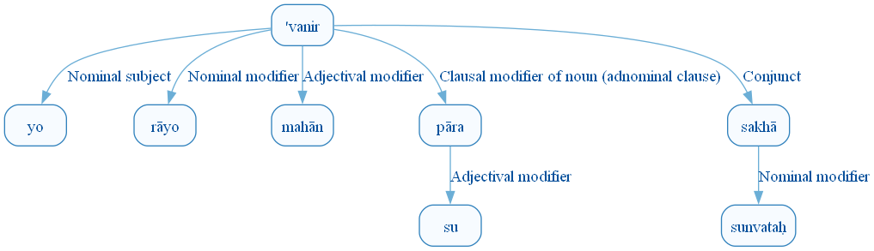
Figure 559: DCS Original Dependency Graph for Sentence ID 576325
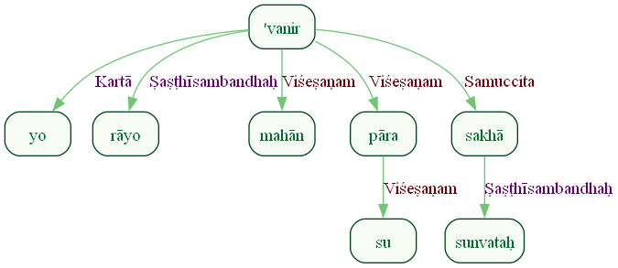
Figure 560: Sanskrit Tags Dependency Graph for Sentence ID 576325
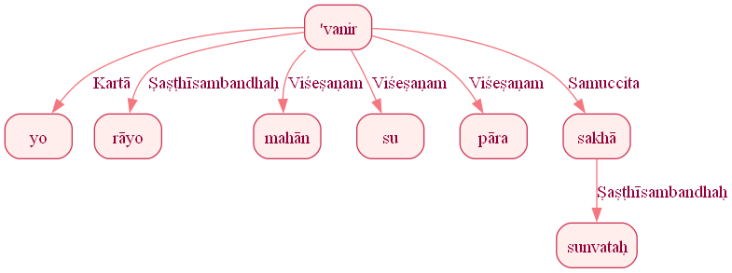
Figure 561: Reduced Dependency Graph for Sentence ID 576325

Sentence ID: 576326
Mantra Text:
tasmā indrāya gāyata
[('0_2', '0_1', 'Viśeṣaṇam'), ('0_3', '0_2', 'Sampradānam')]
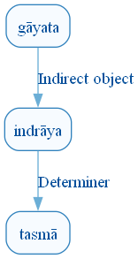
Figure 568: DCS Original Dependency Graph for Sentence ID 576326
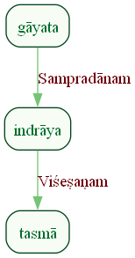
Figure 569: Sanskrit Tags Dependency Graph for Sentence ID 576326
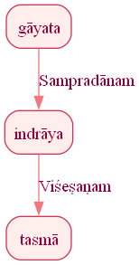
Figure 570: Reduced Dependency Graph for Sentence ID 576326

ConLLU File: ṚV, 1, 5

Sentence ID: 576327
Mantra Text:
ā tu etā ni ṣīdata indram abhi pra gāyata
[('0_3', '0_1', 'Kriyāviśeṣaṇam'), ('0_3', '0_2', 'Discourse_unknown_label'), ('1_2', '1_1', 'Kriyāviśeṣaṇam'), ('1_2', '1_3', 'Karma'), ('2_3', '2_1', 'Kriyāviśeṣaṇam'), ('2_3', '2_2', 'Kriyāviśeṣaṇam')]
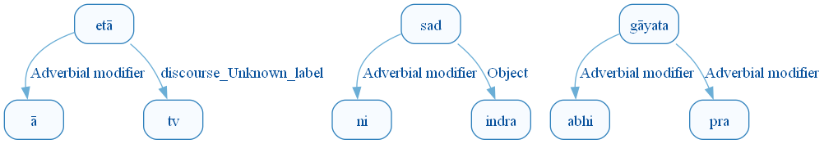
Figure 577: DCS Original Dependency Graph for Sentence ID 576327
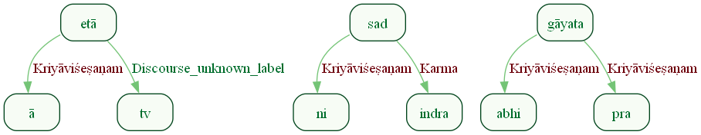
Figure 578: Sanskrit Tags Dependency Graph for Sentence ID 576327
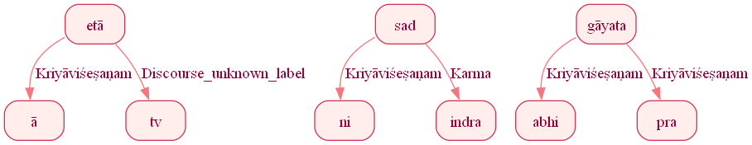
Figure 579: Reduced Dependency Graph for Sentence ID 576327

Sentence ID: 576328
Mantra Text:
sakhāya stomavāhasaḥ
[('0_3', '0_1', 'Kartā'), ('0_3', '0_2', 'Viśeṣaṇam')]
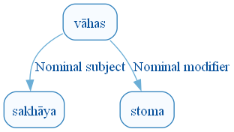
Figure 586: DCS Original Dependency Graph for Sentence ID 576328
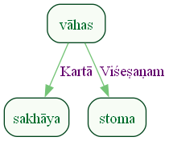
Figure 587: Sanskrit Tags Dependency Graph for Sentence ID 576328
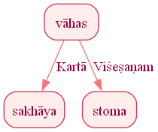
Figure 588: Reduced Dependency Graph for Sentence ID 576328

Sentence ID: 576329
Mantra Text:
purūtamam purūṇām īśānaṃ vāryāṇām
[('0_1', '0_2', 'Ṣaṣṭhīsambandhaḥ'), ('0_1', '0_3', 'Samuccita'), ('0_3', '0_4', 'Ṣaṣṭhīsambandhaḥ')]
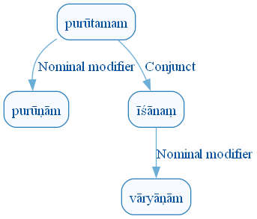
Figure 595: DCS Original Dependency Graph for Sentence ID 576329
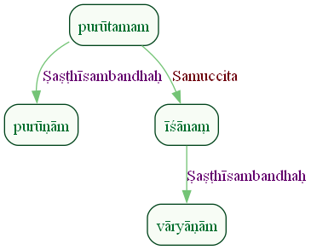
Figure 596: Sanskrit Tags Dependency Graph for Sentence ID 576329
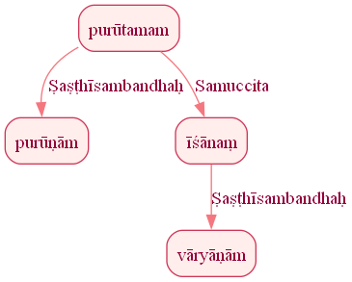
Figure 597: Reduced Dependency Graph for Sentence ID 576329

Sentence ID: 576330
Mantra Text:
indraṃ some sacā sute
[('0_1', '0_2', 'Orphan'), ('0_2', '0_3', 'Karmapravacanīyaḥ'), ('0_2', '0_4', 'Orphan')]
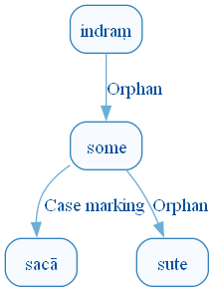
Figure 604: DCS Original Dependency Graph for Sentence ID 576330
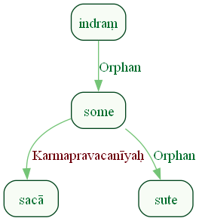
Figure 605: Sanskrit Tags Dependency Graph for Sentence ID 576330
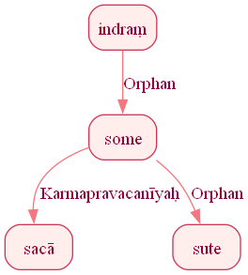
Figure 606: Reduced Dependency Graph for Sentence ID 576330

Sentence ID: 576331
Mantra Text:
sa ghā no yoga ā bhuvat sa rāye sa purandhyām
[('0_6', '0_1', 'Kartā'), ('0_6', '0_2', 'Discourse_unknown_label'), ('0_4', '0_3', 'Ṣaṣṭhīsambandhaḥ'), ('0_6', '0_4', 'Adhikaraṇam'), ('0_6', '0_5', 'Kriyāviśeṣaṇam'), ('0_6', '0_7', 'Samuccita'), ('0_7', '0_8', 'Orphan'), ('0_6', '0_9', 'Samuccita'), ('0_9', '0_10', 'Orphan')]
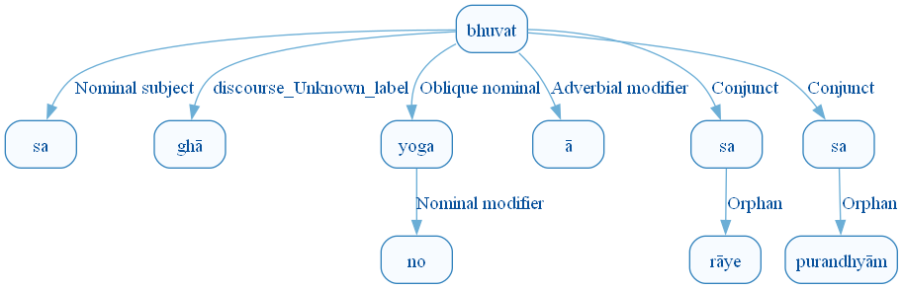
Figure 613: DCS Original Dependency Graph for Sentence ID 576331
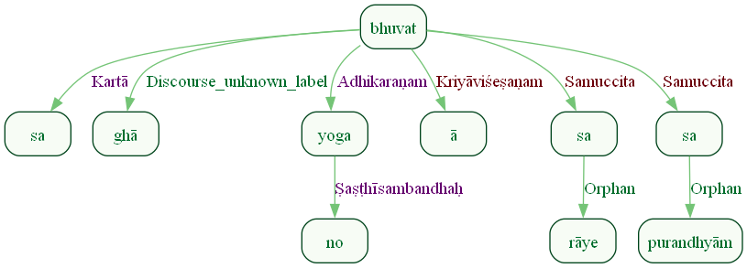
Figure 614: Sanskrit Tags Dependency Graph for Sentence ID 576331
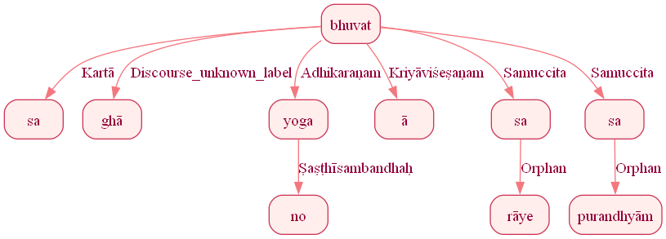
Figure 615: Reduced Dependency Graph for Sentence ID 576331

Sentence ID: 576332
Mantra Text:
gamad vājebhir ā sa naḥ
[('0_1', '0_2', 'Karaṇam'), ('0_1', '0_3', 'Kriyāviśeṣaṇam'), ('0_1', '0_4', 'Kartā'), ('0_1', '0_5', 'Karma')]
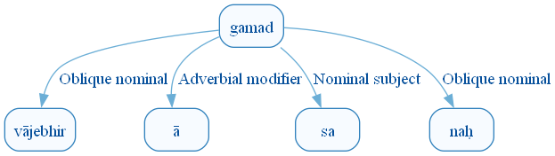
Figure 622: DCS Original Dependency Graph for Sentence ID 576332
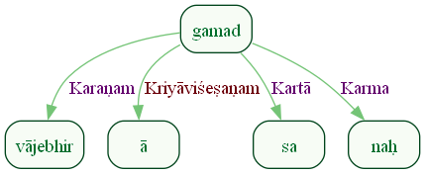
Figure 623: Sanskrit Tags Dependency Graph for Sentence ID 576332
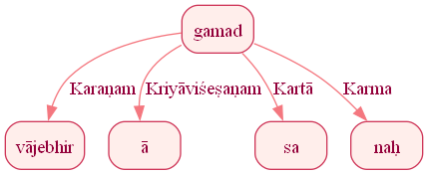
Figure 624: Reduced Dependency Graph for Sentence ID 576332

Sentence ID: 576333
Mantra Text:
yasya saṃsthe na vṛṇvate harī samatsu śatravaḥ
[('0_2', '0_1', 'Ṣaṣṭhīsambandhaḥ'), ('0_4', '0_2', 'Adhikaraṇam'), ('0_4', '0_3', 'Kriyāviśeṣaṇam'), ('0_4', '0_5', 'Karma'), ('0_4', '0_6', 'Adhikaraṇam'), ('0_4', '0_7', 'Kartā')]
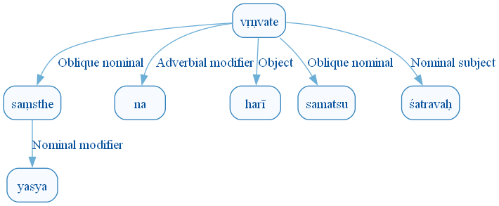
Figure 631: DCS Original Dependency Graph for Sentence ID 576333
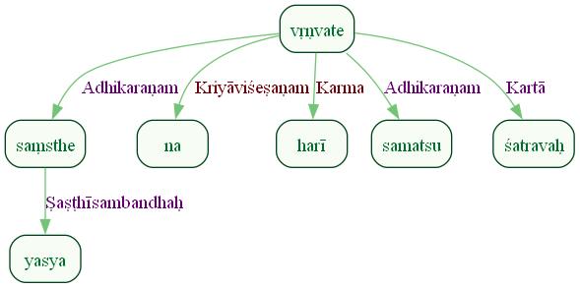
Figure 632: Sanskrit Tags Dependency Graph for Sentence ID 576333
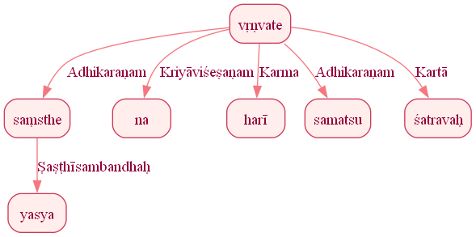
Figure 633: Reduced Dependency Graph for Sentence ID 576333

Sentence ID: 576334
Mantra Text:
tasmā indrāya gāyata
[('0_2', '0_1', 'Viśeṣaṇam'), ('0_3', '0_2', 'Sampradānam')]

Figure 640: DCS Original Dependency Graph for Sentence ID 576334

Figure 641: Sanskrit Tags Dependency Graph for Sentence ID 576334

Figure 642: Reduced Dependency Graph for Sentence ID 576334

Sentence ID: 576335
Mantra Text:
sutapāvne sutā ime śucayo yanti vītaye
[('0_2', '0_1', 'Viśeṣaṇam'), ('0_3', '0_2', 'Kriyāviśeṣaṇam'), ('0_6', '0_3', 'Kriyāviśeṣaṇam'), ('0_5', '0_4', 'Viśeṣaṇam'), ('0_6', '0_5', 'Kartā'), ('0_6', '0_7', 'Kriyāviśeṣaṇam')]
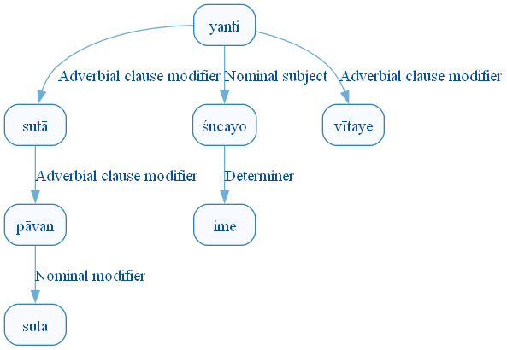
Figure 649: DCS Original Dependency Graph for Sentence ID 576335
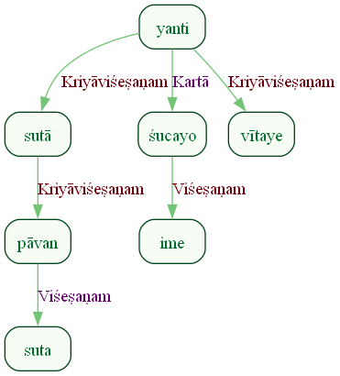
Figure 650: Sanskrit Tags Dependency Graph for Sentence ID 576335
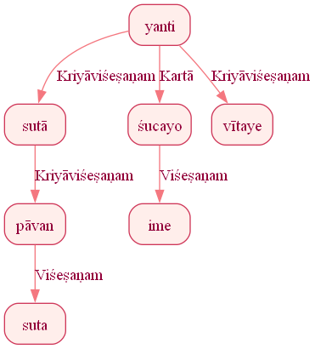
Figure 651: Reduced Dependency Graph for Sentence ID 576335

Sentence ID: 576336
Mantra Text:
somāso dadhyāśiraḥ
[('0_3', '0_2', 'Oblique nominal'), ('0_1', '0_3', 'Viśeṣaṇam')]
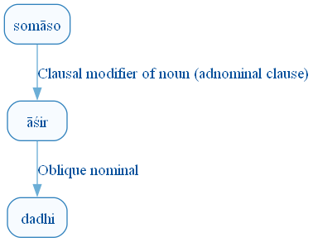
Figure 658: DCS Original Dependency Graph for Sentence ID 576336
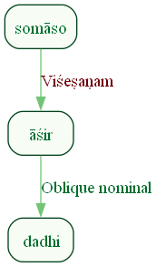
Figure 659: Sanskrit Tags Dependency Graph for Sentence ID 576336
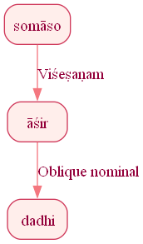
Figure 660: Reduced Dependency Graph for Sentence ID 576336

Sentence ID: 576337
Mantra Text:
tvaṃ sutasya pītaye sadyo vṛddho ajāyathāḥ
[('0_6', '0_1', 'Karma'), ('0_3', '0_2', 'Karma'), ('0_6', '0_3', 'Kriyāviśeṣaṇam'), ('0_5', '0_4', 'Kriyāviśeṣaṇam'), ('0_6', '0_5', 'Kriyāviśeṣaṇam')]
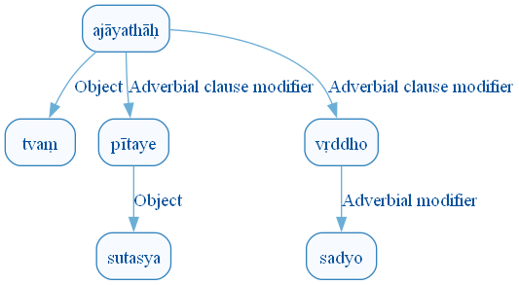
Figure 667: DCS Original Dependency Graph for Sentence ID 576337
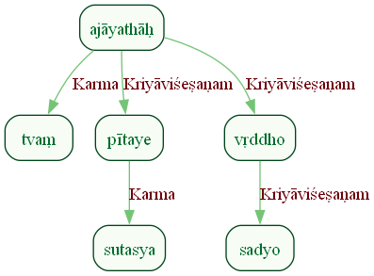
Figure 668: Sanskrit Tags Dependency Graph for Sentence ID 576337
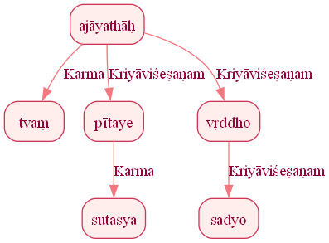
Figure 669: Reduced Dependency Graph for Sentence ID 576337

Sentence ID: 576338
Mantra Text:
indra jyaiṣṭhyāya sukrato
[('0_1', '0_3', 'Viśeṣaṇam')]
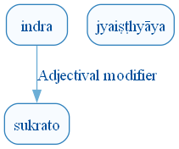
Figure 676: DCS Original Dependency Graph for Sentence ID 576338
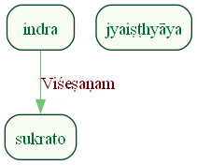
Figure 677: Sanskrit Tags Dependency Graph for Sentence ID 576338
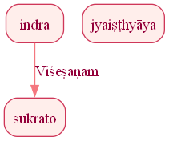
Figure 678: Reduced Dependency Graph for Sentence ID 576338

Sentence ID: 576339
Mantra Text:
ā tvā viśantv āśavaḥ somāsa indra girvaṇaḥ
[('0_3', '0_1', 'Kriyāviśeṣaṇam'), ('0_3', '0_2', 'Karma'), ('0_5', '0_4', 'Viśeṣaṇam'), ('0_3', '0_5', 'Kartā'), ('0_3', '0_6', 'Sambodhyaḥ'), ('0_6', '0_7', 'Viśeṣaṇam')]
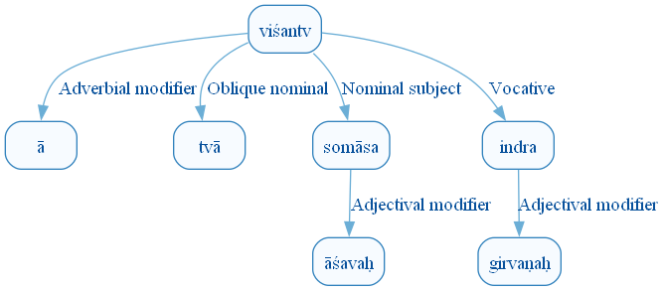
Figure 685: DCS Original Dependency Graph for Sentence ID 576339
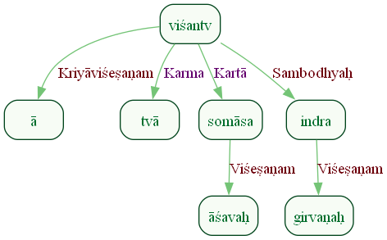
Figure 686: Sanskrit Tags Dependency Graph for Sentence ID 576339
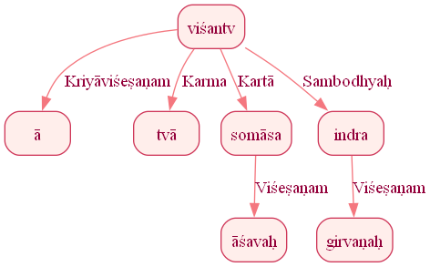
Figure 687: Reduced Dependency Graph for Sentence ID 576339

Sentence ID: 576340
Mantra Text:
śaṃ te santu pracetase
[('0_3', '0_1', 'Kartā'), ('0_3', '0_2', 'Sampradānam'), ('0_2', '0_4', 'Viśeṣaṇam')]
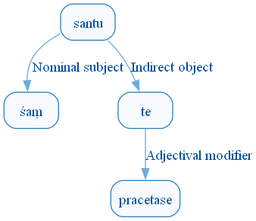
Figure 694: DCS Original Dependency Graph for Sentence ID 576340
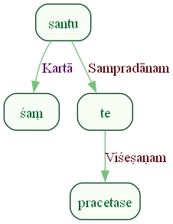
Figure 695: Sanskrit Tags Dependency Graph for Sentence ID 576340
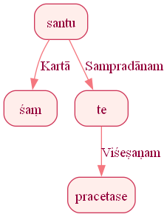
Figure 696: Reduced Dependency Graph for Sentence ID 576340

Sentence ID: 576341
Mantra Text:
tvāṃ stomā avīvṛdhan tvām ukthā śatakrato
[('0_3', '0_1', 'Karma'), ('0_3', '0_2', 'Kartā'), ('0_5', '0_4', 'Orphan'), ('0_3', '0_5', 'Samuccita'), ('0_3', '0_6', 'Sambodhyaḥ')]
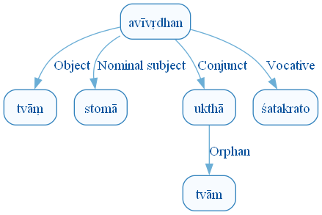
Figure 703: DCS Original Dependency Graph for Sentence ID 576341
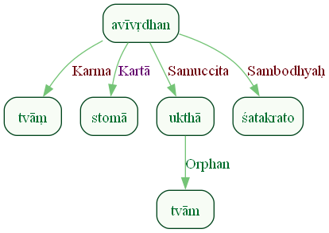
Figure 704: Sanskrit Tags Dependency Graph for Sentence ID 576341
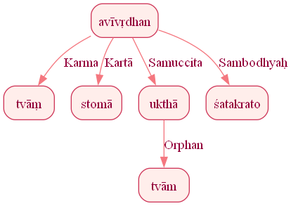
Figure 705: Reduced Dependency Graph for Sentence ID 576341

Sentence ID: 576342
Mantra Text:
tvāṃ vardhantu no giraḥ
[('0_2', '0_1', 'Karma'), ('0_4', '0_3', 'Ṣaṣṭhīsambandhaḥ'), ('0_2', '0_4', 'Kartā')]
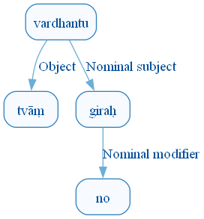
Figure 712: DCS Original Dependency Graph for Sentence ID 576342
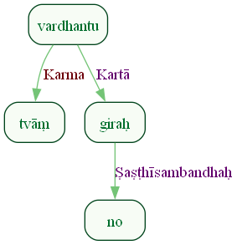
Figure 713: Sanskrit Tags Dependency Graph for Sentence ID 576342
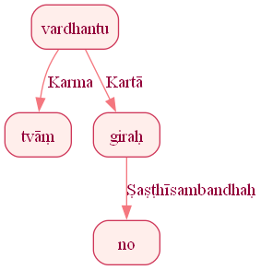
Figure 714: Reduced Dependency Graph for Sentence ID 576342

Sentence ID: 576343
Mantra Text:
akṣitotiḥ saned imaṃ vājam indraḥ sahasriṇam
[('0_2', '0_1', 'Kriyāviśeṣaṇam'), ('0_3', '0_2', 'Viśeṣaṇam'), ('0_4', '0_3', 'Kriyāviśeṣaṇam'), ('0_6', '0_5', 'Viśeṣaṇam'), ('0_4', '0_6', 'Karma'), ('0_4', '0_7', 'Kartā'), ('0_6', '0_8', 'Viśeṣaṇam')]
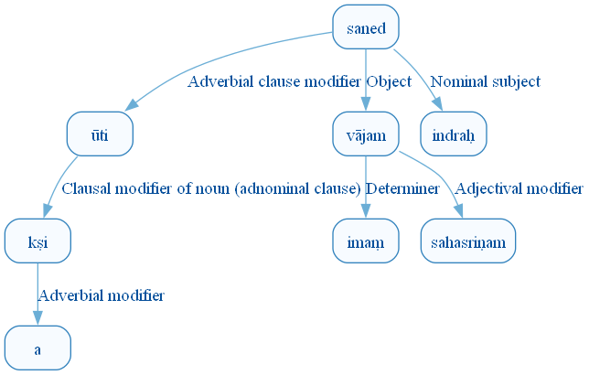
Figure 721: DCS Original Dependency Graph for Sentence ID 576343
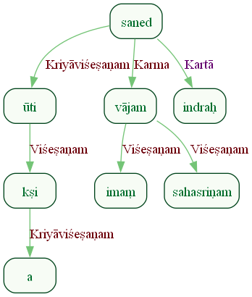
Figure 722: Sanskrit Tags Dependency Graph for Sentence ID 576343
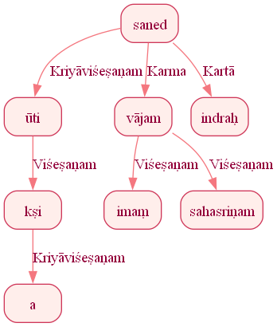
Figure 723: Reduced Dependency Graph for Sentence ID 576343

Sentence ID: 576344
Mantra Text:
yasmin viśvāni pauṃsyā
[('0_3', '0_2', 'Viśeṣaṇam'), ('0_1', '0_3', 'Kartā')]
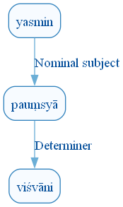
Figure 730: DCS Original Dependency Graph for Sentence ID 576344
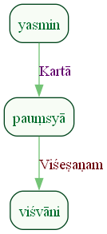
Figure 731: Sanskrit Tags Dependency Graph for Sentence ID 576344
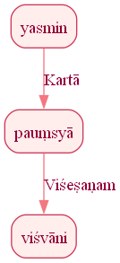
Figure 732: Reduced Dependency Graph for Sentence ID 576344

Sentence ID: 576345
Mantra Text:
mā no martā abhi druhan tanūnām indra girvaṇaḥ
[('0_5', '0_1', 'Kriyāviśeṣaṇam'), ('0_5', '0_2', 'Karma'), ('0_5', '0_3', 'Kartā'), ('0_5', '0_4', 'Kriyāviśeṣaṇam'), ('0_5', '0_6', 'Karma'), ('0_5', '0_7', 'Sambodhyaḥ'), ('0_7', '0_8', 'Viśeṣaṇam')]
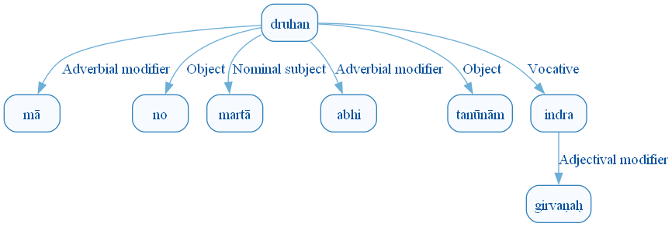
Figure 739: DCS Original Dependency Graph for Sentence ID 576345
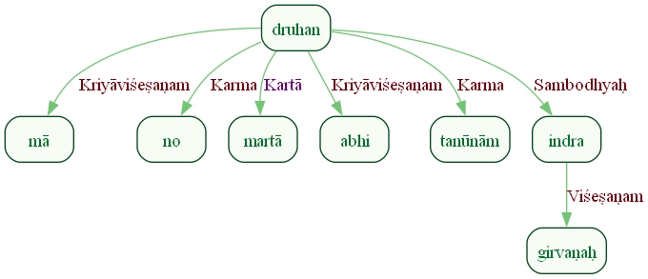
Figure 740: Sanskrit Tags Dependency Graph for Sentence ID 576345
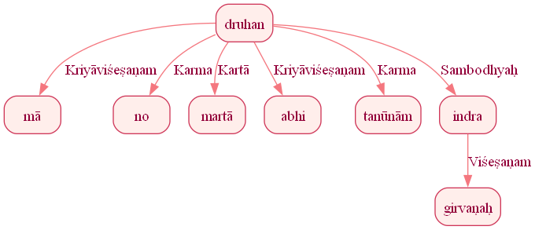
Figure 741: Reduced Dependency Graph for Sentence ID 576345

Sentence ID: 576346
Mantra Text:
īśāno yavayā vadham
[('0_2', '0_1', 'Kriyāviśeṣaṇam'), ('0_2', '0_3', 'Karma')]
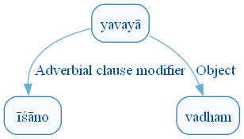
Figure 748: DCS Original Dependency Graph for Sentence ID 576346
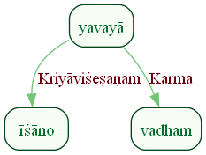
Figure 749: Sanskrit Tags Dependency Graph for Sentence ID 576346
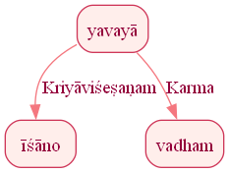
Figure 750: Reduced Dependency Graph for Sentence ID 576346

ConLLU File: ṚV, 1, 6

Sentence ID: 576347
Mantra Text:
yuñjanti bradhnam aruṣaṃ carantam pari tasthuṣaḥ
[('0_1', '0_2', 'Karma'), ('0_2', '0_3', 'Viśeṣaṇam'), ('0_2', '0_4', 'Viśeṣaṇam'), ('0_6', '0_5', 'Karmapravacanīyaḥ'), ('0_2', '0_6', 'Viśeṣaṇam')]
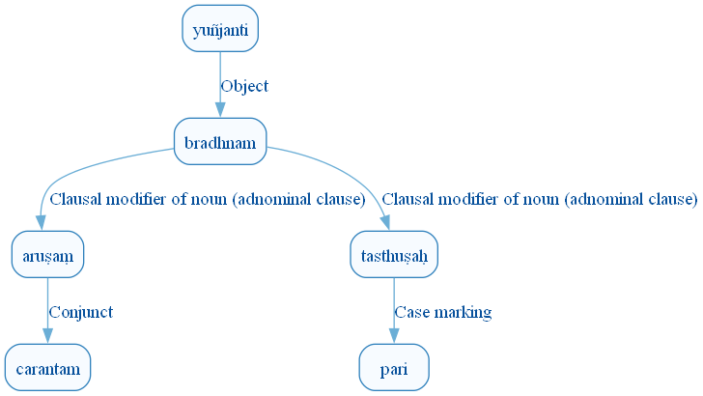
Figure 757: DCS Original Dependency Graph for Sentence ID 576347
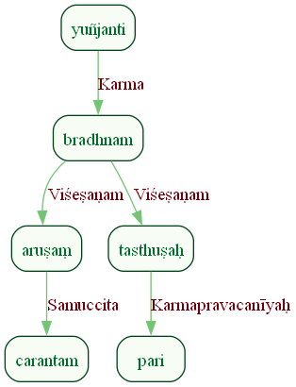
Figure 758: Sanskrit Tags Dependency Graph for Sentence ID 576347
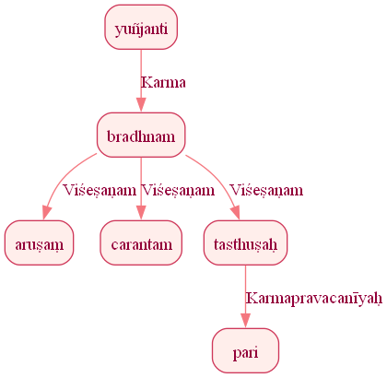
Figure 759: Reduced Dependency Graph for Sentence ID 576347

Sentence ID: 576348
Mantra Text:
rocante rocanā divi
[('0_1', '0_2', 'Kartā'), ('0_1', '0_3', 'Adhikaraṇam')]
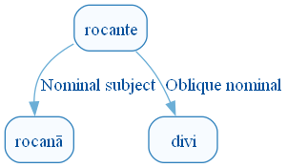
Figure 766: DCS Original Dependency Graph for Sentence ID 576348
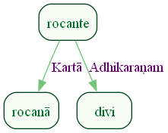
Figure 767: Sanskrit Tags Dependency Graph for Sentence ID 576348
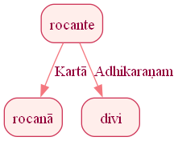
Figure 768: Reduced Dependency Graph for Sentence ID 576348

Sentence ID: 576349
Mantra Text:
yuñjanty asya kāmyā harī vipakṣasā rathe
[('0_4', '0_2', 'Ṣaṣṭhīsambandhaḥ'), ('0_4', '0_3', 'Viśeṣaṇam'), ('0_1', '0_4', 'Karma'), ('0_4', '0_5', 'Viśeṣaṇam'), ('0_1', '0_6', 'Adhikaraṇam')]
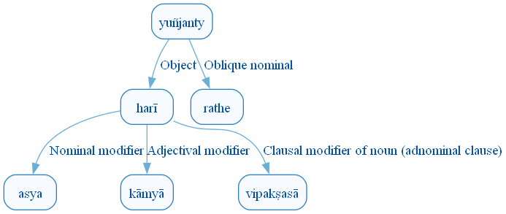
Figure 775: DCS Original Dependency Graph for Sentence ID 576349
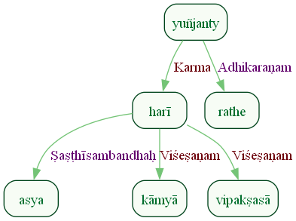
Figure 776: Sanskrit Tags Dependency Graph for Sentence ID 576349
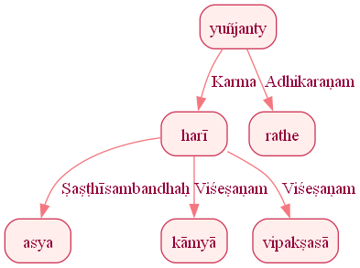
Figure 777: Reduced Dependency Graph for Sentence ID 576349

Sentence ID: 576350
Mantra Text:
śoṇā dhṛṣṇū nṛvāhasā
[('0_1', '0_2', 'Samuccita'), ('0_4', '0_3', 'Karma'), ('0_1', '0_4', 'Viśeṣaṇam')]
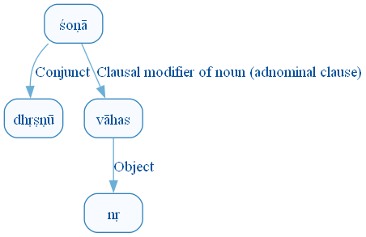
Figure 784: DCS Original Dependency Graph for Sentence ID 576350
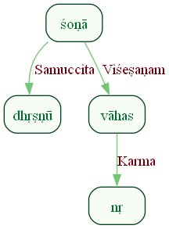
Figure 785: Sanskrit Tags Dependency Graph for Sentence ID 576350
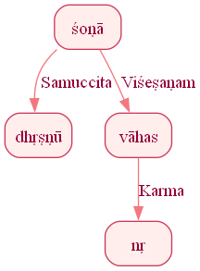
Figure 786: Reduced Dependency Graph for Sentence ID 576350

Sentence ID: 576351
Mantra Text:
ketuṃ kṛṇvann aketave peśo maryā apeśase
[('0_2', '0_1', 'Karma'), ('0_2', '0_3', 'Sampradānam'), ('0_2', '0_4', 'Karma'), ('0_2', '0_5', 'Sambodhyaḥ'), ('0_4', '0_6', 'Viśeṣaṇam')]
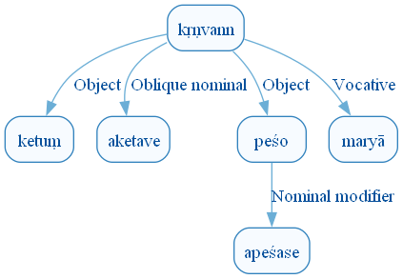
Figure 793: DCS Original Dependency Graph for Sentence ID 576351
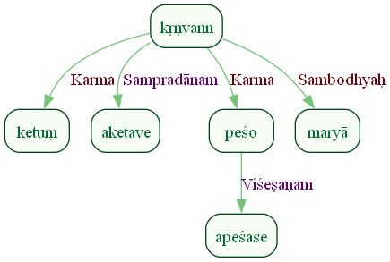
Figure 794: Sanskrit Tags Dependency Graph for Sentence ID 576351
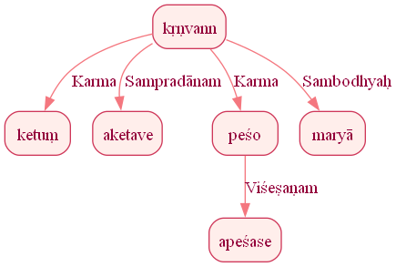
Figure 795: Reduced Dependency Graph for Sentence ID 576351

Sentence ID: 576352
Mantra Text:
sam uṣadbhir ajāyathāḥ
[('0_3', '0_1', 'Kriyāviśeṣaṇam'), ('0_3', '0_2', 'Karaṇam')]
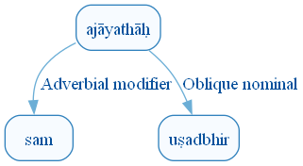
Figure 802: DCS Original Dependency Graph for Sentence ID 576352
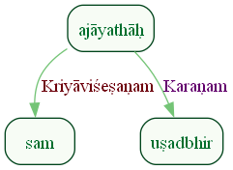
Figure 803: Sanskrit Tags Dependency Graph for Sentence ID 576352
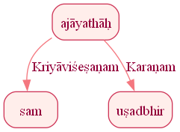
Figure 804: Reduced Dependency Graph for Sentence ID 576352

Sentence ID: 576353
Mantra Text:
ād aha svadhām anu punar garbhatvam erire
[('0_8', '0_1', 'Kriyāviśeṣaṇam'), ('0_8', '0_2', 'Discourse_unknown_label'), ('0_8', '0_3', 'Karmapravacanīya_anvitaḥ'), ('0_3', '0_4', 'Karmapravacanīyaḥ'), ('0_8', '0_5', 'Kriyāviśeṣaṇam'), ('0_7', '0_6', 'Viśeṣaṇam'), ('0_8', '0_7', 'Karma')]
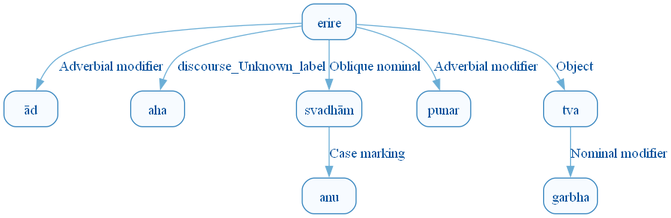
Figure 811: DCS Original Dependency Graph for Sentence ID 576353
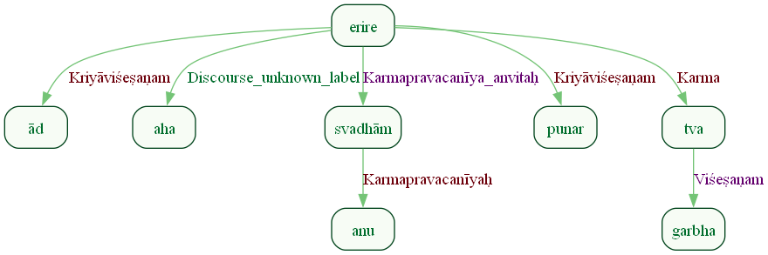
Figure 812: Sanskrit Tags Dependency Graph for Sentence ID 576353
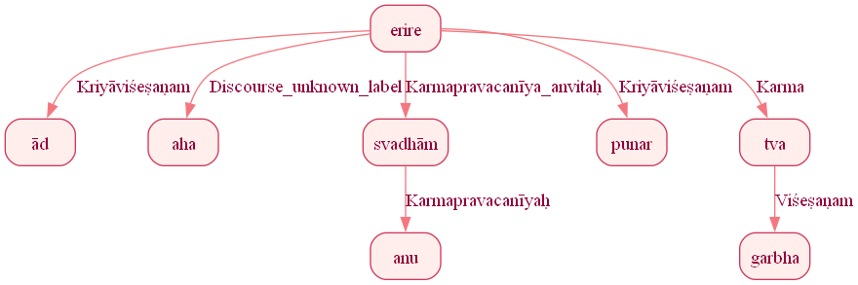
Figure 813: Reduced Dependency Graph for Sentence ID 576353

Sentence ID: 576354
Mantra Text:
dadhānā nāma yajñiyam
[('0_1', '0_2', 'Karma'), ('0_2', '0_3', 'Viśeṣaṇam')]
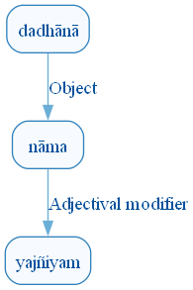
Figure 820: DCS Original Dependency Graph for Sentence ID 576354
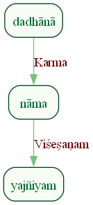
Figure 821: Sanskrit Tags Dependency Graph for Sentence ID 576354
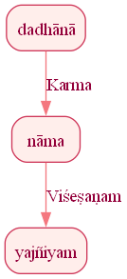
Figure 822: Reduced Dependency Graph for Sentence ID 576354

Sentence ID: 576355
Mantra Text:
vīḍu cid ārujatnubhir guhā cid indra vahnibhiḥ
[('0_1', '0_2', 'Discourse_unknown_label'), ('0_1', '0_3', 'Orphan'), ('0_1', '0_4', 'Samuccita'), ('0_4', '0_5', 'Discourse_unknown_label'), ('0_1', '0_6', 'Sambodhyaḥ'), ('0_1', '0_7', 'Orphan')]
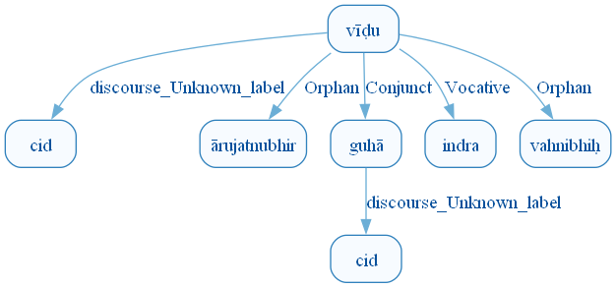
Figure 829: DCS Original Dependency Graph for Sentence ID 576355
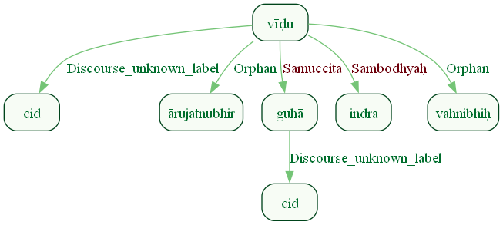
Figure 830: Sanskrit Tags Dependency Graph for Sentence ID 576355
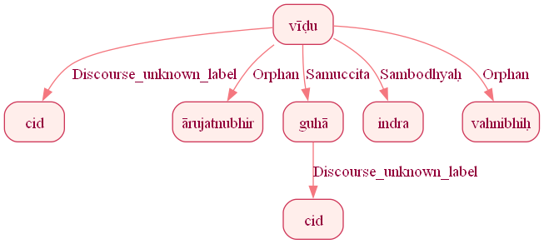
Figure 831: Reduced Dependency Graph for Sentence ID 576355

Sentence ID: 576356
Mantra Text:
avinda usriyā anu
[('0_1', '0_2', 'Karmapravacanīya_anvitaḥ'), ('0_2', '0_3', 'Karmapravacanīyaḥ')]
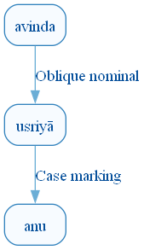
Figure 838: DCS Original Dependency Graph for Sentence ID 576356
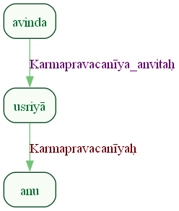
Figure 839: Sanskrit Tags Dependency Graph for Sentence ID 576356
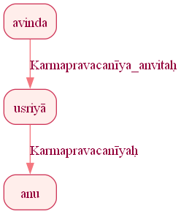
Figure 840: Reduced Dependency Graph for Sentence ID 576356

Sentence ID: 576358
Mantra Text:
devayantaḥ yathā matim acchā vidadvasum giraḥ mahām anūṣata śrutam
[('1_8', '1_1', 'Advcl:manner_unknown_label'), ('1_1', '1_2', 'Mark:sim_unknown_label'), ('1_1', '1_3', 'Orphan'), ('1_8', '1_4', 'Kriyāviśeṣaṇam'), ('1_8', '1_5', 'Obl:goal_unknown_label'), ('1_8', '1_6', 'Kartā'), ('1_5', '1_7', 'Viśeṣaṇam'), ('1_5', '1_9', 'Viśeṣaṇam')]
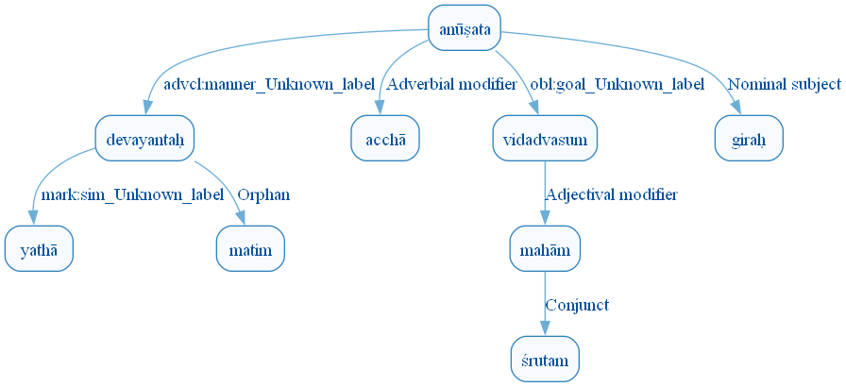
Figure 847: DCS Original Dependency Graph for Sentence ID 576358
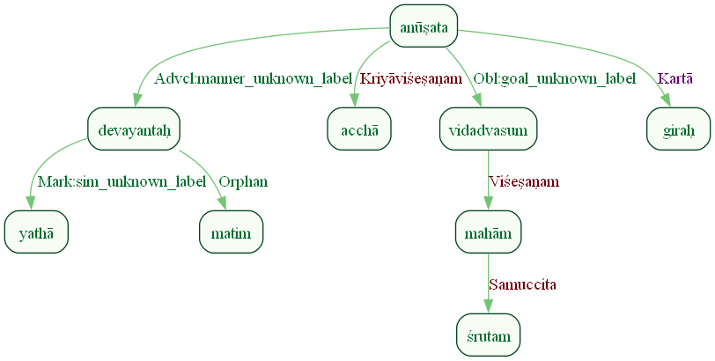
Figure 848: Sanskrit Tags Dependency Graph for Sentence ID 576358
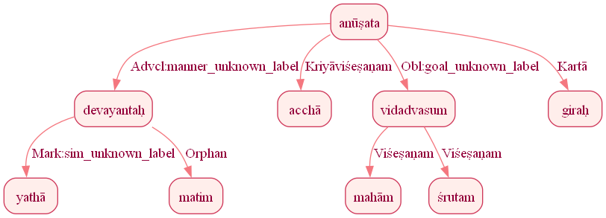
Figure 849: Reduced Dependency Graph for Sentence ID 576358

Sentence ID: 576359
Mantra Text:
indreṇa saṃ hi dṛkṣase saṃjagmāno abibhyuṣā
[('0_4', '0_1', 'Karaṇam'), ('0_4', '0_2', 'Kriyāviśeṣaṇam'), ('0_4', '0_3', 'Discourse_unknown_label'), ('0_4', '0_5', 'Kriyāviśeṣaṇam'), ('0_7', '0_6', 'Kriyāviśeṣaṇam'), ('0_5', '0_7', 'Karaṇam')]
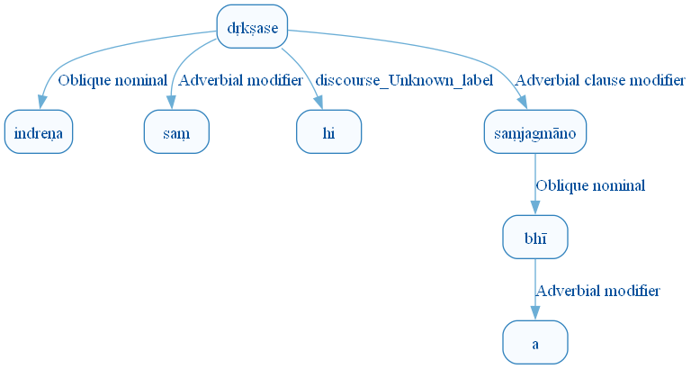
Figure 856: DCS Original Dependency Graph for Sentence ID 576359
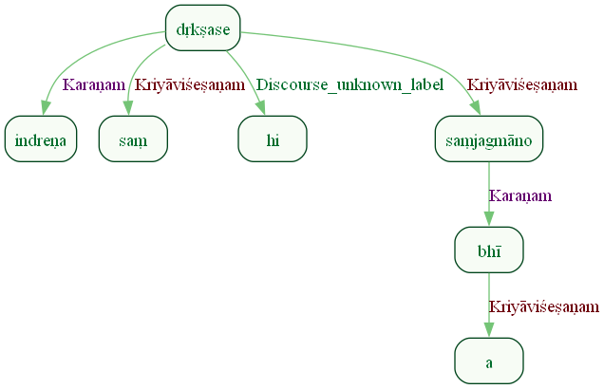
Figure 857: Sanskrit Tags Dependency Graph for Sentence ID 576359
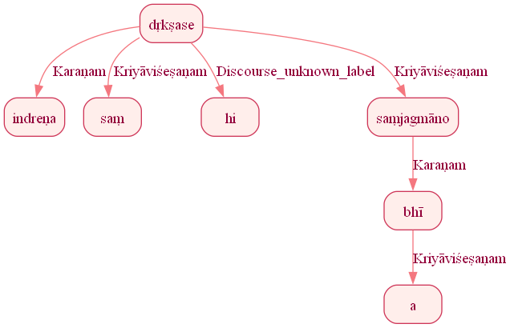
Figure 858: Reduced Dependency Graph for Sentence ID 576359

Sentence ID: 576360
Mantra Text:
mandū samānavarcasā
[('0_3', '0_2', 'Viśeṣaṇam'), ('0_1', '0_3', 'Samuccita')]
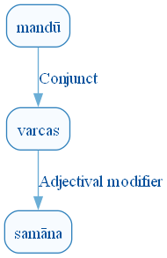
Figure 865: DCS Original Dependency Graph for Sentence ID 576360
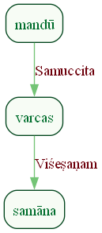
Figure 866: Sanskrit Tags Dependency Graph for Sentence ID 576360
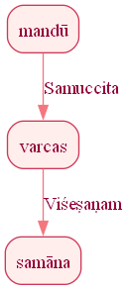
Figure 867: Reduced Dependency Graph for Sentence ID 576360

Sentence ID: 576361
Mantra Text:
anavadyair abhidyubhir makhaḥ sahasvad arcati
[('0_2', '0_1', 'Viśeṣaṇam'), ('0_5', '0_2', 'Karaṇam'), ('0_5', '0_3', 'Kartā'), ('0_5', '0_4', 'Kriyāviśeṣaṇam')]
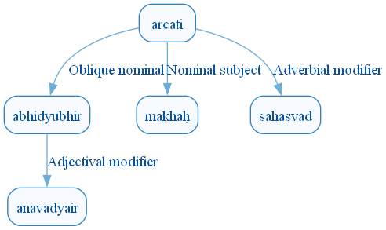
Figure 874: DCS Original Dependency Graph for Sentence ID 576361
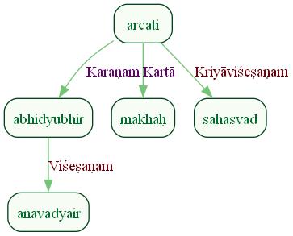
Figure 875: Sanskrit Tags Dependency Graph for Sentence ID 576361
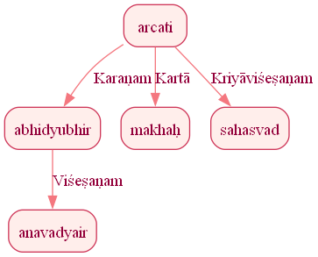
Figure 876: Reduced Dependency Graph for Sentence ID 576361

Sentence ID: 576362
Mantra Text:
gaṇair indrasya kāmyaiḥ
[('0_1', '0_2', 'Ṣaṣṭhīsambandhaḥ'), ('0_1', '0_3', 'Samuccita')]
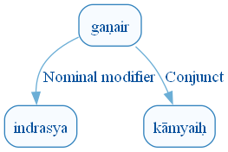
Figure 883: DCS Original Dependency Graph for Sentence ID 576362
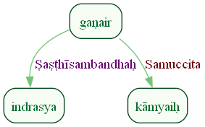
Figure 884: Sanskrit Tags Dependency Graph for Sentence ID 576362
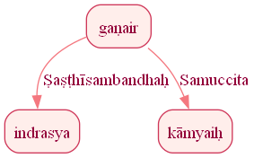
Figure 885: Reduced Dependency Graph for Sentence ID 576362

Sentence ID: 576363
Mantra Text:
ataḥ parijmann ā gahi divo vā rocanād adhi
[('0_4', '0_1', 'Kriyāviśeṣaṇam'), ('0_4', '0_2', 'Sambodhyaḥ'), ('0_4', '0_3', 'Kriyāviśeṣaṇam'), ('0_7', '0_5', 'Ṣaṣṭhīsambandhaḥ'), ('0_7', '0_6', 'Anyatara_dyotakaḥ'), ('0_4', '0_7', 'Apādānam'), ('0_7', '0_8', 'Karmapravacanīyaḥ')]
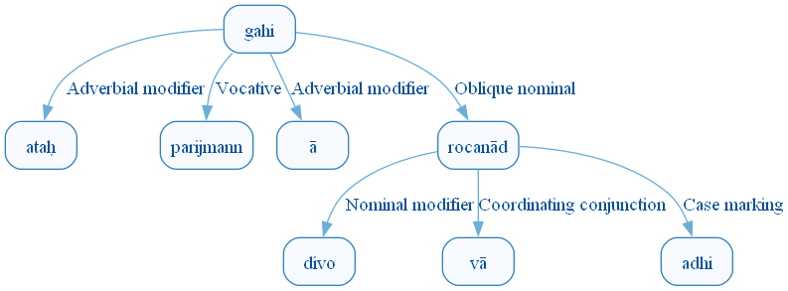
Figure 892: DCS Original Dependency Graph for Sentence ID 576363
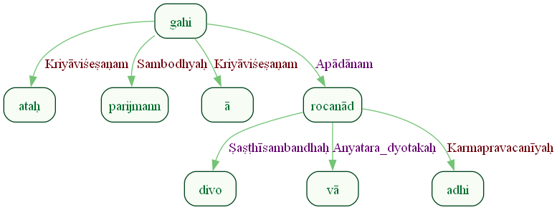
Figure 893: Sanskrit Tags Dependency Graph for Sentence ID 576363
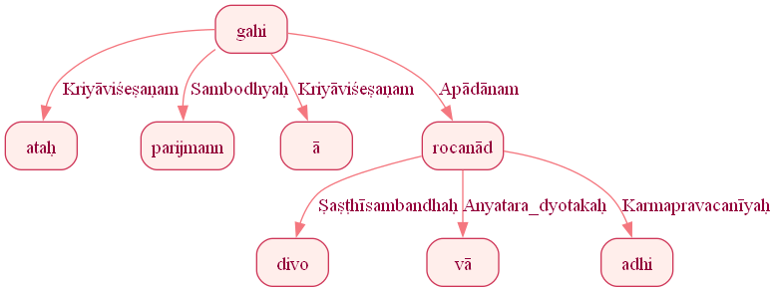
Figure 894: Reduced Dependency Graph for Sentence ID 576363

Sentence ID: 576364
Mantra Text:
sam asminn ṛñjate giraḥ
[('0_3', '0_1', 'Kriyāviśeṣaṇam'), ('0_3', '0_2', 'Adhikaraṇam'), ('0_3', '0_4', 'Kartā')]
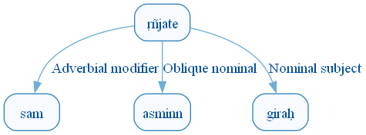
Figure 901: DCS Original Dependency Graph for Sentence ID 576364
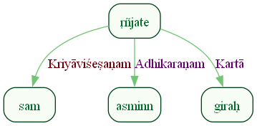
Figure 902: Sanskrit Tags Dependency Graph for Sentence ID 576364
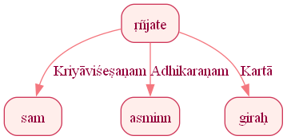
Figure 903: Reduced Dependency Graph for Sentence ID 576364

Sentence ID: 576365
Mantra Text:
ito vā sātim īmahe divo vā pārthivād adhi
[('0_4', '0_1', 'Kriyāviśeṣaṇam'), ('0_4', '0_2', 'Anyatara_dyotakaḥ'), ('0_4', '0_3', 'Karma'), ('0_4', '0_5', 'Apādānam'), ('0_5', '0_6', 'Anyatara_dyotakaḥ'), ('0_4', '0_7', 'Apādānam'), ('0_7', '0_8', 'Karmapravacanīyaḥ')]
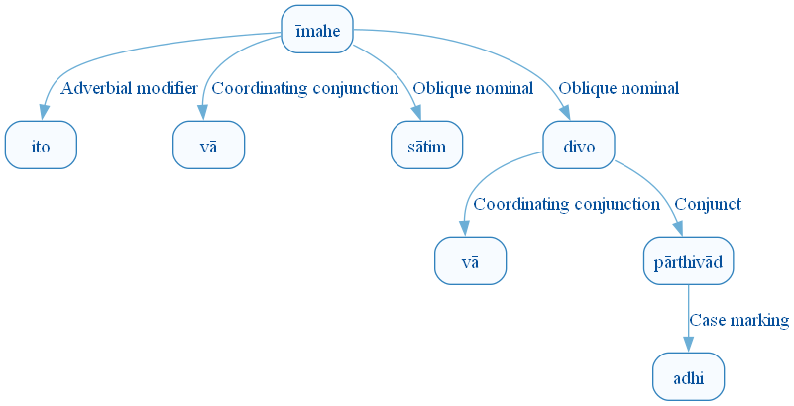
Figure 910: DCS Original Dependency Graph for Sentence ID 576365
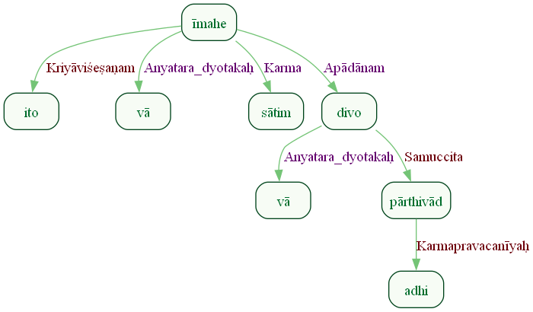
Figure 911: Sanskrit Tags Dependency Graph for Sentence ID 576365
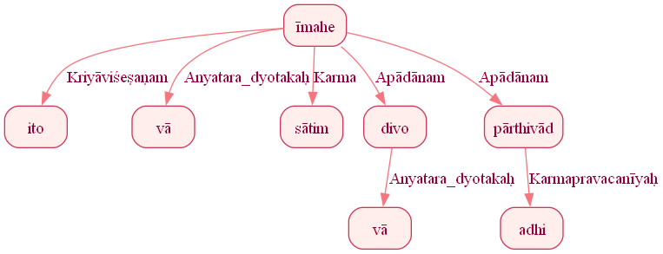
Figure 912: Reduced Dependency Graph for Sentence ID 576365

Sentence ID: 576366
Mantra Text:
indram maho vā rajasaḥ
[('0_4', '0_2', 'Viśeṣaṇam'), ('0_4', '0_3', 'Anyatara_dyotakaḥ'), ('0_1', '0_4', 'Samuccita')]
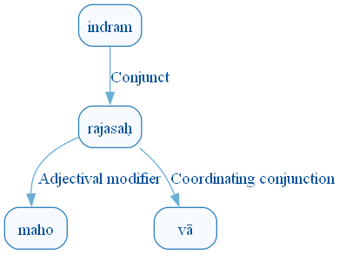
Figure 919: DCS Original Dependency Graph for Sentence ID 576366
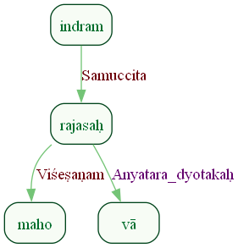
Figure 920: Sanskrit Tags Dependency Graph for Sentence ID 576366
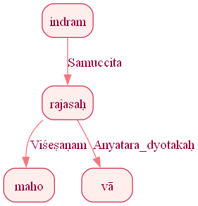
Figure 921: Reduced Dependency Graph for Sentence ID 576366

ConLLU File: ṚV, 1, 7

Sentence ID: 576367
Mantra Text:
indram id gāthino bṛhad indram arkebhir arkiṇaḥ
[('0_3', '0_1', 'Orphan'), ('0_1', '0_2', 'Discourse_unknown_label'), ('0_3', '0_4', 'Orphan'), ('0_7', '0_5', 'Orphan'), ('0_7', '0_6', 'Orphan'), ('0_3', '0_7', 'Samuccita')]
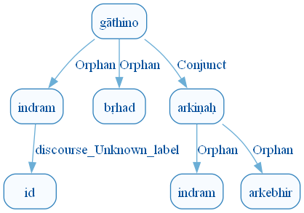
Figure 928: DCS Original Dependency Graph for Sentence ID 576367
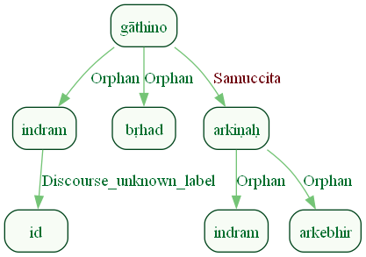
Figure 929: Sanskrit Tags Dependency Graph for Sentence ID 576367
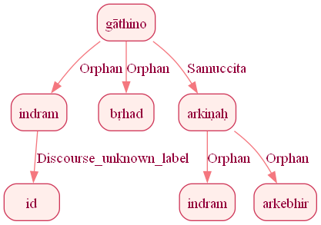
Figure 930: Reduced Dependency Graph for Sentence ID 576367

Sentence ID: 576368
Mantra Text:
indraṃ vāṇīr anūṣata
[('0_3', '0_1', 'Karma'), ('0_3', '0_2', 'Kartā')]
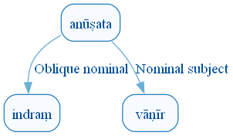
Figure 937: DCS Original Dependency Graph for Sentence ID 576368
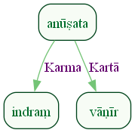
Figure 938: Sanskrit Tags Dependency Graph for Sentence ID 576368
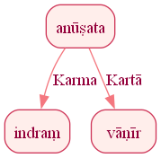
Figure 939: Reduced Dependency Graph for Sentence ID 576368

Sentence ID: 576369
Mantra Text:
indra iddharyoḥ sacā sammiśla ā vacoyujā
[('0_5', '0_1', 'Kartā'), ('0_1', '0_2', 'Discourse_unknown_label'), ('0_5', '0_3', 'Adhikaraṇam'), ('0_3', '0_4', 'Karmapravacanīyaḥ'), ('0_5', '0_6', 'Kriyāviśeṣaṇam'), ('0_8', '0_7', 'Karma'), ('0_5', '0_8', 'Karma')]
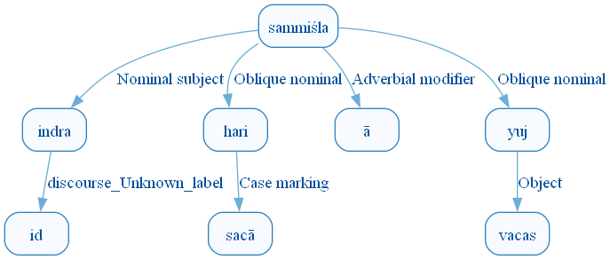
Figure 946: DCS Original Dependency Graph for Sentence ID 576369
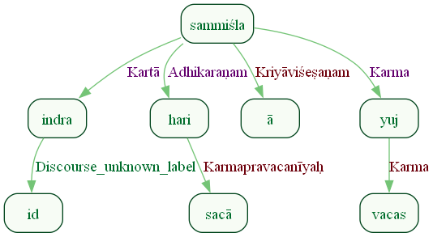
Figure 947: Sanskrit Tags Dependency Graph for Sentence ID 576369
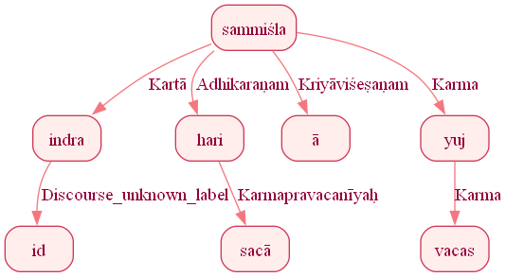
Figure 948: Reduced Dependency Graph for Sentence ID 576369

Sentence ID: 576370
Mantra Text:
indro vajrī hiraṇyayaḥ
[('0_3', '0_1', 'Kartā'), ('0_1', '0_2', 'Appositional modifier')]
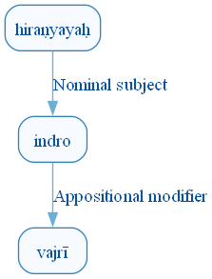
Figure 955: DCS Original Dependency Graph for Sentence ID 576370
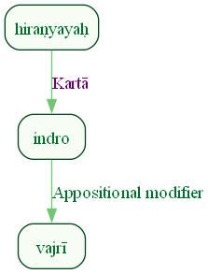
Figure 956: Sanskrit Tags Dependency Graph for Sentence ID 576370
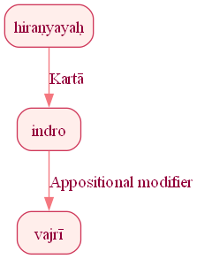
Figure 957: Reduced Dependency Graph for Sentence ID 576370

Sentence ID: 576371
Mantra Text:
indro dīrghāya cakṣasa ā sūryaṃ rohayad divi
[('0_3', '0_1', 'Kartā'), ('0_3', '0_2', 'Viśeṣaṇam'), ('0_6', '0_4', 'Kriyāviśeṣaṇam'), ('0_6', '0_5', 'Karma'), ('0_6', '0_7', 'Adhikaraṇam')]
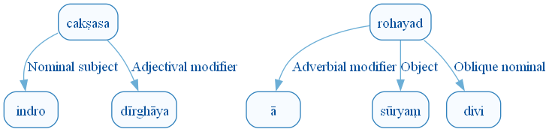
Figure 964: DCS Original Dependency Graph for Sentence ID 576371
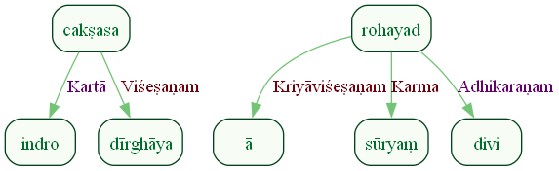
Figure 965: Sanskrit Tags Dependency Graph for Sentence ID 576371
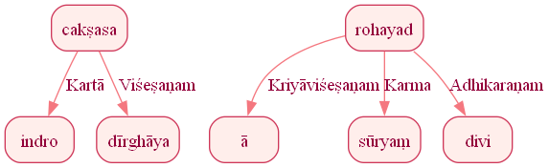
Figure 966: Reduced Dependency Graph for Sentence ID 576371

Sentence ID: 576372
Mantra Text:
vi gobhir adrim airayat
[('0_4', '0_1', 'Kriyāviśeṣaṇam'), ('0_4', '0_2', 'Karaṇam'), ('0_4', '0_3', 'Karma')]
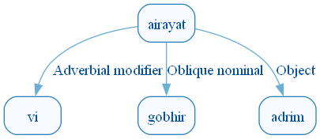
Figure 973: DCS Original Dependency Graph for Sentence ID 576372
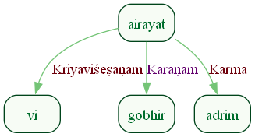
Figure 974: Sanskrit Tags Dependency Graph for Sentence ID 576372
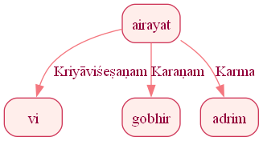
Figure 975: Reduced Dependency Graph for Sentence ID 576372

Sentence ID: 576373
Mantra Text:
indra vājeṣu no 'va sahasrapradhaneṣu ca
[('0_4', '0_1', 'Sambodhyaḥ'), ('0_4', '0_2', 'Adhikaraṇam'), ('0_4', '0_3', 'Karma'), ('0_6', '0_5', 'Viśeṣaṇam'), ('0_4', '0_6', 'Adhikaraṇam'), ('0_6', '0_7', 'Samuccita_dyotakaḥ')]
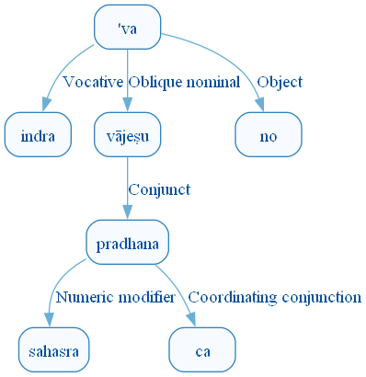
Figure 982: DCS Original Dependency Graph for Sentence ID 576373
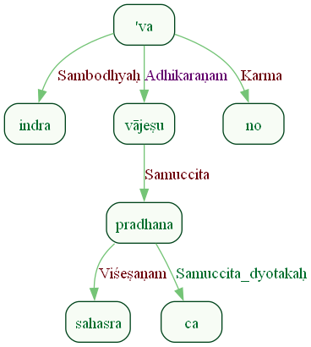
Figure 983: Sanskrit Tags Dependency Graph for Sentence ID 576373
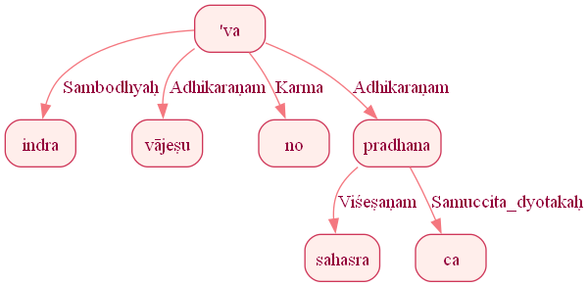
Figure 984: Reduced Dependency Graph for Sentence ID 576373

Sentence ID: 576374
Mantra Text:
ugra ugrābhir ūtibhiḥ
[('0_3', '0_1', 'Kartā'), ('0_3', '0_2', 'Viśeṣaṇam')]
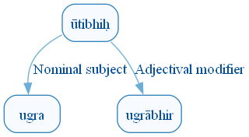
Figure 991: DCS Original Dependency Graph for Sentence ID 576374
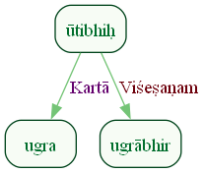
Figure 992: Sanskrit Tags Dependency Graph for Sentence ID 576374
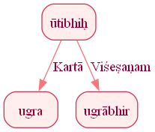
Figure 993: Reduced Dependency Graph for Sentence ID 576374

Sentence ID: 576375
Mantra Text:
indraṃ vayam mahādhana indram arbhe havāmahe
[('0_2', '0_1', 'Orphan'), ('0_2', '0_3', 'Orphan'), ('0_6', '0_4', 'Karma'), ('0_6', '0_5', 'Adhikaraṇam'), ('0_2', '0_6', 'Samuccita')]
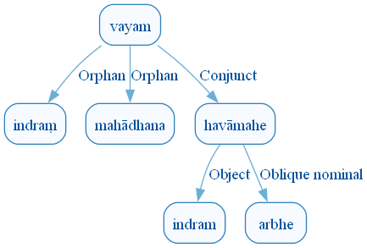
Figure 1000: DCS Original Dependency Graph for Sentence ID 576375
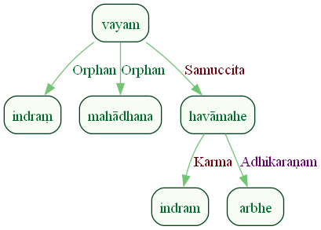
Figure 1001: Sanskrit Tags Dependency Graph for Sentence ID 576375
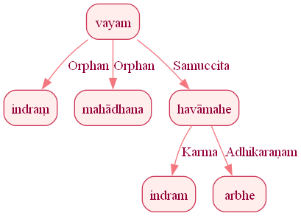
Figure 1002: Reduced Dependency Graph for Sentence ID 576375

Sentence ID: 576376
Mantra Text:
yujaṃ vṛtreṣu vajriṇam
[('0_1', '0_2', 'Adhikaraṇam'), ('0_1', '0_3', 'Samuccita')]
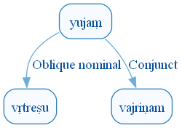
Figure 1009: DCS Original Dependency Graph for Sentence ID 576376
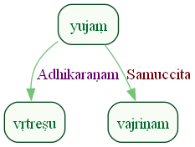
Figure 1010: Sanskrit Tags Dependency Graph for Sentence ID 576376
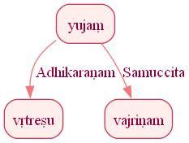
Figure 1011: Reduced Dependency Graph for Sentence ID 576376

Sentence ID: 576377
Mantra Text:
sa no vṛṣann amuṃ caruṃ satrādāvann apā vṛdhi
[('0_8', '0_1', 'Kriyāviśeṣaṇam'), ('0_8', '0_2', 'Sampradānam'), ('0_8', '0_3', 'Sambodhyaḥ'), ('0_5', '0_4', 'Viśeṣaṇam'), ('0_8', '0_5', 'Karma'), ('0_8', '0_6', 'Sambodhyaḥ'), ('0_8', '0_7', 'Kriyāviśeṣaṇam')]
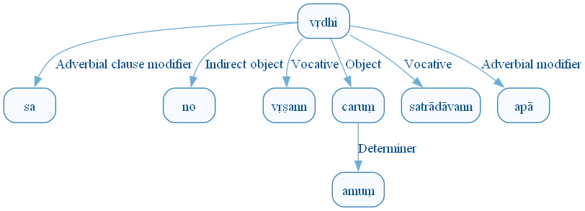
Figure 1018: DCS Original Dependency Graph for Sentence ID 576377
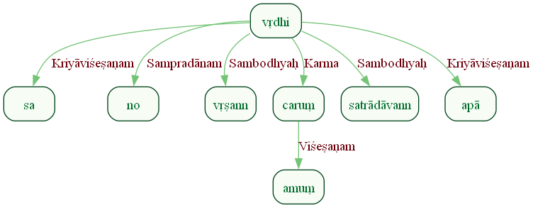
Figure 1019: Sanskrit Tags Dependency Graph for Sentence ID 576377
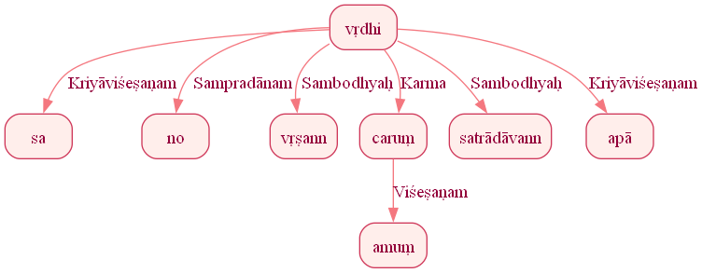
Figure 1020: Reduced Dependency Graph for Sentence ID 576377

Sentence ID: 576378
Mantra Text:
asmabhyam apratiṣkutaḥ
[('0_2', '0_1', 'Orphan')]
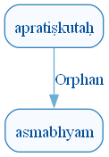
Figure 1027: DCS Original Dependency Graph for Sentence ID 576378
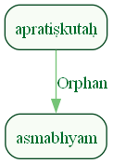
Figure 1028: Sanskrit Tags Dependency Graph for Sentence ID 576378
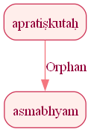
Figure 1029: Reduced Dependency Graph for Sentence ID 576378

Sentence ID: 576379
Mantra Text:
tuñje tuñje ya uttare stomā indrasya vajriṇaḥ
[('0_1', '0_2', 'vīpsā'), ('0_5', '0_3', 'Kartā'), ('0_5', '0_4', 'Viśeṣaṇam'), ('0_1', '0_5', 'Kartā'), ('0_7', '0_6', 'Ṣaṣṭhīsambandhaḥ')]
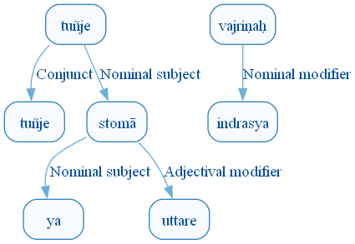
Figure 1036: DCS Original Dependency Graph for Sentence ID 576379
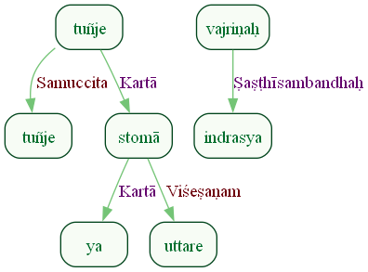
Figure 1037: Sanskrit Tags Dependency Graph for Sentence ID 576379
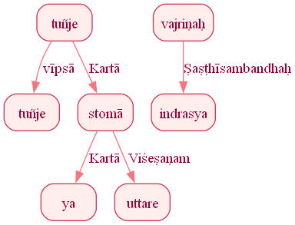
Figure 1038: Reduced Dependency Graph for Sentence ID 576379

Sentence ID: 576380
Mantra Text:
na vindhe asya suṣṭutim
[('0_2', '0_1', 'Kriyāviśeṣaṇam'), ('0_4', '0_3', 'Ṣaṣṭhīsambandhaḥ'), ('0_2', '0_4', 'Karma')]
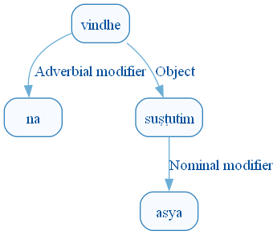
Figure 1045: DCS Original Dependency Graph for Sentence ID 576380
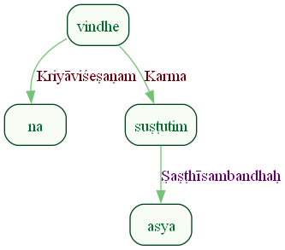
Figure 1046: Sanskrit Tags Dependency Graph for Sentence ID 576380
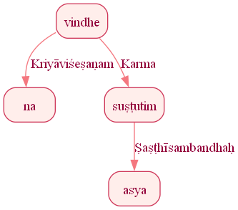
Figure 1047: Reduced Dependency Graph for Sentence ID 576380

Sentence ID: 576381
Mantra Text:
vṛṣā yūtheva vaṃsagaḥ kṛṣṭīr iyarty ojasā
[('0_6', '0_1', 'Kriyāviśeṣaṇam'), ('0_4', '0_2', 'Orphan'), ('0_4', '0_3', 'Marker'), ('0_6', '0_4', 'Kriyāviśeṣaṇam'), ('0_6', '0_5', 'Karma'), ('0_6', '0_7', 'Karaṇam')]
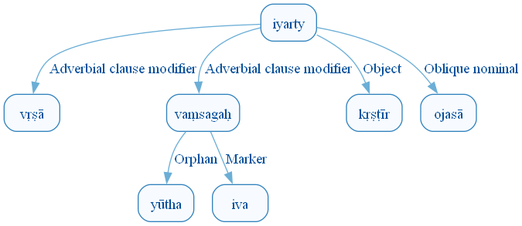
Figure 1054: DCS Original Dependency Graph for Sentence ID 576381
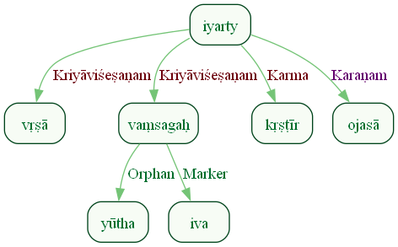
Figure 1055: Sanskrit Tags Dependency Graph for Sentence ID 576381
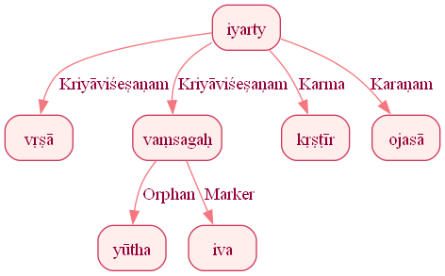
Figure 1056: Reduced Dependency Graph for Sentence ID 576381

Sentence ID: 576382
Mantra Text:
īśāno apratiṣkutaḥ
[('0_2', '0_1', 'Kriyāviśeṣaṇam')]
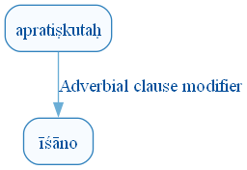
Figure 1063: DCS Original Dependency Graph for Sentence ID 576382
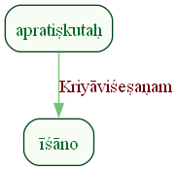
Figure 1064: Sanskrit Tags Dependency Graph for Sentence ID 576382
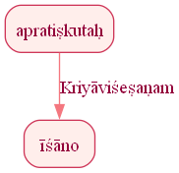
Figure 1065: Reduced Dependency Graph for Sentence ID 576382

Sentence ID: 576383
Mantra Text:
ya ekaś carṣaṇīnāṃ vasūnām irajyati
[('0_5', '0_1', 'Kartā'), ('0_1', '0_2', 'Viśeṣaṇam'), ('0_5', '0_3', 'Karma'), ('0_3', '0_4', 'Viśeṣaṇam')]
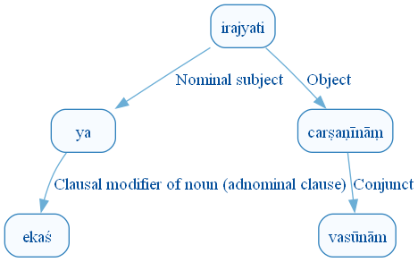
Figure 1072: DCS Original Dependency Graph for Sentence ID 576383
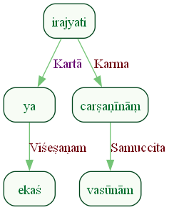
Figure 1073: Sanskrit Tags Dependency Graph for Sentence ID 576383
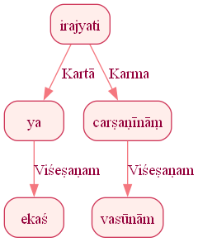
Figure 1074: Reduced Dependency Graph for Sentence ID 576383

Sentence ID: 576384
Mantra Text:
indraḥ pañca kṣitīnām
[('0_2', '0_3', 'Ṣaṣṭhīsambandhaḥ')]
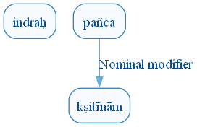
Figure 1081: DCS Original Dependency Graph for Sentence ID 576384
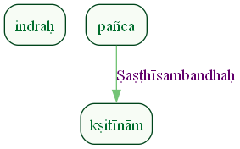
Figure 1082: Sanskrit Tags Dependency Graph for Sentence ID 576384
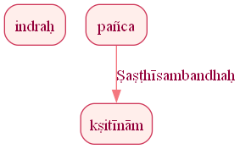
Figure 1083: Reduced Dependency Graph for Sentence ID 576384

Sentence ID: 576385
Mantra Text:
indraṃ vo viśvatas pari havāmahe janebhyaḥ
[('0_5', '0_1', 'Karma'), ('0_5', '0_2', 'Sampradānam'), ('0_5', '0_3', 'Kriyāviśeṣaṇam'), ('0_5', '0_4', 'Kriyāviśeṣaṇam'), ('0_5', '0_6', 'Sampradānam')]
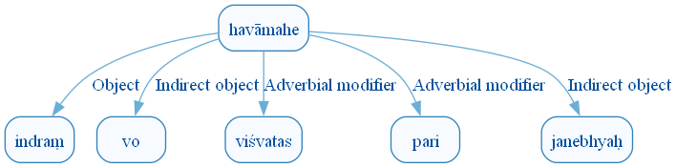
Figure 1090: DCS Original Dependency Graph for Sentence ID 576385
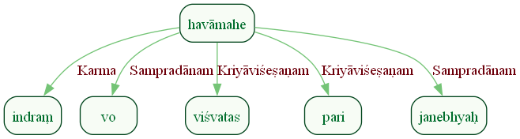
Figure 1091: Sanskrit Tags Dependency Graph for Sentence ID 576385
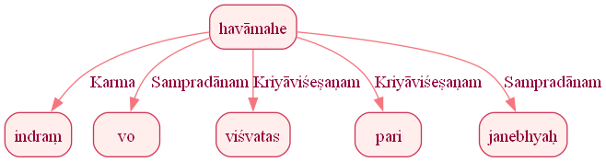
Figure 1092: Reduced Dependency Graph for Sentence ID 576385

Sentence ID: 576386
Mantra Text:
asmākam astu kevalaḥ
[('0_3', '0_1', 'Ṣaṣṭhīsambandhaḥ'), ('0_3', '0_2', 'Copula')]
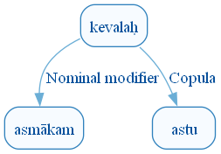
Figure 1099: DCS Original Dependency Graph for Sentence ID 576386
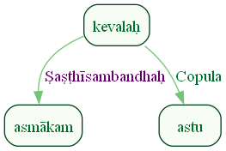
Figure 1100: Sanskrit Tags Dependency Graph for Sentence ID 576386
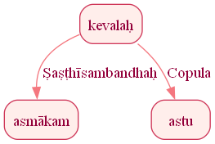
Figure 1101: Reduced Dependency Graph for Sentence ID 576386

ConLLU File: ṚV, 1, 8

Sentence ID: 576388
Mantra Text:
ā indra ūtaye bhara
[('1_4', '1_1', 'Kriyāviśeṣaṇam'), ('1_4', '1_2', 'Sambodhyaḥ'), ('1_4', '1_3', 'Advcl:fin_unknown_label')]
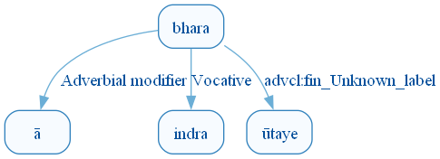
Figure 1108: DCS Original Dependency Graph for Sentence ID 576388
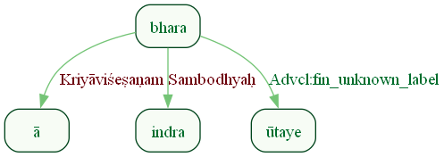
Figure 1109: Sanskrit Tags Dependency Graph for Sentence ID 576388
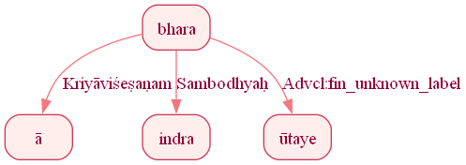
Figure 1110: Reduced Dependency Graph for Sentence ID 576388

Sentence ID: 576389
Mantra Text:
ni yena muṣṭihatyayā ni vṛtrā ruṇadhāmahai
[('0_7', '0_1', 'Kriyāviśeṣaṇam'), ('0_4', '0_2', 'Viśeṣaṇam'), ('0_4', '0_3', 'Viśeṣaṇam'), ('0_7', '0_4', 'Karaṇam'), ('0_7', '0_5', 'Kriyāviśeṣaṇam'), ('0_7', '0_6', 'Karma')]
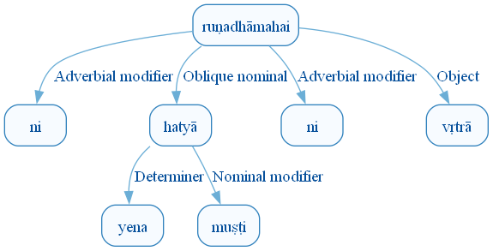
Figure 1117: DCS Original Dependency Graph for Sentence ID 576389
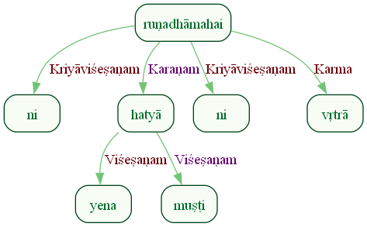
Figure 1118: Sanskrit Tags Dependency Graph for Sentence ID 576389
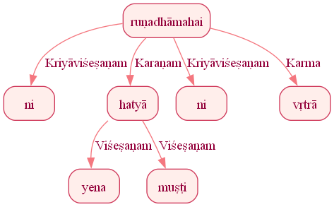
Figure 1119: Reduced Dependency Graph for Sentence ID 576389

Sentence ID: 576390
Mantra Text:
tvotāso ny arvatā
[('0_1', '0_2', 'Kriyāviśeṣaṇam'), ('0_1', '0_3', 'Orphan')]
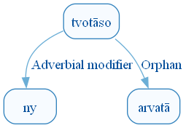
Figure 1126: DCS Original Dependency Graph for Sentence ID 576390
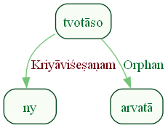
Figure 1127: Sanskrit Tags Dependency Graph for Sentence ID 576390
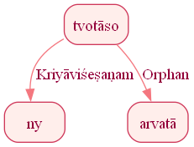
Figure 1128: Reduced Dependency Graph for Sentence ID 576390

Sentence ID: 576391
Mantra Text:
indra tvotāsa ā vayaṃ vajraṃ ghanā dadīmahi
[('0_7', '0_1', 'Sambodhyaḥ'), ('0_7', '0_3', 'Kriyāviśeṣaṇam'), ('0_7', '0_4', 'Kartā'), ('0_7', '0_5', 'Karma'), ('0_7', '0_6', 'Karaṇam')]
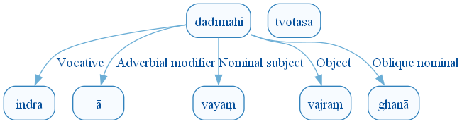
Figure 1135: DCS Original Dependency Graph for Sentence ID 576391
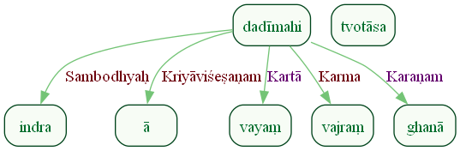
Figure 1136: Sanskrit Tags Dependency Graph for Sentence ID 576391
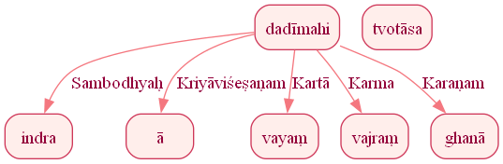
Figure 1137: Reduced Dependency Graph for Sentence ID 576391

Sentence ID: 576392
Mantra Text:
jayema saṃ yudhi spṛdhaḥ
[('0_1', '0_2', 'Kriyāviśeṣaṇam'), ('0_1', '0_3', 'Adhikaraṇam'), ('0_1', '0_4', 'Karma')]
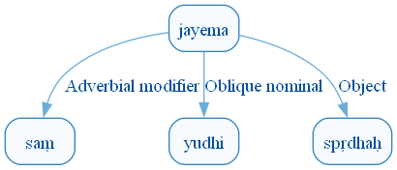
Figure 1144: DCS Original Dependency Graph for Sentence ID 576392
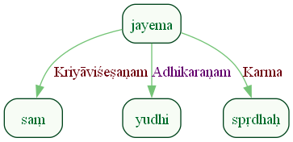
Figure 1145: Sanskrit Tags Dependency Graph for Sentence ID 576392
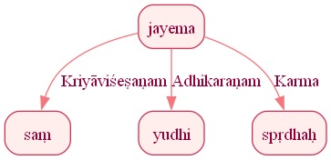
Figure 1146: Reduced Dependency Graph for Sentence ID 576392

Sentence ID: 576393
Mantra Text:
vayaṃ śūrebhir astṛbhir indra tvayā yujā vayam
[('0_3', '0_2', 'Viśeṣaṇam'), ('0_1', '0_3', 'Orphan'), ('0_1', '0_4', 'Sambodhyaḥ'), ('0_1', '0_5', 'Karaṇam'), ('0_5', '0_6', 'Viśeṣaṇam'), ('0_1', '0_7', 'Kartā')]
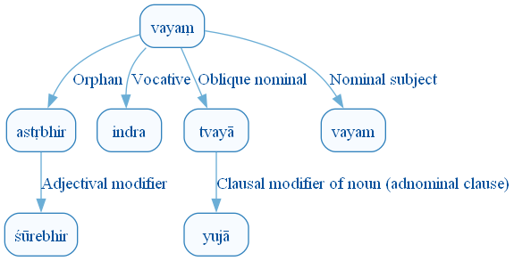
Figure 1153: DCS Original Dependency Graph for Sentence ID 576393
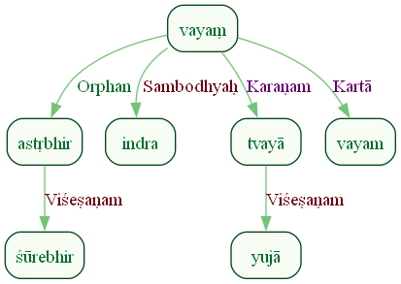
Figure 1154: Sanskrit Tags Dependency Graph for Sentence ID 576393
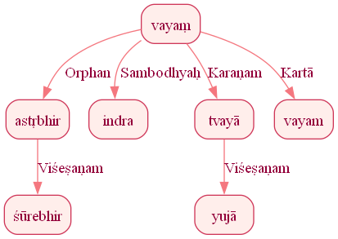
Figure 1155: Reduced Dependency Graph for Sentence ID 576393

Sentence ID: 576394
Mantra Text:
sāsahyāma pṛtanyataḥ
[('0_1', '0_2', 'Karma')]
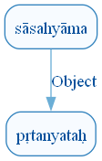
Figure 1162: DCS Original Dependency Graph for Sentence ID 576394
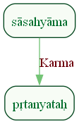
Figure 1163: Sanskrit Tags Dependency Graph for Sentence ID 576394
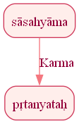
Figure 1164: Reduced Dependency Graph for Sentence ID 576394

Sentence ID: 576395
Mantra Text:
mahāṁ indraḥ paraś ca nu mahitvam astu vajriṇe
[('0_7', '0_3', 'Kriyāviśeṣaṇam'), ('0_7', '0_5', 'Discourse_unknown_label'), ('0_7', '0_6', 'Viśeṣaṇam'), ('0_1', '0_7', 'Kartā'), ('0_7', '0_8', 'Copula'), ('0_7', '0_9', 'Viśeṣaṇam')]
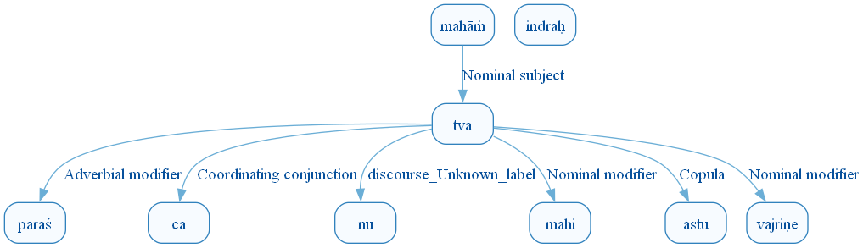
Figure 1171: DCS Original Dependency Graph for Sentence ID 576395
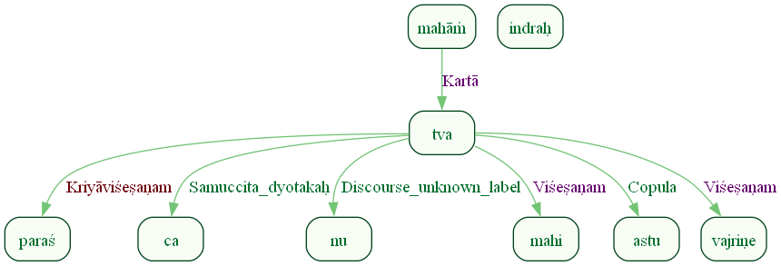
Figure 1172: Sanskrit Tags Dependency Graph for Sentence ID 576395
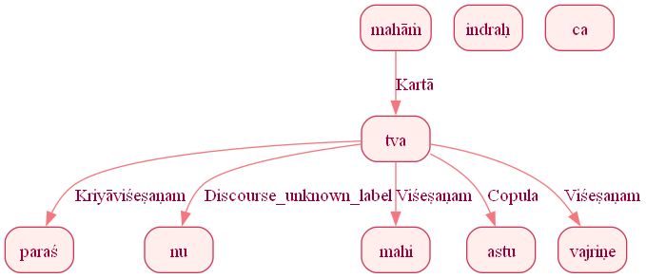
Figure 1173: Reduced Dependency Graph for Sentence ID 576395

Sentence ID: 576396
Mantra Text:
dyaur na prathinā śavaḥ
[('0_4', '0_1', 'Oblique nominal'), ('0_1', '0_2', 'Karmapravacanīyaḥ'), ('0_4', '0_3', 'Karaṇam')]
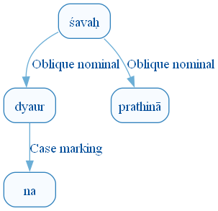
Figure 1180: DCS Original Dependency Graph for Sentence ID 576396
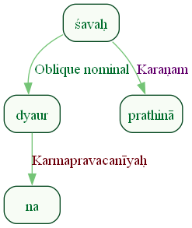
Figure 1181: Sanskrit Tags Dependency Graph for Sentence ID 576396
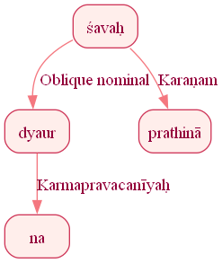
Figure 1182: Reduced Dependency Graph for Sentence ID 576396

Sentence ID: 576397
Mantra Text:
samohe vā ya āśata naras tokasya sanitau
[('0_4', '0_1', 'Adhikaraṇam'), ('0_4', '0_2', 'Anyatara_dyotakaḥ'), ('0_5', '0_3', 'Viśeṣaṇam'), ('0_4', '0_5', 'Kartā'), ('0_7', '0_6', 'Ṣaṣṭhīsambandhaḥ'), ('0_4', '0_7', 'Adhikaraṇam')]
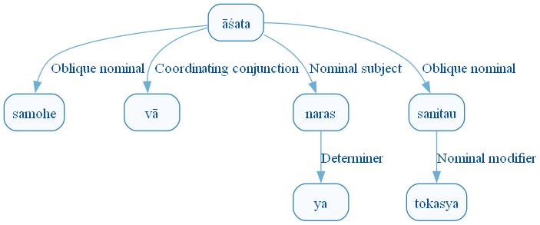
Figure 1189: DCS Original Dependency Graph for Sentence ID 576397
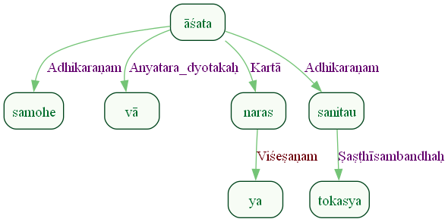
Figure 1190: Sanskrit Tags Dependency Graph for Sentence ID 576397
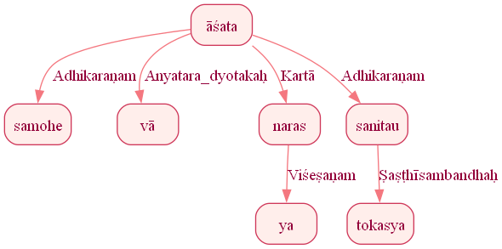
Figure 1191: Reduced Dependency Graph for Sentence ID 576397

Sentence ID: 576398
Mantra Text:
viprāso vā dhiyāyavaḥ
[('0_3', '0_1', 'Kartā'), ('0_1', '0_2', 'Anyatara_dyotakaḥ')]
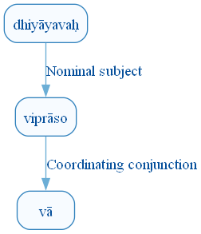
Figure 1198: DCS Original Dependency Graph for Sentence ID 576398
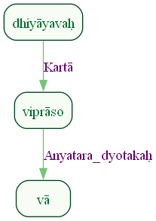
Figure 1199: Sanskrit Tags Dependency Graph for Sentence ID 576398
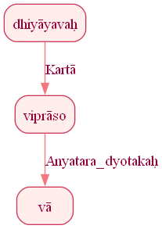
Figure 1200: Reduced Dependency Graph for Sentence ID 576398

Sentence ID: 576399
Mantra Text:
yaḥ kukṣiḥ soma pātamaḥ samudraḥ iva pinvate urvīḥ āpaḥ na kākudaḥ
[('1_2', '1_1', 'Viśeṣaṇam'), ('1_7', '1_2', 'Kartā'), ('1_4', '1_3', 'Karma'), ('1_2', '1_4', 'Viśeṣaṇam'), ('1_7', '1_5', 'Obl:manner_unknown_label'), ('1_5', '1_6', 'Case:sim_unknown_label'), ('1_9', '1_8', 'Viśeṣaṇam'), ('1_11', '1_9', 'Orphan'), ('1_9', '1_10', 'Case:sim_unknown_label'), ('1_7', '1_11', 'Orphan')]
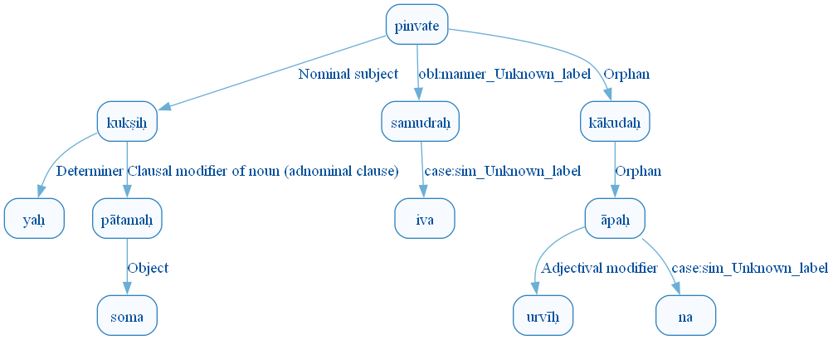
Figure 1207: DCS Original Dependency Graph for Sentence ID 576399
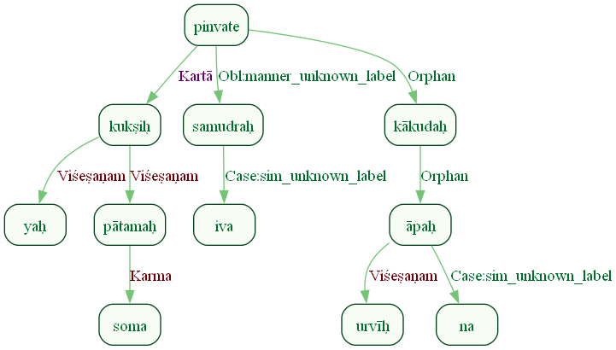
Figure 1208: Sanskrit Tags Dependency Graph for Sentence ID 576399
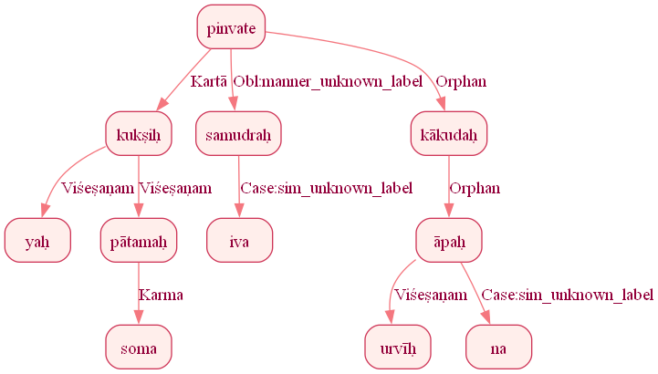
Figure 1209: Reduced Dependency Graph for Sentence ID 576399

Sentence ID: 576401
Mantra Text:
eva hi asya sūnṛtā virapśī gomatī mahī pakvā śākhā na dāśuṣe
[('1_1', '1_2', 'Discourse_unknown_label'), ('1_4', '1_3', 'Ṣaṣṭhīsambandhaḥ'), ('1_1', '1_4', 'Kartā'), ('1_4', '1_5', 'Viśeṣaṇam'), ('1_4', '1_6', 'Viśeṣaṇam'), ('1_4', '1_7', 'Viśeṣaṇam'), ('1_9', '1_8', 'Viśeṣaṇam'), ('1_4', '1_9', 'Viśeṣaṇam'), ('1_9', '1_10', 'Case:sim_unknown_label'), ('1_9', '1_11', 'Orphan')]
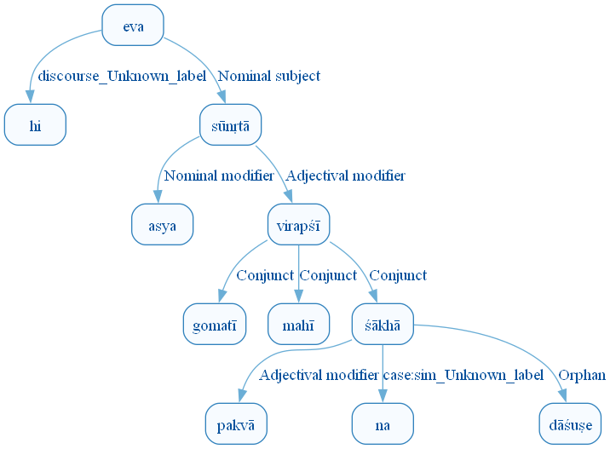
Figure 1216: DCS Original Dependency Graph for Sentence ID 576401
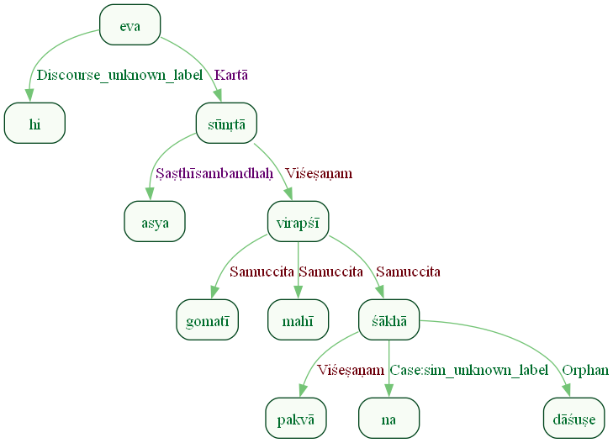
Figure 1217: Sanskrit Tags Dependency Graph for Sentence ID 576401
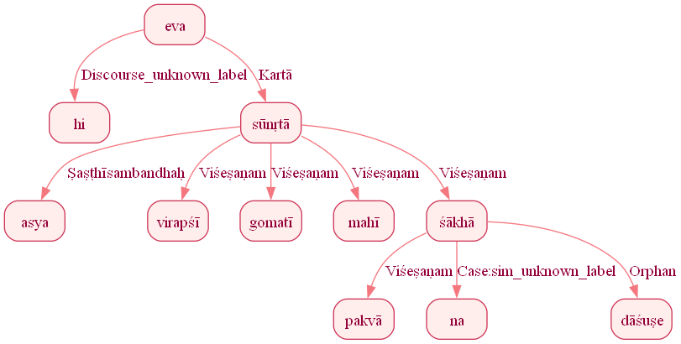
Figure 1218: Reduced Dependency Graph for Sentence ID 576401

Sentence ID: 576403
Mantra Text:
evā hi te vibhūtaya ūtaya indra māvate
[('0_5', '0_1', 'Kriyāviśeṣaṇam'), ('0_5', '0_2', 'Discourse_unknown_label'), ('0_4', '0_3', 'Ṣaṣṭhīsambandhaḥ'), ('0_5', '0_4', 'Kartā'), ('0_5', '0_6', 'Sambodhyaḥ'), ('0_5', '0_7', 'Viśeṣaṇam')]
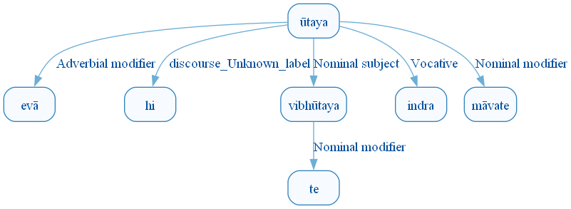
Figure 1225: DCS Original Dependency Graph for Sentence ID 576403
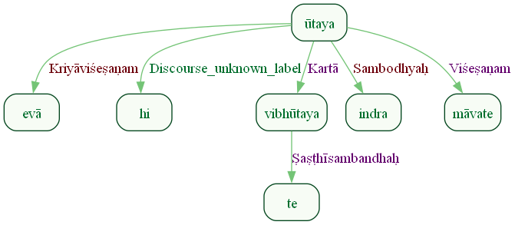
Figure 1226: Sanskrit Tags Dependency Graph for Sentence ID 576403
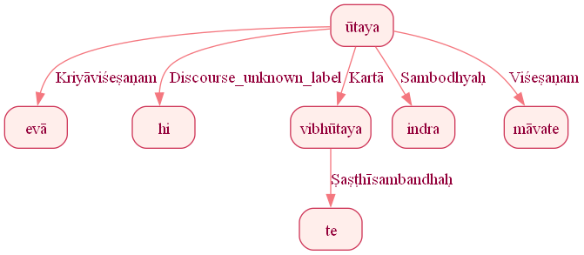
Figure 1227: Reduced Dependency Graph for Sentence ID 576403

Sentence ID: 576404
Mantra Text:
sadyaś cit santi dāśuṣe
[('0_3', '0_1', 'Kriyāviśeṣaṇam'), ('0_3', '0_2', 'Discourse_unknown_label'), ('0_3', '0_4', 'Sampradānam')]
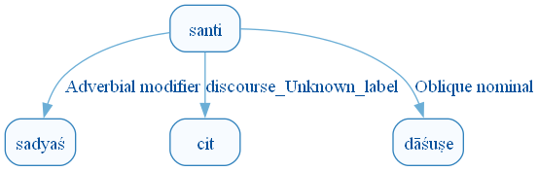
Figure 1234: DCS Original Dependency Graph for Sentence ID 576404
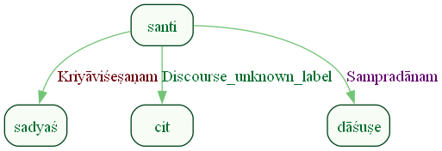
Figure 1235: Sanskrit Tags Dependency Graph for Sentence ID 576404
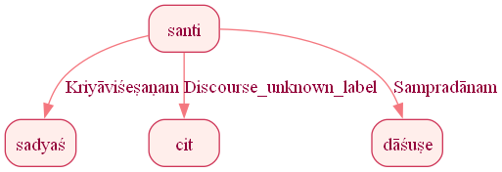
Figure 1236: Reduced Dependency Graph for Sentence ID 576404

Sentence ID: 576405
Mantra Text:
evā hy asya kāmyā stoma ukthaṃ ca śaṃsyā
[('0_8', '0_1', 'Kriyāviśeṣaṇam'), ('0_5', '0_2', 'Discourse_unknown_label'), ('0_5', '0_3', 'Ṣaṣṭhīsambandhaḥ'), ('0_5', '0_4', 'Viśeṣaṇam'), ('0_8', '0_5', 'Karma'), ('0_5', '0_6', 'Viśeṣaṇam'), ('0_8', '0_7', 'Samuccita_dyotakaḥ')]
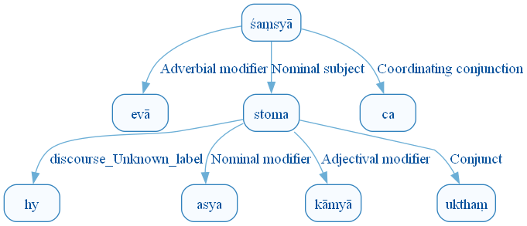
Figure 1243: DCS Original Dependency Graph for Sentence ID 576405
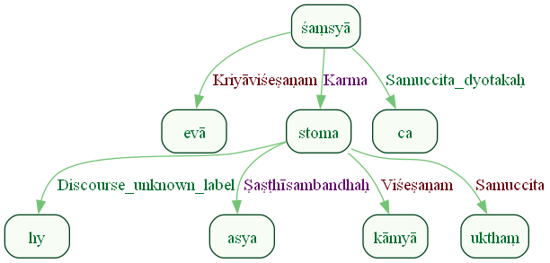
Figure 1244: Sanskrit Tags Dependency Graph for Sentence ID 576405
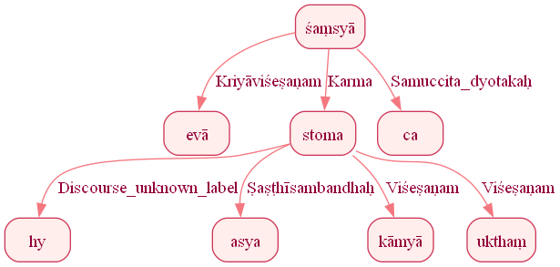
Figure 1245: Reduced Dependency Graph for Sentence ID 576405

Sentence ID: 576406
Mantra Text:
indrāya somapītaye
[('0_3', '0_2', 'Viśeṣaṇam'), ('0_1', '0_3', 'Samuccita')]
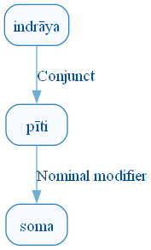
Figure 1252: DCS Original Dependency Graph for Sentence ID 576406
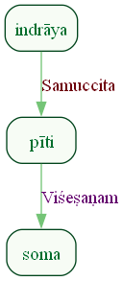
Figure 1253: Sanskrit Tags Dependency Graph for Sentence ID 576406
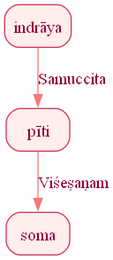
Figure 1254: Reduced Dependency Graph for Sentence ID 576406

ConLLU File: ṚV, 1, 9

Sentence ID: 576407
Mantra Text:
indra ihi matsi andhasaḥ viśvebhiḥ soma parvabhiḥ
[('0_2', '0_1', 'Sambodhyaḥ'), ('1_1', '1_2', 'Oblique nominal'), ('1_5', '1_3', 'Viśeṣaṇam'), ('1_5', '1_4', 'Viśeṣaṇam'), ('1_1', '1_5', 'Karaṇam')]
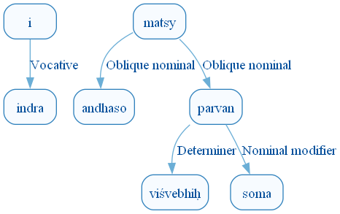
Figure 1261: DCS Original Dependency Graph for Sentence ID 576407
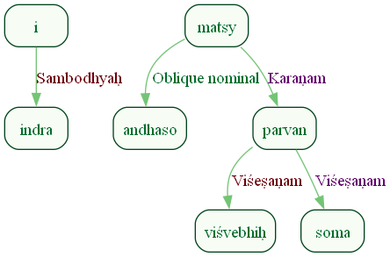
Figure 1262: Sanskrit Tags Dependency Graph for Sentence ID 576407
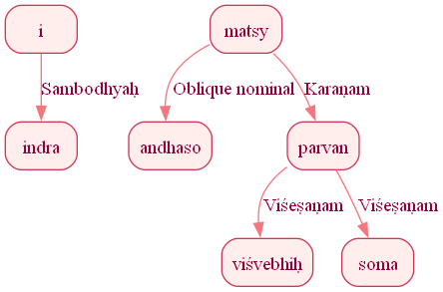
Figure 1263: Reduced Dependency Graph for Sentence ID 576407

Sentence ID: 576408
Mantra Text:
mahāṁ abhiṣṭir ojasā
[('0_2', '0_1', 'Viśeṣaṇam'), ('0_2', '0_3', 'Karaṇam')]
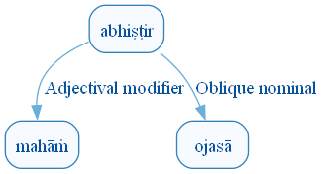
Figure 1270: DCS Original Dependency Graph for Sentence ID 576408
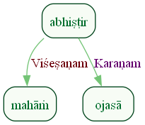
Figure 1271: Sanskrit Tags Dependency Graph for Sentence ID 576408
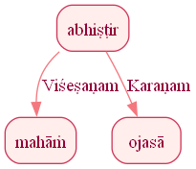
Figure 1272: Reduced Dependency Graph for Sentence ID 576408

Sentence ID: 576409
Mantra Text:
em enaṃ sṛjatā sute mandim indrāya mandine
[('0_4', '0_1', 'Kriyāviśeṣaṇam'), ('0_4', '0_2', 'Karma'), ('0_2', '0_3', 'Viśeṣaṇam'), ('0_4', '0_5', 'Adhikaraṇam'), ('0_2', '0_6', 'Viśeṣaṇam'), ('0_6', '0_7', 'Sampradānam'), ('0_7', '0_8', 'Viśeṣaṇam')]
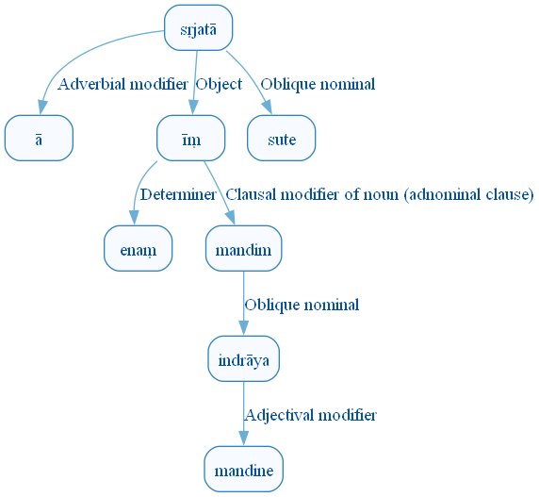
Figure 1279: DCS Original Dependency Graph for Sentence ID 576409
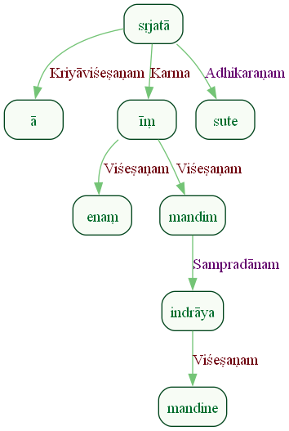
Figure 1280: Sanskrit Tags Dependency Graph for Sentence ID 576409
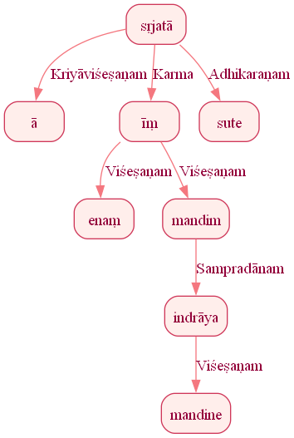
Figure 1281: Reduced Dependency Graph for Sentence ID 576409

Sentence ID: 576410
Mantra Text:
cakriṃ viśvāni cakraye
[('0_1', '0_2', 'Viśeṣaṇam'), ('0_1', '0_3', 'Orphan')]
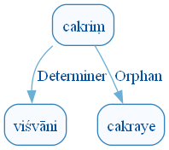
Figure 1288: DCS Original Dependency Graph for Sentence ID 576410
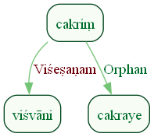
Figure 1289: Sanskrit Tags Dependency Graph for Sentence ID 576410
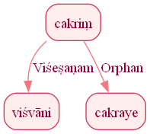
Figure 1290: Reduced Dependency Graph for Sentence ID 576410

Sentence ID: 576411
Mantra Text:
matsvā suśipra mandibhi stomebhir viśvacarṣaṇe
[('0_3', '0_2', 'Kriyāviśeṣaṇam'), ('0_1', '0_3', 'Sambodhyaḥ'), ('0_5', '0_4', 'Viśeṣaṇam'), ('0_1', '0_5', 'Karaṇam'), ('0_1', '0_6', 'Sambodhyaḥ')]
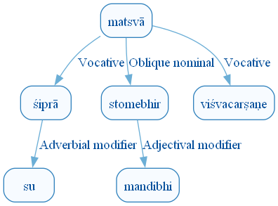
Figure 1297: DCS Original Dependency Graph for Sentence ID 576411
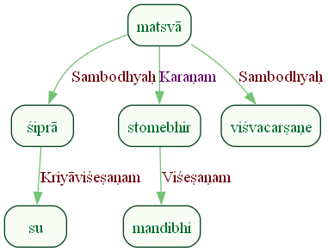
Figure 1298: Sanskrit Tags Dependency Graph for Sentence ID 576411
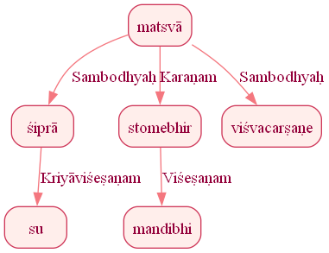
Figure 1299: Reduced Dependency Graph for Sentence ID 576411

Sentence ID: 576412
Mantra Text:
sacaiṣu savaneṣv ā
[('0_3', '0_1', 'Karmapravacanīyaḥ'), ('0_3', '0_2', 'Viśeṣaṇam'), ('0_3', '0_4', 'Karmapravacanīyaḥ')]
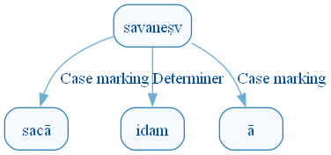
Figure 1306: DCS Original Dependency Graph for Sentence ID 576412
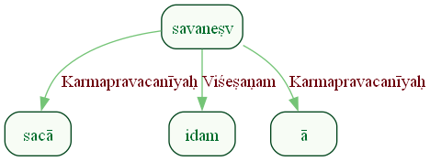
Figure 1307: Sanskrit Tags Dependency Graph for Sentence ID 576412
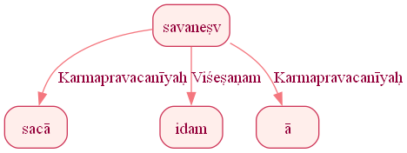
Figure 1308: Reduced Dependency Graph for Sentence ID 576412

Sentence ID: 576413
Mantra Text:
asṛgram indra te giraḥ prati tvām ud ahāsata
[('0_1', '0_2', 'Sambodhyaḥ'), ('0_4', '0_3', 'Ṣaṣṭhīsambandhaḥ'), ('0_1', '0_4', 'Kartā'), ('1_4', '1_1', 'Kriyāviśeṣaṇam'), ('1_4', '1_2', 'Karma'), ('1_4', '1_3', 'Kriyāviśeṣaṇam')]
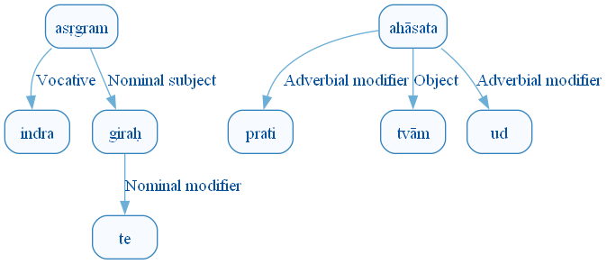
Figure 1315: DCS Original Dependency Graph for Sentence ID 576413
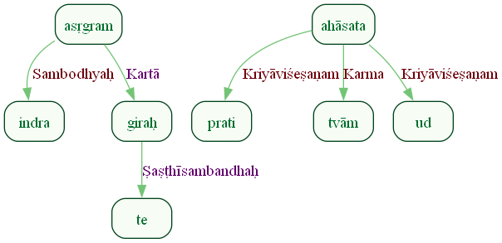
Figure 1316: Sanskrit Tags Dependency Graph for Sentence ID 576413
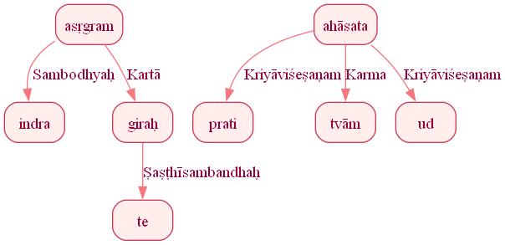
Figure 1317: Reduced Dependency Graph for Sentence ID 576413

Sentence ID: 576414
Mantra Text:
ajoṣā vṛṣabham patim
[('0_1', '0_2', 'Karma'), ('0_2', '0_3', 'Appositional modifier')]
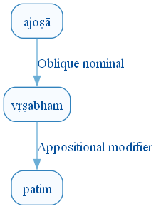
Figure 1324: DCS Original Dependency Graph for Sentence ID 576414
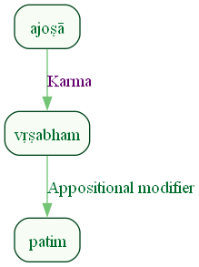
Figure 1325: Sanskrit Tags Dependency Graph for Sentence ID 576414
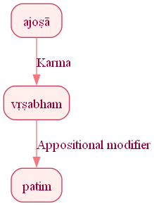
Figure 1326: Reduced Dependency Graph for Sentence ID 576414

Sentence ID: 576415
Mantra Text:
saṃ codaya citram arvāg rādha indra vareṇyam
[('0_2', '0_1', 'Kriyāviśeṣaṇam'), ('0_5', '0_3', 'Viśeṣaṇam'), ('0_2', '0_4', 'Kriyāviśeṣaṇam'), ('0_2', '0_5', 'Karma'), ('0_2', '0_6', 'Sambodhyaḥ'), ('0_5', '0_7', 'Viśeṣaṇam')]
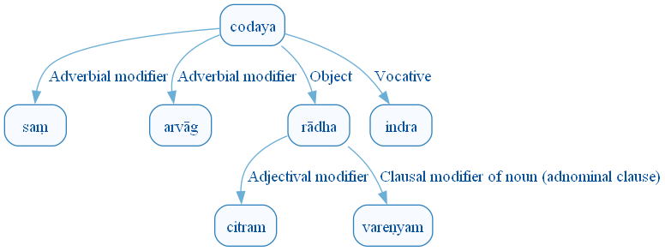
Figure 1333: DCS Original Dependency Graph for Sentence ID 576415
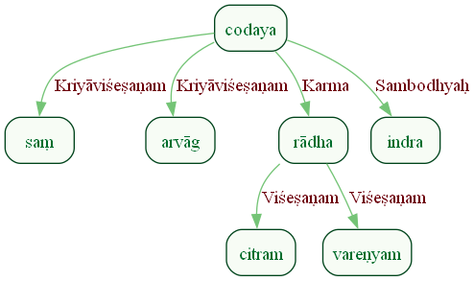
Figure 1334: Sanskrit Tags Dependency Graph for Sentence ID 576415
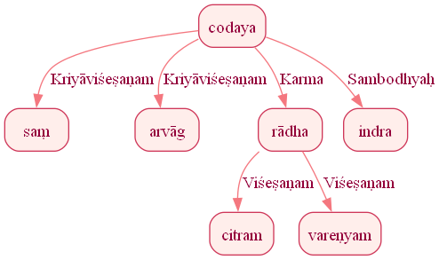
Figure 1335: Reduced Dependency Graph for Sentence ID 576415

Sentence ID: 576416
Mantra Text:
asad it te vibhu prabhu
[('0_4', '0_1', 'Copula'), ('0_1', '0_2', 'Discourse_unknown_label'), ('0_4', '0_3', 'Ṣaṣṭhīsambandhaḥ'), ('0_4', '0_5', 'Samuccita')]
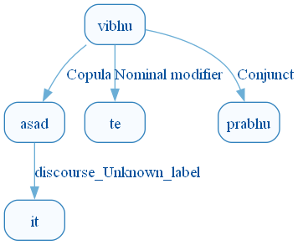
Figure 1342: DCS Original Dependency Graph for Sentence ID 576416
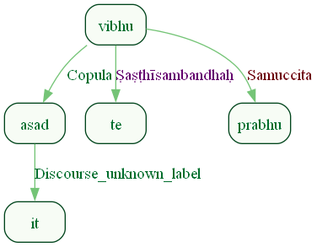
Figure 1343: Sanskrit Tags Dependency Graph for Sentence ID 576416
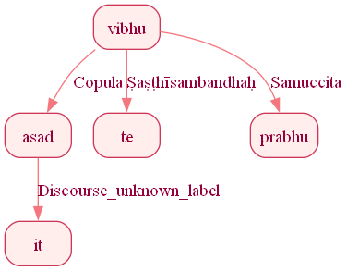
Figure 1344: Reduced Dependency Graph for Sentence ID 576416

Sentence ID: 576417
Mantra Text:
asmān su tatra codayendra rāye rabhasvataḥ
[('0_4', '0_1', 'Karma'), ('0_4', '0_2', 'Kriyāviśeṣaṇam'), ('0_4', '0_3', 'Kriyāviśeṣaṇam'), ('0_4', '0_5', 'Sambodhyaḥ'), ('0_4', '0_6', 'Kriyāviśeṣaṇam'), ('0_4', '0_7', 'Karma')]
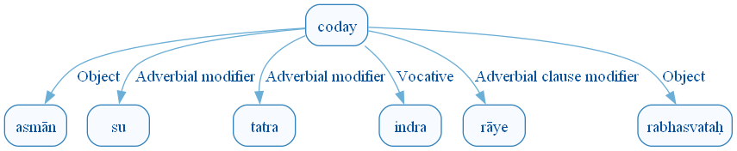
Figure 1351: DCS Original Dependency Graph for Sentence ID 576417
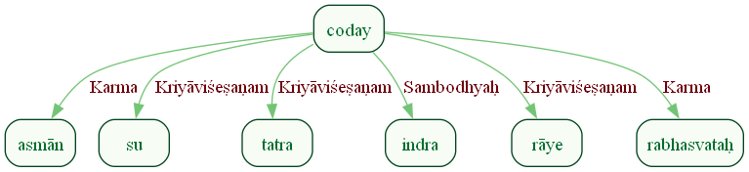
Figure 1352: Sanskrit Tags Dependency Graph for Sentence ID 576417
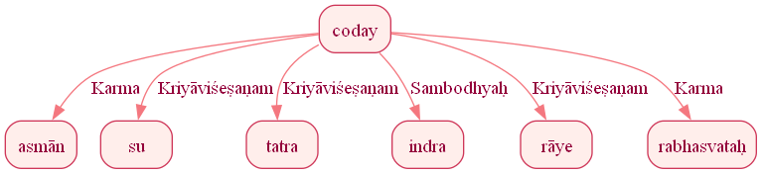
Figure 1353: Reduced Dependency Graph for Sentence ID 576417

Sentence ID: 576418
Mantra Text:
tuvidyumna yaśasvataḥ
[('0_2', '0_1', 'Viśeṣaṇam'), ('0_3', '0_2', 'Sambodhyaḥ')]
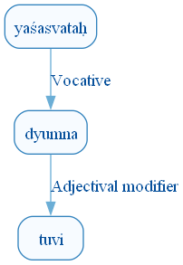
Figure 1360: DCS Original Dependency Graph for Sentence ID 576418
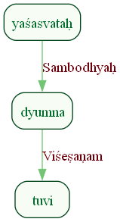
Figure 1361: Sanskrit Tags Dependency Graph for Sentence ID 576418
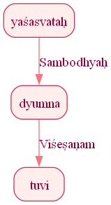
Figure 1362: Reduced Dependency Graph for Sentence ID 576418

Sentence ID: 576419
Mantra Text:
saṃ gomad indra vājavad asme pṛthu śravo bṛhat
[('0_2', '0_1', 'Orphan'), ('0_1', '0_3', 'Sambodhyaḥ'), ('0_2', '0_4', 'Samuccita'), ('0_7', '0_5', 'Orphan'), ('0_7', '0_6', 'Viśeṣaṇam'), ('0_2', '0_7', 'Samuccita'), ('0_7', '0_8', 'Viśeṣaṇam')]
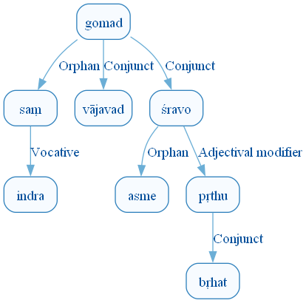
Figure 1369: DCS Original Dependency Graph for Sentence ID 576419
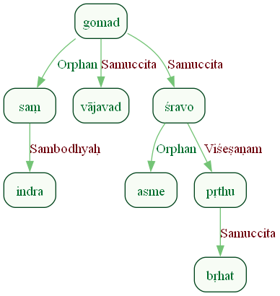
Figure 1370: Sanskrit Tags Dependency Graph for Sentence ID 576419
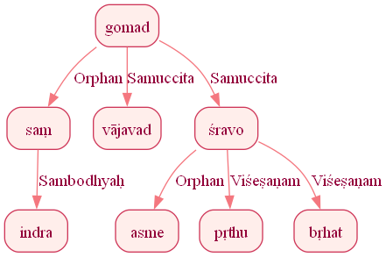
Figure 1371: Reduced Dependency Graph for Sentence ID 576419

Sentence ID: 576420
Mantra Text:
viśvāyur dhehy akṣitam
[('0_2', '0_1', 'Viśeṣaṇam'), ('0_3', '0_2', 'Karma'), ('0_2', '0_4', 'Viśeṣaṇam')]
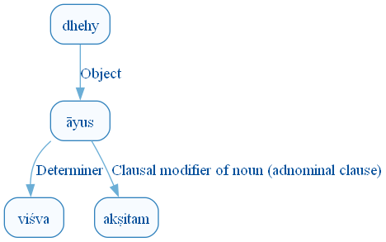
Figure 1378: DCS Original Dependency Graph for Sentence ID 576420
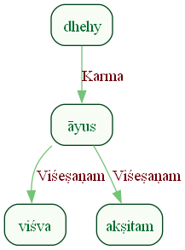
Figure 1379: Sanskrit Tags Dependency Graph for Sentence ID 576420
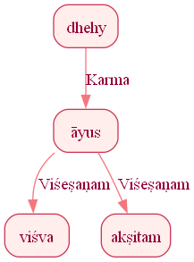
Figure 1380: Reduced Dependency Graph for Sentence ID 576420

Sentence ID: 576421
Mantra Text:
asme dhehi śravo bṛhad dyumnaṃ sahasrasātamam
[('0_2', '0_1', 'Sampradānam'), ('0_2', '0_3', 'Karma'), ('0_5', '0_4', 'Viśeṣaṇam'), ('0_3', '0_5', 'Viśeṣaṇam'), ('0_5', '0_6', 'Viśeṣaṇam'), ('0_5', '0_7', 'Viśeṣaṇam')]
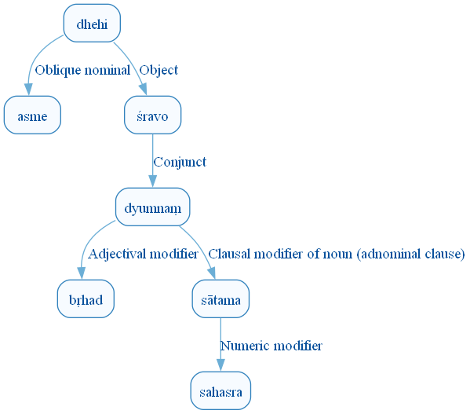
Figure 1387: DCS Original Dependency Graph for Sentence ID 576421
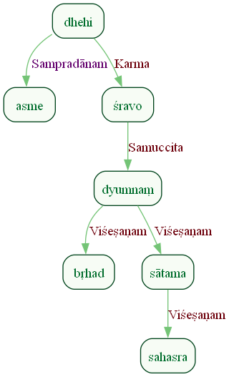
Figure 1388: Sanskrit Tags Dependency Graph for Sentence ID 576421
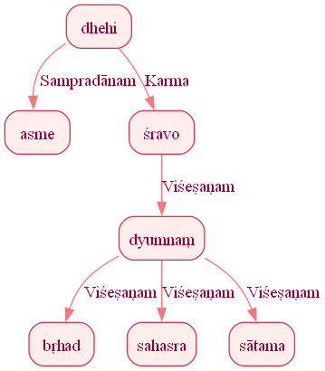
Figure 1389: Reduced Dependency Graph for Sentence ID 576421

Sentence ID: 576422
Mantra Text:
indra tā rathinīr iṣaḥ
[('0_4', '0_1', 'Sambodhyaḥ'), ('0_4', '0_2', 'Viśeṣaṇam'), ('0_4', '0_3', 'Viśeṣaṇam')]
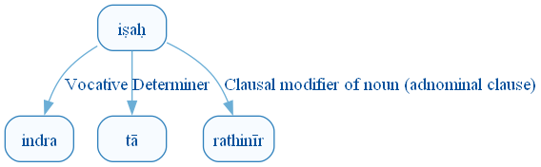
Figure 1396: DCS Original Dependency Graph for Sentence ID 576422
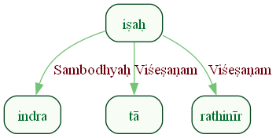
Figure 1397: Sanskrit Tags Dependency Graph for Sentence ID 576422
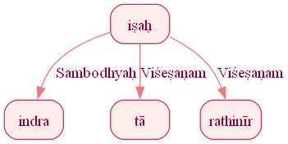
Figure 1398: Reduced Dependency Graph for Sentence ID 576422

Sentence ID: 576423
Mantra Text:
vasor indraṃ vasupatiṃ gīrbhir gṛṇanta ṛgmiyam
[('0_2', '0_1', 'Ṣaṣṭhīsambandhaḥ'), ('0_6', '0_2', 'Karma'), ('0_2', '0_3', 'Viśeṣaṇam'), ('0_2', '0_4', 'Viśeṣaṇam'), ('0_6', '0_5', 'Karaṇam'), ('0_2', '0_7', 'Viśeṣaṇam')]
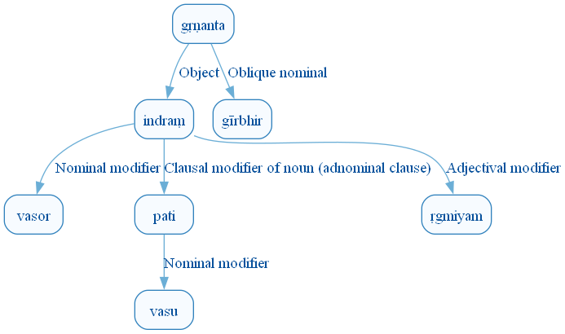
Figure 1405: DCS Original Dependency Graph for Sentence ID 576423
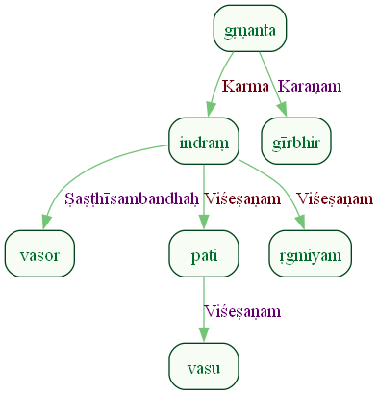
Figure 1406: Sanskrit Tags Dependency Graph for Sentence ID 576423
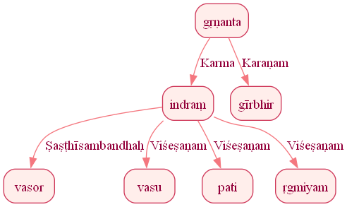
Figure 1407: Reduced Dependency Graph for Sentence ID 576423

Sentence ID: 576424
Mantra Text:
homagantāram ūtaye
[('0_2', '0_1', 'Viśeṣaṇam'), ('0_2', '0_3', 'Kriyāviśeṣaṇam')]
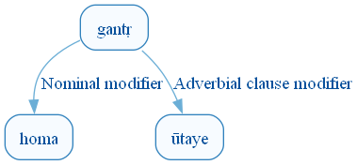
Figure 1414: DCS Original Dependency Graph for Sentence ID 576424
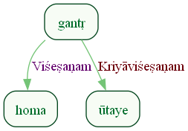
Figure 1415: Sanskrit Tags Dependency Graph for Sentence ID 576424
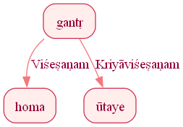
Figure 1416: Reduced Dependency Graph for Sentence ID 576424

Sentence ID: 576425
Mantra Text:
sute sute nyokase bṛhad bṛhata ed ariḥ
[('0_1', '0_2', 'vīpsā'), ('0_1', '0_3', 'Samuccita'), ('0_1', '0_4', 'Samuccita'), ('0_4', '0_5', 'Orphan'), ('0_8', '0_6', 'Kriyāviśeṣaṇam'), ('0_8', '0_7', 'Discourse_unknown_label'), ('0_1', '0_8', 'Kartā')]
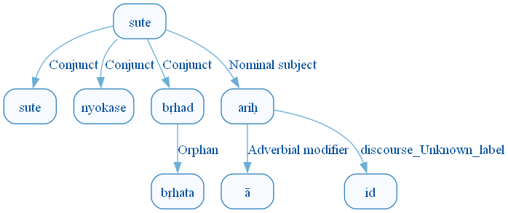
Figure 1423: DCS Original Dependency Graph for Sentence ID 576425
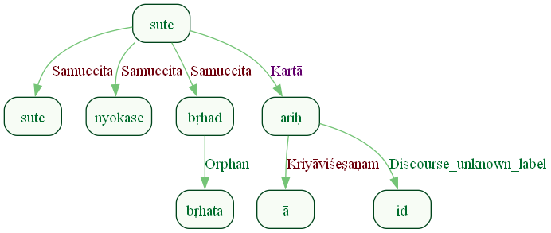
Figure 1424: Sanskrit Tags Dependency Graph for Sentence ID 576425
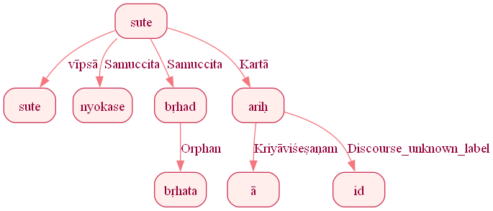
Figure 1425: Reduced Dependency Graph for Sentence ID 576425

Sentence ID: 576426
Mantra Text:
indrāya śūṣam arcati
[('0_3', '0_1', 'Sampradānam'), ('0_3', '0_2', 'Karma')]
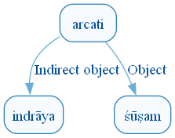
Figure 1432: DCS Original Dependency Graph for Sentence ID 576426
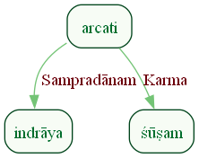
Figure 1433: Sanskrit Tags Dependency Graph for Sentence ID 576426
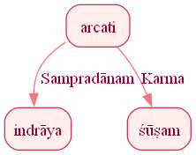
Figure 1434: Reduced Dependency Graph for Sentence ID 576426

