Mary Kozuch

HW3

3/10/2021

1. AWS account with IAM

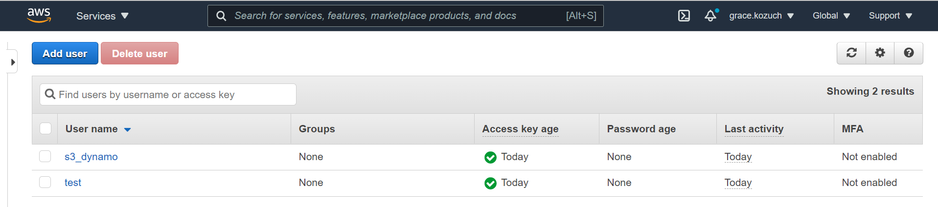

1. Amazon Python Boto3 SDK

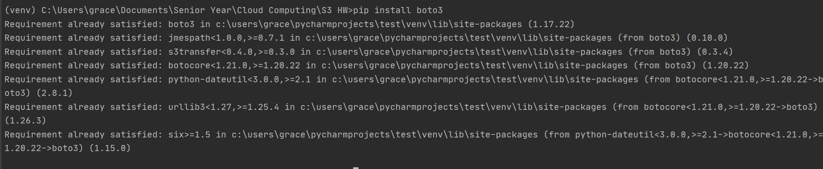

1. Code

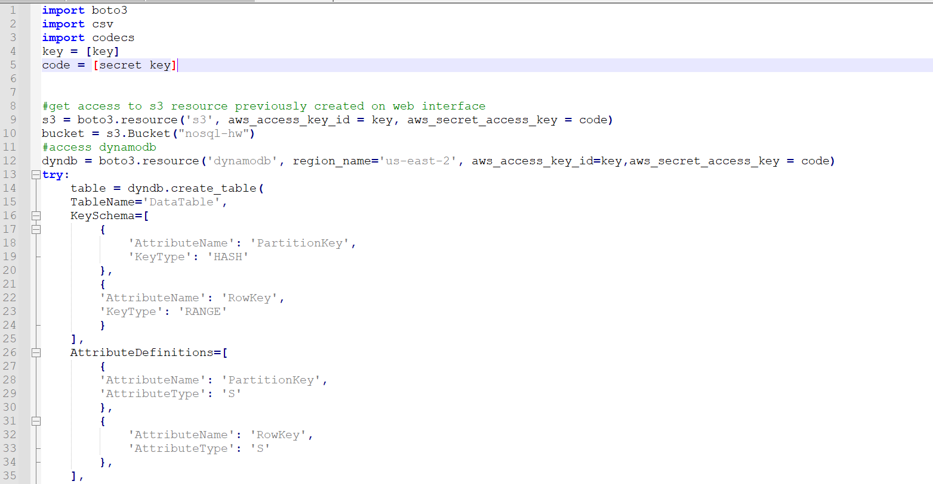

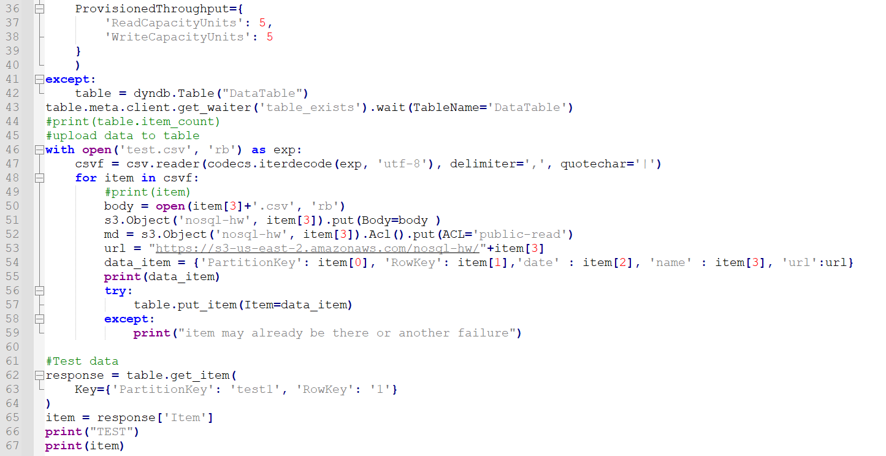

1. Query

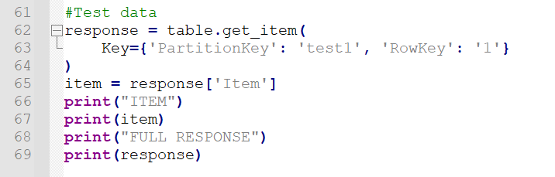

1. Results

