160719:
Git/ pfilter
works well with rbinom.js and rpois.libRmath but slow.
If we use rpois.js, it speed up to 50% but there are some differences compare with rpois.libRmath.

https://github.com/SurajGupta/r-source/blob/a28e609e72ed7c47f6ddfbb86c85279a0750f0b7/src/nmath/rpois.c
I used the code here:
https://github.com/R-js/libRmath.js/blob/master/src/lib/poisson/rpois.ts

In modelSnippet there are 2 options:

1 - Slowabout 1/30 but accurate
/* const libR = require('lib-r-math.js')
const {
Poisson,
rng: { MersenneTwister },
rng: { normal: { Inversion } }
} = libR
const mt = new MersenneTwister(0)
const { rpois } = Poisson(new Inversion(mt))
mt.init(1234)........
let births = rpois(1, birthrate * (1 - va) * del_t )
*/

2 - speed up about 1/3 by calling rpois.js. It replaces Unif = Math.random and Normal = randNormal. Normal effect is considerable.
/*
let rpois = require('./rpois') .........
let births = rpois.rpoisOne(birthrate * (1 - va) * del_t )
*/
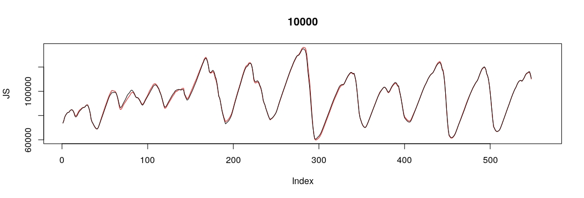
Git/ pfilter with Np = 10,000 and BidataMain using Normal = randNormal.
R = -5615, 46 sec.
js = -5582, 83 sec.
It is still slow and crash the web for Np = 50,000.

Note:
Download/ pfilter with Np = 50,000 and BidataMain using Normal = randNormal.
R = -5559, 218 sec.
js = -5223, 363 sec.
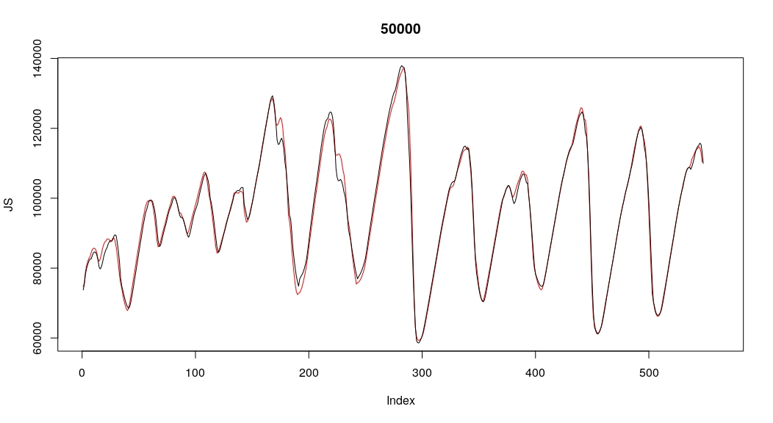

The diference is due to pfilter.js/ main loop and simulator. In Download false version of timing before tdata.

