POP Project



SCIENTIFIC
CALCULATOR

K.Hemanth(17IT218)
Akshay Khatri(17IT206)
Shashank Jaiswal(17IT239)

ABSTRACT

The main objective of this project is to develop a basic scientific calculator using JAVA programming language.
This Scientific calculator is based on three operational levels,those are Standard Mode, Scientific Mode and Expression Mode.

Under these three main categories all the basic functions which are related like addition, subtraction, multiplication, division, complex mathematical functions and trigonometric functions are included. Interface was designed according to user friendly manner.

INTRODUCTION

The entire application which is a scientific calculator is
developed, designed and coded using JAVA Swing.
Most of the mathematical functions have been done using the functions in Math class in java. This calculator is based on three categories.

One is Standard mode which allows the user to deal with ordinary day to day calculations with simple addition, subtraction, multiplication, division etc.

Second is the Scientific mode which allows the user to deal with most of the scientific calculations like trigonometric and advanced mathematical calculations.

Third is the expression mode which allows the user to evaluate expressions.

CLASS DIAGRAM
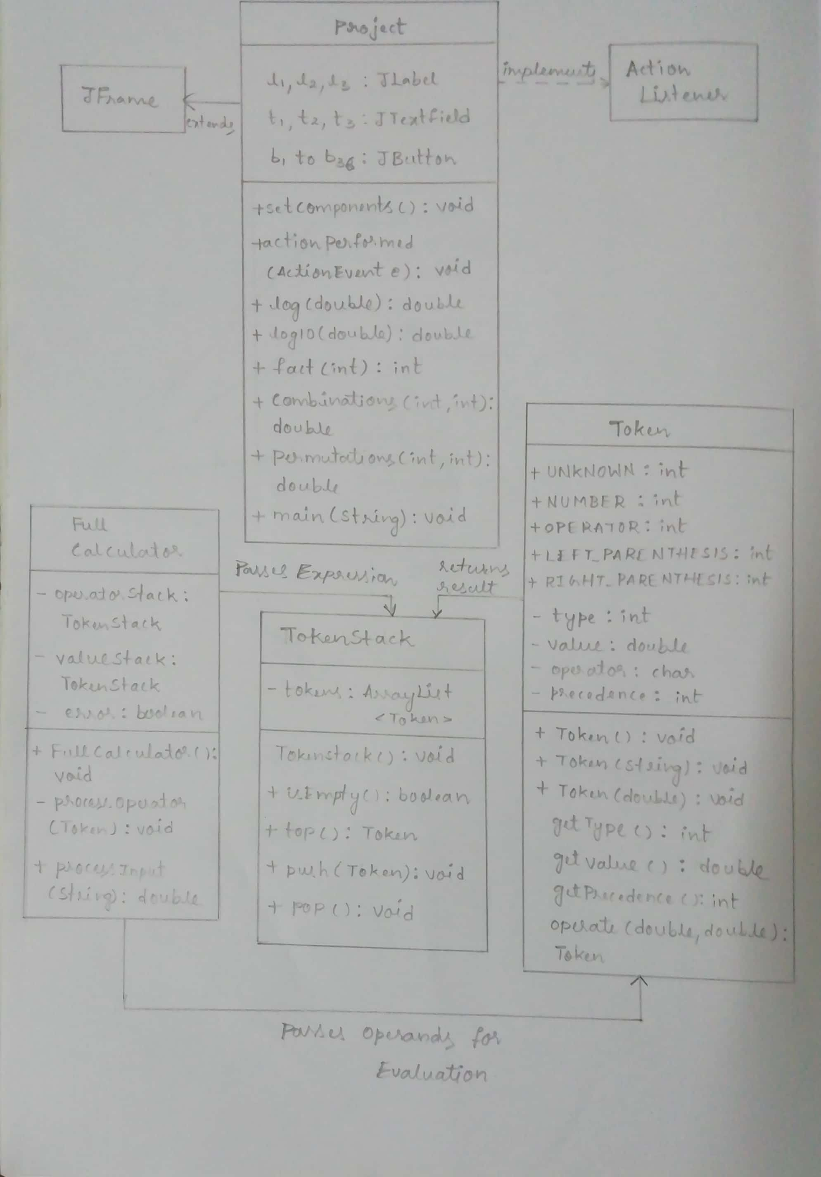
USE CASE DIAGRAM

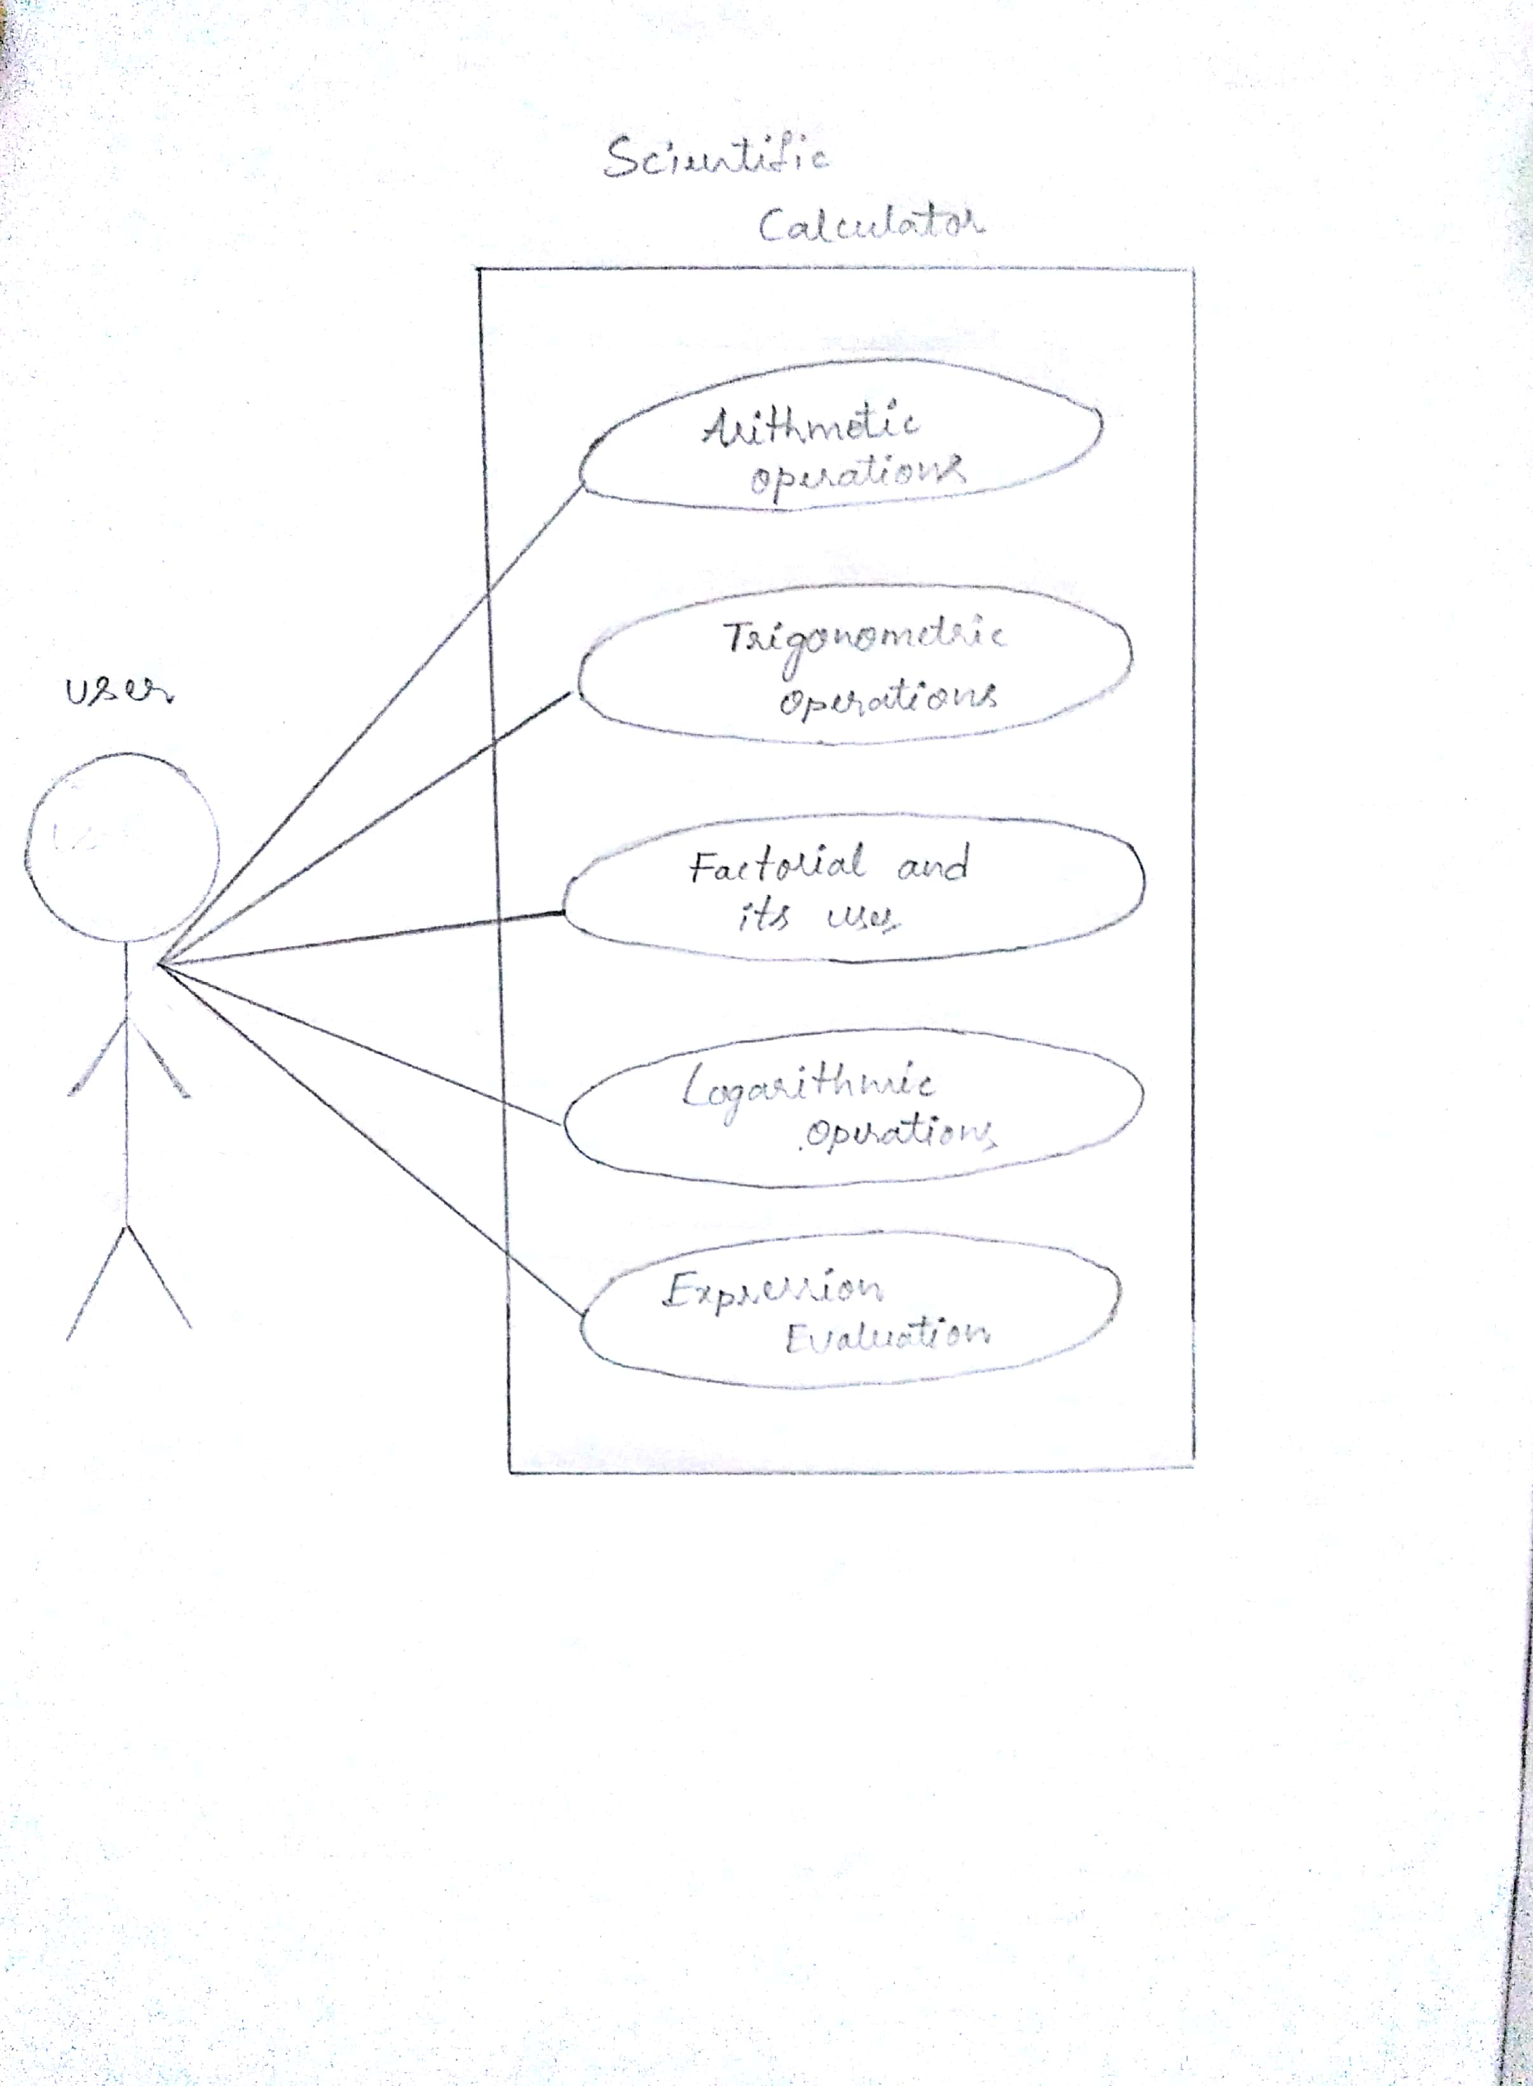

Code Explanation

The implementation of the scientific calculator is done using Java Swing. Buttons for each digit and operations are created. The ActionListener class in java.awt.event package is used to handle the event corresponding to the buttons clicked.

The calculations of the logarithmic, exponential and trigonometric functions are done using the Math class.

The calculator also supports evaluation of simple expressions. The algorithm of expression evaluation is as follows:

Until the end of the expression is reached, get one character and perform only one of the steps (a) through (f):

- (a) If the character is an operand, push it onto the operand stack.
- (b) If the character is an operator, and the operator stack is empty then push it onto the operator stack.
- (c) If the character is an operator and the operator stack is not empty, and the character's precedence is greater than the precedence of the stack top of operator stack, then push the character onto the operator stack.
- (d) If the character is "(", then push it onto operator stack.
- (e) If the character is ")", then "process" as explained above until the corresponding "(" is encountered in operator stack. At this stage POP the operator stack and ignore "(."
- (f) If cases (a), (b), (c), (d) and (e) do not apply, then process as explained above.

Input Format

Evaluating Expressions :-
  - Put it in Textfield T1
  - Ex:- ( a + b ) * ( a – b )
  - Space after each symbol required

Evaluating Single Value :-
  - Put it in Textfield T2
  - Ex:- for sin60 put 60 in T2 and click on sin button
  - For nPr or nCr write it in the same format

Code

import javax.swing.*;
import java.awt.event.*;
import java.util.*;

public class project extends JFrame implements ActionListener{
JLabel l1,l2,l3;
JTextField t1,t2,t3;
JButton b1,b2,b3,b4,b5,b6,b7,b8,b9,b10,b11,b12,b13,b14,b15,b16,b17,b18,b19,b20,b21,b22,b23,b24,b25,b26,b27,b28,b29,b30,b31,b32,b33,b34,b35,b36;
public void setComponents()
{
Elements Inialization
}
public void actionPerformed(ActionEvent e){
if(e.getSource()==b1){
t1.setText(String.valueOf(7));}
else if(e.getSource()==b2){
t1.setText(t1.getText() + String.valueOf(8));
}
else if(e.getSource()==b3){
t1.setText(t1.getText() + String.valueOf(9));
}
else if(e.getSource()==b4){
t1.setText(t1.getText() + String.valueOf(4));
}
else if(e.getSource()==b5){
t1.setText(t1.getText() + String.valueOf(5));
}
else if(e.getSource()==b6){
t1.setText(t1.getText() + String.valueOf(6));
}
else if(e.getSource()==b7){
t1.setText(t1.getText() + String.valueOf(1));
}
else if(e.getSource()==b8){
t1.setText(t1.getText() + String.valueOf(2));
}
else if(e.getSource()==b9){
t1.setText(t1.getText() + String.valueOf(3));
}
else if(e.getSource()==b10){
t1.setText(t1.getText() + String.valueOf(3.14));
}
else if(e.getSource()==b11){
t1.setText(t1.getText() + String.valueOf(0));
}
else if(e.getSource()==b12){
t1.setText(t1.getText() + String.valueOf("."));
}
else if(e.getSource()==b13){
t1.setText(t1.getText() + String.valueOf("+"));
}
else if(e.getSource()==b14){
t1.setText(t1.getText() + String.valueOf("-"));
}
else if(e.getSource()==b15){
t1.setText(t1.getText() + String.valueOf("*"));
}
else if(e.getSource()==b16){
t1.setText(t1.getText() + String.valueOf("/"));
}
else if(e.getSource()==b17){
t1.setText(t1.getText() + String.valueOf("%"));
}
else if(e.getSource()==b18){
String a=t2.getText();
String arr[]=a.split(" ",2);
double x=Double.parseDouble(arr[0]);
double y=Double.parseDouble(arr[1]);
double z=Math.pow(x,y);
t2.setText(String.valueOf(z));

}
else if(e.getSource()==b19){
int n = Integer.parseInt(t2.getText());
if(n<0){
JOptionPane.showMessageDialog(null, "Factorial of Negative!");
}
else
t2.setText(String.valueOf(fact(n)));

}
else if(e.getSource()==b21){
int l = Integer.parseInt(t2.getText());
if(l<0){
JOptionPane.showMessageDialog(null, "log of Negative!");
}
else
t2.setText(String.valueOf(log(l)));

}
else if(e.getSource()==b20){

int l1 = Integer.parseInt(t2.getText());
if(l1<0){
JOptionPane.showMessageDialog(null, "Log of Negative!");
}
else

t2.setText(String.valueOf(log10(l1)));

}
else if(e.getSource()==b22){
String b=t2.getText();
String arr[]=b.split("P",2);
int x1=Integer.parseInt(arr[0]);
int y1=Integer.parseInt(arr[1]);
if(x1<=0 || y1<0 || y1>x1){
JOptionPane.showMessageDialog(null, "Please recheck your entered value");
}
else
t2.setText(String.valueOf(Permutations(x1,y1)));
}
else if(e.getSource()==b23){
String c=t2.getText();
String arr[]=c.split("C",2);
int x2=Integer.parseInt(arr[0]);
int y2=Integer.parseInt(arr[1]);
if(x2<=0 || y2<0 || y2>x2){
JOptionPane.showMessageDialog(null, "Please Recheck your entered value");
}
else
t2.setText(String.valueOf(Combinations(x2,y2)));
}

else if(e.getSource()==b24){
String deg=t2.getText();
double dg=Double.parseDouble(deg);
double rad=Math.toRadians(dg);
double sine=Math.sin(rad);
t2.setText(String.valueOf(sine));
}
else if(e.getSource()==b25){
String deg1=t2.getText();
double dg1=Double.parseDouble(deg1);
double rad1=Math.toRadians(dg1);
double cosine=Math.cos(rad1);
t2.setText(String.valueOf(cosine));
}
else if(e.getSource()==b26){
String deg2=t2.getText();
double dg2=Double.parseDouble(deg2);
double rad2=Math.toRadians(dg2);
double tangent=Math.tan(rad2);
t2.setText(String.valueOf(tangent));
}

else if(e.getSource()==b27){
if(t1.getText()==null){
JOptionPane.showMessageDialog(null, "Enter a value to continue");
}
else{
FullCalculator obj=new FullCalculator();
double x=obj.processInput(t1.getText());
t2.setText(String.valueOf(x));
}
}

else if(e.getSource()==b28){
double x=Double.parseDouble(t2.getText());
double y=Math.pow(x,0.5);
if(x<0){
JOptionPane.showMessageDialog(null, "Square root of negative value!");
}
else
t2.setText(String.valueOf(y));
}
else if(e.getSource()==b29){
t1.setText(null);
}
else if(e.getSource()==b30){
t1.setText(t1.getText() + String.valueOf("("));
}
else if(e.getSource()==b31){
t1.setText(t1.getText() + String.valueOf(")"));
}
else if(e.getSource()==b32){
t2.setText(null);
}
else if(e.getSource()==b33){
double a1=Double.parseDouble(t2.getText());
if(a1>=-1 && a1<=1){
double a2=Math.asin(a1);
double a3=Math.toDegrees(a2);
t2.setText(String.valueOf(a3));
}
else
JOptionPane.showMessageDialog(null, "Out of Range");
}
else if(e.getSource()==b34){
double k1=Double.parseDouble(t2.getText());
if(k1>=-1 && k1<=1){
double k2=Math.acos(k1);
double k3=Math.toDegrees(k2);
t2.setText(String.valueOf(k3));
}
else
JOptionPane.showMessageDialog(null, "Out of Range");
}
else if(e.getSource()==b35){
double m1=Double.parseDouble(t2.getText());
double m2=Math.atan(m1);
double m3=Math.toDegrees(m2);
t2.setText(String.valueOf(m3));
}
else if(e.getSource()==b36){
double e1=Double.parseDouble(t2.getText());
double e2=Math.pow(e1,1/3);
t2.setText(String.valueOf(e2));

}

}

public double log(double a){
return Math.log(a);
}

public double log10(double a){
return (Math.log(a)/Math.log(10));
}

public int fact(int n){
if(n==1 || n==0){
return 1;
}
else
return n*fact(n-1);
}

public double Combinations(int x,int y){
return (fact(x)/(fact(x-y)*fact(y)));
}

public double Permutations(int x,int y){
return (fact(x)/fact(x-y));
}

public static void main(String args[]){

project jf=new project();
jf.setComponents();
jf.setSize(500,500);
jf.setVisible(true);
jf.setDefaultCloseOperation(JFrame.EXIT_ON_CLOSE);

}

}

TokenStack.java

import java.util.*;

public class TokenStack
{
private ArrayList<Token> tokens;
public TokenStack() {
tokens = new ArrayList<Token>();
}
public boolean isEmpty() {
return tokens.size() == 0;
}
public Token top() {
return tokens.get(tokens.size()-1);
}
public void push(Token t) {
tokens.add(t);
}
public void pop() {
tokens.remove(tokens.size()-1);
}
}

FullCalculator.java

import java.util.*;
class Token {
public static final int UNKNOWN = -1;
public static final int NUMBER = 0;
public static final int OPERATOR = 1;
public static final int LEFT_PARENTHESIS = 2;
public static final int RIGHT_PARENTHESIS = 3;

private int type;
private double value;
private char operator;
private int precedence;

public Token() {
type = UNKNOWN;
}

public Token(String contents) {
switch(contents) {
case "+":
type = OPERATOR;
operator = contents.charAt(0);
precedence = 1;
break;
case "-":
type = OPERATOR;
operator = contents.charAt(0);
precedence = 1;
break;
case "*":
type = OPERATOR;
operator = contents.charAt(0);
precedence = 2;
break;
case "/":
type = OPERATOR;
operator = contents.charAt(0);
precedence = 2;
break;
case "(":
type = LEFT_PARENTHESIS;
break;
case ")":
type = RIGHT_PARENTHESIS;
break;
default:
type = NUMBER;
try {
value = Double.parseDouble(contents);
} catch (Exception ex) {
type = UNKNOWN;
}
}
}

public Token(double x) {
type = NUMBER;
value = x;
}

int getType() { return type; }
double getValue() { return value; }
int getPrecedence() { return precedence; }

Token operate(double a,double b) {
double result = 0;
switch(operator) {
case '+':
result = a + b;
break;
case '-':
result = a - b;
break;
case '*':
result = a * b;
break;
case '/':
result = a / b;
break;
}
return new Token(result);
}
}

public class FullCalculator {

private TokenStack operatorStack;
private TokenStack valueStack;
private boolean error;

public FullCalculator() {
operatorStack = new TokenStack();
valueStack = new TokenStack();
error = false;
}

private void processOperator(Token t) {
Token A = null, B = null;
if (valueStack.isEmpty()) {
System.out.println("Expression error.");
error = true;
return;
} else {
B = valueStack.top();
valueStack.pop();
}
if (valueStack.isEmpty()) {
System.out.println("Expression error.");
error = true;
return;
} else {
A = valueStack.top();
valueStack.pop();
}
Token R = t.operate(A.getValue(), B.getValue());
valueStack.push(R);
}

public double processInput(String input) {

String[] parts = input.split(" ");
Token[] tokens = new Token[parts.length];
for (int n = 0; n < parts.length; n++) {
tokens[n] = new Token(parts[n]);
}
for (int n = 0; n < tokens.length; n++) {
Token nextToken = tokens[n];
if (nextToken.getType() == Token.NUMBER) {
valueStack.push(nextToken);
} else if (nextToken.getType() == Token.OPERATOR) {
if (operatorStack.isEmpty() || nextToken.getPrecedence() > operatorStack.top().getPrecedence()) {
operatorStack.push(nextToken);
} else {
while (!operatorStack.isEmpty() && nextToken.getPrecedence() <= operatorStack.top().getPrecedence()) {
Token toProcess = operatorStack.top();
operatorStack.pop();
processOperator(toProcess);
}
operatorStack.push(nextToken);
}
} else if (nextToken.getType() == Token.LEFT_PARENTHESIS) {
operatorStack.push(nextToken);
} else if (nextToken.getType() == Token.RIGHT_PARENTHESIS) {
while (!operatorStack.isEmpty() && operatorStack.top().getType() == Token.OPERATOR) {
Token toProcess = operatorStack.top();
operatorStack.pop();
processOperator(toProcess);
}
if (!operatorStack.isEmpty() && operatorStack.top().getType() == Token.LEFT_PARENTHESIS) {
operatorStack.pop();
} else {
System.out.println("Error: unbalanced parenthesis.");
error = true;
}
}

}

while (!operatorStack.isEmpty() && operatorStack.top().getType() == Token.OPERATOR) {
Token toProcess = operatorStack.top();
operatorStack.pop();
processOperator(toProcess);

if(error == false) {
Token result = valueStack.top();
valueStack.pop();
if (!operatorStack.isEmpty() || !valueStack.isEmpty()) {
System.out.println("Expression error.");
} else {
return result.getValue();
}
}
return 0;
}
}

