代码：

Client.java

/\*

\* To change this license header, choose License Headers in Project Properties.

\* To change this template file, choose Tools | Templates

\* and open the template in the editor.

\*/

package ldu;

/\*\*

\*

\* @author asus

\*/

import java.io.BufferedReader;

import java.io.BufferedWriter;

import java.io.IOException;

import java.io.InputStreamReader;

import java.io.OutputStreamWriter;

import java.net.InetSocketAddress;

import java.net.Socket;

import java.net.SocketAddress;

public class Client {

public static void main(String[] args) {

Socket clientSocket = null;

BufferedReader in = null;

BufferedWriter out = null;

try {

//1.创建客户机套接字

clientSocket = new Socket();

SocketAddress remoteAddr=new InetSocketAddress("localhost",5000);

System.out.println("1.创建客户机套接字成功！");

//2.连接服务器

clientSocket.connect(remoteAddr);

System.out.println("2.客户机连接服务器localhost端口5000成功！");

System.out.println("客户机使用的地址和端口："+clientSocket.getLocalSocketAddress());

//与服务器会话

in = new BufferedReader(

new InputStreamReader(

clientSocket.getInputStream()));

out = new BufferedWriter(

new OutputStreamWriter(

clientSocket.getOutputStream()));

String sendStr="要看银山拍天浪";

out.write(sendStr); //向服务器发送字符串

out.newLine();

out.flush();

System.out.println("3.1向服务器发送字符串成功!"+sendStr);

String recvStr=in.readLine(); //从服务器接收字符串

System.out.println("3.2从服务器接收回送字符串成功！"+recvStr);

} catch (IOException ex) {

System.out.println("异常信息："+ex.getMessage());

}

//关闭套接字和流

try {

if (in != null) in.close();

if (out != null) out.close();

if (clientSocket != null) clientSocket.close();

System.out.println("4.关闭套接字和流成功！");

} catch (IOException ex) {

System.out.println("异常信息："+ex.getMessage());

}

}

}

Server.java

/\*

\* To change this license header, choose License Headers in Project Properties.

\* To change this template file, choose Tools | Templates

\* and open the template in the editor.

\*/

package ldu;

/\*\*

\*

\* @author asus

\*/

import java.io.BufferedReader;

import java.io.BufferedWriter;

import java.io.IOException;

import java.io.InputStreamReader;

import java.io.OutputStreamWriter;

import java.net.InetSocketAddress;

import java.net.ServerSocket;

import java.net.Socket;

import java.net.SocketAddress;

public class Server {

public static void main(String[] args) {

//1.启动服务器

ServerSocket listenSocket = null;

Socket clientSocket = null;

BufferedReader in = null;

BufferedWriter out = null;

try {

listenSocket = new ServerSocket();

SocketAddress serverAddr=new InetSocketAddress("localhost",5000);

listenSocket.bind(serverAddr);

System.out.println("1.服务器启动成功！开始在 localhost 的 5000 端口侦听连接...");

//2.处理连接

clientSocket = listenSocket.accept();

System.out.println("2.客户机连接成功！客户机地址和端口："+clientSocket.getRemoteSocketAddress());

//3.与客户机会话

in = new BufferedReader(

new InputStreamReader(

clientSocket.getInputStream()));

out = new BufferedWriter(

new OutputStreamWriter(

clientSocket.getOutputStream()));

String recvStr1=in.readLine();//从客户机接收字符串

String recvStr="开窗放入大江来";

System.out.println("3.1 服务器收到字符串："+recvStr1);

out.write(recvStr);//向客户机回送字符串

out.newLine();

out.flush();

System.out.println("3.2 服务器回送字符串成功："+recvStr);

} catch (IOException ex) {

System.out.println("异常信息："+ex.getMessage());

}

//4.关闭套接字和流

try {

if (in != null)in.close();

if (out != null) out.close();

if (listenSocket != null) listenSocket.close();

if (clientSocket != null) clientSocket.close();

System.out.println("4.关闭套接字和流成功！");

} catch (IOException ex) {

System.out.println("异常信息"+ex.getMessage());

}

}

}

Client：

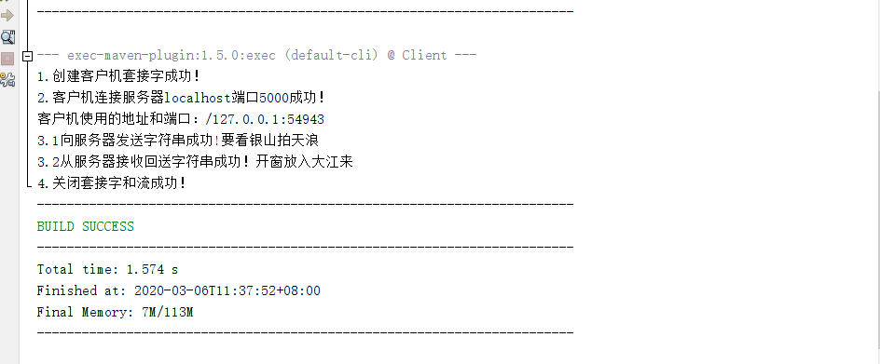

Server：

