DB Lab-03
Muhammad Aun Anis, 24P-3017

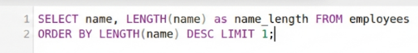
Task 1:

Task 2:

Task 3:

Task 4:

Task 5:

Task 6:

Task 7:

Task 8:

Task 9:
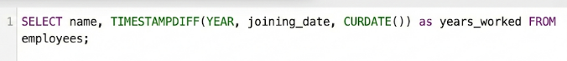

Task 10:

