Lab Task #1

Name: Muhammad Aun Anis
Roll #: 24P-3017
Course: Information and Communication Technology (ICT)
Course Code: CL1000
Semester: 1st
Date: 22/08/2024

Statement #1: Take a picture of a laptop or Computer and identify the hardware, software, communication devices and label them.
Hardware
1) Central Processing Unit (CPU):
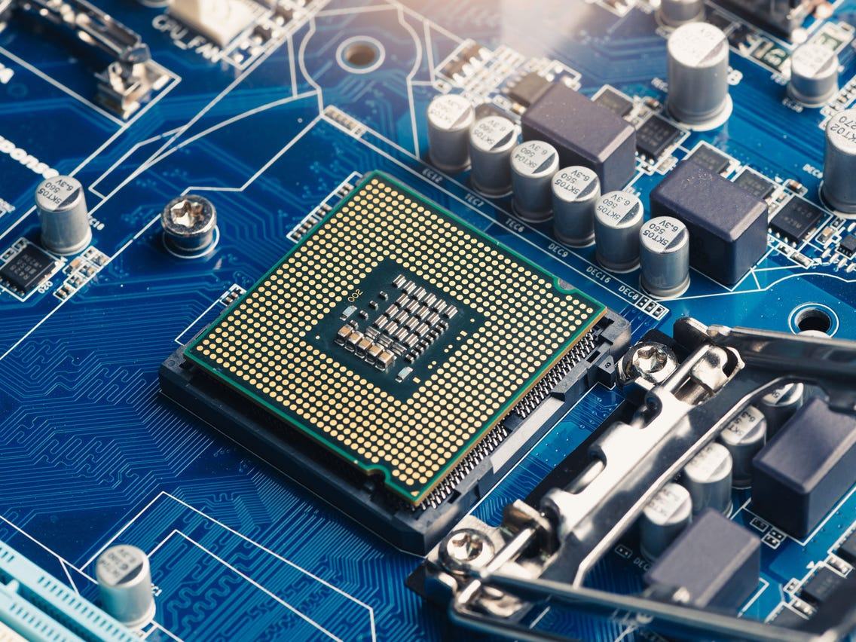
CPU
A Central Processing Unit is a single circuit integration comprised of cores. It is responsible for processing and executing instructions related to computer programs for example: logic and arithmetic controlling, input and output operations.
2) Graphics Processing Unit (GPU):
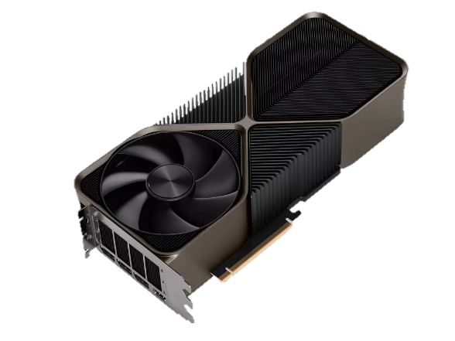
GPU
A Graphics Processing Unit as the name suggests is responsible for all the graphics related work like processing videos, graphics and effects. It is inserted into a PCIe x16 slot on a motherboard.
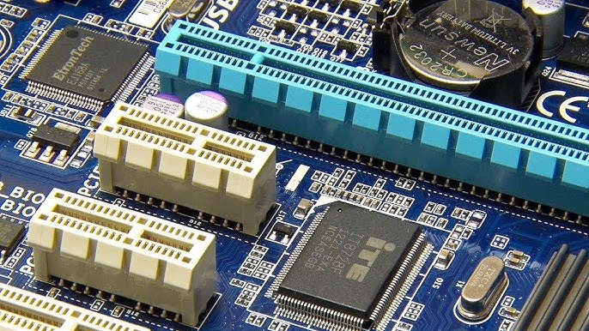
PCIe x16
Slot
3) Random Access Memory (RAM):
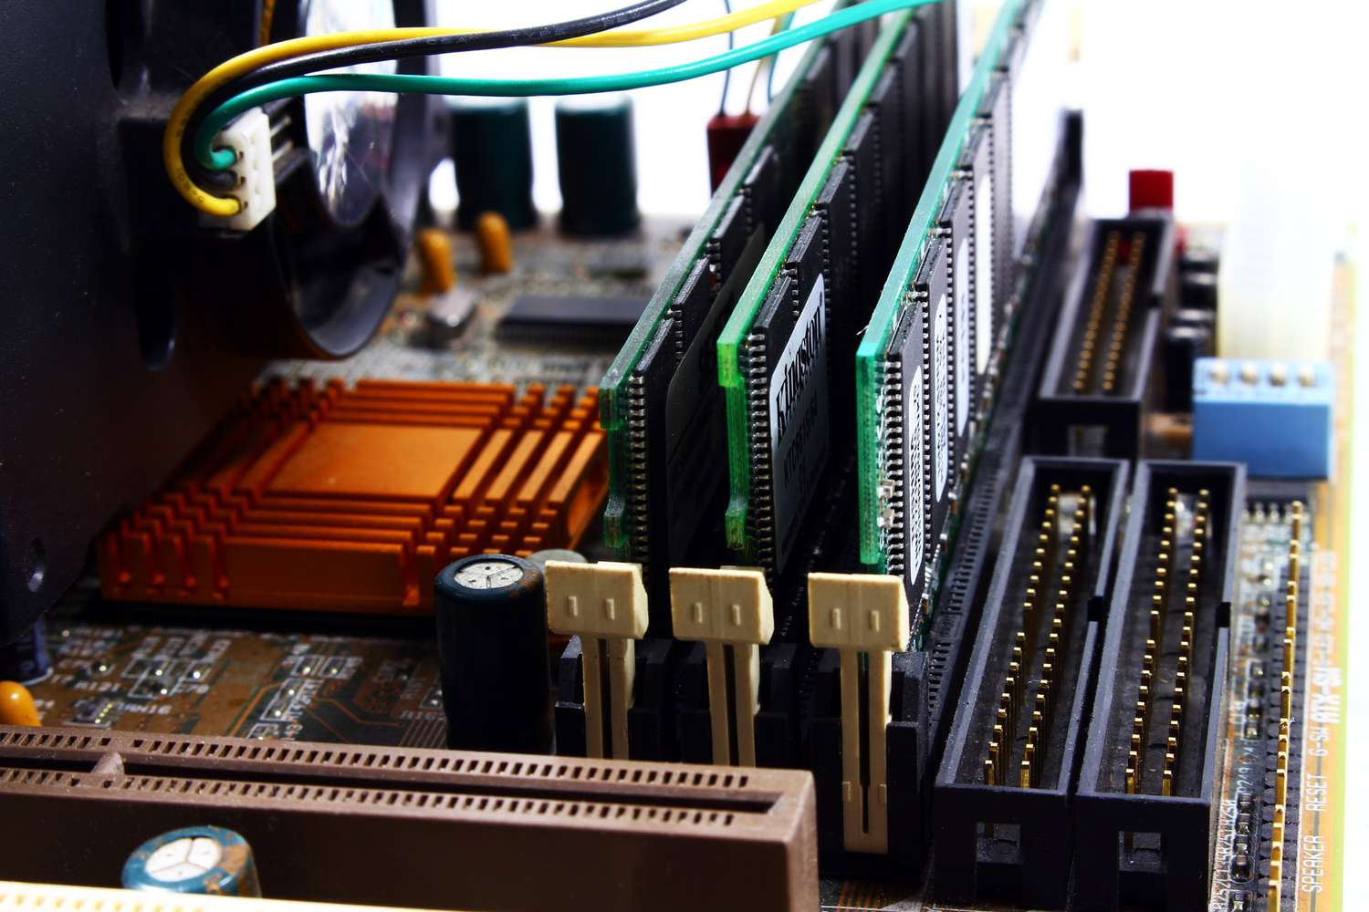
Memory
Slot/Socket
RAM
Stick
Random Access Memory is the main memory type in a computer and is used to temporarily store of operating system programs, software programs or any program that is currently in use. RAM is volatile meaning stored information will be lost without a constant flow of current.
4) Hard Disks and Solid State Drives (HDD and SSD):
Both these drives make up the secondary memory of a computer, they are non volatile therefore they can store large amounts of information. Hard Disks are slower and use magnetic disks to store data while (mechanical), Solid State Drives are faster and use flash memory to store data.

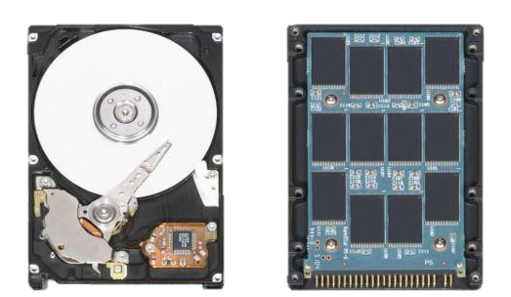
Solid State
Drive
(SSD)
Hard Disk
(HDD)
5) Power Supply:
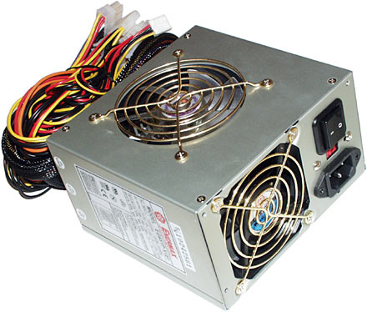
Switch
Power
Supply
A Power Supply provides the necessary electricity to the computer so it can function. It converts electricity from AC to DC and distributes to the rest of the Computer. A power cable may be used and plugged into an outlet to provide electricity to the power supply.

Software

1) Windows:
It is an Operating Software developed and published by Microsoft. It manages multiple operations and provides the baseline for the computer to function. It provides standardized interfaces and helps communicate with input and output devices (keyboard, mouse, monitor).


2) Visual Studio Code:

It is a source code editor and compiler that converts the source code written in a High Level Language to Machine Language Instruction (Low Level Language).
3) Discord:

It is an Applications Software used by people all over the world to chat through text, voice calls and video calls. People can join or create communities and hangout with their friends, family or favourite creators.
4) Google Chrome:

It is a web browser which is a Applications Software used to access information all over the world. When a user requests information from a web browser it fetches data from a web server and displays it on the monitor.
5) Linux:
it is a open source Operating Software popular for running computer servers, mainframes and coding. It is a community developed Software. It has different types called ‘flavours’ each with its own unique speciality.

Communication Devices:
1) Wifi Router (Modem):
it is the network’s central control tower, it’s main function is to direct traffic to our devices. A wired router is known as LAN while a wireless router is known as a WLAN (wireless local area network).
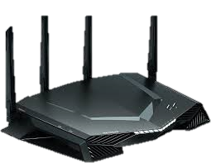
Wifi
Router


2) Bluetooth Device:
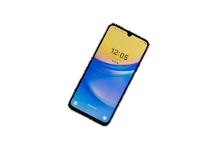
A device which allows us to communicate information between devices and programs without any cables or wires (wirelessly). An example of a Bluetooth device can be a smartphone.

Smartphone

3) Telephone:
It is a device which allows us to transmit our voice over large distances. It converts sound into electronic signals then transmitted via cables and other methods to another telephone and converted back into sound.
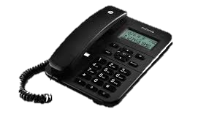
Telephone

Statement #2: Write about the types of Computers. Desktop computers or microcomputers, workstations, notebook computers, Tablet computers, Personal Digital Assistants (PDAs), smart phones, servers, Mainframes, Super Computers.

1) Desktop Computers:
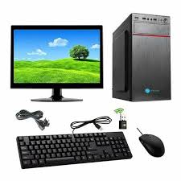
A general purpose computer designed for regular use in a stationary place. It is not portable and requires multiple input and output devices to be setup such as a keyboard, mouse, monitor and speakers. They are usually case oriented and all components of the computer are enclosed inside a tower like case.

CPU
(Case)
Keyboard
Mouse
Monitor

Bluetooth
Dongle

2) Personal Digital Assistant (PDA):
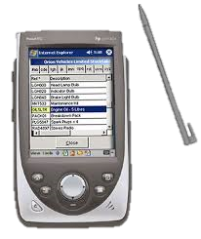

It is a multi purpose device designed to help humans manage information and make time managing easier. They also help in managing tasks, create timetables, provide entertainment and note taking. Examples of modern PDAs are Alexa, Siri and Cortana.


PDA

3) Mainframe:
A Mainframe computer is usually a large (physically) high speed computer used to support multiple workstations. It is popularly used by big organizations and tech companies for bulk data processing and other tasks.
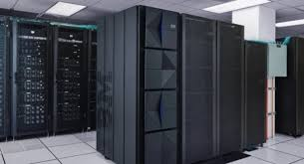
Mainframe

4) Smartphone:

A portable general purpose Computer which typically having a touch screen interface, internet access and other components which are part of a typical computer but in a more portable fashion.

Smartphone

5) Microcomputers:
It is general purpose computer designed to do everything a traditional computer can do but on a small scale. It is usually only usable for one person at a time.

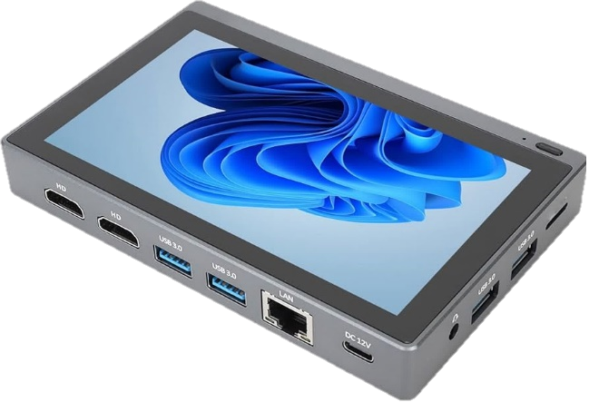
Microcomputer

6) Servers:
They are general purpose computers which perform a range of processes and tasks. Their primary job is to provide information to other computers known as “clients” on a computer network. Inside a network a server is a key cornerstone and manages most of its resources.
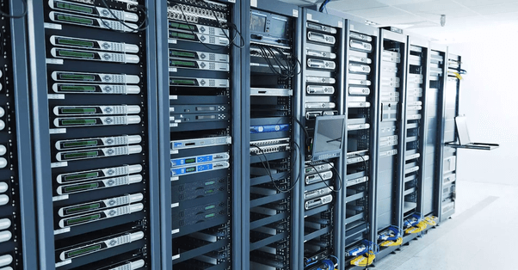

Server

7) Supercomputers:
A Supercomputer is one which provides a much higher level of performance than a normal general purpose computer. It is so fast that the number of processes taking place inside it are measured not in million instructions per second but floating-point operations per second (FLOPS). They are usually used to perform the highest level of computationally intensive tasks such as quantum mechanics, weather forecasting etc.

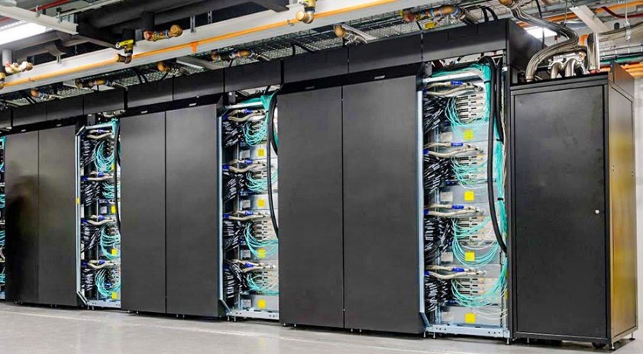
Supercomputer

Statement #3: Write in your own words about the importance of Computers in society.

Computers are without a doubt a significant cornerstone of today’s society. It is safe to say that without computers today’s society will collapse. Many businesses and multibillion dollar companies are not only dependent but built upon computers.
A vital computer in today’s world is the smartphone which is now an integral part of our community as it makes long distance calls, networking and social interactions seamless. Internet browsers accessible on computers make knowledge from all over the world available to us with the touch of a finger.
Traditional computers such as desktop systems, laptops and microcomputers are a key part of offices and many institutes and companies have made personalized networks accessible to their employees through their computers.
A computer can also be a source of income these days as people can freelance and offer their services online to people all over the world and earn a handsome income.
Many mainstream social media platforms without which the humans of today might not be able to function like Facebook, Instagram, Reddit, Discord, Twitter all exist because of the invention of the computer.
A computer in today’s world is a irreplaceable part of society and the realm of computer science will only grow and become more advanced than ever.

Statement #4: Find some common keyboard shortcuts, try them and write in the report.

- Ctrl + C – Copies selected text and images.
- Ctrl + V – Pastes text and images already on the clipboard.
- Ctrl + W – Closes what is on the screen (tabs in browsers)
- Alt + Tab – Switch between currently running programs.
- Ctrl + Shift + Esc – Opens Task Manager.
- Win + Tab – Shows all open windows/tabs on one screen.
- Win + R – Opens run dialog box.
- Ctrl + P – Takes print out of selected document.
- Ctrl + S – Saves changed to document.
- Ctrl + A – Selects every selectable thing on the screen.
- Ctrl + Backspace – Deletes one whole word left to the cursor.
- Alt + F4 – Closes program currently in use.
- Ctrl + b – Opens bookmarks tab on browser.
- Ctrl + L – Locks the computer.
- Ctrl + J – View download history on browser.

-----------------------------------------------------------------------------------------------------

