LAB TASK #2

Name: Muhammad Aun Anis

Roll #: 24P-3017

Course: Information and Communication Technology (ICT)

Course Code: CL1000

Semester: 1st

Date: 27/08/2024

- Use cmd command and open command prompt window
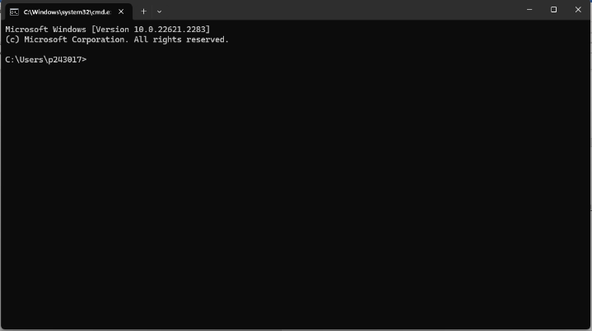
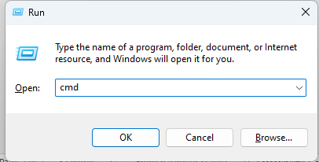

- Use the DOS help command and get idea about md (mkdir) and cd commands
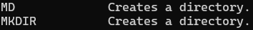
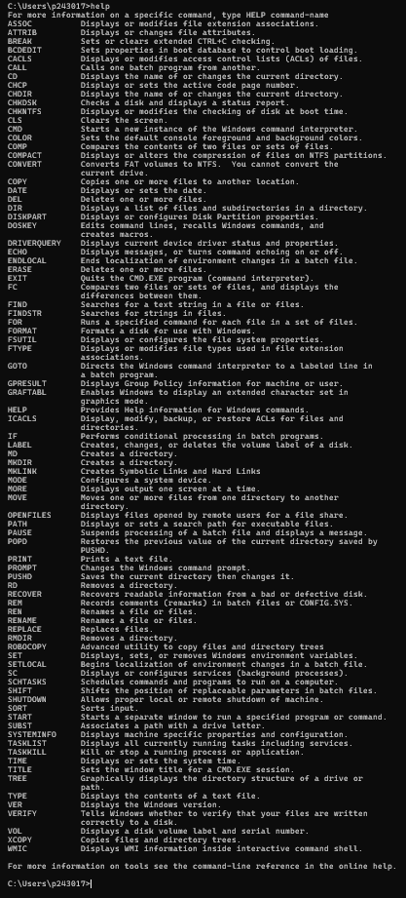


- Use DOS help and get idea on dir command to display information on the folders

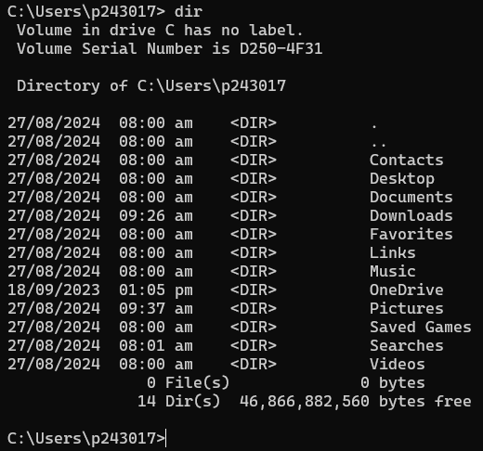

- Type the following commands and see the difference

i) DIR

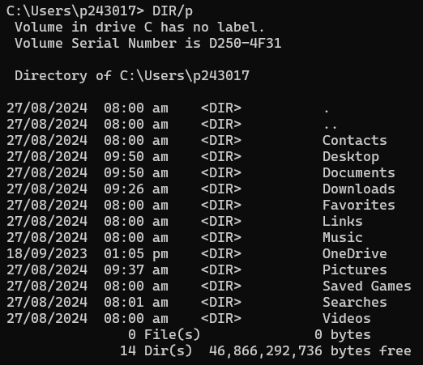
ii) DIR /p

iii) DIR /w
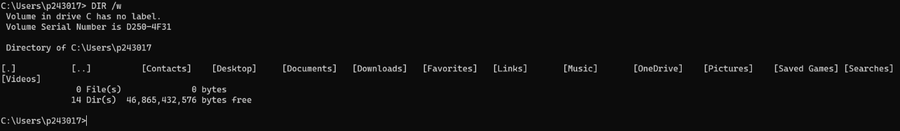

iv) DIR /L /P
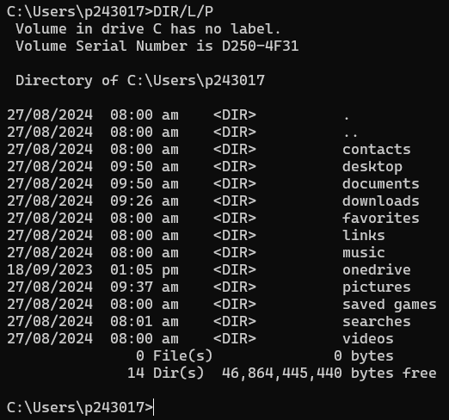

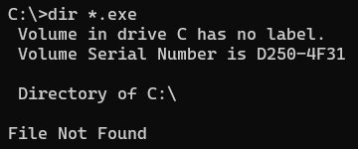
v) DIR *.EXE

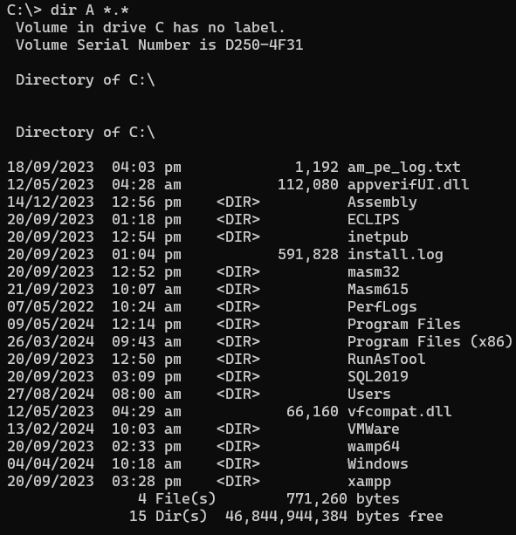
vi) DIR A*.*

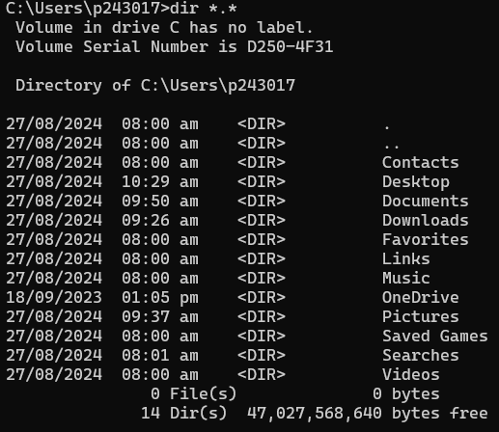

vii) DIR ?????.*
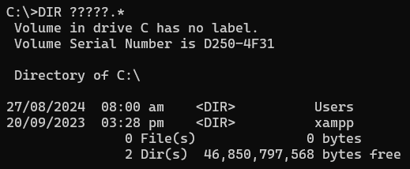
viii) DIR C:\Windows\system
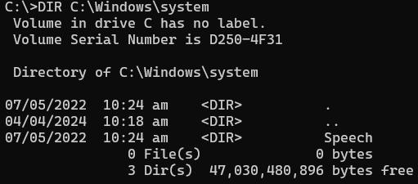

ix) CD Desktop
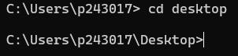

x) CD ..
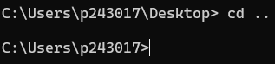

- Use DOS command to create the following folder structure (Create Home folder on your Desktop)
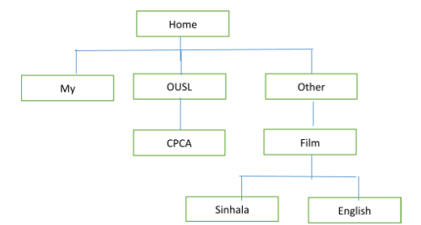
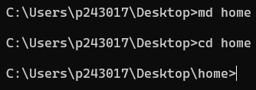
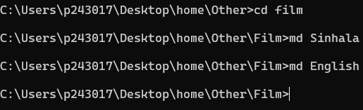
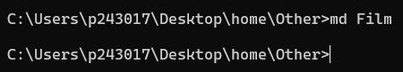
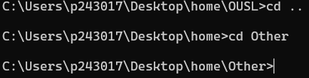
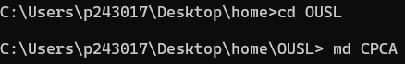
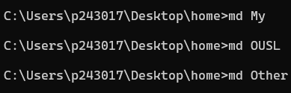

- Use notepad and save all command that are used to create above structure. (name the file as structure.txt and save on Home folder)

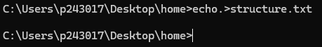

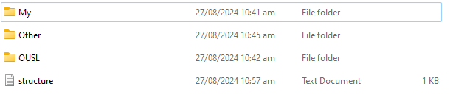
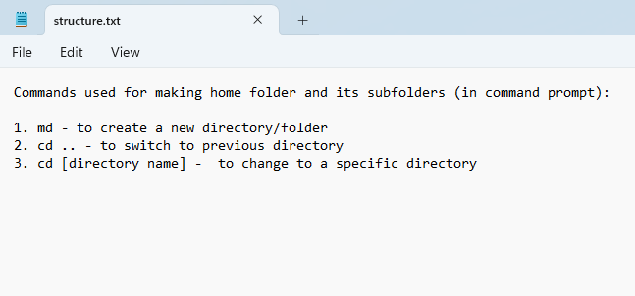

- Use the DOS help command and get idea about copy, ren, mov, tree, del and xcopy commands.

- copy

- ren

- mov

- tree

- del

- xcopy

- Use notepad and create 3 file name ca.txt, Sinhala.txt and info.txt save these files:
ca.txt file on CPCA
Sinhala.txt file on Sinhala
Info.txt file on my
Sinhala.txt file on English

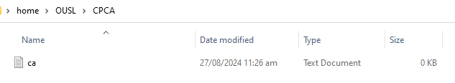
- ca.txt

- Sinhala.txt
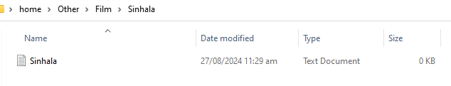

- Info.txt
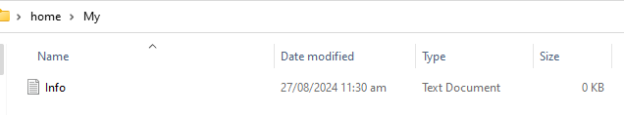

- Sinhala.txt
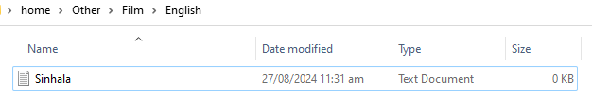

- Use notepad and type “this is a computer application data” on a ca.txt
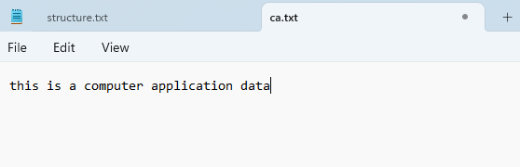

- Use find command and find the file name with the text “application data”
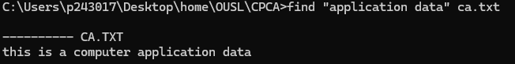

- Rename Sinhala.txt file in English folder as eng.txt

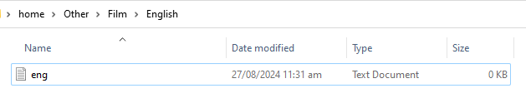

- Go to home folder and see the folder structure through the tree command
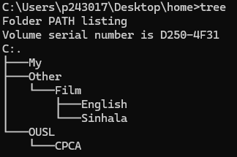

- Create another folder name MYDATA on desktop and copy all the files using xcopy command
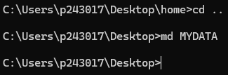
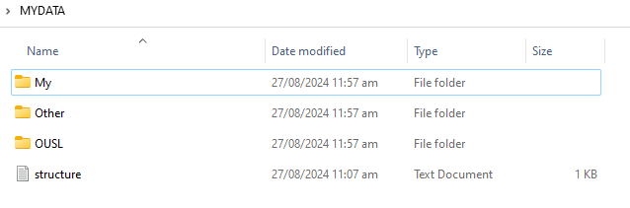
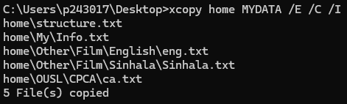

14) Copy all files from MYDATA to OTHER folder
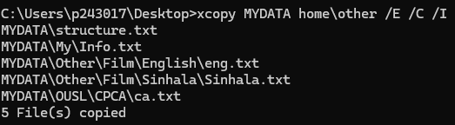

15) Delete ca.txt file on the OTHER folder
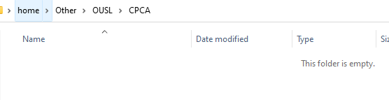

16) Identify what is the task of the following commands

a. Osk – Enables on screen keyboard (virtual keyboard)
b. Notepad – Opens Notepad
c. Time – Displays time taken to execute the command
d. Msconfig – Troubleshoots windows startup process
e. Ping 127.0.0.1 – It verifies whether the TCP/IP protocol is functioning properly or not
f. Ipconfig – Displays basic information about your network configuration (IP, DNS, DHCP)
g. Ver – Prints the name and version of the operating system
h. Start – Starts a program or opens files or directories
i. Path - Tells DOS where external commands are located
j. Cls – Clears the screen or the CLI to start anew

--------------------------------------------------------------------------------------------------

