Lab Task #3

Name: Muhammad Aun Anis

Roll #: 24P-3017

Course: Information and Communication Technology (ICT)

Course Code: CL1000

Semester: 1st

Date: 27/08/2024

1. System Properties:
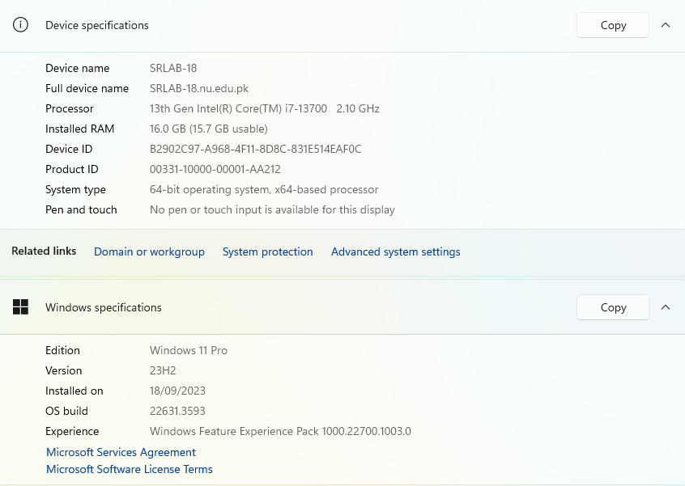
Access the System Properties to view basic information about your computer.

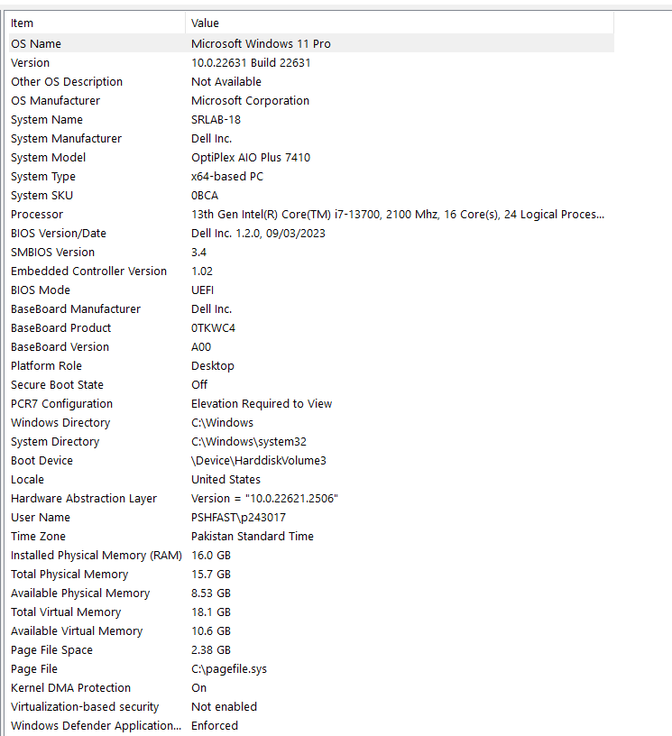

2. Network Settings:
Open the Network and Sharing Center to view or change network settings.
Connect to a Wi-Fi network if available.
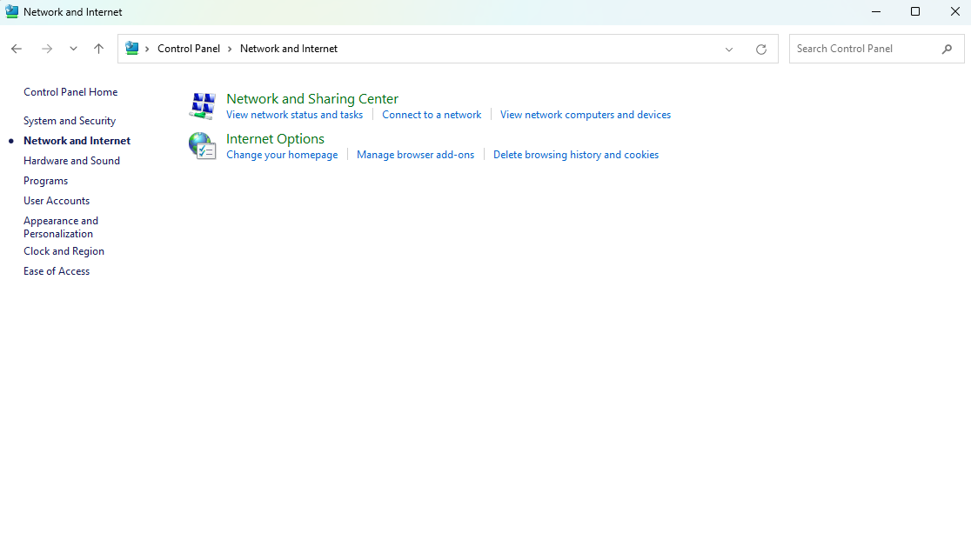

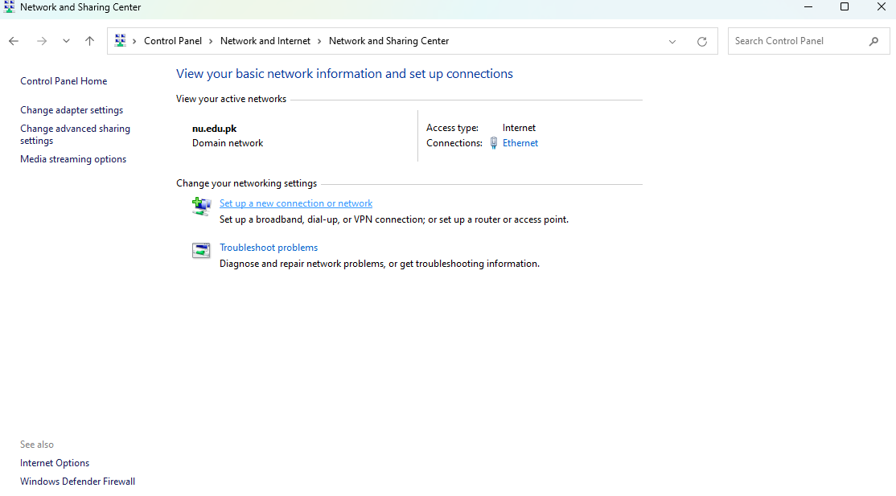

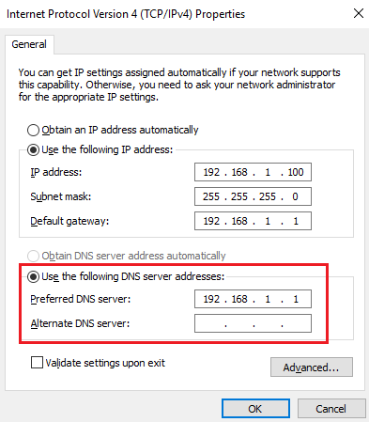
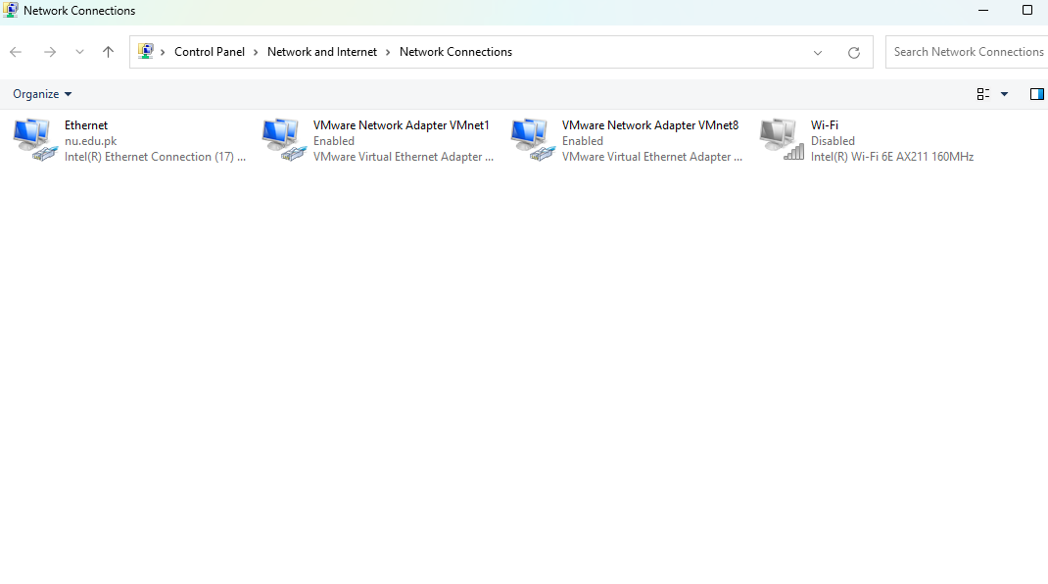

3. Desktop Gadgets or Widgets:
If available, explore and add desktop gadgets or widgets (e.g., clock, weather).

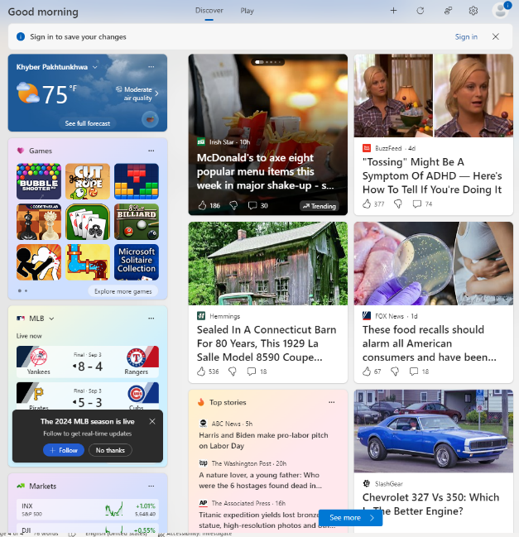




4. User Account Management:
Create a new user account on your computer. Change your account password.

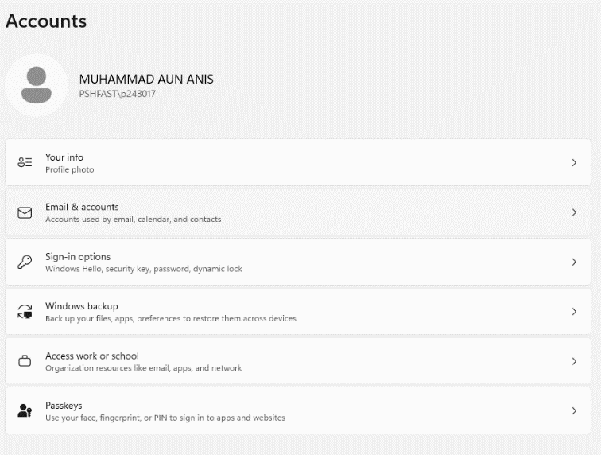

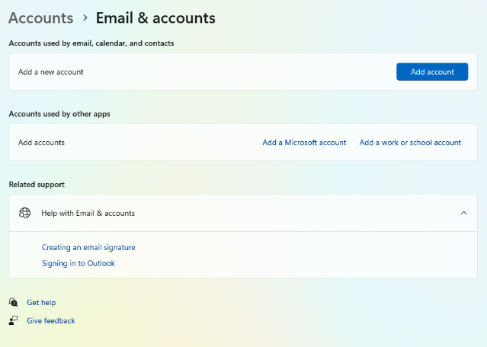

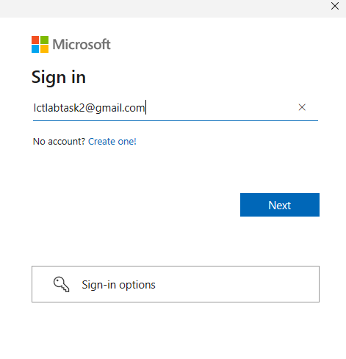

5. Accessibility Features:
Explore and enable accessibility features (e.g., Narrator, Magnifier) from the Ease of Access center.

i) Magnifier:
To zoom or magnify anything displayed on the screen.
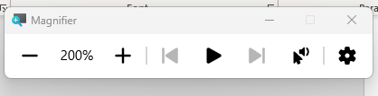

ii) Narrator:
Reads out everything displayed on the screen via an AI generated voice.
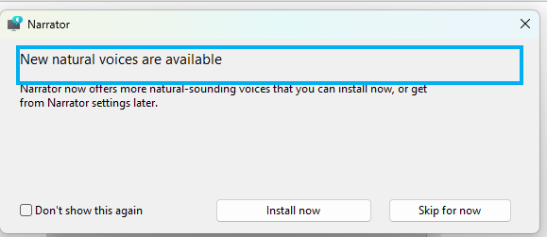

iii) Snipping Tool:
Snips specific parts of the screen and converts them into PNG and JPEG format.
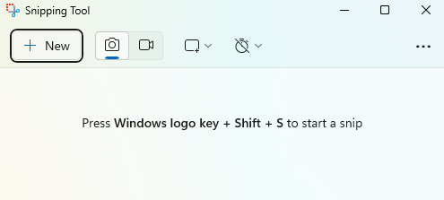

6. Customizing the Taskbar:
Customize the taskbar by adding or removing icons.

