

Circuit Simulation Project
https://esim.fossee.in/circuit-simulation-project

Name of the participant : Yash Gupta

Title of the circuit : sine wave generation using D flip flop

Theory/Description :
About D flip flop:
The D flip flop is the most important flip flop from other clocked types. It ensures that at the same time, both the inputs, i.e., S and R, are never equal to 1. The Delay flip-flop is designed using a gated SR flip-flop with an inverter connected between the inputs allowing for a single input D(Data).

Circuit Diagram(s) :

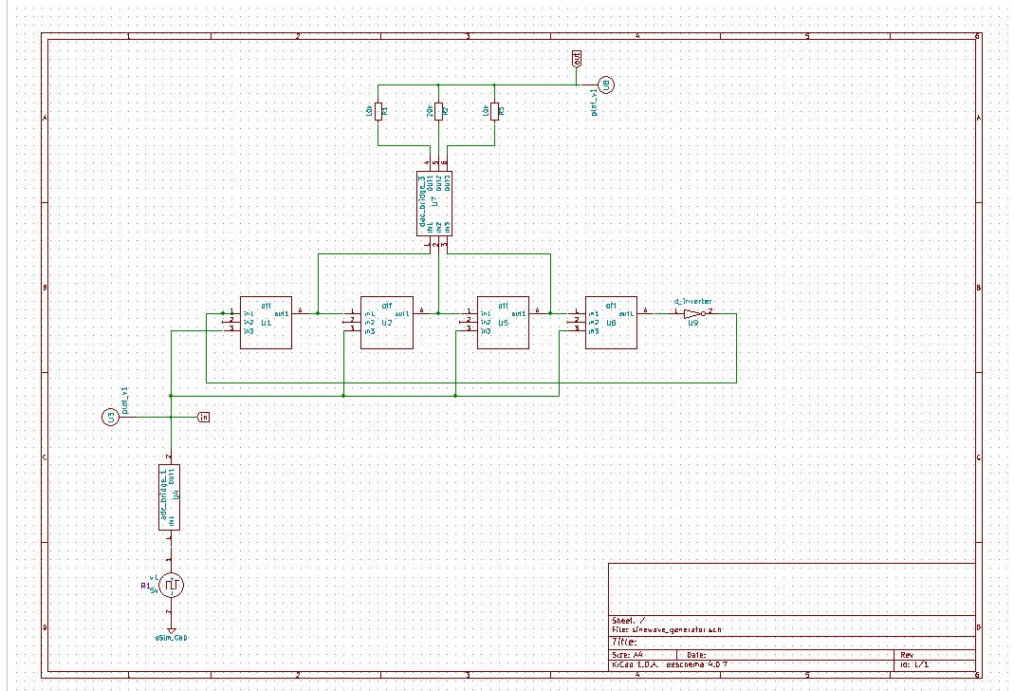

Results (Input, Output waveforms and/or Multimeter readings) :

Source/Reference(s) :

