**Gaming and Simulation Design Principles I**

CIT114

**Game Design Document**

***LOOP***

***Zachary Brennan, Troy Records Jr, Andy Lin, Andyroo Spangenberg***

Fall 2018

*12/02/2018*

**Design History**

***Updated prior each submission***

* + Version 1.0 – *10/22/18.* Filled out introduction and title sections.
  + Version 2.0 – *10/29/18.* Revised introduction section.
  + Version 3.0 – *11/14/18*. Introduced the formal element, revised some of the introduction.
  + Version 4.0 – *11/19/18*. Revised the document and implemented recommended solutions
  + Version 5.0 – 12/06/2018. Revised the document and added the last two sections to it.

Table of Contents

2 INTRODUCTION 4

2.1 Game Logline 4

2.2 Vision 4

3 FORMAL ELEMENTS 4

3.1.1 Players 4

3.1.2 Objectives 5

3.1.3 Procedures 5

3.1.4 Rules 5

3.1.5 Resources 6

3.1.6 Boundaries 6

3.1.7 Outcomes 7

4 DRAMATIC ELEMENTS 7

4.1 Game Characters - *Optional* 7

4.1.1 Player Characters (PC) 7

4.1.2 Non-Player Characters (NPC) 7

4.2 Story - *Optional* 7

4.2.1 Synopsis 7

4.2.2 Complete Story 8

5 GAMEPLAY DESCRIPTION 8

5.1.1 Controls 8

5.1.2 Interfaces 9

5.1.3 Levels 12

6 Media List 12

6.1 Environments 12

6.2 Characters 14

6.3 Music and sound effects 15

# INTRODUCTION

## Game Logline

A puzzle-room based story game where the player discovers a tragic history of the old timey detective, Detective McStuffles.

## Vision

LOOP will compel the player due to the mystery of the game and the story it offers. The story won't be apparent to the player until further explored. This adds for a depth of replay ability for the player to explore. Exploration will be a key factor to the game to allow the player to get a better feel for the story. LOOP is attempting to accomplish a compelling story through fun gameplay mechanics and hidden secrets.

The gameplay will consist of a top down perspective allowing the player to get an overview of the environment. There are three rooms and the player has to go through solving and utilizing the environment to explore the overall mystery presented. The player will have to solve the mystery presented to them by going through the environment, which have varied aesthetics, collecting different items.  The user is put under pressure as each investigation is limited by time.

The player won’t have total control over the game world. They only interact within the world to further solve the mystery. The control they will have is simply moving items around or interacting with other objects such as doors, cabinets, pictures, and teddy bears. They will be using this items to help them solve the mysteries contained within the game.

Our game LOOP should elicit confusion in the player. They will be miss directed at first to hopefully evoke the feeling that the character is supposed to feel. The player will then be able to piece together the story after that if they do everything correctly. After the player is finished with the game, hopefully they are surprised and enjoyed the story.

The goal of LOOP is to allow for a simple game that goes more in-depth into its story the more the player plays. At the beginning the player feels they are just playing an average puzzle game of unique escape rooms. It isn’t until they search the rooms for more answers does the player uncover the story. This gives the game a more unique feel because it can be played either casually or more in-depth.  This makes our game different from other games because we don't make the underlying story apparent from the beginning. It is up to the player to discover the story.

# FORMAL ELEMENTS

### Players

#### Target Audience

Our target audience would be teens and older due to puzzles complexities and the amount of problem-solving skills required to complete the game. Gender is irrelevant to the target player base of our game. Our game will be largely targeted towards those who can speak English so that they can understand the story.

#### Player Interactions Patterns

Our game will be Single Player versus Game. They will be competing against the games systems through the puzzles and the time limit. This applies a pressure onto the player to solve the puzzles in a timely manner. Along with this, they will need to avoid the killer so, timely completion of puzzles in a room. This will hopefully keep pressure on the player throughout.

### Objectives

Exploration and solution are the goals for our player. They will be exploring the world in search of solving the tragic mystery of Detective McStuffles (The player and main character). There will be in game dialogue in the form of on-screen text to inform the player there is a mystery in need of being solved to progress further within the game. The player’s objective will be to complete each level within the time limit and without dying. Accomplishing this will require the player to solve multiple puzzles with multiple different paths to accomplish the puzzle.

### Procedures

The player will begin at a main menu where they will have to select which option they wish (such as new game, load game, options or quit), probably using the arrow keys and the enter key to select. Upon starting a new game, the player will be put into a tutorial. If loading a game, it will place them in their last saved spot in the game (at the start of the floor that they ended on). The tutorial will introduce the character to the general controls of the game. WASD or arrow keys will be in charge of movement. The player will use the ‘E’ key to interact with objects when in range. Through interacting with objects in the levels, they will further discover the main mystery of the current room. Upon fully solving the main mystery of the room, a door will open up, to the next floor. At the last stage of the level, the door will open revealing a portal. The player will enter the portal when they are ready and then there will be a short animation and the player will be spawned in another room, with another mystery to solve. Throughout the game the player will discover the underlying story about the main character. There will be pieces of this mystery scattered throughout the entire game. These clues will be interacted with just as any other object or clue in the game. When the player interacts with a clue or solves a mystery related to the underlying story, they will not be notified that it is a part of the underlying story and not the main story. When the player solves the underlying story, there will be an audio||visual cue, another portal, different from the standard portals, will open up in the nearest doorway. When the player goes through this portal, the character will wake up in a hospital. There will be a short cutscene fully explaining the story of Detective McStuffles. After that, the player has finally and fully completed the game.

### Rules

* Objects
  + Doors, drawers, levers, etc.
  + An Object is something the player can interact with that isn’t stored in inventory.
* Items
  + Keys, handles, puzzle pieces, etc.
  + Items can interact with objects to have unique interactions.
  + The inventory can only hold 5 items.
  + An item is something that the player can hold in their inventory.
* Time limit
  + The player will have a certain amount of time to finish the current puzzle.
  + The time limit will vary between levels.
* Killer Interactions
  + If the player is found by the killer, the killer will instantly kill the player.
* Progression
  + The player cannot move to the next level until the current main series puzzle is solved.
  + The player can move to the next level without completing all of the side puzzles in a level.

### Resources

The players resources are their inventory and time. Each stage of the game will be timed, if the player does not complete the stage in time, the stage will be completely reset. In their inventory, they will be able to hold a certain number of items at a time and will need to learn which items are necessary at which point in the game. The player will not know there is a time limit when they first play. After a set period of time a killer will show up and start following the player throughout the stage. After failing once, they will be an in-game dialogue cue hinting to the player having a time limit.

The player will be able to hold multiple types of items. The first type is a key. These will be used on doors, drawers and other items that are locked. Another item is a part. The player will use these to fix objects. The objects may take one or more parts to fix. This similar to keys, will then allow the player to interact with it.

### Boundaries

This game will take place in three different unique areas. The walls keep the player inside the actual game. The player will also be able to move to different rooms or areas of the level by completing puzzles. Some areas will be locked until other puzzles are finished. For some puzzles, if the steps are messed up it could be locked to the player for that playthrough. There will be other barriers that cannot be passed throughout the world, keeping the player within the area. Along with walls, the player will not be able to walk out onto water, the water will act as a wall. They player cannot fall in either. In the space station level, the player will not be able to walk out into space unless they get the space outfit. If they get that then the boundary is moved to just a box around the space station.

### Outcomes

There is no loss or win condition. The player when failing to complete the puzzle in time, will be reset to the beginning of their current level. The player will never have a game over screen when failing to complete a puzzle or dying. Along with that, there is no win screen. If the player succeeded, they are LOOPed back to the beginning of the game in a cutscene. This is where the end screen comes on, the end screen does not say the player won. The player will never win nor lose. The player is just looped back to the beginning.

In order for the player to get back to the start, they must complete all puzzles both times through. They will not be able to proceed in the game without completing these puzzles so when the player gets to the end, they must have completed all of the puzzles in the game.

# DRAMATIC ELEMENTS

## Game Characters - *Optional*

### Player Characters (PC)

#### **Detective McStuffles**

* Description: This is the main character of the story. The player will play as this character for the entire game.
* Properties: The player can carry up to 5 items at any given time.
* Behaviors: The player will die when caught by The Killer. The player collects items and can interact with certain objects in the levels

### Non-Player Characters (NPC)

#### **The Killer**

* Description: The killer chases the player when they take to long in any individual room and acts as a timer for the player. Too long in a room and the player can be killed and forced to restart that stage/room.
* Properties: The Killer can’t be killed or blocked from chasing the player.
* Behaviors: The killer will chase the player indefinitely when it enters the room until the player leaves or dies. When the player leaves the room, the killer won't follow. The killer will kill the player as soon as it catches up.

## Story - *Optional*

### Synopsis

The game will begin with the main character being stuck in an almost infinite loop of solving crime scenes in various stages. He is stuck inside of this loop due to mistakes he has made in his life, mainly the death of his daughter. His daughter was killed in a car accident due to Detective McStuffles driving while intoxicated. This loop is him being stuck in Pergretitory, and while he is here, he must solve the mystery of his own life and learn why he is being punished in this world. A manifestation of his regrets and mistakes, in the form of his daughter, is chasing him throughout pergretitoy in attempt to kill him. Detective McStuffles is locked in this loop for all eternity only to complete these puzzles with the hope of one day escaping.

### Complete Story

Detective McStuffles is greeted with a gruesome scene in an old timey mansion. It is a classic example of a murder scene from a detective show. McStuffles traverses through this level, maybe finding clues to the overarching story, but nothing to give the story completely away. After solving the first mystery, McStuffles goes through a door leaving him at the next mystery. This is where the player realizes it's not an ordinary detective game.

The next two following areas are in space and on a pirate ship. This is to hint to the player that there is more to this than meets the eye, but also keeping a bit of mystery. After solving the puzzles of the following rooms, the player will be sent back to the first mystery. Here is where the story begins. The player can traverse through the main sequence puzzles again, but will find different side missions that can unveil the story to them in more details.

Eventually, the player will realize that McStuffles had a daughter who was tragically killed. At first the scene doesn't make sense; the player will be shown a cutscene of the daughter’s silhouette being attacked by what seems to be a giant teddy bear. This isn’t how she truly died, it is just a figment of his grief. The teddy bear symbolizes him because his name being McStuffles. At this point the player will realize that this endless “loop” is a manifestation of McStuffles’ regret.

After completing all the side quests, it is revealed McStuffles’ daughter was killed in a car crash that McStuffles was the driver in. He blames himself and the player can see this if they uncover the killer’s identity which is actually his daughter. This is only a symbol to torment him. After finding the entire story, McStuffles will wake up in a hospital bed with no one around. The player will think McStuffles torment is over and proceed to walk around. The player will walker around until they find a door, which when opened will take them back to the first level. This is when the end screen comes up, not giving them a win or a loss.

# GAMEPLAY DESCRIPTION

### Controls

This game is mostly about collecting and utilizing the items that the player collects. In order to interact/pickup items the player must press ‘E’. If it work it will implement an event or it will have a subtitle saying it doesn’t work and give a hint. To go or do anything you click on it.

|  |  |  |
| --- | --- | --- |
| W | Move Up | As long as the player holds this key They will move upward. Upon Release the player will stop moving in that direction. |
| A | Move Left | As long as the player holds this key They will move Left. Upon Release the player will stop moving in that direction. |
| S | Move Down | As long as the player holds this key They will move Downward. Upon Release the player will stop moving in that direction. |
| D | Move Right | As long as the player holds this key They will move Right. Upon Release the player will stop moving in that direction. |
| E | Interact/Pickup | On key press, if an object or item is near the player, the player will interact or pick up respectively. |
| I | Inventory | When the player presses this(If the pause menu is not open), the inventory menu will open. If the player has the inventory menu open, this will close the menu. |
| ESC | Pause | If the player has neither the pause menu or the inventory menu open, pressing this will open the pause menu. If the player has either menu open, it will close out of the menu and return them to the game. |
| Left Click | Menu Interact | Pressing on any button in any menu will bring up the menu that it leads to. In the inventory menu, left clicking an object gives the option to drop the item. |

### Interfaces

**-In-game HUD-**

--------------------------------------------------------------------------------------------------------------------------------

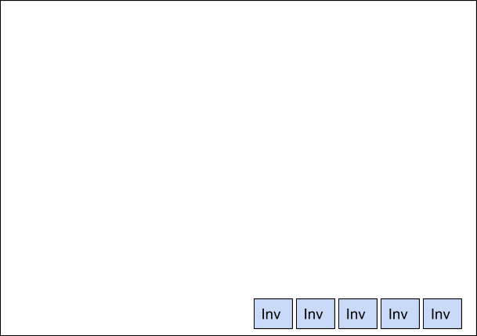

--------------------------------------------------------------------------------------------------------------------------------

**- Pause Menu(Opened with ESC) -**

--------------------------------------------------------------------------------------------------------------------------------





--------------------------------------------------------------------------------------------------------------------------------

Clicking Resume Will close the menu immediately and will allow the player to continue playing

Clicking quit game will bring up a yes or no option, it will look like this:



Clicking yes will take the player back to the main screen.

Clicking no will close the popup

**- Inventory Menu(Opened with ‘I’) -**

--------------------------------------------------------------------------------------------------------------------------------



--------------------------------------------------------------------------------------------------------------------------------

When the player left clicks on the image, it will bring up a popup for dropping the item at the location of the cursor

https://docs.google.com/drawings/u/1/d/siDQK635vhQi0XQyqlOLRqQ/image?w=239&h=58&rev=21&ac=1&parent=1LjPcrpvImiPK-EmUN4eLehZOMRpcYj0byArObaNUiHA

Relative To the image:

https://docs.google.com/drawings/u/1/d/sUXUXR_Y-cpC9C3c1ndjxJA/image?w=82&h=20&rev=1&ac=1&parent=1LjPcrpvImiPK-EmUN4eLehZOMRpcYj0byArObaNUiHA

Clicking Drop will drop the item from the players inventory.

**-Start Menu-**

--------------------------------------------------------------------------------------------------------------------------------

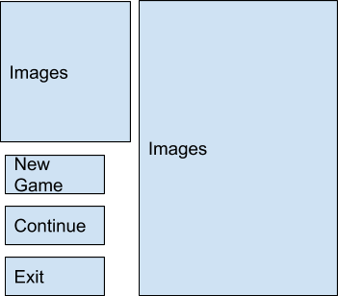

This is the game’s start menu which consists of pictures, play buttons and a way for the player to exit the game.The play buttons consist of new game and continue, new game will restart the game while continue will start from where they left off. The exit button will allow them to leave the game and close the application.

### Levels

We will have 3 different level designs. These designs are an old house, a pirate ship and a space station. Each level will have unique puzzle designs that fits the theme of the level. The old house will include sounds of creaking boards while walking and falling shelves. The pirate ship will include cannons and treasure. Finally the space station will include the ability for the player to go out in space for some puzzles and exploding pipes.

# Media List

## Environments

Top down perspective with a pixel style. This would be a space level and have assets that you would find in space. This could be comets, space suits, etc.

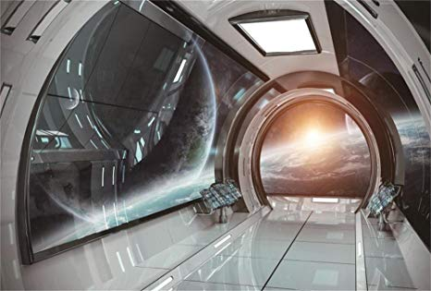  
<https://www.amazon.com/Yeele-Spacecraft-Photoshoot-Photography-Background/dp/B07C23YZ7Q>

Top down perspective with a pixel style. This would be a pirate ship level and consist of different pirate themes puzzles.

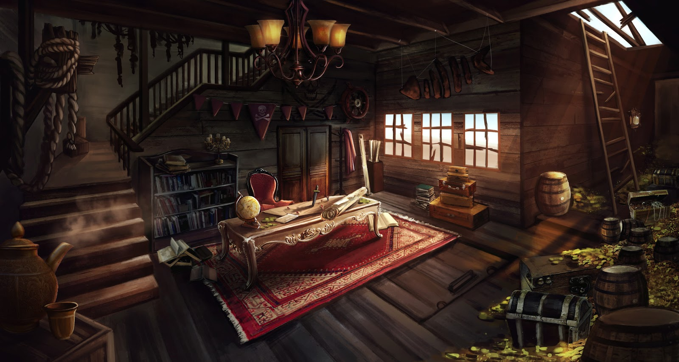

<https://luckyzz.artstation.com/projects/RePGm>

Top down perspective with a pixel style. This would be designed like an old fashioned mansion.

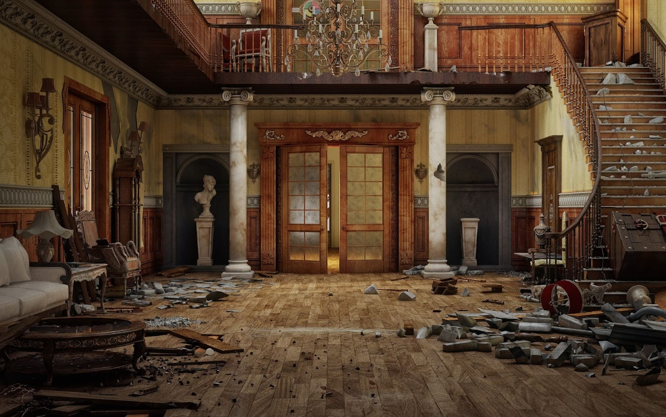

<https://www.pinterest.com/pin/626985579344275711/>

## Characters

https://docs.google.com/drawings/u/1/d/sMI7-C2aMGRYJ2a7UmfJKyA/image?w=395&h=50&rev=66&ac=1&parent=1LjPcrpvImiPK-EmUN4eLehZOMRpcYj0byArObaNUiHA

An old-timey detective, Detective McStuffles.

https://filmstarjackets.com/image/cache/data/J15/Buy-Sherlock-Holmes-Robert-JR-Costume-1000x1100.jpg

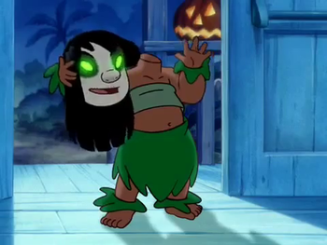

<https://tvtropes.org/pmwiki/pmwiki.php/NightmareFuel/LiloAndStitchTheSeries>

## Music and sound effects

Space - Halo music

Pirate - Pirates of the Caribbean

Old/Spooky house - Luigi Mansion

Item Pickups: Similar to minecraft item pickup

Death Sound: “Snake! Snake! Snaaaaaake!!”

Walking: Walking Sound