**1. import pandas as pd**

**import numpy as np**

**import matplotlib.pyplot as plt**

**import seaborn as sns**

**2. dataset = pd.read_excel("2255872-anime_data.xlsx")**

**3. dataset.head(2)**

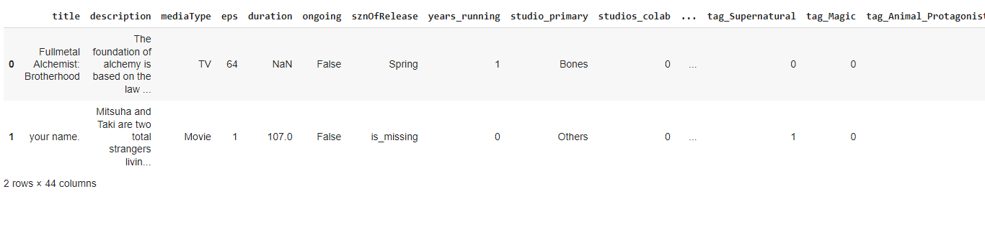

**4. dataset.shape**



**5. dataset.eps.describe()**

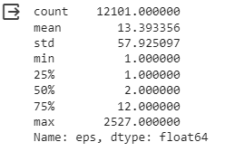

**6. dataset.columns**

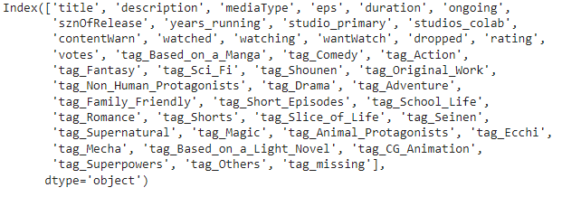

**7. dataset[(dataset['eps'] > 24) & (dataset.duration.isna())].shape**



**8. dataset_excluding_out = dataset[dataset['eps'] < 50]**

**9.dataset_excluding_out['eps_brackets'] = pd.cut(dataset_excluding_out['eps'], bins = [1,10,20,30,40,50],\**

**labels = ['cat1','cat2','cat3','cat4','cat5'])**

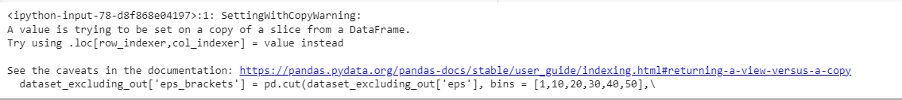

**10. dataset_excluding_out.shape**



**11. dataset_excluding_out.groupby(['eps_brackets']).duration.mean()**

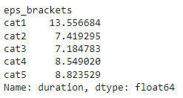

**12. dataset_excluding_out.groupby(['eps_brackets']).title.count()**

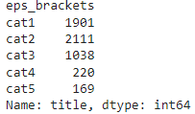

**13. dataset_excluding_out[dataset_excluding_out['eps_brackets'] == 'cat1'].shape**



**14. dataset[(dataset['eps'] < 24) & (~dataset.duration.isna())].describe()**

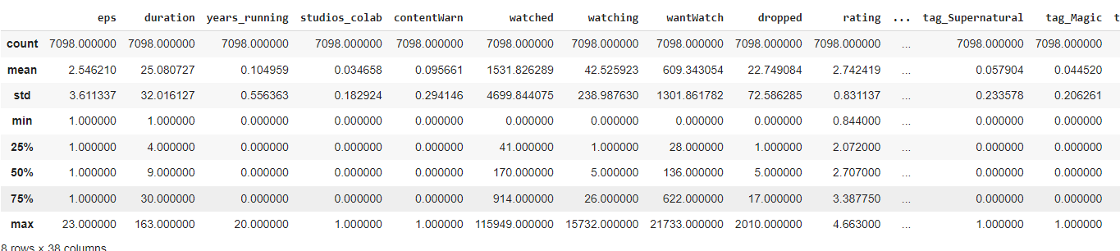

**15.dataset_excluding_out.groupby('mediaType').agg({'duration':'mean','mediaType':'count'})**

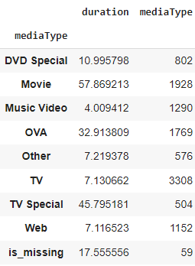

**16.dataset.isna().sum()**

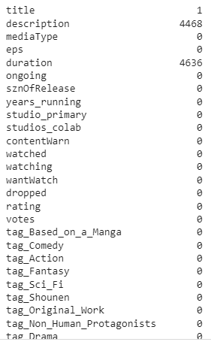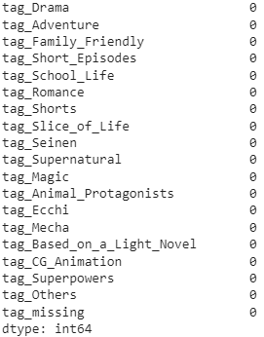

**17. dataset.info()**

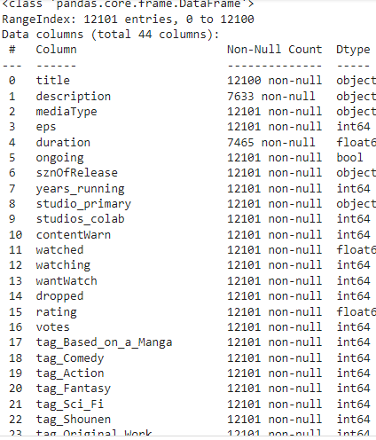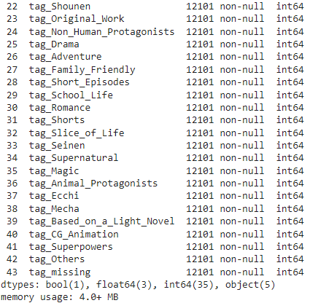

**18. dataset.describe().T**

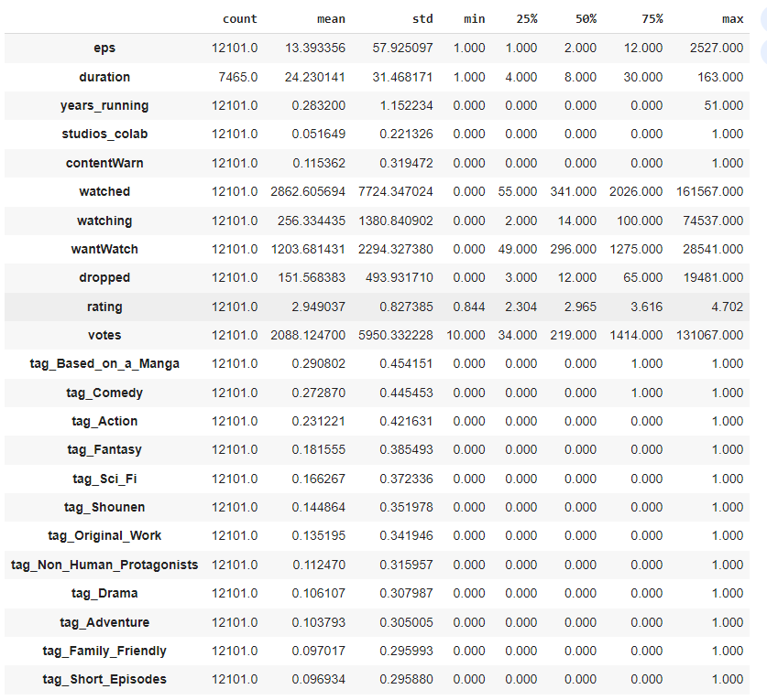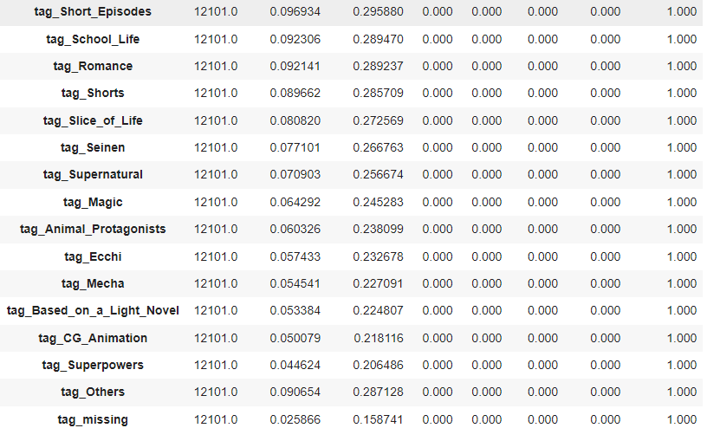

**19. dataset.drop(columns = ['title','description'], axis=1, inplace=True)**

**20. dataset.head()**

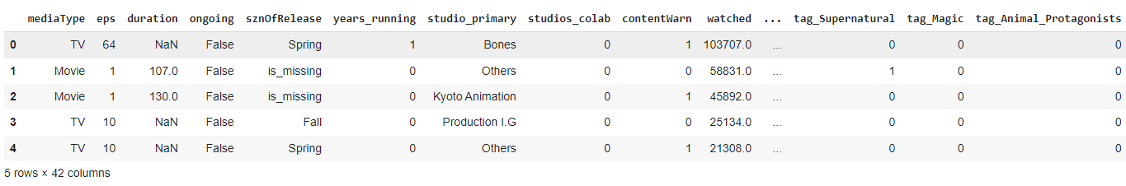

**21. dataset.rating.describe()**

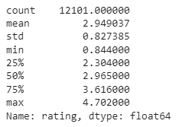

**22. dataset.dropna(inplace=True)**

**dataset.shape**



**23. def continuous_univariate_analysis(data,**

**feature,**

**figsize=(12,8),**

**kde=False,**

**bins=None):**

**f1, (ax_box,**

**ax_hist) = plt.subplots(nrows=2,**

**sharex=True,**

**gridspec_kw={'height_ratios': (0.25,0.75)},**

**figsize=figsize)**

**sns.color_palette("viridis", as_cmap=True)**

**sns.boxplot(data=data,**

**x=feature,**

**ax=ax_box,**

**showmeans=True,**

**color='yellow')**

**sns.histplot(data=data,**

**x=feature,**

**ax=ax_hist,**

**showmeans=True,**

**color='crest',**

**bins=bins,**

**kde=kde) if bins else sns.histplot(**

**data=data, x=feature, ax=ax_hist, kde=kde, color='blue')**

**ax_hist.axvline(data[feature].mean(), color='cyan', linestyle='--')**

**ax_hist.axvline(data[feature].median(), color='orange', linestyle="-")**

**24.**

**def discrete_univariate_analysis(data, feature, perc=False, n=None):**

**total = len(data[feature])**

**count = data[feature].nunique()**

**if n is None:**

**plt.figure(figsize=(count + 1, 5))**

**else:**

**plt.figure(figsize=(n + 1, 5))**

**plt.xticks(rotation=90, fontsize=15)**

**ax = sns.countplot(**

**data=data,**

**x=feature,**

**palette="flare",**

**order=data[feature].value_counts().index[:n].sort_values(ascending=False))**

**for p in ax.patches:**

**if perc == True:**

**label = "{:.1f}%".format(100 * p.get_height() / total)**

**else:**

**label = p.get_height()**

**x = p.get_x() + p.get_width() / 2**

**y = p.get_height()**

**ax.annotate(label, (x, y),**

**ha="center",**

**va="center",**

**size=12,**

**xytext=(0, 5),**

**textcoords="offset points")**

**plt.show()**

**25. dataset.columns**

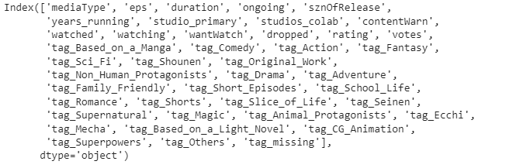

**26. continuous_univariate_analysis(dataset, 'rating')**

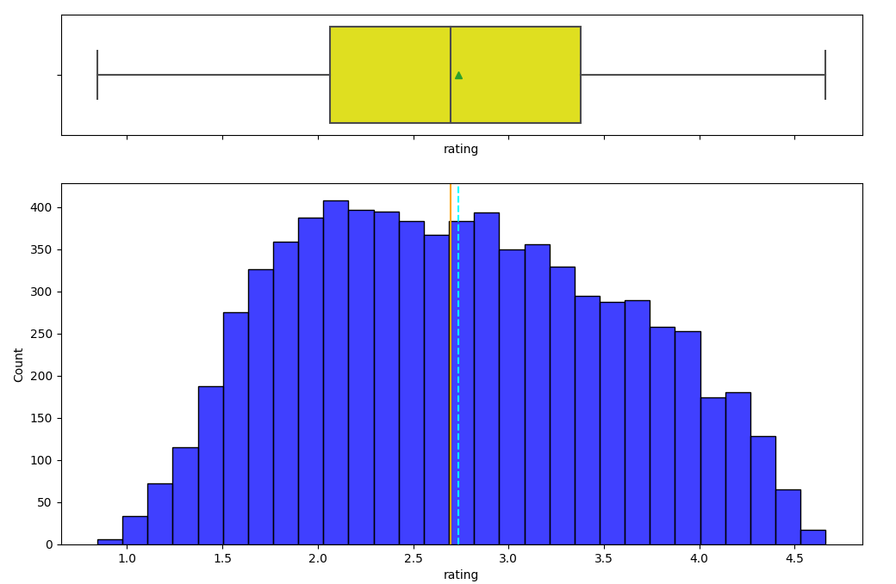

**27. continuous_univariate_analysis(dataset, 'duration')**

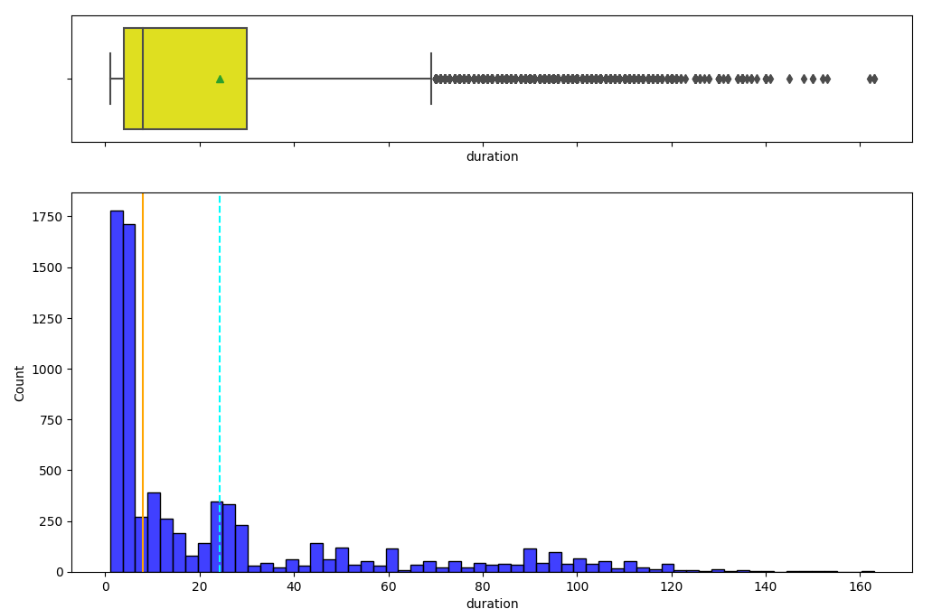

**28. dataset[dataset['duration'] >=80]['rating'].mean()**



**29. dataset[dataset['duration'] >=100]['rating'].mean()**



**30. dataset[dataset['duration'] >=110]['rating'].mean()**



**31. dataset[(dataset['duration'] >=5) & (dataset['duration']<=30)]['rating'].mean()**



**32. discrete_univariate_analysis(dataset, "ongoing", perc=True)**

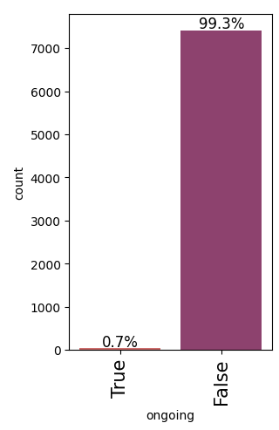

**33. dataset[dataset['ongoing'] == True]['rating'].mean()**



**34. dataset[dataset['ongoing'] == True]['duration'].mean()**



**35. discrete_univariate_analysis(dataset, "sznOfRelease", perc=True)**

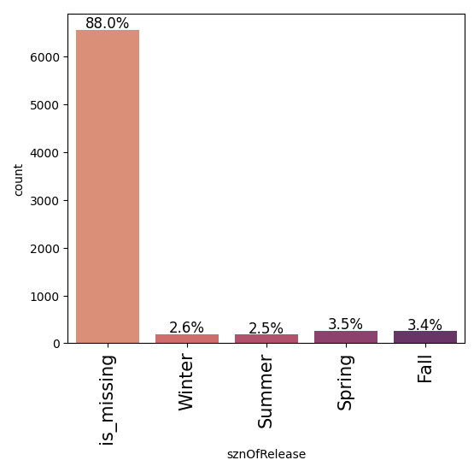

**36. discrete_univariate_analysis(dataset , "studio_primary", perc=True)**

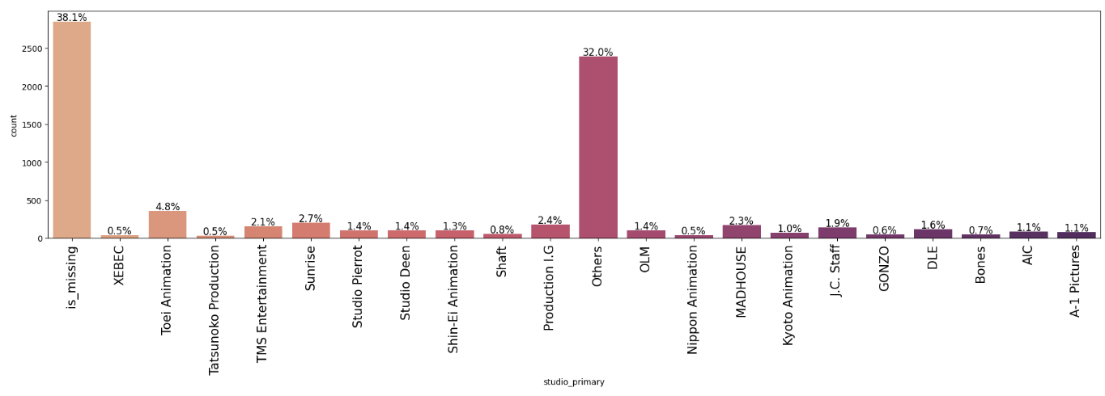

**37. dataset[dataset['rating'] > 4]['studio_primary'].value_counts(normalize=True).mul(100).round(2)**

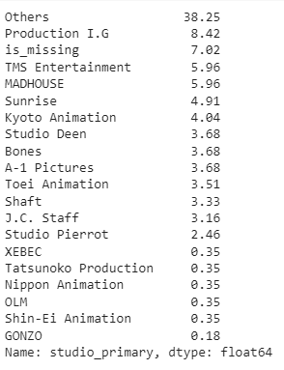

**38. discrete_univariate_analysis(dataset, 'contentWarn', perc=True)**

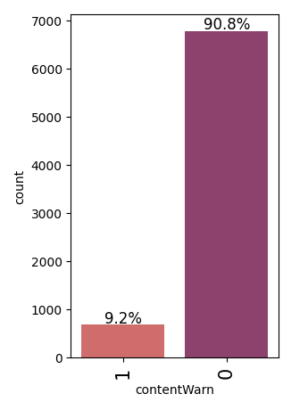

**39. corr_cols = [item for item in dataset.columns if "tag" not in item]**

**40. corr_cols**

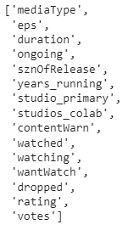

**41. plt.figure(figsize=(16,7))**

**sns.heatmap(dataset[corr_cols].corr(), annot=True, vmin = -1, fmt=' .2f', cmap='Spectral')**

**plt.show()**

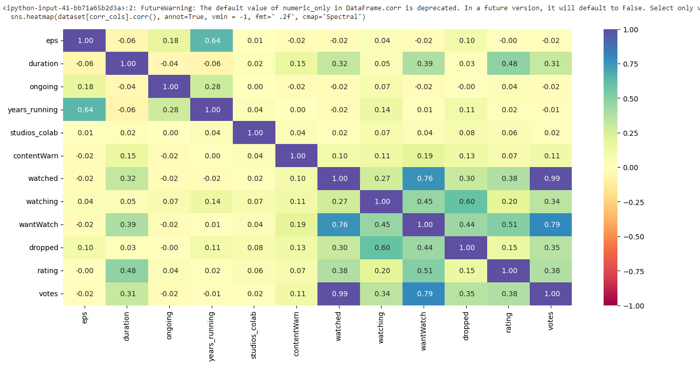

**42. dataset.drop(columns= ['eps', 'watched'], inplace=True)**

**43. dataset.shape**



**44.** plt.figure(figsize=(15,8))

sns.boxplot(x = 'sznOfRelease', y='rating', data=dataset)

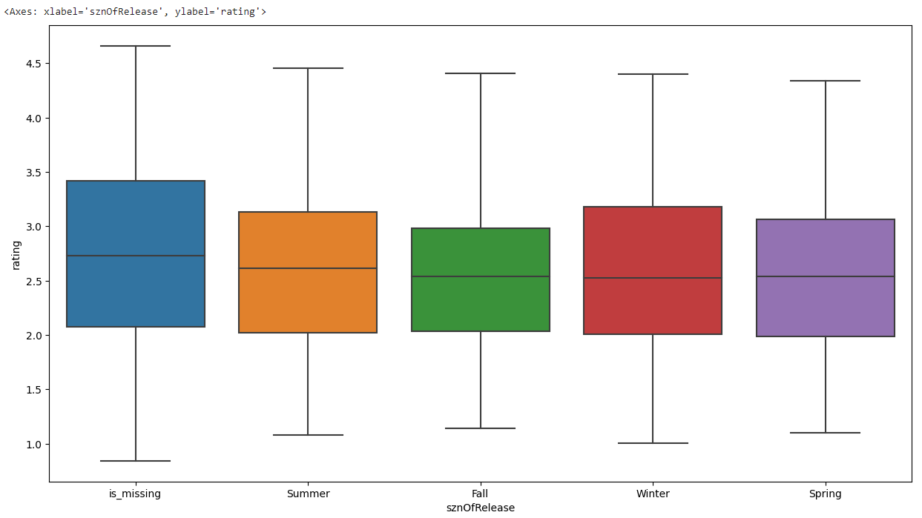

##Model Building - Regression

**45.** x = dataset.drop(['rating'], axis=1)

y = dataset['rating']

**46.** x.info()

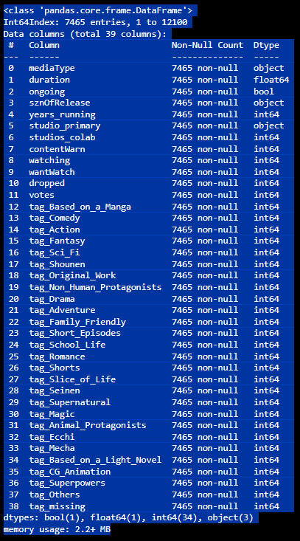

**47.** x = pd.get_dummies(x, columns=x.select_dtypes(include=['object', 'category']).columns.tolist(), drop_first=True)

x.head()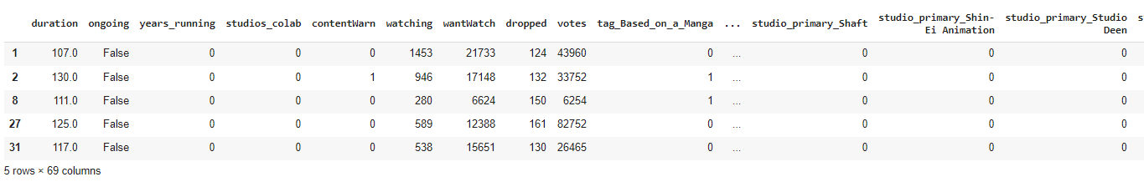

**48.** x.drop(columns='ongoing', inplace=True)

**49.** x.info()

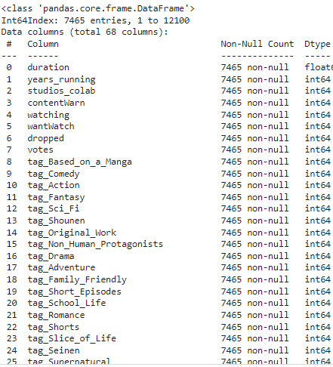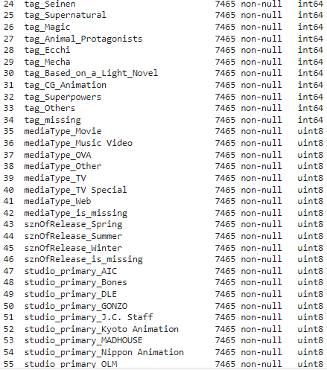

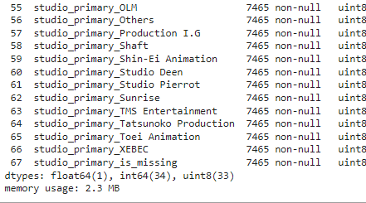

**50.** from sklearn.model_selection import train_test_split

from sklearn.linear_model import LinearRegression

from sklearn.metrics import mean_squared_error, r2_score, mean_absolute_error

**51.** X_train, X_test, Y_train, Y_test = train_test_split(x,y, test_size=0.2, random_state=1)

**52.** X_train, X_test, Y_train, Y_test = train_test_split(x,y, test_size=0.2, random_state=1)

**53.** print("Number of samples for train", X_train.shape[0])

print("Number of samples for test", X_test.shape[0])

**54.** lin_model = LinearRegression()

lin_model.fit(X_train, Y_train)

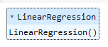

**55.** def Model_performance(model, predictor, target):

    pred = model.predict(predictor)

    r2 = r2_score(target, pred)

    rmse = np.sqrt(mean_squared_error(target, pred))

    results= pd.DataFrame({

        "RMSE":rmse,

        "R2 Score":r2

    }, index=[0]

    )

    return results

**56.** print("Training Data Performance")

lin_model_train = Model_performance(lin_model, X_train, Y_train)

lin_model_train

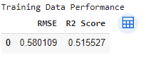

**57.** x.columns

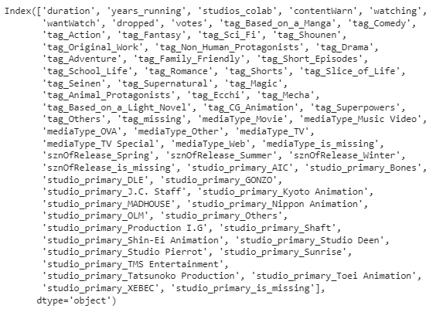

##feature selection technique

**58.** ##conda install mlxtend

!pip install mlxtend

import mlxtend

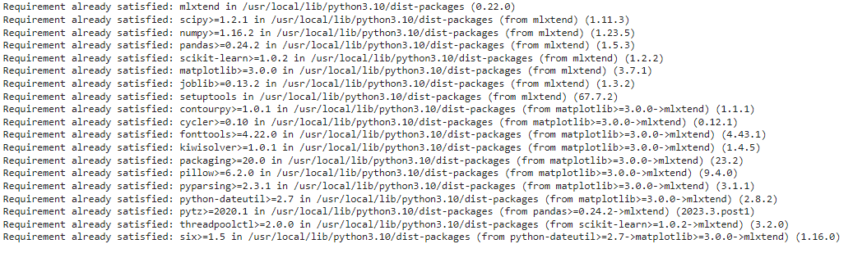

**59.** from mlxtend.feature_selection import SequentialFeatureSelector as SFS

reg = LinearRegression()

sfs = SFS(reg, k_features = X_train.shape[1],

forward = True, floating=False, scoring='r2', n_jobs= -1, cv=5)

sfs = sfs.fit(X_train, Y_train)

**60.** from mlxtend.plotting import plot_sequential_feature_selection as plot_sfs

fig1 = plot_sfs(sfs.get_metric_dict(), kind='std_err', figsize=(15,5))

plt.title("Feature Selector - SFS")

plt.xticks(rotation=90)

plt.show()

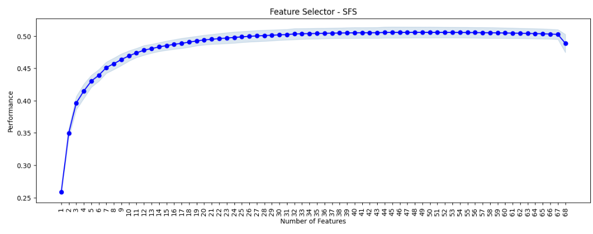

**61.** from mlxtend.feature_selection import SequentialFeatureSelector as SFS

reg = LinearRegression()

sfs = SFS(reg, k_features = 30,

         forward = True, floating=False, scoring='r2', n_jobs= -1, cv=5)

sfs = sfs.fit(X_train, Y_train)

**62.** from mlxtend.plotting import plot_sequential_feature_selection as plot_sfs

fig1 = plot_sfs(sfs.get_metric_dict(), kind='std_err', figsize=(15,5))

plt.title("Feature Selector - SFS")

plt.xticks(rotation=90)

plt.show()

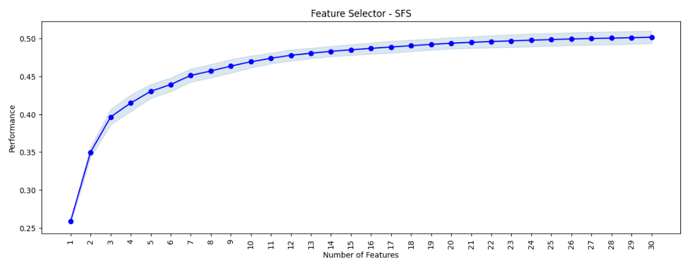

**63.** from mlxtend.feature_selection import SequentialFeatureSelector as SFS

reg = LinearRegression()

sfs = SFS(reg, k_features = 35,

       forward = True, floating=False, scoring='r2', n_jobs= -1, cv=5)

sfs = sfs.fit(X_train, Y_train)

**64.** from mlxtend.plotting import plot_sequential_feature_selection as plot_sfs

fig1 = plot_sfs(sfs.get_metric_dict(), kind='std_err', figsize=(15,5))

plt.title("Feature Selector - SFS")

plt.xticks(rotation=90)

plt.show()

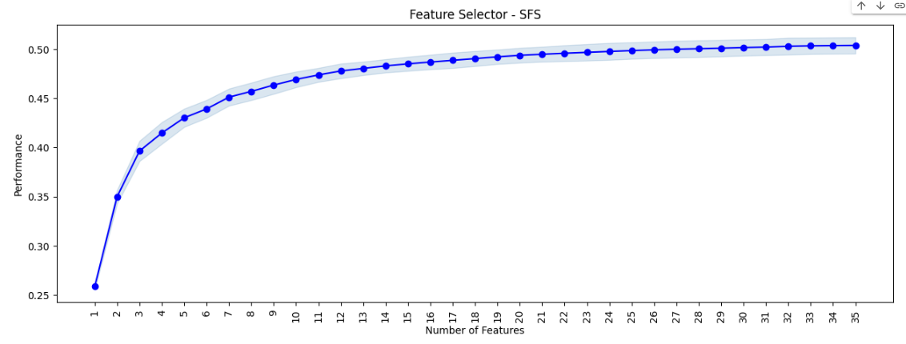

**65.** feature_index = list(sfs.k_feature_idx_)

print(feature_index)



**66.** X_train.columns[feature_index]

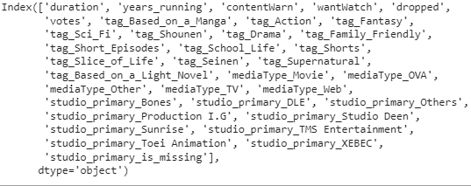

**67.** print("Training Data Performance")

lin_model_train = Model_performance(lin_model, X_train, Y_train)

lin_model_train

**68.** print("Training Data Performance")

lin_model_train = Model_performance(lin_model, X_test, Y_test)

lin_model_train

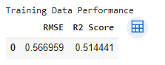

**69.** X_train.columns[feature_index]

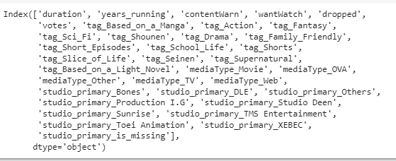

**70.** X_train.head(2)

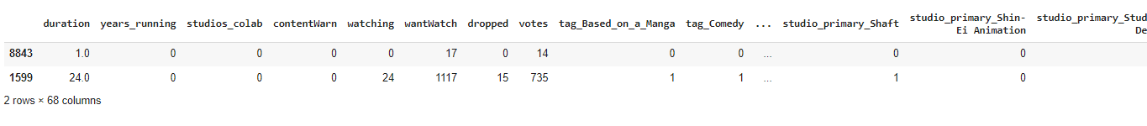

**Name –** Prashant Suthar

**Batch-**DS with ML and Python

**Certificate Code**- TCRIB4R162