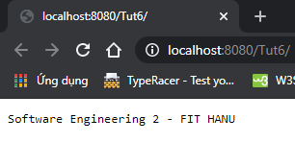

Student

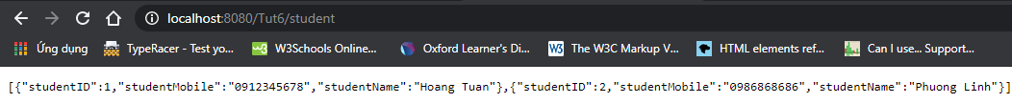

Course

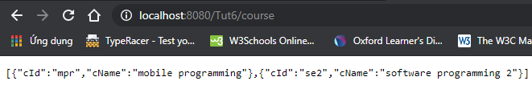

Enrollment

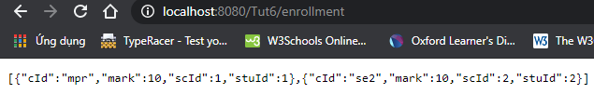

I cannot use ***APPLICATION_XML***

I user ***APPLICATION_JSON*** instead