**PROJECT TITLE:** Implementation of Clustering Algorithms in C to offer Business Insights

**ABSTRACT**

The project aims to implement clustering algorithms in C to offer business insights. Clustering is the task of dividing the population or data points into a number of groups such that data points in the same groups are more similar to other data points in the same group than those in other groups. In simple words, the aim is to segregate groups with similar traits and assign them into clusters. Today many businesses generate a lot of data. Clustering can help businesses to manage their data better – Customer segmentation, grouping web pages, market segmentation and information retrieval are four examples. For retail businesses, data clustering helps with customer shopping behavior, sales campaigns and customer retention. In the insurance industry, clustering is regularly employed in fraud detection, risk factor identification and customer retention efforts. In banking, clustering is used for customer segmentation, credit scoring and analyzing customer profitability.

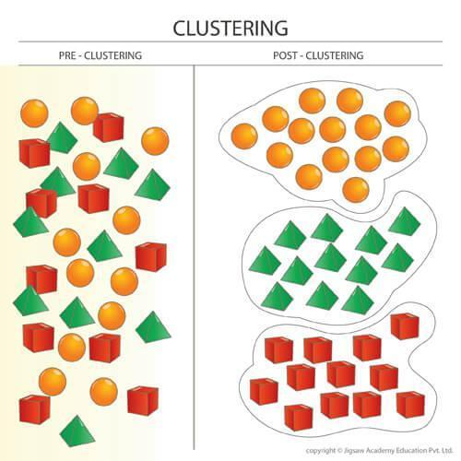

**Submitted by:**

**SUYASH SHARMA(18SCE1140053)**

**KASHIF AHAMAD(19SCSE1180046)**

**VARUNDEEP SINGH(18SCSE1140043)**