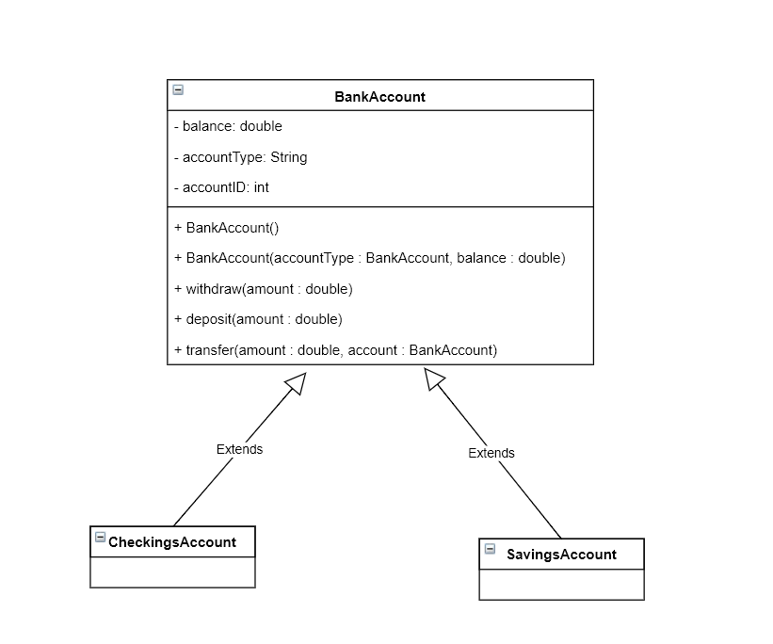

Diagram 1. Bank Account Class Diagram

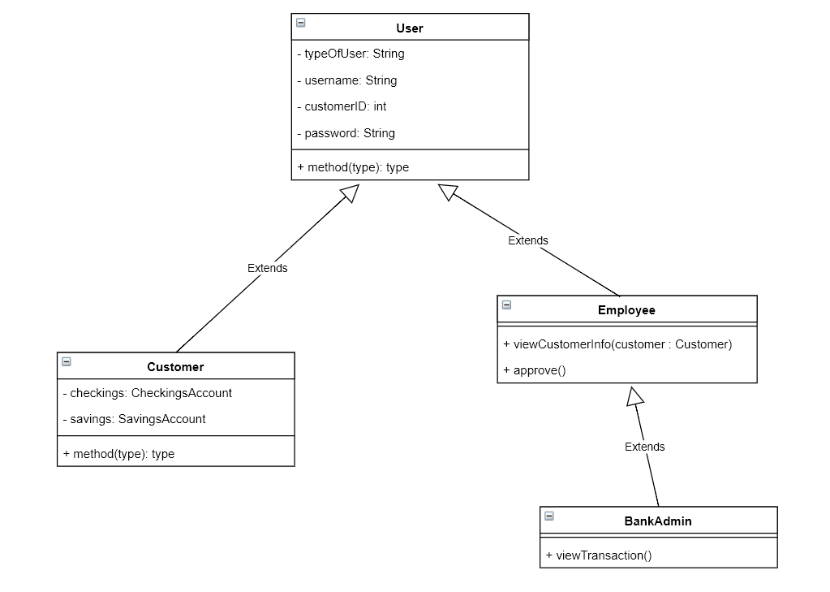

Diagram 2. User Class Diagram

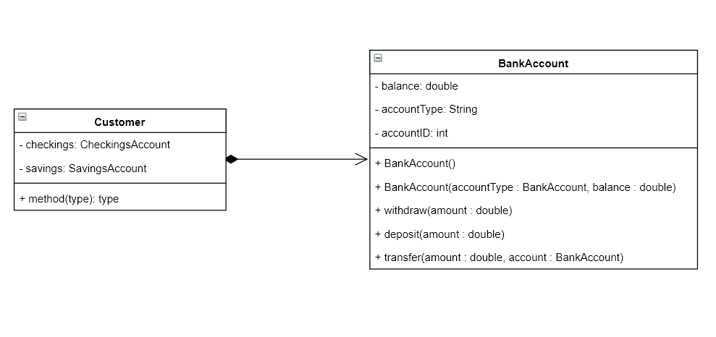

Diagram 3. Composition