Setting up Linux VM Virtual Box

**2018**

Vibranarayanan



Table of Contents

Change Log 2

VM Virtual box 2

Install Virtual box 3

VM Virtual box initial screen 3

Installing Cent OS 3

Download Cent OS 3

Virtual box - Setting name and OS bit version 3

Virtual Box - Setting Memory size 3

Virtual Box - Setting Hard disk 4

Virtual Box - Setting hard drive file type 4

Virtual Box - CentOS Instance Created 5

CentOS Instance settings 5

Virtual box - Setting downloaded ISO image 5

Start Virtual machine 6

Select Language 7

Setting update system details 7

Installing CentOS 8

Setting up root password 8

Installation completed 8

Before reboot - Unmount ISO file 8

Initial login screen 9

## Change Log

|  |  |
| --- | --- |
| Date | Details |
| 05/16/2018 | * Download and installation. |
| O5/17/2018 | * Analysis on 05/16 installation failure * Document step by step Virtual Box set-up * Document step by step CentOS Installation.   Pages (3 - 9) |
|  |  |

## VM Virtual box

Download VM virtual box from below URL . in this POC downloaded windows binary.   
https://www.virtualbox.org/wiki/Downloads

## Install Virtual box

After download click downloaded exe and finish installation.

## VM Virtual box initial screen

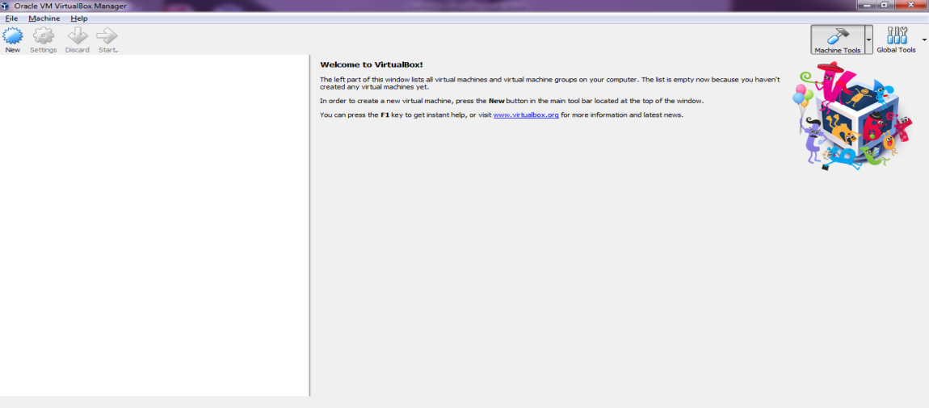

## Installing Cent OS

## Download Cent OS

go to https://www.centos.org/ get CentOS >> DVD ISO file

### Virtual box - Setting name and OS bit version

Select new button and enter name. in this POC this centOS, by typing name vbox will automatically populate bit version.

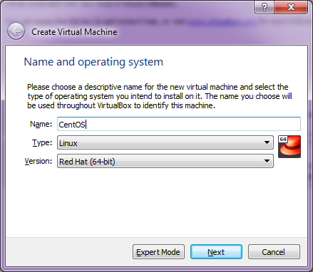

### Virtual Box - Setting Memory size

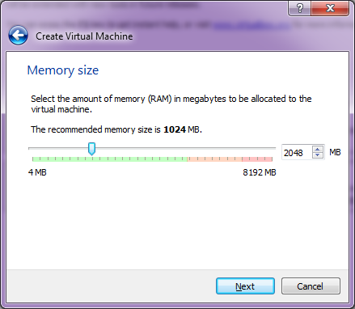

### Virtual Box - Setting Hard disk

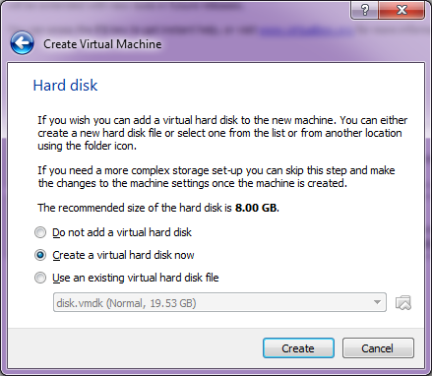

### Virtual Box - Setting hard drive file type

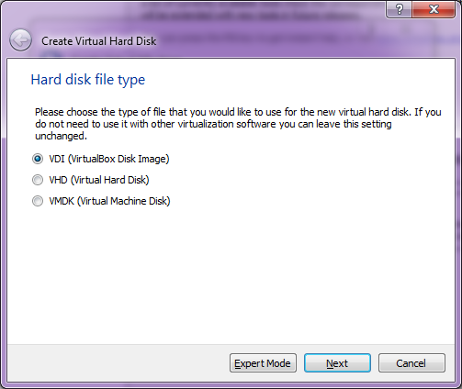  
Virtual Box - Physical file storage settings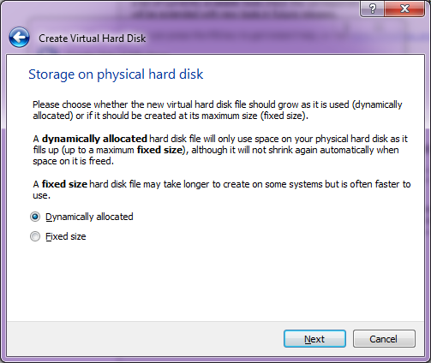  
Next screen select the size need to be allocated and finish

### Virtual Box - CentOS Instance Created

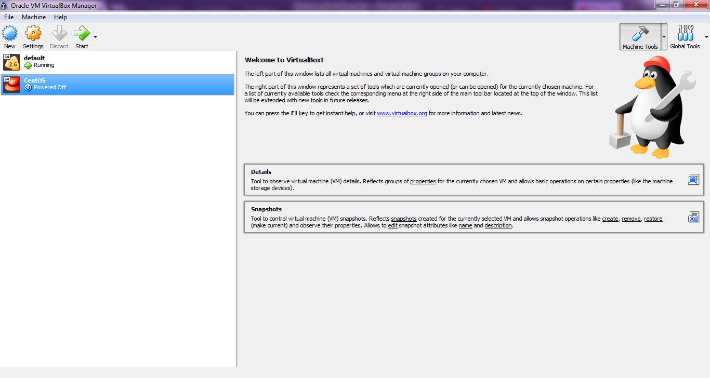

### CentOS Instance settings

select newly created CentOS instance and select setting. in below screen under Advanced you can select Clipboard and drag and drop as bidirectional. this will allow you to access window and linux in efficient way

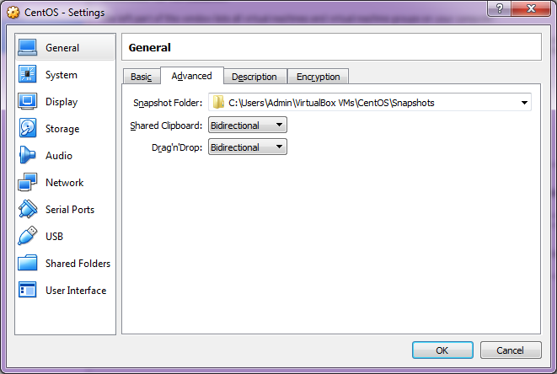

### Virtual box - Setting downloaded ISO image

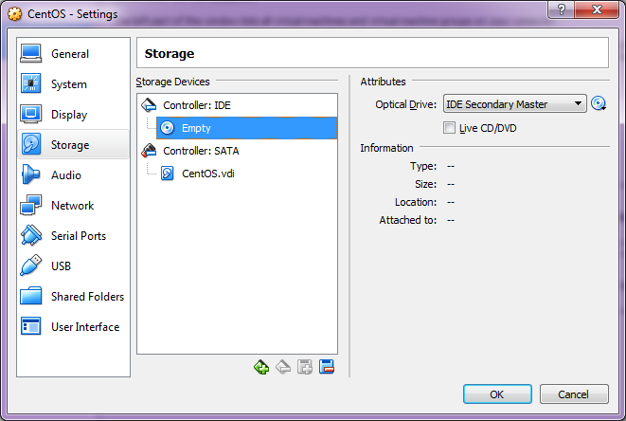

select empty under storage section. and in Optical driver select the downloaded DVD ISO file.

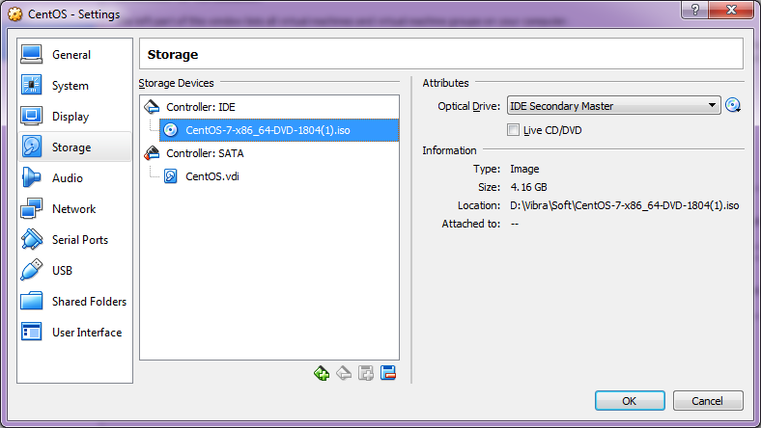

### Start Virtual machine

Select CentOS and click start.

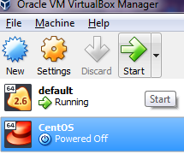

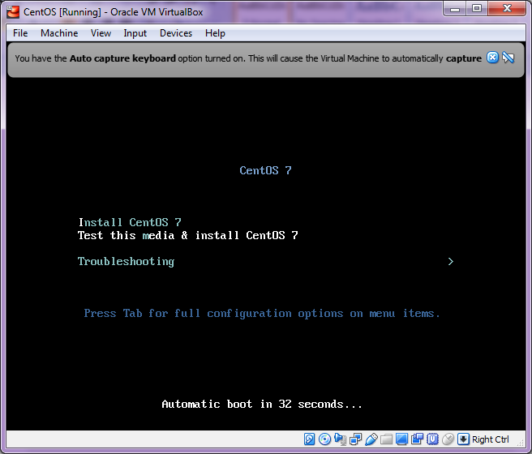

### Select Language

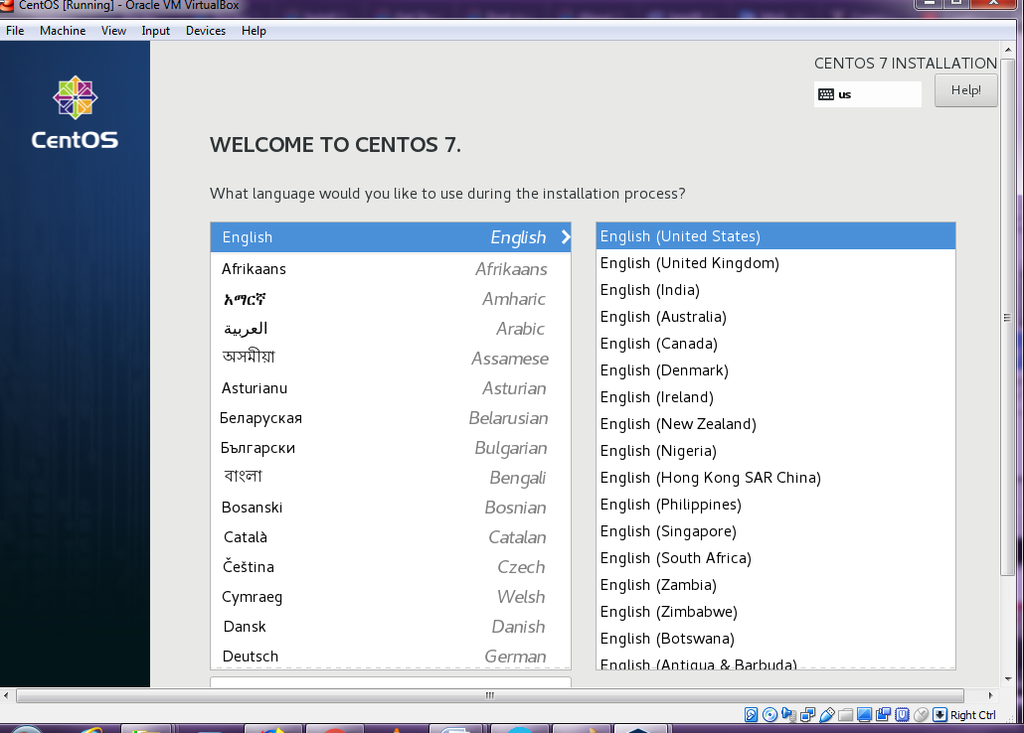

### Setting update system details

Click on each icon and update required details  
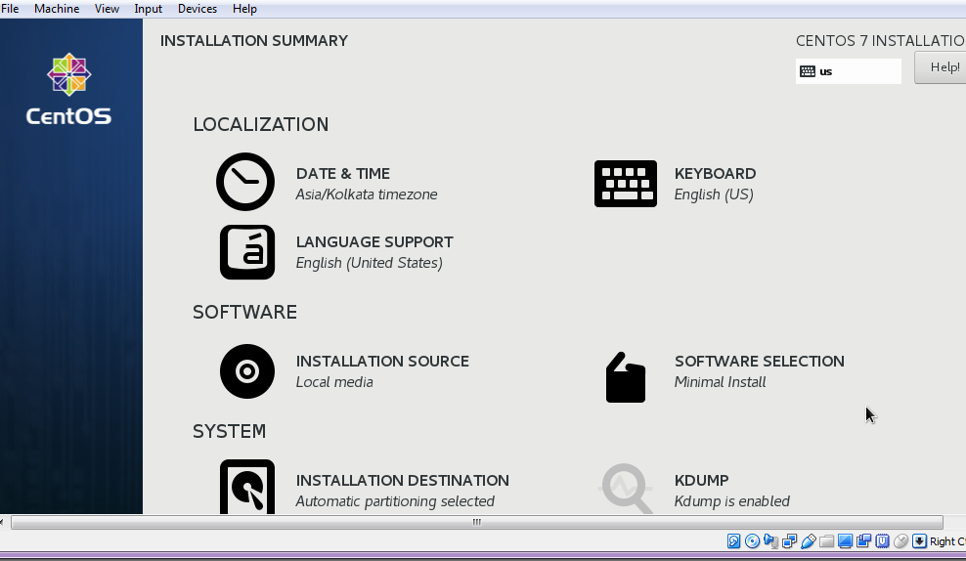

under installation destination make sure automatic partitioning checked.

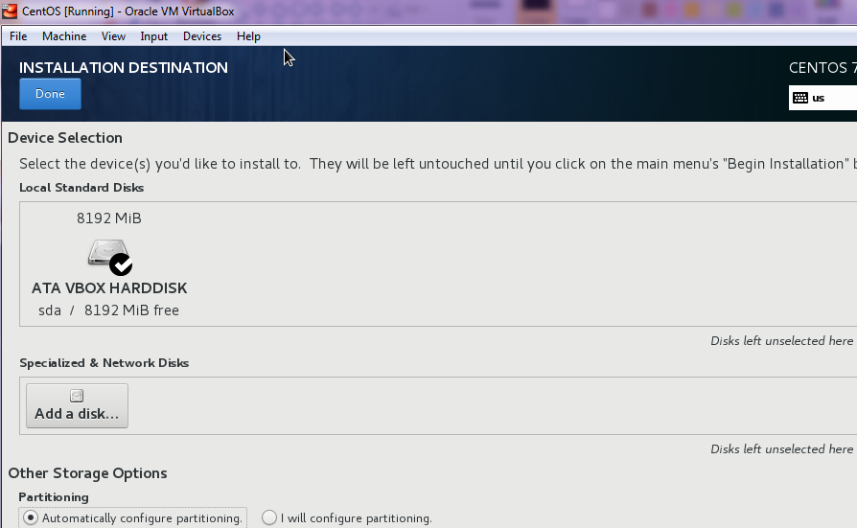

Once you done update to all section, Begin installation button will be enabled. click to install  
Begin Installation

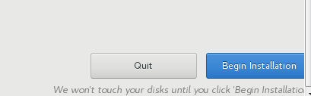

### Installing CentOS

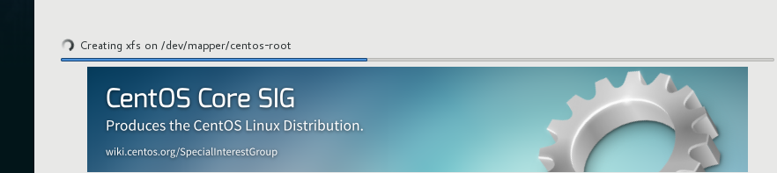

### Setting up root password

Above installation will take a sometime and we can set root password and can create if any user needed.

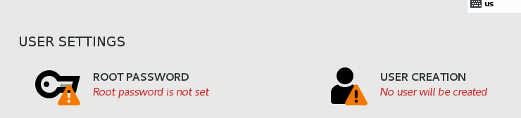

### Installation completed

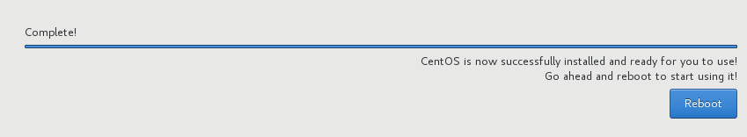

### Before reboot - Unmount ISO file

Uncheck CentOS ISO file checked under devices >> Optical Devices 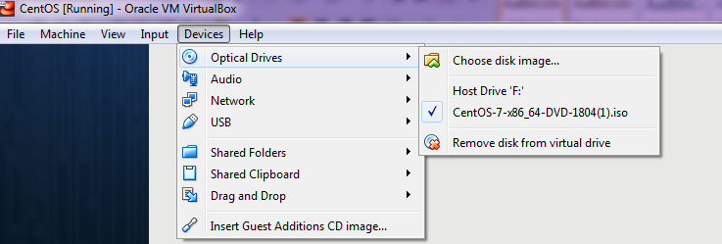

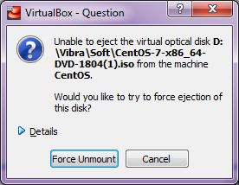  
Click force unmount and click reboot  
Reset Machine  
Once you see black screen click machine >> reset

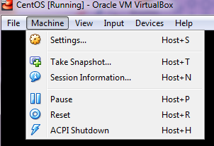

### Initial login screen

