**Assignment- Virtual Art Gallery**

Created tables, and input the values as given in the pdf

**Solve the below queries:**

**1. Retrieve the names of all artists along with the number of artworks they have in the gallery, and list them in descending order of the number of artworks.**

select art.Name, count(artwk.ArtworkID) as CountOfArtWork from Artists art

left join Artworks artwk on art.ArtistID = artwk.ArtistID

group by art.Name order by CountOfArtWork desc;



**2. List the titles of artworks created by artists from 'Spanish' and 'Dutch' nationalities, and order them by the year in ascending order.**

select artwk.Title, artwk.Year from Artworks artwk

join Artists art on artwk.ArtistID = art.ArtistID

where art.Nationality in ('Spanish', 'Dutch') order by artwk.Year;

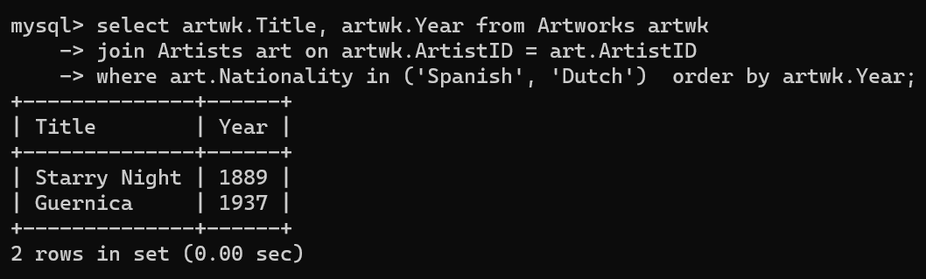

**3. Find the names of all artists who have artworks in the 'Painting' category, and the number of artworks they have in this category.**

select art.Name, count(artwk.ArtworkID) as ArtworkCount from Artists art

join Artworks artwk on art.ArtistID = artwk.ArtistID

join Categories cat on artwk.CategoryID = cat.CategoryID

where cat.Name = 'Painting' group by art.Name;

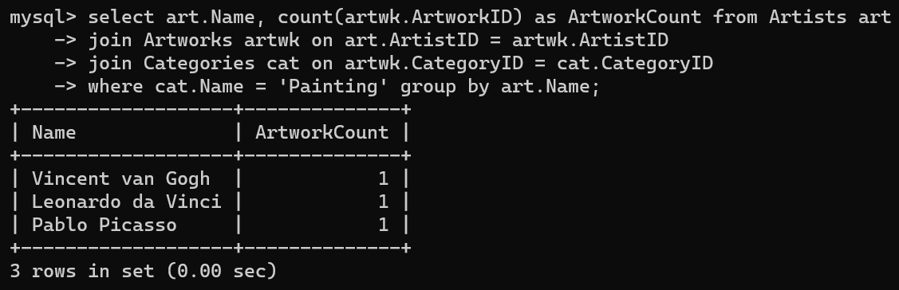

**4. List the names of artworks from the 'Modern Art Masterpieces' exhibition, along with their artists and categories.**

select artwk.Title, art.Name as Artist, cat.Name as Category from ExhibitionArtworks exartwk

join Artworks artwk on exartwk.ArtworkID = artwk.ArtworkID

join Artists art on artwk.ArtistID = art.ArtistID

join Categories cat on artwk.CategoryID = cat.CategoryID

join Exhibitions exb on exartwk.ExhibitionID = exb.ExhibitionID

where exb.Title = 'Modern Art Masterpieces';

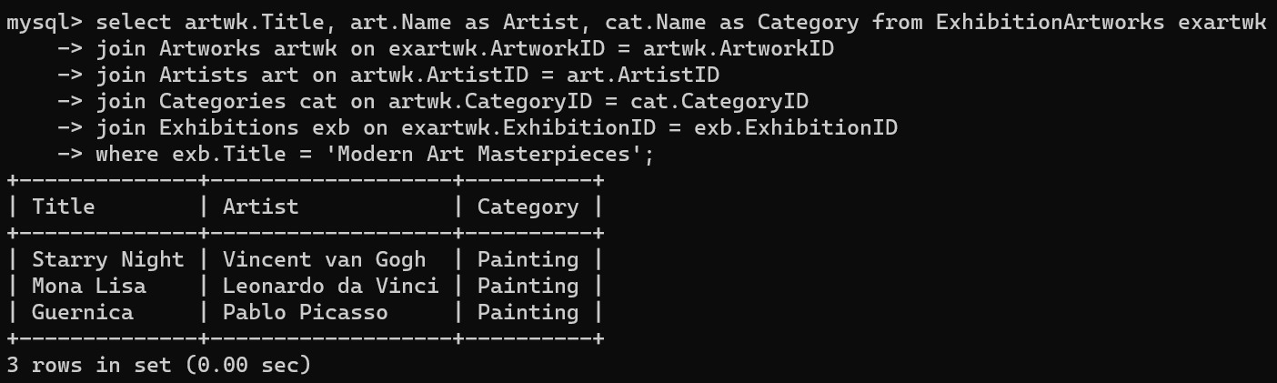

**5. Find the artists who have more than two artworks in the gallery.**

select art.Name, count(artwk.ArtworkID) as CountOfArtWork from Artists art

join Artworks artwk on art.ArtistID = artwk.ArtistID

group by art.Name having count(artwk.ArtworkID) >2;



**6. Find the titles of artworks that were exhibited in both 'Modern Art Masterpieces' and 'Renaissance Art' exhibitions**

select artwk.Title from ExhibitionArtworks exartwk1

join Exhibitions exb1 on exartwk1.ExhibitionID = exb1.ExhibitionID

join Artworks artwk on exartwk1.ArtworkID = artwk.ArtworkID

where exb1.Title in( 'Modern Art Masterpieces', 'Renaissance Art');

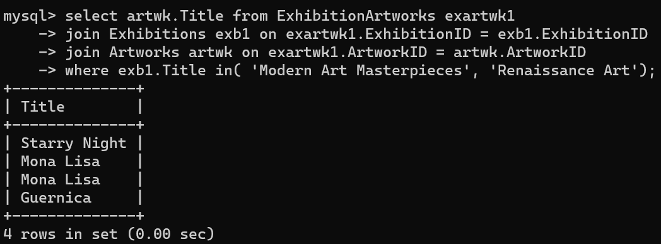

**7. Find the total number of artworks in each category**

select cat.Name as Category, count(artwk.ArtworkID) as TotalArtworks from Categories cat

left join Artworks artwk on cat.CategoryID = artwk.CategoryID

group by cat.Name;

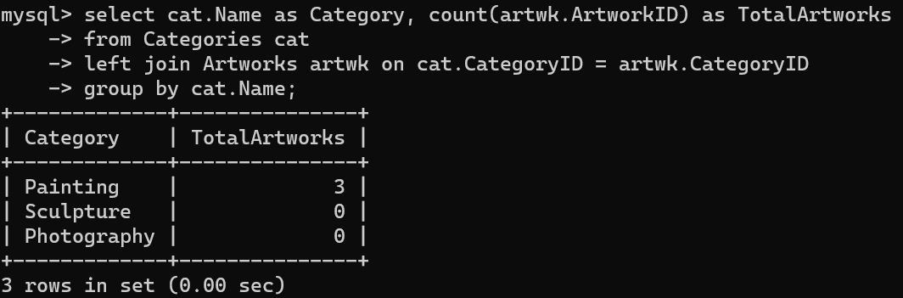

**8. List artists who have more than 3 artworks in the gallery.**

select art.Name, count(artwk.ArtworkID) as ArtworkCount from Artists art

join Artworks artwk on art.ArtistID = artwk.ArtistID group by art.Name

having count(artwk.ArtworkID) > 3;



**9. Find the artworks created by artists from a specific nationality (e.g., Spanish).**

select artwk.Title, art.Name as Artist, art.Nationality from Artworks artwk

join Artists art on artwk.ArtistID = art.ArtistID

where art.Nationality = 'Spanish';



**10. List exhibitions that feature artwork by both Vincent van Gogh and Leonardo da Vinci.**

select exb.Title from Exhibitions exb

join ExhibitionArtworks exartwk on exb.ExhibitionID = exartwk.ExhibitionID

join Artworks artwk on exartwk.ArtworkID = artwk.ArtworkID

join Artists art on artwk.ArtistID = art.ArtistID

where art.Name in( 'Vincent van Gogh' , 'Leonardo da Vinci' );

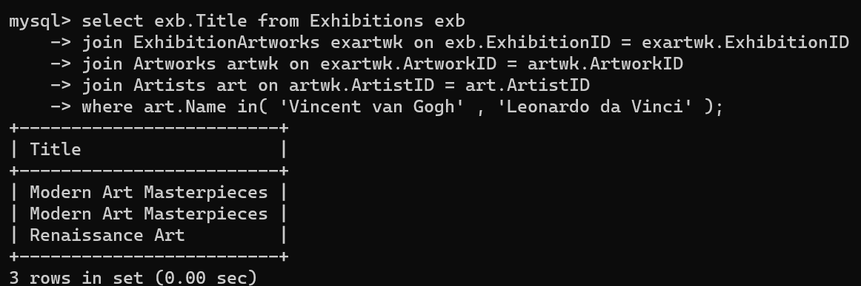

**11. Find all the artworks that have not been included in any exhibition.**

select artwk.Title from Artworks artwk

left join ExhibitionArtworks exartwk on artwk.ArtworkID = exartwk.ArtworkID

where exartwk.ExhibitionID is null;



**12. List artists who have created artworks in all available categories.**

select art.Name from Artists art

join Artworks artwk on art.ArtistID = artwk.ArtistID group by art.Name

having count( artwk.CategoryID) = (select count(*) from Categories);



**13. List the total number of artworks in each category.**

select cat.Name as Category, count(artwk.ArtworkID) as TotalArtworks from Categories cat

left join Artworks artwk on cat.CategoryID = artwk.CategoryID group by cat.Name;

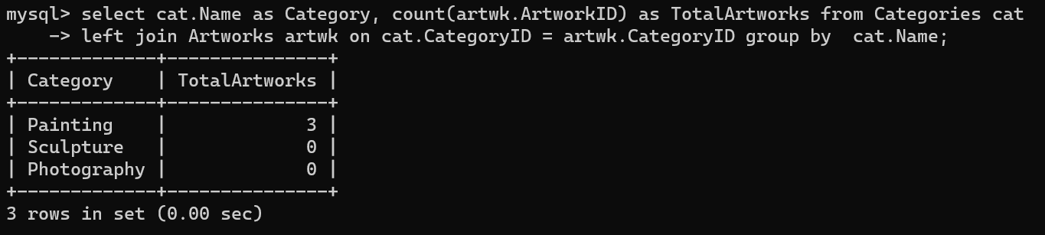

**14. Find the artists who have more than 2 artworks in the gallery.**

select art.Name, count(artwk.ArtworkID) as CountOfArtWork from Artists art

join Artworks artwk on art.ArtistID = artwk.ArtistID

group by art.Name having count(artwk.ArtworkID) >2;



**15. List the categories with the average year of artworks they contain, only for categories with more than 1 artwork.**

select cat.Name as Category, avg(artwk.Year) as AvgYear from Categories cat

join Artworks artwk on cat.CategoryID = artwk.CategoryID

group by cat.CategoryID, cat.Name having count(artwk.ArtworkID) > 1;

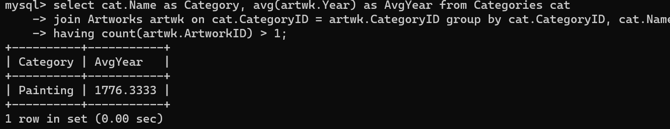

**16. Find the artworks that were exhibited in the 'Modern Art Masterpieces' exhibition.**

select artwk.Title from Artworks artwk

join ExhibitionArtworks exartwk on artwk.ArtworkID = exartwk.ArtworkID

join Exhibitions exb on exartwk.ExhibitionID = exb.ExhibitionID

where exb.Title = 'Modern Art Masterpieces';

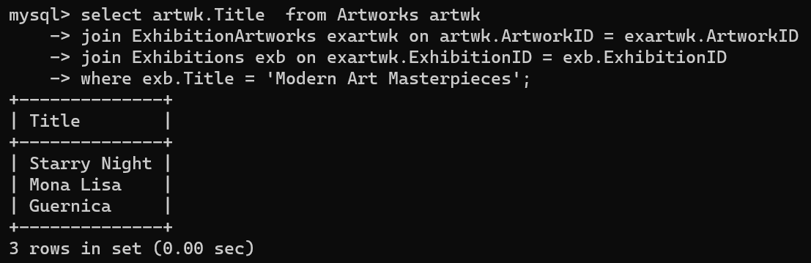

**17. Find the categories where the average year of artworks is greater than the average year of all artworks.**

select cat.Name as Category, avg(artwk.Year) as AvgCategoryYear from Categories cat

join Artworks artwk on cat.CategoryID = artwk.CategoryID

group by cat.CategoryID, cat.Name

having avg(artwk.Year) > (select avg(Year) from Artworks);



**18. List the artworks that were not exhibited in any exhibition.**

select artwk.Title from Artworks artwk

left join ExhibitionArtworks exartwk on artwk.ArtworkID = exartwk.ArtworkID

where exartwk.ExhibitionID is null;



**19. Show artists who have artworks in the same category as "Mona Lisa."**

select art.Name from Artists art

join Artworks artwk on art.ArtistID = artwk.ArtistID

where artwk.CategoryID = ( select CategoryID from Artworks where Title = 'Mona Lisa' );



**20. List the names of artists and the number of artworks they have in the gallery.**

select art.Name as Artist, count(artwk.ArtworkID) as ArtworkCount from Artists art

left join Artworks artwk ON art.ArtistID = artwk.ArtistID

group by art.ArtistID, art.Name;

