# Portfolio guidelines.

Welcome, this document provides guidance on writing an online portfolio to showcase your technical abilities and knowledge. From this online portfolio, you’ll be able to generate a Word and PDF versions.

The following sections **MUST** be completed by you, then approved by your Trainer:

* Job title
* Industry Equivalency
* About Me
* Education
* Certification (if applicable)
* Skills Matrix
* Projects

These sections are optional and may be requested by your Trainer:

* Work Experience (leave blank unless notified differently by Quality Team)
* Other Experience
* Honors & Awards

1. **Job Title**

Click the “+” symbol under your name, select your job title from the dropdown, and click update button.

*For JTA Associates - select “Software Development Engineer at Test”.*

*For JEE and .NET Associates - select “Software Developer”*

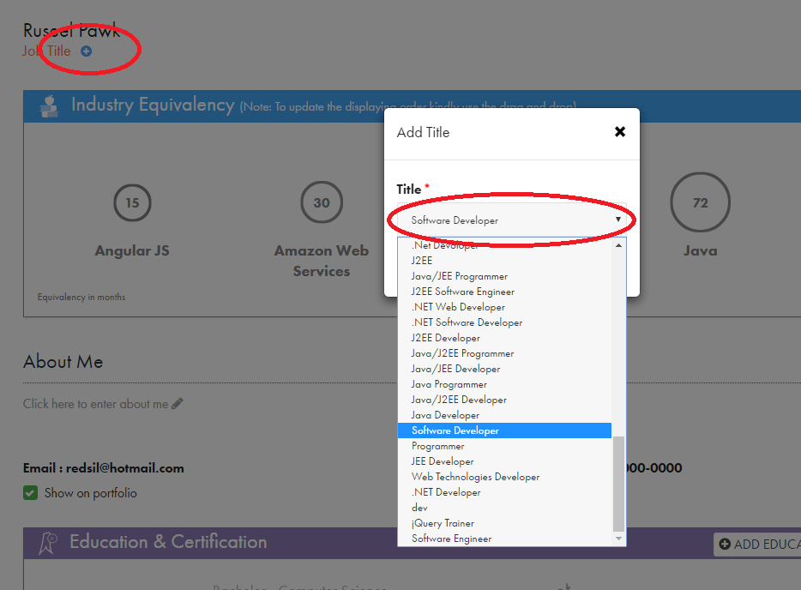

1. **Industry Equivalency**

Click the “+” symbol at the end of the section, to add equivalency skills from a popup menu.



In the dropdown select top key skills that are **relevant** to your core technology stack. Agile and Git are **not** allowed. *The dropdown is populated from completed projects and will change overtime.*

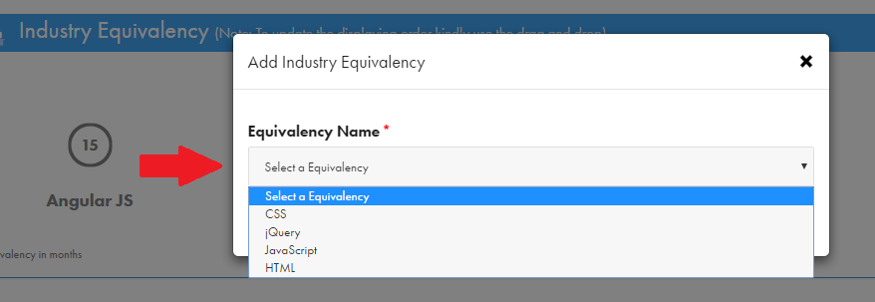

Repeat until you have **at least** 5 relevant key skills listed in Industry Equivalency section. *To re-order the skills, drag and drop the circles.* **Please note only the trainer can change these numbers.**

*Example for a JavaScript web developer*

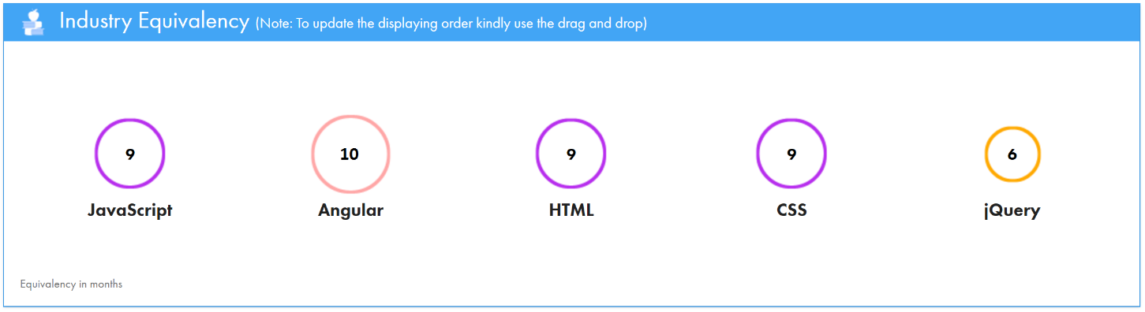

**Please order from greatest amount of months to least..

1. **About Me** (professional summary)

This section will include a concise “professional summary” paragraph and key “responsibilities” list.

To start, click inside the “About Me” section to open up a text editor menu.

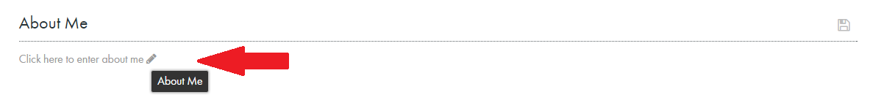

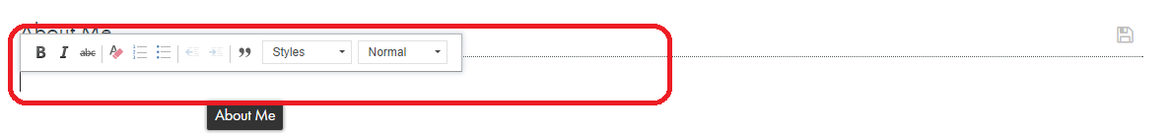

The “About Me” section must reflect that you are a software developer within your core technology, that works on **all** tiers of an application, i.e. end-to-end development. It should provide a high-level overview of your skill set. *Don’t forget to click the save icon.*

*Guidelines for writing professional summary:*

* The about me should be around 3-5 sentences.
* First sentence will be I am a (what kind of developer you are). Note in the picture below.
* Use active voice (Start sentence with an action verb then state your experience, note in picture below).
* Use strong language, i.e. be assertive and confident.
* Use first person voice, i.e. the “I” noun.
* It’s unnecessary to use “I” repeatedly, twice in the entire paragraph will be sufficient.
* Don’t use plural nouns, like “we, “us”, “my partner”, “the team”, etc.

*Example of a web developer with back-end experience*

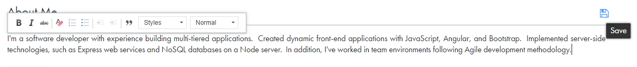

Note, this is concise description of a full-stack JavaScript developer, who builds web applications. It naturally flows from front-end frameworks to server-side technologies. Also, it includes a few primary technologies. The About Me section **should not** include non-technical skills, hobbies, and personal activities.

1. **About Me** (key responsibilities)

After writing your “professional summary”, let’s add key responsibilities in the About Me section.

So, within the About Me section, start a newline after the “professional summary” paragraph. On the editor menu click the 2nd icon for a bulleted list, an arrow should appear on screen. *If bullets are numbered, please switch them to arrows.*

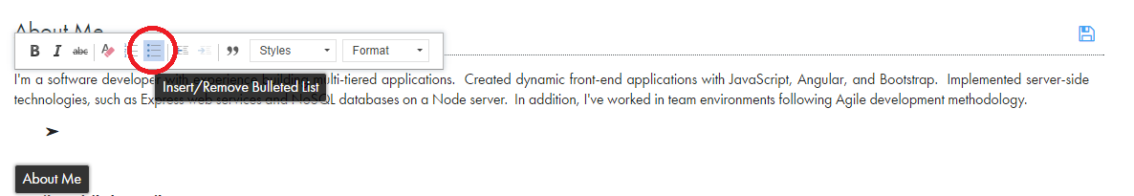

This bulleted list shows an understanding of various frameworks and how to leverage their features. As with the “professional summary”, these bullets must have a logical flow reinforcing your end-to-end experience.

*Guidelines for writing responsibilities:*

* Previous guidelines must be applied as well.
* Using “I” is unnecessary, the resume is about you. Stay using active voice.
* You **must** have at least 12 bullets.
* The first bullet should reiterate the full stack tech, or your extensive. note with the picture below.
* 1 sentence per responsibility.
* Each bullet **must** end with a period.
* Bold the technologies in each bullet.
* Use a workflow that starts with front-end, goes to a middle tier, and lastly a back-end layer.
* Use strong language.
* These are some words that can be used to start bullets:

**experienced, develop, designed, implement, architected, built, coded, configure, constructed, consume, crafted, created, deployed, employed, execute, expose, incorporate, integrate, leverage, manage, utilized, worked**

* **Don’t** use passive voice, it implies uncertainty:

comfortable, familiar, knowledgeable,aware of, I saw

*Following example is for a JavaScript web developer*

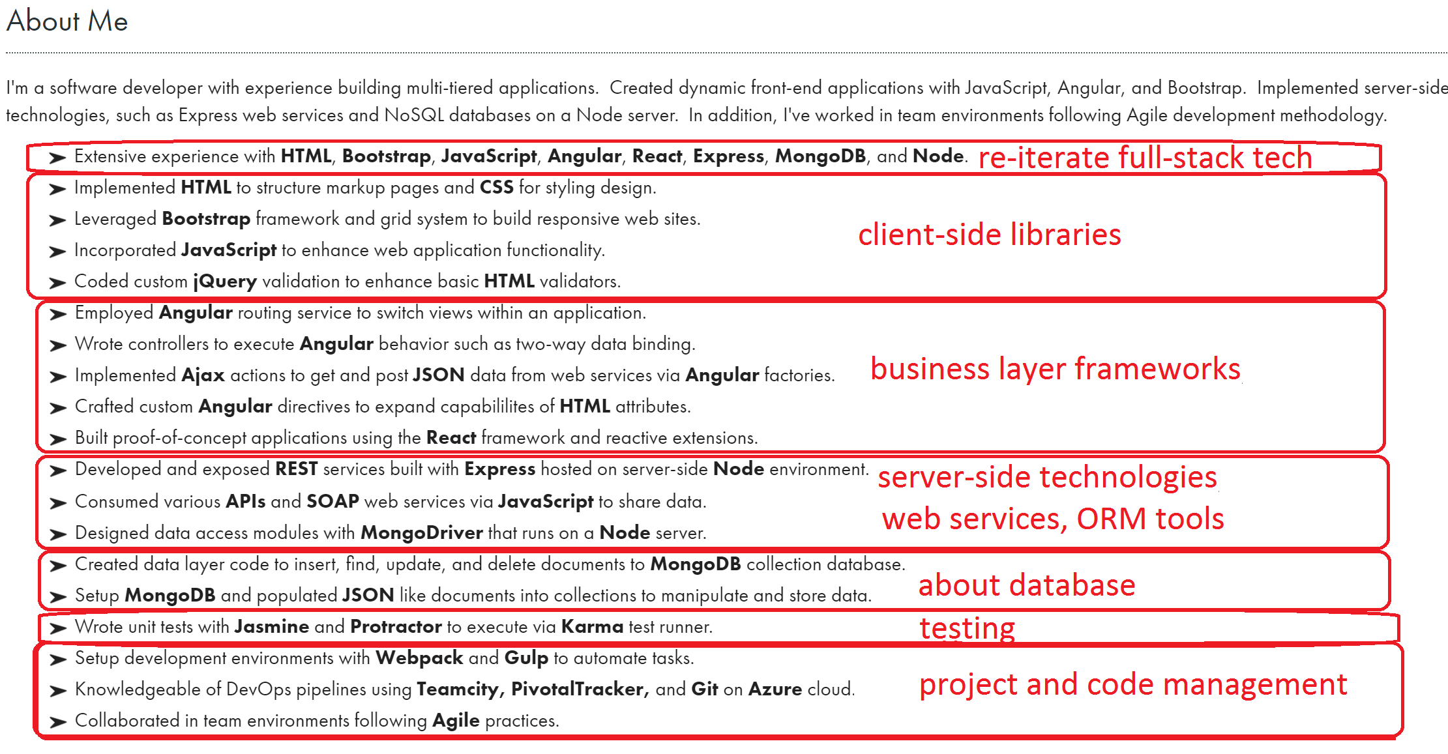

Lastly, please uncheck the “show on portfolio” option for both email and phone number.

*Checked*



*Unchecked*



1. **Education**

This section is for university degrees you have **earned.** To start, click the add button for education.

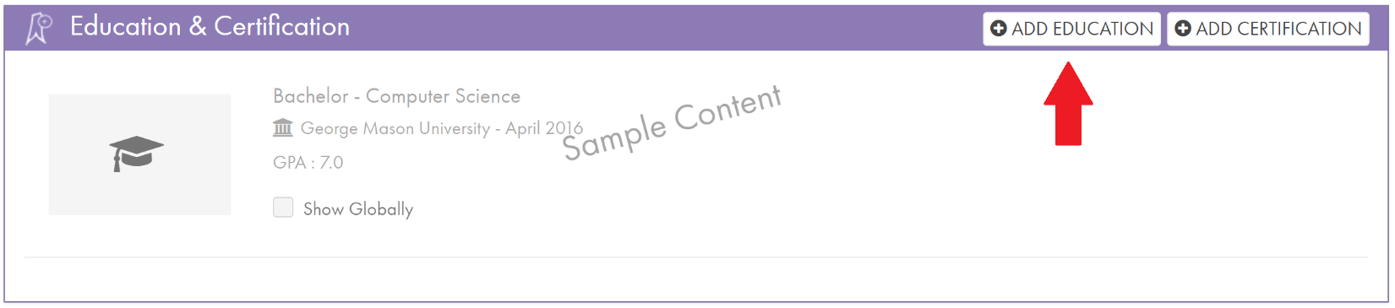

*Guidelines for adding education:*

* Select completed Degree.
* Major is required, completed Minors are allowed.
* Include full University name.
* GPA is not required, unless requested by the Trainer.

Please, **only** fill out the required fields for degree, major, and university. Also, include your graduation date and check to show globally. *An existing education from another portfolio can be selected and added.*

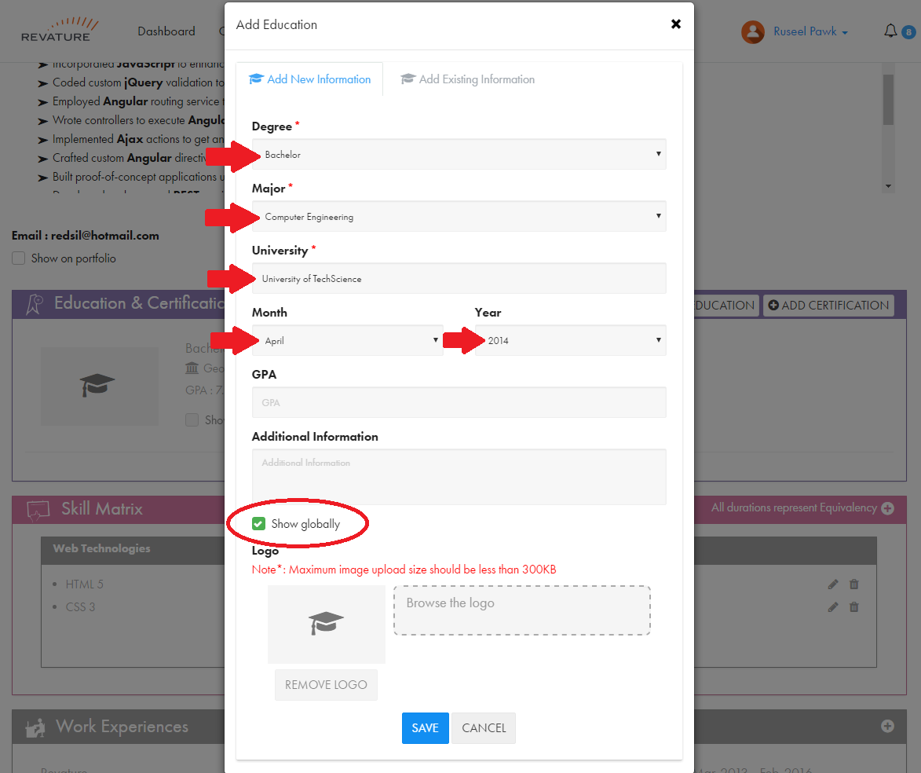

*Example for education*

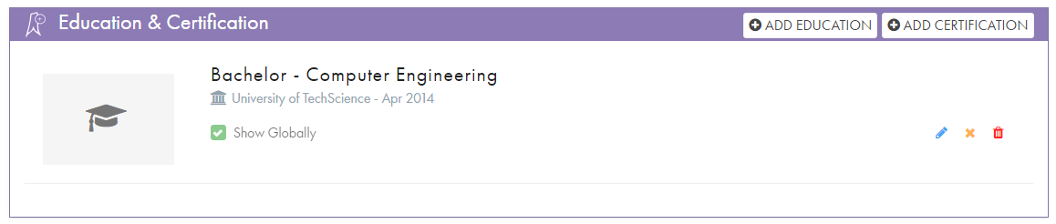

1. **Certification**

Adding technicalcertifications, you have achieved, is similar process to adding education. Start by clicking the add certification button. *Only include certifications that are technical which you passed.*

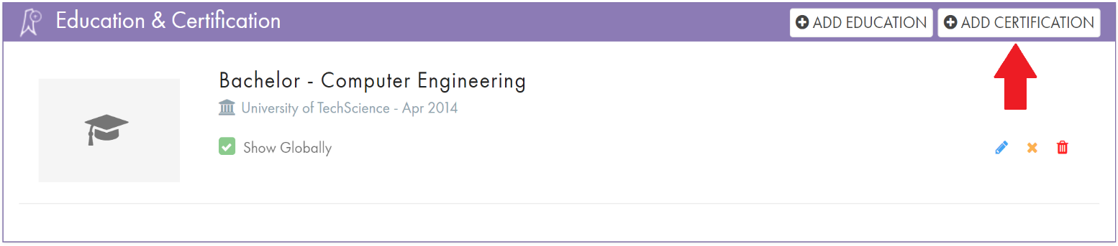

*Guidelines for adding certification:*

* **Must** be completed.
* **Only** technical certifications.
* Include full certification title.
* Add date certification was issued. This date can be when you successfully pass it.
* Logo is required.

Please, **only** fill out the required fields for certification, number, issued by, issued on, and certification url. Also, include certification logo and check to show globally. *An existing certification from another portfolio can be selected and added.*

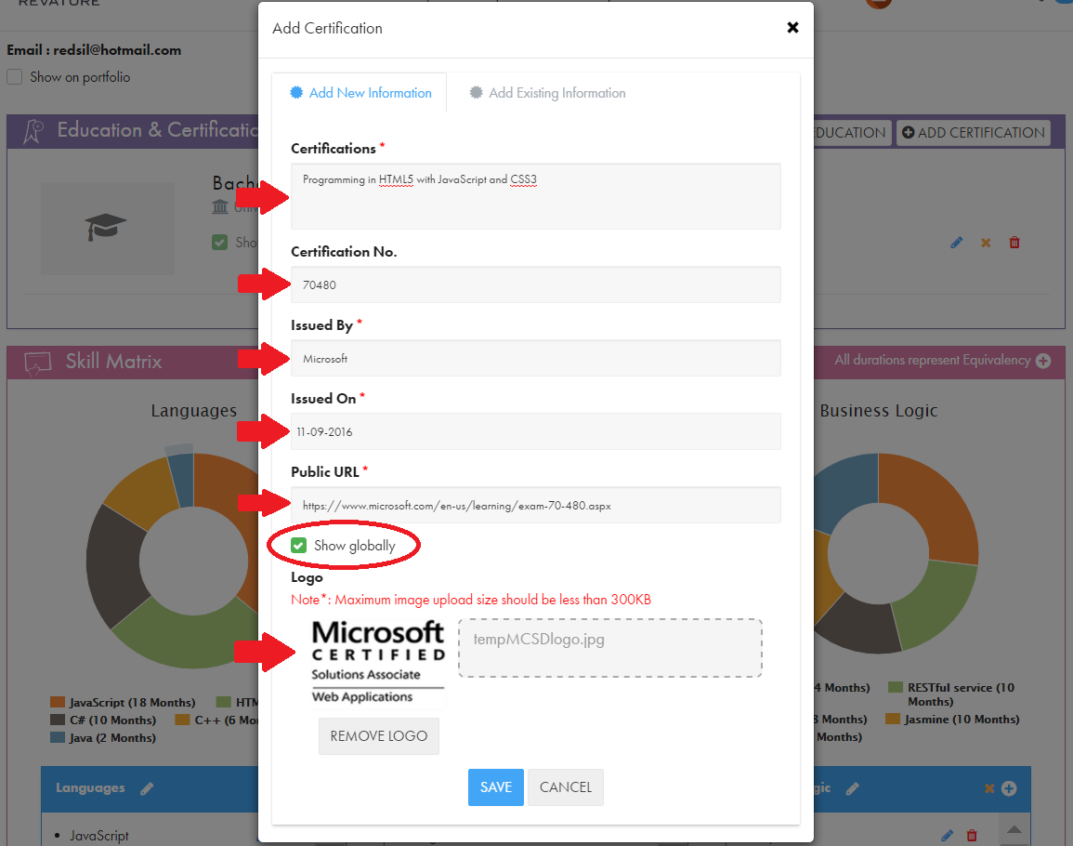

*Example certification*

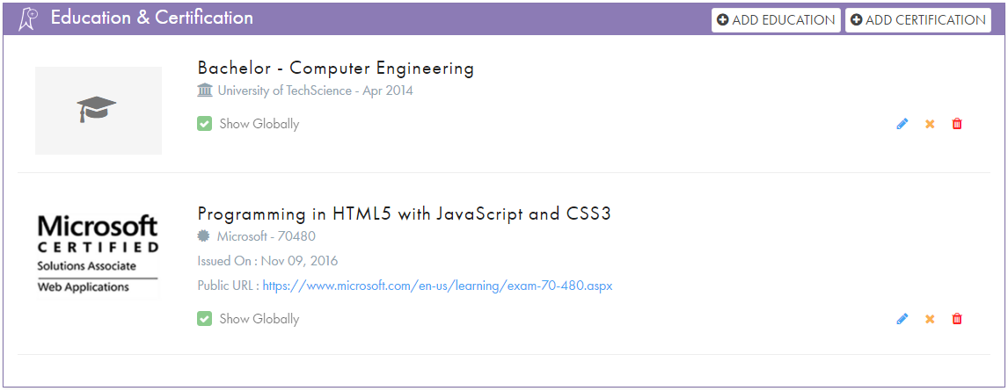

1. **Skill Matrix**

This section will have multiple lists of related key terms and technologies, in a table like format. Each category represents a subset of skills. Order is important, core technologies listed first, followed by front-end, middle-tier, then back-end.

To start, click the add category button.

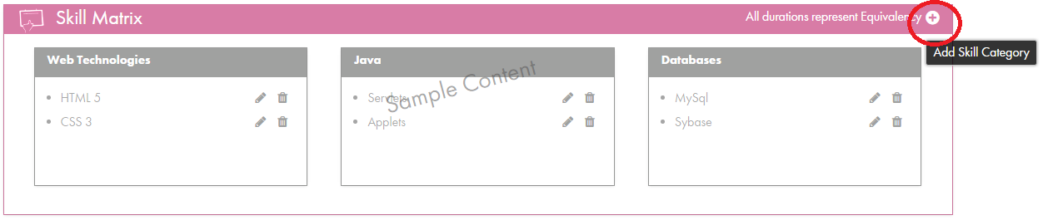

Type in a skill category name, mark as show globally, and click save button.

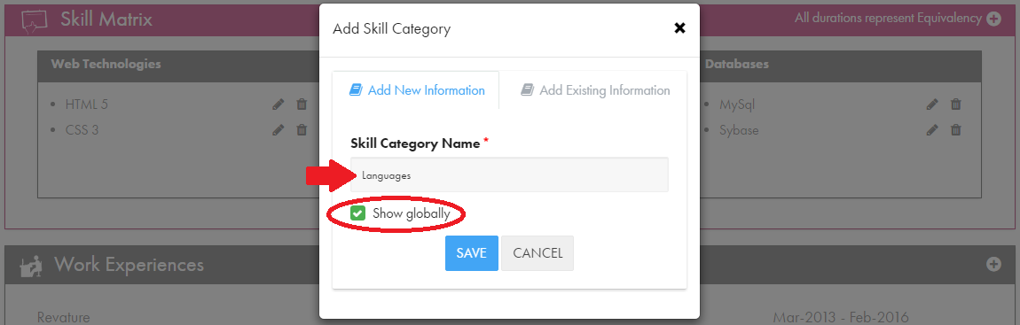

Please obey the following guidelines when adding skills to each category.

*Guidelines for building skills matrix:*

* Equivalency for each skill is between 3-18 months.
* Check spelling and capitalization of key terms and technologies.
* Each category/matrix is a set of related technologies and IT skills.
* **You must have at least 5 categories.**
* **You must have at least 6 skills per category.**
* Add skills in the order of importance and equivalency.
* Suggested category headings:

**Languages, Core Frameworks, Client-Side, Front-End, Business Layer, Business Logic, Middle-Tier, Middleware, Back-end, Server-side, Services, SOA, Data Access, Database, Other Technologies, DevOps**

* Categories **not** allowed:

Gaming, Hobbies, Personal, Interests, Course, Classes, Curriculum, University, Scholastic

* Order and flow of categories is **important**.
* **Make sure that each skill that is also mentioned in the Industry Equivalency match each other regarding the months of experience. (Trainer handles industry equivalency)**
* Skills in the skill matrix should be a **minimum** of 3 months.

Start by clicking the Add Skill button. In the popup box, on the Skill Name dropdown, select custom option. Then, fill out the Custom Skill Name and Experience In Months fields. Click Save button to updated the category.

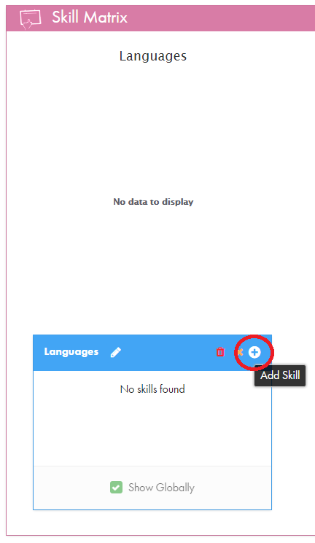 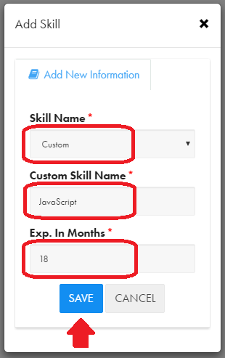 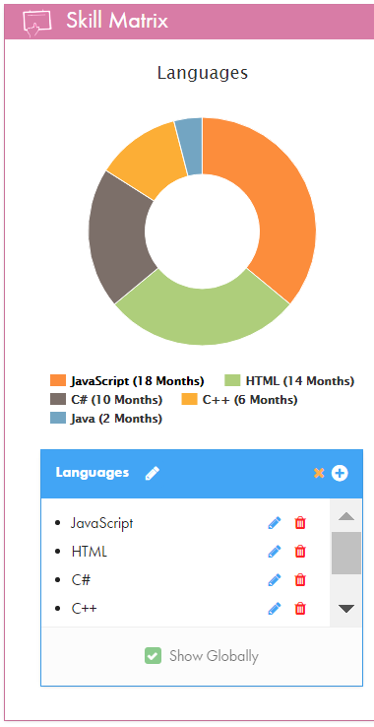

Please, repeat this step until you have 6 or more skills per category and at least 5 different categories.

*Following is an example for a JavaScript web developer*

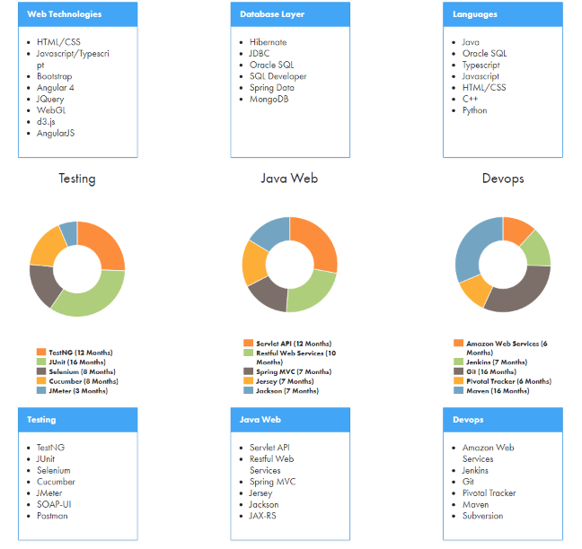

1. **Projects**

Here, we’ll add the projects you completed during bootcamp training. To start, click the Add Project button.

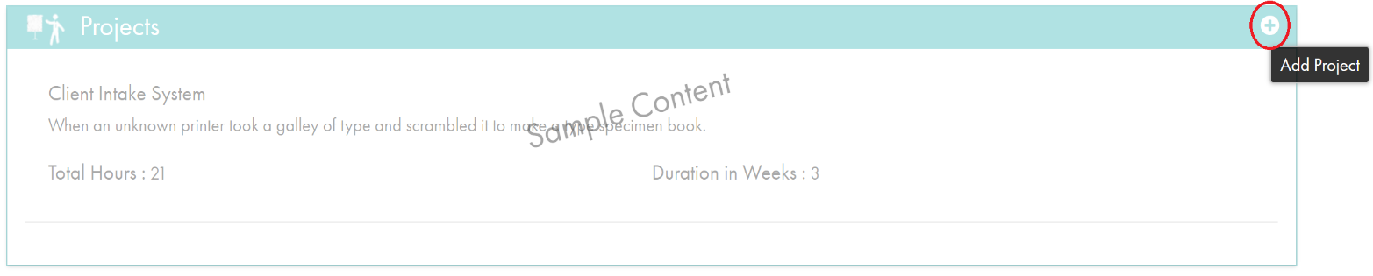

In the popup box, select a project from the Select Project dropdown and click save button. *This dropdown is populated by your completed projects that the Trainer has approved.* **Make sure that the project order shows the most recent project to the least recent.**

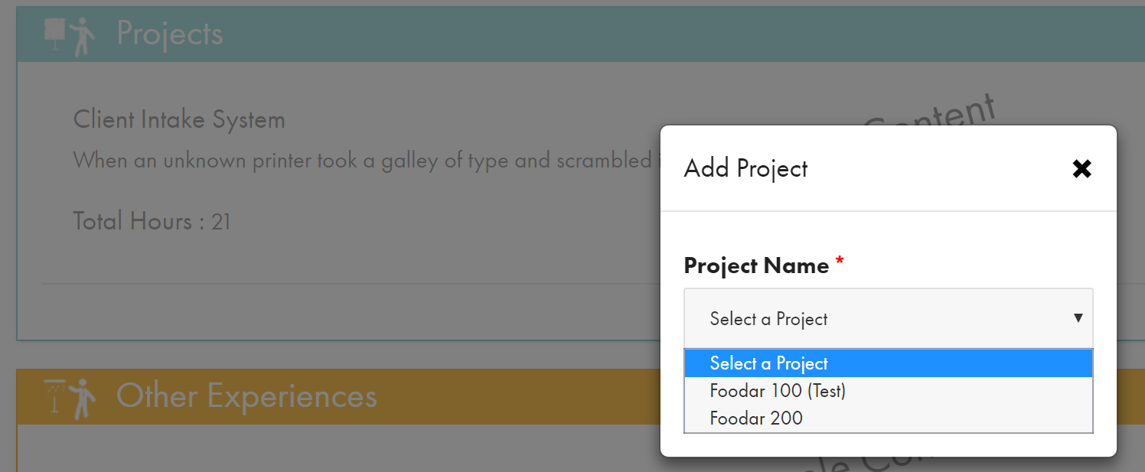

After adding the project, we need to add and edit the bulleted Responsibilities and Technologies lists.

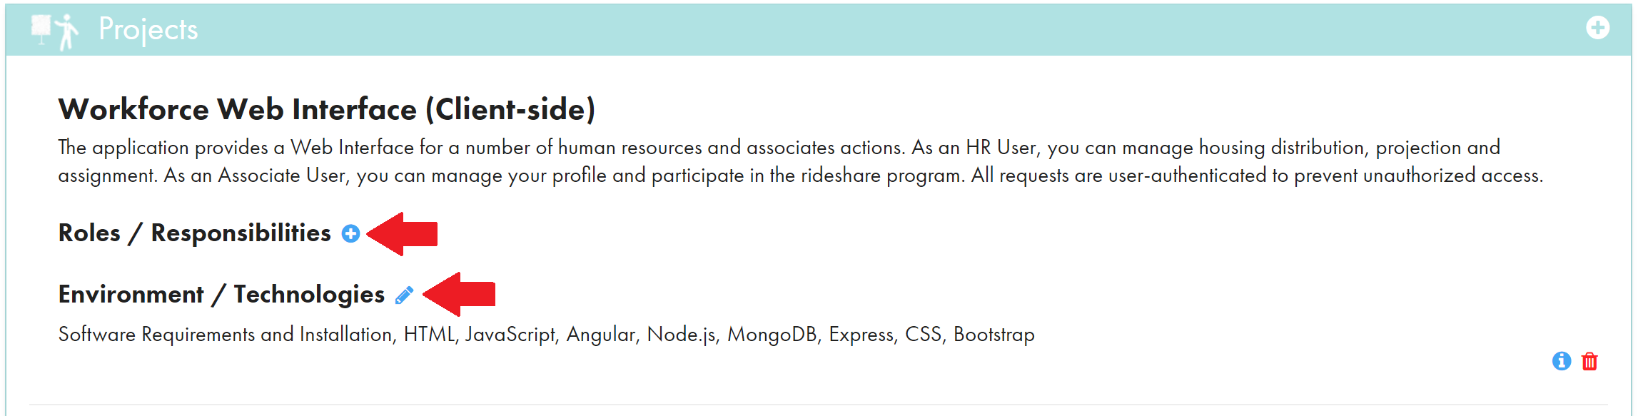

*Guidelines for writing project responsibilities:*

* The guidelines from the About Me section also apply, excluding bolding technologies. Leave them as they are.
* When you add your projects, add them in order.
* Use active voice and strong language.
* Each project **must** have at least 8 bulleted responsibilities.
* Each project **must** have a list of technologies.
* These bullets are specific to the project.

To start, click ‘+’ button to add responsibilities. In the popup box, as with the About Me section, type the bulleted list of responsibilities. *Remember to click the 2nd icon for a bulleted list*.

Please, repeat until you have **8 or more** responsibilities.

*Following is an example for a client-side and JavaScript project*

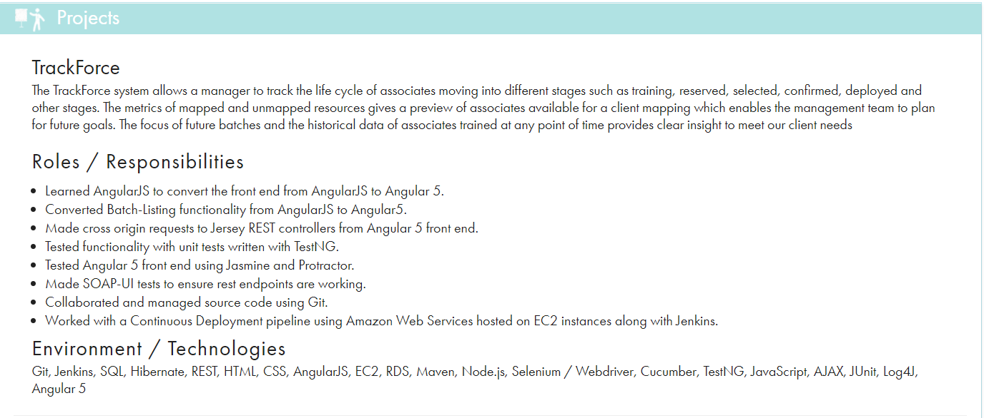

1. **Other Experiences**

In this section, you may **only** include experience that is related to software development or technically based. For example, university project developing an application or writing software for systems. These work entries **must** be brief and concise. To start, click the plus button to add a other experience.

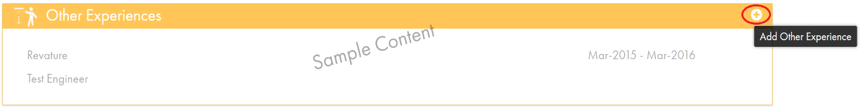

In the popup, fill in the required fields for Employer, dates, and job title. For college project, the employer is your university and job title is student. Also, mark as show globally and click save button.

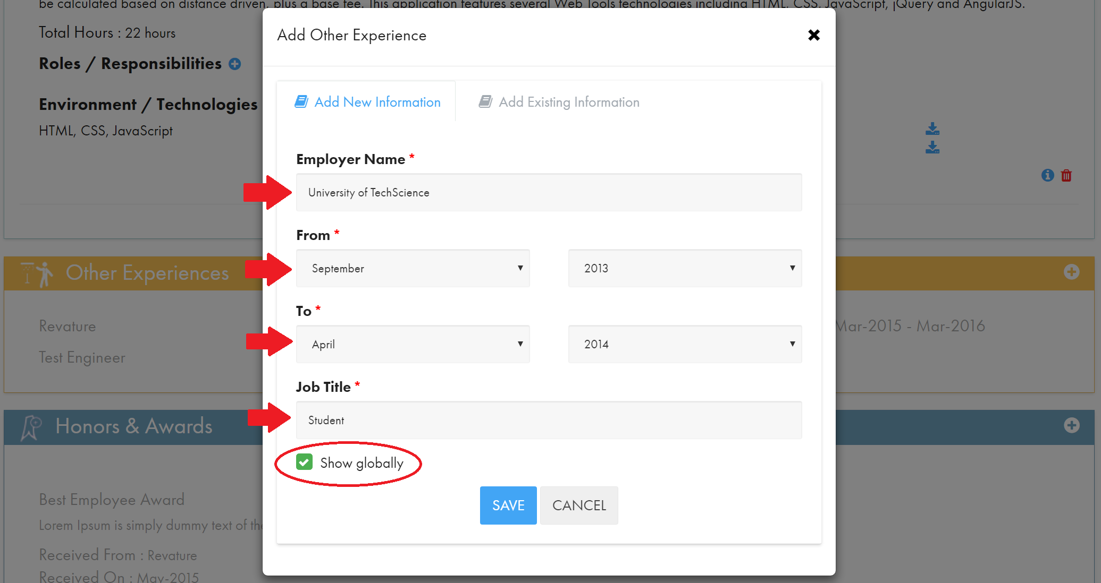

After saving the employment information, then add details about your project. To add project, click the plus button on the other experience.

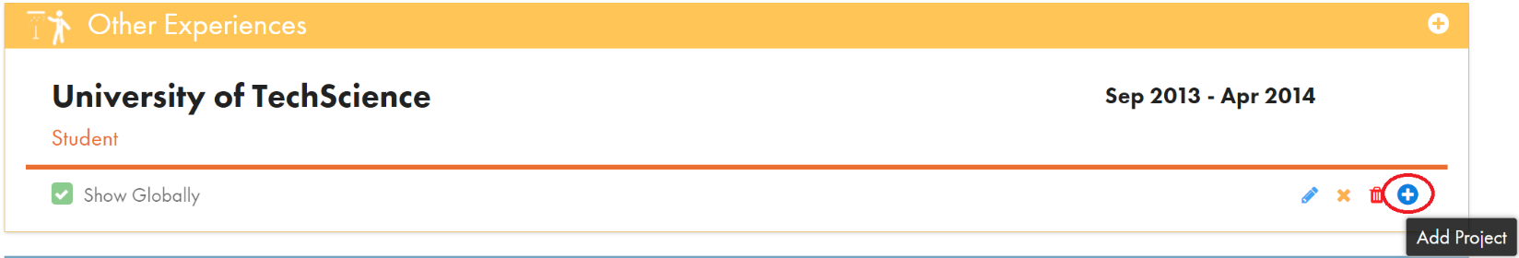

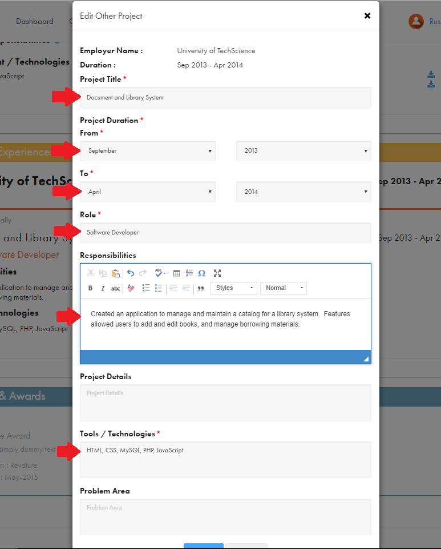

*Following example for other experience*

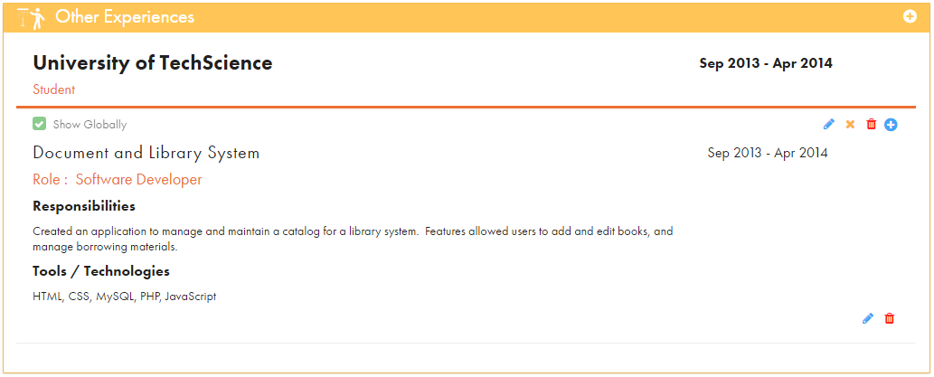

1. **Honors & Awards**

In this section, you may **only** include relevant awards that are related to technology and science. Leadership honors **must** be approved by your Trainer. To start, click the plus button to add an award.

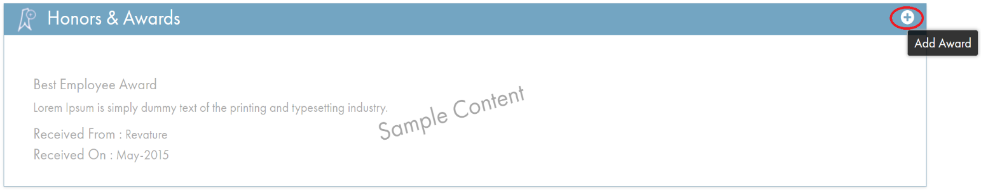

*Guidelines for adding awards:*

* **Must** be a recognized award.
* **Only** technical honors.
* Include full certification title.
* Add date certification was issued.

Please, **only** fill out the required fields for title, description, received from, and received on. Also, check to show globally. *An existing award from another portfolio can be selected and added.*

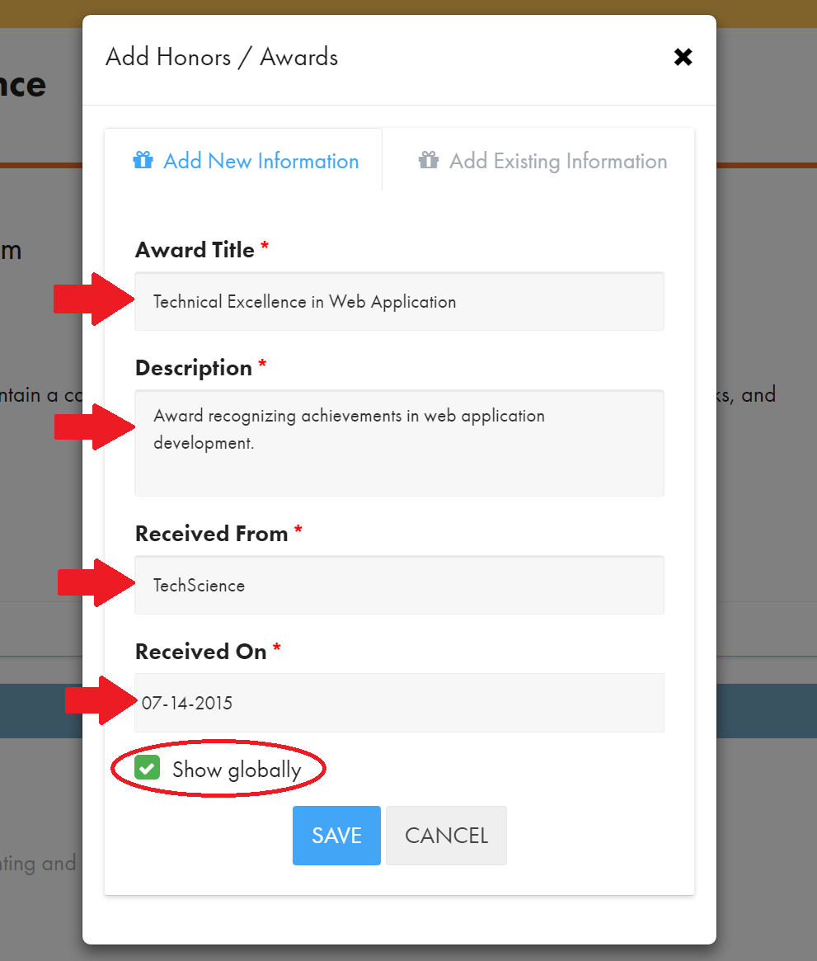

*Following example for an award*

