AWS

coursework

Abeykoon Mudiyanselage, Nirmal P.

20/21

Table of Contents

1.Creating functions 2

Average of a, b, and c 2

Middle value of a, b and c 4

Value of a to the power of b 6

Square root of a squared plus b squared. 8

2.API Browser output 10

Average of a, b and c2 10

Middle value of a, b and c 10

Value of a to the power of b 10

Square root of a squared plus b squared 11

3.Webapp screengrabs 11

Average of a, b and c2 11

Middle value of a, b and c 11

Value of a to the power of b 12

Square root of a squared plus b squared 12

# 1.Creating functions

## Average of a, b, and c

Test event :

{

"A": "2",

"B": "2",

"C": "2"

}

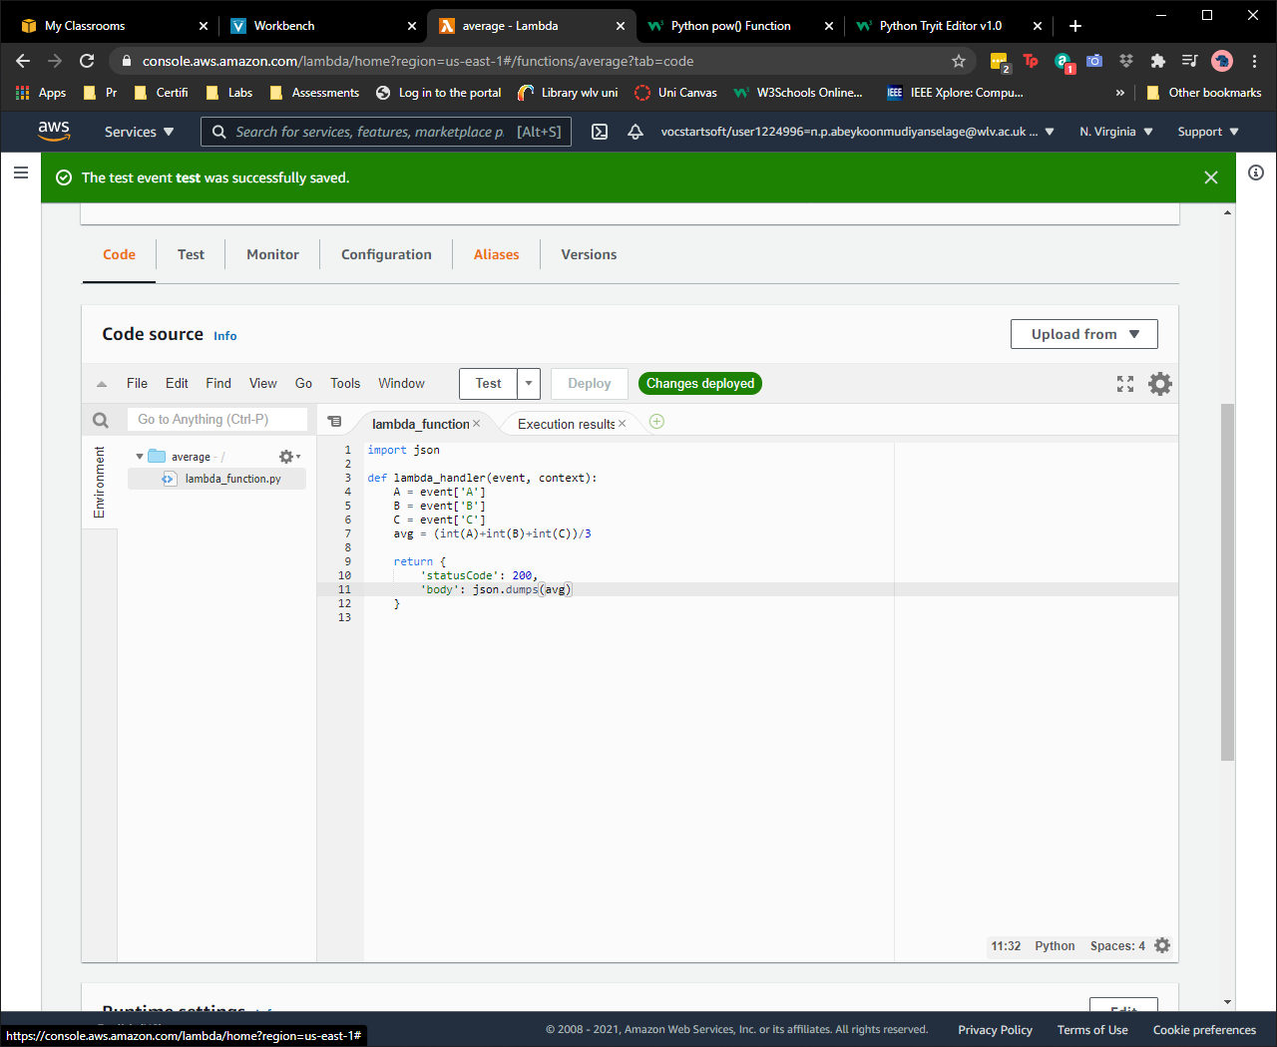

Figure 1:Average function

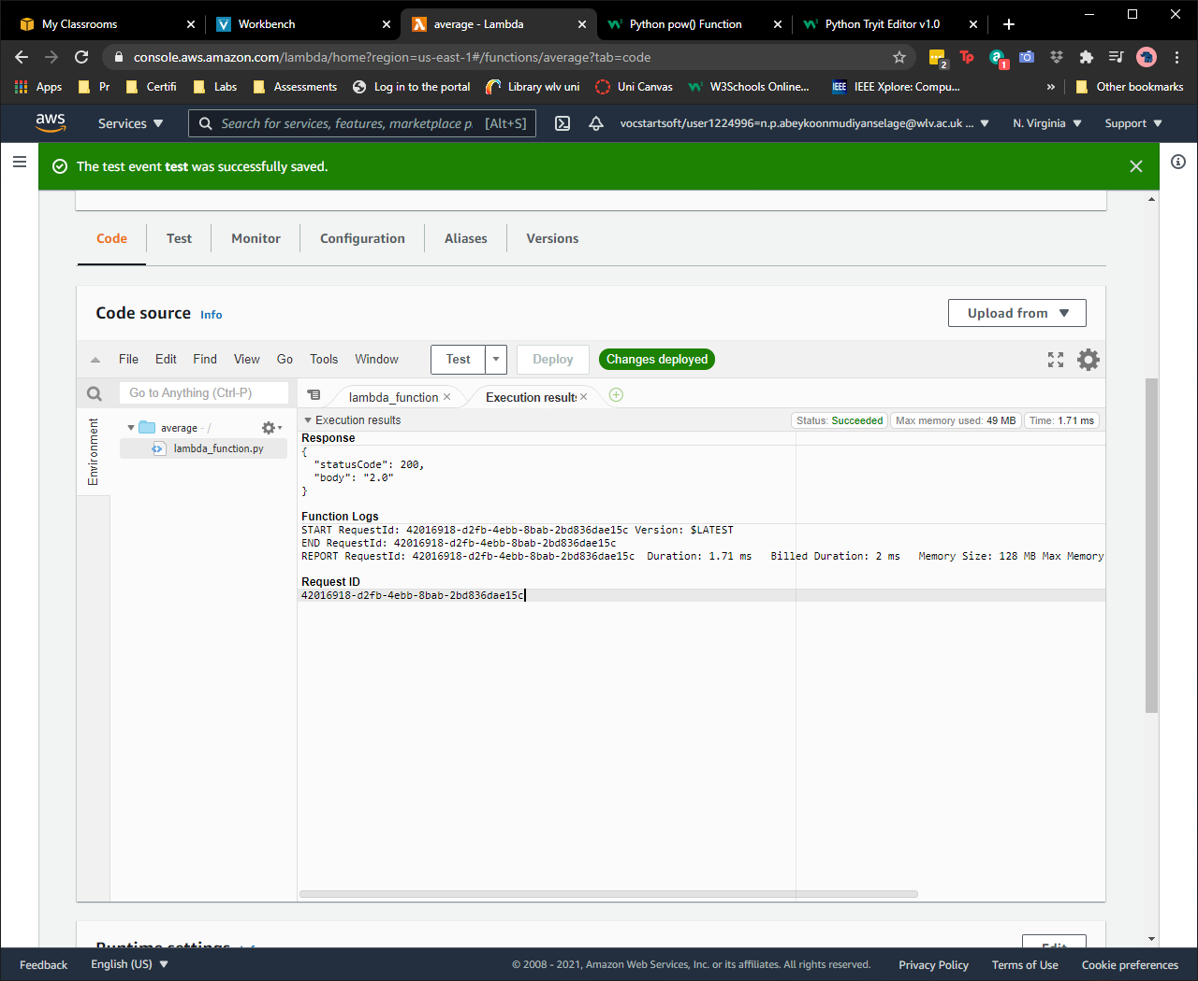

Figure 2:Test

## Middle value of a, b and c

Test event:

{

"A": "1",

"B": "2",

"C": "3"

}

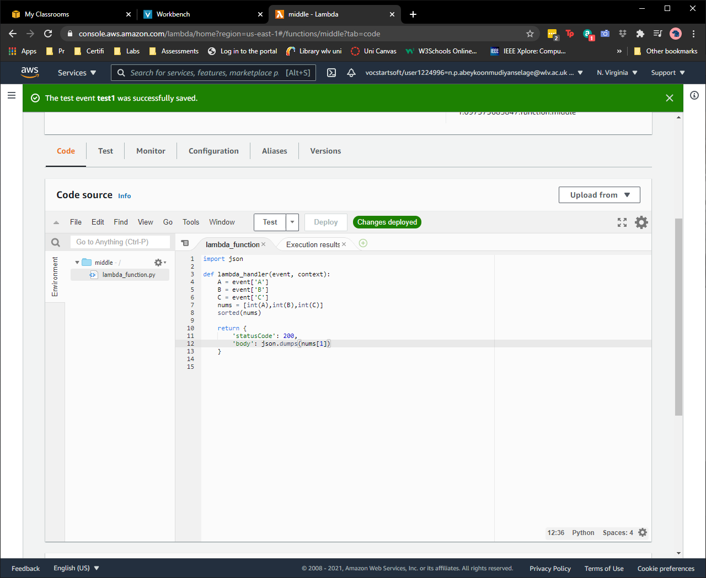

Figure 3:Middel Number

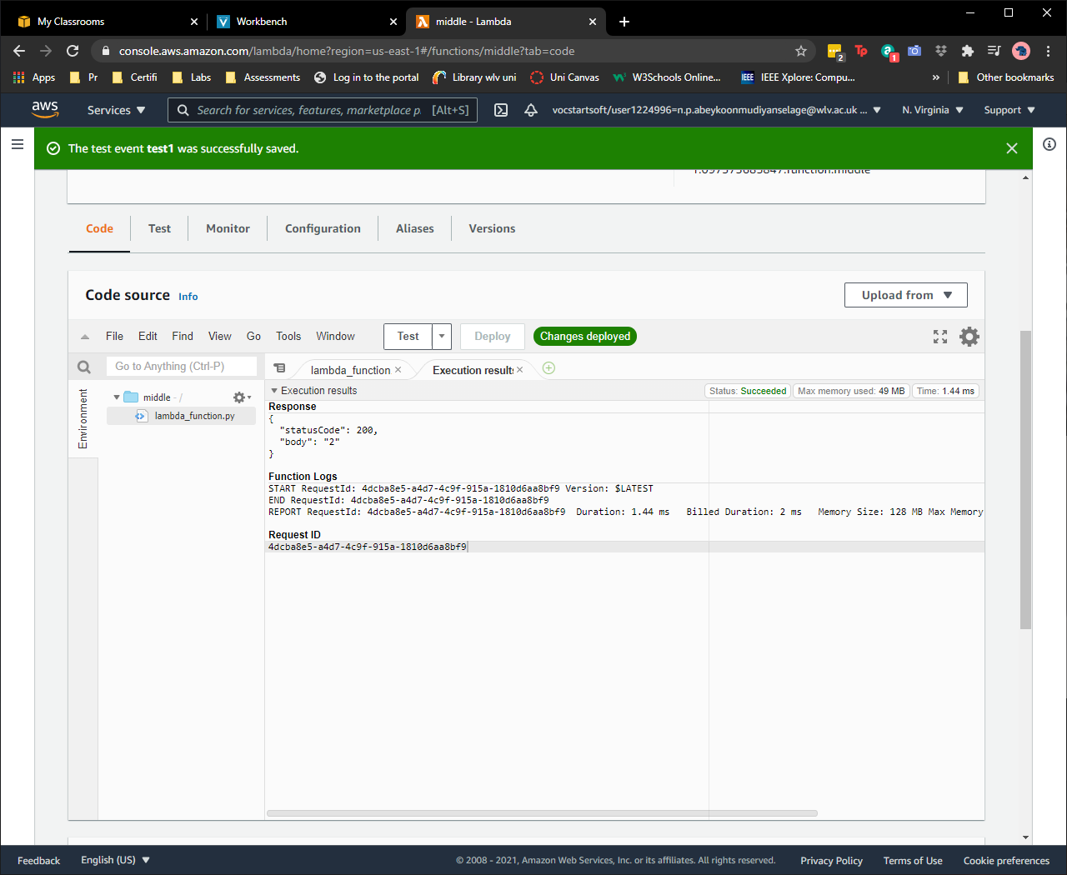

Figure 4:Test

## Value of a to the power of b

Test event :

{

"A": "2",

"B": "3",

"C": "4"

}

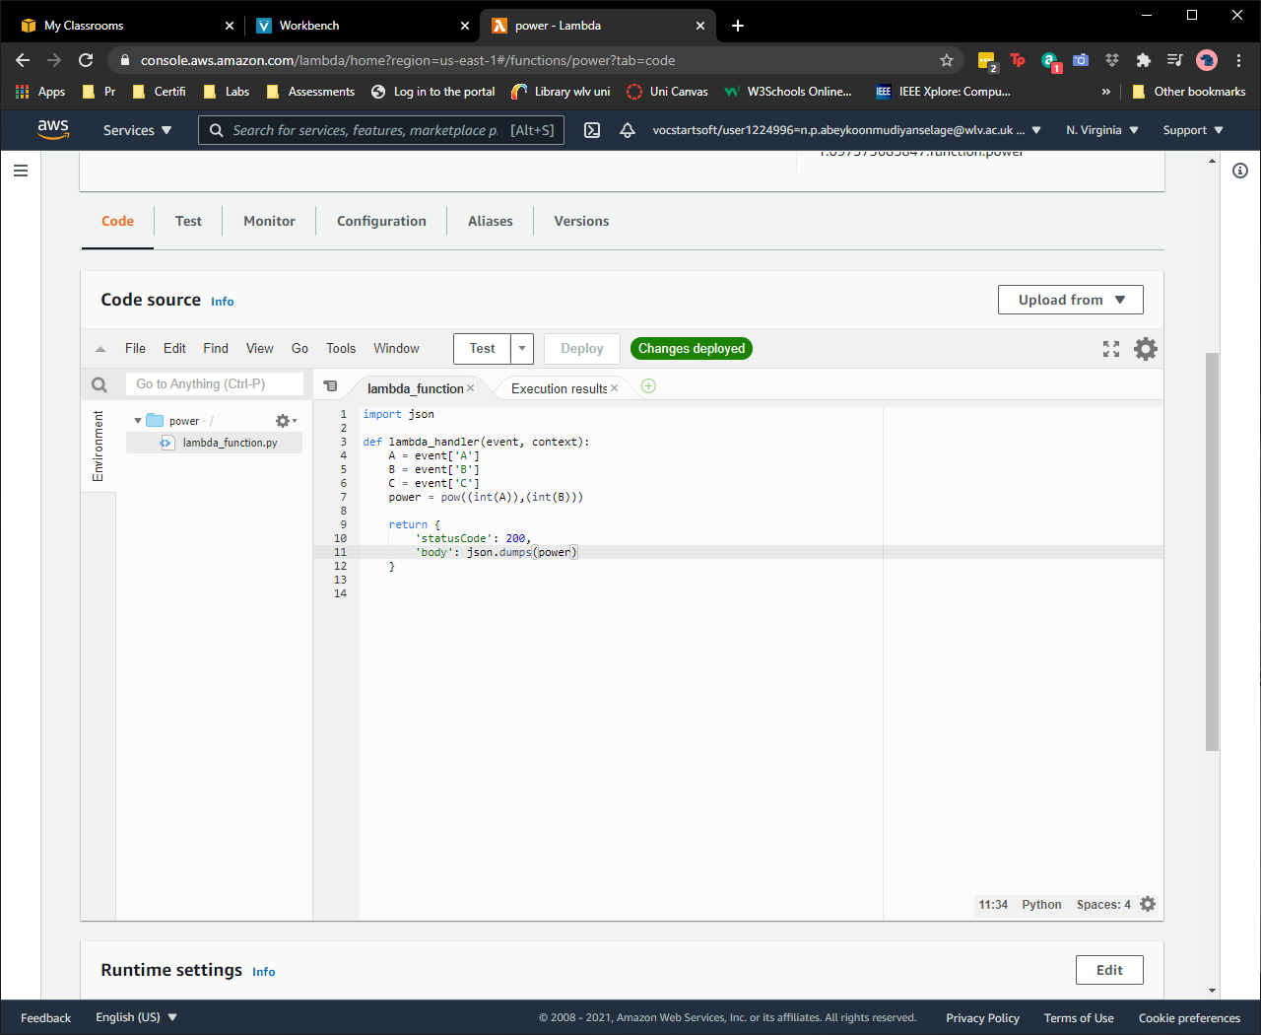

Figure 5:power

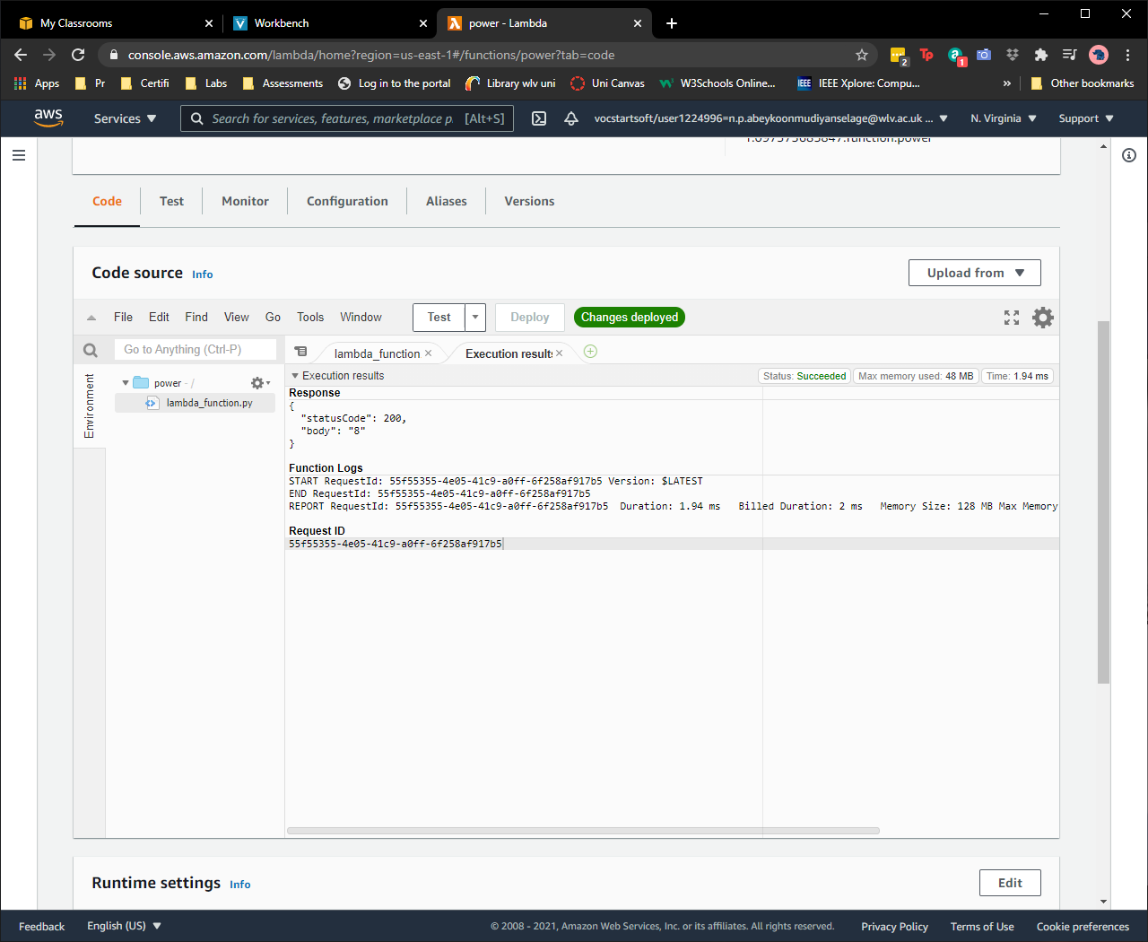

Figure 6:Test

## Square root of a squared plus b squared.

Test event:

{

"A": "3",

"B": "4",

"C": "5"

}

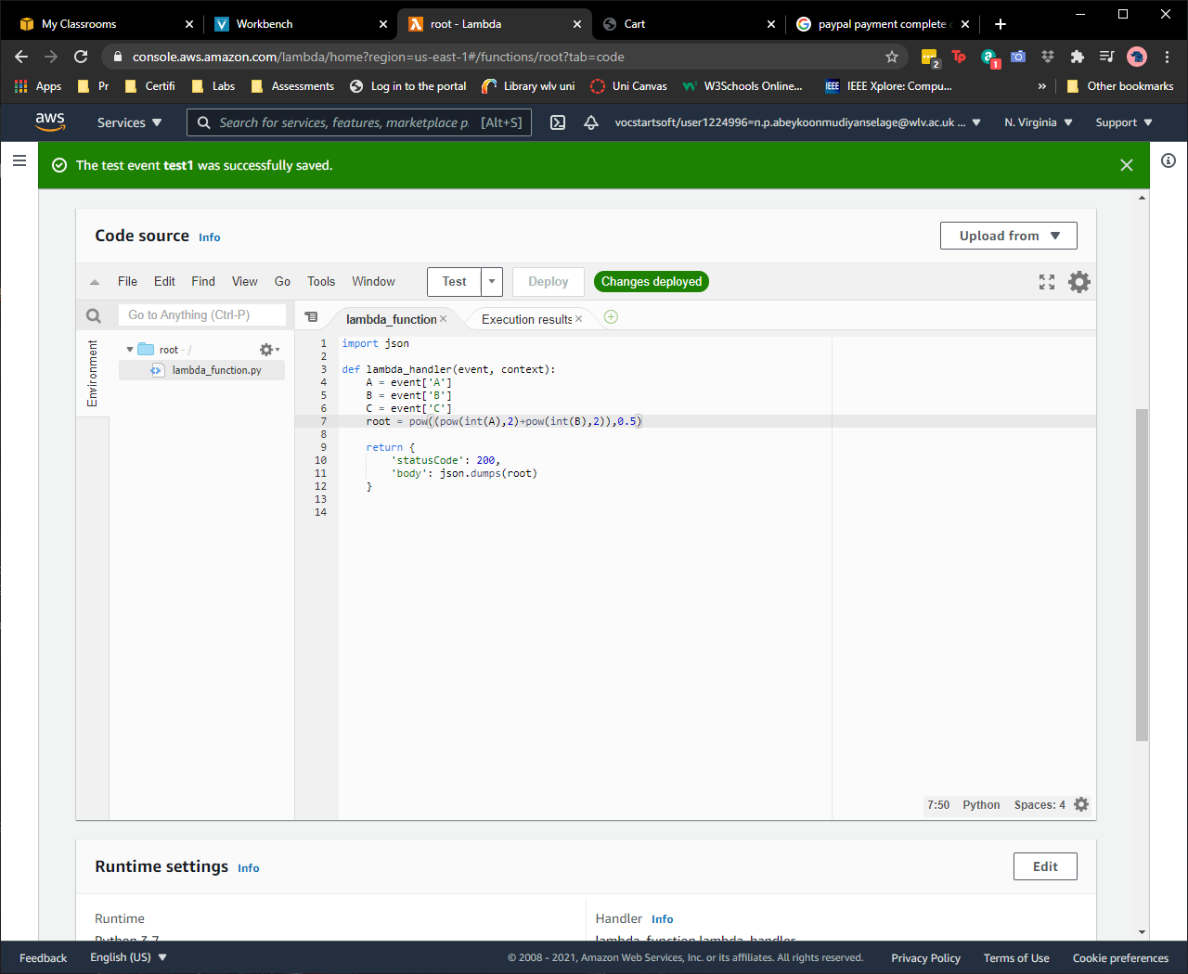

Figure 7:Sqroot

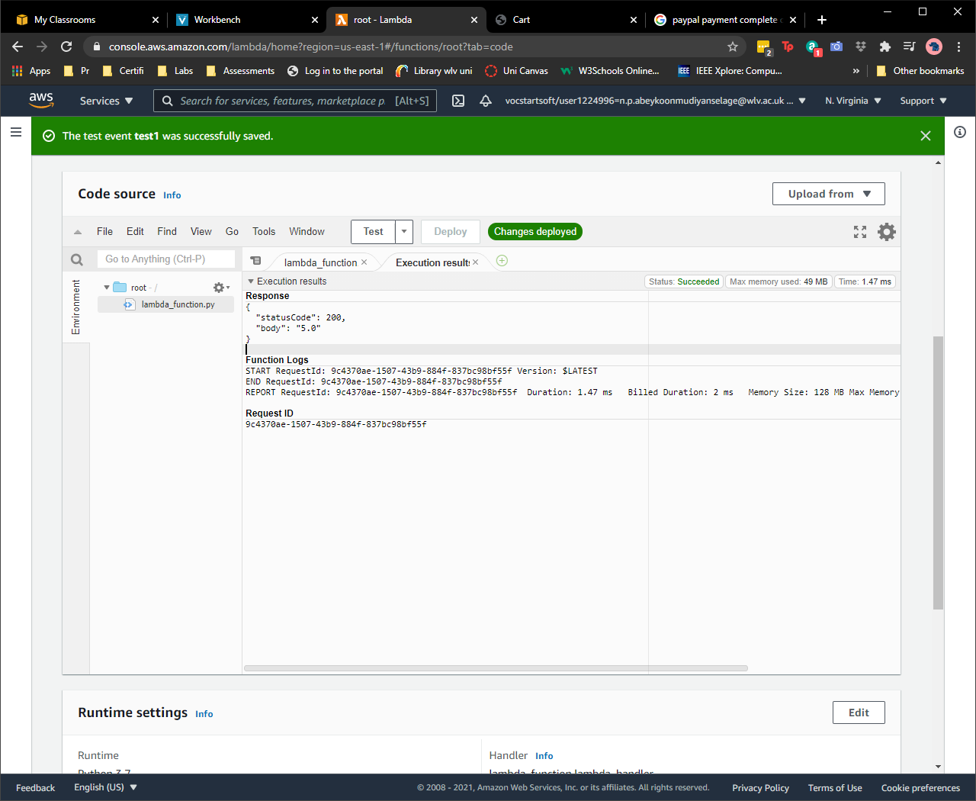

Figure 8:Test

# 2.API Browser output

## Average of a, b and c2

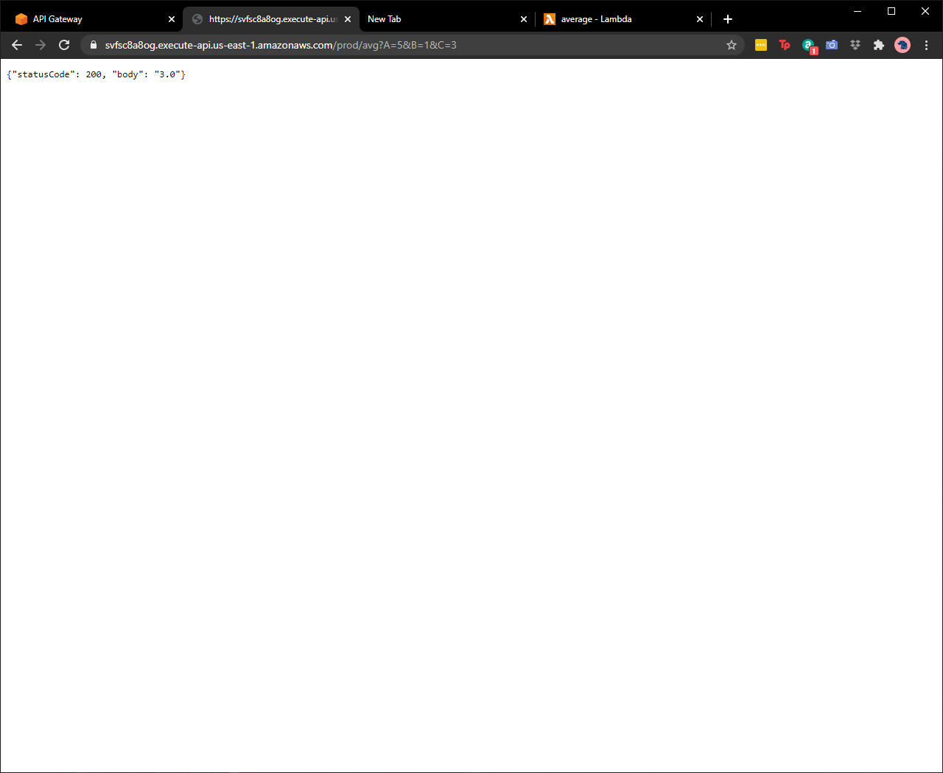

## Middle value of a, b and c

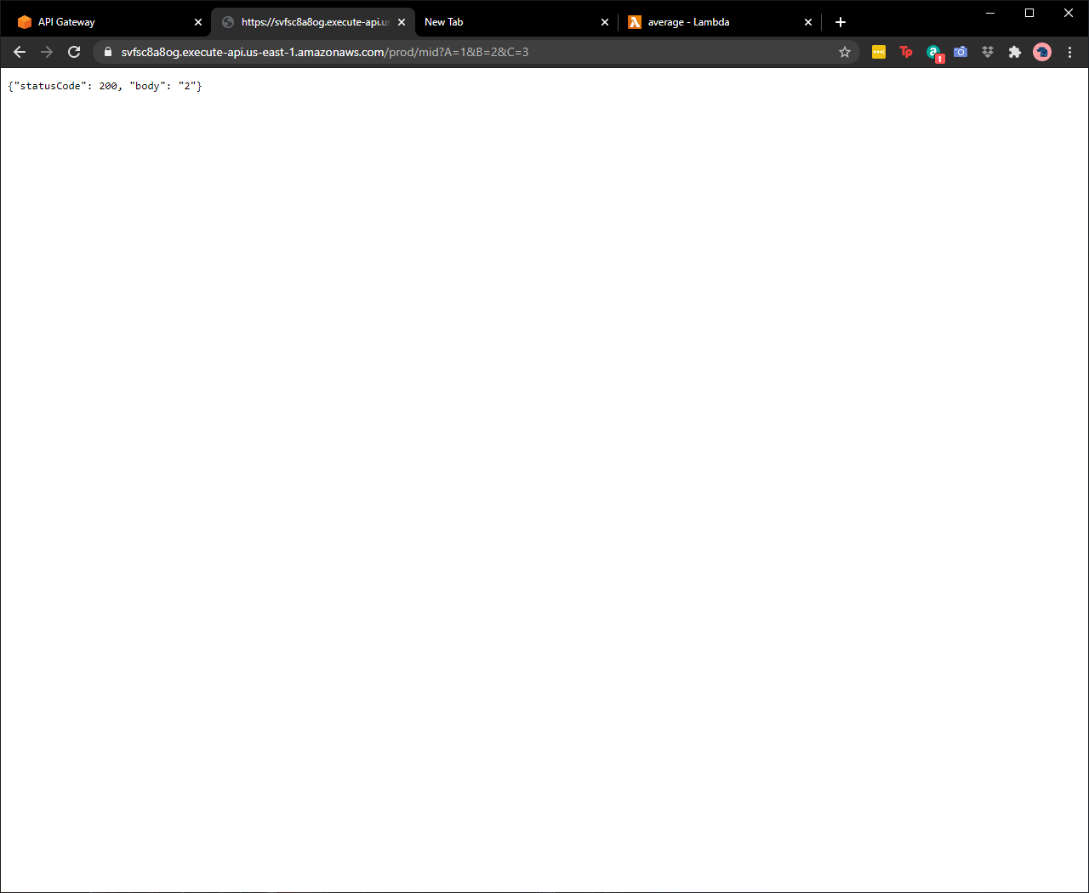

## Value of a to the power of b

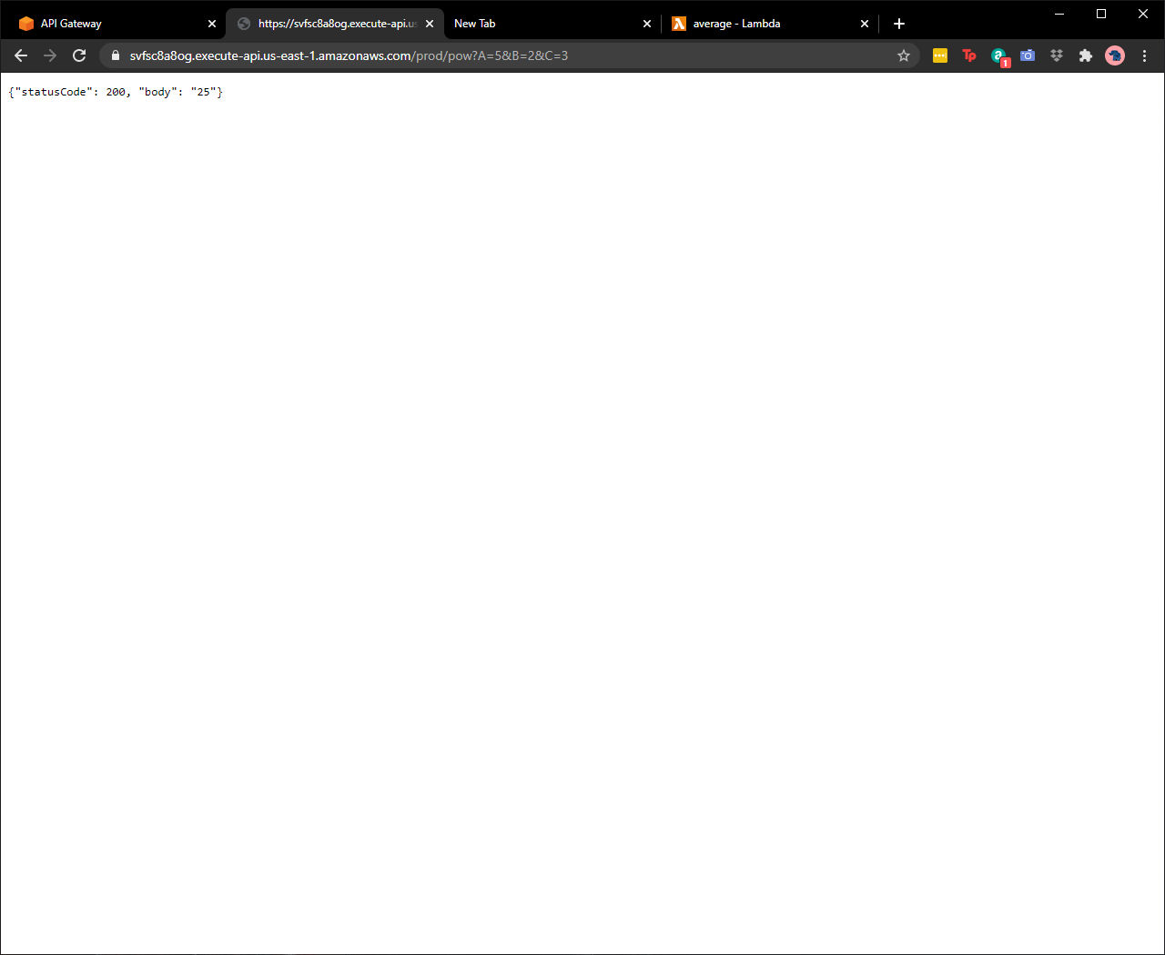

## Square root of a squared plus b squared

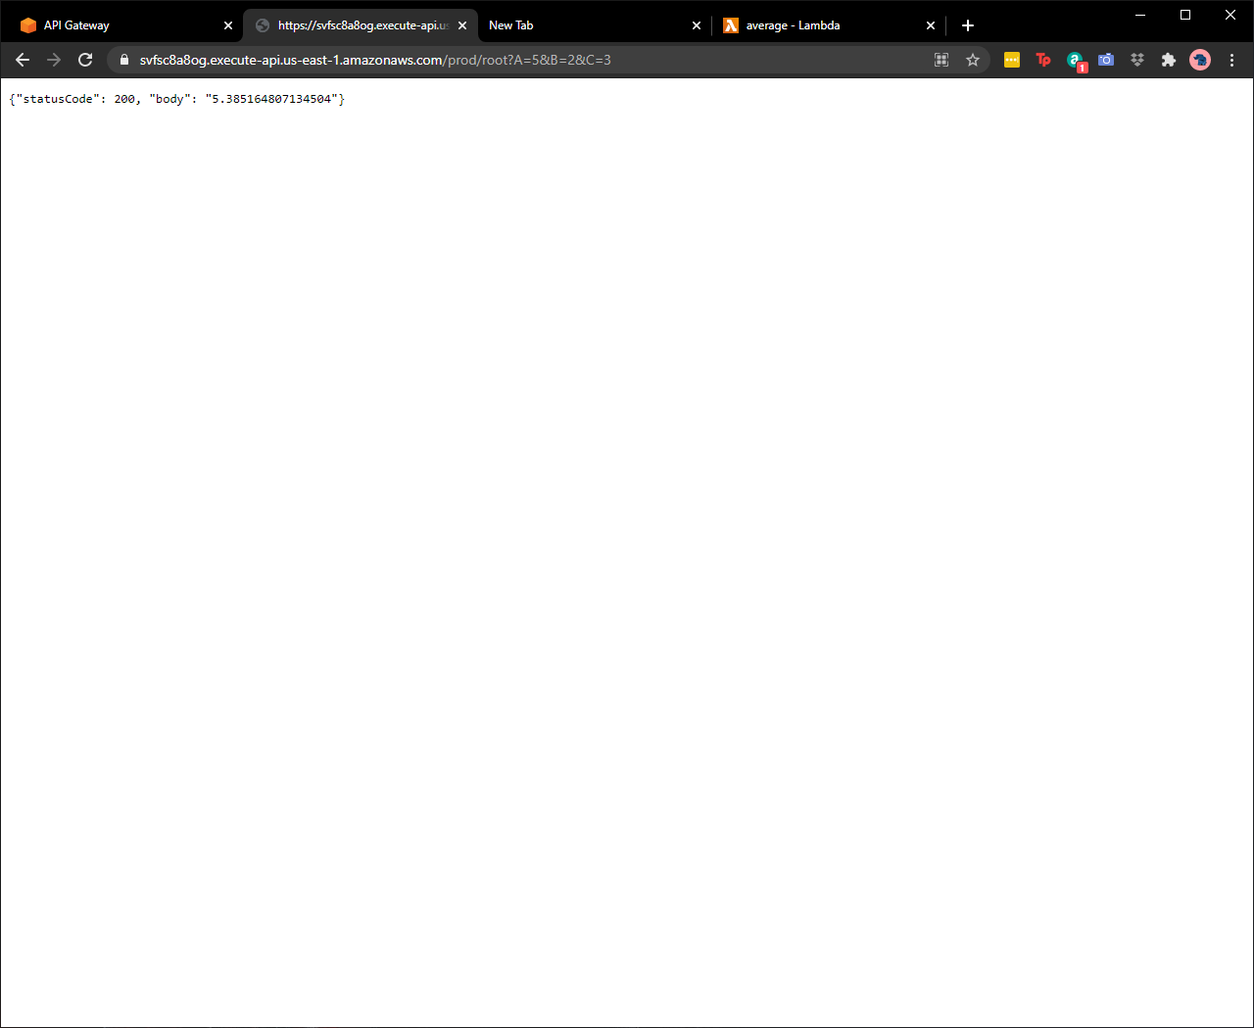

# 3.Webapp screengrabs

URL= <http://calc2-1811342.s3-website-us-east-1.amazonaws.com/>

## Average of a, b and c2

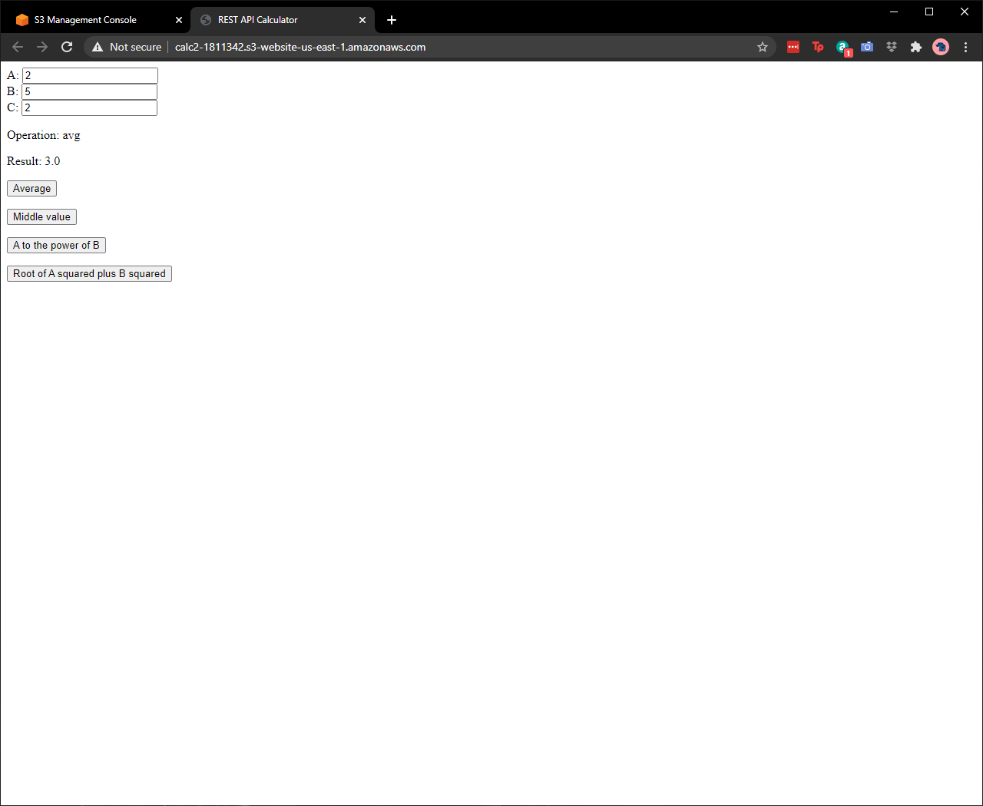

## Middle value of a, b and c

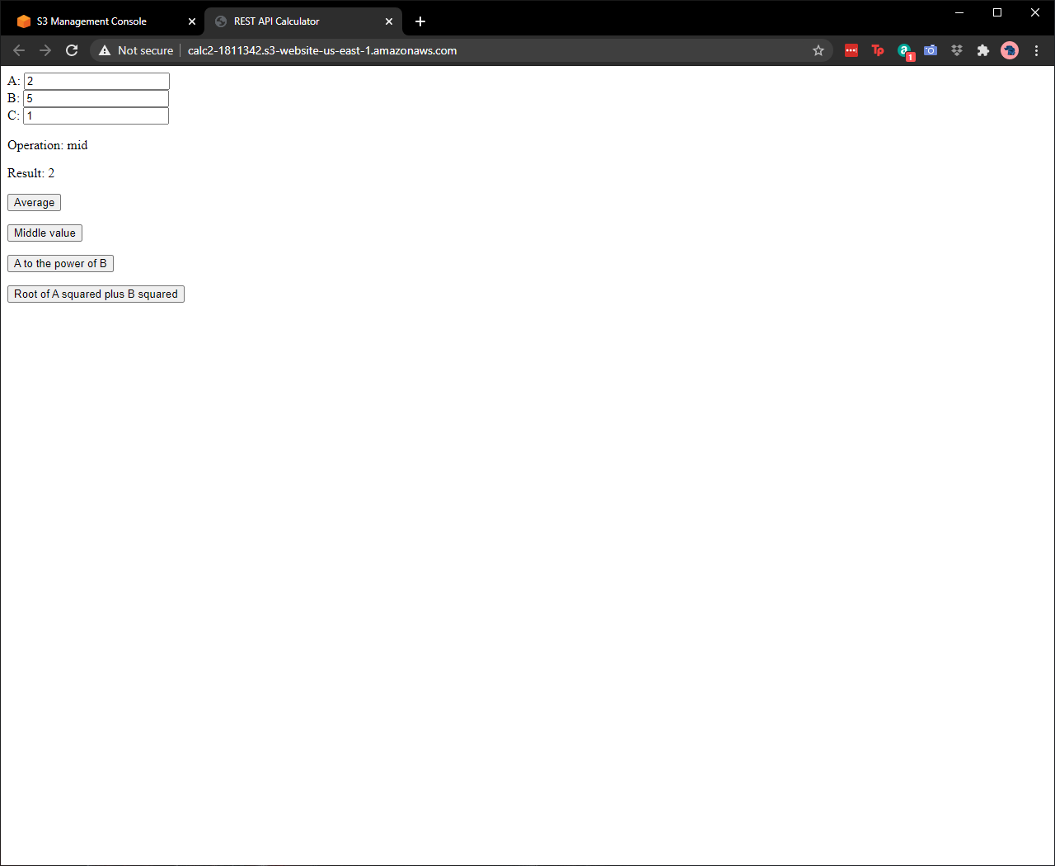

## Value of a to the power of b

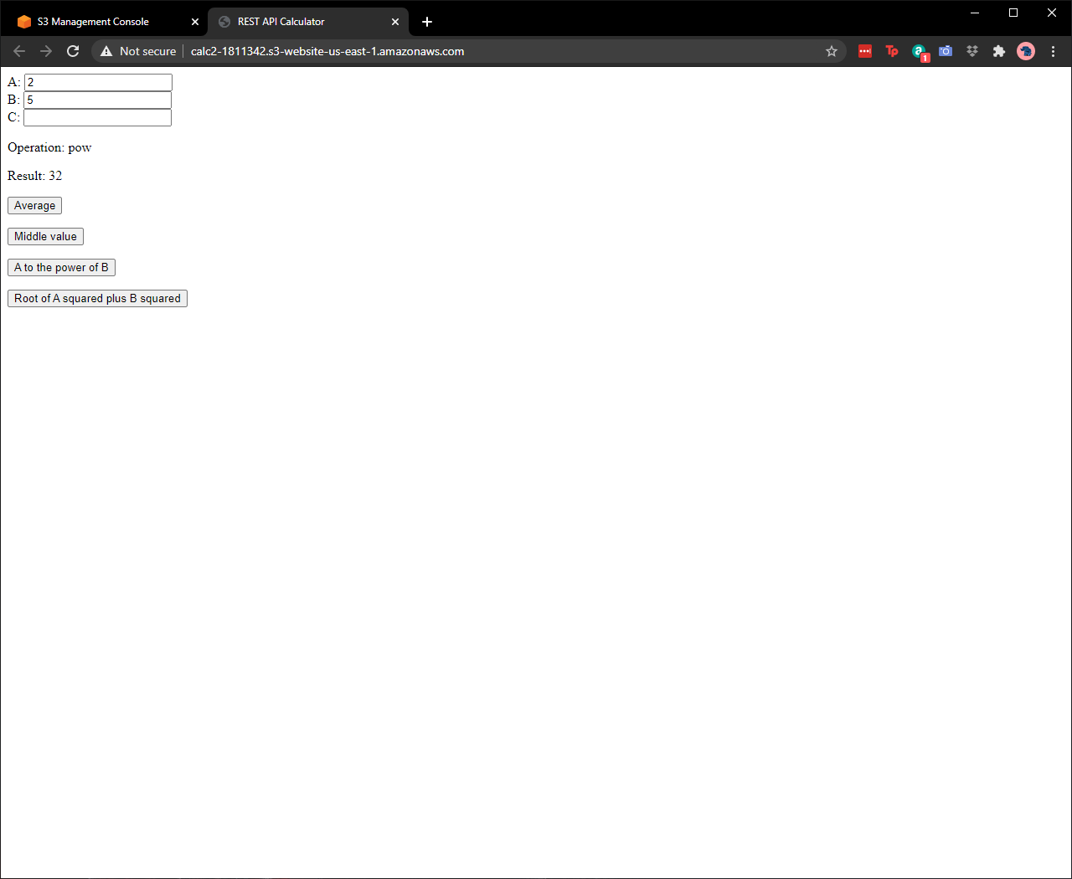

## Square root of a squared plus b squared

