Creating a multi-function calculator with REST API with AWS Lambda

assessed Workshop

Abeykoon Mudiyanselage, Nirmal P.-1811342

# Task 1. Create a function for Addition.

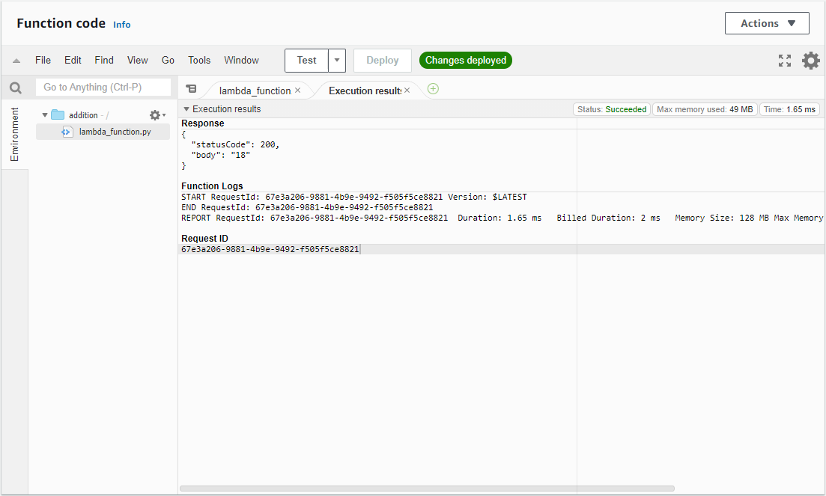

Figure 1:Addition Funtion Output

# Task 2. Create a REST API for addition.

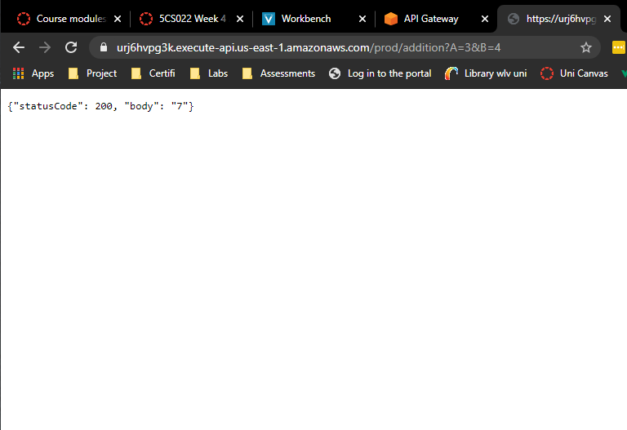

Figure 2: Addition REST API browser output

# Create 3 more Lambda functions for subtraction, multiplication, and division and their corresponding REST APIs .

## subtraction

Code

import json

def lambda_handler(event, context):

A = event['A']

B = event['B']

C = int(A) - int(B)

return {

'statusCode': 200,

'body': json.dumps(C)

}

Browser Screengrab

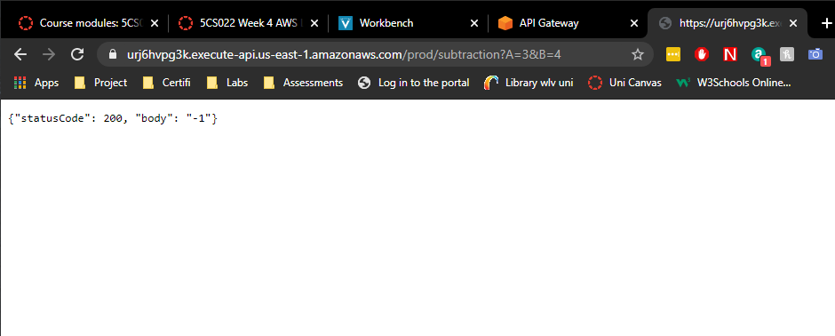

Figure 3:Subtraction REST API browser output

## Multiplication

Code

import json

def lambda_handler(event, context):

A = event['A']

B = event['B']

C = int(A) * int(B)

return {

'statusCode': 200,

'body': json.dumps(C)

}

Screengrab

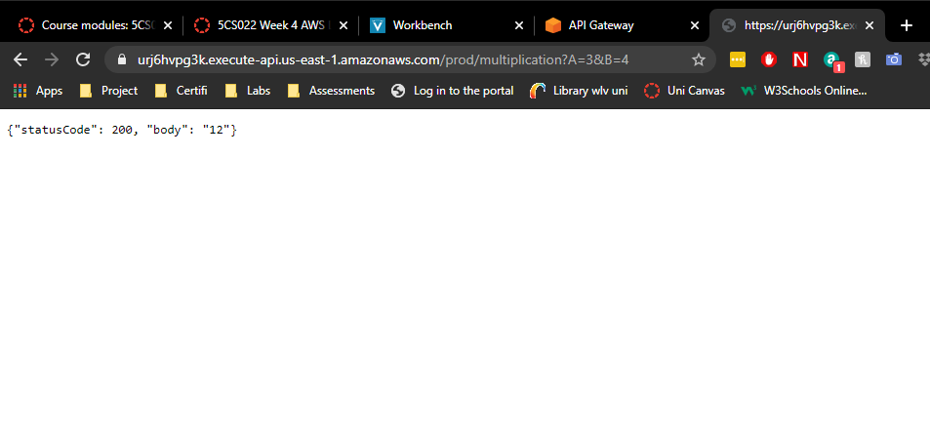

Figure 4:Multiplication REST API browser output

## Division

Code

import json

def lambda_handler(event, context):

A = event['A']

B = event['B']

C = int(A) / int(B)

return {

'statusCode': 200,

'body': json.dumps(C)

}

Screengrab

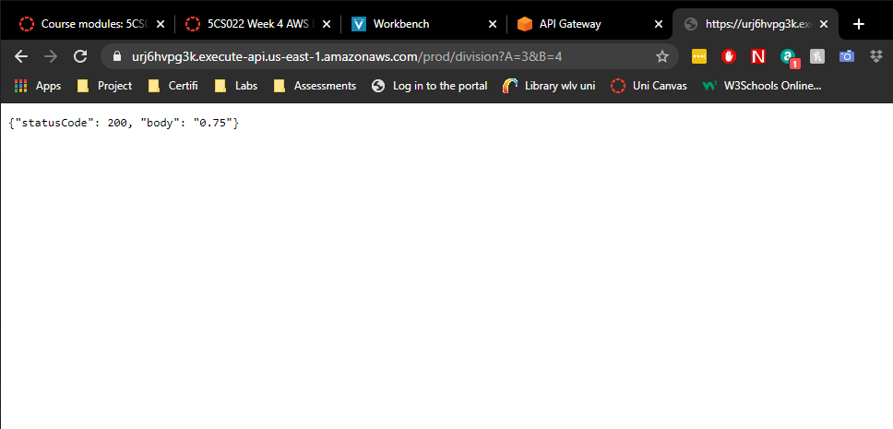

Figure 5:Division REST API browser output

# Final webapp

URL = <http://calc-nirmal-1811342.s3-website-us-east-1.amazonaws.com/>

## Addition

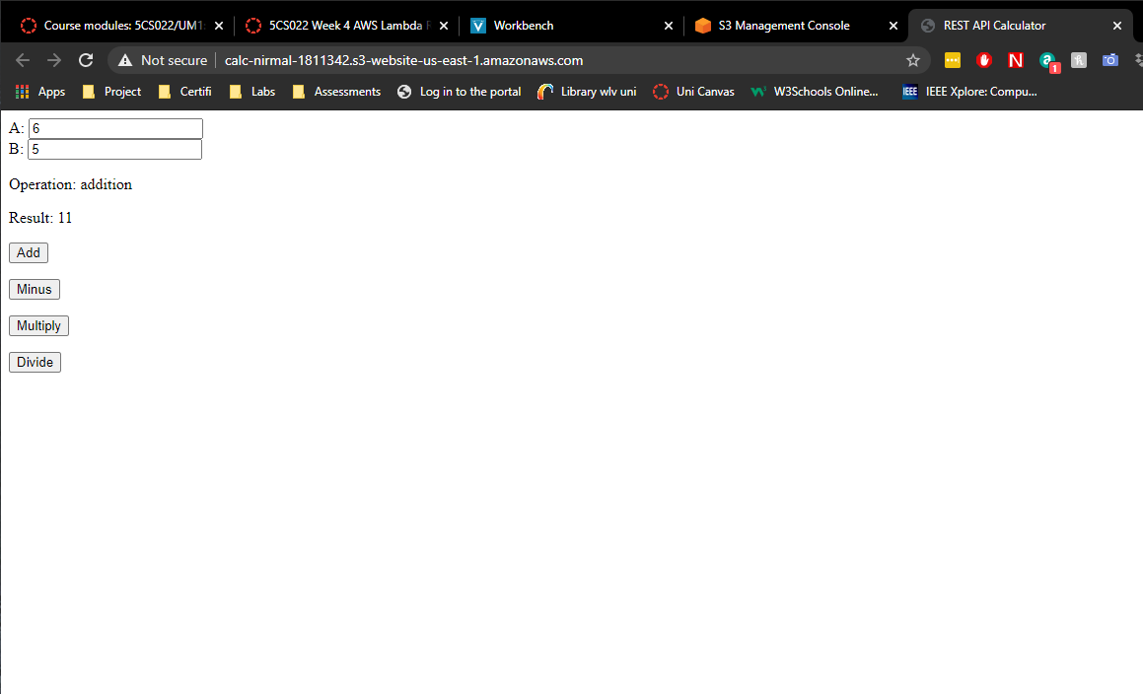

## Subtraction

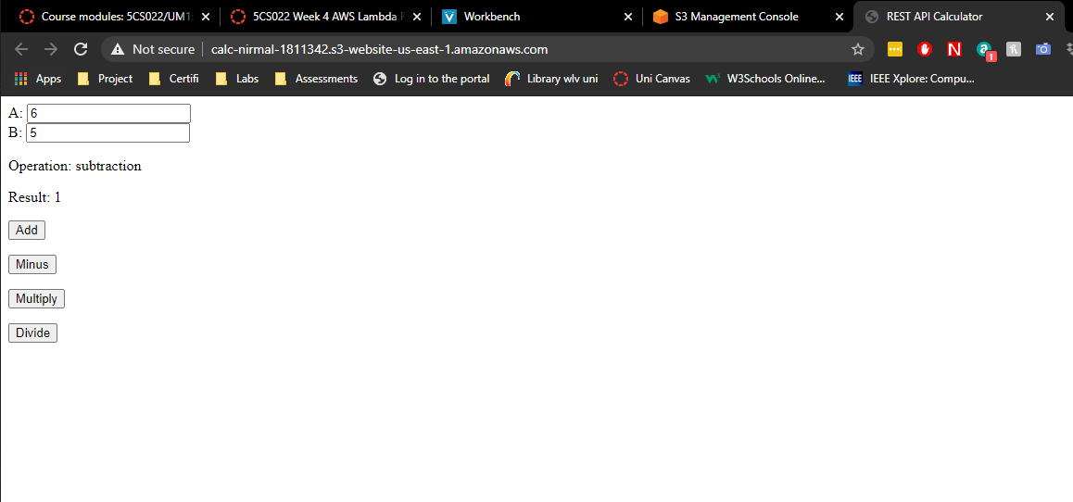

## Multiplication

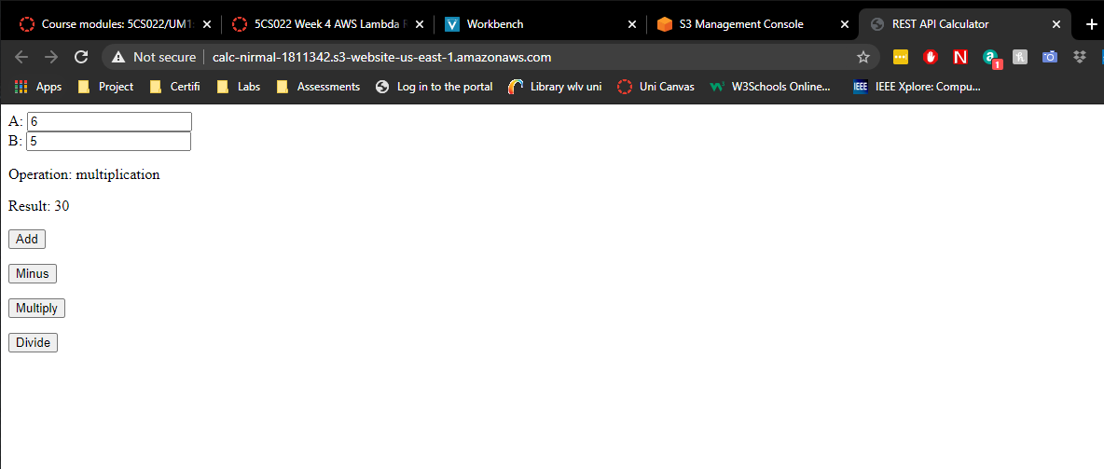

## Division

