1. SCREENSHOT01.png

1. SCREENSHOT02.png

1. SCREENSHOT03.png

1. SCREENSHOT04.png

1. SCREENSHOT05.png

1. SCREENSHOT06.png

1. SCREENSHOT07.png

1. SCREENSHOT08.png

1. SCREENSHOT09.png

1. SCREENSHOT10.png

1. SCREENSHOT11.png

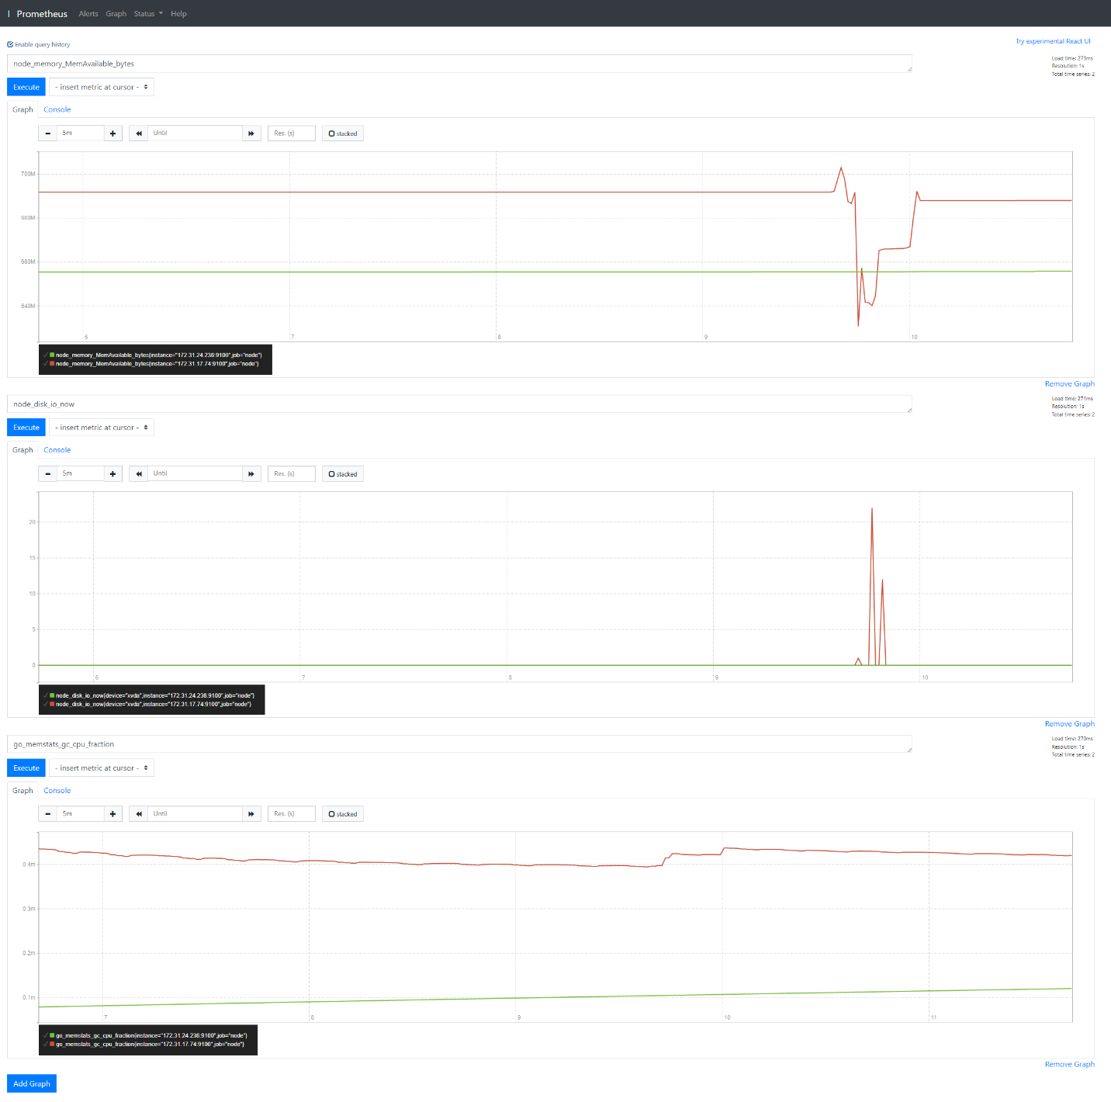

1. SCREENSHOT12.png

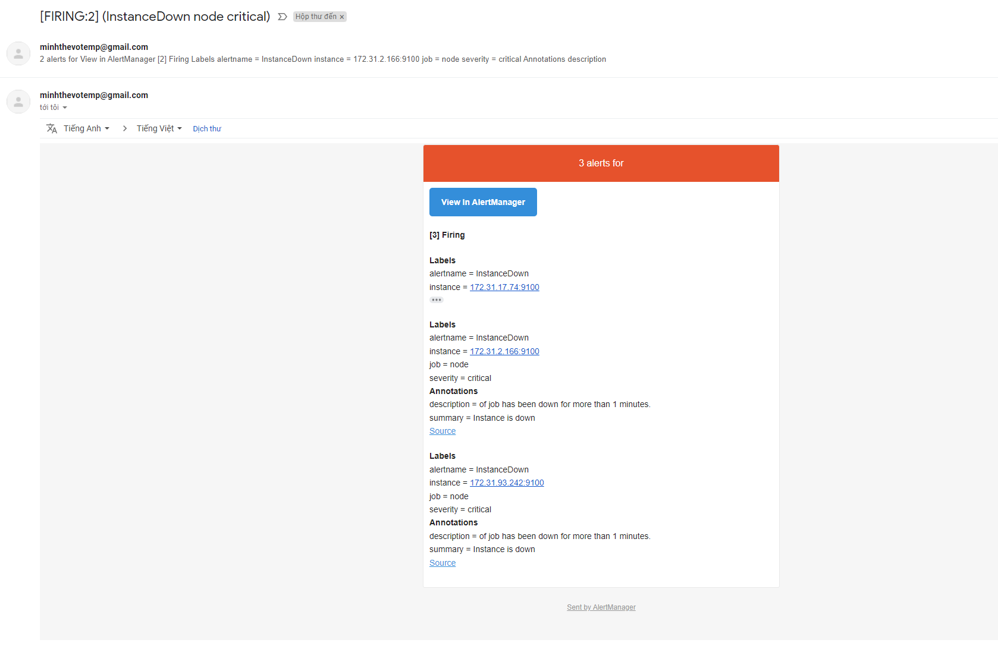

1. URL01

* <https://github.com/18120211/devops-udacity-project3>

1. URL02

* S3: <http://udapeople-be78f425-a8e2-4170-b5d3-a49ad9095bbd.s3.amazonaws.com/index.html>
* API_URL in this run: <http://54.172.120.47:3030>

1. URL03_SCREENSHOT.png

1. URL04_SCREENSHOT.png

1. URL05_SCREENSHOT.png

