**VIETNAM NATIONAL UNIVERSITY**

**UNIVERSITY OF SCIENCE**

**FACULTY OF INFORMATION TECHNOLOGY**



**PROJECT 02**

MEMBERS

Lâm Ngọc Phương Anh 18127039

Hoàng Nguyên Trúc 18127055

**Subject: Artificial Intelligence**

**Ho Chi Minh City – 2020**

# TABLE OF CONTENTS

TABLE OF CONTENTS 2

INTRODUCTION 3

ENVIRONMENT 7

CHECK LIST 8

ASSIGNMENT PLAN 9

ALGORITHM COMMENTS 10

INSTRUCTIONS 11

REFERENCE MATERIALS 12

# INTRODUCTION

* **Game description:** Entertainment.
* **Supports:** macOS, Linux and Windows.
* **Language:** English.
* **Characters:**

|  |  |
| --- | --- |
| AGENT |  |
| WUMPUS |  |
| GOLD |  |
| PIT |  |
| STENCH |  |
| BREEZE |  |

* **Maps:**

|  |  |
| --- | --- |
|  | **MAP** |
| 1 |  |
| 2 |  |
| 3 |  |
| 4 |  |
| 5 |  |
| 6 |  |

# ENVIRONMENT

* IDE: Visual Studio Code A close up of a sign

  Description automatically generated

* Programming Language: Python

* GUI Programming toolkit for Python: Tkinter
* Communication: GitHub 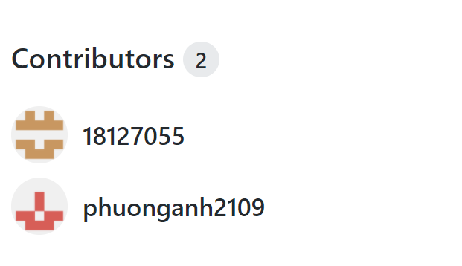

# CHECK LIST

|  |  |  |
| --- | --- | --- |
| No. | Specifications | Completion Level (%) |
| 1 | Finish problem successfully. |  |
| 2 | Graphical demonstration of each step of the running process. You can demo in console screen or use any other graphical library. |  |
| 3 | Generate at least 5 maps with difference structures such as position and number of Pit, Gold and Wumpus. |  |
| 4 | Report your algorithm, experiment with some reflection or comments. |  |

# ASSIGNMENT PLAN

|  |  |  |  |  |  |
| --- | --- | --- | --- | --- | --- |
| No. | ID | Name | Job | Time | Completion Level |
| 1 | 18127039 | Lâm Ngọc Phương Anh | Finish problem successfully. | 22/08-29/08 | 100 |
| 2 | 18127055 | Hoàng Nguyên Trúc | Graphical demonstration. | 22/08-  29/08 | 100 |
| Generate maps. | 28/08 | 100 |
| Writing report. | 28/08-  30/08 | 100 |

# ALGORITHM COMMENTS

**Comparison between BFS and A* for level 1:**

* A* algorithm is chosen because time complexity and space complexity of explored set are more optimal.

**Comparison between A* and BFS for level 2:**

* A* algorithm is chosen because time complexity and space complexity of explored set are more optimal.

**Algorithm comments of level 3:**

* BFS is chosen since pacman does not know all positions of the map.
* The idea is if pacman sees foods in 3x3 area, pacman will choose the way that decreases Manhattan to get closer to the closet food. On the way to eat food, pacman avoids monster by choosing way that evades monster next move.

**Algorithm comments of level 4:**

* Idea for monster’s moving function:

1) Calculate distance from monster to pacman.

2) Pick 1 out of 4 ways that has the smallest Manhattan value.

* Idea for pacman’s moving function:

1. Scan 7x7 area around current pacman position.
2. In 4 squares that pacman can go:

+ Pacman will choose square which has not been passed before.

+ If there are foods in scanned area and square, pacman will choose the way that has closet Manhattan value to food.

+ If squares have been passed, pacman will choose square which has the least number of passed times (square least appears in ex_step).

* There are 3 cases making the algorithm stop:

+ When pacman has only one way to go and Manhattan value between monster & pac man equals to 1.

+ When pacman eats all foods.

+ There is no way to move.

* Bug: When pacman has two directions which have same Manhattan value, pacman will repeat its move many times.

# INSTRUCTIONS

⮱ *Scenario of new game*:

☞ Input path of map.txt file.

☞ Game will be loaded on screen.

⮱ *Scenario of exit game*:

☞ When game ends, the game option console will pop up.

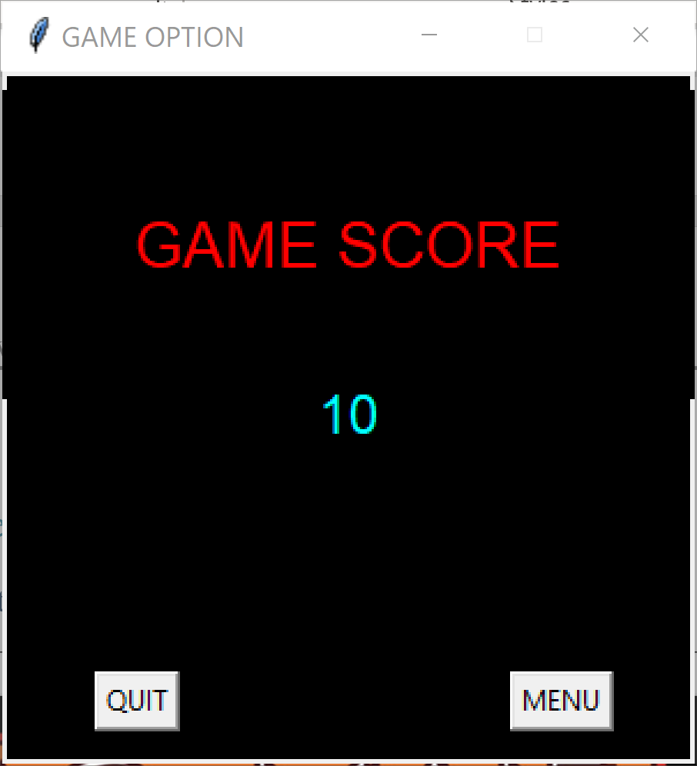

☞ Click QUIT button to exit game.

☞ Click MENU button and the start menu will appear, then you can start Pacman game again.

# REFERENCE MATERIALS

* <https://wiki.python.org/moin/TkInter>
* <https://www.tutorialspoint.com/python/python_gui_programming.htm>
* <https://www.geeksforgeeks.org/python-gui-tkinter/>
* <https://docs.python.org/3/>
* CSC14003-Project02