Homework 4: Machine Learning

qi ren

2023-06-05

Table of Contents

# The Bechdel Test

<https://fivethirtyeight.com/features/the-dollar-and-cents-case-against-hollywoods-exclusion-of-women/>

The [Bechdel test](https://bechdeltest.com) is a way to assess how women are depicted in Hollywood movies. In order for a movie to pass the test:

1. It has to have at least two [named] women in it
2. Who talk to each other
3. About something besides a man

There is a nice article and analysis you can find here <https://fivethirtyeight.com/features/the-dollar-and-cents-case-against-hollywoods-exclusion-of-women/> We have a sample of 1394 movies and we want to fit a model to predict whether a film passes the test or not.

bechdel <- read_csv(here::here("data", "bechdel.csv")) %>%   
 mutate(test = factor(test))

## Rows: 1394 Columns: 10  
## ── Column specification ────────────────────────────────────────────────────────  
## Delimiter: ","  
## chr (4): title, test, rated, genre  
## dbl (6): year, budget_2013, domgross_2013, intgross_2013, metascore, imdb_ra...  
##   
## ℹ Use `spec()` to retrieve the full column specification for this data.  
## ℹ Specify the column types or set `show_col_types = FALSE` to quiet this message.

glimpse(bechdel)

## Rows: 1,394  
## Columns: 10  
## $ year <dbl> 2013, 2013, 2013, 2013, 2013, 2013, 2013, 2013, 2013, 20…  
## $ title <chr> "12 Years a Slave", "2 Guns", "42", "47 Ronin", "A Good …  
## $ test <fct> Fail, Fail, Fail, Fail, Fail, Pass, Pass, Fail, Pass, Pa…  
## $ budget_2013 <dbl> 2.00, 6.10, 4.00, 22.50, 9.20, 1.20, 1.30, 13.00, 4.00, …  
## $ domgross_2013 <dbl> 5.3107035, 7.5612460, 9.5020213, 3.8362475, 6.7349198, 1…  
## $ intgross_2013 <dbl> 15.8607035, 13.2493015, 9.5020213, 14.5803842, 30.424919…  
## $ rated <chr> "R", "R", "PG-13", "PG-13", "R", "R", "PG-13", "PG-13", …  
## $ metascore <dbl> 97, 55, 62, 29, 28, 55, 48, 33, 90, 58, 52, 78, 83, 53, …  
## $ imdb_rating <dbl> 8.3, 6.8, 7.6, 6.6, 5.4, 7.8, 5.7, 5.0, 7.5, 7.4, 6.2, 7…  
## $ genre <chr> "Biography", "Action", "Biography", "Action", "Action", …

How many films fail/pass the test, both as a number and as a %?

bechdel %>%   
 summarise(  
 total_passes = sum(test == "Pass"),  
 props = mean(test == "Pass")  
 )

## # A tibble: 1 × 2  
## total_passes props  
## <int> <dbl>  
## 1 622 0.446

## Movie scores

ggplot(data = bechdel, aes(  
 x = metascore,  
 y = imdb_rating,  
 colour = test  
)) +  
 geom_point(alpha = .3, size = 3) +  
 scale_colour_manual(values = c("tomato", "olivedrab")) +  
 labs(  
 x = "Metacritic score",  
 y = "IMDB rating",  
 colour = "Bechdel test"  
 ) +  
 theme_light()

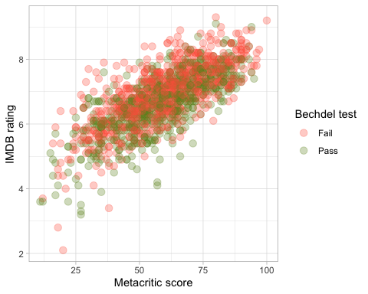

# Split the data

# **Split the data**  
  
set.seed(123)  
  
data_split <- initial_split(bechdel, # updated data  
 prop = 0.8,   
 strata = test)  
  
bechdel_train <- training(data_split)   
bechdel_test <- testing(data_split)

Check the counts and % (proportions) of the test variable in each set.

bechdel_train %>%   
 summarise(  
 total_passes = sum(test == "Pass"),  
 props = mean(test == "Pass")  
 )

## # A tibble: 1 × 2  
## total_passes props  
## <int> <dbl>  
## 1 497 0.446

bechdel_test %>%   
 summarise(  
 total_passes = sum(test == "Pass"),  
 props = mean(test == "Pass")  
 )

## # A tibble: 1 × 2  
## total_passes props  
## <int> <dbl>  
## 1 125 0.446

## Feature exploration

## Any outliers?

bechdel %>%   
 select(test, budget_2013, domgross_2013, intgross_2013, imdb_rating, metascore) %>%   
  
 pivot_longer(cols = 2:6,  
 names_to = "feature",  
 values_to = "value") %>%   
 ggplot()+  
 aes(x=test, y = value, fill = test)+  
 coord_flip()+  
 geom_boxplot()+  
 facet_wrap(~feature, scales = "free")+  
 theme_bw()+  
 theme(legend.position = "none")+  
 labs(x=NULL,y = NULL)

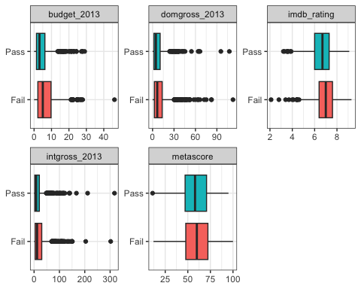

## Scatterplot - Correlation Matrix

Write a paragraph discussing the output of the following

bechdel %>%   
 select(test, budget_2013, domgross_2013, intgross_2013, imdb_rating, metascore)%>%   
 ggpairs(aes(colour=test), alpha=0.2)+  
 theme_bw()

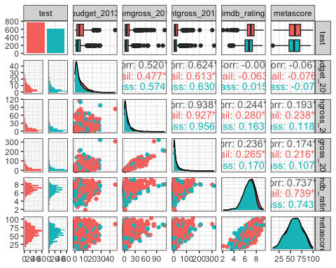

## Categorical variables

Write a paragraph discussing the output of the following

films that failed the test have higher median imdb_rating and meta score than films that passed the test.

Imdb_ratings are skewed to the right while meta-scores are normally distributed with mean score in the 50s.

bechdel %>%   
 group_by(genre, test) %>%  
 summarise(n = n()) %>%   
 mutate(prop = n/sum(n))

## `summarise()` has grouped output by 'genre'. You can override using the  
## `.groups` argument.

## # A tibble: 24 × 4  
## # Groups: genre [14]  
## genre test n prop  
## <chr> <fct> <int> <dbl>  
## 1 Action Fail 260 0.707  
## 2 Action Pass 108 0.293  
## 3 Adventure Fail 52 0.559  
## 4 Adventure Pass 41 0.441  
## 5 Animation Fail 63 0.677  
## 6 Animation Pass 30 0.323  
## 7 Biography Fail 36 0.554  
## 8 Biography Pass 29 0.446  
## 9 Comedy Fail 138 0.427  
## 10 Comedy Pass 185 0.573  
## # ℹ 14 more rows

bechdel %>%   
 group_by(rated, test) %>%  
 summarise(n = n()) %>%   
 mutate(prop = n/sum(n))

## `summarise()` has grouped output by 'rated'. You can override using the  
## `.groups` argument.

## # A tibble: 10 × 4  
## # Groups: rated [5]  
## rated test n prop  
## <chr> <fct> <int> <dbl>  
## 1 G Fail 16 0.615  
## 2 G Pass 10 0.385  
## 3 NC-17 Fail 5 0.833  
## 4 NC-17 Pass 1 0.167  
## 5 PG Fail 115 0.561  
## 6 PG Pass 90 0.439  
## 7 PG-13 Fail 283 0.529  
## 8 PG-13 Pass 252 0.471  
## 9 R Fail 353 0.568  
## 10 R Pass 269 0.432

# Train first models. test ~ metascore + imdb_rating

lr_mod <- logistic_reg() %>%   
 set_engine(engine = "glm") %>%   
 set_mode("classification")  
  
lr_mod

## Logistic Regression Model Specification (classification)  
##   
## Computational engine: glm

tree_mod <- decision_tree() %>%   
 set_engine(engine = "C5.0") %>%   
 set_mode("classification")  
  
tree_mod

## Decision Tree Model Specification (classification)  
##   
## Computational engine: C5.0

lr_fit <- lr_mod %>% # parsnip model  
 fit(test ~ metascore + imdb_rating, # a formula  
 data = bechdel_train # dataframe  
 )  
  
tree_fit <- tree_mod %>% # parsnip model  
 fit(test ~ metascore + imdb_rating, # a formula  
 data = bechdel_train # dataframe  
 )

## Logistic regression

lr_fit %>%  
 broom::tidy()

## # A tibble: 3 × 5  
## term estimate std.error statistic p.value  
## <chr> <dbl> <dbl> <dbl> <dbl>  
## 1 (Intercept) 2.80 0.494 5.68 1.35e- 8  
## 2 metascore 0.0207 0.00536 3.86 1.13e- 4  
## 3 imdb_rating -0.625 0.100 -6.24 4.36e-10

lr_preds <- lr_fit %>%  
 augment(new_data = bechdel_train) %>%  
 mutate(.pred_match = if_else(test == .pred_class, 1, 0))

### Confusion matrix

lr_preds %>%   
 conf_mat(truth = test, estimate = .pred_class) %>%   
 autoplot(type = "heatmap")

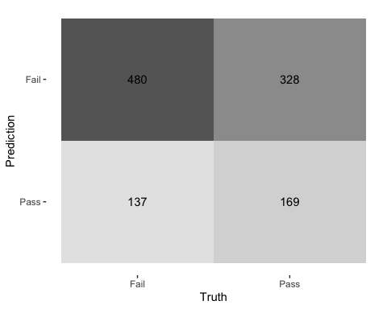

## Decision Tree

tree_preds <- tree_fit %>%  
 augment(new_data = bechdel) %>%  
 mutate(.pred_match = if_else(test == .pred_class, 1, 0))

tree_preds %>%   
 conf_mat(truth = test, estimate = .pred_class) %>%   
 autoplot(type = "heatmap")

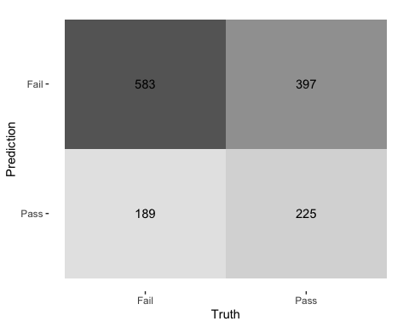

## Draw the decision tree

draw_tree <-   
 rpart::rpart(  
 test ~ metascore + imdb_rating, # test is predicted by metascore + imdb_rating  
 data = bechdel_train, # uses data that contains both birth weight and `low`  
 control = rpart::rpart.control(maxdepth = 5, cp = 0, minsplit = 10)  
 ) %>%   
 partykit::as.party()  
plot(draw_tree)

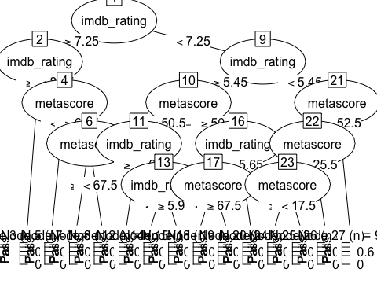

# Cross Validation

Run the code below. What does it return?

set.seed(123)  
bechdel_folds <- vfold_cv(data = bechdel_train,   
 v = 10,   
 strata = test)  
bechdel_folds

## # 10-fold cross-validation using stratification   
## # A tibble: 10 × 2  
## splits id   
## <list> <chr>   
## 1 <split [1002/112]> Fold01  
## 2 <split [1002/112]> Fold02  
## 3 <split [1002/112]> Fold03  
## 4 <split [1002/112]> Fold04  
## 5 <split [1002/112]> Fold05  
## 6 <split [1002/112]> Fold06  
## 7 <split [1002/112]> Fold07  
## 8 <split [1004/110]> Fold08  
## 9 <split [1004/110]> Fold09  
## 10 <split [1004/110]> Fold10

## fit_resamples()

Trains and tests a resampled model.

lr_fit <- lr_mod %>%  
 fit_resamples(  
 test ~ metascore + imdb_rating,  
 resamples = bechdel_folds  
 )  
  
  
tree_fit <- tree_mod %>%  
 fit_resamples(  
 test ~ metascore + imdb_rating,  
 resamples = bechdel_folds  
 )

## collect_metrics()

Unnest the metrics column from a tidymodels fit_resamples()

collect_metrics(lr_fit)

## # A tibble: 2 × 6  
## .metric .estimator mean n std_err .config   
## <chr> <chr> <dbl> <int> <dbl> <chr>   
## 1 accuracy binary 0.575 10 0.0149 Preprocessor1_Model1  
## 2 roc_auc binary 0.606 10 0.0189 Preprocessor1_Model1

collect_metrics(tree_fit)

## # A tibble: 2 × 6  
## .metric .estimator mean n std_err .config   
## <chr> <chr> <dbl> <int> <dbl> <chr>   
## 1 accuracy binary 0.571 10 0.0156 Preprocessor1_Model1  
## 2 roc_auc binary 0.547 10 0.0201 Preprocessor1_Model1

tree_preds <- tree_mod %>%   
 fit_resamples(  
 test ~ metascore + imdb_rating,   
 resamples = bechdel_folds,  
 control = control_resamples(save_pred = TRUE) #<<  
 )  
  
# What does the data for ROC look like?  
tree_preds %>%   
 collect_predictions() %>%   
 roc_curve(truth = test, .pred_Fail)

## # A tibble: 29 × 3  
## .threshold specificity sensitivity  
## <dbl> <dbl> <dbl>  
## 1 -Inf 0 1   
## 2 0.262 0 1   
## 3 0.317 0.00201 0.989  
## 4 0.373 0.00805 0.982  
## 5 0.440 0.0181 0.976  
## 6 0.459 0.0443 0.943  
## 7 0.460 0.0765 0.924  
## 8 0.464 0.115 0.901  
## 9 0.465 0.147 0.887  
## 10 0.465 0.191 0.864  
## # ℹ 19 more rows

# Draw the ROC  
tree_preds %>%   
 collect_predictions() %>%   
 roc_curve(truth = test, .pred_Fail) %>%   
 autoplot()

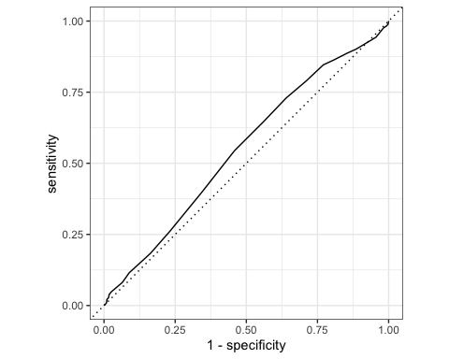

# Build a better training set with recipes

## Preprocessing options

* Encode categorical predictors
* Center and scale variables
* Handle class imbalance
* Impute missing data
* Perform dimensionality reduction
* … …

## To build a recipe

1. Start the recipe()
2. Define the variables involved
3. Describe **pre**processing [step-by-step]

## Collapse Some Categorical Levels

Do we have any genre with few observations? Assign genres that have less than 3% to a new category ‘Other’

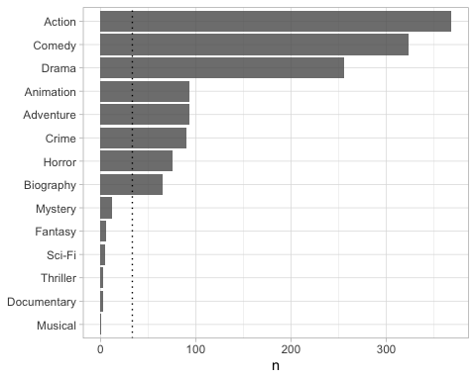

movie_rec <-  
 recipe(test ~ .,  
 data = bechdel_train) %>%  
   
 # Genres with less than 5% will be in a category 'Other'  
 step_other(genre, threshold = .03)

## Before recipe

## # A tibble: 14 × 2  
## genre n  
## <chr> <int>  
## 1 Action 293  
## 2 Comedy 254  
## 3 Drama 213  
## 4 Adventure 75  
## 5 Animation 72  
## 6 Crime 68  
## 7 Horror 68  
## 8 Biography 50  
## 9 Mystery 7  
## 10 Fantasy 5  
## 11 Sci-Fi 3  
## 12 Thriller 3  
## 13 Documentary 2  
## 14 Musical 1

## After recipe

movie_rec %>%   
 prep() %>%   
 bake(new_data = bechdel_train) %>%   
 count(genre, sort = TRUE)

## # A tibble: 9 × 2  
## genre n  
## <fct> <int>  
## 1 Action 293  
## 2 Comedy 254  
## 3 Drama 213  
## 4 Adventure 75  
## 5 Animation 72  
## 6 Crime 68  
## 7 Horror 68  
## 8 Biography 50  
## 9 other 21

## step_dummy()

Converts nominal data into numeric dummy variables

movie_rec <- recipe(test ~ ., data = bechdel) %>%  
 step_other(genre, threshold = .03) %>%   
 step_dummy(all_nominal_predictors())   
  
movie_rec

##

## ── Recipe ──────────────────────────────────────────────────────────────────────

##

## ── Inputs

## Number of variables by role

## outcome: 1  
## predictor: 9

##

## ── Operations

## • Collapsing factor levels for: genre

## • Dummy variables from: all_nominal_predictors()

## Let’s think about the modelling

What if there were no films with rated NC-17 in the training data?

* Will the model have a coefficient for rated NC-17?
* What will happen if the test data includes a film with rated NC-17?

## step_novel()

Adds a catch-all level to a factor for any new values not encountered in model training, which lets R intelligently predict new levels in the test set.

movie_rec <- recipe(test ~ ., data = bechdel) %>%  
 step_other(genre, threshold = .03) %>%   
 step_novel(all_nominal_predictors) %>% # Use *before* `step_dummy()` so new level is dummified  
 step_dummy(all_nominal_predictors())

## step_zv()

Intelligently handles zero variance variables (variables that contain only a single value)

movie_rec <- recipe(test ~ ., data = bechdel) %>%  
 step_other(genre, threshold = .03) %>%   
 step_novel(all_nominal(), -all_outcomes()) %>% # Use *before* `step_dummy()` so new level is dummified  
 step_dummy(all_nominal(), -all_outcomes()) %>%   
 step_zv(all_numeric(), -all_outcomes())

## step_normalize()

Centers then scales numeric variable (mean = 0, sd = 1)

movie_rec <- recipe(test ~ ., data = bechdel) %>%  
 step_other(genre, threshold = .03) %>%   
 step_novel(all_nominal(), -all_outcomes()) %>% # Use *before* `step_dummy()` so new level is dummified  
 step_dummy(all_nominal(), -all_outcomes()) %>%   
 step_zv(all_numeric(), -all_outcomes()) %>%   
 step_normalize(all_numeric())

## step_corr()

Removes highly correlated variables

movie_rec <- recipe(test ~ ., data = bechdel) %>%  
 step_other(genre, threshold = .03) %>%   
 step_novel(all_nominal(), -all_outcomes()) %>% # Use *before* `step_dummy()` so new level is dummified  
 step_dummy(all_nominal(), -all_outcomes()) %>%   
 step_zv(all_numeric(), -all_outcomes()) %>%   
 step_normalize(all_numeric())   
 #step_corr(all_predictors(), threshold = 0.75, method = "spearman")   
  
  
movie_rec

##

## ── Recipe ──────────────────────────────────────────────────────────────────────

##

## ── Inputs

## Number of variables by role

## outcome: 1  
## predictor: 9

##

## ── Operations

## • Collapsing factor levels for: genre

## • Novel factor level assignment for: all_nominal(), -all_outcomes()

## • Dummy variables from: all_nominal(), -all_outcomes()

## • Zero variance filter on: all_numeric(), -all_outcomes()

## • Centering and scaling for: all_numeric()

# Define different models to fit

## Model Building  
  
# 1. Pick a `model type`  
# 2. set the `engine`  
# 3. Set the `mode`: regression or classification  
  
# Logistic regression  
log_spec <- logistic_reg() %>% # model type  
 set_engine(engine = "glm") %>% # model engine  
 set_mode("classification") # model mode  
  
# Show your model specification  
log_spec

## Logistic Regression Model Specification (classification)  
##   
## Computational engine: glm

# Decision Tree  
tree_spec <- decision_tree() %>%  
 set_engine(engine = "C5.0") %>%  
 set_mode("classification")  
  
tree_spec

## Decision Tree Model Specification (classification)  
##   
## Computational engine: C5.0

# Random Forest  
library(ranger)  
  
rf_spec <-   
 rand_forest() %>%   
 set_engine("ranger", importance = "impurity") %>%   
 set_mode("classification")  
  
  
# Boosted tree (XGBoost)  
library(xgboost)

##   
## Attaching package: 'xgboost'

## The following object is masked from 'package:dplyr':  
##   
## slice

xgb_spec <-   
 boost_tree() %>%   
 set_engine("xgboost") %>%   
 set_mode("classification")   
  
# K-nearest neighbour (k-NN)  
knn_spec <-   
 nearest_neighbor(neighbors = 4) %>% # we can adjust the number of neighbors   
 set_engine("kknn") %>%   
 set_mode("classification")

# Bundle recipe and model with workflows

log_wflow <- # new workflow object  
 workflow() %>% # use workflow function  
 add_recipe(movie_rec) %>% # use the new recipe  
 add_model(log_spec) # add your model spec  
  
# show object  
log_wflow

## ══ Workflow ════════════════════════════════════════════════════════════════════  
## Preprocessor: Recipe  
## Model: logistic_reg()  
##   
## ── Preprocessor ────────────────────────────────────────────────────────────────  
## 5 Recipe Steps  
##   
## • step_other()  
## • step_novel()  
## • step_dummy()  
## • step_zv()  
## • step_normalize()  
##   
## ── Model ───────────────────────────────────────────────────────────────────────  
## Logistic Regression Model Specification (classification)  
##   
## Computational engine: glm

## A few more workflows  
  
tree_wflow <-  
 workflow() %>%  
 add_recipe(movie_rec) %>%   
 add_model(tree_spec)   
  
rf_wflow <-  
 workflow() %>%  
 add_recipe(movie_rec) %>%   
 add_model(rf_spec)   
  
xgb_wflow <-  
 workflow() %>%  
 add_recipe(movie_rec) %>%   
 add_model(xgb_spec)  
  
knn_wflow <-  
 workflow() %>%  
 add_recipe(movie_rec) %>%   
 add_model(knn_spec)

HEADS UP

1. How many models have you specified?

* 2 models: logistic regression and decision tree

1. What’s the difference between a model specification and a workflow?

* **Model Specification**: A model specification is a precise description of the model that you are going to fit. This includes the computational method (e.g., linear regression, random forest, etc.) and the model parameters (also called hyperparameters). The Model specification does not contain any information about the data to be used.
* **Workflow**: A workflow in tidymodels is a flexible way of tying together your modelling components (like pre-processing, feature engineering, and model fitting) in one object. It lets you specify a model and a recipe (for data pre-processing) together. The workflow can then be estimated or used for prediction.

1. Do you need to add a formula (e.g., test ~ .) if you have a recipe?

* A formula is not needed if you are already specifying a recipe in your workflow. The reason is that the recipe itself includes the formula which specifies the relationship between your outcome (or response) variable and your predictor variables.

# Model Comparison

You now have all your models. Adapt the code from slides code-from-slides-CA-housing.R, line 400 onwards to assess which model gives you the best classification.

## Evaluate Models  
  
## Logistic regression results{.smaller}  
  
log_res <- log_wflow %>%   
 fit_resamples(  
 resamples = bechdel_folds,   
 metrics = metric_set(  
 recall, precision, f_meas, accuracy,  
 kap, roc_auc, sens, spec),  
 control = control_resamples(save_pred = TRUE))

## → A | warning: glm.fit: algorithm did not converge

## There were issues with some computations A: x1 → B | warning: prediction from a rank-deficient fit may be misleading  
## There were issues with some computations A: x1There were issues with some computations A: x1 B: x1There were issues with some computations A: x2 B: x1There were issues with some computations A: x2 B: x2There were issues with some computations A: x3 B: x2There were issues with some computations A: x3 B: x3There were issues with some computations A: x4 B: x3There were issues with some computations A: x5 B: x4There were issues with some computations A: x5 B: x5There were issues with some computations A: x6 B: x5There were issues with some computations A: x6 B: x6There were issues with some computations A: x7 B: x6There were issues with some computations A: x7 B: x7There were issues with some computations A: x8 B: x7There were issues with some computations A: x8 B: x8There were issues with some computations A: x9 B: x8There were issues with some computations A: x9 B: x9There were issues with some computations A: x10 B: x9There were issues with some computations A: x10 B: x10There were issues with some computations A: x10 B: x10

# Show average performance over all folds (note that we use log_res):  
log_res %>% collect_metrics(summarize = TRUE)

## # A tibble: 8 × 6  
## .metric .estimator mean n std_err .config   
## <chr> <chr> <dbl> <int> <dbl> <chr>   
## 1 accuracy binary 0.478 10 0.0184 Preprocessor1_Model1  
## 2 f_meas binary 0.491 10 0.0285 Preprocessor1_Model1  
## 3 kap binary -0.0420 10 0.0356 Preprocessor1_Model1  
## 4 precision binary 0.531 10 0.0221 Preprocessor1_Model1  
## 5 recall binary 0.469 10 0.0413 Preprocessor1_Model1  
## 6 roc_auc binary 0.473 10 0.0189 Preprocessor1_Model1  
## 7 sens binary 0.469 10 0.0413 Preprocessor1_Model1  
## 8 spec binary 0.489 10 0.0435 Preprocessor1_Model1

# Show performance for every single fold:  
log_res %>% collect_metrics(summarize = FALSE)

## # A tibble: 80 × 5  
## id .metric .estimator .estimate .config   
## <chr> <chr> <chr> <dbl> <chr>   
## 1 Fold01 recall binary 0.403 Preprocessor1_Model1  
## 2 Fold01 precision binary 0.581 Preprocessor1_Model1  
## 3 Fold01 f_meas binary 0.476 Preprocessor1_Model1  
## 4 Fold01 accuracy binary 0.509 Preprocessor1_Model1  
## 5 Fold01 kap binary 0.0417 Preprocessor1_Model1  
## 6 Fold01 sens binary 0.403 Preprocessor1_Model1  
## 7 Fold01 spec binary 0.64 Preprocessor1_Model1  
## 8 Fold01 roc_auc binary 0.508 Preprocessor1_Model1  
## 9 Fold02 recall binary 0.339 Preprocessor1_Model1  
## 10 Fold02 precision binary 0.477 Preprocessor1_Model1  
## # ℹ 70 more rows

## `collect_predictions()` and get confusion matrix{.smaller}  
  
log_pred <- log_res %>% collect_predictions()  
  
log_pred %>% conf_mat(test, .pred_class)

## Truth  
## Prediction Fail Pass  
## Fail 289 254  
## Pass 328 243

log_pred %>%   
 conf_mat(test, .pred_class) %>%   
 autoplot(type = "mosaic") +  
 geom_label(aes(  
 x = (xmax + xmin) / 2,   
 y = (ymax + ymin) / 2,   
 label = c("TP", "FN", "FP", "TN")))

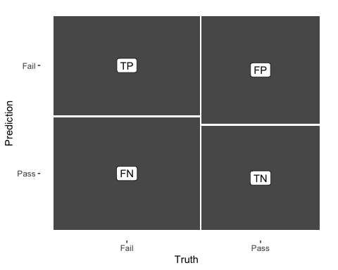

log_pred %>%   
 conf_mat(test, .pred_class) %>%   
 autoplot(type = "heatmap")

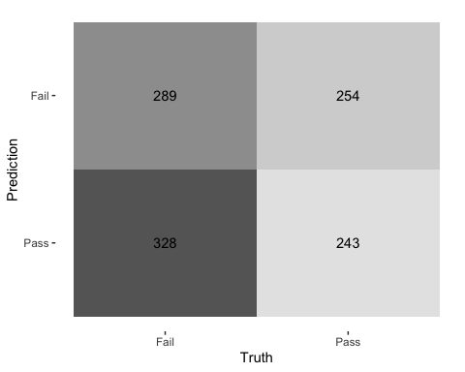

## ROC Curve  
  
log_pred %>%   
 group_by(id) %>% # id contains our folds  
 roc_curve(test, .pred_Fail) %>%   
 autoplot()

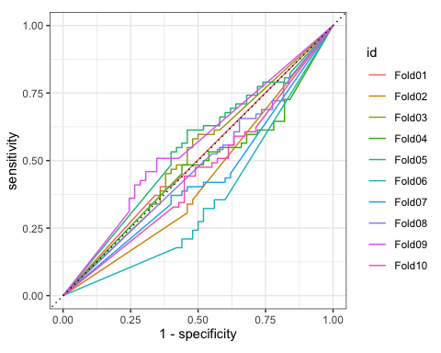

## Decision Tree results  
  
tree_res <-  
 tree_wflow %>%   
 fit_resamples(  
 resamples = bechdel_folds,   
 metrics = metric_set(  
 recall, precision, f_meas,   
 accuracy, kap,  
 roc_auc, sens, spec),  
 control = control_resamples(save_pred = TRUE)  
 )   
  
tree_res %>% collect_metrics(summarize = TRUE)

## # A tibble: 8 × 6  
## .metric .estimator mean n std_err .config   
## <chr> <chr> <dbl> <int> <dbl> <chr>   
## 1 accuracy binary 0.590 10 0.0131 Preprocessor1_Model1  
## 2 f_meas binary 0.632 10 0.0126 Preprocessor1_Model1  
## 3 kap binary 0.168 10 0.0276 Preprocessor1_Model1  
## 4 precision binary 0.629 10 0.0125 Preprocessor1_Model1  
## 5 recall binary 0.637 10 0.0194 Preprocessor1_Model1  
## 6 roc_auc binary 0.591 10 0.0181 Preprocessor1_Model1  
## 7 sens binary 0.637 10 0.0194 Preprocessor1_Model1  
## 8 spec binary 0.530 10 0.0283 Preprocessor1_Model1

## Random Forest  
  
rf_res <-  
 rf_wflow %>%   
 fit_resamples(  
 resamples = bechdel_folds,   
 metrics = metric_set(  
 recall, precision, f_meas,   
 accuracy, kap,  
 roc_auc, sens, spec),  
 control = control_resamples(save_pred = TRUE)  
 )   
  
rf_res %>% collect_metrics(summarize = TRUE)

## # A tibble: 8 × 6  
## .metric .estimator mean n std_err .config   
## <chr> <chr> <dbl> <int> <dbl> <chr>   
## 1 accuracy binary 0.637 10 0.0139 Preprocessor1_Model1  
## 2 f_meas binary 0.704 10 0.0115 Preprocessor1_Model1  
## 3 kap binary 0.247 10 0.0291 Preprocessor1_Model1  
## 4 precision binary 0.643 10 0.0112 Preprocessor1_Model1  
## 5 recall binary 0.778 10 0.0155 Preprocessor1_Model1  
## 6 roc_auc binary 0.659 10 0.0216 Preprocessor1_Model1  
## 7 sens binary 0.778 10 0.0155 Preprocessor1_Model1  
## 8 spec binary 0.462 10 0.0221 Preprocessor1_Model1

## Boosted tree - XGBoost  
  
xgb_res <-   
 xgb_wflow %>%   
 fit_resamples(  
 resamples = bechdel_folds,   
 metrics = metric_set(  
 recall, precision, f_meas,   
 accuracy, kap,  
 roc_auc, sens, spec),  
 control = control_resamples(save_pred = TRUE)  
 )   
  
xgb_res %>% collect_metrics(summarize = TRUE)

## # A tibble: 8 × 6  
## .metric .estimator mean n std_err .config   
## <chr> <chr> <dbl> <int> <dbl> <chr>   
## 1 accuracy binary 0.634 10 0.0126 Preprocessor1_Model1  
## 2 f_meas binary 0.683 10 0.0105 Preprocessor1_Model1  
## 3 kap binary 0.252 10 0.0270 Preprocessor1_Model1  
## 4 precision binary 0.660 10 0.0136 Preprocessor1_Model1  
## 5 recall binary 0.712 10 0.0171 Preprocessor1_Model1  
## 6 roc_auc binary 0.645 10 0.0169 Preprocessor1_Model1  
## 7 sens binary 0.712 10 0.0171 Preprocessor1_Model1  
## 8 spec binary 0.539 10 0.0295 Preprocessor1_Model1

## K-nearest neighbour  
  
knn_res <-   
 knn_wflow %>%   
 fit_resamples(  
 resamples = bechdel_folds,   
 metrics = metric_set(  
 recall, precision, f_meas,   
 accuracy, kap,  
 roc_auc, sens, spec),  
 control = control_resamples(save_pred = TRUE)  
 )

## → A | warning: While computing binary `precision()`, no predicted events were detected (i.e. `true_positive + false_positive = 0`).   
## Precision is undefined in this case, and `NA` will be returned.  
## Note that 61 true event(s) actually occured for the problematic event level, 'Fail'.  
## There were issues with some computations A: x1There were issues with some computations A: x1

knn_res %>% collect_metrics(summarize = TRUE)

## # A tibble: 8 × 6  
## .metric .estimator mean n std_err .config   
## <chr> <chr> <dbl> <int> <dbl> <chr>   
## 1 accuracy binary 0.543 10 0.0110 Preprocessor1_Model1  
## 2 f_meas binary 0.712 9 0.00136 Preprocessor1_Model1  
## 3 kap binary 0.000823 10 0.00424 Preprocessor1_Model1  
## 4 precision binary 0.554 9 0.00102 Preprocessor1_Model1  
## 5 recall binary 0.897 10 0.0997 Preprocessor1_Model1  
## 6 roc_auc binary 0.548 10 0.0231 Preprocessor1_Model1  
## 7 sens binary 0.897 10 0.0997 Preprocessor1_Model1  
## 8 spec binary 0.104 10 0.0996 Preprocessor1_Model1

## Model Comparison  
  
log_metrics <-   
 log_res %>%   
 collect_metrics(summarise = TRUE) %>%  
 # add the name of the model to every row  
 mutate(model = "Logistic Regression")   
  
tree_metrics <-   
 tree_res %>%   
 collect_metrics(summarise = TRUE) %>%  
 mutate(model = "Decision Tree")  
  
rf_metrics <-   
 rf_res %>%   
 collect_metrics(summarise = TRUE) %>%  
 mutate(model = "Random Forest")  
  
xgb_metrics <-   
 xgb_res %>%   
 collect_metrics(summarise = TRUE) %>%  
 mutate(model = "XGBoost")  
  
knn_metrics <-   
 knn_res %>%   
 collect_metrics(summarise = TRUE) %>%  
 mutate(model = "Knn")  
  
# create dataframe with all models  
model_compare <- bind_rows(log_metrics,  
 tree_metrics,  
 rf_metrics,  
 xgb_metrics,  
 knn_metrics)   
  
#Pivot wider to create barplot  
 model_comp <- model_compare %>%   
 select(model, .metric, mean, std_err) %>%   
 pivot_wider(names_from = .metric, values_from = c(mean, std_err))   
  
# show mean are under the curve (ROC-AUC) for every model  
model_comp %>%   
 arrange(mean_roc_auc) %>%   
 mutate(model = fct_reorder(model, mean_roc_auc)) %>% # order results  
 ggplot(aes(model, mean_roc_auc, fill=model)) +  
 geom_col() +  
 coord_flip() +  
 scale_fill_brewer(palette = "Blues") +  
 geom_text(  
 size = 3,  
 aes(label = round(mean_roc_auc, 2),   
 y = mean_roc_auc + 0.08),  
 vjust = 1  
 )+  
 theme_light()+  
 theme(legend.position = "none")+  
 labs(y = NULL)

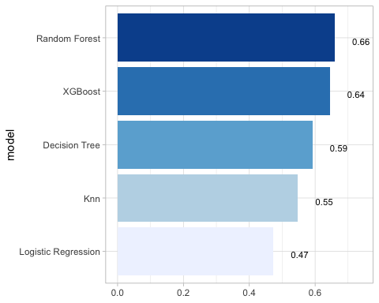

## `last_fit()` on test set  
  
# - `last_fit()` fits a model to the whole training data and evaluates it on the test set.   
# - provide the workflow object of the best model as well as the data split object (not the training data).   
   
last_fit_xgb <- last_fit(xgb_wflow,   
 split = data_split,  
 metrics = metric_set(  
 accuracy, f_meas, kap, precision,  
 recall, roc_auc, sens, spec))  
  
last_fit_xgb %>% collect_metrics(summarize = TRUE)

## # A tibble: 8 × 4  
## .metric .estimator .estimate .config   
## <chr> <chr> <dbl> <chr>   
## 1 accuracy binary 0.568 Preprocessor1_Model1  
## 2 f_meas binary 0.630 Preprocessor1_Model1  
## 3 kap binary 0.114 Preprocessor1_Model1  
## 4 precision binary 0.599 Preprocessor1_Model1  
## 5 recall binary 0.665 Preprocessor1_Model1  
## 6 sens binary 0.665 Preprocessor1_Model1  
## 7 spec binary 0.448 Preprocessor1_Model1  
## 8 roc_auc binary 0.610 Preprocessor1_Model1

#Compare to training  
xgb_res %>% collect_metrics(summarize = TRUE)

## # A tibble: 8 × 6  
## .metric .estimator mean n std_err .config   
## <chr> <chr> <dbl> <int> <dbl> <chr>   
## 1 accuracy binary 0.634 10 0.0126 Preprocessor1_Model1  
## 2 f_meas binary 0.683 10 0.0105 Preprocessor1_Model1  
## 3 kap binary 0.252 10 0.0270 Preprocessor1_Model1  
## 4 precision binary 0.660 10 0.0136 Preprocessor1_Model1  
## 5 recall binary 0.712 10 0.0171 Preprocessor1_Model1  
## 6 roc_auc binary 0.645 10 0.0169 Preprocessor1_Model1  
## 7 sens binary 0.712 10 0.0171 Preprocessor1_Model1  
## 8 spec binary 0.539 10 0.0295 Preprocessor1_Model1

## Variable importance using `{vip}` package  
  
library(vip)  
  
last_fit_xgb %>%   
 pluck(".workflow", 1) %>%   
 pull_workflow_fit() %>%   
 vip(num_features = 10) +  
 theme_light()

## Warning: `pull_workflow_fit()` was deprecated in workflows 0.2.3.  
## ℹ Please use `extract_fit_parsnip()` instead.  
## This warning is displayed once every 8 hours.  
## Call `lifecycle::last_lifecycle_warnings()` to see where this warning was  
## generated.

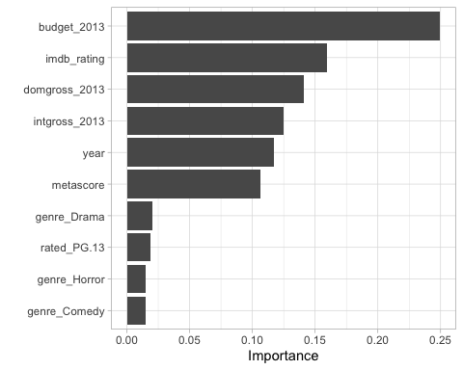

## Final Confusion Matrix  
  
last_fit_xgb %>%  
 collect_predictions() %>%   
 conf_mat(test, .pred_class) %>%   
 autoplot(type = "heatmap")

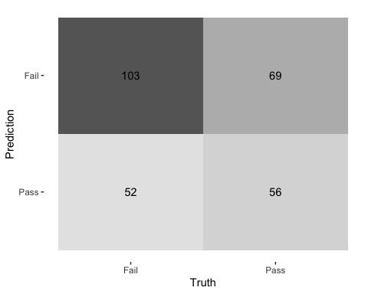

## Final ROC curve  
last_fit_xgb %>%   
 collect_predictions() %>%   
 roc_curve(test, .pred_Fail) %>%   
 autoplot()

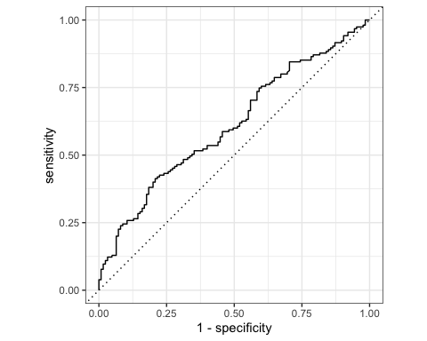

# Deliverables

There is a lot of explanatory text, comments, etc. You do not need these, so delete them and produce a stand-alone document that you could share with someone. Knit the edited and completed R Markdown (Rmd) file as a Word or HTML document (use the “Knit” button at the top of the script editor window) and upload it to Canvas. You must be commiting and pushing your changes to your own Github repo as you go along.

# Details

* Who did you collaborate with: TYPE NAMES HERE
* Approximately how much time did you spend on this problem set: ANSWER HERE
* What, if anything, gave you the most trouble: ANSWER HERE

**Please seek out help when you need it,** and remember the [15-minute rule](https://dsb2023.netlify.app/syllabus/#the-15-minute-rule). You know enough R (and have enough examples of code from class and your readings) to be able to do this. If you get stuck, ask for help from others, post a question on Slack– and remember that I am here to help too!

As a true test to yourself, do you understand the code you submitted and are you able to explain it to someone else?

# Rubric

13/13: Problem set is 100% completed. Every question was attempted and answered, and most answers are correct. Code is well-documented (both self-documented and with additional comments as necessary). Used tidyverse, instead of base R. Graphs and tables are properly labelled. Analysis is clear and easy to follow, either because graphs are labeled clearly or you’ve written additional text to describe how you interpret the output. Multiple Github commits. Work is exceptional. I will not assign these often.

8/13: Problem set is 60–80% complete and most answers are correct. This is the expected level of performance. Solid effort. Hits all the elements. No clear mistakes. Easy to follow (both the code and the output). A few Github commits.

5/13: Problem set is less than 60% complete and/or most answers are incorrect. This indicates that you need to improve next time. I will hopefully not assign these often. Displays minimal effort. Doesn’t complete all components. Code is poorly written and not documented. Uses the same type of plot for each graph, or doesn’t use plots appropriate for the variables being analyzed. No Github commits.