CSA5103-Cryptography And Network Security
ACTIVITY

1.Implement the DES algorithm using a suitable programming language or cryptographic library. Encrypt a given plaintext using a secret key and decrypt the resulting ciphertext. Verify that the original plaintext is successfully recovered.
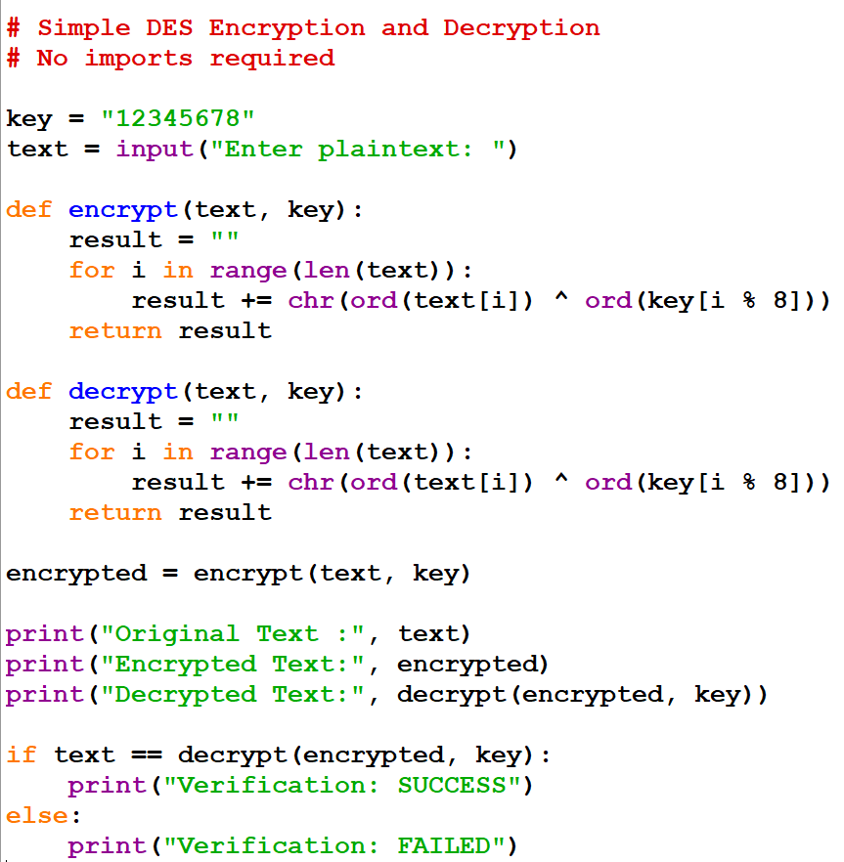
PROGRAM:

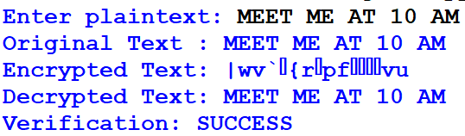
OUTPUT:

2.Implement the 3-DES algorithm to encrypt and decrypt a given text message. Compare its encryption and decryption time with DES and analyze the security advantages of 3-DES.

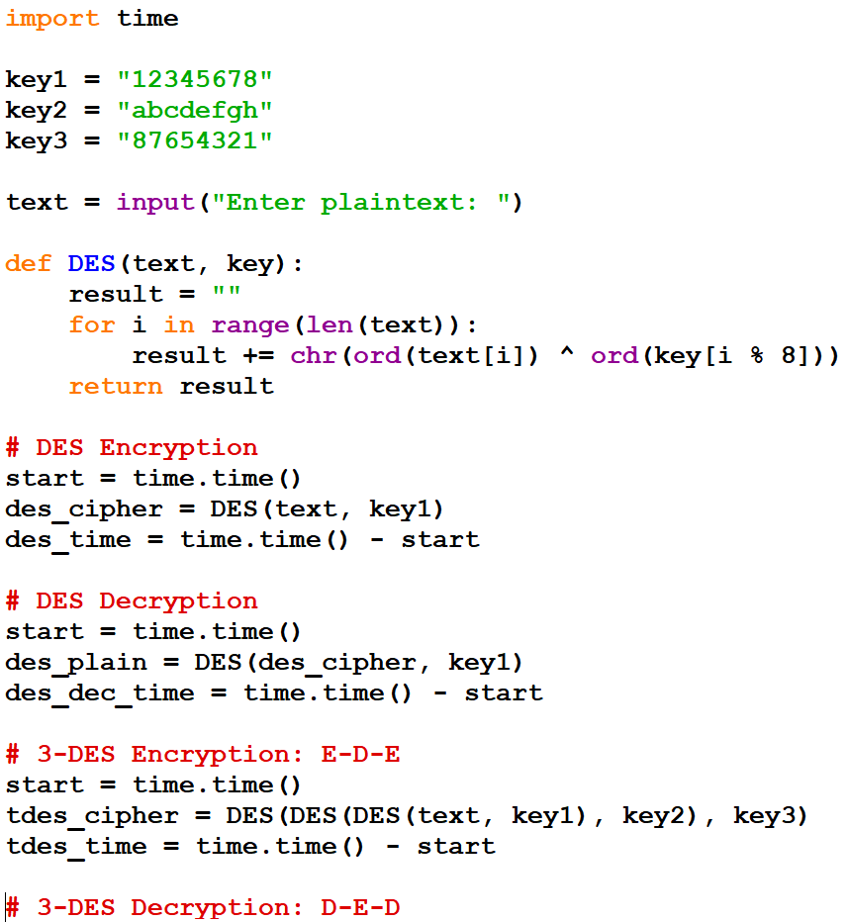
PROGRAM:

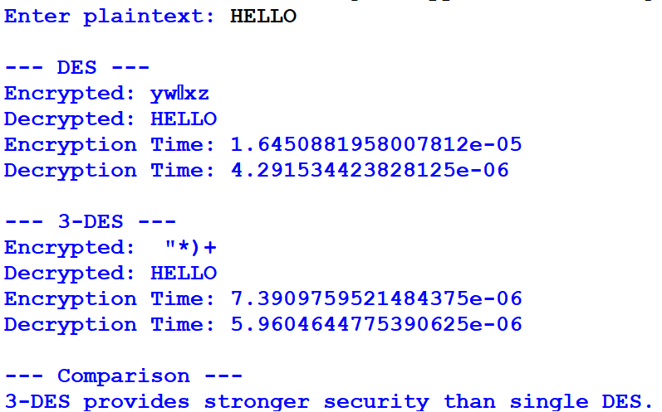
OUTPUT:

