**1、打开SQL Developer**

**新建连接如图所示**

**sde、sde、sde，localhost、1521、orcl**

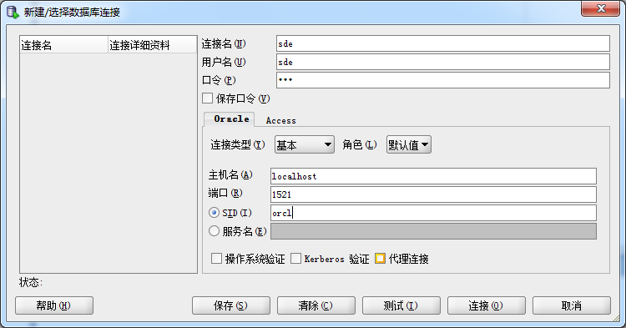

**2、导入空间数据**

**1）打开ArcCatalog,** 先在ArcCatalog中连接文件夹c:\test

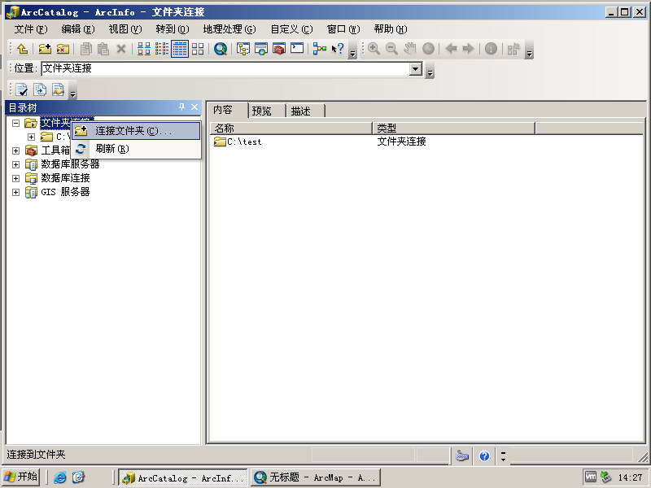

**2）双击“添加空间数据库连接”，如下图。**

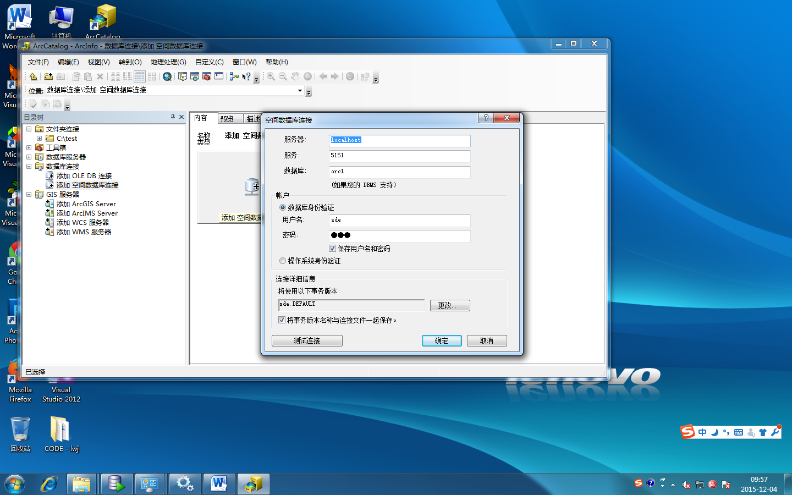

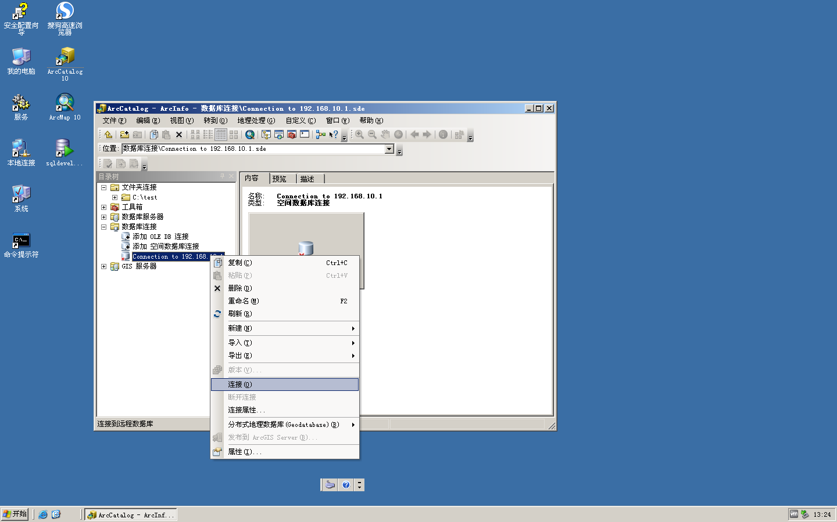

**3）导入空间数据** 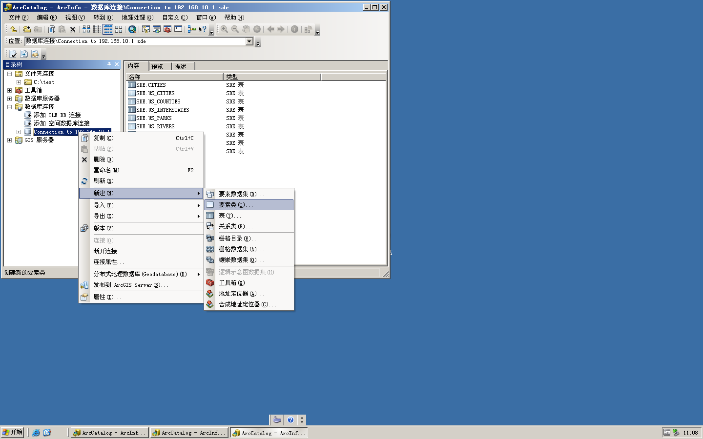

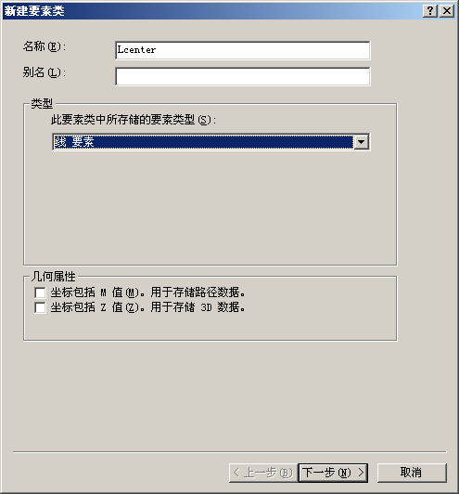

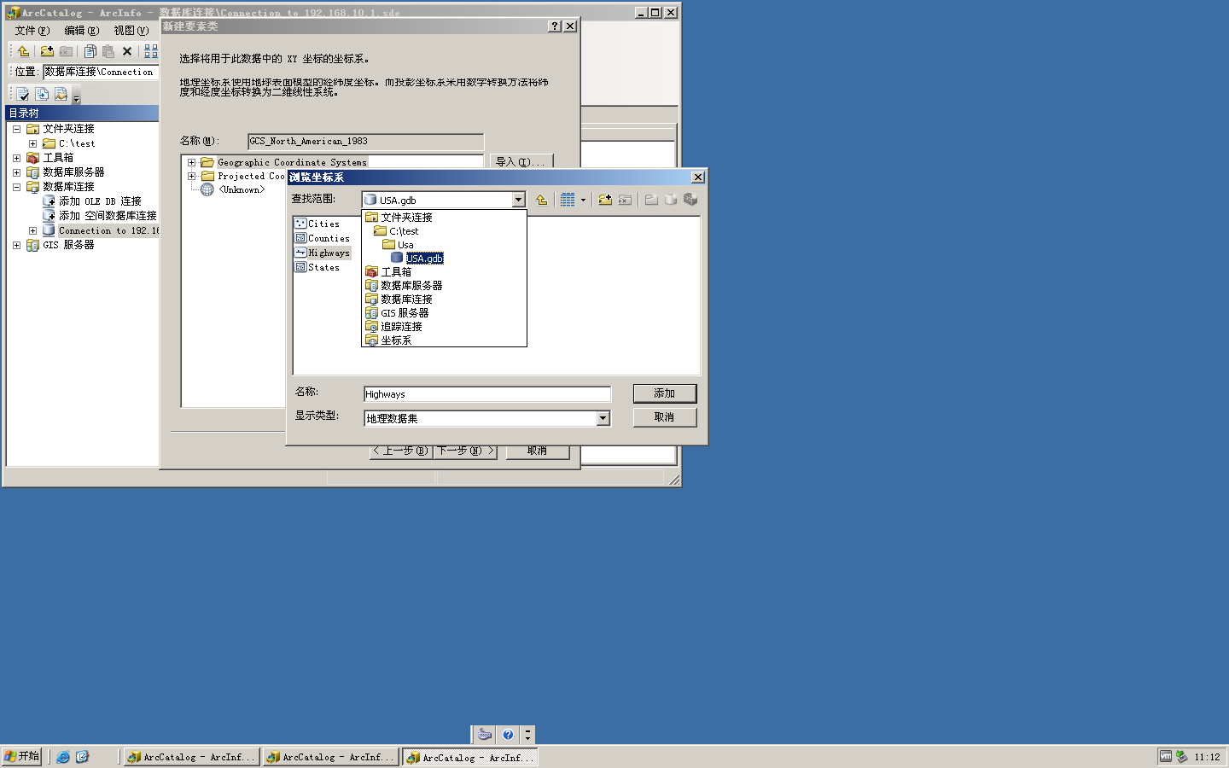

**下一步，下一步，**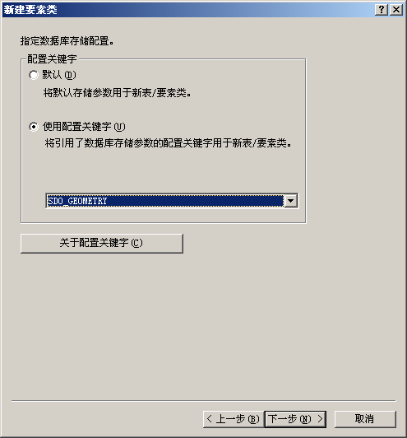

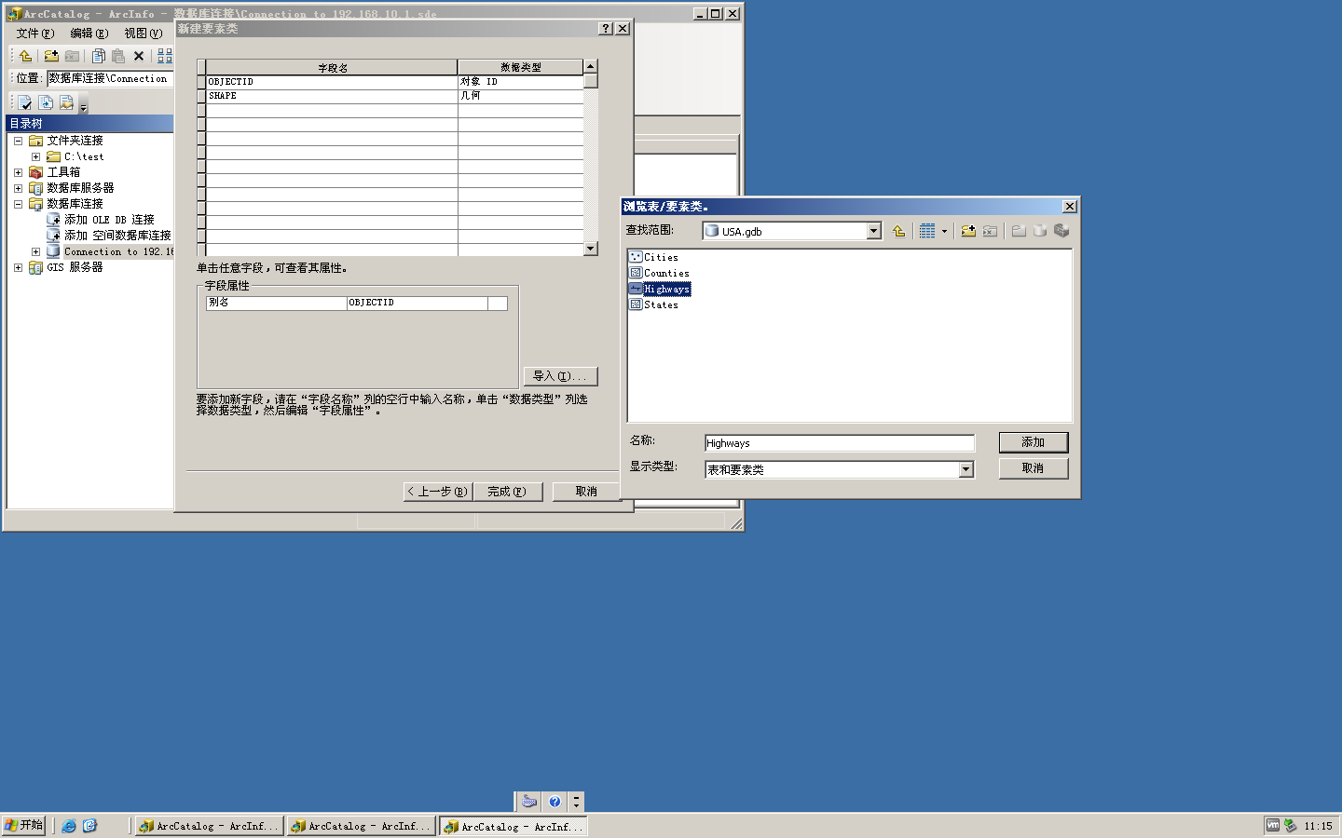

**导入、添加后完成。**

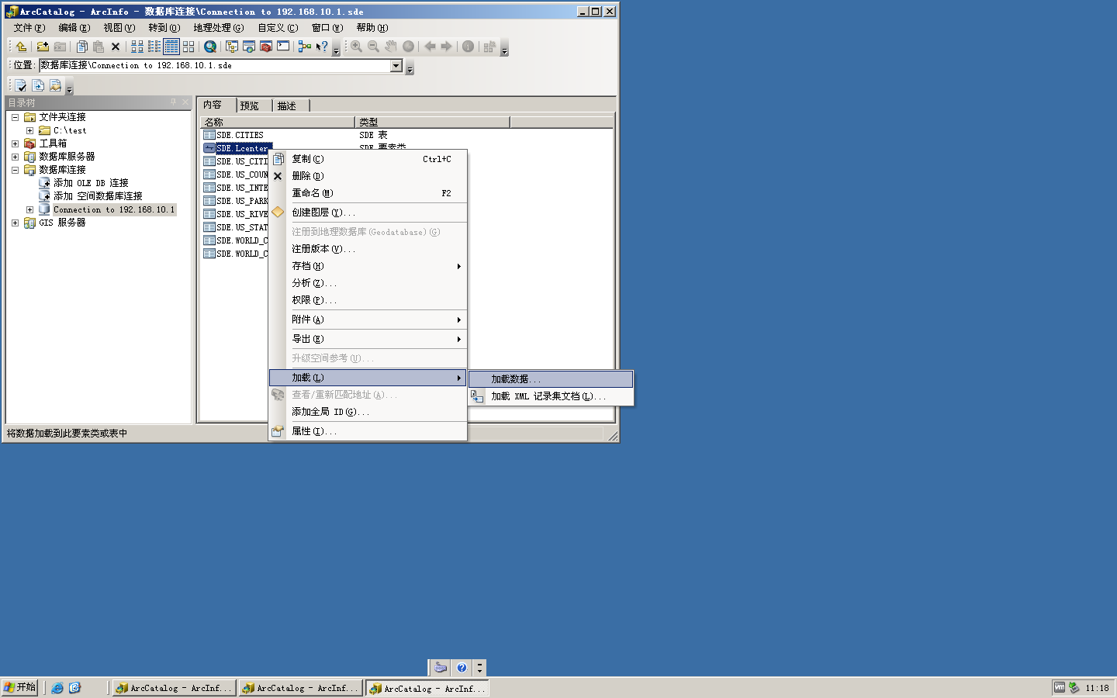

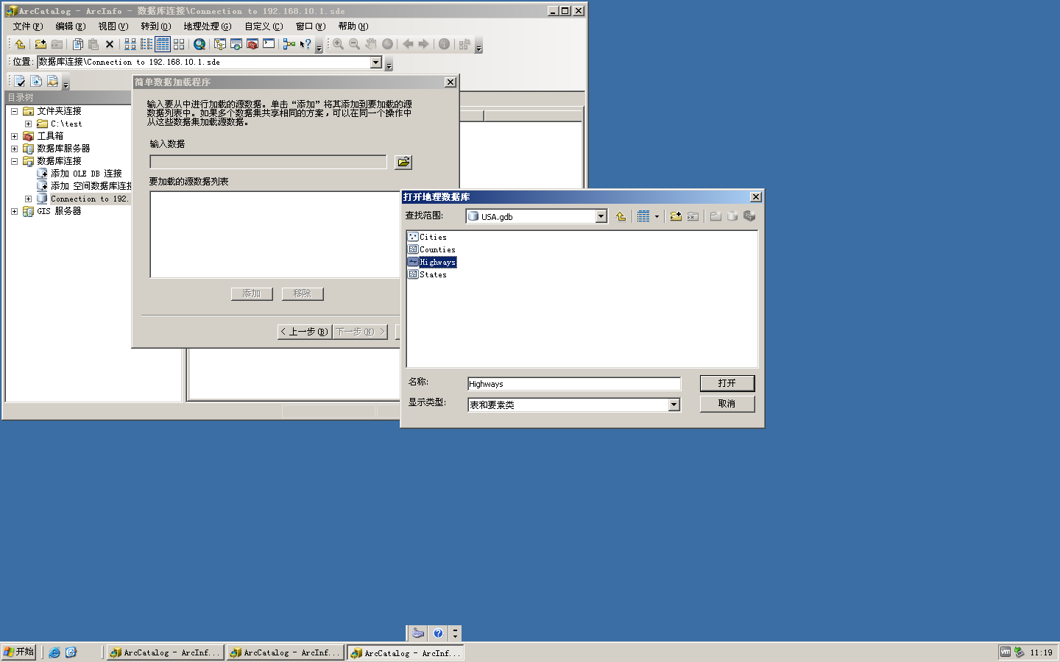

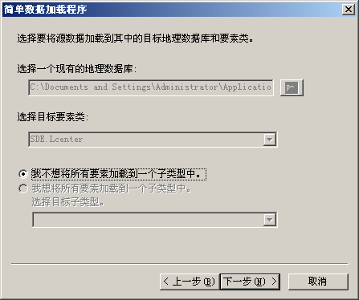

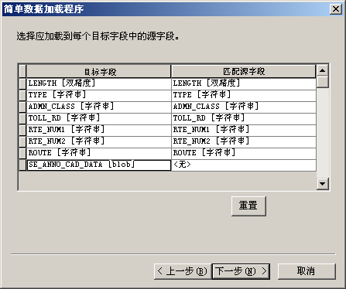

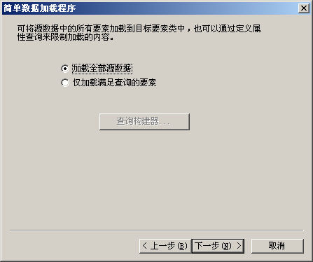

**4）在SQL Developer中刷新“表（已过滤）”，查看新建的表Lcenter,在“数据”选项中发现其空间数据项shape字段的彩色标识和格式区分，这是GeoRaptor的功能。**

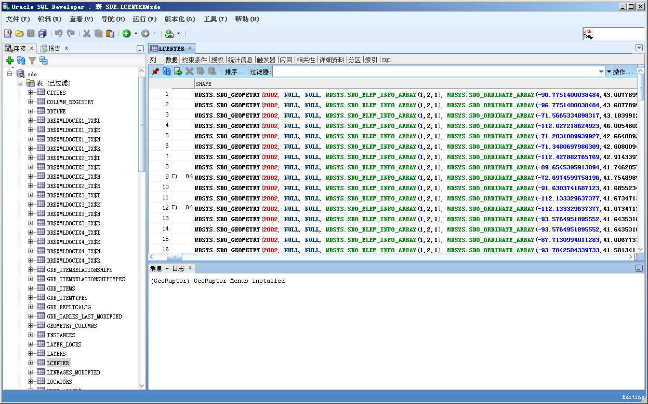

**3、GeoRaptor是一套基于SQL Developer工具上的插件。**

**功能1：显示空间数据图形**

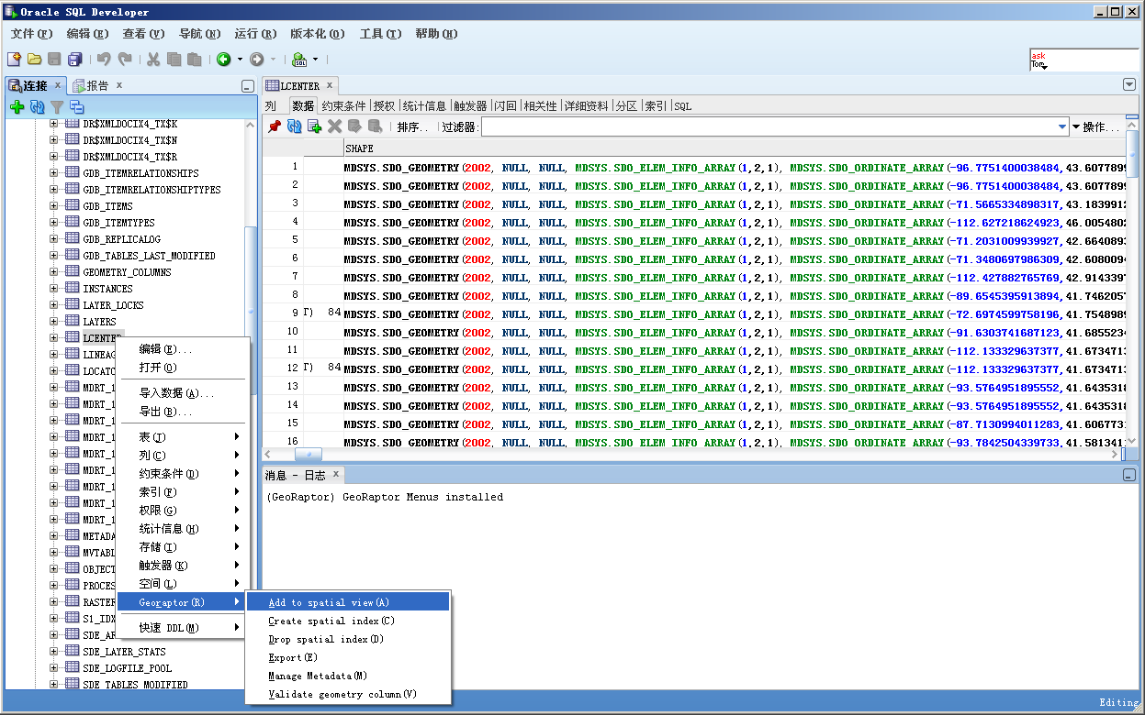

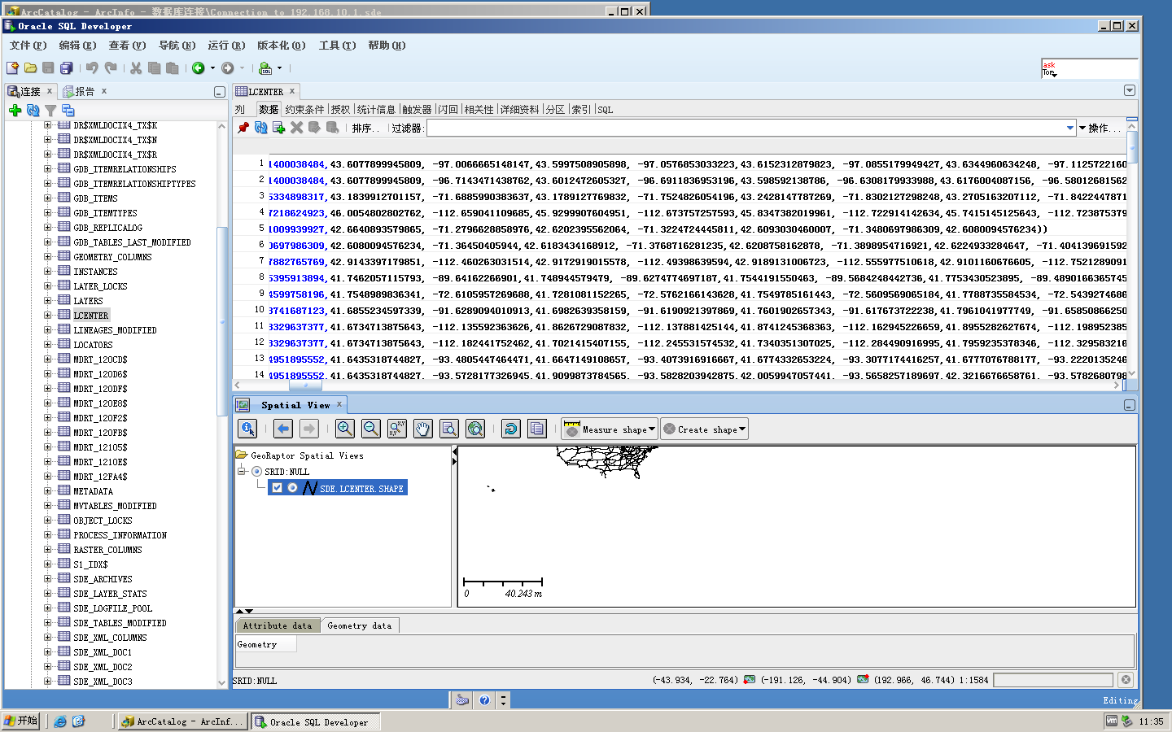

**GeoRaptor的功能2：创建或删除空间索引**

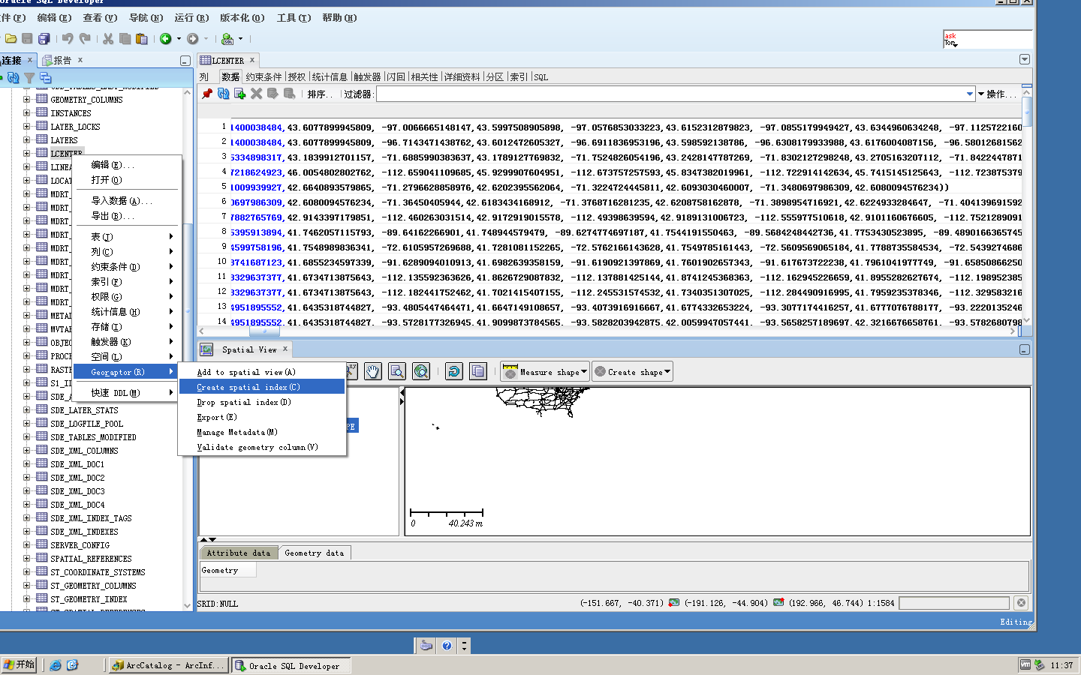

**GeoRaptor的功能3：导出空间数据**

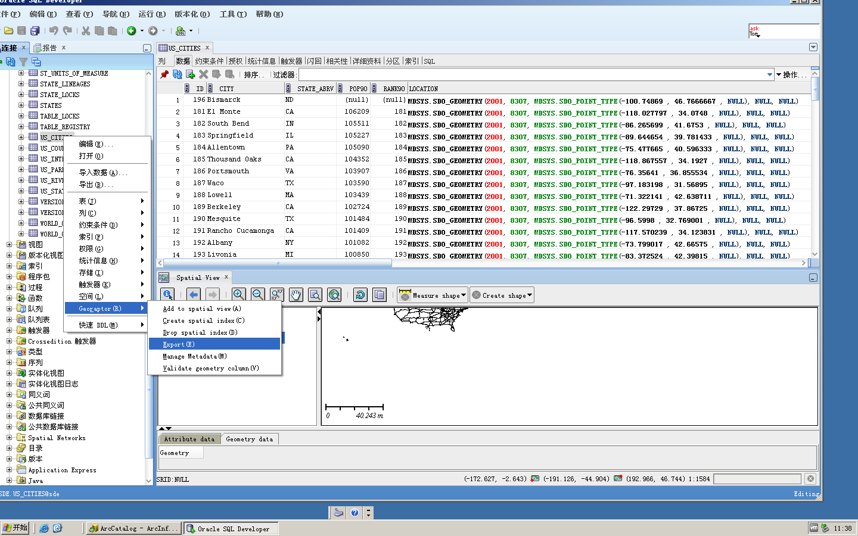

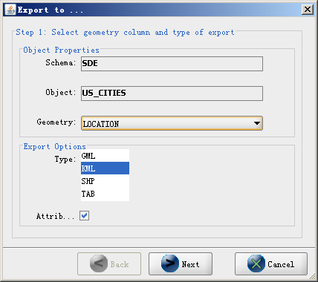

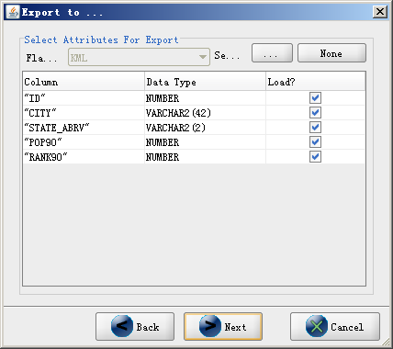

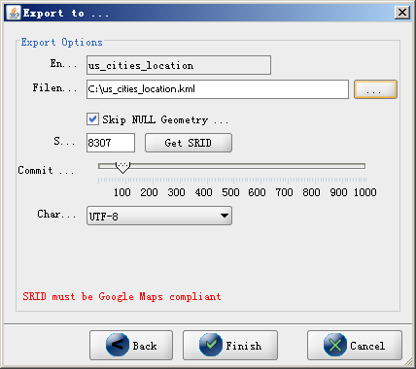

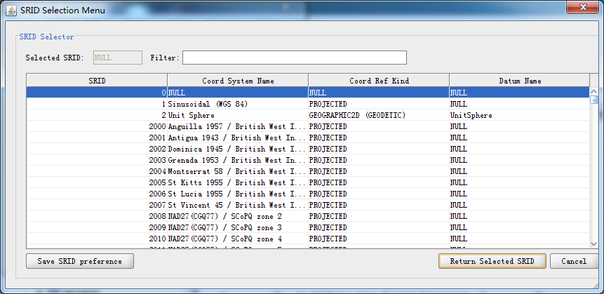

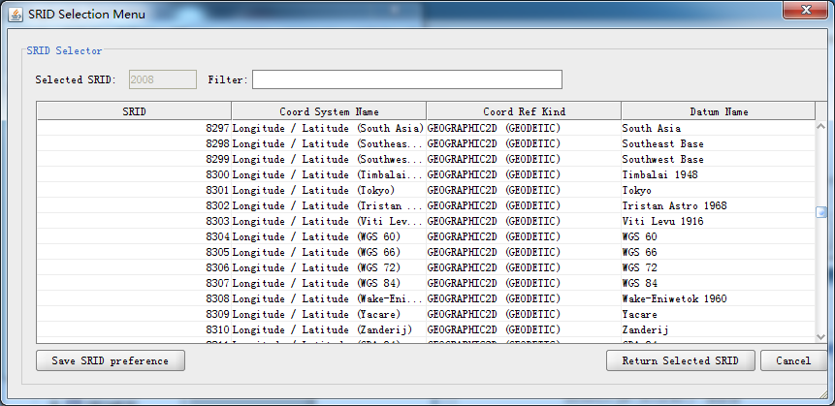

**利用google earth可将用GeoRaptor保存的us_cities_location.kml加载入地图中。**

**4、查看空间数据**

**1)在命令提示符中输入imp sde/sde@orcl file=c:\test\map_large.dmp ignore=y full=y，如图**

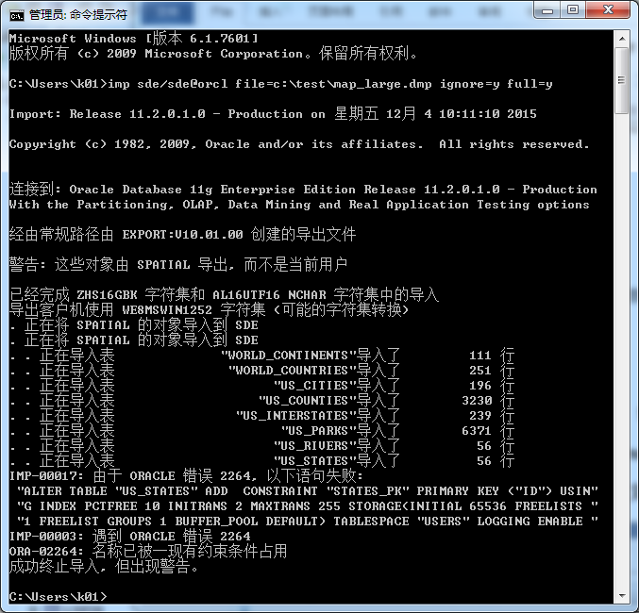

**2)SQL Developer中查询数据：**

**文件｜新建SQL文件test.sql:**

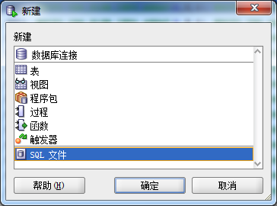

**输入select * from us_cities;**

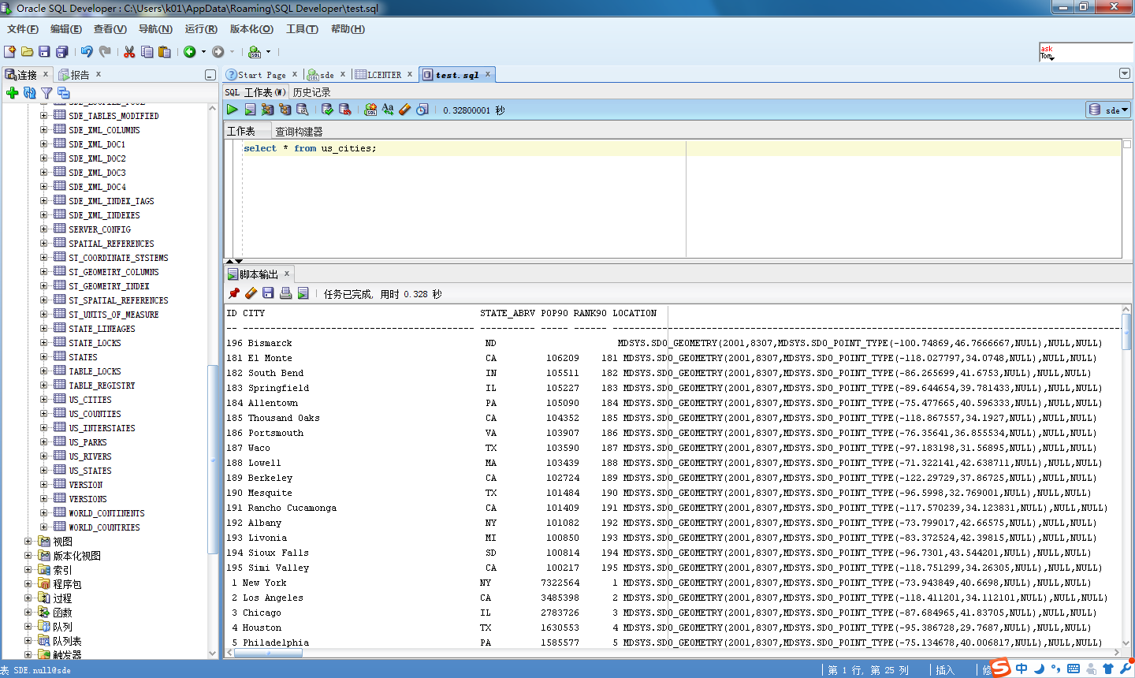

**F5或点“运行“执行。**

**可看到us_cities表中空间数据类型是SDO_POINT_TYPE.**

**如MDSYS.SDO_GEOMETRY(2001,8307,MDSYS.SDO_POINT_TYPE(-100.74869,46.7666667,NULL),NULL,NULL)，请分析其格式。**

**3)再执行：**

**create table my_cities as select city,sdo_geom.sdo_buffer(location,0.25,0.5,'arc_tolerance=0.005 unit=kilometer') geom from us_cities;**

**建立基于us_cities表得到的空间缓冲数据。**

**刷新“表（已过滤）”找到my_cities表，可查看其列结构和数据内容。**

**其geom列的数据取值如MDSYS.SDO_GEOMETRY(2003,8307,NULL,MDSYS.SDO_ELEM_INFO_ARRAY(1,1003,1),MDSYS.SDO_ORDINATE_ARRAY(-100.746375691027,46.768256876942,-100.747437493709,46.7687443899297,-100.74869,46.7689155827589,-100.749942506291,46.7687443899297,-100.751004308973,46.768256876942,-100.751713749566,46.7675272703343,-100.751962830821,46.766666653204,-100.751713653254,46.76580604965,-100.751004172767,46.7650764758182,-100.749942409979,46.7645889956064,-100.74869,46.7644178163535,-100.747437590021,46.7645889956064,-100.746375827233,46.7650764758182,-100.745666346746,46.76580604965,-100.745417169179,46.766666653204,-100.745666250434,46.7675272703343,-100.746375691027,46.768256876942))，请分析其格式。**

**4)使用GeoRaptor查看my_cities表。**

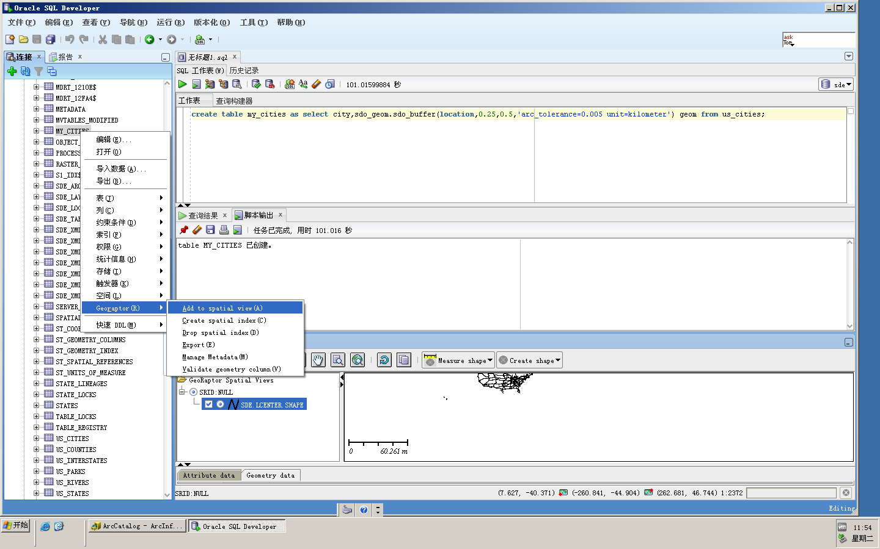

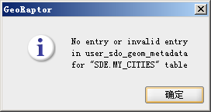

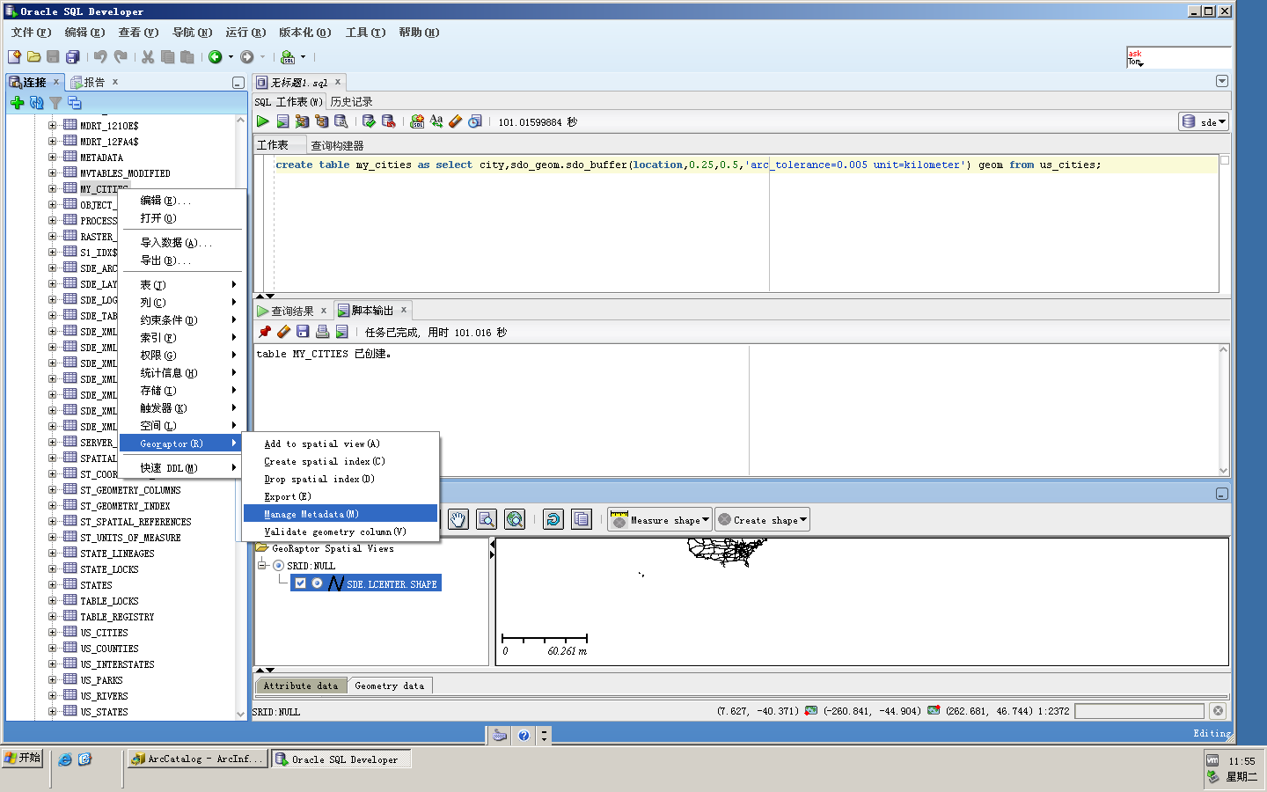

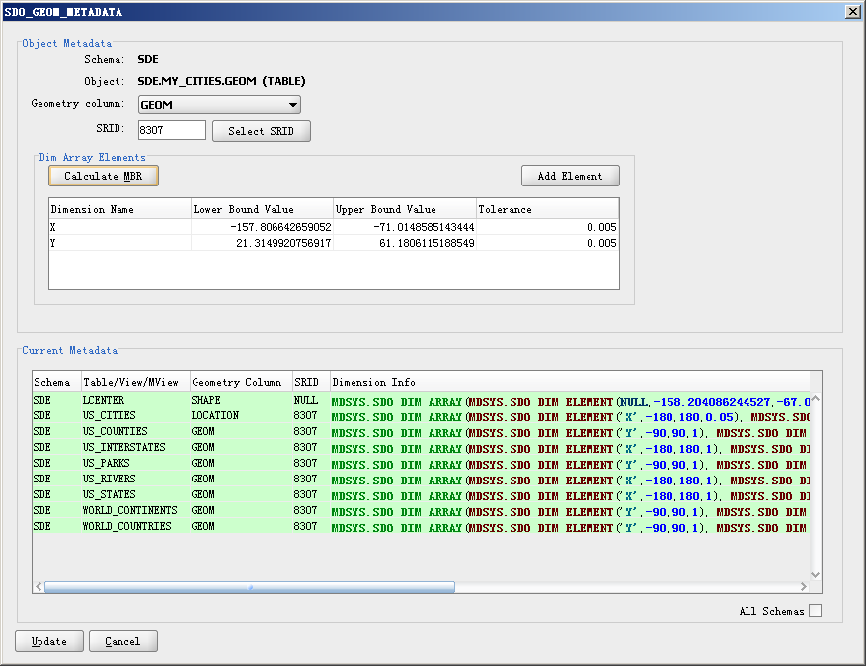

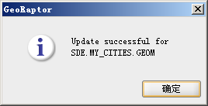

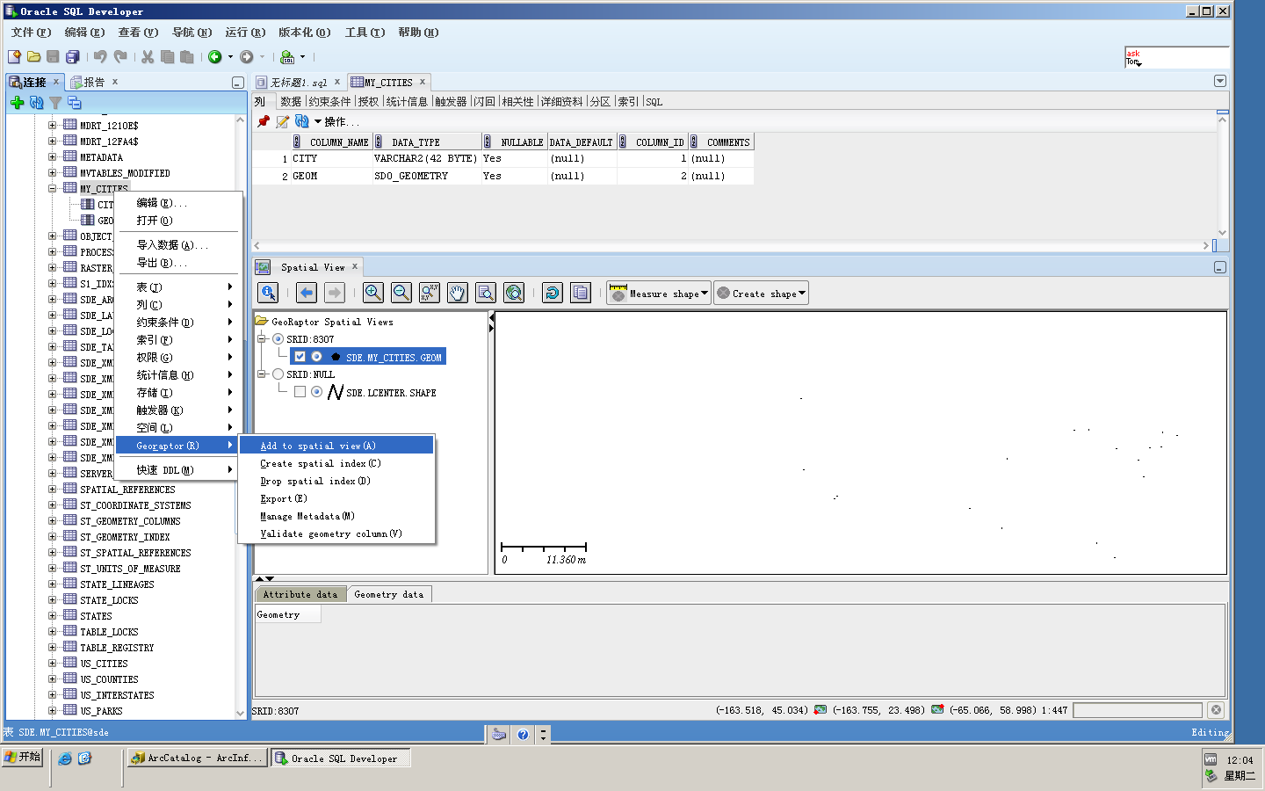

**5.选做。机房无法登录，在自己机器上练习**

**oracle enterprise manager (oem)使用**

**桌面上搜狗浏览器登录**[**https://localhost:1158/em**](https://localhost:1158/em)**或**[**https://127.0.0.1:1158/em，**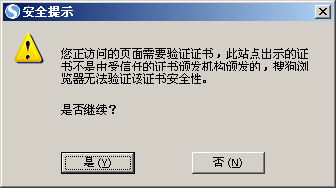](https://127.0.0.1:1158/em，)

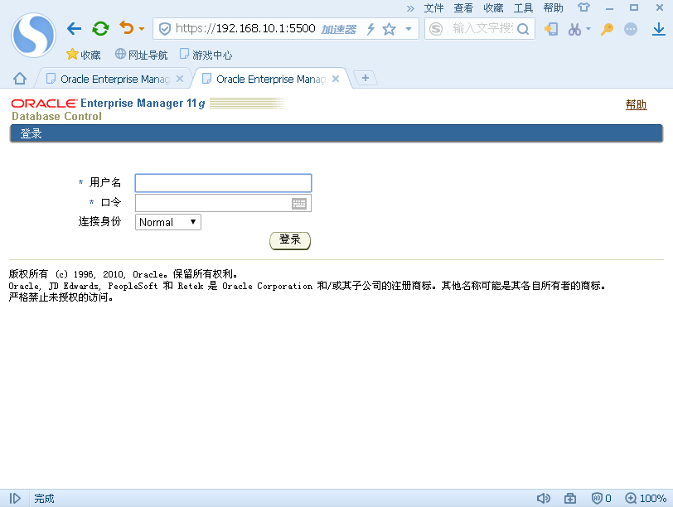

**如果不能正常登录，在命令提示符窗口中输入相关命令后再 登录。**

