[WP、Win10开发或者WPF开发时绘制自定义窗体~例如：一个手机](http://www.cnblogs.com/dunitian/p/4934968.html)

**WP and Win10**

效果：（数字是参考值，和UI无关）

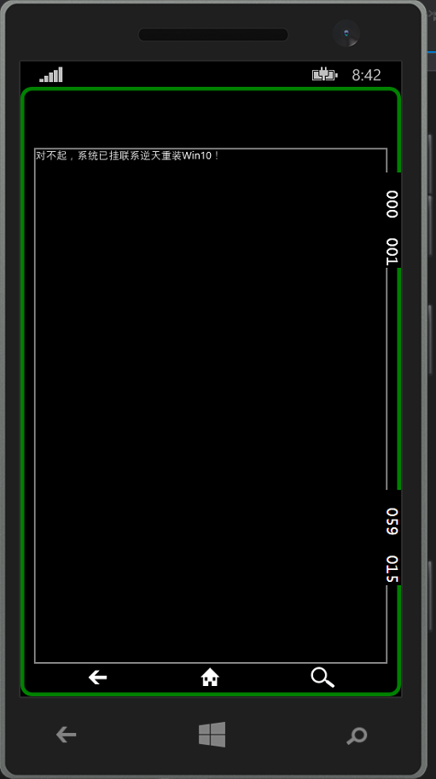

|  |  |
| --- | --- |
| 1  2  3  4  5  6  7  8  9  10  11  12  13  14  15  16  17  18  19  20  21  22  23  24  25  26  27  28  29  30  31  32  33  34  35  36  37  38  39  40 | <Page      x:Class="_05.AllControls._BorderUsePage"      xmlns="<http://schemas.microsoft.com/winfx/2006/xaml/presentation>"      xmlns:x="<http://schemas.microsoft.com/winfx/2006/xaml>"      xmlns:local="using:_05.AllControls"      xmlns:d="<http://schemas.microsoft.com/expression/blend/2008>"      xmlns:mc="<http://schemas.openxmlformats.org/markup-compatibility/2006>"      mc:Ignorable="d"      Background="{ThemeResource ApplicationPageBackgroundThemeBrush}">        <!--快乐玩耍：DIV一个手机-->      <Grid>          <!--手机整体-->          <Border BorderBrush="Green"                  BorderThickness="4"                  CornerRadius="10,10,10,10">              <Grid>                  <!--主屏幕-->                  <Border BorderBrush="Gray"                  BorderThickness="2"                  Margin="10,60,10,30">                      <TextBlock FontFamily="微软雅黑">对不起，系统已挂联系逆天重装Win10！</TextBlock>                  </Border>                  <!--底部-->                  <Border BorderBrush="Black"                  BorderThickness="2"                  CornerRadius="0,0,10,10"                  VerticalAlignment="Bottom"                  Height="30">                      <!--底部按键-->                      <Grid>                          <SymbolIcon Symbol="Back" HorizontalAlignment="Left" Margin="50,0,0,0" Width="50" />                          <SymbolIcon Symbol="Home" HorizontalAlignment="Center" Width="50" />                          <SymbolIcon Symbol="Zoom" HorizontalAlignment="Right" Margin="0,0,50,0" Width="50" />                      </Grid>                  </Border>              </Grid>          </Border>      </Grid>  </Page> |

**WPF**

效果：（边框想要div必须注意==>WindowStyle="None" Background="Transparent" AllowsTransparency="True" MouseLeftButtonDown="DragWindow"）

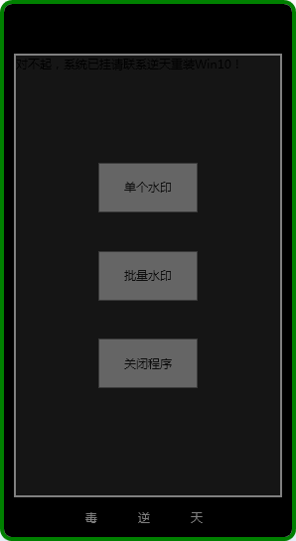

代码：

|  |  |
| --- | --- |
| 1  2  3  4  5  6  7  8  9  10  11  12  13  14  15  16  17  18  19  20  21  22  23  24  25  26  27  28  29  30  31  32  33  34  35  36  37  38  39  40  41  42  43  44  45  46  47 | <Window x:Class="WaterMarkAPP.MainWindow"          xmlns="<http://schemas.microsoft.com/winfx/2006/xaml/presentation>"          xmlns:x="<http://schemas.microsoft.com/winfx/2006/xaml>"          Title="水印工具" Height="545" Width="298" Background="Transparent" AllowsTransparency="True"          WindowStyle="None" ShowInTaskbar="False" WindowStartupLocation="CenterScreen" MouseLeftButtonDown="DragWindow">        <!--快乐玩耍：DIV一个手机-->      <!--手机整体-->      <Border BorderBrush="Green"              Background="Black"              BorderThickness="4"              CornerRadius="10,10,10,10">          <Grid>              <!--主屏幕-->              <Border BorderBrush="Gray"                  BorderThickness="2"                  Margin="10,50,10,40">                  <Grid Background="#FF151515">                      <Grid.RowDefinitions>                          <RowDefinition></RowDefinition>                          <RowDefinition></RowDefinition>                          <RowDefinition></RowDefinition>                          <RowDefinition></RowDefinition>                          <RowDefinition></RowDefinition>                      </Grid.RowDefinitions>                      <TextBlock FontFamily="微软雅黑">对不起，系统已挂请联系逆天重装Win10！</TextBlock>                      <Button Grid.Row="1" Opacity="0.4"  HorizontalAlignment="Center" VerticalAlignment="Center" Height="50" Width="100" Click="Button_Click">单个水印</Button>                      <Button Grid.Row="2" Opacity="0.4"  HorizontalAlignment="Center" VerticalAlignment="Center" Height="50" Width="100" Click="Button_Click_1">批量水印</Button>                      <Button Grid.Row="3" Opacity="0.4"  HorizontalAlignment="Center" VerticalAlignment="Center" Height="50" Width="100" Click="Button_Click_2">关闭程序</Button>                  </Grid>              </Border>              <!--底部-->              <Border BorderBrush="Black"                  BorderThickness="2"                  CornerRadius="0,0,10,10"                  VerticalAlignment="Bottom"                  Height="40">                  <!--底部按键-->                  <Grid>                      <TextBlock Text="毒" HorizontalAlignment="Left" VerticalAlignment="Center" Margin="80,0,0,0" Width="20" Foreground="Gray" MouseLeave="TextBlock_MouseLeave" />                      <TextBlock Text="逆" HorizontalAlignment="Center" VerticalAlignment="Center" Width="20" Foreground="Gray"  MouseLeave="TextBlock_MouseLeave_1"/>                      <TextBlock Text="天" HorizontalAlignment="Right" VerticalAlignment="Center" Margin="0,0,80,0" Width="20" Foreground="Gray"  MouseLeave="TextBlock_MouseLeave_2"/>                  </Grid>              </Border>          </Grid>      </Border>  </Window> |

**扩：DragWindow事件如图**

