[Spring.Net在Mvc4.0中应用的说明](http://www.cnblogs.com/dunitian/p/4325064.html)

案例Demo：http://yunpan.cn/cJ5aZrm7Uybi3 访问密码 414b

Spring.Net在Mvc4.0中应用的说明

1.引用dll

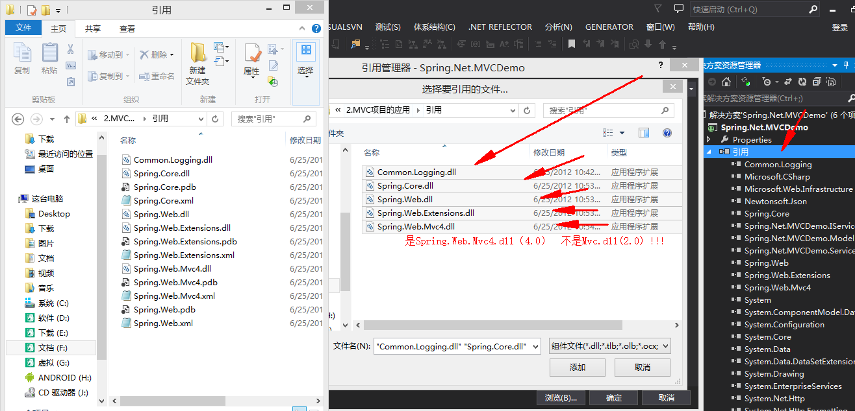

2.修改Global文件 (SpringMvcApplication)

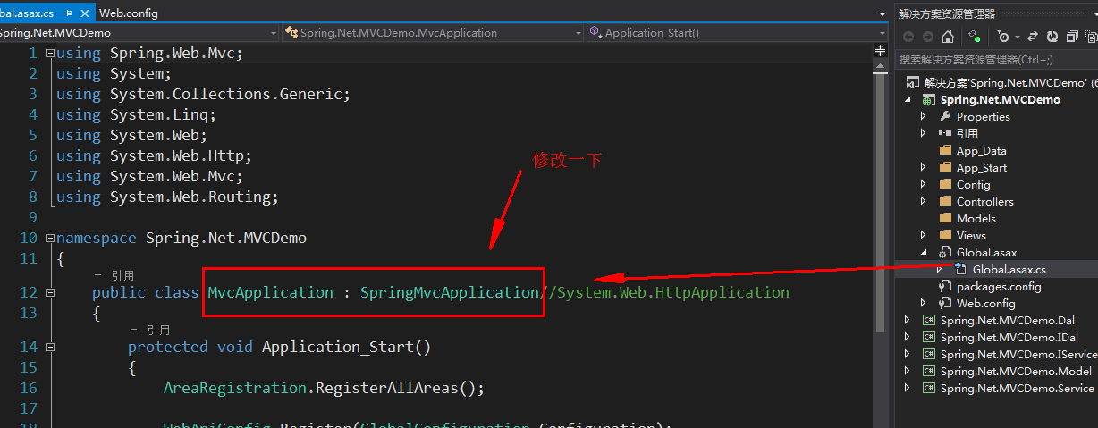

3.控制器添加属性

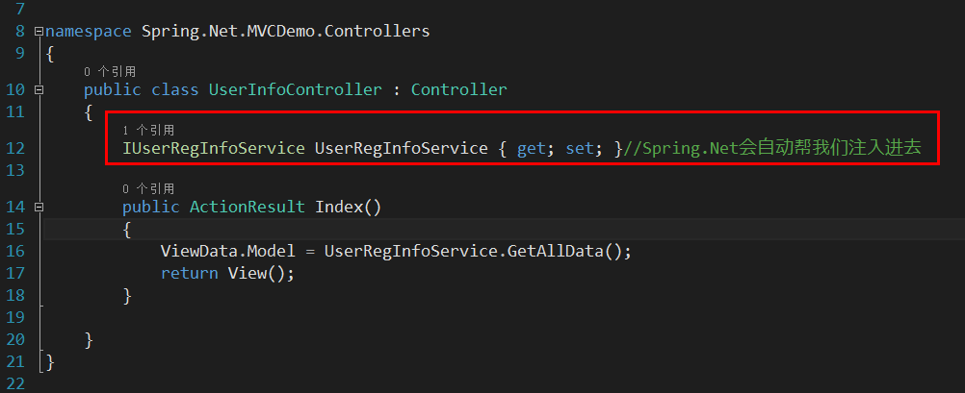

4.WebConfig配置

<!--必须紧跟着configuration之后-->

  <configSections>

    <sectionGroup name="spring">

      <section name="context" type="Spring.Context.Support.MvcContextHandler, Spring.Web.Mvc4"/>

    </sectionGroup>

  </configSections>

  <!--Spring.Net节点详细配置-->

  <spring>

    <context>

      <!--配置文件在网站根目录下的Config文件夹下的Spring.xml记得把xml文件设置成始终复制到输出目录-->

      <resource uri="file://~/Config/Spring.xml"/>

    </context>

  </spring>

  <!--Spring.Net节点详细配置结束-->

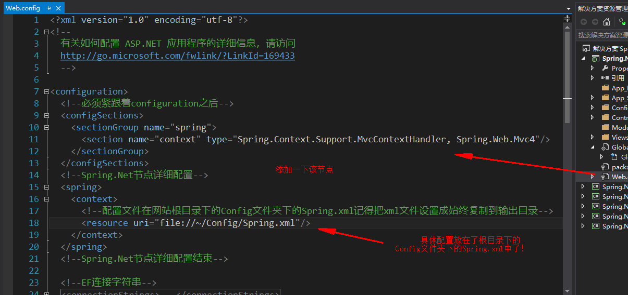

5.Spring.xml的配置(**记得右键属性设置Spring.xml始终复制到输入目录**)

<objects xmlns="http://www.springframework.net">

  <!--放容器里面的所有的节点  type属性的规范：程序集名称在内的类型全名,程序集名-->

  <object type="Spring.Net.MVCDemo.Controllers.UserInfoController,Spring.Net.MVCDemo" singleton="false" >

    <!--给UserInfoController注入UserRegInfoService对象-->

    <property name="UserRegInfoService" ref="UserRegInfoService" />

  </object>

  <!--配置Service-->

  <object name="UserRegInfoService" type="Spring.Net.MVCDemo.Service.UserRegInfoService,Spring.Net.MVCDemo.Service" singleton="false" >

  </object>

</objects>

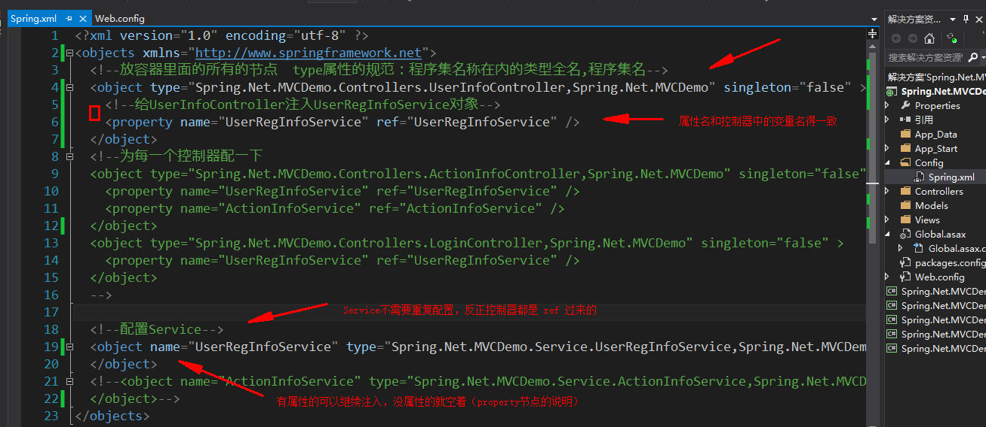

6.注意此异常信息

*Could not load type from string value 'Spring.Net.MVCDemo.Service.UserRegInfoService,Spring.Net.MVCDemo.Service'.*

**说明:**执行当前 Web 请求期间，出现未经处理的异常。请检查堆栈跟踪信息，以了解有关该错误以及代码中导致错误的出处的详细信息。   
  
**异常详细信息:**System.TypeLoadException: Could not load type from string value 'Spring.Net.MVCDemo.Service.UserRegInfoService,Spring.Net.MVCDemo.Service'.  
  
**源错误:**

|  |
| --- |
| 执行当前 Web 请求期间生成了未经处理的异常。可以使用下面的异常堆栈跟踪信息确定有关异常原因和发生位置的信息。 |

**堆栈跟踪:**

|  |
| --- |
| [TypeLoadException: Could not load type from string value 'Spring.Net.MVCDemo.Service.UserRegInfoService,Spring.Net.MVCDemo.Service'.]     Spring.Core.TypeResolution.TypeResolver.Resolve(String typeName) in f:\bamboo-home\xml-data\build-dir\SPRNET-RELEASE-JOB1\src\Spring\Spring.Core\Core\TypeResolution\TypeResolver.cs:81     Spring.Core.TypeResolution.GenericTypeResolver.Resolve(String typeName) in f:\bamboo-home\xml-data\build-dir\SPRNET-RELEASE-JOB1\src\Spring\Spring.Core\Core\TypeResolution\GenericTypeResolver.cs:91     Spring.Core.TypeResolution.CachedTypeResolver.Resolve(String typeName) in f:\bamboo-home\xml-data\build-dir\SPRNET-RELEASE-JOB1\src\Spring\Spring.Core\Core\TypeResolution\CachedTypeResolver.cs:107     Spring.Core.TypeResolution.TypeResolutionUtils.ResolveType(String typeName) in f:\bamboo-home\xml-data\build-dir\SPRNET-RELEASE-JOB1\src\Spring\Spring.Core\Core\TypeResolution\TypeResolutionUtils.cs:101     Spring.Objects.Factory.Support.AbstractObjectDefinition.ResolveObjectType() in f:\bamboo-home\xml-data\build-dir\SPRNET-RELEASE-JOB1\src\Spring\Spring.Core\Objects\Factory\Support\AbstractObjectDefinition.cs:639     Spring.Objects.Factory.Support.AbstractObjectFactory.ResolveObjectType(RootObjectDefinition rod, String objectName) in f:\bamboo-home\xml-data\build-dir\SPRNET-RELEASE-JOB1\src\Spring\Spring.Core\Objects\Factory\Support\AbstractObjectFactory.cs:1123    [CannotLoadObjectTypeException: Cannot resolve type [Spring.Net.MVCDemo.Service.UserRegInfoService,Spring.Net.MVCDemo.Service] for object with name 'UserRegInfoService' defined in file [C:\Users\DNT\Desktop\Spring.Net.MVCDemo\Spring.Net.MVCDemo\Spring.Net.MVCDemo\Config\Spring.xml] line 19]     Spring.Objects.Factory.Support.AbstractObjectFactory.ResolveObjectType(RootObjectDefinition rod, String objectName) in f:\bamboo-home\xml-data\build-dir\SPRNET-RELEASE-JOB1\src\Spring\Spring.Core\Objects\Factory\Support\AbstractObjectFactory.cs:1127     Spring.Objects.Factory.Support.AbstractAutowireCapableObjectFactory.PredictObjectType(String objectName, RootObjectDefinition mod) in f:\bamboo-home\xml-data\build-dir\SPRNET-RELEASE-JOB1\src\Spring\Spring.Core\Objects\Factory\Support\AbstractAutowireCapableObjectFactory.cs:160     Spring.Objects.Factory.Support.DefaultListableObjectFactory.IsFactoryObject(String objectName, RootObjectDefinition rod) in f:\bamboo-home\xml-data\build-dir\SPRNET-RELEASE-JOB1\src\Spring\Spring.Core\Objects\Factory\Support\DefaultListableObjectFactory.cs:1079     Spring.Objects.Factory.Support.DefaultListableObjectFactory.DoGetObjectNamesForType(Type type, Boolean includeNonSingletons, Boolean allowEagerInit) in f:\bamboo-home\xml-data\build-dir\SPRNET-RELEASE-JOB1\src\Spring\Spring.Core\Objects\Factory\Support\DefaultListableObjectFactory.cs:1011     Spring.Objects.Factory.Support.DefaultListableObjectFactory.DoGetObjectsOfType(Type type, Boolean includePrototypes, Boolean includeFactoryObjects, IDictionary resultCollector) in f:\bamboo-home\xml-data\build-dir\SPRNET-RELEASE-JOB1\src\Spring\Spring.Core\Objects\Factory\Support\DefaultListableObjectFactory.cs:841     Spring.Objects.Factory.Support.DefaultListableObjectFactory.GetObjectsOfType(Type type, Boolean includePrototypes, Boolean includeFactoryObjects) in f:\bamboo-home\xml-data\build-dir\SPRNET-RELEASE-JOB1\src\Spring\Spring.Core\Objects\Factory\Support\DefaultListableObjectFactory.cs:835     Spring.Context.Support.AbstractApplicationContext.GetObjectsOfType(Type type, Boolean includePrototypes, Boolean includeFactoryObjects) in f:\bamboo-home\xml-data\build-dir\SPRNET-RELEASE-JOB1\src\Spring\Spring.Core\Context\Support\AbstractApplicationContext.cs:1476     Spring.Context.Support.AbstractApplicationContext.GetObjectsOfType(Type type) in f:\bamboo-home\xml-data\build-dir\SPRNET-RELEASE-JOB1\src\Spring\Spring.Core\Context\Support\AbstractApplicationContext.cs:1411     Spring.Web.Mvc.SpringMvcDependencyResolver.GetService(Type serviceType) in f:\bamboo-home\xml-data\build-dir\SPRNET-RELEASE-JOB1\src\Spring\Spring.Web.Mvc4\SpringMvcDependencyResolver.cs:77     System.Web.Mvc.DependencyResolverExtensions.GetService(IDependencyResolver resolver) +56     System.Web.Mvc.SingleServiceResolver`1.GetValueFromResolver() +43     System.Lazy`1.CreateValue() +416     System.Lazy`1.LazyInitValue() +152     System.Lazy`1.get_Value() +75     System.Web.Mvc.SingleServiceResolver`1.get_Current() +15     System.Web.Mvc.MvcRouteHandler.GetSessionStateBehavior(RequestContext requestContext) +125     System.Web.Mvc.MvcRouteHandler.GetHttpHandler(RequestContext requestContext) +33     System.Web.Mvc.MvcRouteHandler.System.Web.Routing.IRouteHandler.GetHttpHandler(RequestContext requestContext) +10     System.Web.Routing.UrlRoutingModule.PostResolveRequestCache(HttpContextBase context) +9770076     System.Web.Routing.UrlRoutingModule.OnApplicationPostResolveRequestCache(Object sender, EventArgs e) +82     System.Web.SyncEventExecutionStep.System.Web.HttpApplication.IExecutionStep.Execute() +136     System.Web.HttpApplication.ExecuteStep(IExecutionStep step, Boolean& completedSynchronously) +69 |

**版本信息:** Microsoft .NET Framework 版本:4.0.30319; ASP.NET 版本:4.0.30319.34009

 解释如图：

