**IIS7.5+WebConfig实现页面伪静态和301重定向**

使用URLRewriter组件在windows 2003 +iis 6.0下配置伪静态的文章网络上一大堆。但在iis7.0或iis 7.5 环境下配置的网站基本上没有讲解的，就算有也是一些无用的代码段，今天好不容易配置成功了，发个日记共享一下经验。

1. 先下载URLRewriter组件**（**[**点**](http://download.microsoft.com/download/0/4/6/0463611e-a3f9-490d-a08c-877a83b797cf/MSDNURLRewriting.msi)**）**

[**http://download.microsoft.com/download/0/4/6/0463611e-a3f9-490d-a08c-877a83b797cf/MSDNURLRewriting.msi**](http://download.microsoft.com/download/0/4/6/0463611e-a3f9-490d-a08c-877a83b797cf/MSDNURLRewriting.msi)

1. 在网站项目中添加URLRewriter程序集的引用

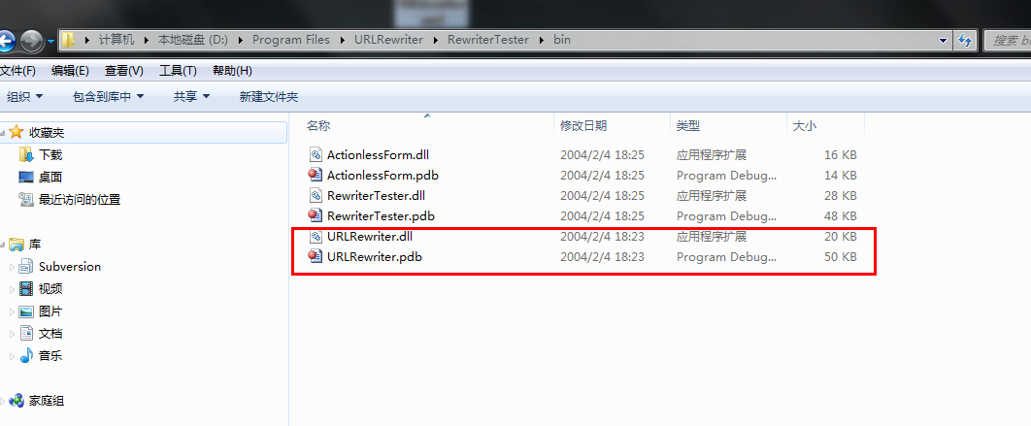

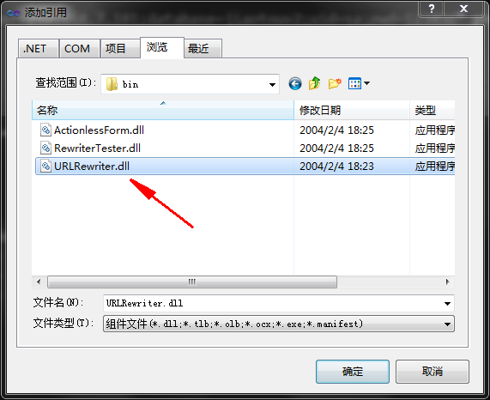

1. 配置webconfig文件

**（1）在<configuration>与</configSections>节点中间设置：**

**<section name="RewriterConfig" type="URLRewriter.Config.RewriterConfigSerializerSectionHandler, URLRewriter" />**

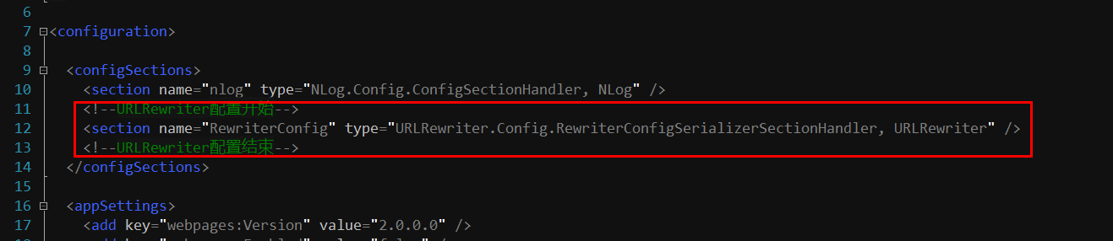

**（2） 在<httpHandlers>与</httpHandlers>节点中间设置：**

**<add name="shtml" verb="*" path="*.shtml" type="URLRewriter.RewriterFactoryHandler, URLRewriter" />**

**<add name="html" verb="*" path="*.html" type="URLRewriter.RewriterFactoryHandler, URLRewriter" />**

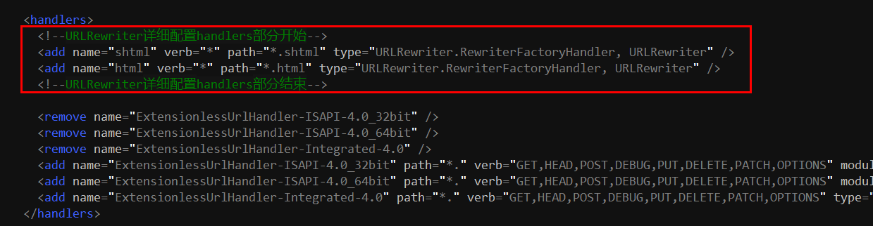

**（3） 在<httpModules>与</httpModules>节点中间设置：**

**<httpModules>**

**<add type="URLRewriter.ModuleRewriter, URLRewriter" name="ModuleRewriter"/>**

**</httpModules>**

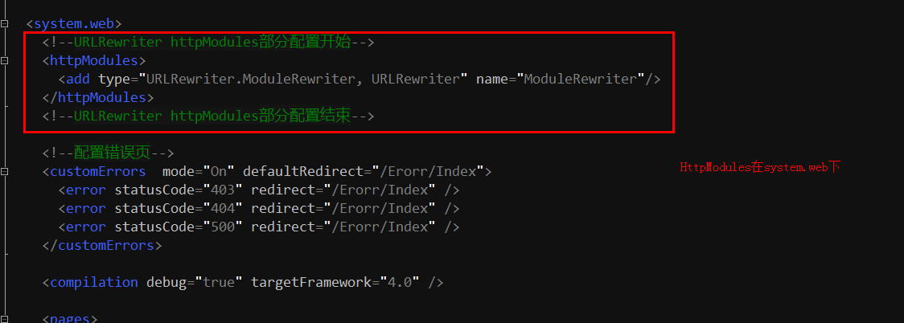

**（4）规则配置的语法：**

**在<configuration>与</configuration>之间加入<RewriterConfig></RewriterConfig>节点。**

**在<RewriterConfig>与</RewriterConfig>之间加入规则：**

**<!--URLRewriter详细配置规则部分开始-->**

**<RewriterConfig>**

**<Rules>**

**<!--伪静态配置开始-->**

**<!--定义伪静态第一条规则 资料下载详细页-->**

**<RewriterRule>**

**<LookFor>^(.*)/Downloadshow/([0-9]+)\.shtml$</LookFor>**

**<SendTo>$1/Downloadshow/$2</SendTo>**

**</RewriterRule>**

**<!--定义伪静态第二条规则 学校课程详细页-->**

**<RewriterRule>**

**<LookFor>^(.*)/s-courseDetail/([0-9]+)\.shtml$</LookFor>**

**<SendTo>$1/schoolsite/courseDetail/$2</SendTo>**

**</RewriterRule>**

**<!--定义301重定向第一条规则 资料下载详细页-->**

**<RewriterRule>**

**<LookFor>^(.*)/downdetail-([0-9]+)\.html$</LookFor>**

**<SendTo>$1/_301Deal/DownDetail/$2</SendTo>**

**</RewriterRule>**

**<!--定义301重定向第二条规则 学校菜单列表页-->**

**<RewriterRule>**

**<LookFor>^(.*)/xuexiao-(\w+)-([0-9]+)-([0-9]+)-([0-9]+)-([0-9]+)-([0-9]+)-\.html$</LookFor>**

**<SendTo>$1/_301Deal/SchoolList/$2-$3-$4-$5-$6-$7</SendTo>**

**</RewriterRule>**

**</Rules>**

**</RewriterConfig>**

**<!--URLRewriter详细配置规则部分结束-->**

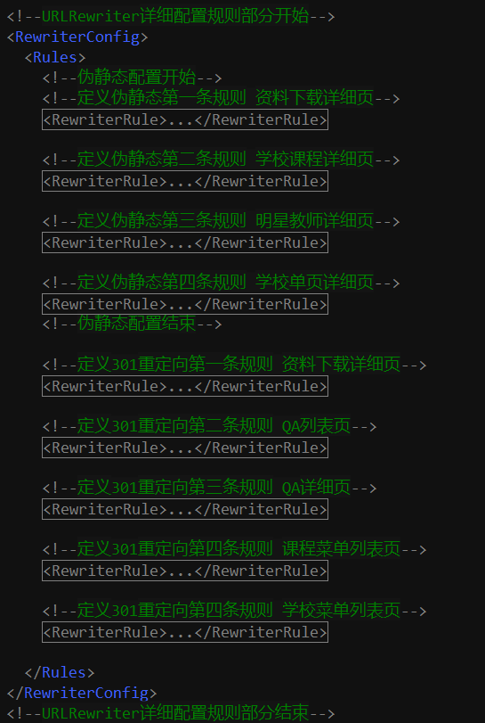

**~~~收工~~~**