异常处理汇总-数据库系列  <http://www.cnblogs.com/dunitian/p/4522990.html>

后期会在博客首发更新：[http://dnt.dkill.net/Article/Detail/313](http://dnt.dkill.net/Article/Detail/313" \t "_blank)

错误如图，怎么执行都没有自己想要的效果（return掉了，还有个啥？？？！！！）

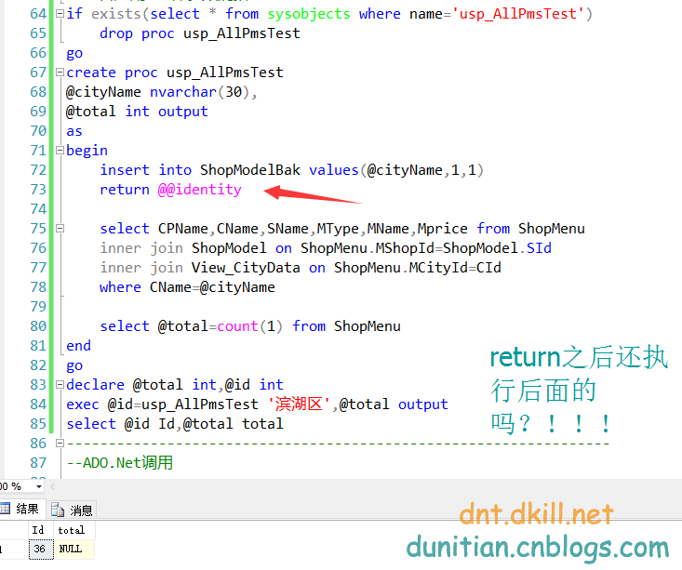

处理后：

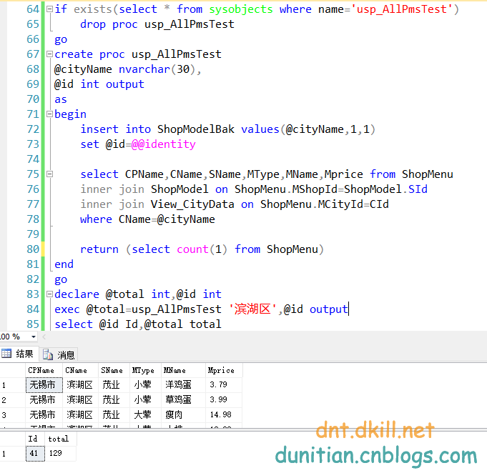

|  |
| --- |
| if exists(select \* from sysobjects where name='usp\_AllPmsTest')      drop proc usp\_AllPmsTest  go  create proc usp\_AllPmsTest  @cityName nvarchar(30),  @id int output  as  begin      insert into ShopModelBak values(@cityName,1,1)      set @id=@@identity        select CPName,CName,SName,MType,MName,Mprice from ShopMenu      inner join ShopModel on ShopMenu.MShopId=ShopModel.SId      inner join View\_CityData on ShopMenu.MCityId=CId      where CName=@cityName        return (select count(1) from ShopMenu)  end  go  declare @total int,@id int  exec @total=usp\_AllPmsTest '滨湖区',@id output  select @id Id,@total total |

ADO.Net

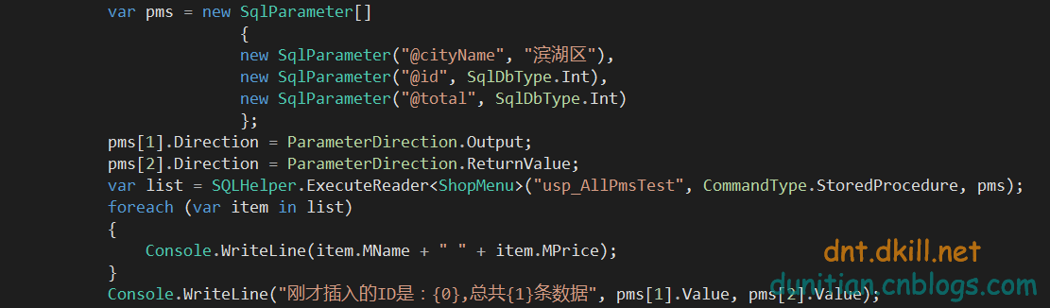

|  |
| --- |
| var pms = new SqlParameter[]                            {                            new SqlParameter("@cityName", "滨湖区"),                            new SqlParameter("@id", SqlDbType.Int),                            new SqlParameter("@total", SqlDbType.Int)                            };              pms[1].Direction = ParameterDirection.Output;              pms[2].Direction = ParameterDirection.ReturnValue;              var list = SQLHelper.ExecuteReader<ShopMenu>("usp\_AllPmsTest", CommandType.StoredProcedure, pms);              foreach (var item in list)              {                  Console.WriteLine(item.MName + " " + item.MPrice);              }              Console.WriteLine("刚才插入的ID是：{0},总共{1}条数据", pms[1].Value, pms[2].Value); |

相关文章：http://www.cnblogs.com/dunitian/p/5362528.html