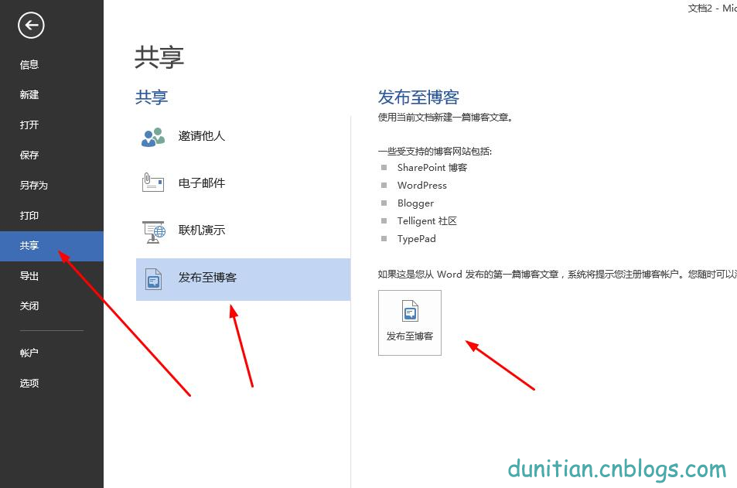



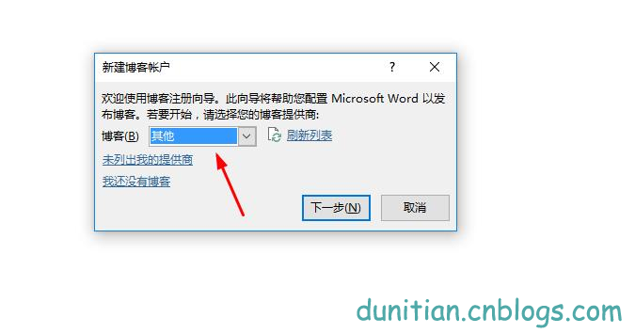







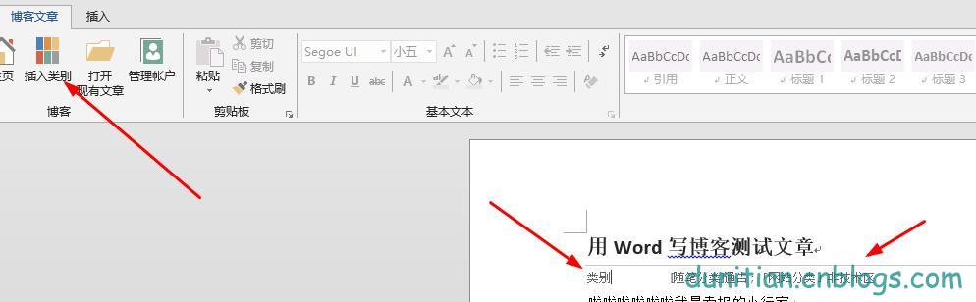

**效果如下：**

啦啦啦啦啦啦我是卖报的小行家



|  |
| --- |
| /// <summary>  /// Word转换成PDF  /// </summary>  /// <param name="inputPath">载入路径</param>  /// <param name="outputPath">保存路径</param>  /// <param name="startPage">初始页码（默认为第一页[0]）</param>  /// <param name="endPage">结束页码（默认为最后一页）</param>  public static bool WordToPDF(string inputPath, string outputPath, int startPage =0, int endPage = 0)  {  bool b = true;    #region初始化  //初始化一个application  Application wordApplication = new Application();  //初始化一个document  Document wordDocument = null;  #endregion    #region参数设置~~我去累死宝宝了~~  //word路径  object wordPath = Path.GetFullPath(inputPath);    //输出路径  string pdfPath = Path.GetFullPath(outputPath);    //导出格式为PDF  WdExportFormat wdExportFormat = WdExportFormat.wdExportFormatPDF;    //导出大文件  WdExportOptimizeFor wdExportOptimizeFor =WdExportOptimizeFor.wdExportOptimizeForPrint;    //导出整个文档  WdExportRange wdExportRange = WdExportRange.wdExportAllDocument;    //开始页码  int startIndex = startPage;    //结束页码  int endIndex = endPage;    //导出不带标记的文档（这个可以改）  WdExportItem wdExportItem = WdExportItem.wdExportDocumentContent;    //包含word属性  bool includeDocProps = true;    //导出书签  WdExportCreateBookmarks paramCreateBookmarks =WdExportCreateBookmarks.wdExportCreateWordBookmarks;    //默认值  object paramMissing = Type.Missing;    #endregion    #region转换  try  {  //打开word  wordDocument = wordApplication.Documents.Open(ref wordPath, ref paramMissing, refparamMissing, ref paramMissing, ref paramMissing, ref paramMissing, refparamMissing, ref paramMissing, ref paramMissing, ref paramMissing, refparamMissing, ref paramMissing, ref paramMissing, ref paramMissing, refparamMissing, ref paramMissing);  //转换成指定格式  if (wordDocument != null)  {  wordDocument.ExportAsFixedFormat(pdfPath, wdExportFormat, false, wdExportOptimizeFor, wdExportRange, startIndex, endIndex, wdExportItem, includeDocProps, true, paramCreateBookmarks, true, true, false, ref paramMissing);  }  }  catch (Exception ex)  {  b = false;  }  finally  {  //关闭  if (wordDocument != null)  {  wordDocument.Close(ref paramMissing, ref paramMissing, ref paramMissing);  wordDocument = null;  }    //退出  if (wordApplication != null)  {  wordApplication.Quit(ref paramMissing, ref paramMissing, ref paramMissing);  wordApplication = null;  }  }    return b;  #endregion  } |