**DATABASE MANAGEMENT LAB PROJECT**

**Batch 2 Name: Akshada Naik Roll no: 1830**

**Project Topic: Super Market Management System.**

**Super Market Management System**

**Introduction:**

It is a web-based application implemented in VB.NET (Visual Studio 2019) using MySQL server as the database. This project is targeted for mainly big supermarkets and particularly aims at automation of various management procedures such as managing sales and purchases, stock details, etc. All the details and records in the supermarket are maintained in a centralized database.

**About Super Market Management System:**

It is easy to manage mini markets as the customers entering such stores are less and the items in the inventory too is less. Even with few human resources deployment and paper works, small supermarkets or mini-markets can be effectively managed. But, the case is no so with big supermarkets with tens of thousands of items in various inventories and high traffic flow of customers and retailers.

**Existing System:**

The existing system is very paper based in small as well as medium supermarkets. Even though the paper work and manpower requirement is less, the existing system is not very economical for these markets. Relevant and irrelevant information are entered and stored in the same place, which is very clumsy and untidy process.

In case of big supermarkets, the existing system is computerized to some extent, but it is not fully automated to cover all the aspects of the super markets. The data entry, storing, and retrieval procedure is very inefficient. Further, there are chances of data misplacement and wrong data entry. The System is still very insecure and inflexible to adapt users requirements.

**Requirement:**

Front End: Visual Studio 2019 (Windows forms) using VB.NET.

Back End: Xampp for Mysql database (phpMyAdmin), Mysql for Visual Studio, Mysql Connector for .NET.

Internet Connectivity.

**Design of System:**

**Proposed System:**

The proposed supermarket management system aims at full automation of big, medium, and mini supermarkets by making the system reliable, fast, user-friendly and informative. It reduces paperwork, manpower requirement, and increases the productivity of the Super Market. Using this application, one can add, modify, update, save, delete, and print details. There’s also a search feature to find products available in the supermarket.

**Features:**

It reduces the time and manpower required for management and maintenance of different tasks. It reduces the paper work is existing system, hence it is economical and efficient. With this system, customers can even give feedback which can be stored in the database. As the entire system is fully computerized, records of daily and monthly purchases and sales can be recorded and analysed. This system is very secure, user-friendly and reliable.

**Implementation:**

The main modules in Super Market Management System are:

**Administrative Module:**

This module is handled by an admin who has full control over the system. Admin is required to log in to the system with a unique user id and password. They have control over all the modules and features of the System. Admin can allocate unique user id (username and password) to the employees and staff.

**Employee Module:**

Employee can use this module with their user id. They can keep track of items in the super market, and are responsible for recording details of purchases and sales.

**Purchase Module:**

This module stores all the purchase details of the supermarket.

**Sales Module:**

This module stores all the sales details of the supermarket.

**Billing Module:**

With the help of this module all the payment details based on purchases and sales can be shown.

User Interface (UI) windows forms for the users so that they can store, add, delete, update records in the database using the Visual studio.

MySQL database is used to create tables and store the data and retrieve it whenever needed.

MySQL for visual studio and Mysql Connector for .NET for connecting visual studio to database.

**Result:**

**Conclusion:**

The proposed Super Market Management System is very useful for big super markets as well as small ones to manage their inventories, staffs, and records of the purchases and sales.

New features and modules can be easily added into the system, so the project is very flexible and can adopt to the requirements of the supermarket and its users.

**USE CASE DIAGRAM:**

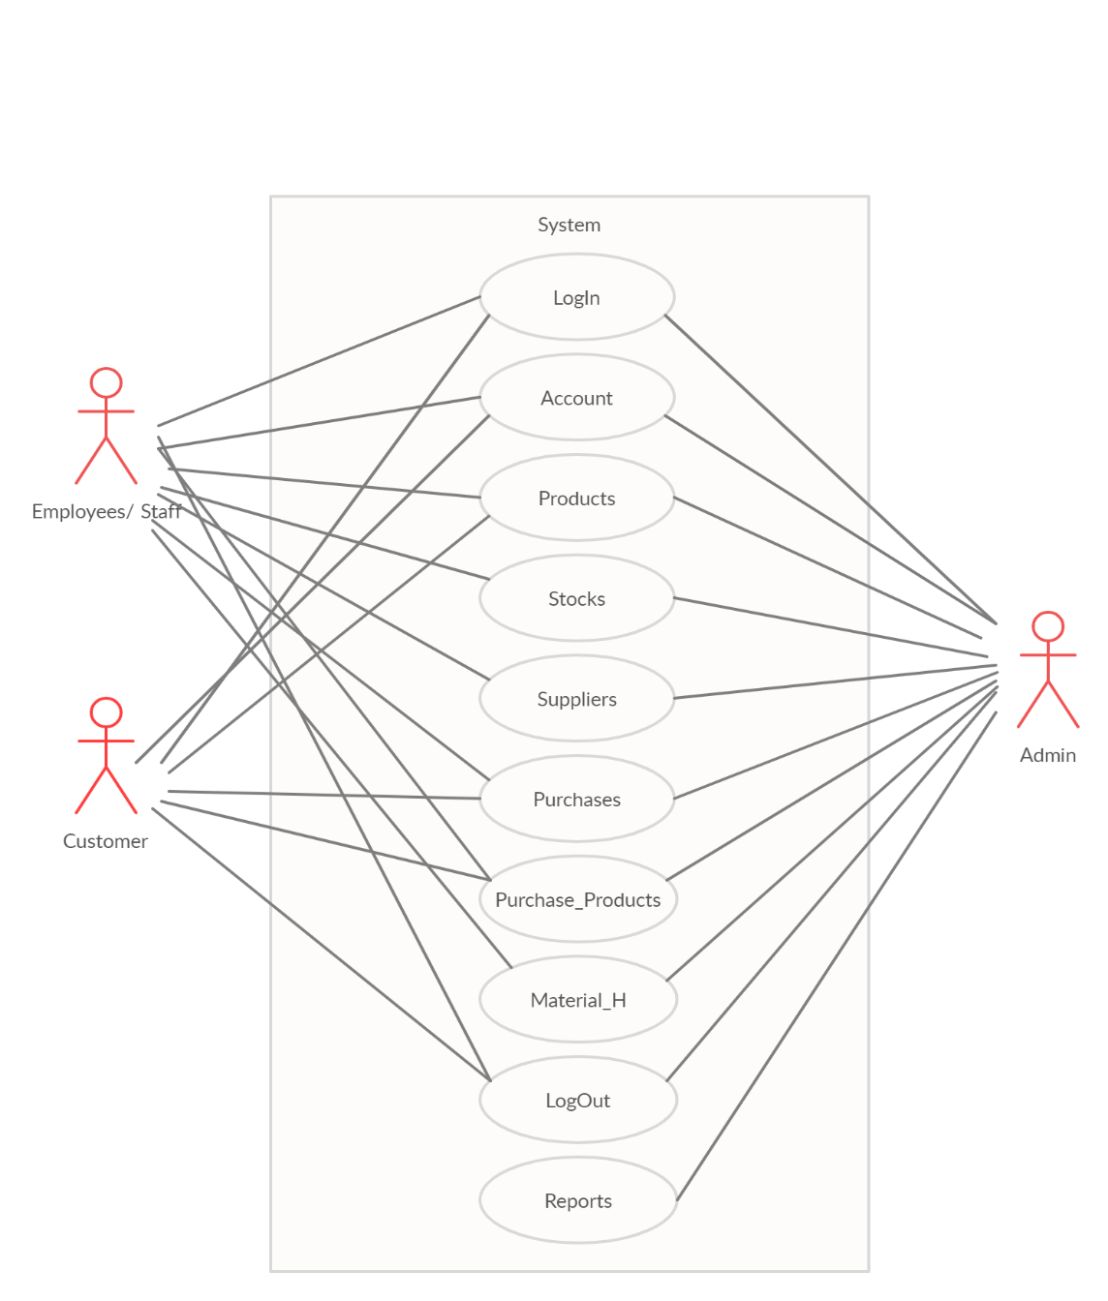

**Login**

**Account**

**Transactions**

**Bill**

**Reports**

**logout**

**Employees**

**Change Password**

**Account**

**Products**

**Orders**

**Arrival**

**Administrator**

**Customer Bill Payment**

**Purchase Bill payments**

**Issued Report**

**Stock Report**

**Purchase Report**

**Customer**

**Suppliers**

**Stocks**

**Suppliers**

**Products**

**Items**

**Customer**

**Issued**

**NEW**

**SAVE**

**DELETE**

**PRINT**

**CLOSE**

**MODIFY**

**VIEW**

**SEARCH**

**NEXT**

**LAST**

**FIRST**

**Arrival Report**

**ER Diagram:**

