DMX203 Computer Game Logic

Assignment: Power-Gaming Strategies for Games

# Objective

Conduct research into a retro game to understand more about the history, artwork, audio and the power-gaming strategies required to win at it.

# Instructions

|  |  |
| --- | --- |
| Website | <https://www.retrogames.cc/> |
| Game | Choose 1 game from this list:  <https://docs.google.com/spreadsheets/d/1blJ3uW2-7D4koYC8tx8D_WldLWyzmNYkSJ70LtivyTU/edit?usp=sharing>  Find it on the website and declare on this Google Form <https://forms.gle/Z3sVQkfqNmzbLCHs9> |
| Research and Analysis | Play this game and research on the power-gaming strategies which players can use to win.  **You need to submit a few screen shots of the gameplay and includes a selfie with the game and the last one is the end of level 1**. |
| Submission | Submit this document via Blackboard |
| How to Submit | Enter your research into the form from the next page onwards |
| Submission Deadline | 21st January 2020, Tuesday, 2359 hour. |

Example of Selfie with the game:



Example of Winning Screen:

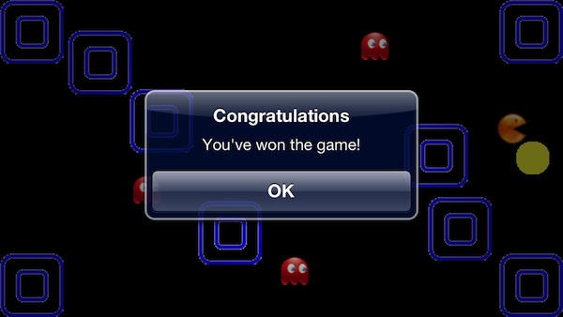

# Input your research here:

1. **Name of the Game (2%)**

Click or tap here to enter text.

1. **Link to the Game (2%)**

Click or tap here to enter text.

1. **Year which this game was first created (1%)**

Click or tap here to enter text.

1. **Description of the Game (50 ~ 200 words) (5%)**

Click or tap here to enter text.

1. **Selfie of yourself with the game start screen (5%)**



1. **Screen shots of the gameplay #1 (5%)**



1. **Screen shots of Winning Screen (5%)**



1. **Discussion about the Artwork and Audio(100 ~ 200 words) (10%)**

Click or tap here to enter text.

1. **Discussion about the Game Design and the power-gaming strategies (200 ~ 500 words) (25%)**

Click or tap here to enter text.

===== End of DMX203 Computer Game Logic Assignment =====