The Framework Design of a Digital and Intelligent Ecosystem for K–12 Mathematics Education

Xinguo YU
National Engineering Research Center for E-Learning, Central China Normal University, Wuhan, China 430079,
xgyu@ccnu.edu.cn
Jing Xia
College of International Cultural Exchange, Central China Normal University, Wuhan, China 430079,
1026847278@qq.com
Chengjun HE
National Engineering Research Center for E-Learning, Central China Normal University, Wuhan, China 430079,
xgyu@ccnu.edu.cn

Abstract: This paper presents the design of a Digital and Intelligent Ecosystem for Mathematics Education (DIEM) aimed at transforming K–12 mathematics teaching and learning through enhanced Connectivity, Customization, and Intelligence. Unlike traditional Intelligent Tutoring Systems (ITSs) that often operate in isolation and support only specific tasks, our ecosystem leverages a cloud-based infrastructure to interlink eight key educational scenarios. Customized applications ensure seamless transitions between classroom lecturing, self-study, lecture preparation, family study, companion study, group study, homework completion, and grading activities. Central to the ecosystem are AI-powered modules—namely a problem-solving engine, a dynamic symbol recommendation service, and an automatic grading component—which collectively provide personalized guidance, interactive support, and real-time analytics for both students and teachers. Evaluation demonstrates that our framework outperforms conventional ITSs in connectivity, adaptability, and intelligent assistance. We conclude by outlining implementation strategies and proposing directions for future research in intelligent education ecosystems.
Keywords: Mathematics Education; Intelligent Ecosystem; Cloud Infrastructure; Adaptive Learning; AI in Education; Intelligent Tutoring Systems

1. Introduction
The rapid advancement of educational cloud platforms [13] and artificial intelligence technologies [2,3] has created unprecedented opportunities to overcome the limitations of classical Intelligent Tutoring Systems (ITSs), which typically function as standalone engines for narrow tasks [8]. In response, we propose DIEM, a holistic ecosystem that unifies diverse mathematics education scenarios into a coherent, AI-driven environment. By emphasizing three core objectives—Connectivity, Customization, and Intelligence—the ecosystem remedies the isolation and lock-in of traditional ITSs, fostering seamless data synchronization and personalized learning pathways across K–12 settings.
Connectivity is achieved through a centralized cloud hub that aggregates learner interactions from eight identified scenarios: classroom lecturing, self-study, lecture preparation, family study, companion study, group study, homework completion, and grading [13]. Customization allows each application to adapt content, pacing, and interaction styles to individual learner profiles without disrupting their established routines [2]. Intelligence is delivered via integrated AI components, including a robust problem-solving engine, symbol recommendation agent, and automated grading tool [5,15].
The remainder of this paper is structured as follows: Section 2 reviews related work; Section 3 defines the ecosystem’s design goals; Section 4 details the overall architecture; Section 5 describes proprietary AI technologies; Section 6 presents scenario-specific interaction schemes; Section 7 discusses implications and future directions; and Section 8 concludes the study.

2 Literature Review
2.1 Digital Learning Systems in Mathematics Education
Platforms such as Khan Academy, GeoGebra, and Desmos offer interactive visualization and practice that enhance conceptual understanding in mathematics [1]. These tools demonstrate the potential of cloud-based resources to support learner engagement and scaffold complex ideas.
2.2 Intelligent Tutoring Systems and Adaptive Learning
AI-powered ITSs like Carnegie Learning and DreamBox provide adaptive learning paths informed by real-time analytics [2]. However, most existing systems rely on isolated rule-based templates, limiting their ability to support holistic learning journeys [8].
2.3 Human–Computer Interaction in Education
Effective educational interfaces draw on usability heuristics and design principles articulated by Nielsen and Shneiderman to create intuitive, accessible tools [7]. Multimodal interfaces further enrich learning by incorporating speech, handwriting, and visual interactions.
2.4 The Role of Teachers in Digital Ecosystems
Teacher-facing functionalities—dashboards, analytics, and content customization—are critical for informed instructional decisions and targeted support [9]. Empowering educators enhances the pedagogical impact of AI-driven systems.

3 Design Goals of the Ecosystem
In light of the limitations of existing ITSs, DIEM is founded on three principles:
Goal 1: Connectivity. Link all learner activities across diverse scenarios to maintain a unified user profile and enable seamless transitions (e.g., from in-person lessons to virtual exercises) without loss of continuity [13].
Goal 2: Customization. Tailor content, feedback, and pacing to individual learner strengths, weaknesses, and preferences—whether through visual aids, step-by-step guidance, or interactive exercises—to maximize engagement and learning efficiency [2].









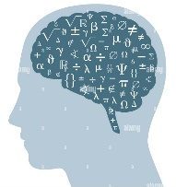
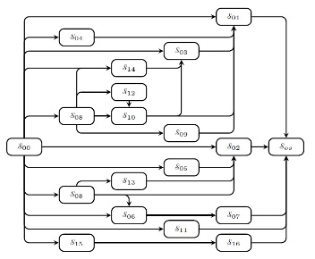
Goal 3: Intelligence. Integrate AI modules—problem-solving engine, symbol recommendation, and video generation—to provide personalized guidance, predictive analytics, and real-time feedback to both students and teachers [5,15].
Figure 1. The mathematics education ecosystem that the educational cloud connects the eight education scenarios.
Educational Cloud
Lecture Preparation
Self-study
Classroom Lecturing
Family Study
Companion Study
Group Study
Doing Homework
Grading Homework
Figure 2. The illustration of the process that the mathematics solving engine solves a problem.
Problem Input: A fruit shop has 30 crates of pears. The number of apple crates is twice that of pears, and the number of orange crates is 16 more than apples. How many crates of oranges are there?
Solution Output:
State 01 (relation sets):
Fruit shop has 30 crates of pears→Pears = 30 crates;
Apple crates are twice that of pears→Apples = Pears × 2; Orange crates are 16 more than apples→Oranges = Apples + 16 crates
State 02 (equations):
a = 30, b = a × 2, c = b + 16.
[Pears: a, Apples: b, Oranges: c]
State 03 (solution):
a: 30, b: 60, c: 76.
Answer: There are 76 crates of oranges.

.
4. Overall Structure of the DIEM
The Digital and Intelligent Ecosystem for Mathematics Education (DIEM) is proposed to achieve Connectivity, Customization, and Intelligence through alleviating self-containment and uniform. To achieve the design goal, the eight scenarios are identified. As Figure 1 has illustrated, the educational cloud is used as the infrastructures to connect these eight main scenarios. The eight main scenarios are Classroom Lecturing, Self-Study, Lecture Preparation, Family Study, Companion Study, Doing Homework, Group Study, and Group Homework. Figure 1 illustrates the ecosystem’s architecture, which comprises three layers: 1. Cloud Infrastructure. A central coordination hub for resource synchronization, user management, and security. 2. Scenario Applications. Customized interfaces for eight scenarios, each conforming to standard API specifications for interoperability. 3. AI Services. Backend modules providing advanced problem solving, symbol recommendation, and automated grading [5,15].
Users—students, teachers, and parents—access the ecosystem via web or mobile clients, enabling high availability and scalability.

5 Proprietary AI Technologies
Three Proprietary Technologies are used to Build The DIEM: Mathematics Solving Engine, Symbol recommendation and Mathematics Assignment Grading. This section describes them briefly.

  - Mathematics Solving Engine
Through more than one-decade accumulation, we have built a Mathematics Solving Engine illustrated in Figure 2, which has the following properties.
Basic Structure: Its basic structure is a state-transform graph, which is built by integrating a set of existing solving algorithms. On the other hand, an existing algorithm could be a partial graph.
Performance: Based on its structure, it has the following abilities.
- It can solve the text-diagram problems at about 90%, and can improve the accuracy gradually on the popular datasets.
- It can generate the full solution with knowledge annotation.
In other word, it outperforms any single algorithm in both accuracy and tutoring potentiality.

5.2 Dynamic Keyboard for Aiding Input
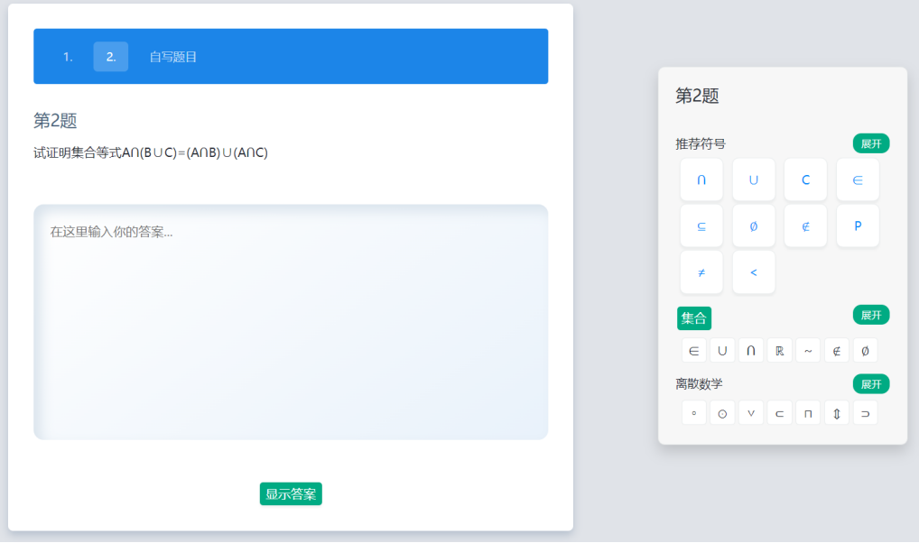
The process of doing mathematics homework by students involves inputting symbols. Dynamic keyboard is an application that provide the probable need symbols in the virtual board so that user can input the symbols through selecting symbols from the virtual board, this is illustrated by Figure 3.
Figure 3. The illustration of the mode that the dynamic symbol recommendation technology aids the students in doing homework.
The symbols appear in the virtual board are given by an algorithm, which gives the symbols according to the context information. In other words, the context information and a set of symbols with the probabilities to be used in the context are the input and the output of the algorithm. The context information of the current version of the algorithm is the mathematics problem assigned by teacher and the output is a set of symbols with the probabilities to be used in the solution of the problem [].
contains symbols for the subject ”Discrete Mathematics”.
The core of the Dynamic Keyboarding Service is the construction of the exercise-symbol pattern, which is a mapping relationship between questions and symbols, as shown in Figure 3. Through the establishment of the exercise-symbol pattern, the most relevant set of symbols can be found, which can further strengthen the relevance of potential symbols or reduce the relevance of irrelevant symbols.
The technical framework of Dynamic Keyboarding Service includes two parts: multidisciplinary symbol library construc- tion and symbol recommendation model. Multidisciplinary symbol library construction is based on the subject test ques- tions, answers and subject knowledge map, and through the discovery of scenario patterns of test questions and the asso- ciation of scenario pattern symbols, a ”test question-symbol” scenario pattern is established, which is then collaboratively constructed with the subject knowledge map. Then we can build a multidisciplinary symbol library in collaboration with nstruct the dynamic keyboard. As shown in Fig.4.
  - Assignment Grading
Leveraging solution-path enumeration and semantic alignment models, the grading module automatically evaluates diverse student solution processes for equation-type and system-of-equations problems, seamlessly handling incomplete or unconventional steps [5].
With the significant increase in curriculum tasks leading to a substantial growth in homework
requiring grading, teachers' time spent on grading has risen markedly. Consequently,
automatic grading tools have emerged. Automatic grading represents a critical application of
artificial intelligence technology in intelligent education, whose core lies in achieving automated evaluation of students' problem-solving processes through algorithmic models. However, existing automatic grading methods predominantly rely on rule templates or answer
matching, lacking utilization of machine solving technology. To address this, this paper proposes an automatic grading method for elementary math word problems based on solution path enumeration, leveraging machine solving technology to enumerate solution paths and achieve automated grading of students' diverse solution processes. This study focuses on students' equation-type and equation-system-type problem-solving processes, aiming to automatically grade students' step-by-step solutions. When missing solution paths hinder grading, machine solving models must be employed to generate solution paths to assist automatic grading. The specific research contributions include: Implicit solution path enumeration via scene analysis: Addressing the lack of stepwise solution paths for grading equation-type stepwise solutions, we categorize scene types and construct a scene decomposer to break down problems into singular sub-problems. A semantic
alignment-based Seq2Seq model is adopted to implicitly enumerate stepwise solution paths.
The generated stepwise solution paths are suitable for automatically grading equation-type stepwise solution processes. Implicit enumeration-based automatic grading: To resolve inaccuracies in mapping solution paths to students' stepwise processes, we combine implicit solution path enumeration with expression parsing technology to analyze mappi

5. Interaction Schemes of Selection Scenarios
5.1 Interaction Scheme of Homework Management for Students
Homework is a frequent activity for students, making an effective Homework Management Interaction Scheme crucial for building a comprehensive learning ecosystem. Figure 5 illustrates this scheme, which covers the complete workflow from homework acceptance to submission. The key components of this scheme are detailed below:
‌Action 1 (Homework Acceptance):‌
Students log into the Digital and Intelligent Homework Management system (DIM) to accept their assignments. The system then interacts with students to establish personalized reminder plans for each assignment.
‌Action 2 (Homework Completion):‌
This phase consists of four key scenarios:
Device Selection: The student chooses an appropriate device for completing the homework.
Problem Solving: While working on problems, the system provides symbol recommendation support, including suggestions based on common student mistakes.
Solution Review: The student can request the grading tool to evaluate their solution.
Solution Revision: Based on the grading tool's feedback, the student revises their work accordingly.
‌Action 3 (Homework Submission):‌
Students log back into DIM to submit their completed assignments.

  - Interaction Scheme of Homework Management for Teachers
Teachers do their side actions for homework, which are mainly the following three actions.
Action 1 (Homework Distribution):‌
The teacher logs into the Digital and Intelligent Homework Management System (DIM) to distribute assignments to students. The system then collaborates with the teacher to establish a customized reminder schedule for each assignment.
‌Action 2 (Grading Homework):‌
Case 1: The teacher utilizes the automated grading tool to evaluate student submissions.
Case 2: The teacher manually reviews pre-graded submissions for quality assurance.
‌Action 3 (Remedial Support):‌
For submissions receiving unsatisfactory marks, the system conducts comprehensive analysis through: Homework evaluation sheets and Error pattern tracking. This identifies specific weaknesses (e.g., comprehension gaps, incorrect application of concepts, or calculation errors) to guide targeted interventions.
‌Action 4 (Homework Feedback):‌
The AI-powered tool performs comparative analysis of homework submissions, then: Provides personalized feedback to students. Archives all data in the system for future reference

- Conclusions and Future Work
Our framework demonstrates how AI and cloud technologies can elevate mathematics education by fostering interconnected, adaptive, and intelligent learning environments. Future research will explore:
Designing an effective, intelligent digital ecosystem for mathematics education requires striking the right integration of cutting-edge technology and sound pedagogical principles. Our framework delivers a unified platform that is both accessible and customizable, putting students and teachers at its center. Key features include:
Cloud-based deployment for seamless access across classrooms, homes, and mobile environments
Automated grading engine that delivers instant, detailed feedback
Dynamic tutoring-video generation driven by advanced mathematical algorithms
Comprehensive homework management with auto-generated assignments
Predictive analytics to track concept mastery and identify learning gaps
Personalized learning recommendations tailored to each student’s progress
Interactive educational chatbot to guide and engage learners in real time
By integrating these components into a cohesive whole, we demonstrate how AI and cloud technologies can elevate the intelligence and adaptability of mathematics instruction.

To further strengthen and expand our ecosystem, we identify four strategic areas for future development:
Ecosystem Connectivity
- Broaden the cloud foundation to encompass all eight targeted mathematics-education scenarios
- Design bespoke interaction workflows for each scenario (e.g., collaborative problem solving, exam review)
- Integrate emerging AI advances (e.g., multimodal understanding, reinforcement-learning tutors) to boost system intelligence
System Enhancement
- Incorporate additional educational scenarios and their specific variants
- Embed autonomous AI agents to facilitate hands-on activities and peer-learning simulations
- Advance natural-language understanding so the platform can engage more fluently with both students and instructors
- Roll out unified educational analytics dashboards for instructors to visualize cohort- and individual-level progress
Educational Content Enrichment
- Curate advanced mathematics materials grounded in embodied-learning design, bridging abstract concepts with concrete experiences
- Develop visual-mapping tools that link meta-mathematical models to real-world phenomena
- Create “serious games” that reinforce higher-order reasoning skills through interactive challenges
Chatbot Advancement
- Extend the chatbot into a fully personalized tutor, capable of adapting to each learner’s style and next-step needs
- Implement fine-grained, real-time feedback (hints, error remediation, motivational nudges) during problem solving
- Strengthen conversational fluency so the chatbot becomes a proactive learning companion
- These enhancements will propel our ecosystem toward truly individualized, intelligent support for mathematics learners and educators alike—paving the way for deeper understanding, greater motivation, and measurable gains in mathematical proficiency.

Acknowledgment: This work is partially supported by the National Natural Science Foundation of China (62277022).

REFERENCE
- Abrahamson D, Tancredi S, et al. Embodied design of digital resources for mathematics education: Theory, methodology, and framework of a pedagogical research program. Handbook of Digital (Curriculum) Resources in Mathematics Education. Springer.
- Létourneau AL, Deslandes MM, Charland P, et al. A systematic review of AI-driven intelligent tutoring systems (ITS) in K-12 education. npj Science of Learning. 2025;10:01.
- Gupta A, Reddig J, Calo T, et al. Beyond final answers: Evaluating large language models for math tutoring. arXiv. 2025;2503.16460v1.
- Liu V, Latif E, Zhai X. Advancing education through tutoring systems: A systematic literature review. arXiv. 2025;2503.09748v1.
- Yeung AC, Yu J, Cheung KC, et al. Zero-shot LLM framework for automatic assignment grading in higher education. arXiv. 2025;2501.14305v1.
- Fang Y, He B, et al. Evaluating the design features of an intelligent tutoring system for advanced mathematics learning. IEEE Trans. Educ. 2024;67(1):1–10.
- Topali P, Ortega-Arranz A, Rodríguez-Triana MJ, et al. Designing human-centered learning analytics and artificial intelligence in education solutions: A systematic literature review. Behaviour & Info Tech. 2024;doi:10.1080/0144929X.2024.2345295.
- Son T. Intelligent tutoring systems in mathematics education: A systematic literature review using the substitution, augmentation, modification, redefinition model. Computers. 2024;13(10).
- Seo K, Yoo M, Dodson S, Jin S-H. Augmented teachers: K–12 teachers’ needs for artificial intelligence’s complementary role in personalized learning. J. Res. Technol. Educ. 2024; March.
- Rane N, Choudhary S, Rane J. Education 4.0 and 5.0: Integrating Artificial Intelligence (AI) for personalized and adaptive learning. Journal of Artificial Intelligence and Robotics. 2024;March.
- Memarian B, Doleck T. A review of assessment for learning with artificial intelligence. Computers in Human Behavior Artificial Humans. 2023;2:100040.
- Kamalov F, Calonge DS, Gurrib I. New era of artificial intelligence in education: Towards a sustainable multifaceted revolution. Sustainability. 2023;15:12451.
- Xu X, Pian Y, Chen P, Meng Q, Cao Y. A smart learning ecosystem design for delivering data-driven thinking in STEM education. In: Proc. IEEE Int. Conf. Adv. Learn. Technol. 2022:1–5.
- Xu X, Yu X, Sheng W, et al. A personalized intelligent tutoring system for mathematics homework. IEIR. 2023.
- Yu X, Cheng W, et al. A theoretical review on solving algebra problems. arXiv. 2024;2411.00031.
- Hahn MG, Navarro SMB, et al. A systematic review of the effects of automatic scoring and automatic feedback in educational settings. IEEE Access. 2021;7:100203.
- Cunska A. Effective learning strategies and artificial intelligence support for accelerated math acquisition. In: Proc. Int. Conf. Educ. & Educ. Psychol.. European Publisher; 2020.
- Spitzer M, Moeller K. Performance increases in mathematics during COVID-19 pandemic distance learning in Austria: Evidence from an intelligent tutoring system for mathematics. Trends in Neuroscience and Education. 2023;31:100203.
- Lu Y, Pian Y, Chen P, Meng Q, Cao Y. RadarMath: An intelligent tutoring system for math education. AAAI. 2021;35(18):16087–16090.
IEEEconferencetemplatescontainguidancetextforcomposingandformattingconferencepapers.Pleaseensurethatalltemplatetextisremovedfromyourconferencepaperpriortosubmissiontotheconference.Failuretoremovetemplatetextfromyourpapermayresultinyourpapernotbeingpublishe

